CLASS ASSIGNMENT 7
DATE : 08-10-2025
ID : 12341550

QUESTION 1

#include<pthread.h>
#include<stdio.h>

int global_id = 10;

void * thread_func(void * arg){
int thread_local;
printf("Thread %d : local address = %p, global address = %p\n",
*(int*)arg, (void*)&thread_local, (void*)&global_id);
}
int main(){
pthread_t id1;
pthread_t id2;
int local_id = 42;
pthread_create(&id1,NULL,thread_func,&global_id);
pthread_create(&id2,NULL,thread_func,&local_id);
pthread_join(id1,NULL);
pthread_join(id2,NULL);
printf("Main: local address = %p, global address = %p\n",
(void*)&local_id, (void*)&global_id);
printf("Thread finished.\n");
return 0;
}

OUTPUT :

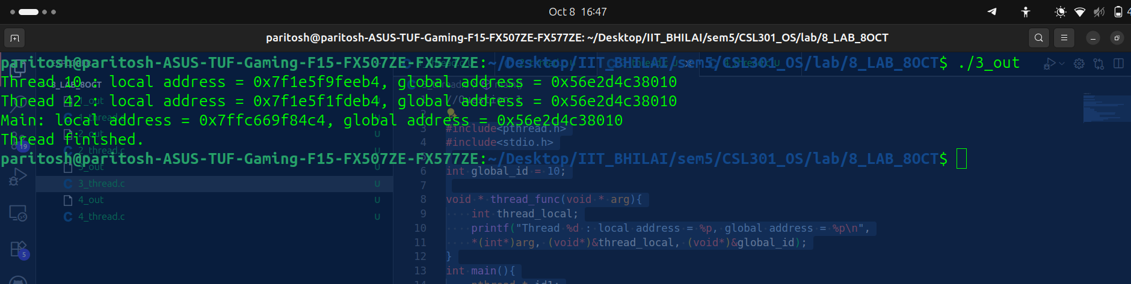
EXPLANATION:
local address is different while global address remain same. I think local created a child thats why local addresses are different.

QUESTION 2

#include<pthread.h>
#include<stdio.h>

void * print_id(void * arg){
int id = *(int*)arg;
printf("Thread ID : %d is running\n",id);
return NULL;
}

int main(){
pthread_t arr[10] = {1,2,3,4,5,6,7,8,9,10};
int id[10] = {1,2,3,4,5,6,7,8,9,10};
for(int i = 0; i < 10; i++){
pthread_create(&arr[i],NULL,print_id,&id[i]);
}
for(int i = 0; i < 10; i++){
pthread_join(arr[i],NULL);
}
printf("All threads completed.\n");
return 0;
}

OUTPUT :

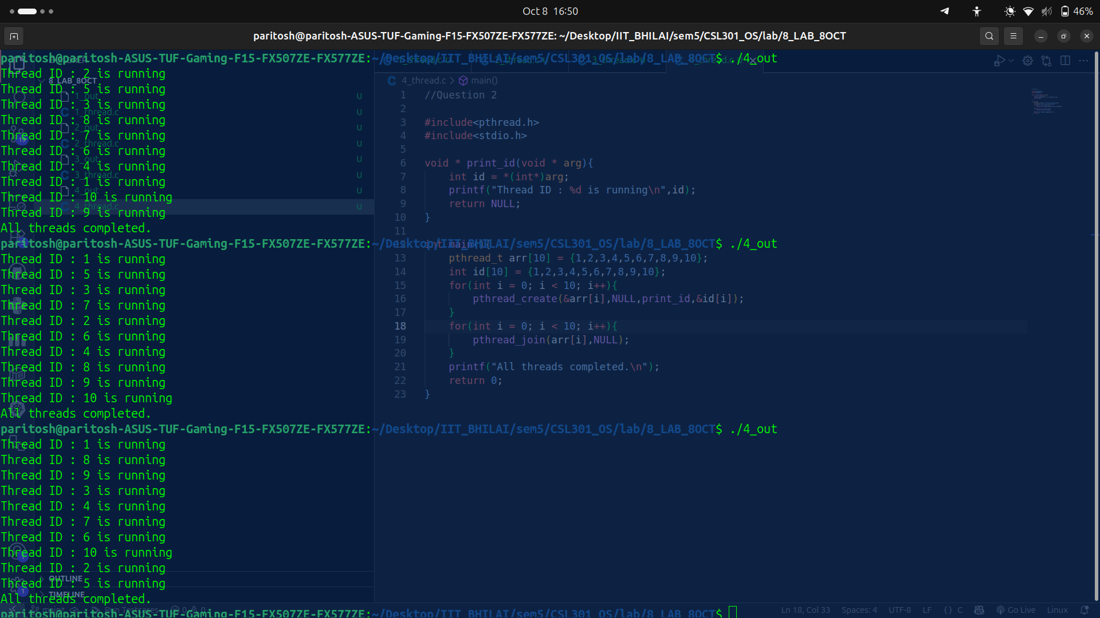

EXPLANATION:
At each run ordering is not same because in threadinng ordering doesn’t matter.

QUESTION 3

#include<pthread.h>
#include<stdio.h>

int global_var = 10;

void * thread_func(void * arg){
int id = *(int*)arg;
global_var += 1000000;
printf("Thread ID : %d , golbal var : %d\n",id,global_var);
return NULL;
}

int main(){
pthread_t arr[10] = {1,2,3,4,5,6,7,8,9,10};
int id[10] = {1,2,3,4,5,6,7,8,9,10};
for(int i = 0; i < 10; i++){
pthread_create(&arr[i],NULL,thread_func,&id[i]);
}
for(int i = 0; i < 10; i++){
pthread_join(arr[i],NULL);
}
printf("All threads completed.\n");
return 0;
}

OUTPUT :

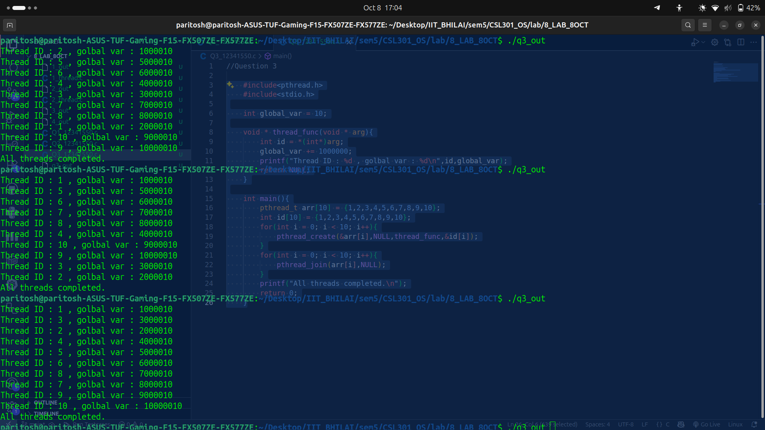

EXPLANATION:

QUESTION 4

#include<pthread.h>
#include<stdio.h>
#include<stdlib.h>

void * compute_square(void * arg){
int number = *(int*)arg;
int * result = malloc(sizeof(int));
*result = number * number;
return result;
}

int main(){
pthread_t tid;
void * result;
int number;
printf("Enter the number : ");
scanf("%d",&number);
pthread_create(&tid,NULL,compute_square,&number);
pthread_join(tid,&result);

int * value = (int*)result;
printf("Output : %d\n",*value);

free(value);

return 0;
}

OUTPUT :

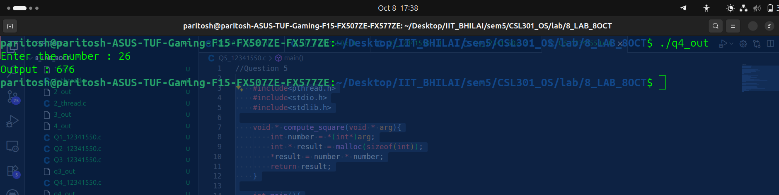

EXPLANATION:

QUESTION 5

#include <pthread.h>
#include <stdio.h>
#include <stdlib.h>

void * compute_square(void * arg){
int number = *(int*)arg;
int * result = malloc(sizeof(int));
*result = number * number;
return result;
}

int main(){
int n;
printf("Enter number of threads : ");
scanf("%d", &n);

pthread_t tid[n];
void * res[n];
int * nums = malloc(n * sizeof(int));

for(int i = 0; i < n; i++){
printf("Enter the number : ");
scanf("%d", &nums[i]);
pthread_create(&tid[i], NULL, compute_square, &nums[i]);
}

for(int i = 0; i < n; i++){
pthread_join(tid[i], &res[i]);
}

for(int i = 0; i < n; i++){
int * val = (int*)res[i];
printf("Thread %d returned %d\n", nums[i], *val);
free(val);
}

free(nums);
return 0;
}

OUPTPUT :

