CLASS ASSIGNMENT – 11
ID : 12341550
DATE : 19-11-25

Q1
output:
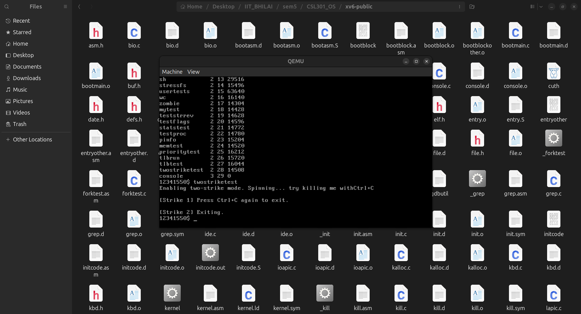

Q2

code :
#include <stdio.h>
#include <stdlib.h>
#include <string.h>
#include <dirent.h>
#include <sys/stat.h>
#include <sys/types.h>
#include <pwd.h>
#include <grp.h>
#include <unistd.h>
#include <time.h>
#include <limits.h>

#ifndef PATH_MAX
#define PATH_MAX 4096
#endif

void print_permissions(mode_t mode) {
char type = '-';
if (S_ISDIR(mode)) type = 'd';
else if (S_ISLNK(mode)) type = 'l';
else if (S_ISCHR(mode)) type = 'c';
else if (S_ISBLK(mode)) type = 'b';
else if (S_ISSOCK(mode)) type = 's';
else if (S_ISFIFO(mode)) type = 'p';

printf("%c", type);
printf( (mode & S_IRUSR) ? "r" : "-");
printf( (mode & S_IWUSR) ? "w" : "-");
printf( (mode & S_IXUSR) ? "x" : "-");
printf( (mode & S_IRGRP) ? "r" : "-");
printf( (mode & S_IWGRP) ? "w" : "-");
printf( (mode & S_IXGRP) ? "x" : "-");
printf( (mode & S_IROTH) ? "r" : "-");
printf( (mode & S_IWOTH) ? "w" : "-");
printf( (mode & S_IXOTH) ? "x" : "-");
}

void print_file_details(const char *path, const char *name) {
char fullpath[PATH_MAX];

if (snprintf(fullpath, sizeof(fullpath), "%s/%s", path, name) >= (int)sizeof(fullpath)) {
fprintf(stderr, "Path too long: %s/%s\n", path, name);
return;
}

struct stat sb;
if (lstat(fullpath, &sb) == -1) {
perror("stat");
return;
}

print_permissions(sb.st_mode);

struct passwd *pwd = getpwuid(sb.st_uid);
struct group *grp = getgrgid(sb.st_gid);

char timebuf[64];
struct tm *tm_info = localtime(&sb.st_mtime);
if (tm_info) {
strftime(timebuf, sizeof(timebuf), "%b %e %H:%M", tm_info);
} else {
strncpy(timebuf, "??? ?? ??:??", sizeof(timebuf));
timebuf[sizeof(timebuf) - 1] = '\0';
}

printf(" %2ld %s %s %8lld %s %s\n",
(long)sb.st_nlink,
pwd ? pwd->pw_name : "?",
grp ? grp->gr_name : "?",
(long long)sb.st_size,
timebuf,
name);

}

int main(int argc, char *argv[]) {
int long_format = 0;
char *dirpath = NULL;

if (argc == 1) {
dirpath = ".";
} else if (argc == 2) {
if (strcmp(argv[1], "-l") == 0)
dirpath = ".";
else
dirpath = argv[1];
} else if (argc == 3 && strcmp(argv[1], "-l") == 0) {
long_format = 1;
dirpath = argv[2];
} else {
fprintf(stderr, "Usage: %s [-l] [directory]\n", argv[0]);
exit(1);
}

if (argc >= 2 && strcmp(argv[1], "-l") == 0)
long_format = 1;

DIR *dir = opendir(dirpath);
if (!dir) {
perror("opendir");
return 1;
}

struct dirent *entry;
while ((entry = readdir(dir)) != NULL) {
if (strcmp(entry->d_name, ".") == 0 || strcmp(entry->d_name, "..") == 0)
continue;

if (long_format)
print_file_details(dirpath, entry->d_name);
else
printf("%s\n", entry->d_name);
}

closedir(dir);
return 0;
}

OUTPUT:
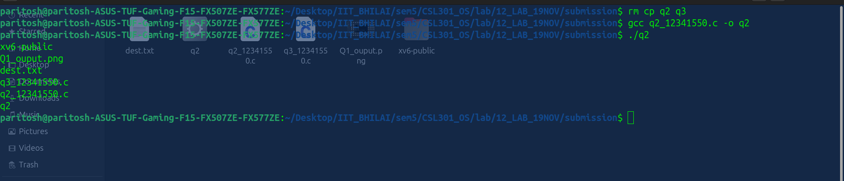

Q3

code:

#include <stdio.h>
#include <stdlib.h>
#include <fcntl.h>
#include <unistd.h>
#include <sys/stat.h>
#include <string.h>
#include <errno.h>

#define BUF_SIZE 4096

int copy_file(const char *src, const char *dest) {
int src_fd, dest_fd;
struct stat src_stat;
char buffer[BUF_SIZE];
ssize_t bytes_read, bytes_written;

src_fd = open(src, O_RDONLY);
if (src_fd < 0) { perror("open source"); return -1; }

if (stat(src, &src_stat) < 0) {
perror("stat");
close(src_fd);
return -1;
}

dest_fd = open(dest, O_WRONLY | O_CREAT | O_TRUNC, src_stat.st_mode);
if (dest_fd < 0) {
perror("open destination");
close(src_fd);
return -1;
}

while ((bytes_read = read(src_fd, buffer, sizeof(buffer))) > 0) {
ssize_t total_written = 0;

while (total_written < bytes_read) {
bytes_written = write(dest_fd, buffer + total_written, bytes_read - total_written);
if (bytes_written < 0) {
perror("write");
close(src_fd);
close(dest_fd);
unlink(dest);
return -1;
}
total_written += bytes_written;
}
}

if (bytes_read < 0) {
perror("read");
close(src_fd);
close(dest_fd);
unlink(dest);
return -1;
}

close(src_fd);
close(dest_fd);
return 0;
}

int move_file(const char *src, const char *dest) {
if (rename(src, dest) == 0) {
return 0;
}

if (errno != EXDEV) {
perror("rename");
return -1;
}

if (copy_file(src, dest) < 0) {
return -1;
}

if (unlink(src) < 0) {
perror("unlink");
unlink(dest);
return -1;
}

return 0;
}

int main(int argc, char *argv[]) {
const char *prog;
const char *src;
const char *dest;

if (argc == 3) {
// ln -s a.out cp
// ln -s a.out mv
// ./cp src dest or ./mv src dest
prog = strrchr(argv[0], '/');
prog = (prog == NULL) ? argv[0] : prog + 1;
src = argv[1];
dest = argv[2];
} else if (argc == 4) {
// ./a.out cp src dest or ./a.out mv src dest
prog = argv[1];
src = argv[2];
dest = argv[3];
} else {
fprintf(stderr, "Usage:\n");
fprintf(stderr, " %s <source> <destination>\n", argv[0]);
fprintf(stderr, " %s <cp|mv> <source> <destination>\n", argv[0]);
exit(EXIT_FAILURE);
}

if (strcmp(prog, "cp") == 0) {
if (copy_file(src, dest) == 0)
printf("File copied successfully from '%s' to '%s'\n", src, dest);
else
fprintf(stderr, "Copy failed.\n");
}
else if (strcmp(prog, "mv") == 0) {
if (move_file(src, dest) == 0)
printf("File moved successfully from '%s' to '%s'\n", src, dest);
else
fprintf(stderr, "Move failed.\n");
}
else {
fprintf(stderr, "Error: Invalid command name '%s'. Use cp or mv.\n", prog);
exit(EXIT_FAILURE);
}

return 0;
}

OUPUT:

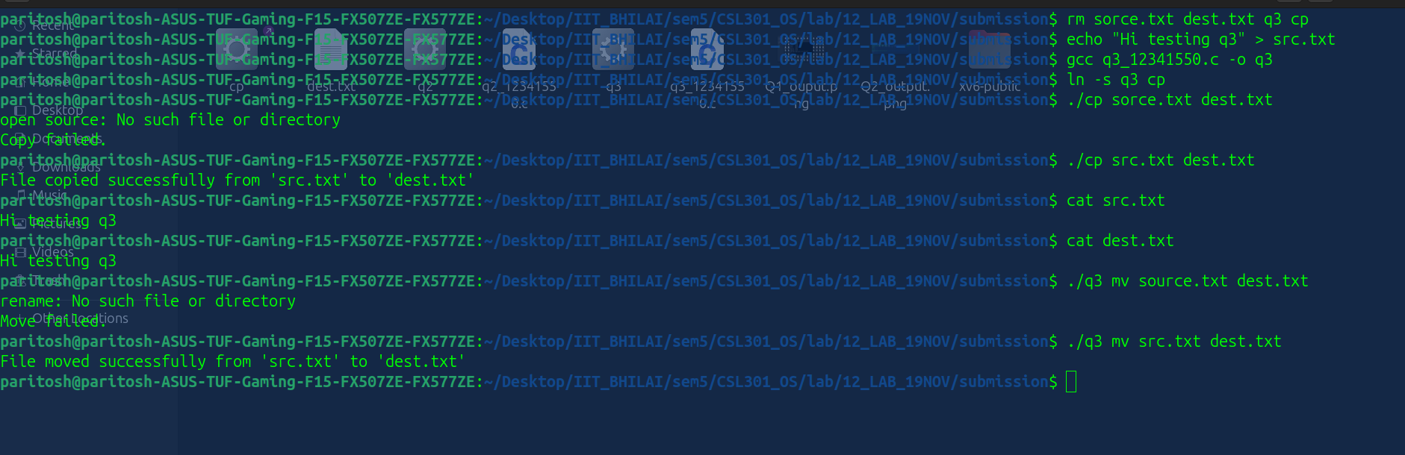

Q4

code:

#include <stdio.h>
#include <stdlib.h>
#include <string.h>
#include <time.h>

#define MAX_INODES 8
#define MAX_BLOCKS 64
#define MAX_FILENAME 32
#define MAX_DESC 64
#define DIRECT_PTRS 4
#define MAX_DIR_ENTRIES 16

struct inode {
int used; // 0 = free, 1 = allocated
int size; // file size in bytes
int type; // 0 = file, 1 = directory
int creator_id; // user ID who created file
time_t created_at; // creation timestamp
char description[MAX_DESC]; // short file description
int direct[DIRECT_PTRS]; // direct data block pointers
};

struct dir_entry {
char name[MAX_FILENAME];
int inum;
};

struct inode inode_table[MAX_INODES];
int data_block_bitmap[MAX_BLOCKS]; // 0 = free, 1 = used
struct dir_entry directory[MAX_DIR_ENTRIES];
int dir_count = 0;

int alloc_inode() {
for (int i = 0; i < MAX_INODES; i++) {
if (!inode_table[i].used) {
inode_table[i].used = 1;
inode_table[i].size = 0;
inode_table[i].type = 0;
inode_table[i].creator_id = 0;
inode_table[i].created_at = time(NULL);
strcpy(inode_table[i].description, "No description");
for (int j = 0; j < DIRECT_PTRS; j++)
inode_table[i].direct[j] = -1;
return i;
}
}
return -1;
}

void free_inode(int inum) {
inode_table[inum].used = 0;
inode_table[inum].size = 0;
inode_table[inum].creator_id = 0;
inode_table[inum].created_at = 0;
strcpy(inode_table[inum].description, "");
for (int j = 0; j < DIRECT_PTRS; j++)
inode_table[inum].direct[j] = -1;
}

int alloc_block() {
for (int i = 0; i < MAX_BLOCKS; i++) {
if (data_block_bitmap[i] == 0) {
data_block_bitmap[i] = 1;
return i;
}
}
return -1;
}

void free_block(int blocknum) {
if (blocknum >= 0 && blocknum < MAX_BLOCKS)
data_block_bitmap[blocknum] = 0;
}

int fs_create(const char *name, int creator_id, const char *desc) {
for (int i = 0; i < dir_count; i++) {
if (strcmp(directory[i].name, name) == 0) {
printf("Error: File '%s' already exists\n", name);
return -1;
}
}

int inum = alloc_inode();
if (inum < 0) {
printf("Error: No free inode available\n");
return -1;
}
if (dir_count >= MAX_DIR_ENTRIES) {
printf("Error: Directory full\n");
free_inode(inum);
return -1;
}

inode_table[inum].creator_id = creator_id;
inode_table[inum].created_at = time(NULL);
inode_table[inum].size = 0;
inode_table[inum].type = 0;
strncpy(inode_table[inum].description, desc, MAX_DESC - 1);
inode_table[inum].description[MAX_DESC - 1] = '\0';

int block = alloc_block();
if (block < 0) {
printf("Error: No free data block available\n");
free_inode(inum);
return -1;
}

inode_table[inum].direct[0] = block;
inode_table[inum].size = 0;

strcpy(directory[dir_count].name, name);
directory[dir_count].inum = inum;
dir_count++;

printf("File '%s' created (inode %d, block %d)\n", name, inum, block);
return inum;
}

int fs_delete(const char *name) {
int found = -1;
for (int i = 0; i < dir_count; i++) {
if (strcmp(directory[i].name, name) == 0) {
found = i;
break;
}
}

if (found < 0) {
printf("Error: File '%s' not found\n", name);
return -1;
}

int inum = directory[found].inum;

for (int j = 0; j < DIRECT_PTRS; j++) {
if (inode_table[inum].direct[j] != -1) {
free_block(inode_table[inum].direct[j]);
inode_table[inum].direct[j] = -1;
}
}

free_inode(inum);

for (int i = found; i < dir_count - 1; i++)
directory[i] = directory[i + 1];
dir_count--;

printf("File '%s' deleted (inode %d freed)\n", name, inum);
return 0;
}

void fs_show_state() {
printf("\n--- File System State ---\n");
printf("Directory entries (%d):\n", dir_count);
for (int i = 0; i < dir_count; i++)
printf(" %s → inode %d\n", directory[i].name, directory[i].inum);

printf("\nInode table:\n");
for (int i = 0; i < MAX_INODES; i++) {
if (inode_table[i].used) {
printf(" inode %d: creator=%d, size=%d, desc='%s'\n",
i, inode_table[i].creator_id, inode_table[i].size, inode_table[i].description);
printf(" created: %s", ctime(&inode_table[i].created_at));
printf(" blocks: ");
for (int j = 0; j < DIRECT_PTRS; j++)
if (inode_table[i].direct[j] != -1)
printf("%d ", inode_table[i].direct[j]);
printf("\n");
}
}
printf("--------------------------\n\n");
}

int main() {
printf("File Creation and Deletion with Metadata Simulation\n");

fs_create("file1.txt", 101, "User text document");
fs_create("report.pdf", 102, "PDF project report");
fs_create("data.bin", 103, "Binary data log");
fs_show_state();

fs_delete("report.pdf");
fs_show_state();

fs_create("notes.txt", 104, "Important notes");
fs_show_state();

return 0;
}

OUPUT:
