CLASS ASSIGNMENT – 10
ID : 12341550
DATE : 04-11-25

Q1

code:
#include <stdio.h>
#include <pthread.h>
#include <unistd.h>

#define N 102 // number of cycles

pthread_mutex_t lock = PTHREAD_MUTEX_INITIALIZER;
pthread_cond_t cond = PTHREAD_COND_INITIALIZER;

int turn = 0; // 0 -> A, 1 -> B, 2 -> C

void *printA(void *arg) {
for (int i = 0; i < N; i++) {
pthread_mutex_lock(&lock);
while (turn != 0)
pthread_cond_wait(&cond, &lock);

printf("A ");
fflush(stdout);

turn = 1;
pthread_cond_broadcast(&cond);
pthread_mutex_unlock(&lock);
}
return NULL;
}

void *printB(void *arg) {
for (int i = 0; i < N; i++) {
pthread_mutex_lock(&lock);

while (turn != 1)
pthread_cond_wait(&cond, &lock);
printf("B ");
fflush(stdout);

turn = 2;
pthread_cond_broadcast(&cond);
pthread_mutex_unlock(&lock);
}
return NULL;
}

void *printC(void *arg) {
for (int i = 0; i < N; i++) {
pthread_mutex_lock(&lock);
while (turn != 2)
pthread_cond_wait(&cond, &lock);

printf("C ");
fflush(stdout);

turn = 0;
pthread_cond_broadcast(&cond);
pthread_mutex_unlock(&lock);
}
return NULL;
}

int main() {
pthread_t tA, tB, tC;
pthread_create(&tA, NULL, printA, NULL);
pthread_create(&tB, NULL, printB, NULL);
pthread_create(&tC, NULL, printC, NULL);

pthread_join(tA, NULL);
pthread_join(tB, NULL);
pthread_join(tC, NULL);
return 0;
}

output:
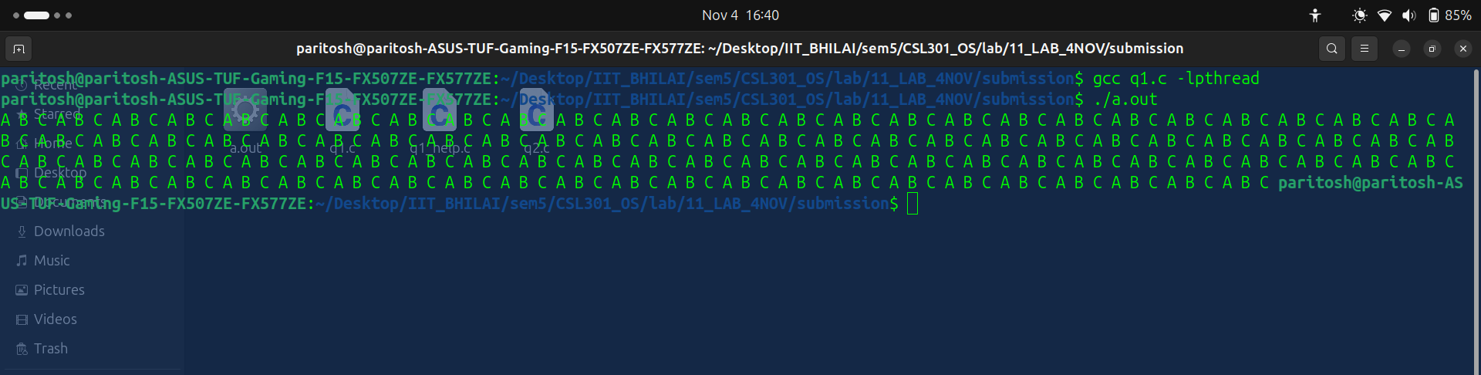
Explanation:
Switched to condition-variable rotation so exactly one thread prints at a time and order cycles A→B→C.

Q2

code :
#include <stdio.h>
#include <pthread.h>
#include <unistd.h>

pthread_mutex_t lock = PTHREAD_MUTEX_INITIALIZER;
pthread_cond_t can_read = PTHREAD_COND_INITIALIZER;
pthread_cond_t can_write = PTHREAD_COND_INITIALIZER;

int read_count = 0;
int write_count = 0;
int waiting_writers = 0;

void start_read() {
pthread_mutex_lock(&lock);
while (write_count > 0 || waiting_writers > 0) {
pthread_cond_wait(&can_read, &lock);
}
read_count++;
pthread_mutex_unlock(&lock);
}

void end_read() {
pthread_mutex_lock(&lock);
read_count--;
if (read_count == 0)
pthread_cond_signal(&can_write);
pthread_mutex_unlock(&lock);
}

void start_write() {
pthread_mutex_lock(&lock);
waiting_writers++;
while (write_count > 0 || read_count > 0) {
pthread_cond_wait(&can_write, &lock);
}
waiting_writers--;
write_count = 1;
pthread_mutex_unlock(&lock);
}

void end_write() {
pthread_mutex_lock(&lock);
write_count = 0;
if (waiting_writers > 0)
pthread_cond_signal(&can_write);
else
pthread_cond_broadcast(&can_read);
pthread_mutex_unlock(&lock);
}

void *reader(void *id) {
for (int i = 0; i < 5; i++) {
start_read();
printf("Reader %ld reading\n", (long)id);
usleep(100000);
end_read();
}
return NULL;
}

void *writer(void *id) {
for (int i = 0; i < 3; i++) {
start_write();
printf("Writer %ld writing\n", (long)id);
usleep(150000);
end_write();
}
return NULL;
}

int main() {
pthread_t r[3], w[2];
for (long i = 0; i < 3; i++) pthread_create(&r[i], NULL, reader, (void *)i);
for (long i = 0; i < 2; i++) pthread_create(&w[i], NULL, writer, (void *)i);
for (int i = 0; i < 3; i++) pthread_join(r[i], NULL);
for (int i = 0; i < 2; i++) pthread_join(w[i], NULL);
return 0;
}

output:
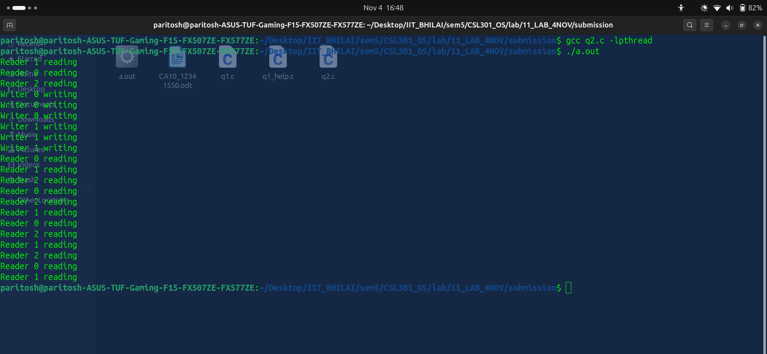
Explanation:
Added fairness by blocking readers when writers are active or waiting and by waking writers before readers.

Q3

code:
#include <stdio.h>
#include <pthread.h>
#include <stdlib.h>
#include <string.h>
#include <unistd.h>

#define MAX_LOGS 10

char *log_buffer[MAX_LOGS];
int count = 0;

pthread_mutex_t buffer_lock = PTHREAD_MUTEX_INITIALIZER;
pthread_cond_t not_empty = PTHREAD_COND_INITIALIZER;
pthread_cond_t not_full = PTHREAD_COND_INITIALIZER;

void *worker(void *id) {
for (int i = 0; i < 3; i++) {
char msg[64];
sprintf(msg, "Worker %ld message %d", (long)id, i);

pthread_mutex_lock(&buffer_lock);
while (count == MAX_LOGS)
pthread_cond_wait(&not_full, &buffer_lock);

log_buffer[count++] = strdup(msg);
printf("Worker %ld queued log. (count=%d)\n", (long)id, count);

pthread_cond_signal(&not_empty);
pthread_mutex_unlock(&buffer_lock);
usleep(100000);
}
return NULL;
}

void *logger(void *arg) {
FILE *f = fopen("log.txt", "w");
if (!f) {
perror("fopen");
return NULL;
}

while (1) {

pthread_mutex_lock(&buffer_lock);
while (count == 0)
pthread_cond_wait(&not_empty, &buffer_lock);

char *msg = log_buffer[--count];

pthread_cond_signal(&not_full);
pthread_mutex_unlock(&buffer_lock);

fprintf(f, "%s\n", msg);
fflush(f);
printf("Logger wrote: %s\n", msg);

free(msg);
usleep(50000);
}

fclose(f);
return NULL;
}

int main() {
pthread_t log_thread, workers[3];
pthread_create(&log_thread, NULL, logger, NULL);
for (long i = 0; i < 3; i++)
pthread_create(&workers[i], NULL, worker, (void *)i);

for (int i = 0; i < 3; i++)
pthread_join(workers[i], NULL);

sleep(1);

pthread_cancel(log_thread);
pthread_join(log_thread, NULL);

printf("\nAll workers finished. Check 'log.txt' for output.\n");
return 0;
}

output:

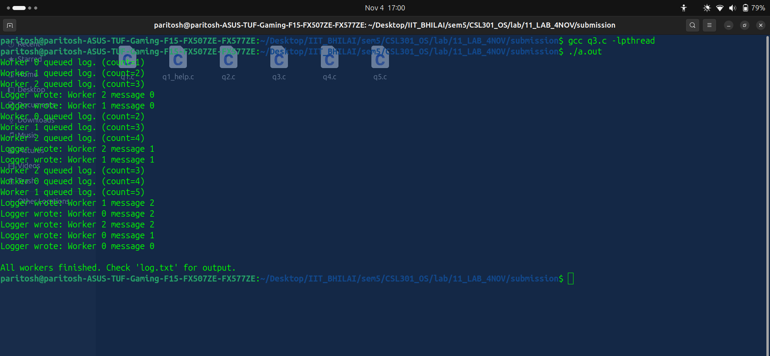

Explanation:
Guarded the bounded log buffer with mutex/conditions to block producers when full and consumers when empty.

Q4
code:

#include <stdio.h>
#include <pthread.h>
#include <unistd.h>

#define NTHREADS 3

struct thread_event {
pthread_mutex_t m;
pthread_cond_t c;
int awake;
};

struct thread_event events[NTHREADS];

void *sleeper(void *id) {
long tid = (long)id;
pthread_mutex_lock(&events[tid].m);

while (!events[tid].awake) {
printf("Thread %ld sleeping...\n", tid);
//ADD YOUR CODE
pthread_cond_wait(&events[tid].c, &events[tid].m);
}

printf("Thread %ld woke up!\n", tid);

pthread_mutex_unlock(&events[tid].m);
return NULL;
}

void *waker(void *arg) {
sleep(2);

printf("Waker: waking all threads...\n");

for (int i = 0; i < NTHREADS; i++) {
//ADD YOUR CODE
pthread_mutex_lock(&events[i].m);
events[i].awake = 1;
pthread_cond_signal(&events[i].c);
pthread_mutex_unlock(&events[i].m);
}

return NULL;
}

int main() {
pthread_t t[NTHREADS], w;

for (int i = 0; i < NTHREADS; i++) {
events[i].awake = 0;
pthread_mutex_init(&events[i].m, NULL);
pthread_cond_init(&events[i].c, NULL);
pthread_create(&t[i], NULL, sleeper, (void *)(long)i);
}

pthread_create(&w, NULL, waker, NULL);
pthread_join(w, NULL);

for (int i = 0; i < NTHREADS; i++)
pthread_join(t[i], NULL);

printf("All threads finished.\n");
return 0;
}

output:
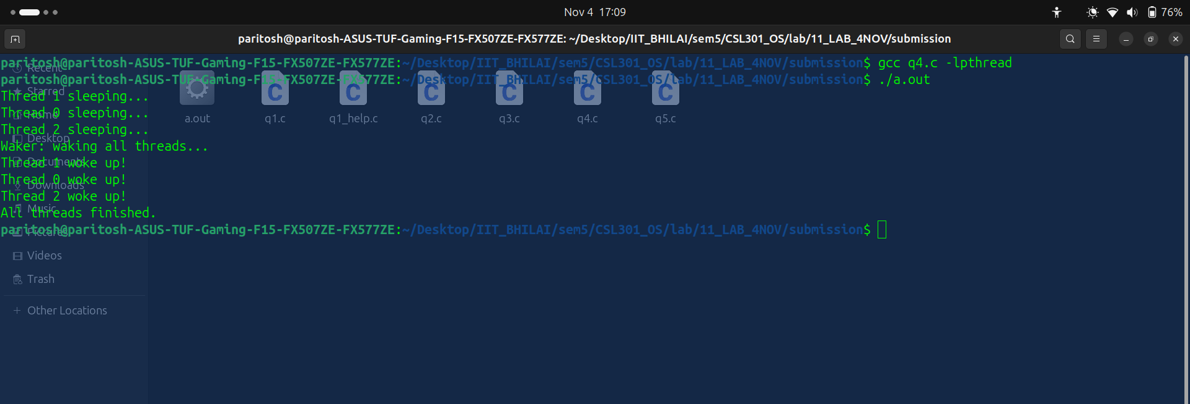

Explanation:
Each sleeper waits on its own condition until waker signals under lock, ensuring clean wake-up ordering.

q5

code:

#include <stdio.h>
#include <pthread.h>
#include <unistd.h>

#define MAX_JOBS 5
#define NUM_WORKERS 3

int jobs[MAX_JOBS];
int count = 0;

pthread_mutex_t lock = PTHREAD_MUTEX_INITIALIZER;
pthread_cond_t not_full = PTHREAD_COND_INITIALIZER;
pthread_cond_t not_empty = PTHREAD_COND_INITIALIZER;

void *dispatcher(void *arg) {
int job_id = 1;
while (job_id <= 10) {
pthread_mutex_lock(&lock);

while (count == MAX_JOBS)
pthread_cond_wait(&not_full, &lock);

jobs[count++] = job_id;
printf("Dispatcher added job %d (count=%d)\n", job_id, count);

pthread_cond_signal(&not_empty);
pthread_mutex_unlock(&lock);
job_id++;

usleep(100000);
}
return NULL;
}

void *worker(void *arg) {
long id = (long)arg;

while (1) {
pthread_mutex_lock(&lock);

while (count == 0)
pthread_cond_wait(&not_empty, &lock);

int job = jobs[--count];
printf("Worker %ld processing job %d (remaining=%d)\n", id, job, count);

pthread_cond_signal(&not_full);
pthread_mutex_unlock(&lock);

usleep(200000);
}
return NULL;
}

int main() {
pthread_t disp, workers[NUM_WORKERS];

pthread_create(&disp, NULL, dispatcher, NULL);
for (long i = 0; i < NUM_WORKERS; i++)
pthread_create(&workers[i], NULL, worker, (void *)i);

pthread_join(disp, NULL);
sleep(2);

printf("All jobs dispatched. Exiting...\n");
return 0;
}

output:
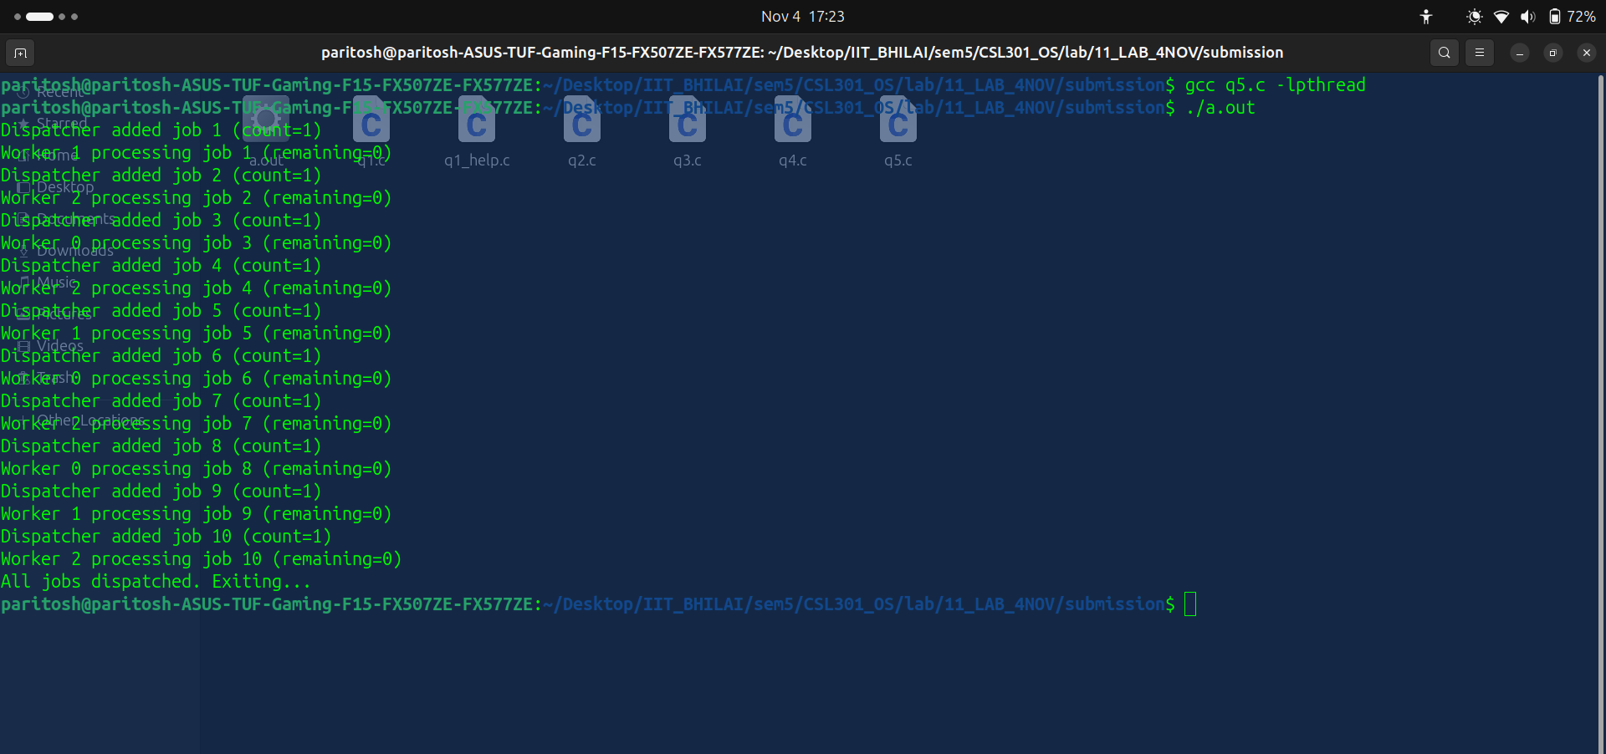

Explanation:
Replaced busy polling with pthread_cond_wait/signal, letting dispatcher block when the queue is full and workers block when empty so CPU time isn’t wasted.

