CLASS ASSINGMENT 8
DATE : 15-10-25
ID : 12341550

Q1

part1:

code:

#include <stdio.h>
#include <pthread.h>
#include <semaphore.h>

sem_t sem;

void* threadA(void* arg)
{
printf("Hello from A\n");
sem_post(&sem);
return NULL;
}
void* threadB(void* arg)
{
sem_wait(&sem);
printf("Hello from B\n");
return NULL;
}
int main()
{
pthread_t tA, tB;

sem_init(&sem, 0, 0);

pthread_create(&tA, NULL, threadA, NULL);
pthread_create(&tB, NULL, threadB, NULL);

pthread_join(tA, NULL);
pthread_join(tB, NULL);

sem_destroy(&sem);
return 0;
}

output:

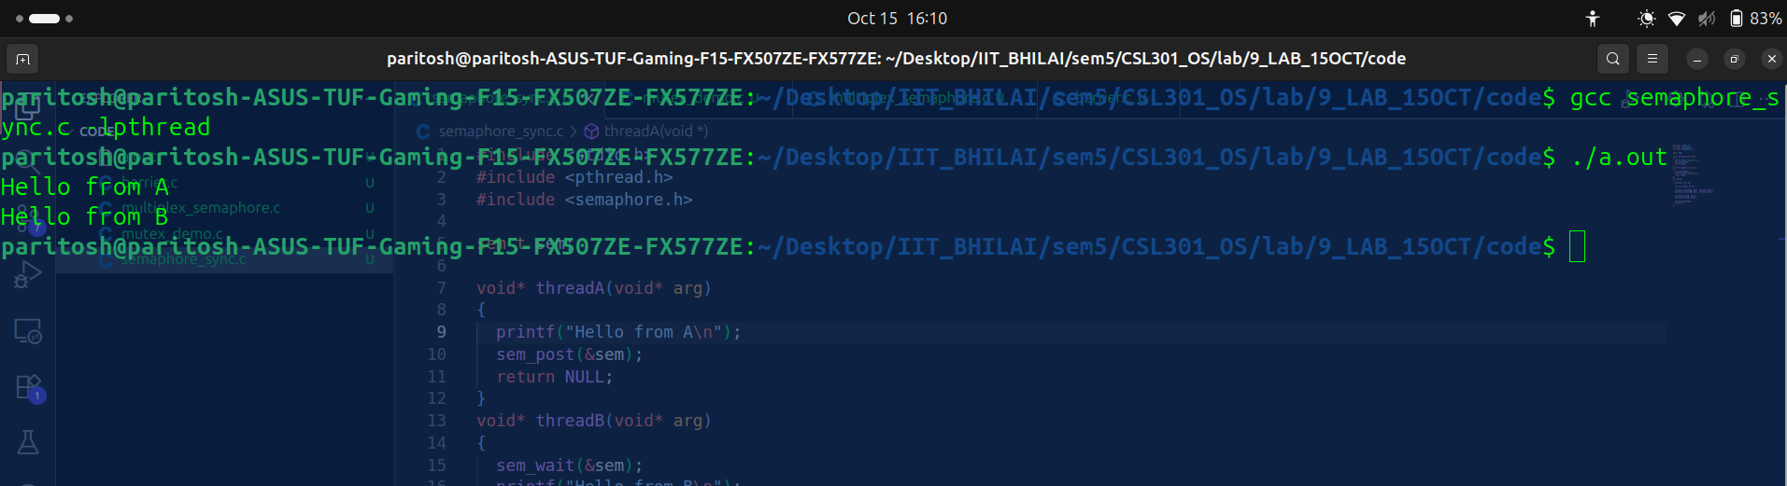

observation:
Here order is maintain first A then B is printed due to semaphores...without A , B can not be printed.

part2:
code:

#include <stdio.h>
#include <pthread.h>
#include <semaphore.h>

void* threadA(void* arg)
{
printf("Hello from A\n");

return NULL;
}
void* threadB(void* arg)
{

printf("Hello from B\n");
return NULL;
}
int main()
{
pthread_t tA, tB;

pthread_create(&tA, NULL, threadA, NULL);
pthread_create(&tB, NULL, threadB, NULL);

pthread_join(tA, NULL);
pthread_join(tB, NULL);

return 0;
}

ouput:
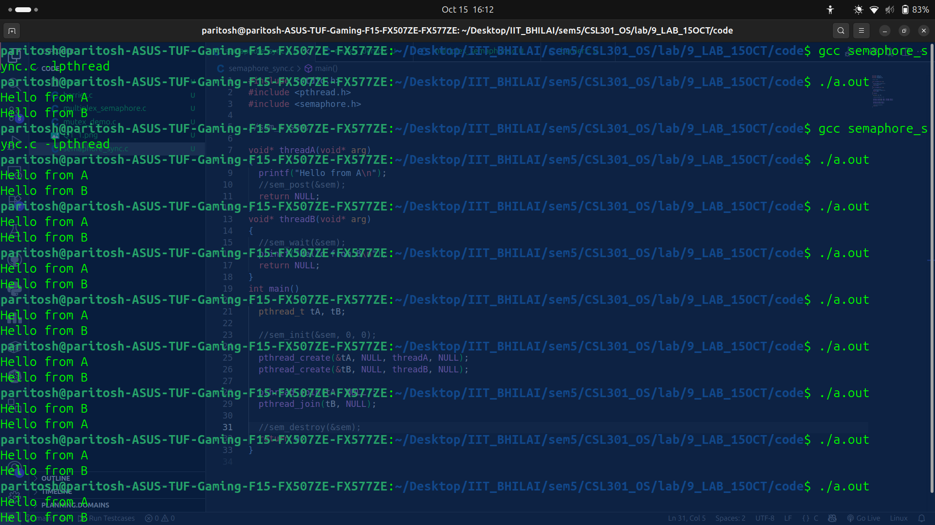

observation:
here order is not maintained , A or B any can print first.

part3:

code:
#include <stdio.h>
#include <pthread.h>
#include <semaphore.h>

sem_t sem1,sem2;

void* threadA(void* arg)
{
printf("Hello from A\n");
sem_post(&sem1);
return NULL;
}
void* threadB(void* arg)
{
sem_wait(&sem1);
printf("Hello from B\n");
sem_post(&sem2);
return NULL;
}
void* threadC(void* arg)
{
sem_wait(&sem2);
printf("Hello from B\n");
return NULL;
}
int main()
{
pthread_t tA, tB;

sem_init(&sem1, 0, 0);
sem_init(&sem2,0 ,0);

pthread_create(&tA, NULL, threadA, NULL);
pthread_create(&tB, NULL, threadB, NULL);

pthread_join(tA, NULL);
pthread_join(tB, NULL);

sem_destroy(&sem1);
sem_destroy(&sem2);
return 0;
}

ouput:
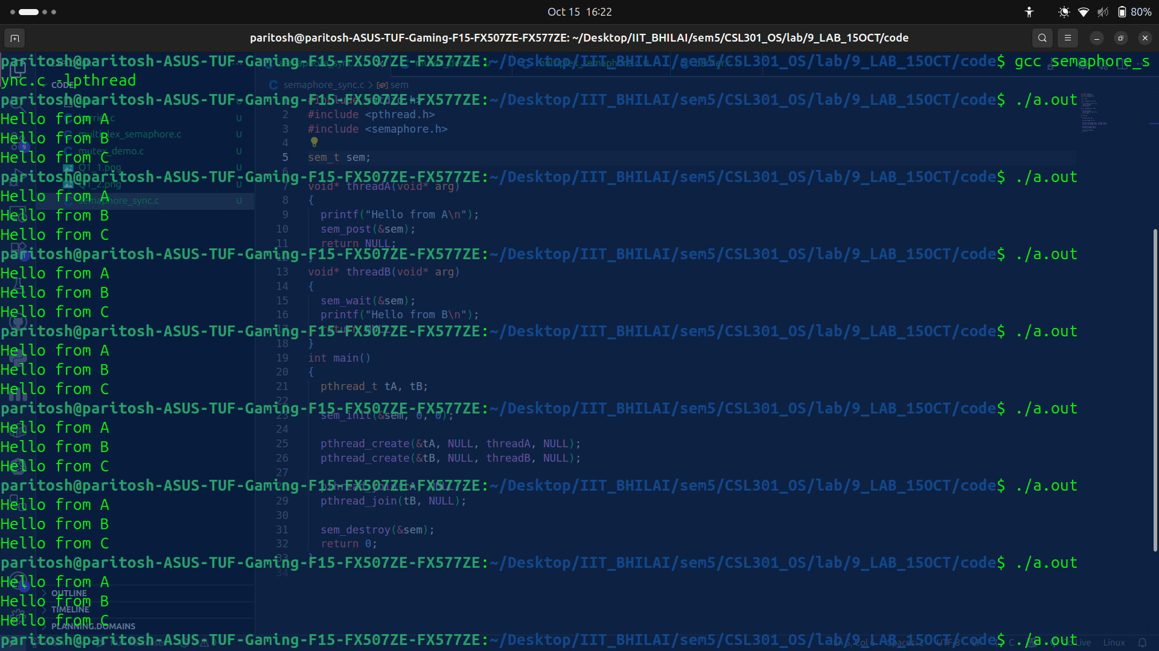

observation:
here order is maintained A , B, C..due to semaphores.

Q2: Rendezvous Between Two Threads

code:
#include <stdio.h>
#include <pthread.h>
#include <semaphore.h>

sem_t aArrived, bArrived;

void* threadA(void* arg)
{
printf("A1 (Starting task)\n");
sem_post(&aArrived);
sem_wait(&bArrived);
printf("A2 (Ending task)\n");
return NULL;
}
void* threadB(void* arg)
{
printf("B1 (Starting task)\n");
sem_post(&bArrived);
sem_wait(&aArrived);
printf("B2 (Ending task)\n");
return NULL;
}

int main()
{
pthread_t tA, tB;

sem_init(&aArrived, 0, 0);
sem_init(&bArrived,0 ,0);

pthread_create(&tA, NULL, threadA, NULL);
pthread_create(&tB, NULL, threadB, NULL);

pthread_join(tA, NULL);
pthread_join(tB, NULL);

sem_destroy(&aArrived);
sem_destroy(&bArrived);
return 0;
}

output:
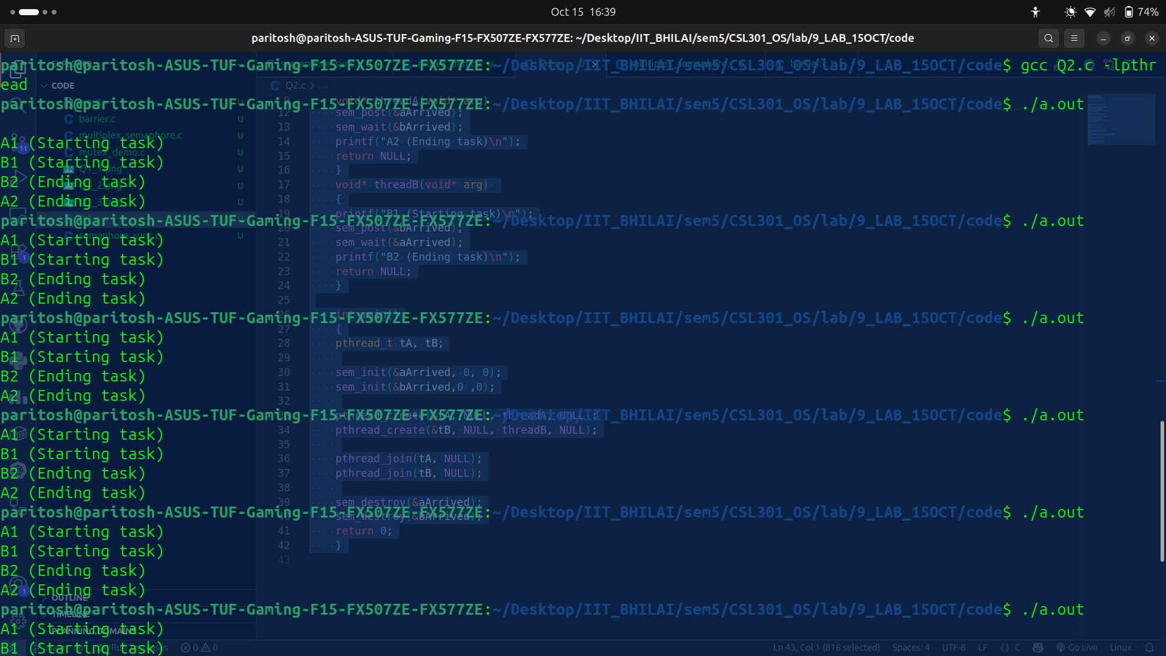

observation:
here we observes rendezvous pattern , its sure that A2 and B2 only execute after A1 and B1..after having synchronixation at a common point.

Q3: Thread Synchronization Using Mutex

code : mutex_demo.c

#include <stdio.h>
#include <pthread.h>

int counter = 0;
pthread_mutex_t lock;

void* increment(void* arg)
{
for(int i = 0; i < 5; i++)
{
pthread_mutex_lock(&lock);
counter = counter + 1;
printf("Thread %ld: Counter = %d\n", (long)arg, counter);
pthread_mutex_unlock(&lock);
}
return NULL;
}

int main()
{
pthread_t t1, t2;

pthread_mutex_init(&lock, NULL);

pthread_create(&t1, NULL, increment, (void*)1);
pthread_create(&t2, NULL, increment, (void*)2);

pthread_join(t1, NULL);
pthread_join(t2, NULL);

return 0;
}

output:
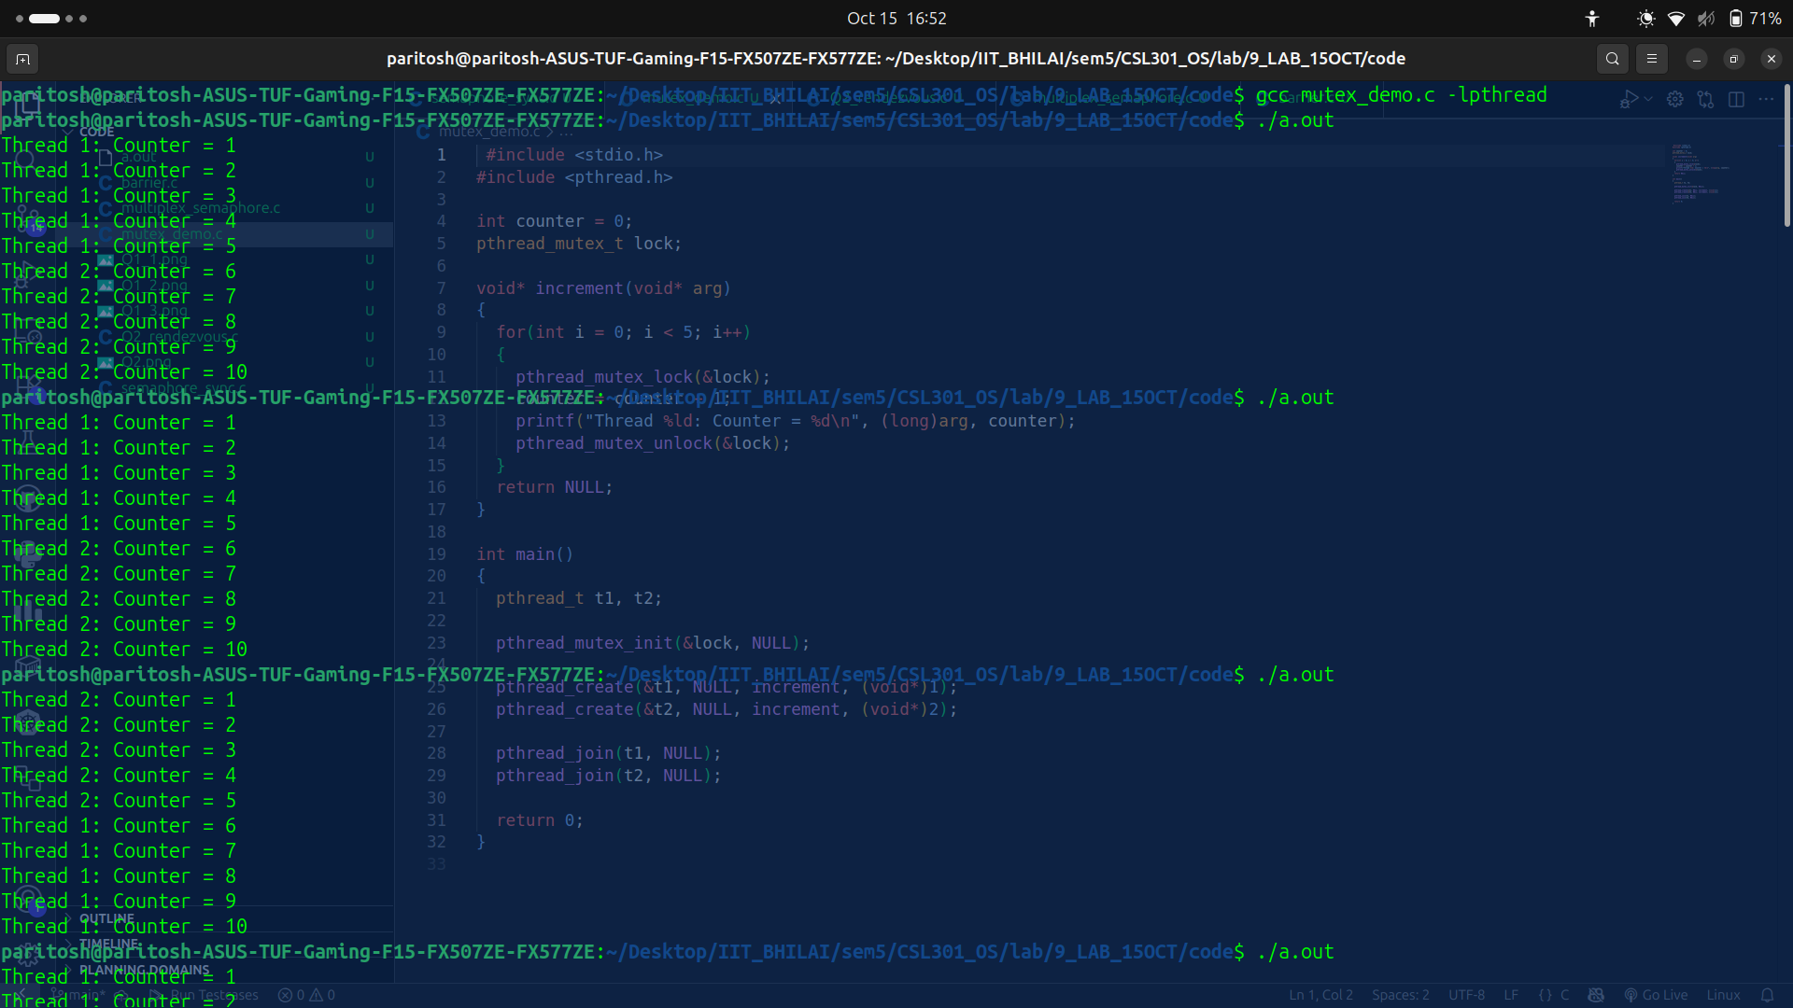
Observation:
Here I observe that counter is incremented in order no matter which thread is doing it , mutex ensures no disturbance occur at time of increment.

part2: with mutex
code :

#include <stdio.h>
#include <pthread.h>

int counter = 0;
pthread_mutex_t lock;

void* increment(void* arg)
{
for(int i = 0; i < 2; i++)
{
pthread_mutex_lock(&lock);
counter = counter + 50000;
printf("Thread %ld: Counter = %d\n", (long)arg, counter);
pthread_mutex_unlock(&lock);
}
return NULL;
}

int main()
{
pthread_t arr_t[10];

pthread_mutex_init(&lock, NULL);

for(int i = 0; i < 10; i++){
pthread_create(&arr_t[i], NULL, increment, (void*)i+1);
}
/* pthread_create(&t1, NULL, increment, (void*)1);
pthread_create(&t2, NULL, increment, (void*)2); */

for(int i = 0; i < 10; i++){
pthread_join(arr_t[i],NULL);
}
/* pthread_join(t1, NULL);
pthread_join(t2, NULL); */

return 0;
}

output:

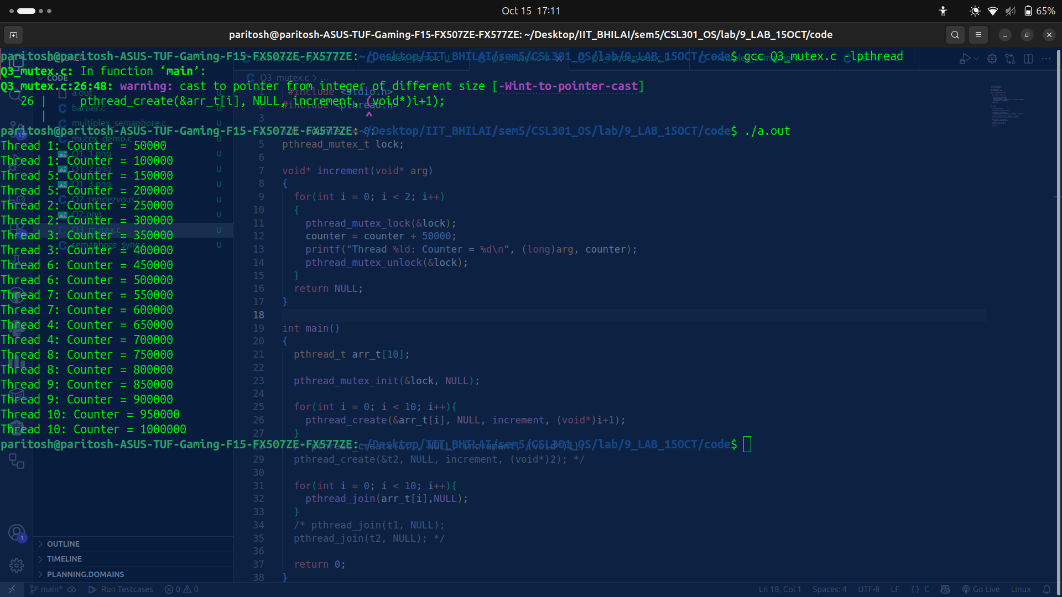
observation:
Counter is incremented in order no matter which thread is doing it , mutex ensures no disturbance occur at time of increment.

part3: without mutex
code:

#include <stdio.h>
#include <pthread.h>

int counter = 0;

void* increment(void* arg)
{
for(int i = 0; i < 2; i++)
{
counter = counter + 50000;
printf("Thread %ld: Counter = %d\n", (long)arg, counter);
}
return NULL;
}

int main()
{
pthread_t arr_t[10];

for(int i = 0; i < 10; i++){
pthread_create(&arr_t[i], NULL, increment, (void*)i+1);
}

for(int i = 0; i < 10; i++){
pthread_join(arr_t[i],NULL);
}

return 0;
}
output:

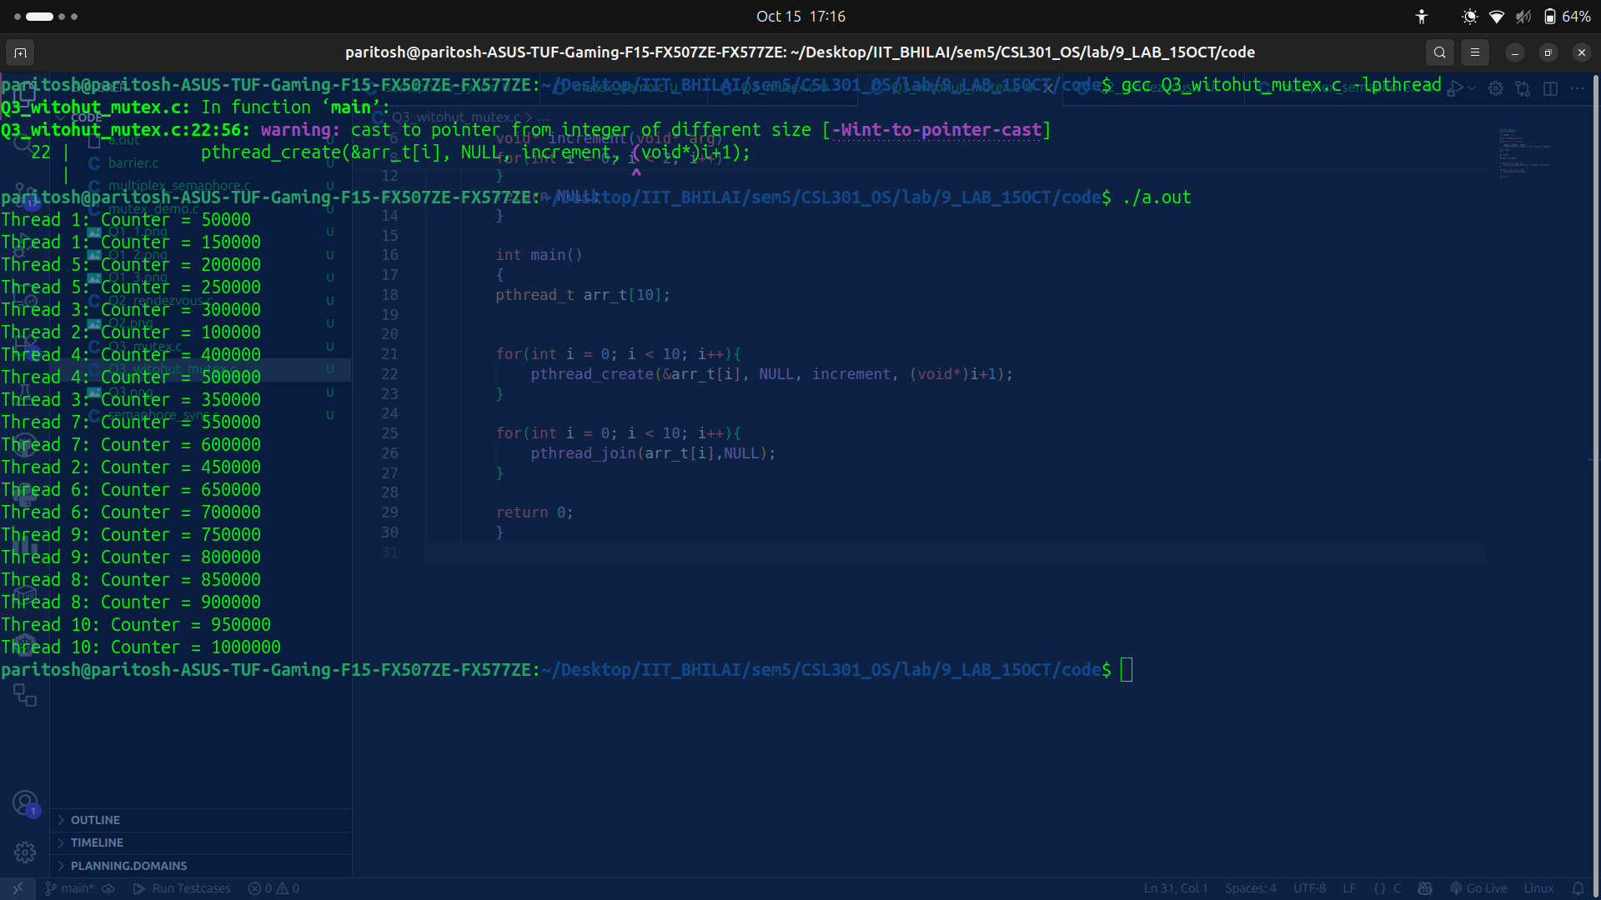

observation:
Here without mutex threads access and modify counter simultaneously but results are inconsistent due to race conditions.

Results are inconsistent due to race conditions.

Q4: Multiplex / Bounded Semaphore

code: multiplex_semaphore.c

output:

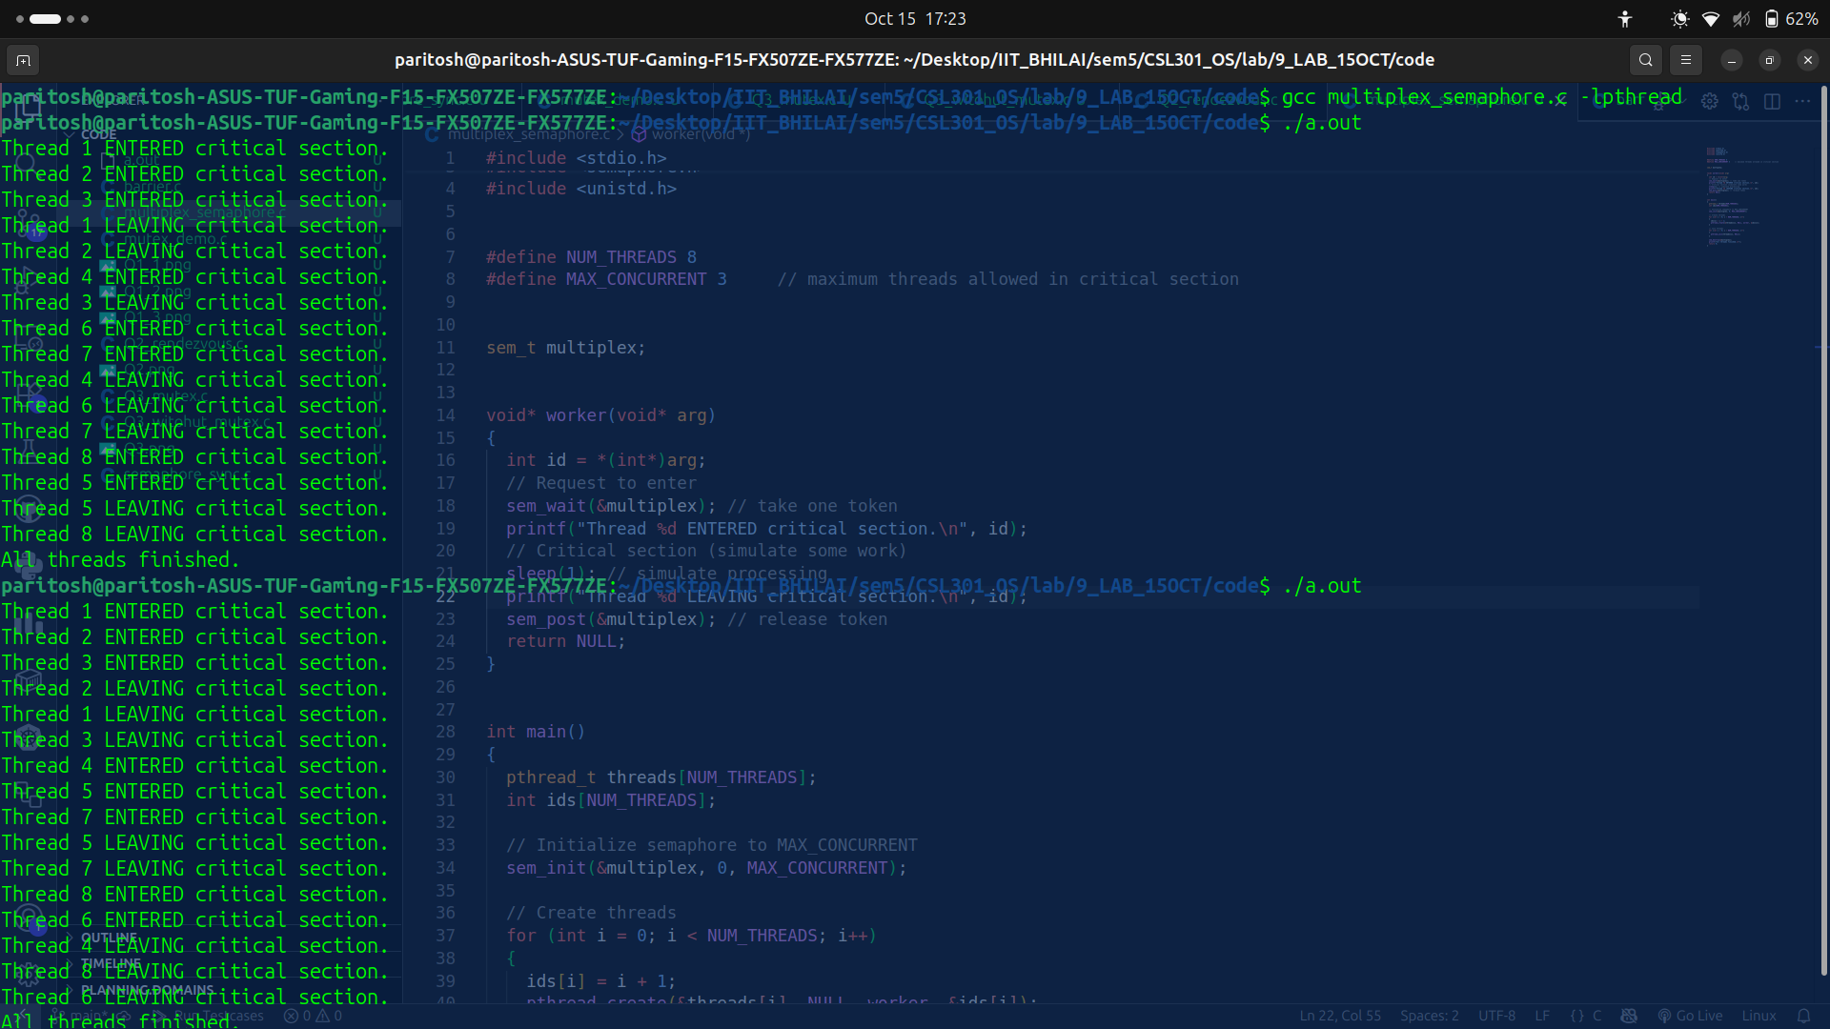

Q5: Barrier Synchronization

part A
code:

#include <stdio.h>
#include <stdlib.h>
#include <pthread.h>
#include <semaphore.h>

#define N 5

int count = 0;
pthread_mutex_t mutex;
sem_t barrier;

void* thread_func(void* arg)
{
int id = *(int*)arg;
printf("Thread %d reached the barrier\n", id);
pthread_mutex_lock(&mutex);
count++;
pthread_mutex_unlock(&mutex);
if (count == N)
{
sem_post(&barrier); // Only one thread is signaled!
}

sem_wait(&barrier); // All threads wait, but only one is signaled
printf("Thread %d passed the barrier\n", id);
return NULL;
}

int main() {
pthread_t threads[N];
int ids[N];
pthread_mutex_init(&mutex, NULL);
sem_init(&barrier, 0, 0);
for (int i = 0; i < N; i++) {
ids[i] = i + 1;
pthread_create(&threads[i], NULL, thread_func, &ids[i]);
}
for (int i = 0; i < N; i++) {
pthread_join(threads[i], NULL);
}
pthread_mutex_destroy(&mutex);
sem_destroy(&barrier);
return 0;
}

output:

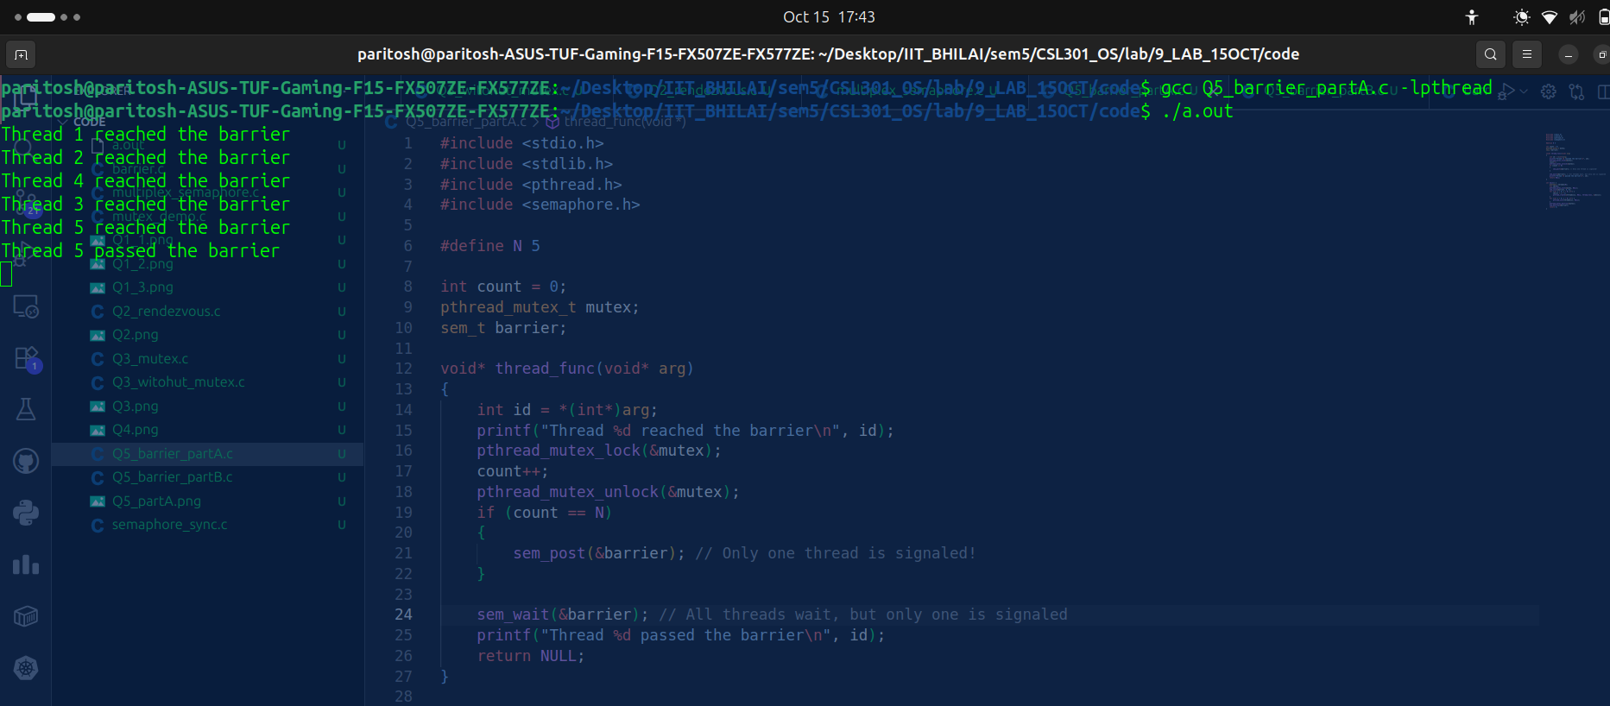

observation:
Only one thread is released because only one sem_post(&barrier) is done.
Other threads remain blocked at sem_wait(&barrier).
Demonstrates an incorrect barrier implementation.

partB

code:

#include <stdio.h>
#include <stdlib.h>
#include <pthread.h>
#include <semaphore.h>

#define N 5

int count = 0;
pthread_mutex_t mutex;
sem_t turnstile , turnstile2;

void* thread_func(void* arg)
{
int id = *(int*)arg;
printf("Thread %d reached the barrier\n", id);
pthread_mutex_lock(&mutex);
count++;
if (count == N)
{
sem_wait(&turnstile2);
sem_post(&turnstile);
}
pthread_mutex_unlock(&mutex);
sem_wait(&turnstile);
sem_post(&turnstile);
printf("Thread %d passed the barrier\n", id);
return NULL;
}

int main() {
pthread_t threads[N];
int ids[N];
pthread_mutex_init(&mutex, NULL);
sem_init(&turnstile, 0, 0);
sem_init(&turnstile2, 0, 1);

for (int i = 0; i < N; i++) {
ids[i] = i + 1;
pthread_create(&threads[i], NULL, thread_func, &ids[i]);
}
for (int i = 0; i < N; i++) {
pthread_join(threads[i], NULL);
}
pthread_mutex_destroy(&mutex);
sem_destroy(&turnstile);
sem_destroy(&turnstile2);

return 0;
}

output:
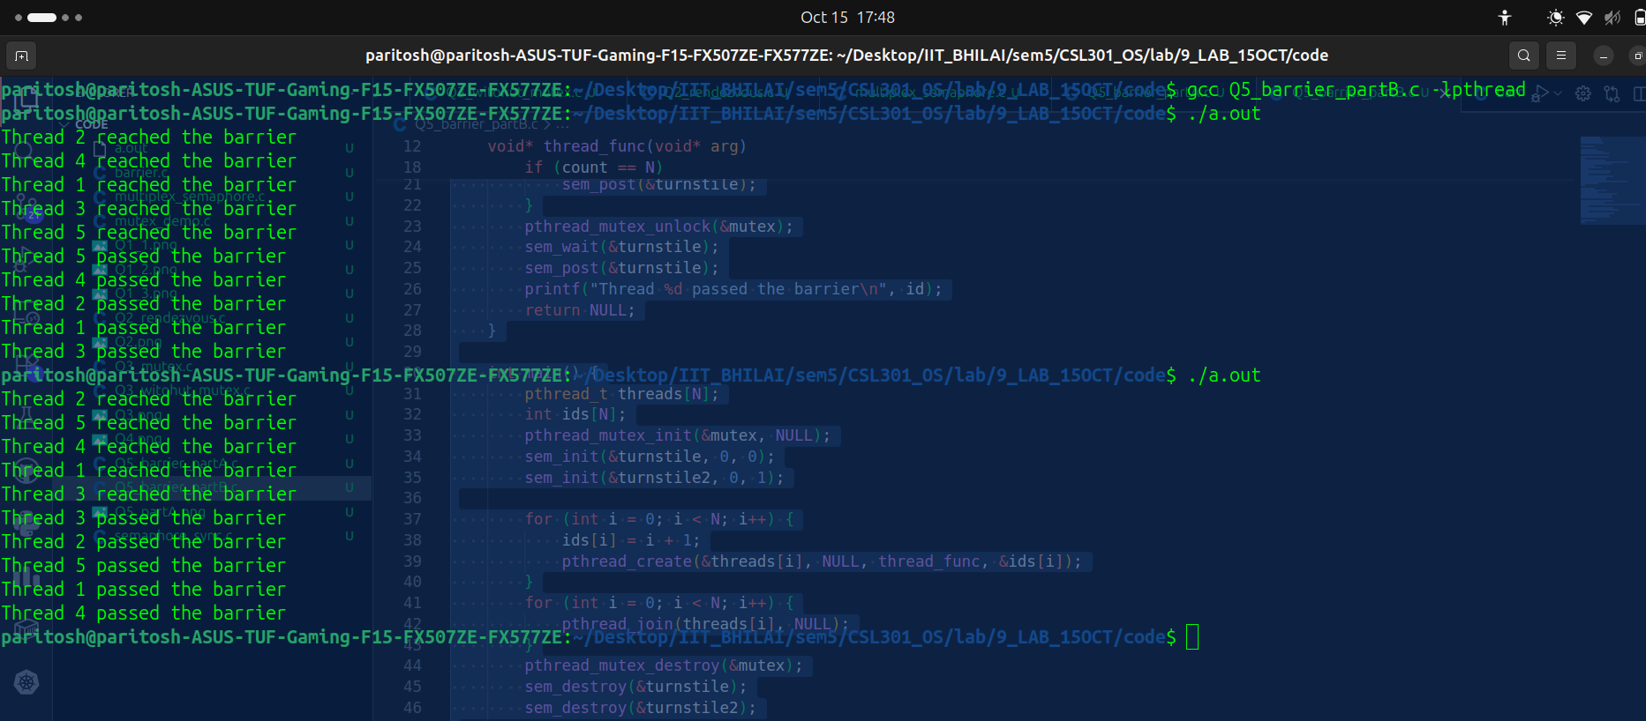

observation:

All threads reach the barrier → wait until count == N.
Then turnstile opens → all pass the barrier.
Correct barrier synchronization, allowing all threads to proceed only after everyone has reached the barrier point.

