CSL304 – LAB EXAM
ID : 12341550
DATE : 22-10-2025

Q1

output:
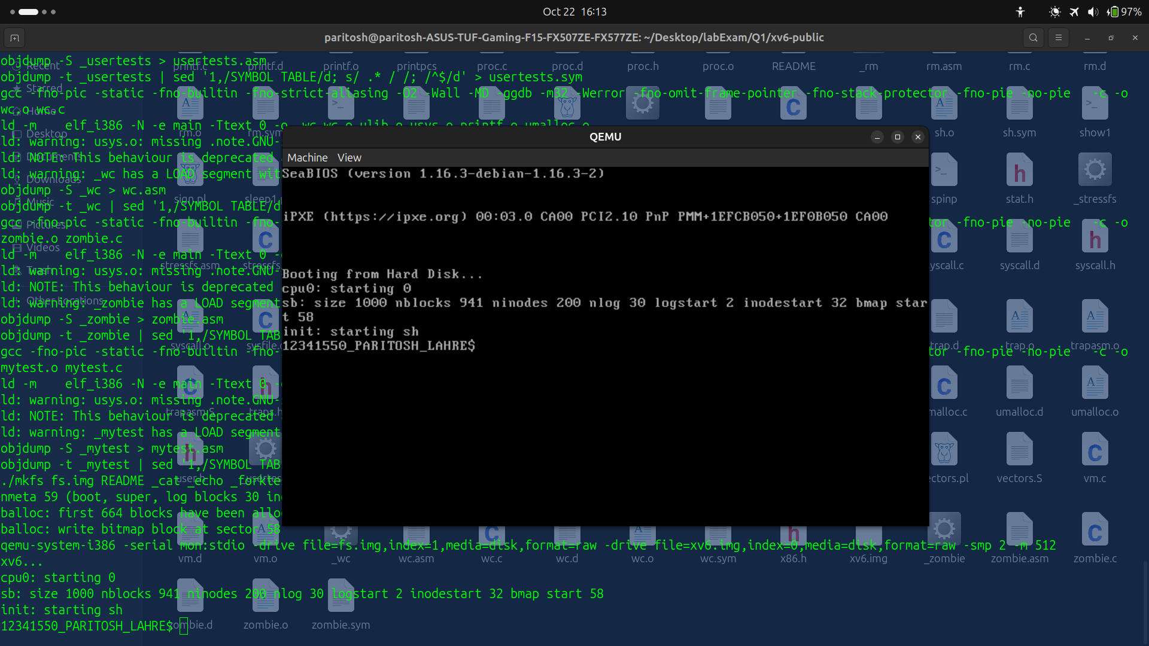

Q2

output:
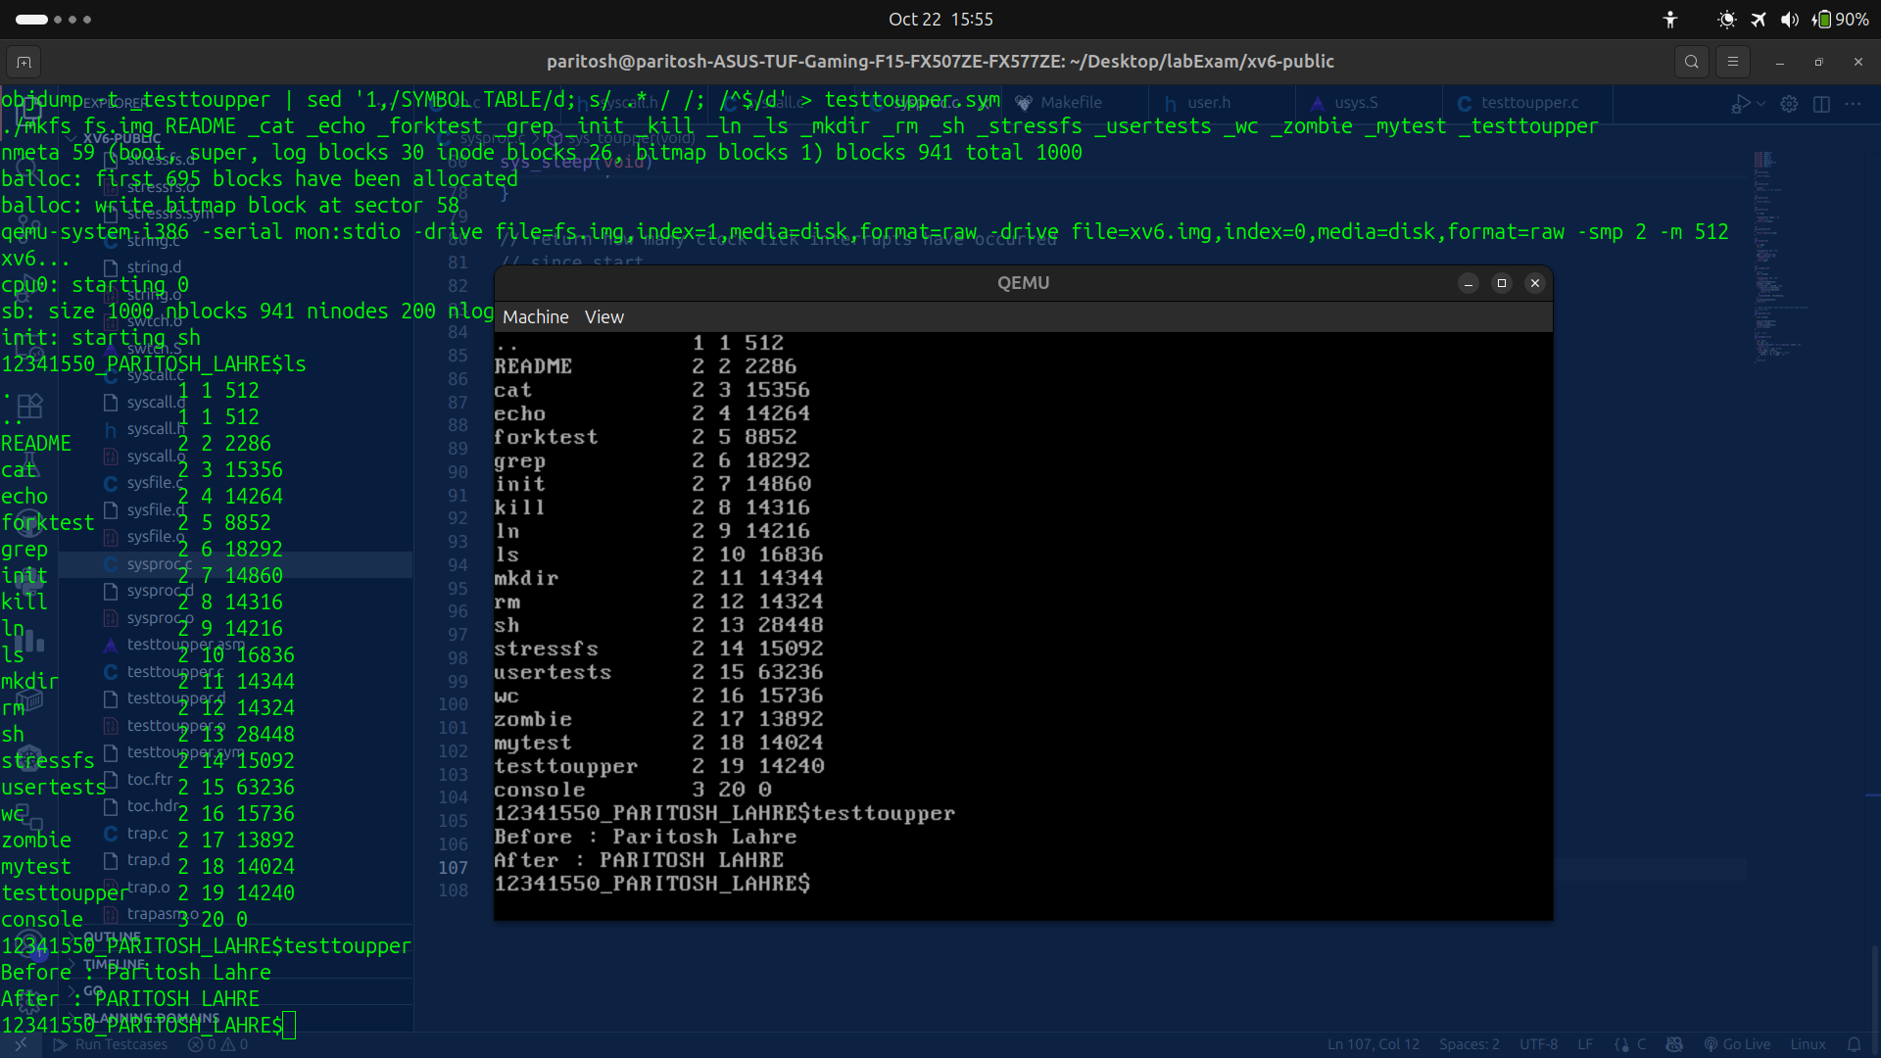

Q3

output:

Q4

output:
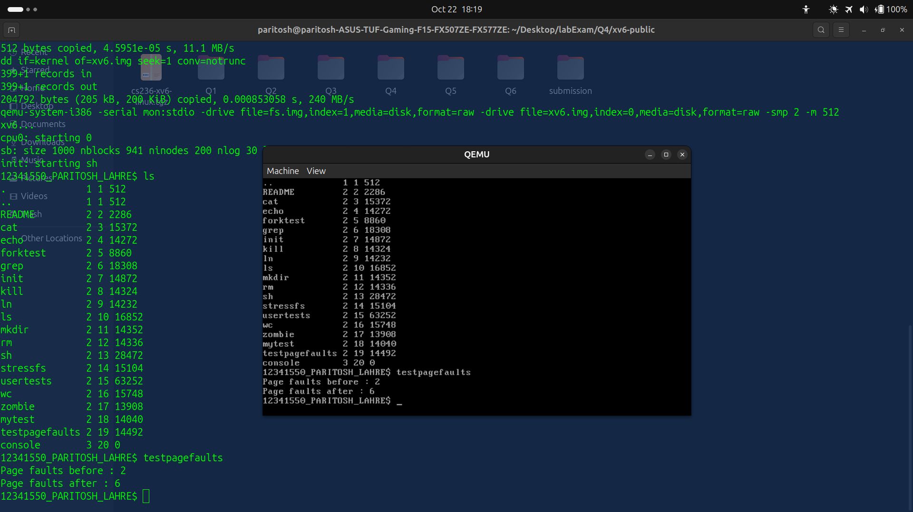

Q5

output:

Q6

output:
page frame 3

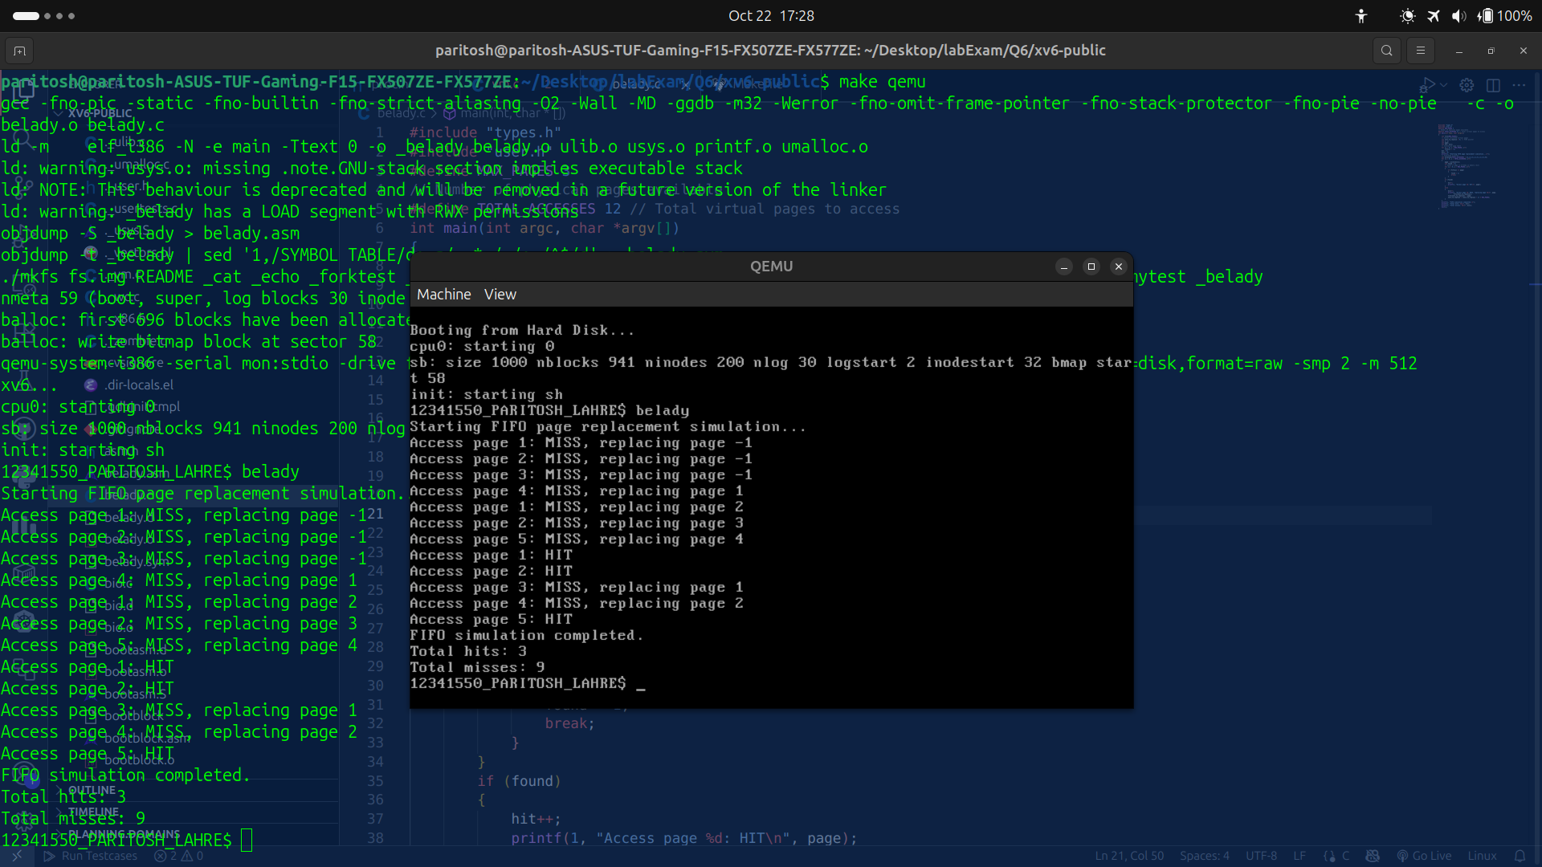
page frame 4

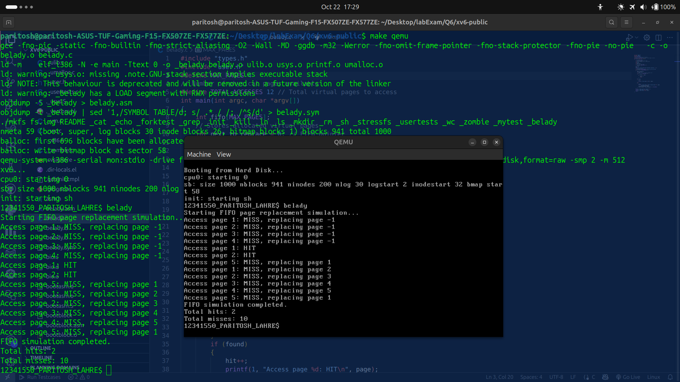

Belady’s anomaly :
Total hits reduces from 3 to 2 which was not expected because its known that on increasing page frame hits increases but here it decreased in case of FIFO.

