**Final Report**

**On**

**IPL Cricket Tournament Schedular**

**BACHELOR OF TECHNOLOGY IN**

**COMPUTER SCIENCE AND ENGINEERING**

**Submitted to: Dr. Harwant Singh Arri**

**By**

**Sandeep Kumar (12211815)**

**Roll No: A-29**

**Section: K22FR**

**CSE101**



**School of Computer Science and Engineering**

**Lovely Professional University**

**Abstract**

**The project is a result of the inputs given by Sandeep Kumar (12211815), Mahek (12212106), Happy Singh (12212159) Talha Shamo (12212341).**

**The title of project is IPL cricket Schedular". The project has been made by using c language. C programming. C language is a procedural and general-purpose language that provides low-level access to system memory. A program written in C must be run through a C-complier to Convert it into an executable file that a computer can run. The main aim of this project is to generate a schedule for the given teams and save it in a file. firstly, the user gives input for the no. of teams and names of teams, then the program maps two teams to each other and displays the schedule and saves it in a file. The next option is to modify the schedule by editing the teams. At last, the program givers an option of deleting the schedule i.e. cleaning all the data.**

**ACKNOWLEDGEMENT**

**I would like to express my gratitude to all those who have contributed to the successful completion of my CSE101 Computer Programming final project report. First and foremost, I would like to thank my instructor, Dr. Harwant Singh Arri, for providing me with the knowledge and guidance needed to complete this project. Their unwavering support and constructive feedback have been invaluable throughout the process. I am also grateful to my classmates, for their continuous encouragement, insightful discussions, and collaboration during the project. Furthermore, I would like to extend my appreciation to the resources provided by the University, such as the computer lab facilities, online libraries, and tutorials, which have enabled me to gain a deeper understanding of the programming concepts and tools. Thank you all once again**

**Modules in Project:**

**1. Add record.**

**This module will take the different inputs from user Such as teams participating the names of team participants. and finally match dates. This module will have data Validation checks to ensure that the usen enters valid input.**

**2. View Record.**

**This module displays the record which is input from user like the name of teams.**

**3.** **View Schedule.**

**This module is responsible for displaying the schedule of matches in a user-friendly format. It will also provide option for the user to export the schedule in Excel format.**

**4.** **Modify record.**

**This module allows the user to rectify the input details of teams and dates**

**5. Delete.**

**This module helps in adding a whole new team to already made Schedule and thus the schedule is altered completely. To accommodate new details.**

**What is a File?**

**A file is a container in computer storage devices used for storing data.**

**Why files are needed When a program is terminated, the term entire data is lost. storing in a file will preserve your data even if the program terminates.**

**We can easily access the controls of the file using a few commands. We can easily move our data from one computer to another without any changes.**

**Types of files**

**1. Text files: - Text files are normal .txt files. we can easily create txt files using any simple text editors such as notepad. We can see all the contents within the file as plain text. They take minimum effort to maintain easily readable, and provide least security and takes bigger storage space.**

**2. Binary files - Binary files are mostly the .bin files in your computer. Instead of storing data in plain text, they store it in the binary form (0 & 1). They can hold a higher amount of data, are not readable equably and provides better security then text files.**

**File Operations**

**In C, we can file Operations perform five major operations on files, either text or binary file:**

1.Creation of a new file (**fopen () with attributes as “a” or “a+” or “w” or “w+”)**

2.Opening an existing file (**fopen ()**)

3.Reading from file (**fscanf () or fgets()**)

4.Writing to a file (**fprintf () or fputs()**)

5.Closing a file (**fclose ()**)

**Working with files**

**When working with files, we need to declare a pointer of type file. This declaration is needed for communication between the file and the program. Syntax: → FILE * P;**

**Opening a file for creation and edit**

**Opening a file is performed using the fopen () function defined in the stdio.h header file. SYNTAX: P= fopen ("file open","mode");**

**Closing a file**

**Closing a file is performed using the fclose () function. Syntax: fclose ()**

**here, P is a file pointer associated with the file to be closed**

**Reading and writing to a text file: → for reading and writing to a text Ale, we use the functions fprintf (). and Fscanf ().**

**Syntax writes to a text file: FprintF (format specifier, variable).**

**Syntax: Read from a text file fscanf (P, format specifier, & variable)**

**Reading and writing to a binary file:**

**function fread () and fwrite () are used for reading from and writing to a file on the disk respectively in case of binary files.**

**Code for IPL tournament Schedular**

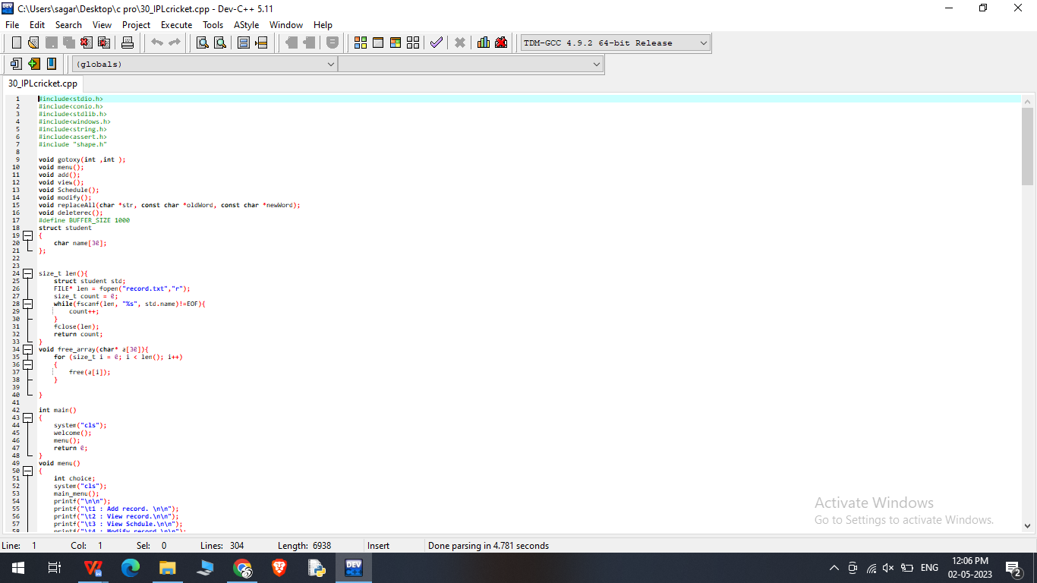

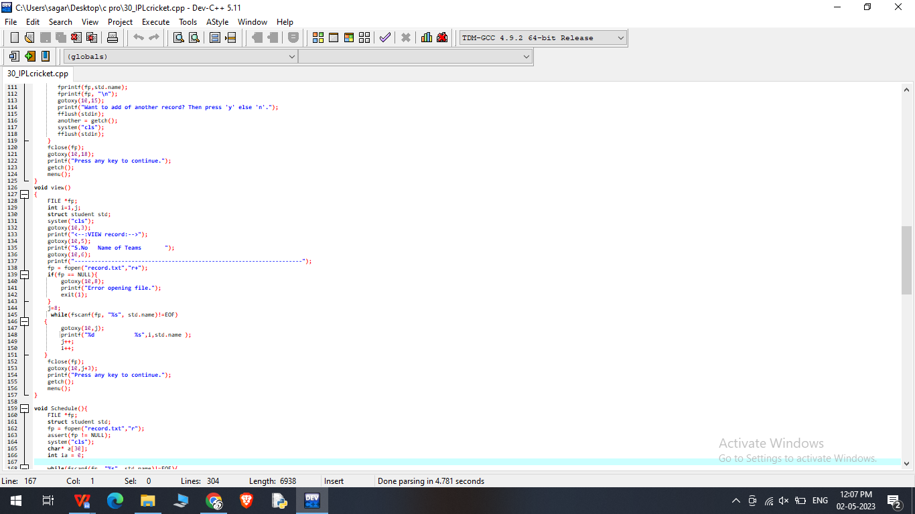

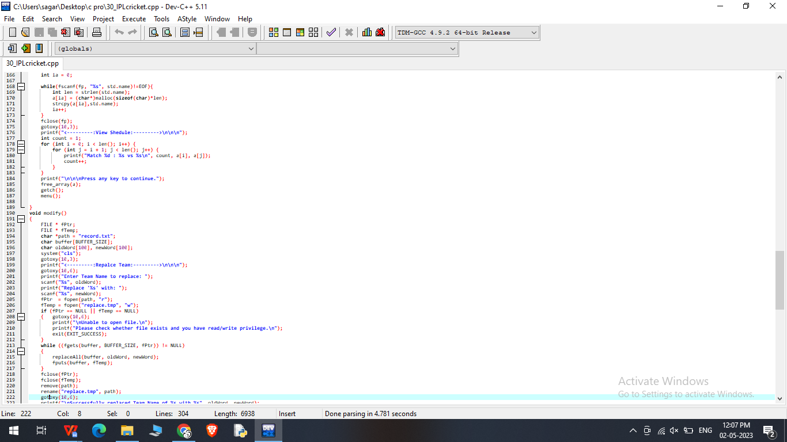

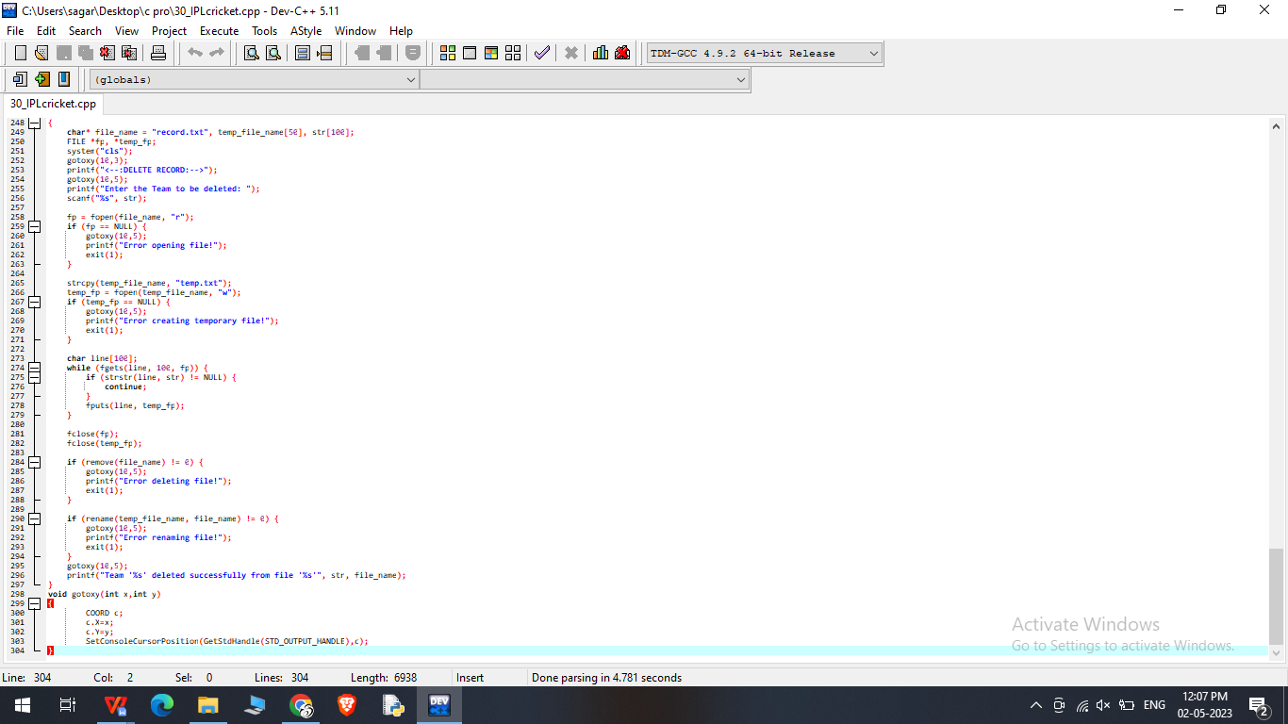

Output of the code

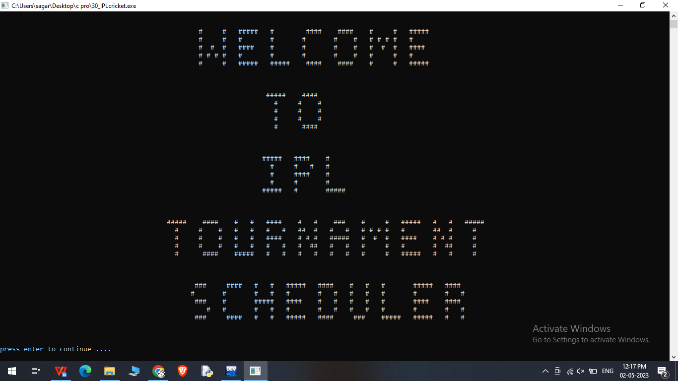

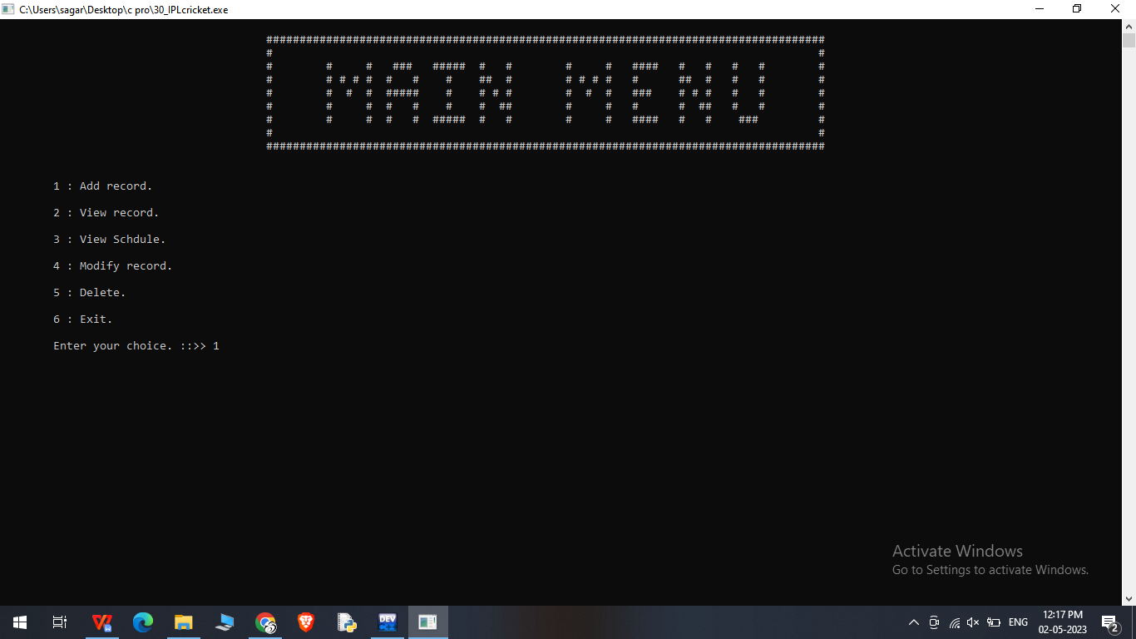

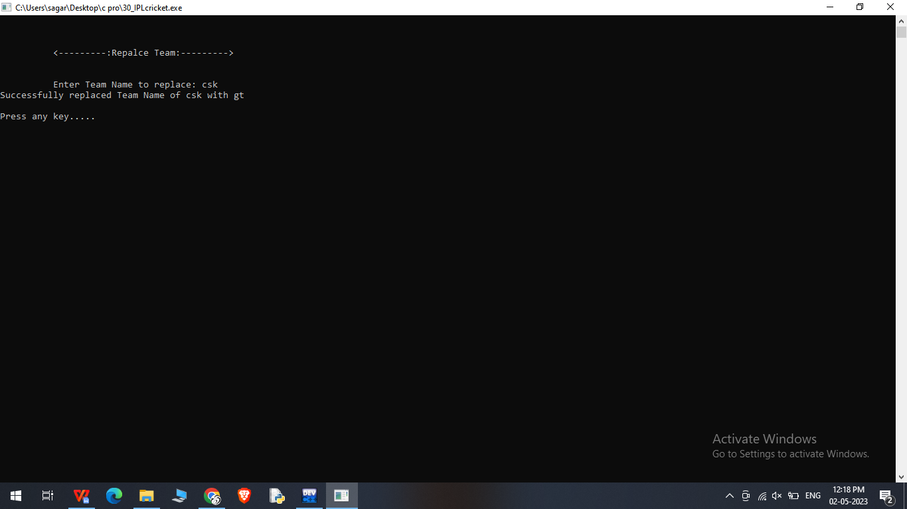

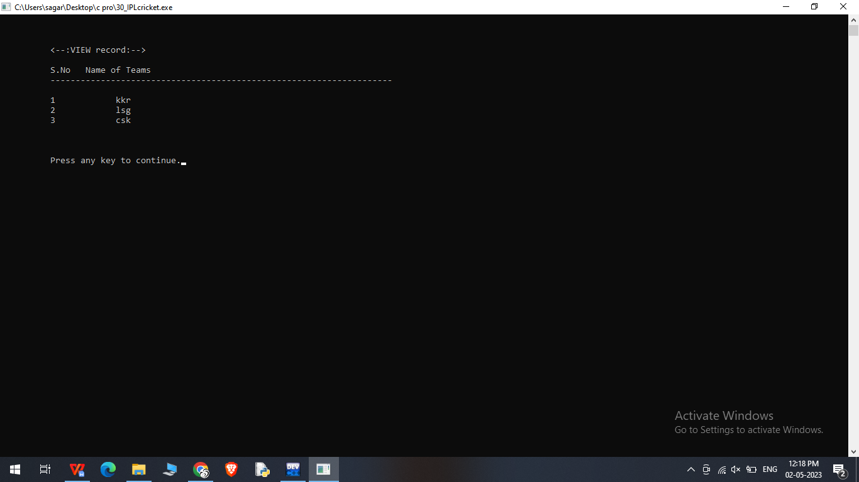

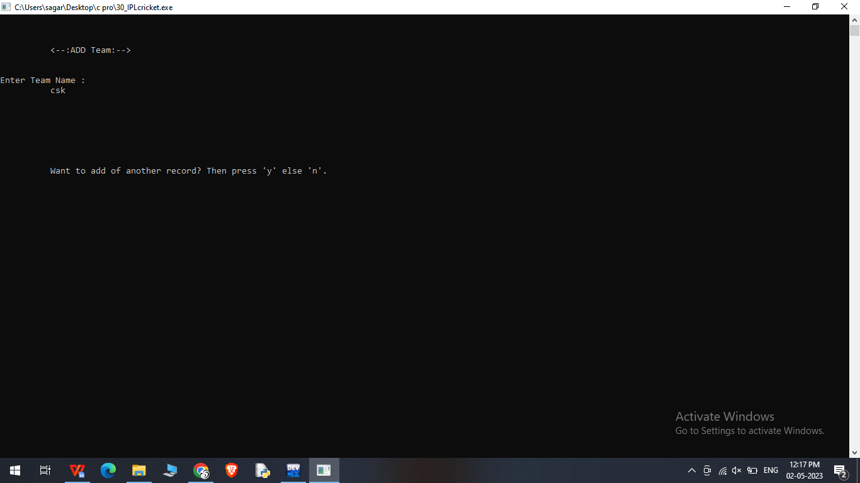

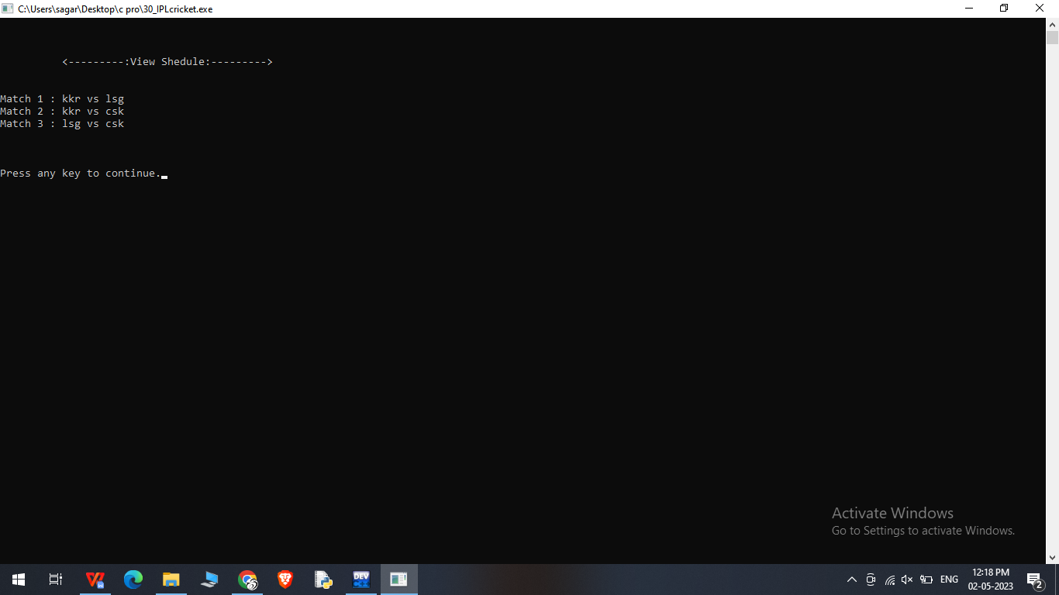

**References**

[**www.w3schools.com**](http://www.w3schools.com)

[**www.javatpoint.com**](http://www.javatpoint.com)

[**www.programiz.com**](http://www.programiz.com)

[**www.geeksforgeeks.org**](http://www.geeksforgeeks.org)

[**www.tutorialspoint.com**](http://www.tutorialspoint.com)

**Thank You**