- Introduction

1.1 Overview

Wise Ultima is an AI-driven platform designed to simplify and optimize IT operations for complex
cloud and IT environments. By leveraging advanced artificial intelligence, deep learning, large
language models (LLMs), and automation workflow modules, Wise Ultima delivers predictive
and prescriptive insights, enabling organizations to proactively manage their IT infrastructure.

The platform targets CXOs, top management, and IT heads, oﬀering a top-down view, real-time
analytics, and automated actions to enhance performance, reduce costs, and improve customer
satisfaction.

Intelligent Operations, Simplified!

1.2 Purpose

Wise Ultima addresses critical challenges in IT operations, including:

• Complexity of managing multiple cloud and IT environments.
• Lack of real-time insights, leading to delayed decision-making.
- Reactive responses, resulting in downtime and ineﬃciencies.

The platform empowers organizations with:

• Proactive issue detection and resolution.
- Resource optimization and cost management.
- Simplified, executive-friendly dashboards and insights.

1.3 Target Audience

Primary: CXOs (CIOs, CTOs), top management, and IT heads.
Industries: Finance, healthcare, retail, manufacturing, and other sectors with complex IT
infrastructures.
Use Cases: Ensuring uptime for critical systems, optimizing cloud resources, reducing operational
costs.

2. Key Features

Wise Ultima oﬀers a suite of features designed to streamline IT operations:

2.1 Predictive Health Monitoring

Monitors IT infrastructure health in real time.
Uses Green, Amber, Red to indicate system status.
Green: Healthy, no issues.
Amber: Warning, potential issues detected.
Red: Critical, immediate action required.

Enables early detection of issues (25% overall, 60% for P1/P2 critical issues).
2.2 Prescriptive Actions

Provides AI-driven, real-time recommendations to prevent or resolve issues.
Supports one-click execution of fixes (e.g., increasing table space, clearing alert logs).
Integrates with ticketing systems like ServiceNow for seamless escalation.

2.3. Intelligent Automation

AI engines that heal, optimize, and govern infrastructure
Optional AI-driven transactional execution

2.4 Wise Board

WiseBoard is the centralized hub for IT operations, designed to serve both:

CXOs, who require strategic and high-level insights
IT teams, who need detailed, system-level intelligence

WiseBoard displays:

Current Health – real-time system conditions
One-Week Health – AI-driven short-term predictions
One-Month Health – AI-driven medium-term forecasts

2.4.1 Predictive Intelligence & Dependency Awareness

- Wise Ultima’s Prediction module identifies and categorizes high-risk systems across regions and applications.
By navigating into a red/amber status server, users can view:
- Current and predicted issues
- Possible root causes
- System metadata (type, region, environment)

2. A key differentiator of Wise Ultima is the “Potential Impacts on Connected Systems” view.
This feature:
- Visualizes upstream and downstream dependencies
- Creates a complete dependency map of the infrastructure
- Clearly shows which systems may be impacted if an issue occurs

This dependency intelligence helps organizations:
- Understand the blast radius of incidents
- Prioritize fixes based on business impact
- Prevent cascading failures across environments

2.4.2 Continuous Learning Through Feedback

Wise Ultima includes a feedback loop that allows Subject Matter Experts (SMEs) to guide AI behavior.
- Experts can re-prioritize issues (e.g., change Red → Amber)
- The AI incorporates this feedback in the next prediction cycle
- Predictions continuously align with organizational context and priorities

This ensures context-aware AI, not generic automation.

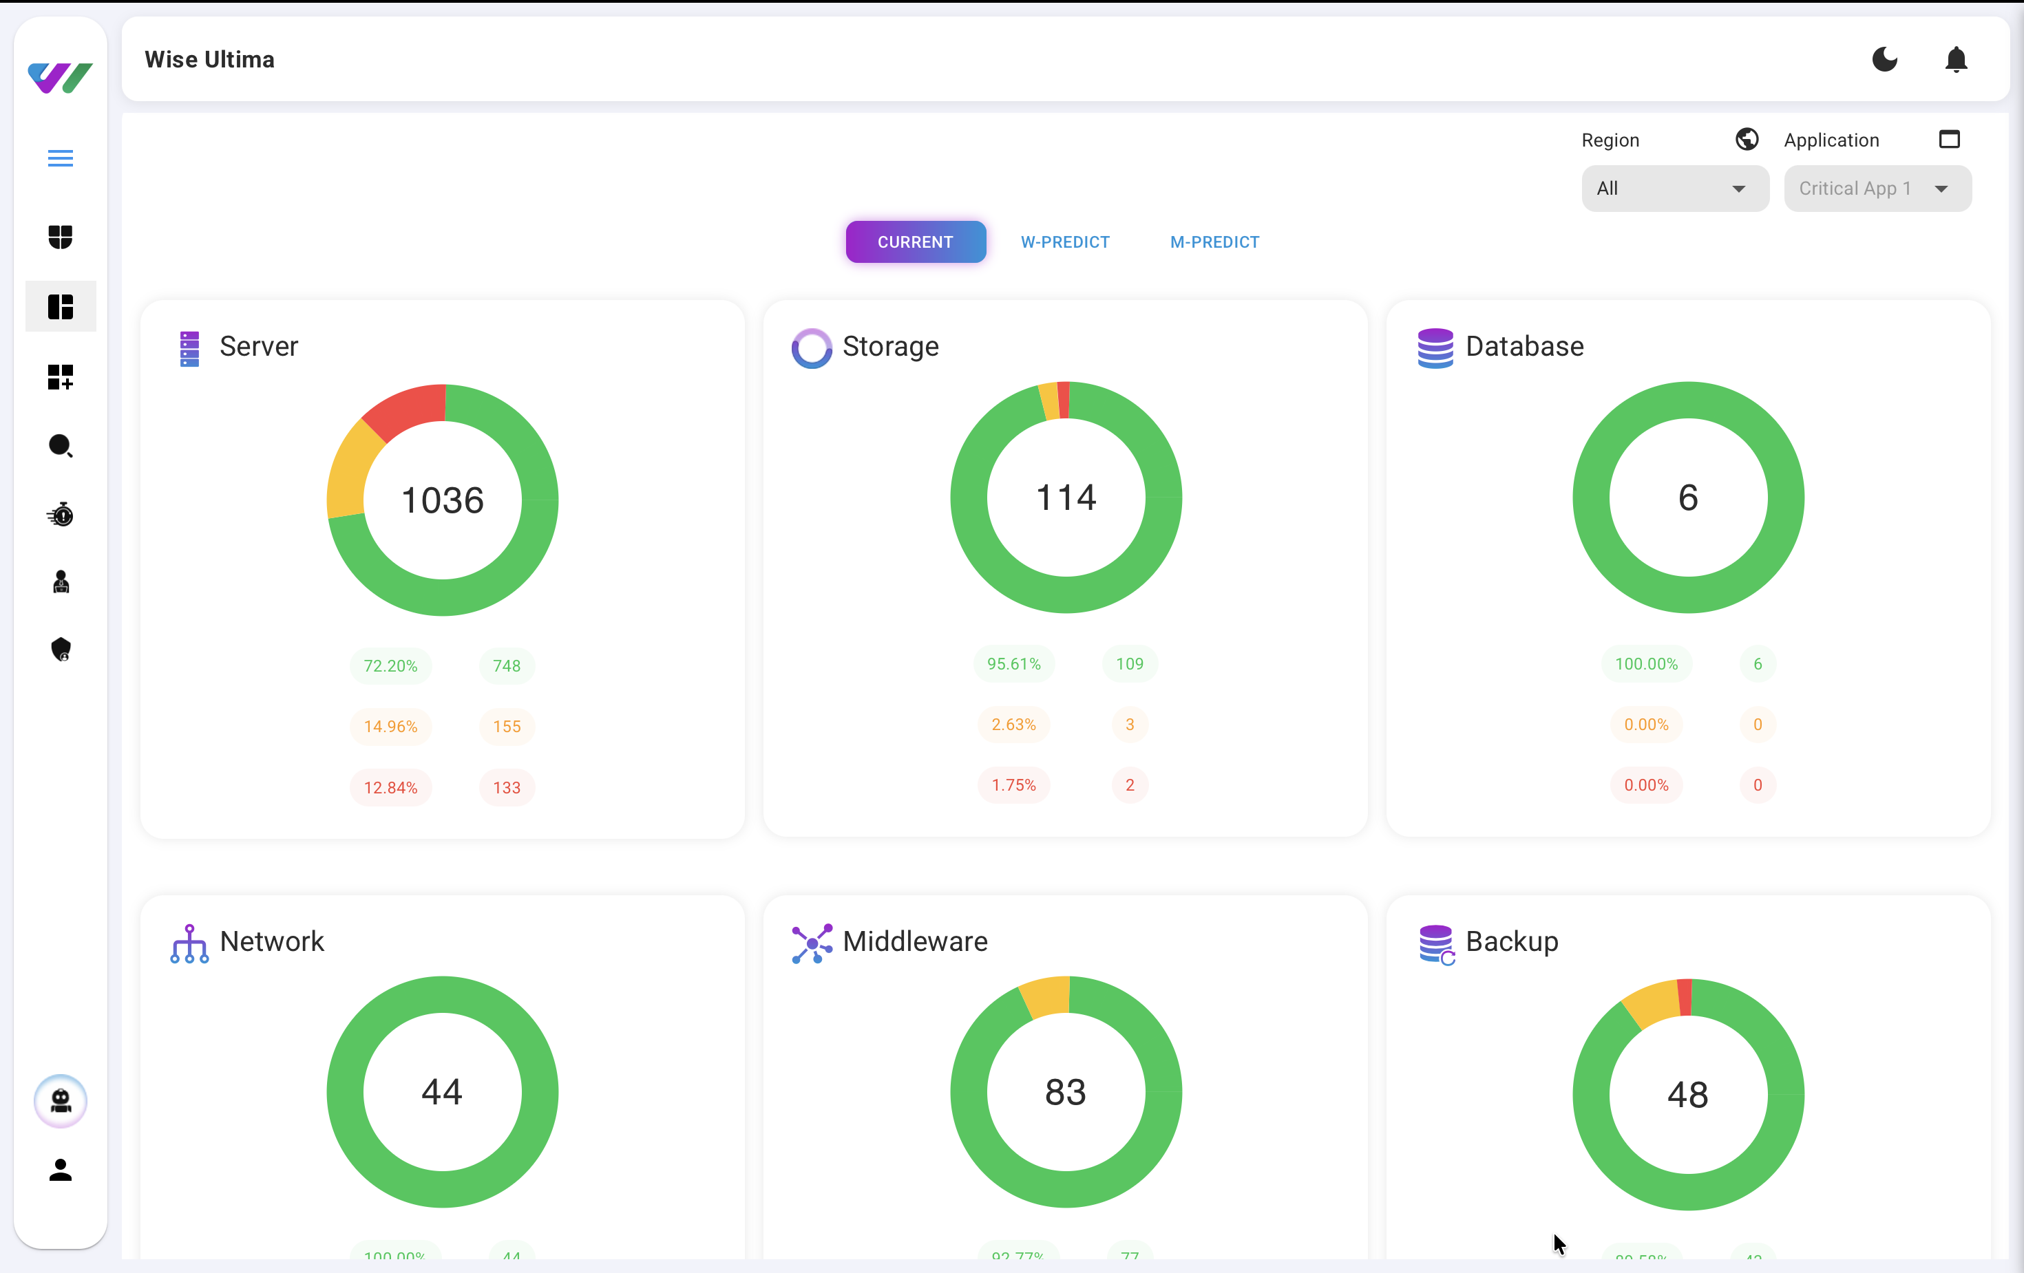
2.4.3 Visual Assets
WISE BOARD
A centralized hub for performance metrics, alerts, and predictive insights, offering a
top-down view of the entire IT infrastructure.

2.5 Wise Actions

Wise Actions is where insights become solutions.

Unlike traditional monitoring tools, Wise Ultima:
- Prescribes real-time fixes
- Leverages an enterprise runbook-driven knowledge base
- Generates tailored remediation recommendations

Example :
When server reports potential disk exhaustion, Wise Ultima recommends:
- Deleting or archiving unnecessary files
- Clearing logs or temporary directories

Execution Options
- One-click automated fix
- Raise ServiceNow ticket with auto-populated details
- Assignment automatically routed to the correct support group

Once resolved:
- Resolution notes are captured
- Knowledge base is updated
- Future recommendations improve automatically

This automation reduces incident resolution time by up to 50%.

2.5.1 Visual Assets
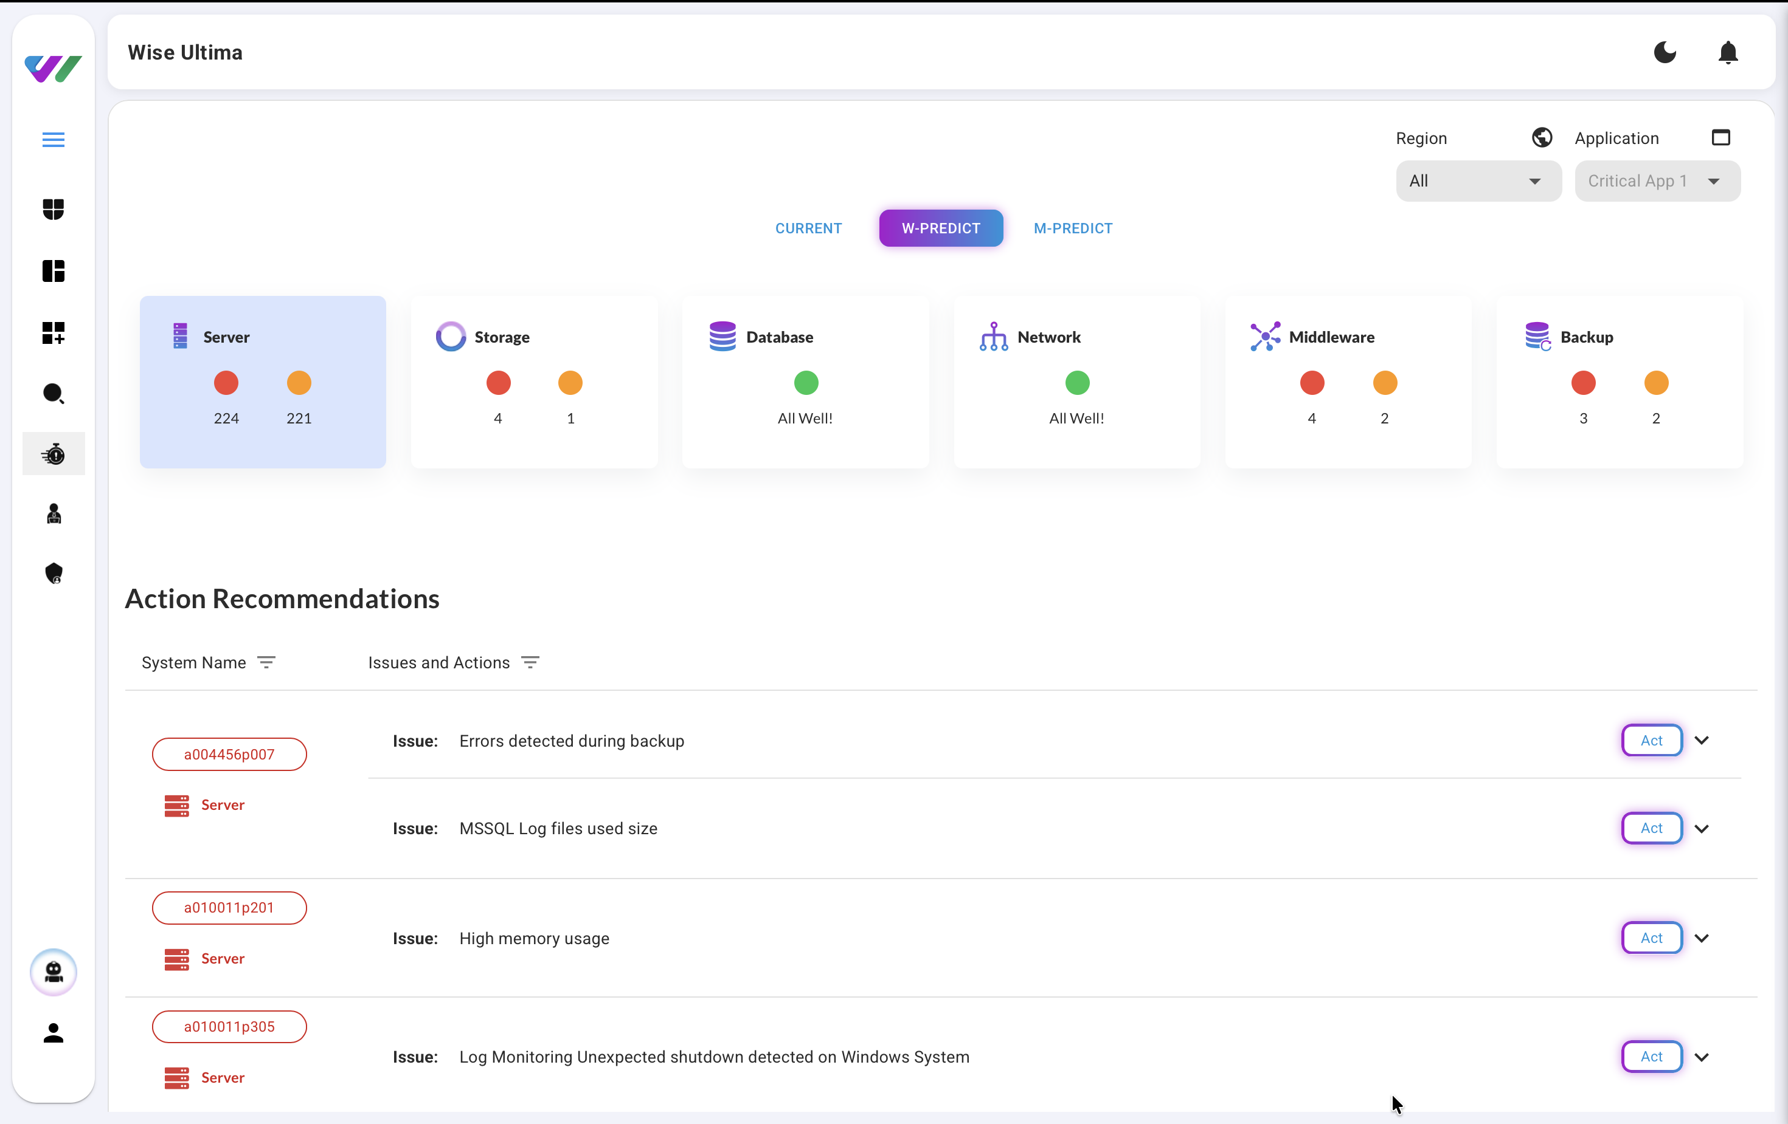
WISE ACTIONS
A centralized action hub in the Ultima platform, enabling users to auto-fix issues or raise
tickets seamlessly.

2.6 Wise Explore

Wise Explore acts as an intelligent search engine for IT operations.

Users can filter by:
- Health status (Red / Amber / Green)
- Component type (server, database, etc.)
- Environment (production, testing)
- Application and region

This enables:
- Fast identification of critical issues
- Detailed issue exploration without losing context
- Significant time savings for operations teams

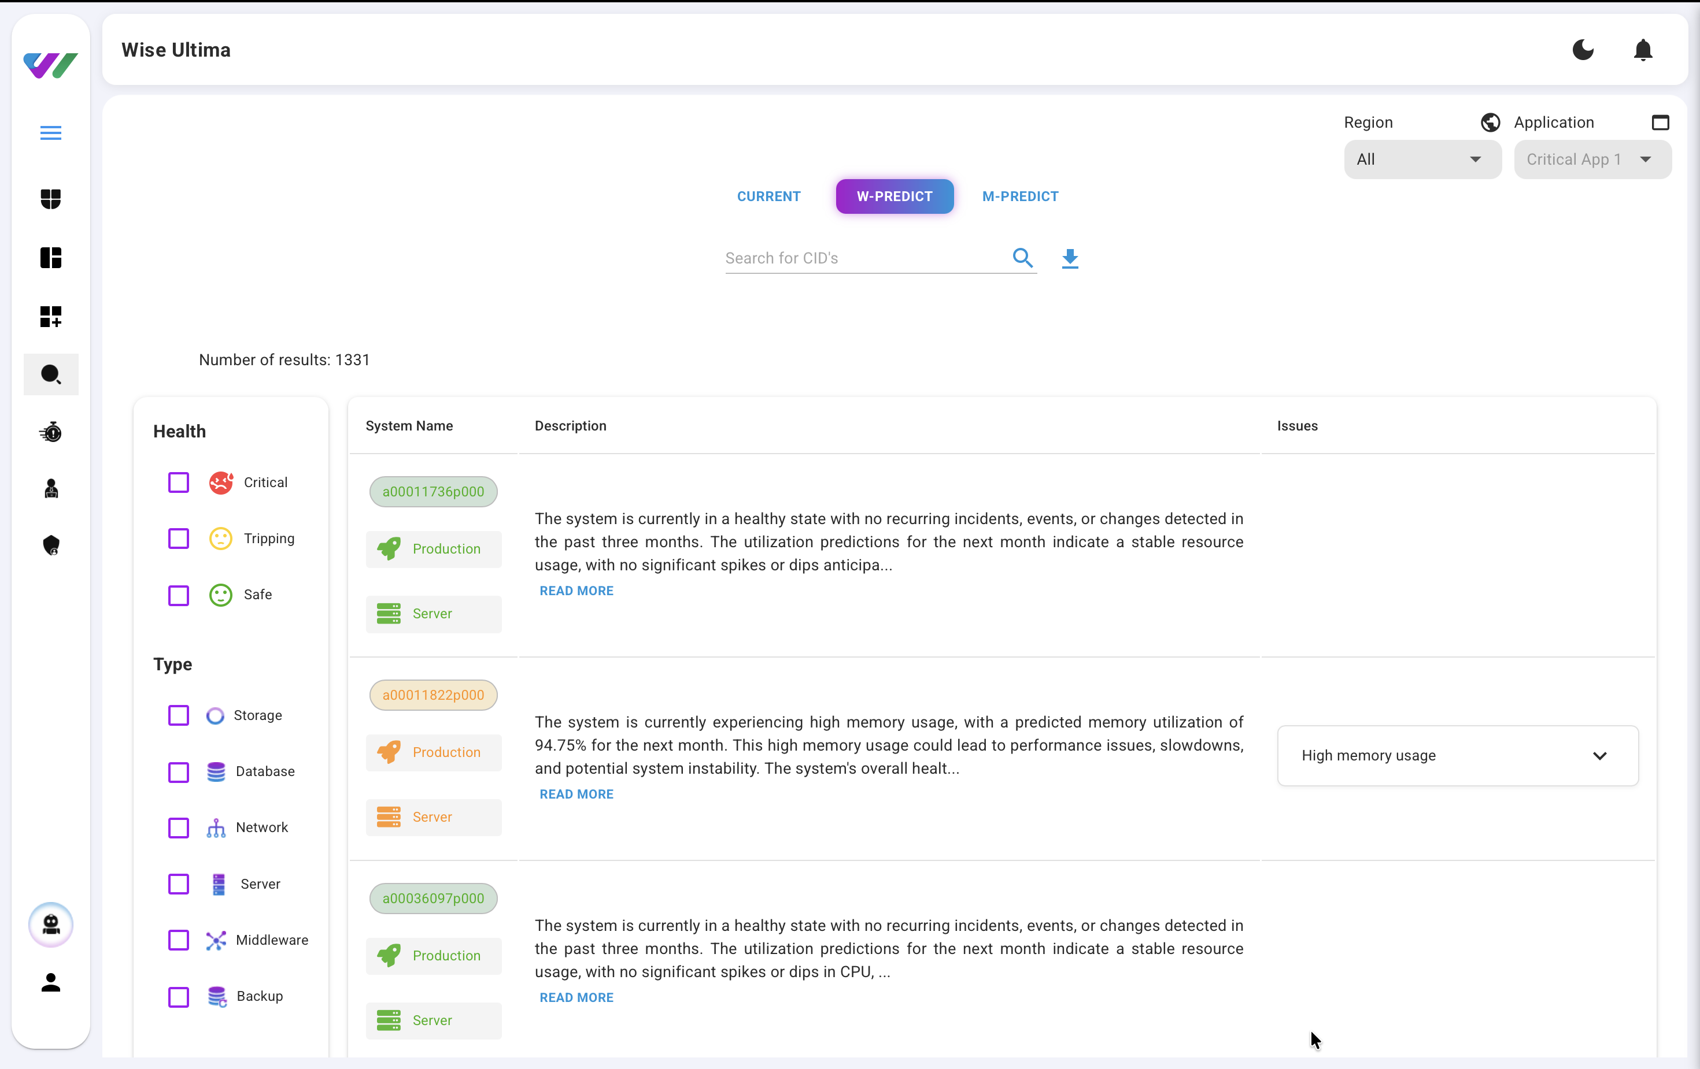
2.6.1 Visual Assets
WISE EXPLORE
An intelligent search engine within the Ultima platform that streamlines navigation by
delivering precise, relevant insights, features, and data instantly

2.7 Wise Monitory

Wise Monitoring provides a live, detailed view of individual systems, including:
- CPU, memory, disk, and network utilization
- System logs and database logs
- Uptime, sync status, and trends

AI-Driven Insights
- Flags anomalies and security risks early
- Detects inefficient resource usage
- Predicts future utilization spikes

This is especially critical during peak traffic events such as:
- Black Friday sales
- Large-scale campaigns
- Seasonal demand surges

Wise Ultima alerts teams before thresholds are breached, enabling proactive scaling rather than reactive firefighting.

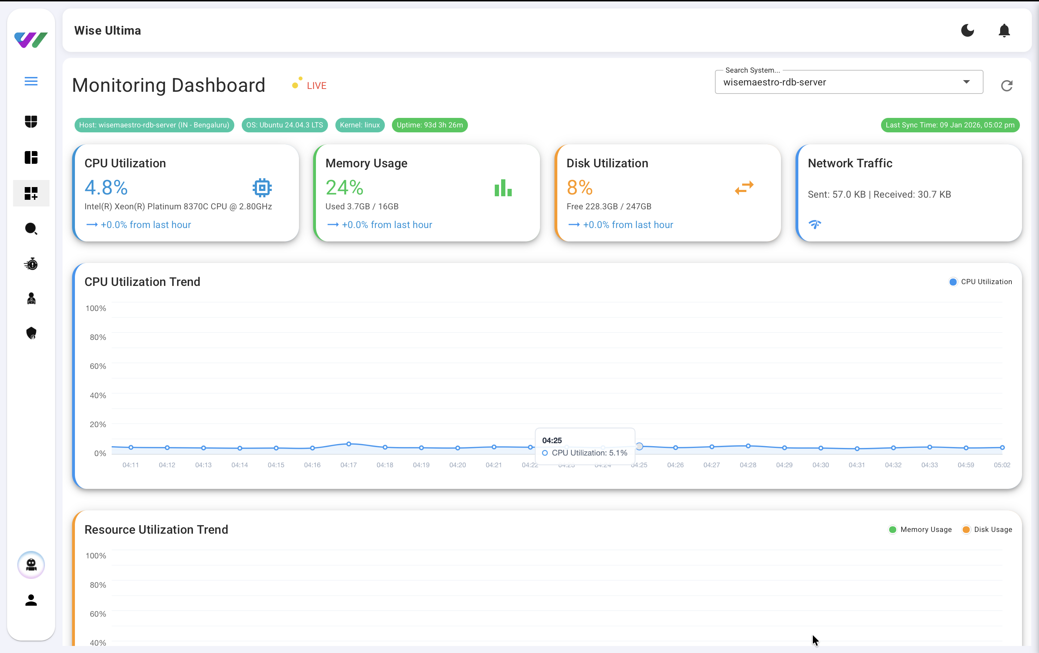
2.7.1 Visual Assets
WISE MONITORY
This page helps us to understand the peak patterns for the system and could identify the potential failures via DB & System logs

2.8 Wise AI

Wise AI Chat transforms Wise Ultima into a virtual IT consultant.
Powered by advanced language models, it understands natural language questions and provides actionable insights.

Capabilities across key areas.

- For health monitoring, we can ask: "What's the health status of systems with ID a010065p210?" or "Show me the overall health distribution."
- For incident analysis: "What systems had incidents with unexpected shutdown?" or "Show me P1 incidents."
- For resource utilization: "Which systems have high CPU usage?" or "Which systems have high memory usage?"
- For system attributes: "Which systems use an OS with Windows?"
- For ticket management: "What are the details of ticket INC0010586?"
- And for actions: "What actions can I take for system a010065p210?"

The AI continuously learns from interactions and operational data, making infrastructure intelligence accessible to all levels of the organization.

2.8.1 Visual Assets
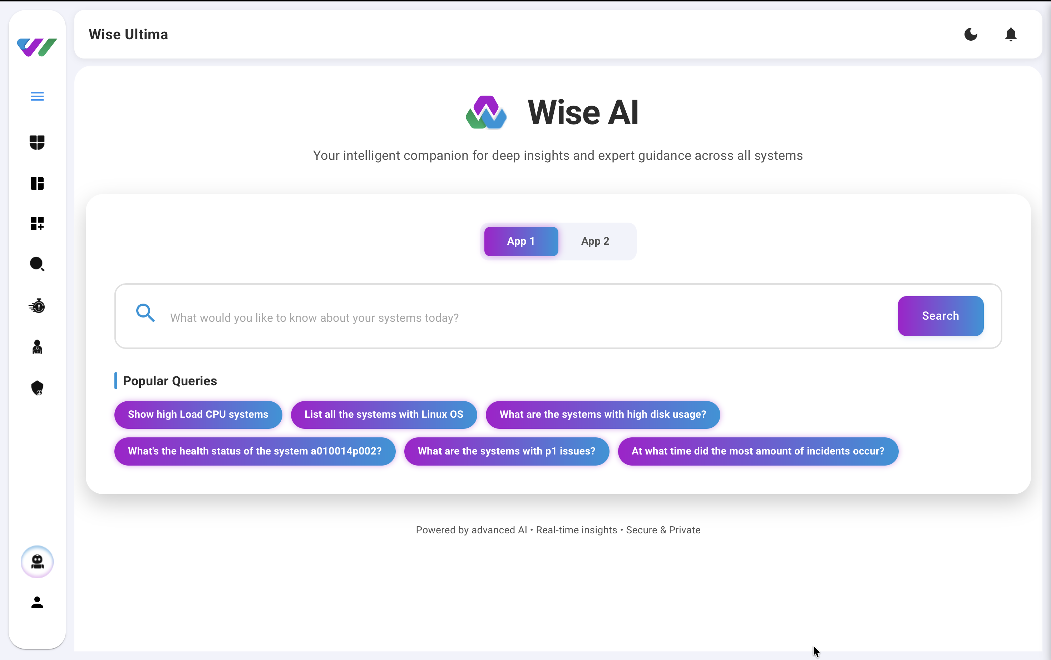
WISE AI
Delivers Deep Insights, Tailored Assessments, And Expert Guidance To Optimize It
Infrastructure Efficiently.

2.9 Ease of Use

• Simplifies health monitoring for non-technical users.
• Top-Down Approach: Oﬀers a high-level view for executives, with drill-down capabilities for
technical teams.
- Explains complex issues in plain language.

2.9.1 AI Workflows (Supported Auto-Healing Fixes)

Wise Ultima includes pre-built and configurable AI workflows to automatically detect, diagnose, and remediate common service failures across critical enterprise platforms.
These workflows enable proactive self-healing, reducing manual intervention and minimizing downtime.

2.9.1.1 Supported Services for AI-Driven Fixes

Wise Ultima AI workflows currently support automated remediation for the following services:
- MongoDB
- Apache HTTP Server
- Microsoft SQL Server (MSSQL)
- Nginx

Each workflow follows a closed loop model:
Detect → Diagnose → Fix → Validate → AI Re-Learn

2.9.1.2 MSSQL

Wise Ultima can automatically identify and remediate critical SQL Server startup failures:
a. MSSQL Binary Permission Failure (status=203/EXEC)
- Cause: Execute permission removed from SQL Server binary
- Impact: SQL Server fails to start due to inability to execute binary
- AI Fix:
  - Restores execute permissions on SQL Server binary
  - Validates service startup
  - Confirms healthy status
b. MSSQL Binary Not Found Failure (status=203/EXEC)
- Cause: SQL Server binary renamed or missing from expected path
- Impact: SQL Server service fails to start
- AI Fix:
  - Detects missing binary
  - Restores binary to correct path or alerts for corrective action
  - Reattempts service startup

2.9.1.3 Nginx

c. Nginx Worker Freeze Failure

- Cause: Nginx worker processes suspended using SIGSTOP
- Impact: Requests are not handled, leading to connection timeouts
- AI Fix:
  - Identifies frozen worker processes
  - Resumes or restarts affected processes
  - Validates request handling

d. Nginx Binary Permission Error (status=203/EXEC)
- Cause: Execute permission removed from Nginx binary
- Impact: Nginx fails to start
- AI Fix:
  - Restores correct binary permissions
  - Restarts Nginx service
  - Confirms service availability

e. HTTP 403 Access Forbidden Error

- Cause: Incorrect file or directory permissions, or misconfigured access rules
- Impact: End-users receive 403 Forbidden errors
- AI Fix:
  - Analyzes permission and configuration issues
  - Corrects access rules or permissions
  - Validates application accessibility

2.9.1.4 Apache

f. Apache Missing VirtualHost Closure Failure

- Cause: Unclosed <VirtualHost *:80> block in 000-default.conf
- Impact: Apache fails to start due to syntax error
- AI Fix:
  - Detects configuration syntax issue
  - Restores valid VirtualHost configuration
  - Restarts Apache service

g. Apache Invalid DocumentRoot Failure

- Cause: DocumentRoot points to a non-existent directory
- Impact: Apache fails to start due to missing path
- AI Fix:
  - Detects invalid DocumentRoot path
  - Corrects path or restores default configuration
  - Restarts Apache service successfully

2.9.1.5 MongoDB

h. MongoDB Binary Permission Failure (status=203/EXEC)
- Cause: Execute permission removed from /usr/bin/mongod
- Impact: MongoDB fails to start
- AI Fix:
  - Restores execute permissions
  - Validates MongoDB startup

i. MongoDB Binary Not Found Failure (status=203/EXEC)
- Cause: MongoDB binary renamed or missing
- Impact: MongoDB fails to start
- AI Fix:
  - Detects missing binary
  - Restores binary or alerts based on policy
  - Reattempts startup

j. MongoDB Configuration Corruption Failure (status=100/n/a)
- Cause: mongod.conf truncated or corrupted
- Impact: MongoDB fails due to invalid configuration
- AI Fix:
  - Detects configuration corruption
  - Restores last known good configuration
  - Restarts MongoDB service

k. MongoDB Data Directory Ownership Failure (status=14/n/a)
- Cause: Ownership of /var/lib/mongodb changed incorrectly
- Impact: Permission denied on data directory
- AI Fix:
  - Restores correct directory ownership
  - Validates data access
  - Restarts MongoDB safely

2.9.1.6 Next Step in progress

Wise Ultima is continuously evolving to extend its AI-driven remediation capabilities beyond predefined workflows. The following enhancements are currently in progress and form part of the platform’s near term roadmap.

1. AI-Driven Auto-Fix via Conversational Interface

The auto-fix workflows described in the previous sections will be executable directly through the Wise AI Chat interface.

This enables authorized users to initiate infrastructure actions using natural language commands, such as:
- Restarting services within a virtual machine or server
- Restarting complete servers
- Triggering remediation workflows

These actions will be executed securely through AI controlled workflows, operating under
role-based access control, approval policies, and full audit logging.

2. Flexible Service Integration & Human-in-the-Loop Automation

Wise Ultima introduces enhanced flexibility to support new and additional services beyond the currently supported stack.

Key capabilities include:
- Integration of new services and applications into Wise Ultima
- Creation of custom auto-remediation workflows
- Execution of remediation actions with human-in-the-loop approval
- Progressive transition from manual approval to full automation, based on organizational confidence and policy

This approach ensures:
- Controlled adoption of automation
- Reduced operational risk
- Alignment with enterprise governance and compliance requirements

Strategic Outcome :

These next-step enhancements further position Wise Ultima as an intelligent, conversational, and extensible AIOps platform, enabling organizations to move confidently from AI-assisted operations to AI-driven autonomous operations.

3. Benefits and Outcomes

Wise Ultima delivers measurable business value:

25% Early Issue Detection: Identifies potential problems before they escalate.
60% Early Detection of P1/P2 Issues: Catches critical issues early, minimizing downtime.
50% Reduction in Incident Resolution Time: Accelerates problem resolution through automation.
40% Reduction in Operational Costs: Optimizes resources and reduces manual eﬀort.

4. Technical Architecture

4.1 Technology Stack

Wise Ultima leverages cutting-edge technologies:

• Artificial Intelligence (AI): Predictive analytics and decision-making.
- Deep Learning: Pattern recognition for issue detection.
- Large Language Models (LLMs): Natural language processing for insights and reporting.

4.2 System Components

Data Sources: Collects telemetry data from servers, databases, logs, Incident, Events, Change, Utilization Metrics, CMDB and external services ITSM Tools (ServiceNow).
Data Lake: Centralized repository for storing and processing data.
AI Engine: Analyzes data to predict health and prescribe actions.
Action Hub: Executes automated fixes or escalates issues via tickets.
User Interface: Wise Board, Wise Explore, and action interfaces.

4.3 Workflow

Data Ingestion:
Collects real-time data on CPU, memory, disk, network, incidents, events, and utilization metrics, systems logs.
Integrates with external systems (e.g., ServiceNow for incident reports).

Data Processing:
Stores data in a data lake for analysis.
Uses AI and deep learning to identify patterns and anomalies.

Prediction:
Assesses infrastructure health (Green, Amber, Red).
Flags potential issues with 25%–60% early detection rates.

Prescription and Action Execution:
Recommends real-time solutions (e.g., increase table space, clear logs).
Automates fixes via Wise Actions or escalates to ticketing systems.
Provides feedback on action outcomes.

Reporting:
Delivers insights via Wise Board and Wise AI (Chat Interface).
5. How Wise Ultima Works

5.1 Operational Flow

Wise Ultima operates as a closed-loop system:

• Monitoring: Continuously tracks IT infrastructure via data sources.
• Analysis: AI engine processes data to predict issues and assess health.
• Action: Prescribes and executes fixes or escalates issues.
• Feedback: Monitors outcomes and refines predictions.

6. Use Cases

Wise Ultima is versatile and applicable across industries:

6.1 Finance

Challenge: Prevent outages during high traﬃc trading periods.
Solution: Predictive monitoring and automated resource scaling.
Outcome: 60% early detection of critical issues, zero downtime.

6.2 Healthcare

Challenge: Ensure 24/7 uptime for patient management systems.
Solution: Real-time health monitoring and AI-driven fixes.
Outcome: 50% faster incident resolution, improved patient care.

6.3 Retail

Challenge: Optimize e-commerce platforms during peak sales.
Solution: Predictive analytics and resource optimization.
Outcome: 40% cost reduction, enhanced customer experience.

6.4 Manufacturing

Challenge: Manage complex on-premises and cloud infrastructure.
Solution: Top-down visibility and AI agents for automation.
Outcome: 25% early issue detection, streamlined operations

7. Frequently Asked Questions (FAQs)

7.1 General

What is Wise Ultima?
An AI-driven platform for predictive IT operations, oﬀering real-time insights and automation.

Who is it for?
CXOs, IT heads, and organizations with complex IT infrastructures.

7.2 Technical

What data sources does it support?
Servers, databases, logs, ServiceNow, CMDB,Utilization data (CPU,Disk,Memory).

Is it compatible with existing tools?
Yes, it integrates with customer’s ServiceNow via APIs.

7.3 Business

How does it save costs?
By optimizing resources, automating fixes, and reducing downtime (40% cost reduction).

What is the ROI?
Customers typically see ROI within 6 months due to faster resolutions and lower costs.

7.4 Implementation

How long does setup take?
2–4 weeks, depending on the environment.

Do I need technical expertise to use it?
No, the colour system in dashboard and natural language insights are user-friendly.

8. Conclusion

Wise Ultima transforms IT operations through:

- Observability with real-time and predictive intelligence
- Proactive self-healing with automation and ITSM integration
- Intelligent operations powered by AI and conversational analysis

Wise Ultima enables enterprises to predict, prevent, and act, turning IT from a reactive function into a strategic advantage.
We look forward to tailoring this solution to your organization’s unique challenges.

9. Contact Information

For inquiries, support, or demonstrations:
Company: Wise Work
Website: wisework.in
Email: info@wisework.in

