
Coffee Shop Sales Dashboard Report
Prepared by: Sandy Moseru
Project: Power BI Sales Analysis

Table of Contents
1. Project Overview
2. Business Questions
3. Data Preparation
4. Dashboard Design
5. Key Insights
6. Business Recommendations
7. Conclusion
8. Skills Demonstrated

1. Project Overview
The purpose of this project was to analyse coffee shop sales data using Microsoft Power BI. The dashboard helps management monitor sales performance and make data-driven decisions.

2. Business Questions
• What is the total sales revenue?
• How many transactions were completed?
• What is the average sale value?
• What is the busiest sales hour?
• Which coffee products sell the most?
• Which weekdays generate the highest sales?
• How do sales change over time?
• Which time of day generates the highest sales?

3. Data Preparation
The dataset was cleaned in Power Query by correcting data types, formatting currency, creating month and weekday sort columns, and checking for missing or duplicate values.

4. Dashboard Design
The dashboard includes KPI cards, interactive slicers, and charts showing monthly trends, sales by time of day, top-selling coffee, weekday performance, and peak sales hour.
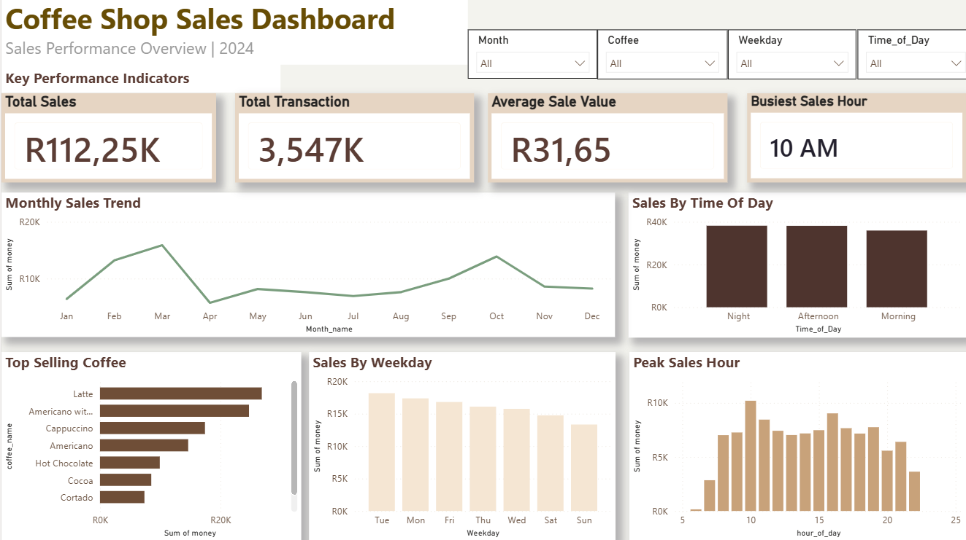

5. Key Insights
The dashboard identified strong sales performance, an average sale value of approximately R31.65, and 10 AM as the busiest sales hour.

6. Business Recommendations
Increase staffing during peak hours, maintain stock of top-selling products, and use sales trends to improve planning.

7. Conclusion
This project demonstrates practical Power BI, DAX, Power Query, and dashboard design skills.

8. Skills Demonstrated
Power BI, Power Query, DAX, Data Cleaning, Data Visualisation, Dashboard Design, Business Intelligence, KPI Reporting.

