Q8)

TABLE SCRIPTS :

CREATE SET TABLE TD_BIM_FR_TRNG_DB.SALES_3000200,NO FALLBACK ,

NO BEFORE JOURNAL,

NO AFTER JOURNAL,

CHECKSUM = DEFAULT,

DEFAULT MERGEBLOCKRATIO

(

CUSTNUM INTEGER,

PRODID INTEGER,

LOCID INTEGER,

TRANS_DT DATE FORMAT 'YYYY-MM-DD',

QUANTITY INTEGER,

REVENUE DECIMAL(10,2)

)

PRIMARY INDEX CUST_PI (CUSTNUM,PRODID,LOCID,TRANS_DT);

INSERT INTO TD_BIM_FR_TRNG_DB.SALES_3000200 VALUES(1,1,1,'2009-09-09',2,20000);

INSERT INTO TD_BIM_FR_TRNG_DB.SALES_3000200 VALUES(1,2,1,'2009-10-09',3,30000);

INSERT INTO TD_BIM_FR_TRNG_DB.SALES_3000200 VALUES(1,3,1,'2009-10-09',3,50000);

INSERT INTO TD_BIM_FR_TRNG_DB.SALES_3000200 VALUES(1,1,1,'2010-10-09',3,60000);

INSERT INTO TD_BIM_FR_TRNG_DB.SALES_3000200 VALUES(2,1,1,'2010-09-09',4,30000);

INSERT INTO TD_BIM_FR_TRNG_DB.SALES_3000200 VALUES(2,2,1,'2009-10-09',3,30000);

INSERT INTO TD_BIM_FR_TRNG_DB.SALES_3000200 VALUES(2,3,1,'2011-10-09',5,70000);

INSERT INTO TD_BIM_FR_TRNG_DB.SALES_3000200 VALUES(2,1,1,'2010-10-09',3,60000);

INSERT INTO TD_BIM_FR_TRNG_DB.SALES_3000200 VALUES(3,1,1,'2009-09-09',2,20000);

INSERT INTO TD_BIM_FR_TRNG_DB.SALES_3000200 VALUES(3,2,1,'2009-10-09',3,30000);

INSERT INTO TD_BIM_FR_TRNG_DB.SALES_3000200 VALUES(3,3,1,'2009-10-09',4,70000);

INSERT INTO TD_BIM_FR_TRNG_DB.SALES_3000200 VALUES(3,1,1,'2010-10-09',3,60000);

INSERT INTO TD_BIM_FR_TRNG_DB.SALES_3000200 VALUES(4,1,1,'2010-09-09',4,30000);

INSERT INTO TD_BIM_FR_TRNG_DB.SALES_3000200 VALUES(4,2,1,'2009-10-09',3,30000);

INSERT INTO TD_BIM_FR_TRNG_DB.SALES_3000200 VALUES(4,3,1,'2011-10-09',2,30000);

INSERT INTO TD_BIM_FR_TRNG_DB.SALES_3000200 VALUES(4,1,1,'2010-10-09',3,60000);

INSERT INTO TD_BIM_FR_TRNG_DB.SALES_3000200 VALUES(5,1,1,'2009-09-09',2,20000);

INSERT INTO TD_BIM_FR_TRNG_DB.SALES_3000200 VALUES(5,2,1,'2009-10-09',3,60000);

INSERT INTO TD_BIM_FR_TRNG_DB.SALES_3000200 VALUES(5,3,1,'2009-10-09',3,40000);

INSERT INTO TD_BIM_FR_TRNG_DB.SALES_3000200 VALUES(5,1,1,'2010-10-09',3,60000);

INSERT INTO TD_BIM_FR_TRNG_DB.SALES_3000200 VALUES(6,1,1,'2010-09-09',4,30000);

INSERT INTO TD_BIM_FR_TRNG_DB.SALES_3000200 VALUES(6,2,1,'2009-10-09',3,30000);

INSERT INTO TD_BIM_FR_TRNG_DB.SALES_3000200 VALUES(6,3,1,'2011-10-09',5,80000);

INSERT INTO TD_BIM_FR_TRNG_DB.SALES_3000200 VALUES(6,1,1,'2010-10-09',3,60000);

INSERT INTO TD_BIM_FR_TRNG_DB.SALES_3000200 VALUES(7,1,1,'2009-09-09',2,20000);

INSERT INTO TD_BIM_FR_TRNG_DB.SALES_3000200 VALUES(7,2,1,'2009-10-09',3,50000);

INSERT INTO TD_BIM_FR_TRNG_DB.SALES_3000200 VALUES(7,3,1,'2009-10-09',4,70000);

INSERT INTO TD_BIM_FR_TRNG_DB.SALES_3000200 VALUES(7,1,1,'2010-10-09',3,60000);

INSERT INTO TD_BIM_FR_TRNG_DB.SALES_3000200 VALUES(8,1,1,'2010-09-09',4,30000);

INSERT INTO TD_BIM_FR_TRNG_DB.SALES_3000200 VALUES(8,2,1,'2009-10-09',3,40000);

INSERT INTO TD_BIM_FR_TRNG_DB.SALES_3000200 VALUES(8,3,1,'2011-10-09',2,70000);

INSERT INTO TD_BIM_FR_TRNG_DB.SALES_3000200 VALUES(8,1,1,'2010-10-09',3,60000);

INSERT INTO TD_BIM_FR_TRNG_DB.SALES_3000200 VALUES(9,1,1,'2009-09-09',2,70000);

INSERT INTO TD_BIM_FR_TRNG_DB.SALES_3000200 VALUES(9,2,1,'2009-10-09',2,40000);

INSERT INTO TD_BIM_FR_TRNG_DB.SALES_3000200 VALUES(9,3,1,'2009-10-09',5,80000);

INSERT INTO TD_BIM_FR_TRNG_DB.SALES_3000200 VALUES(9,1,1,'2010-10-09',3,90000);

INSERT INTO TD_BIM_FR_TRNG_DB.SALES_3000200 VALUES(10,1,1,'2010-09-09',4,50000);

INSERT INTO TD_BIM_FR_TRNG_DB.SALES_3000200 VALUES(10,2,1,'2009-10-09',3,40000);

INSERT INTO TD_BIM_FR_TRNG_DB.SALES_3000200 VALUES(10,3,1,'2011-10-09',2,30000);

INSERT INTO TD_BIM_FR_TRNG_DB.SALES_3000200 VALUES(10,1,1,'2010-10-09',3,70000);

CREATE TABLE CUST

(

CUSTNUM INTEGER,

CUSTNAME VARCHAR(50),

DOB DATEFORMAT'YYYY-MM-DD',

GENDER CHAR(1)

)

PRIMARY INDEX (CUSTNUM);

INSERT INTO CUST (CUSTNUM , CUSTNAME,DOB,GENDER) VALUES (1,'SMITH', '1988-09-27','M');

INSERT INTO CUST (CUSTNUM , CUSTNAME,DOB,GENDER)VALUES (2,'ROY', '1988-07-27','M');

INSERT INTO CUST (CUSTNUM , CUSTNAME,DOB,GENDER)VALUES (3,'LINI', '1987-09-27','F');

INSERT INTO CUST (CUSTNUM , CUSTNAME,DOB,GENDER)VALUES (4,'JANICE', '1982-05-27','F');

INSERT INTO CUST (CUSTNUM , CUSTNAME,DOB,GENDER)VALUES (5,'MARK', '1988-05-27','M');

INSERT INTO CUST (CUSTNUM , CUSTNAME,DOB,GENDER)VALUES (6,'TINA', '1988-07-27','F');

INSERT INTO CUST (CUSTNUM , CUSTNAME,DOB,GENDER)VALUES (7,'LIONEL', '1985-04-27','M');

INSERT INTO CUST (CUSTNUM , CUSTNAME,DOB,GENDER)VALUES (8,'JANE', '1982-05-27','F');

INSERT INTO CUST (CUSTNUM , CUSTNAME,DOB,GENDER)VALUES (9,'MARCO', '1981-05-27','M');

INSERT INTO CUST (CUSTNUM , CUSTNAME,DOB,GENDER)VALUES (10,'RAINA', '1990-07-25','F');

SOL:

A)

**SELECT** **TOP** 1 CUSTNUM,SUM(REVENUE) **FROM** SALES_3000200 **GROUP** **BY** CUSTNUM **ORDER** **BY** 2 **DESC;**

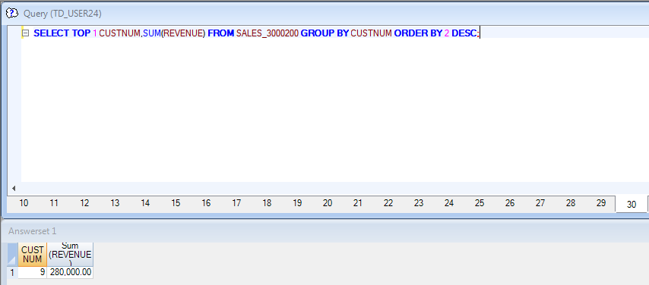

B)

**SELECT** **TOP** 1 CUSTNUM,SUM(REVENUE) **FROM** SALES_3000200 **WHERE** EXTRACT (YEAR FROM trans_dt)=2009 **GROUP** **BY** CUSTNUM **ORDER** **BY** 2**;**

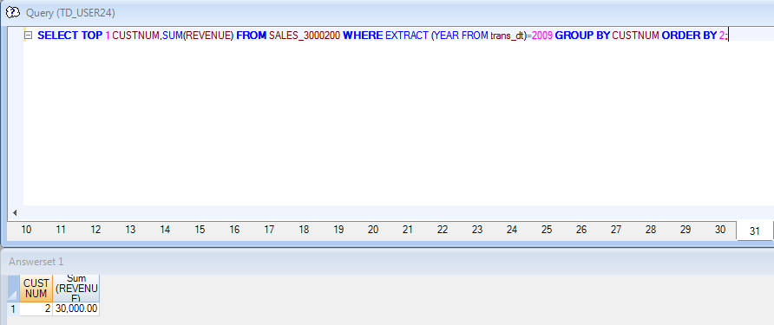

C)

**SELECT** **TOP** 1 CUSTNUM,SUM(REVENUE) **FROM** SALES_3000200 **WHERE** PRODID=3 **GROUP** **BY** CUSTNUM **ORDER** **BY** 2 **DESC;**

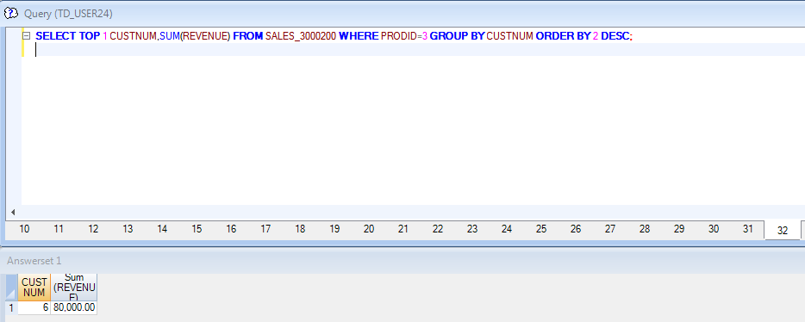

D) **SELECT** **TOP** 2 SALES_3000200.CUSTNUM,CUSTNAME,SUM(REVENUE) **FROM** SALES_3000200 **INNER** **JOIN** CUST **ON** SALES_3000200.CUSTNUM=CUST.CUSTNUM **WHERE** GENDER='F' **GROUP** **BY** SALES_3000200.CUSTNUM,CUSTNAME **ORDER** **BY** 2 **DESC;**

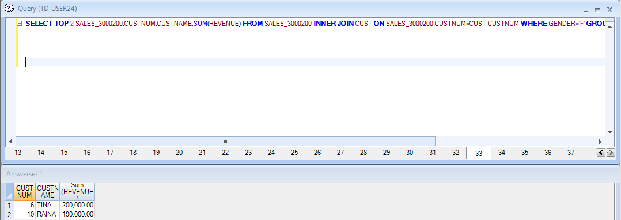

E)

**SELECT** **TOP** 2 SALES_3000200.CUSTNUM,CUSTNAME,PRODID,LOCID,GENDER,SUM(REVENUE) OVER (**PARTITION** **BY** SALES_3000200.CUSTNUM **ORDER** **BY** GENDER **ROWS** BETWEEN UNBOUNDED PRECEDING **AND** **CURRENT** **ROW**) **FROM** SALES_3000200 **INNER** **JOIN** CUST **ON** SALES_3000200.CUSTNUM=CUST.CUSTNUM**;**

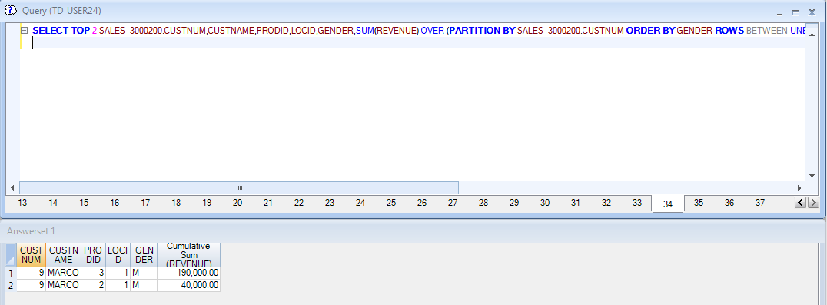

**SELECT** **TOP** 2 SALES_3000168.CUSTNUM,CUSTNAME,SUM(REVENUE) **FROM** SALES_3000168 **INNER** **JOIN** CUST_3000168 **ON** SALES_3000168.CUSTNUM=CUST_3000168.CUSTNUM **WHERE** GENDER='F' **GROUP** **BY** SALES_3000168.CUSTNUM,CUSTNAME **ORDER** **BY** 2 **DESC;**

