**AI- BASED HEART STROKE PREDICTION USING ECG AND PPG BIO-SIGNALS**

**ABSTRACT**

This project uses artificial intelligence (AI)-based decision makers to forecast heart strokes based on information gathered from various patients. The information will be gathered from the physionbanktm database or any other publicly accessible databases of heart attacks. Artificial Neural Networks (ANN) will be used in our work as the decision-making tool. The ANN will first be trained using the various datasets that were obtained from the aforementioned databases. The training phase will then be validated, and the ANN's accuracy will be tested during the test phase. We anticipate that utilising ANN, we will be able to predict heart attacks with an accuracy of above 92%. The neural network model used in the proposed study is based on deep learning and is therefore more reliable and accurate than conventional machine learning decision-making methods. Our goal is to create findings that are more accurate than those of earlier works or algorithms.

**Keywords:** Heart Stroke, Artificial Intelligence (AI), Artificial Neural Networks (ANN), Machine Learning (ML), Accuracy.

**CHAPTER 1**

**INTRODUCTION**

Hemorrhagic stroke, which occurs when a blood vessel breaks, and ischemic stroke, which occurs when a blood artery providing blood to a portion of the brain is blocked, are two different types of stroke. It is a neurological condition that has a specific brain injury as its underlying cause [1]–[5]. Since it can cause aphasia, ataxia, visual impairment, awareness impairment, and dementia, stroke is regarded as one of the most dangerous diseases in contemporary civilization [6]. The top 10 causes of death accounted for 55% of all deaths that were reported in 2019 (about 55.4 million individuals), according to the 2019 Causes of Death Report published by the World Health Organization (WHO) in December 2020 severe cases, cause death, as well as physical and mental issues including hemiparesis, speech impairment.

Cerebrovascular disease was believed to be the second most common cause of mortality among them, causing 6 million deaths [7]. According to the United Nations (UN), a nation is considered to have an ageing society when at least 7% of its total population is 65 years of age or over, an elderly society when at least 14% is, and a super-aged society when at least 20% is [8]. As a result, the social issues of the ageing society are starting to stand out enough to allow for segmentation analysis. Over 20% of the population is over 65. It has been predicted that 34 countries will have super-aged societies by 2030 [8].

In addition, a study on ageing by the international credit rating agency Moody's found that as of 2013, Japan, Germany, Italy, and other countries had super-aged societies, where the percentage of the old was over 20%. It has been predicted that 34 countries will have super-aged societies by 2030 [8]. Age and the location of the stroke's start have a significant impact on the prognosis and health status of patients.

An earlier study on stroke found that older persons 65 and older accounted for more than 66% of all stroke incidence [9]. The incidence and mortality of stroke are anticipated to become significant social and economic challenges in addition to these societal difficulties.

The neurological diagnosis and severity information provided by a medical team are used to determine the diagnosis of stroke, which is represented by cerebrovascular disease [6], [10]–[12].

Brain MRI and CT are the primary techniques used for neurological diagnosis in stroke diagnosis, but additional research has shown that bio-signals including brain waves, muscular activity, and EKG can also be used to diagnose and prevent stroke disorders [13]–[15]. In addition, single photon emission computed tomography (SPECT), echocardiography, cerebral angiography, and ultrasound evaluation are being utilised to identify the common causes of stroke.

Although imaging methods like CT and MRI are now frequently used to diagnose strokes, there are still drawbacks to these methods, including radiation exposure, claustrophobia in confined spaces, and hypersensitive reactions based on the drug penetration of the contrast agent. It's possible that the test findings contain inaccuracies, thus making a decision based on the medical staff's expert knowledge and empirical data is thought to be crucial. Next, a research technique called the national institutes of health stroke scale (NIHSS), which is published by the US National Institute of Health, is used to assess early disability in stroke patients and avoid recurrence.

Therefore, a method for the aged to assess their unique stroke risk factors and identify potential disease early in real-time is required. Recent research have tried to predict stroke disorders using statistical or machine learning approaches while taking specific risk factors into account in order to get over these constraints. The drawback of these approaches is that they also produce black-box findings for predictions, which makes them challenging to understand. Heuristic methodologies can be used with decision tree methodologies to supplement partial analytical approaches, but studies on predictive systems that can take into account prior studies' methodologies as well as the possibility of developing disease and semantic interpretations are currently highly desired.

In this study, we offer a new method that uses multi-modal bio-signals based on ECG and PPG to detect stroke disease and provide semantic interpretation findings for the elderly. By gathering multi-modal bio-signals in real-time, the suggested system may instantaneously identify and forecast the prognostic symptoms of stroke disease in the elderly.

ECG and PPG multi-modal bio-signals were captured and stored from the participants in this study, who were 65 years of age or older, as they walked. Signal waveforms are used to categorize the features of the gathered multi-modal bio-signals data, which are then utilized to develop machine learning predictive models and generate reasonably accurate predictions as well as semantic interpretations.

The ability of deep learning time series analysis models to properly identify stroke prognostic symptoms without the need for independent attribute extraction or features has also been experimentally demonstrated. This research proposes a multimodal bio-signals-based illness prediction system for the aged that can identify and forecast in real-time the prognostic signs of stroke with high mortality and incidence rates. In this study, we describe and identify 29 novel qualities that were not previously employed in machine learning and deep learning investigations using multi-modal bio-signals based on ECG and PPG. This is a significant addition since it enables medical professionals to actively use semantic analysis results for objective diagnosis and prognosis treatment.

It was experimentally proven that the stroke prediction and monitoring system discussed in this research can be used for low-cost, everyday healthcare services as well as the real-time prediction of prognostic symptoms of stroke disease. The real-time bio-signals of ECG and PPG that were recorded while seniors 65 and older were walking were employed in this experiment.

**Artificial Neural Networks (ANN)**

Basic and advanced ideas of ANNs are provided via the Artificial Neural Network Tutorial. Our Artificial Neural Network tutorial was created for both professionals and beginners. The phrase "artificial neural network" refers to a branch of artificial intelligence that was inspired by biology and is based on the brain. A computational network based on biological neural networks, which create the structure of the human brain, is typically referred to as an artificial neural network. Artificial neural networks also feature neurons that are linked to each other in different layers of the networks, just as neurons in a real brain. Nodes are the name for these neurons. The lesson for artificial neural networks covers every facet of these networks. We will explore artificial neural networks (ANNs), adaptive resonance theory, and Kohonen self-organizing map, Building blocks, unsupervised learning, Genetic algorithm, etc.

The biological neural networks that shape the structure of the human brain are where the phrase "artificial neural network" originates. Artificial neural networks also feature neurons that are interconnected to one another in different levels of the networks, much like the human brain, which has neurons that are coupled to one another. Nodes are the name for these neurons.

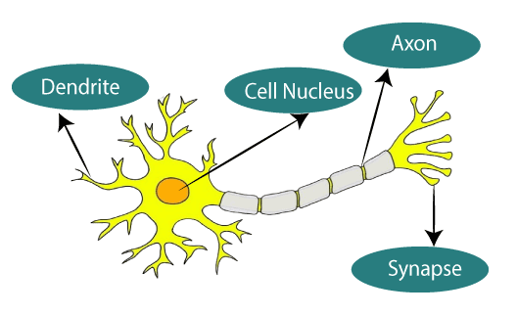

The given figure illustrates the typical diagram of Biological Neural Network.

The typical Artificial Neural Network looks something like the given figure.

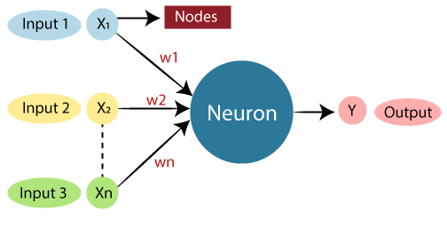

Dendrites from Biological Neural Network represent inputs in Artificial Neural Networks, cell nucleus represents Nodes, synapse represents Weights, and Axon represents Output.

Relationship between Biological neural network and artificial neural network:

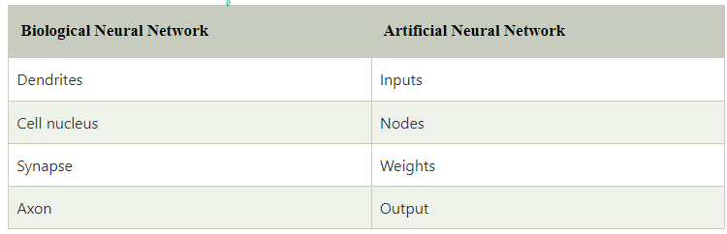

An Artificial Neural Network in the field of Artificial intelligence where it attempts to mimic the network of neurons makes up a human brain so that computers will have an option to understand things and make decisions in a human-like manner. The artificial neural network is designed by programming computers to behave simply like interconnected brain cells.

There are around 1000 billion neurons in the human brain. Each neuron has an association point somewhere in the range of 1,000 and 100,000. In the human brain, data is stored in such a manner as to be distributed, and we can extract more than one piece of this data when necessary from our memory parallelly. We can say that the human brain is made up of incredibly amazing parallel processors.

We can understand the artificial neural network with an example, consider an example of a digital logic gate that takes an input and gives an output. "OR" gate, which takes two inputs. If one or both the inputs are "On," then we get "On" in output. If both the inputs are "Off," then we get "Off" in output. Here the output depends upon input. Our brain does not perform the same task. The outputs to inputs relationship keep changing because of the neurons in our brain, which are "learning”.

The architecture of an artificial neural network:

To understand the concept of the architecture of an artificial neural network, we have to understand what a neural network consists of. In order to define a neural network that consists of a large number of artificial neurons, which are termed units arranged in a sequence of layers. Lets us look at various types of layers available in an artificial neural network.

Artificial Neural Network primarily consists of three layers:

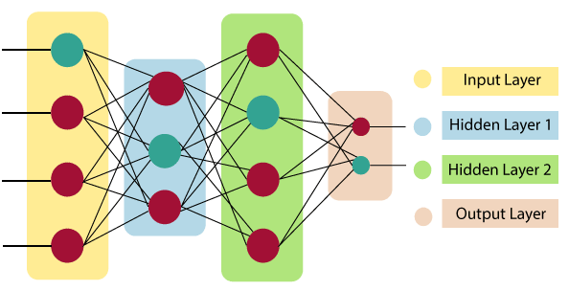

**Input Layer**

As the name suggests, it accepts inputs in several different formats provided by the programmer.

**Hidden Layer**

The hidden layer presents in-between input and output layers. It performs all the calculations to find hidden features and patterns.

**Output Layer**

The input goes through a series of transformations using the hidden layer, which finally results in output that is conveyed using this layer.

The artificial neural network takes input and computes the weighted sum of the inputs and includes a bias. This computation is represented in the form of a transfer function.

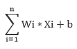

It determines weighted total is passed as an input to an activation function to produce the output. Activation functions choose whether a node should fire or not. Only those who are fired make it to the output layer. There are distinctive activation functions available that can be applied upon the sort of task we are performing.

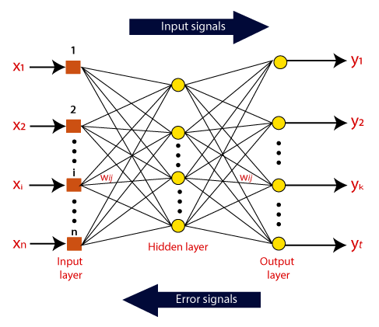

**Fig: Working and flow of Data in an ANN**

**CHAPTER 2**

**LITERATURE SURVEY**

**[1] S. De Raedt, A. De Vos, and J. De Keyser, ‘‘Autonomic dysfunction inacute ischemic stroke: An underexplored therapeutic area?’’ J. Neurol. Sci., vol. 348, nos. 1–2, pp. 24–34, Jan. 2015.:**

Impaired autonomic function, characterized by a predominance of sympathetic activity, is common in patients with acute ischemic stroke. This review describes methods to measure autonomic dysfunction in stroke patients. It summarizes a potential relationship between ischemic stroke-associated autonomic dysfunction and factors that have been associated with worse outcome, including cardiac complications, blood pressure variability changes, hyperglycemia, immune depression, sleep disordered breathing, thrombotic effects, and malignant edema. Involvement of the insular cortex has been suspected to play an important role in causing sympathovagal imbalance, but its exact role and that of other brain regions remain unclear. Although sympathetic overactivity in patients with ischemic stroke appears to be a negative prognostic factor, it remains to be seen whether therapeutic strategies that reduce sympathetic activity or increase parasympathetic activity might improve outcome.

**Summary:** Studied aboutAutonomic dysfunction inacute ischemic stroke, An underexplored therapeutic area.

**[2] K.-D. Seo, M. J. Kang, G. S. Kim, J. H. Lee, S. H. Suh, and K.-Y. Lee, ‘‘National trends in clinical outcomes of endovascular therapy for ischemic stroke in South Korea between 2008 and 2016,’’ J. Stroke, vol. 22, no. 3, pp. 412–415, Sep. 2020:**

This study has several limitations. We used insurance claims data rather than well-designed clinical trial or prospective registry data. Therefore, we were unable to adjust for detailed and important prognostic factors such initial National Institutes of Health Stroke Scale scores, occlusion sites, recanalization status, and interval from symptom onset to recanalization. In addition, we were unable to verify the precise number of patients who received ET in the period when solitaire stents, the most common ET instrument, were only used off-label or when the solitaire stents were not covered by insurance. Improved outcomes of patients treated with ET in the transitional period compared to those of patients treated with ET in the non-advanced MT period is likely attributed to the increasing use of MT. However, we had no data on the proportion of patients treated with MT during the transition period and our interpretation is not supported by formal analysis.

**Summary:** Studied about National trends in clinical outcomes of endovascular therapy for ischemic stroke in South Korea between 2008 and 2016.

**[3] T. D. Musuka, S. B. Wilton, M. Traboulsi, and M. D. Hill, ‘‘Diagnosis and management of acute ischemic stroke: Speed is critical,’’ Can. Med. Assoc. J., vol. 187, no. 12, pp. 887–893, Sep. 2015.:**

Globally, stroke is the second leading cause of death.1 The estimated 62 000 strokes that occur each year in Canada affect all age groups, from neonates to elderly people, with occurrence rates rising by age. The lifetime risk of overt stroke is estimated at one in four by age 80 years, and the lifetime risk of silent or covert stroke is likely closer to 100%. Stroke affects men and women equally and causes major social and economic burdens to society, with direct costs above $3 billion annually in Canada.2 Acute stroke and acute coronary syndromes have many similarities. Here, we review the diagnosis and management of acute ischemic stroke and compare its treatment with that of acute coronary syndrome, to help illustrate how the rapid relief of arterial occlusion and restoration of normal blood flow can save lives and prevent disability. This narrative review is based upon a critical appraisal of relevant clinical trials.

**Summary:** Studied about Diagnosis and management of acute ischemic stroke, Speed is critical.

**[4] Q. Song, X. Liu, W. Zhou, L. Wang, X. Zheng, X. Wang, and S. Wu, ‘‘Long sleep duration and risk of ischemic stroke and hemorrhagic stroke: The Kailuan prospective study,’’ Sci. Rep., vol. 6, no. 1, pp. 1–9, Sep. 2016:**

The objective of this study was to examine the relationship between sleep duration and ischemic and hemorrhagic stroke in a community-based cohort. The current analysis included 95,023 Chinese participants who were free of stroke at the baseline survey (2006-2007). Cox proportional hazards models were used to calculate hazard ratios (HRs) and their confidence intervals (CIs) for stroke, according to sleep duration. After a mean follow-up period of 7.9 years, 3,135 participants developed stroke (2,504 ischemic stroke and 631 hemorrhagic stroke). The full adjusted hazard ratio (95% CI) of total stroke (with 6-8 hours of night sleep being considered for the reference group) for individuals reporting greater than 8 hours was 1.29 (1.01-1.64). More significant association between long sleep duration and total stroke was found in the elderly (HR, 1.47; 95% CI, 1.05-2.07). Compared with participants getting 6-8 hours of sleep, only women who reported sleeping more than 8 hours per night were associated with hemorrhagic stroke (HR, 3.58; 95% CI, 1.28-10.06). This study suggested that long sleep duration might be a potential predictor/ marker for total stroke, especially in the elderly. And long sleep duration increased the risk of hemorrhagic stroke only in women.

**Summary:** Studied about Long sleep duration and risk of ischemic stroke and hemorrhagic stroke: The Kailuan prospective study.

**[5] J. Yu, S. Park, H. Lee, C. S. Pyo, and Y. S. Lee, ‘‘An elderly health monitoring system using machine learning and in-depth analysis techniques on the NIH stroke scale,’’ Mathematics, vol. 8, no. 7, pp. 1–16, Jul. 2020:**

Recently, with the rapid change to an aging society and the increased interest in healthcare, disease prediction and management through various healthcare devices and services is attracting much attention. In particular, stroke, represented by cerebrovascular disease, is a very dangerous disease, in which death or mental and physical aftereffects are very large in adults and the elderly. The sequelae of such stroke diseases are very dangerous, because they make social and economic activities difficult. In this paper, we propose a new system to prediction and in-depth analysis stroke severity of elderly over 65 years based on the National Institutes of Health Stroke Scale (NIHSS). In addition, we use the algorithm of decision tree of C4.5, which is a methodology of prediction and analysis of machine learning techniques. The C4.5 decision trees are machine learning algorithms that provide additional in-depth rules of the execution mechanism and semantic interpretation analysis. Finally, in this paper, it is verified that the C4.5 decision tree algorithm can be used to classify and predict stroke severity, and to obtain additional NIHSS features reduction effects. Therefore, during the operation of an actual system, the proposed model uses only 13 features out of the 18 stroke scale features, including age, so that it can provide faster and more accurate service support. Experimental results show that the system enables this by reducing the patient NIH stroke scale measurement time and making the operation more efficient, with an overall accuracy, using the C4.5 decision tree algorithm, of 91.11%.

**SUMMARY:** Studied about An elderly health monitoring system using machine learning and in-depth analysis techniques on the NIH stroke scale.

**CHAPTER 3**

**EXISTING METHOD**

In this paper, we propose a method for monitoring elderly stroke patients' health based on multimodal bio-signals of ECG and PPG recorded in real-time. The suggested method extracts features based on the peak values of waveforms from the raw data of ECG and PPG in order to predict the prognostic symptoms of stroke in the elderly in real-time. Additionally, the deep learning model is employed to efficiently estimate the prognostic symptoms of stroke disease in real-time using the raw ECG and PPG data. The suggested system's organizational elements are as follows:

An ECG and PPG sensor measurement and transmission module; a module for gathering, storing, and transmitting multimodal bio-signals created in real-time to a server; a module for extracting and updating significant attributes from stored bio-signals; and a module for learning based on a machine learning algorithm using property information for each bio-signal and a deep learning model

For each multimodal bio-signal among ECG and PPG from the elderly and general old suffering from stroke, the recommended system measures, collects, and conducts preprocessing operations in order to store and keep crucial features.

In this part, the entire process of real-time data collection and measurement is covered.

A method that can predict stroke disease among the bio-signals that were recorded and collected in this work was tested using EEG and PPG in trials. According to earlier studies, abnormalities in the sympathetic and autonomic nervous systems appear as a stroke or its precursor symptoms develop.

It is very difficult to accurately anticipate stroke symptoms with just one bio-signal. The PPG, which measures the changes in blood volume that occur with heart contraction and relaxation, and the ECG, which can confirm the frequency and regularity of heartbeats, were two different forms of multimodal bio-signals that were used in this investigation to extract significant characteristic values.

We suggest using a feature that combines two bio-signals to correctly forecast the onset and symptoms of a stroke.

The ECG measuring technique is largely divided into standard 12-lead ECG and chest guidance depending on where the attachment is performed. Additionally, bipolar standard guidance and unipolar extremities guiding are two subtypes of the 12-lead standard ECG. For this experiment, the ECGs of elderly stroke patients and the elderly in general were precisely monitored and recorded using the chest guiding technique. The three ECG electrode attachment sites that were used in the testing for this research are shown in great detail in Figure 2. The sensors were simply attached to the subject's left and right index fingers, as shown in Figure 3, to provide real-time data storage for the PPG bio-signals that were captured and gathered for this work.

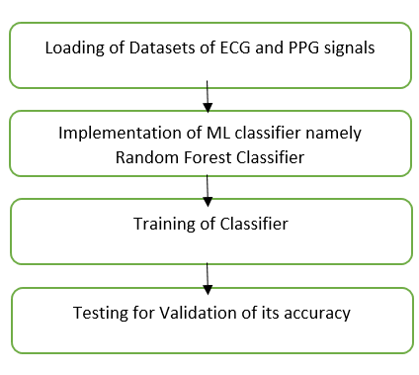

**Fig: Flow of Existing Method**

These EEG and PPG bio-signals were collected from participants 65 years of age or older in the emergency room and the department of rehabilitation medicine at Chungnam National University Hospital, Republic of Korea, during 2017 and 2018. The study's participants were patients who were treated at the Department of Neurology and Rehabilitation Medicine of Chungnam National University and who had been diagnosed with a stroke within a month at the hospital. The medical staff primarily selected the subject candidates, who were healthy older citizens who had recently suffered a stroke. The secondary examination of the candidates' stroke-related subjects by the neurologist faculty.

Using data gathered from a variety of patients and decision-making tools powered by artificial intelligence, heart stroke is diagnosed. The information will be gathered from the physionbanktm database or any other publicly accessible databases of heart attacks. Random Forest will be used in our work as the decision-making tool. The random forest will initially be trained using the various datasets obtained from the aforementioned databases. After the test phase, in which we will evaluate the random forest's accuracy, the training phase will be validated.

**Disadvantages:**

* The existing method results in lower accuracy than the desired level.
* The existing method is inconsistent at dealing massive or large amount of datasets.

**CHAPTER 4**

**PROPOSED METHOD**

In this article, we suggest a system based on multimodal bio-signals of ECG and PPG recorded in real-time for monitoring stroke disease and health in the elderly. The proposed method uses a machine learning algorithm to predict the prognostic symptoms of stroke in the elderly in real-time by extracting features based on the peak values of waveforms from the raw data of ECG and PPG. Additionally, the deep learning model is used to use the raw ECG and PPG data to effectively forecast the prognostic signs of stroke disease in real-time. The suggested system's structure consists of the following:

A module for real-time bio-signal measurement and transmission includes: 1) an ECG and PPG sensor measurement and transmission module; 2) a module for collecting, storing, and transmitting multimodal bio-signals generated in real-time to a server; 3) a module for extracting and updating significant attributes from stored bio-signals; and 4) a module for learning based on a machine learning algorithm using property information for each bio-signal and a deep learning model.

In other words, the suggested system measures, collects, and performs preprocessing operations for each multimodal bio-signal among ECG and PPG from the elderly and general old suffering from stroke in order to store and maintain important properties.

It was also created to use machine learning and preprocess raw data-based deep learning models to predict and analyze stroke prognostic symptoms in real-time characteristics of every bio-signal.

The procedure for real-time data gathering and measurement is covered in full in this section.

EEG and PPG were employed in experiments for a performance verification of a system that can predict stroke disease among the bio-signals that were recorded and collected in this study. Previous research have suggested that anomalies in the sympathetic and autonomic nervous systems manifest at the development of a stroke or its antecedent symptoms.

Using a single bio-signal to reliably predict stroke symptoms is quite challenging. Important characteristic values were taken from two different types of multimodal bio-signals in this study: the ECG, which can verify the frequency and regularity of heartbeats, and the PPG, which measures the changes in blood volume that occur with heart contraction and relaxation.

We suggest using a feature that combines two bio-signals to correctly forecast the onset and symptoms of a stroke.

Depending on where the attachment is made, the ECG measuring method is mainly split into standard 12-lead ECG and chest guidance. Standard 12-lead ECG can also be further divided into bipolar standard guidance and unipolar extremity guidance. The ECGs of old stroke patients and the aged in general were precisely measured and captured for this investigation utilising the chest guiding technique. Figure 2 provides a detailed illustration of the three ECG electrode attachment sites that were used in the tests for this paper. The real-time data storage for the PPG bio-signals recorded and gathered in this paper simply affixing the sensors to the subject's left and right index fingers, as depicted in Figure 3.

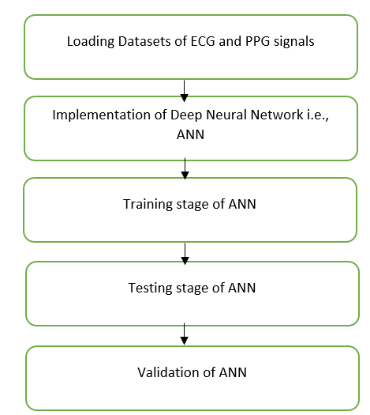

**Fig: Flow of Proposed Method**

In the emergency room and the department of rehabilitation medicine at Chungnam National University Hospital, Republic of Korea, these EEG and PPG bio-signals were taken from subjects 65 years of age or older between 2017 and 2018. Patients treated at Chungnam National University's Department of Neurology and Rehabilitation Medicine and who had received a stroke diagnosis within a month at the hospital were the study's subjects. The medical team primarily chose the subject applicants, who were stroke sufferers and healthy senior persons. The neurologist faculty secondary verified the stroke-related subjects among the candidates.

An offline module and an online module made up the system for delivering data on stroke prognosis and prediction information for the elderly using multimodal bio-signals of ECG and PPG collected in real-time. First, all participants' ECGs and PPGs were gathered and saved, and offline submodules were used to extract preprocessing and significant features from the raw data. Different machine learning and deep learning algorithms were trained to produce prediction models for stroke illnesses and give semantic interpretation data using feature values obtained during preprocessing. As illustrated in Figure, the online module then supplied prognostic and predictive data on stroke in the elderly using multimodal bio-signals and feature values of ECG and PPGs acquired in real-time.

The offline module in Figure 4 consists of a total of five sub-blocks. The first block at the bottom left stores various bio-signals that can be measured in the elderly during daily activities. In addition to ECG and PPG, this block measures, collects, and stores bio-signals.

The second block includes the pre-processing of the ECG recorded using three electrodes and the PPG signal recorded using a linear relationship between the variation in blood volume caused by the contraction and relaxation of the heart and the quantity of light absorbed by Haemoglobin in the blood.

The raw ECG and PPG data values are cleaned up of the momentarily unmeasured null values, and the remaining data is then normalized using the Z-score approach. The third sub-block develops and stores a trained predictive model as well as extracts and saves features for machine learning from preprocessed raw data. Prediction and analysis make up the fourth block are carried out utilizing machine learning techniques based on features gathered from stroke patients and healthy elderly persons using PPG and ECG bio-signals.

There are four separate blocks in the online module.

The first sub-block records and maintains real-time PPG and ECG biosignal data from older people who walk as part of their everyday lives. The second sub-block removes null values from the ECG and PPG raw data that have been obtained before storing and managing the values that have been normalised using Z-score normalisation. In the third sub-block, significant portions of the ECG and PPG raw data are isolated from the information, and feature values are then extracted for each bio-signal. Using machine learning and deep learning models with the feature values and raw data extracted from the previous block, real-time stroke illness prediction is carried out in the fourth block.

The multimodal bio-signals of EEG and PPG acquired in real-time by the online module can be used to obtain findings for stroke disease prediction and analysis information for the elderly. Because of this, the proposed stroke illness prediction results and analysis information can be used as factual information by medical professionals to make a diagnosis and provide appropriate therapy.

This section explains how multimodal biosignals, such as ECG and PPG data, are gathered and prepared for use in machine learning and deep learning-based stroke illness prediction, as well as in-depth analysis and verification. ECG and PPG multimodal data that are recorded and gathered in real-time are the bio-signals employed in the studies carried out in this work. The terms "bio-signals" refer to values that can represent both the contraction and relaxation of the heart as well as the flow of the electric current that travels through the three intestines during a heartbeat and is visualised as a wavy line. ECG and PPG monitor the electrical activity of the heart, heart rhythm, and peripheral areas to measure changes in blood vessel volume.

The occurrence of serious cardiovascular disorders like arrhythmias or atrial fibrillation as well as chronic conditions like hypertension can be seen by examining the bio-signals of the ECG and PPG. Therefore, in this work, we made use of the clinical findings demonstrating that anomalies in the sympathetic and autonomic nervous systems may arise as a result of the prognostic signs of stroke.

By using medical judgement and the diagnostic findings of aberrant symptoms, such as cardiac arrest or arrhythmia in ECG and PPG, we tried to anticipate the prognostic symptoms of stroke disease and interpret the meanings. Additionally, a deep learning model was employed to validate the stroke prognosis and prediction tests in the elderly using the raw data of the bio-signals from the ECG and PPG.

Two types of data are used in this paper: 2) Raw data values of ECG and PPG bio-signals, which are directly used for the deep learning approach. 1) The value retrieved from the raw data by splitting the ECG and PPG bio-signal waveforms of stroke patients and the general aged by section. The Z-score technique was used to normalize the acquired ECG and PPG bio-signals' raw values after eliminating any blank values that weren't momentarily recorded. The model was trained and validated using ECG and PPG bio-signals in units of 5 sec frame windows because this is the smallest unit that is considered medically and clinically necessary for medical personnel to perform their duties and determine conditions such as heart disease based on the waveforms of ECG and PPG.

Real-time ECG measurements were made, and the gathered three-electrode-based ECG data's raw data values were retrieved and saved. In the instance of PPG data, the sensors were positioned on the left and right index fingers in order to extract and collect the raw data values. The location and portion of the attribute were retrieved from the raw ECG and PPG data and used in the machine learning-based experiment. The ECG bio-signals waveform and the position details of the features described in this paper are shown in Figure 5.

The significant properties of the ECG waveform's position and interval values are then retrieved.

This part verifies the efficacy of predicting stroke prognostic symptoms using the bio-signals of ECG and PPG and assesses system performance. Equations (4) through (7) provide in-depth descriptions of each of the four performance evaluation indices that were used in this study [14], [50], and [51]. The percentage of the total that properly identified elderly with stroke as stroke and normal elderly as normal is known as accuracy. The harmonic mean of memory, precision, and F1-score is recall.

**CHAPTER 5**

**ADVANTAGES AND APPLICATIONS**

**Advantages:**

* The advantage of the ANN is so accurate than the existing ML classifiers.
* ANN can solve large number of data unlike any ML classifiers.
* ANN is a neural network based which is more robust than the typical ML classifiers.
* ANN is best for classifying the signals with greater accuracy.

**Applications:**

* Applications of are: Bio-Medical Signal Processing, Signal Processing, Digital Signal Processing and Real-Time Signals Processing.

**CHAPTER 6**

**RESULTS**

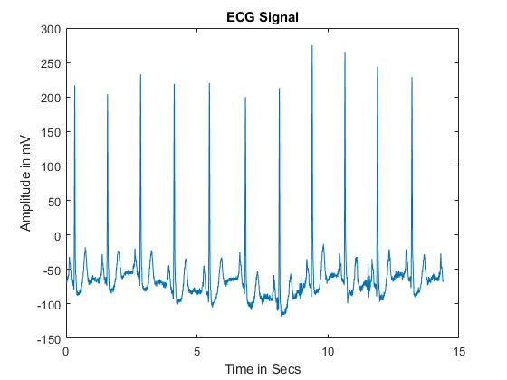

**Fig 1: ECG Signal**

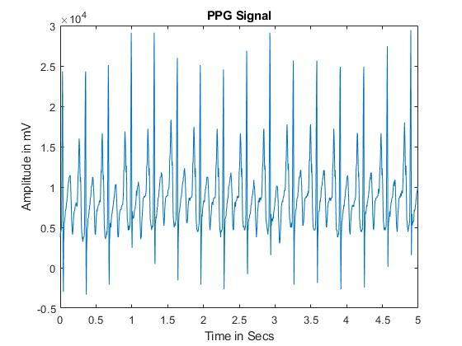

**Fig 2: PPG Signal**

**CHAPTER 7**

**CONCLUSION**

The AI-based decision support system for predicting Heart Strokes based on ECG and PPG Signals is a conclusion. In comparison to earlier efforts, the deployment of deep neural network-based decision making for the prediction of heart attacks yields very near predictions with an accuracy rate of roughly 95%. Because of its neural connections and networking technique, which maintains the estimates as closely as possible until they match the real values through back propagation, the neural network implementation is more reliable.

**REFERENCES**

[1] G. Sannino and G. De Pietro, ‘‘A deep learning approach for ECG-based heartbeat classification for arrhythmia detection,’’ Future Gener. Comput. Syst., vol. 86, pp. 446–455, Sep. 2018.

[2] J. S. Wang, W. C. Chiang, Y. L. Hsu, and Y. T. C. Yang, ‘‘ECG arrhythmia classification using a probabilistic neural network with a feature reduction method,’’ Neurocomputing, vol. 116, pp. 38–45, Sep. 2013.

[3] I.-S. Oh, J.-S. Lee, and B.-R. Moon, ‘‘Hybrid genetic algorithms for feature selection,’’ IEEE Trans. Pattern Anal. Mach. Intell., vol. 26, no. 11, pp. 1424–1437, Nov. 2004.

[4] S. De Raedt, A. De Vos, and J. De Keyser, ‘‘Autonomic dysfunction inacute ischemic stroke: An underexplored therapeutic area?’’ J. Neurol. Sci., vol. 348, nos. 1–2, pp. 24–34, Jan. 2015.

[5] C. P. Warlow, ‘‘Epidemiology of stroke,’’ Lancet, vol. 352, pp. 1–4, Oct. 1998.

[6] K.-D. Seo, M. J. Kang, G. S. Kim, J. H. Lee, S. H. Suh, and K.-Y. Lee, ‘‘National trends in clinical outcomes of endovascular therapy for ischemic stroke in South Korea between 2008 and 2016,’’ J. Stroke, vol. 22, no. 3, pp. 412–415, Sep. 2020.

[7] T. D. Musuka, S. B. Wilton, M. Traboulsi, and M. D. Hill, ‘‘Diagnosis and management of acute ischemic stroke: Speed is critical,’’ Can. Med. Assoc. J., vol. 187, no. 12, pp. 887–893, Sep. 2015.

[8] Q. Song, X. Liu, W. Zhou, L. Wang, X. Zheng, X. Wang, and S. Wu, ‘‘Long sleep duration and risk of ischemic stroke and hemorrhagic stroke: The Kailuan prospective study,’’ Sci. Rep., vol. 6, no. 1, pp. 1–9, Sep. 2016.

[9] J. Yu, S. Park, H. Lee, C. S. Pyo, and Y. S. Lee, ‘‘An elderly health monitoring system using machine learning and in-depth analysis techniques on the NIH stroke scale,’’ Mathematics, vol. 8, no. 7, pp. 1–16, Jul. 2020.

[10] World Health Organization. The Top 10 Causes of Death. Accessed: Apr. 22, 2022. [Online]. Available: https://www.who.int/newsroom/fact-sheets/detail/the-top 10-causes-of-death.

**BIBLIOGRAPHY**

**Introduction To Matlab**

What Is MATLAB?

The name MATLAB stands for Matrix Laboratory. The software is built up around vectors and matrices. This makes the software particularly useful for linear algebra but MATLAB is also a great tool for solving algebraic and differential equations and for numerical integration. MATLAB has powerful graphic tools and can produce nice pictures in both 2D and 3D. It is also a programming language, and is one of the easiest programming languages for writing mathematical programs. These factors make MATLAB an excellent tool for teaching and research.

MATLAB was written originally to provide easy access to matrix software developed by the LINPACK (linear system package) and EISPACK (Eigen system package) projects. It integrates computation, visualization, and programming environment. Furthermore, MATLAB is a modern programming language environment: it has sophisticated data structures, contains built-in editing and debugging tools, and supports object-oriented programming. MATLAB has many advantages compared to conventional computer languages (e.g., C, FORTRAN) for solving technical problems.

MATLAB abilities a family of add-on software program utility software application software program software utility software-unique solutions called toolboxes. Very essential to maximum customers of MATLAB, toolboxes assist you to studies and observe specialized technology. Toolboxes are entire collections of MATLAB abilities (M-files) that increase the MATLAB surroundings to remedy precise schooling of problems. Areas in which toolboxes are to be had embody signal processing, manipulate systems, neural networks, fuzzy correct judgment, wavelets, simulation, and hundreds of others.

It has powerful built-in routines that enable a very wide variety of computations. It also has easy to use graphics commands that make the visualization of results immediately available. Specific applications are collected in packages referred to as toolbox. There are toolboxes for signal processing, symbolic computation, control theory, simulation, optimization, and several other fields of applied science and engineering. MATLAB is an interactive system whose basic data element is an array that does not require dimensioning. The software package has been commercially available since 1984 and is now considered as a standard tool at most universities and industries worldwide.

**Brief History of MATLAB:**

Cleve Moler, the chairman of the computer science department at the University of New Mexico, started developing MATLAB in the late 1970s. The first MATLAB® was not a programming language; it was a simple interactive matrix calculator. There were no programs, no toolboxes, no graphics and no ODEs or FFTs. He designed it to give his student’s access to LINPACK and EISPACK without them having to learn FORTRAN. It soon spread to other universities and found a strong audience within the applied mathematics community. The mathematical basis for the first version of MATLAB was a series of research papers by J. H. Wilkinson and 18 of his colleagues, published between 1965 and 1970 and later collected in Handbook for Automatic Computation, Volume II, Linear Algebra*,* edited by Wilkinson and C. Reinsch. These papers present algorithms, implemented in Algol 60, for solving matrix linear equation and Eigen value problems.

In the 1970s and early 1980s, I was teaching Linear Algebra and Numerical Analysis at the University of New Mexico and wanted my students to have easy access to LINPACK and EISPACK without writing FORTRAN programs. By “easy access,” I meant not going through the remote batch processing and the repeated edit-compile-link-load-execute process that was ordinarily required on the campus central mainframe computer. Jack little, an engineer, was exposed to it during a visit Moler made to Stanford University in 1983. Recognizing its commercial potential, he joined with Moler and Steve Bangert. They rewrote MATLAB in C and founded Math Works in 1984 to continue its development. These rewritten libraries were known as JACKPAC. In 2000, MATLAB was rewritten to use a newer set of libraries for matrix manipulation, LAPACK. MATLAB was first adopted by researchers and practitioners in control engineering, Little's specialty, but quickly spread to many other domains. It is now also used in education, in particular the teaching of linear algebra and numerical analysis, and is popular amongst scientists involved in video processing**.**

## **EISPACK and LINPACK**:

In 1970, a group of researchers at Argonne National Laboratory proposed to the U.S. National Science Foundation (NSF) to “explore the methodology, costs, and resources required to produce, test, and disseminate high-quality mathematical software and to test, certify, disseminate, and support packages of mathematical software in certain problem areas.” The group developed EISPACK (Matrix Eigen system Package) by translating the Algol procedures for Eigen value problems in the handbook into FORTRAN and working extensively on testing and portability. The first version of EISPACK was released in 1971 and the second in 1976.

In 1975, four of us Jack Dongarra, Pete Stewart, Jim Bunch, and myself proposed to the NSF another research project that would investigate methods for the development of mathematical software. A byproduct would be the software itself, dubbed LINPACK, for Linear Equation Package. This project was also centered at Argonne. LINPACK originated in FORTRAN; it did not involve translation from Algol. The package contained 44 subroutines in each of four numeric precisions. In a sense, the LINPACK and EISPACK projects were failures. We had proposed research projects to the NSF to “explore the methodology, costs, and resources required to produce, test, and disseminate high-quality mathematical software.” We never wrote a report or paper addressing those objectives. We only produced software.

So, I studied Niklaus Wirth’s book Algorithms + Data Structures *=* Programs and learned how to parse programming languages. I wrote the first MATLAB an acronym for Matrix Laboratory in FORTRAN, with matrix as the only data type. The project was a kind of hobby, a new aspect of programming for me to learn and something for my students to use. There was never any formal outside support, and certainly no business plan. This first MATLAB was just an interactive matrix calculator. This snapshot of the start-up screen shows all the reserved words and functions. There are only 71. To add another function, you had to get the source code from me, write a FORTRAN subroutine, add your function name to the parse table, and recompile MATLAB.

**Starting MATLAB:**

After logging into your account, you can enter MATLAB by double-clicking on the MATLAB shortcut icon (MATLAB 7.0.4) on your Windows desktop. When you start MATLAB, a special window called the MATLAB desktop appears. The desktop is a window that contains other windows. The major tools within or accessible from the desktop are:

* The Command Window
* The Command History
* The Workspace
* The Current Directory
* The Help Browser

**Current Folder:** This panel allows you to access the project folders and files.

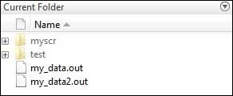

**Command Window:** This is the main area where commands can be entered at the command line. It is indicated by the command prompt (>>).

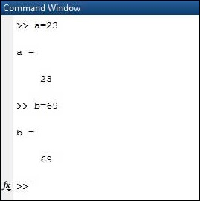

**Workspace:**  The workspace shows all the variables created and/or imported from files.

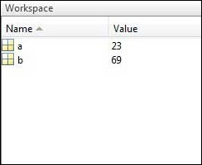

**Command History:** This panel shows or return commands that are entered at the command line.

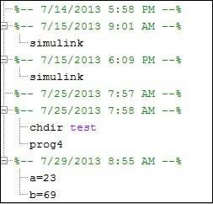

**Help Browser:**

The critical way to get assist online is to use the MATLAB help browser, opened as a separate window every through clicking at the question mark photograph (?) on the computing tool toolbar, or through manner of typing assist browser on the spark off in the command window. The assist Browser is an internet browser blanketed into the MATLAB computing tool that shows a Hypertext Markup Language (HTML) files. The Help Browser consists of panes, the help navigator pane, used to find out information, and the show pane, used to view the information. Self-explanatory tabs apart from navigator pane are used to performs are searching out.

**MATLAB language:**

This is a high-level matrix/array language with control flow statements, functions, data structures, input/output, and object-oriented programming features. It allows both "programming in the small" to rapidly create quick and dirty throw-away programs, and "programming in the large" to create complete large and complex application programs.

**MATLAB working environment:**

This is the set of tools and facilities that you work with as the MATLAB user or programmer. It includes facilities for managing the variables in your workspace and importing and exporting data. It also includes tools for developing, managing, debugging, and profiling M-files, MATLAB's applications.

**MATLAB mathematical function library:**

This is a vast collection of computational algorithms ranging from elementary functions like sum, sine, cosine, and complex arithmetic, to more sophisticated functions like matrix inverse, matrix eigenvalues, Bessel functions, and fast Fourier transforms.

**MATLAB Application Program Interface (API):**

This is a library that allows you to write C and FORTRAN programs that interact with MATLAB. It includes facilities for calling routines from MATLAB (dynamic linking), calling MATLAB as a computational engine, and for reading and writing MAT-files.

**MATLAB DESKTOP:**

MATLAB Desktop is the precept MATLAB utility window. The computing tool includes five sub home windows, the command window, the workspace browser, the modern-day-day list window, the command records window, and one or greater decide domestic windows, which is probably confirmed high-quality on the identical time due to the truth the client suggests a photo. The command window is in which the character types MATLAB instructions and expressions at the spark off (>>) and in which the output of these commands is displayed. MATLAB defines the workspace because the set of variables that the client creates in a bit consultation. The workspace browser suggests those variables and some facts about them. Double clicking on a variable within the workspace browser launches the Array Editor, which may be used to gain statistics and profits instances edit exceptional homes of the variable.

The modern-day-day-day Directory tab above the workspace tab suggests the contents of the cutting-edge list, whose path is shown inside the modern-day list window. For example, in the home windows on foot machine the path is probably as follows: C: MATLAB Work, indicating that listing “artwork” is a subdirectory of the number one list “MATLAB”; WHICH IS INSTALLED IN DRIVE C. Clicking on the arrow within the modern list window suggests a listing of these days used paths. Clicking at the button to the right of the window permits the individual to trade the present day listing. MATLAB uses a seeking out path to find out M-documents and one-of-a-type MATLAB associated documents, which can be put together in directories within the computer document tool. Any report run in MATLAB need to be dwelling in the modern-day-day listing or in a list that is on is looking for course. By default, the documents supplied with MATLAB and math works toolboxes are included inside the searching out direction. The first-rate manner to look which directories are on the searching out route. The satisfactory manner to appearance which directories are speedy the quest route, or to characteristic or regulate a searching for course, is to pick out outset path from the File menu the computing device, and then use the set course talk discipline. It is proper exercise to feature any generally used directories to the hunt route to avoid again and again having the exchange the cutting-edge-day listing.

The Command History Window contains a file of the instructions a person has entered in the command window, together with every contemporary-day and former MATLAB periods. Previously entered MATLAB instructions can be determined on and re-completed from the command statistics window thru proper clicking on a command or series of commands. This movement launches a menu from which to select numerous options similarly to executing the commands. This is useful to select out abilities options in addition to executing the instructions. This is a beneficial feature at the equal time as experimenting with numerous commands in a piece session.

**Using the MATLAB Editor to create M-Files:**

The MATLAB editorial manager is a literary substance proofreader particular for growing M-facts and a graphical MATLAB debugger. The supervisor can seem in a window through command facts technique for itself, or it is probably a right-clicking inside the PC. M-information this gadget signified through the use of the expansion .M, as in pixel up.M. The MATLAB editorial supervisor window has a few draws down menus for obligations collectively with sparing, seeing, and troubleshooting facts. Since it plays more than one easy test and furthermore affects utilization of shade to separate among exclusive variables of code, this article editorial supervisor is often supported due to reality the system of a need for composing and altering M-talents. To open the manager, type at enact opens the M-document filename. M in a supervisor window, sorted out for enhancing. As stated earlier than, the file should be inside the cutting-edge posting, or in a posting in the seeking out direction.

## **Features of MATLAB:**

Following are the basic features of MATLAB.

* It is a high-level language for numerical computation, visualization and application development.
* It also provides an interactive environment for iterative exploration, design and problem solving.
* It provides vast library of mathematical functions for linear algebra, statistics, Fourier analysis, filtering, optimization, numerical integration and solving ordinary differential equations.
* It provides built-in graphics for visualizing data and tools for creating custom plots.
* MATLAB's programming interface gives development tools for improving code quality maintainability and maximizing performance.
* It provides tools for building applications with custom graphical interfaces.
* It provides functions for integrating MATLAB based algorithms with external applications and languages such as C, Java, .NET and Microsoft Excel.

## **Uses of MATLAB:**

MATLAB is widely used as a computational tool in science and engineering encompassing the fields of physics, chemistry, math and all engineering streams. It is used in a range of applications including

* Signal Processing and Communications
* Video and Video Processing
* Control Systems
* Test and Measurement
* Computational Finance
* Computational Biology

**Applications of MATLAB:**

MATLAB can be used as a tool for simulating various electrical networks but the recent developments in MATLAB make it a very competitive tool for Artificial Intelligence, Robotics, Video processing, Wireless communication, Machine learning, Data analytics and whatnot. Though it’s mostly used by circuit branches and mechanical in the engineering domain to solve a basic set of problems its application is vast. It is a tool that enables computation, programming and graphically visualizing the results. The basic data element of MATLAB as the name suggests is the Matrix or an array. MATLAB toolboxes are professionally built and enable you to turn your imaginations into reality. MATLAB programming is quite similar to C programming and just requires a little brush up of your basic programming skills to start working with.

Below are a few applications of MATLAB –

* **Statistics and machine learning (ML)**

This toolbox in MATLAB can be very handy for the programmers. Statistical methods such as descriptive or inferential can be easily implemented. So is the case with machine learning. Various models can be employed to solve modern-day problems. The algorithms used can also be used for big data applications.

* **Curve fitting**

The curve fitting toolbox helps to analyze the pattern of occurrence of data. After a particular trend which can be a curve or surface is obtained, its future trends can be predicted. Further plotting, calculating integrals, derivatives, interpolation, etc. can be done.

* **Control systems**

Systems nature can be obtained. Factors such as closed-loop, open-loop, its controllability and observability, Bode plot, NY Quist plot, etc. can be obtained. Various controlling techniques such as PD, PI and PID can be visualized. Analysis can be done in the time domain or frequency domain.

* **Signal Processing**

Signals and systems and digital signal processing are taught in various engineering streams. But MATLAB provides the opportunity for proper visualization of this. Various transforms such as Laplace, Z, etc. can be done on any given signal. Theorems can be validated. Analysis can be done in the time domain or frequency domain. There are multiple built-in functions that can be used.

* **Mapping**  
  Mapping has multiple applications in various domains. For example, in Big Data, the Map Reduce tool is quite important which has multiple applications in the real world. Theft analysis or financial fraud detection, regression models, contingency analysis, predicting techniques in social media, data monitoring, etc. can be done by data mapping.
* **Deep learning**

It’s a subclass of machine learning which can be used for speech recognition, financial fraud detection, and medical video analysis. Tools such as time-series, Artificial neural network (ANN), Fuzzy logic or combination of such tools can be employed.

* **Financial analysis**

An entrepreneur before starting any endeavor needs to do a proper survey and the financial analysis in order to plan the course of action. The tools needed for this are all available in MATLAB. Elements such as profitability, solvency, liquidity, and stability can be identified. Business valuation, capital budgeting, cost of capital, etc. can be evaluated.

* **Video processing**

The most common application that we observe almost every day are bar code scanners, selfie (face beauty, blurring the background, face detection), video enhancement, etc. The digital video processing also plays quite an important role in transmitting data from far off satellites and receiving and decoding it in the same way. Algorithms to support all such applications are available.

* **Text analysis**

Based on the text, sentiment analysis can be done. Google gives millions of search results for any text entered within a few milliseconds. All this is possible because of text analysis. Handwriting comparison in forensics can be done. No limit to the application and just one software which can do this all.

* **Electric vehicles designing**

Used for modeling electric vehicles and analyze their performance with a change in system inputs. Speed torque comparison, designing and simulating of a vehicle, whatnot.

* **Aerospace**

This toolbox in MATLAB is used for analyzing the navigation and to visualize flight simulator.

* **Audio toolbox**

Provides tools for audio processing, speech analysis, and acoustic measurement. It also provides algorithms for audio and speech feature extraction and audio signal transformation.

**COMMUNICATION:**

Communications System Toolbox™ offers algorithms and gear for the layout, simulation, and analysis of communications systems. These capabilities are furnished as MATLAB ® features, MATLAB System gadgets™, and Simulink ® blocks. The machine toolbox includes algorithms for source coding, channel coding, interleaving, modulation, equalization, synchronization, and channel modeling. Tools are supplied for bit blunders charge evaluation, producing eye and constellation diagrams, and visualizing channel characteristics. The machine toolbox additionally provides adaptive algorithms that allow you to version dynamic communications structures that use OFDM, OFDMA, and MIMO techniques. Algorithms support fixed-point facts arithmetic and C or HDL code era.

**Key Features**

▪ Algorithms for designing the physical layer of communications systems, which includes supply coding, channel coding, interleaving, modulation, channel fashions, MIMO, equalization, and synchronization

▪ GPU-enabled System objects for computationally intensive algorithms together with Turbo, LDPC, and Viterbi decoders

▪ Interactive visualization equipment, consisting of eye diagrams, constellations, and channel scattering capabilities

▪ Graphical tool for evaluating the simulated bit mistakes rate of a machine with analytical outcomes

▪ Channel models, consisting of AWGN, Multipath Rayleigh Fading, Rician Fading, MIMO Multipath Fading, and

LTE MIMO Multipath Fading

▪ Basic RF impairments, along with nonlinearity, section noise, thermal noise, and section and frequency offsets

▪ Algorithms available as MATLAB features, MATLAB System objects, and Simulink blocks

▪ Support for fixed-point modeling and C and HDL code technology

**System Design, Characterization, and Visualization:**

The layout and simulation of a communications gadget requires analyzing its reaction to the noise and interference inherent in real-world environments, reading its behavior the usage of graphical and quantitative manner, and determining whether the resulting overall performance meets requirements of acceptability. Communications System Toolbox implements a selection of obligations for communications machine layout and simulation. Many of the functions, System objects™, and blocks inside the device toolbox perform computations associated with a specific thing of a communications gadget, consisting of a demodulator or equalizer. Other talents are designed for visualization or evaluation.

**System Characterization**

The system toolbox offers several standard methods for quantitatively characterizing system performance:

▪ Bit error rate (BER) computations

▪ Adjacent channel power ratio (ACPR) measurements

▪ Error vector magnitude (EVM) measurements

▪ Modulation error ratio (MER) measurements

Because BER computations are fundamental to the characterization of any communications system, the system toolbox provides the following tools and capabilities for configuring BER test scenarios and accelerating BER simulations:

**BER tool**— A graphical user interface that enables you to analyze BER performance of communications systems. You can analyze performance via a simulation-based, semi analytic, or theoretical approach.

**Error Rate Test Console** — A MATLAB object that runs simulations for communications systems to measure error rate performance. It supports user-specified test points and generation of parametric performance plots and surfaces. Accelerated performance can be realized when running on a multi core computing platform.

**Multi core and GPU acceleration** — A capability provided by Parallel Computing Toolbox™ that enables you to accelerate simulation performance using multi core and GPU hardware within your computer.

**Distributed computing and cloud computing support** — Capabilities provided by Parallel Computing Toolbox and MATLAB Distributed Computing Server™ that enable you to leverage the computing power of your server farms and the Amazon EC2 Web service. Performance Visualization. The system toolbox provides the following capabilities for visualizing system performance:

**Channel visualization tool** — For visualizing the characteristics of a fading channel

**Eye diagrams and signal constellation scatter plots** — for a qualitative, visual understanding of system behavior that enables you to make initial design decisions

**Signal trajectory plots** — for a continuous picture of the signal’s trajectory between decision points

**BER plots** — for visualizing quantitative BER performance of a design candidate, parameterized by metrics such as SNR and fixed-point word size

**Analog and Digital Modulation**

Analog and digital modulation strategies encode the facts circulation into a sign this is appropriate for transmission. Communications System Toolbox presents some of modulation and corresponding demodulation abilities. These talents are available as MATLAB features and gadgets, MATLAB System Modulation sorts provided by the toolbox are:

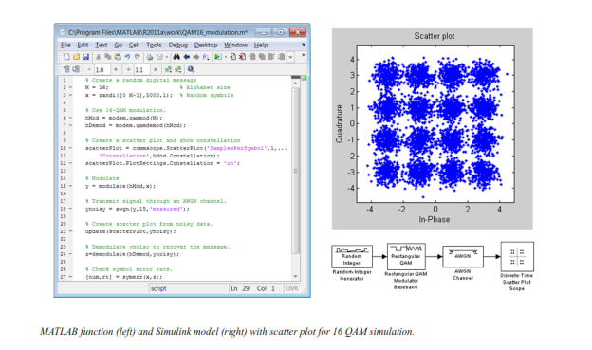**Source and Channel Coding**

Communications System Toolbox affords source and channel coding talents that can help you develop and compare communications architectures fast, enabling you to discover what-if eventualities and avoid the need to create coding competencies from scratch.

**Source Coding**

Source coding, also referred to as quantization or signal formatting, is a manner of processing facts a good way to lessen redundancy or prepare it for later processing. The system toolbox offers a diffusion of styles of algorithms for imposing source coding and interpreting, inclusive of:

▪ Quantizing

▪ Companding (*µ*-law and A-law)

▪ Differential pulse code modulation (DPCM)

▪ Huffman coding

▪ Arithmetic coding

**Channel Coding**

▪ orthogonal area-time block code (OSTBC) (encoder and decoder for MIMO channels)

▪ Turbo encoder and decoder examples

The gadget toolbox offers application functions for developing your personal channel coding. You can create generator polynomials and coefficients and syndrome deciphering tables, in addition to product parity-take a look at and generator matrices.

The system toolbox additionally presents block and convolutional interleaving and deinters leaving functions to reduce facts errors as a result of burst mistakes in a conversation machine:

**Block,** including General block interleaver, algebraic interleaver, helical scan interleaver, matrix interleaver, and random interleaver.

**Convolutional,** including General multiplexed interleaver, convolutional interleaver, and helical interleaver

**Channel Modeling and RF Impairments**

Channel Modeling

Communications System Toolbox provides algorithms and tools for modeling noise, fading, interference, and different distortions which might be commonly found in communications channels. The system toolbox supports the subsequent styles of channels:

▪ Additive white Gaussian noise (AWGN)

▪ Multiple-enter multiple-output (MIMO) fading

▪ Single-enter single-output (SISO), Rayleigh, and Rician fading

▪ Binary symmetric

A MATLAB channel object provides a concise, configurable implementation of channel models, enabling you to

specify parameters such as:

▪ Path delays

▪ Average path gains

▪ Maximum Doppler shifts

▪ K-Factor for Rician fading channels

▪ Doppler spectrum parameters

For MIMO systems, the MATLAB MIMO channel object expands these parameters to also include:

▪ Number of transmit antennas (up to 8)

▪ Number of receive antennas (up to 8)

▪ Transmit correlation matrix

▪ Receive correlation matrix

To combat the effects noise and channel corruption, the system toolbox provides block and convolutional coding and decoding techniques to implement error detection and correction. For simple error detection with no inherent correction, a cyclic redundancy check capability is also available. Channel coding capabilities provided by the system toolbox include:

▪ BCH encoder and decoder

▪ Reed-Solomon encoder and decoder

▪ LDPC encoder and decoder

▪ Convolutional encoder and Viterbi decoder

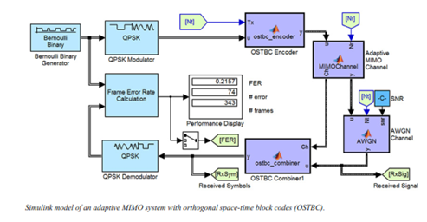

**RF Impairments**

To model the effects of a non-ideal RF front end, you can introduce the following impairments into your communications system, enabling you to explore and characterize performance with real-world effects:

▪ Memory less nonlinearity

▪ Phase and frequency offset

▪ Phase noise

▪ Thermal noise

You can include more complex RF impairments and RF circuit models in your design using SimRF™.

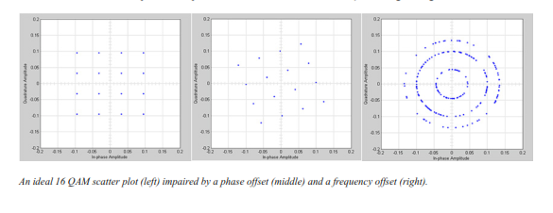

**Equalization and Synchronization**

Communications System Toolbox lets you discover equalization and synchronization strategies. These techniques are usually adaptive in nature and tough to design and symbolize. The machine toolbox affords algorithms and tools that will let you swiftly select the proper approach on your communications machine. Equalization To compare one-of-a-kind techniques to equalization, the device toolbox offers you with adaptive algorithms which include:

▪ LMS

▪ Normalized LMS

▪ Variable step LMS

▪ Signed LMS

▪ MLSE (Viterbi)

▪ RLS

▪ CMA

These adaptive equalizers are available as nonlinear decision feedback equalizer (DFE) implementations and as

Linear (symbol or fractionally spaced) equalizer implementations.

**Synchronization**

The device toolbox provides algorithms for each service segment synchronization and timing phase synchronization. For timing section synchronization, the machine toolbox presents a MATLAB Timing Phase Synchronizer object that offers the following implementation techniques:

▪ Early-late gate timing method

▪ Gardner’s method

▪ Fourth-order nonlinearity method

**Stream Processing in MATLAB and Simulink**

Most verbal exchange structures cope with streaming and frame-primarily based statistics using a aggregate of temporal processing and simultaneous multi frequency and multichannel processing. This form of streaming multidimensional processing can be visible in superior communication architectures consisting of OFDM and MIMO. Communications System Toolbox enables the simulation of advanced communications structures via helping move processing and frame-based simulation in MATLAB and Simulink. In MATLAB, circulate processing is enabled by way of System items™, which use MATLAB objects to symbolize time-based and facts-driven algorithms, sources, and sinks. System objects implicitly manipulate many information of flow processing, including information indexing, buffering, and management of set of rules state. You can mix System gadgets with fashionable MATLAB functions and operators. Most System items have a corresponding Simulink block with the identical abilities. Simulink handles circulation processing implicitly with the aid of coping with the float of information thru the blocks that make up a Simulink model. Simulink is an interactive graphical environment for modeling and simulating dynamic systems that uses hierarchical diagrams to symbolize a machine version. It includes a library of widespread-reason, predefined blocks to represent algorithms, resources, sinks, and device hierarchy.

**Implementing a Communications System**

Fixed-Point Modeling Many communications systems use hardware that requires a fixed-point representation of your design.

Communications System Toolbox supports fixed-point modeling in all relevant blocks and System objects™ with tools that help you configure fixed-point attributes.

Fixed-point support in the system toolbox includes:

▪ Word sizes from 1 to 128 bits

▪ Arbitrary binary-point placement

▪ Overflow handling methods (wrap or saturation)

▪ Rounding methods: ceiling, convergent, floor, nearest, round, simplest, and zero

Fixed-Point Tool in Simulink Fixed Point™ facilitates the conversion of floating-point data types to fixed point. For configuration of fixed-point properties, the tool tracks overflows and maxima and minima.

**Code Generation**

Once you've got advanced your set of rules or communications device, you can robotically generate C code from it for verification, rapid prototyping, and implementation. Most System gadgets, functions, and blocks in Communications System Toolbox can generate ANSI/ISO C code the use of MATLAB Coder™, Simulink Coder™, or Embedded Coder™. A subset of System gadgets and Simulink blocks also can generate HDL code. To leverage present highbrow belongings, you can choose optimizations for specific processor architectures and integrate legacy C code with the generated code.

You can also generate C code for both floating-point and fixed-point data types.

DSP Proto typing DSPs are used in communication system implementation for verification, rapid prototyping, or final hardware implementation. Using the processor-in-the-loop (PIL) simulation capability found in Embedded Coder, you can verify generated source code and compiled code by running your algorithm’s implementation code on a target processor. FPGA Prototyping

FPGAs are used in communication systems for implementing high-speed signal processing algorithms. Using the FPGA-in-the-loop (FIL) capability found in HDL Verifier™, you can test RTL code in real hardware for any existing HDL code, either manually written or automatically generated HDL code.