**Variables**

# Variables are named locations which are used to store references to the object stored in memory

**Rules**

# All identifiers must start with letter or underscore ( _ ) , you can’t use digits. For e.g. my_var is valid identifier while 1digit is not.

# Identifiers can contain letters, digits and underscores ( _ ).

# They can be of any length.

# Identifier can’t be a keyword (keywords are reserved words that Python uses for special purpose)

False class finally is return

None continue for lambda try

True def from nonlocal while

and del global not with

as elif if or yield

pass else import assert

break except in raise

# In python you don’t need to declare types of variable ahead of time. Interpreter automatically detects the type of the variable by the data it contains

a = 10

pi = 3.17

name = "Sandy"

comments are preceded by a pound sign ( # )

**python everything is object even basic data types like int, float, string,**

**Data Types**

Python has 5 standard data types namely.

a) [Numbers](http://thepythonguru.com/python-numbers/)  
b) [String](http://thepythonguru.com/python-strings/)  
c) [List](http://thepythonguru.com/python-lists/)  
d) [Tuple](http://thepythonguru.com/python-tuples/)  
e) [Dictionary](http://thepythonguru.com/python-dictionaries/)  
f)  Boolean – In Python True and False  are Boolean literals.  But the following values are also considered as false.

* 0 – zero , 0.0 ,
* [] – empty list , () – empty tuple , {} – empty dictionary ,  ”
* None

**Numbers**

1. **int** – for integer values like 45 .
2. **float** – for floating point values like 2.3 .
3. **complex** – for complex numbers like 3+2j .

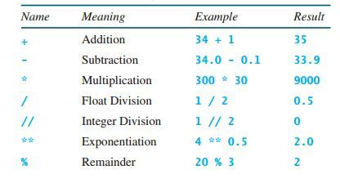

**String**

Strings in python are contiguous series of characters delimited by single or double quotes

Name =”Sandy”

String indexing, string slicing

**ord()** – function returns the ASCII code of the character.  
**chr()** – function returns character represented by a ASCII number.

String function are len(),min(),max()

String comparision - > , < , <= , <= , == , !=

Iteration using string

**List**

List type is another sequence type defined by the list class of python. List allows you add, delete or process elements in very simple ways. List is very similar to arrays.

Lists are mutable.