**Project: My Auction**

**User Manual**

Team 10

Xin Huang & Zhenzhen Yang

**Introduction**:

In this “My Auction” system, we aim to realize the functions that help the customers to put products on auction and bid these products. In addition, the administrator should have the ability to browse the statistics of products and make some changes to the system.

**User Guide:**



**Register:**

If there is a new customer, he can choose to register for our system from the beginning, since we provide him a registration option.

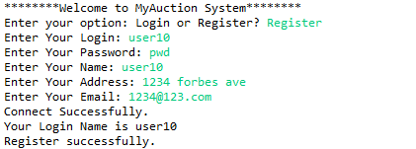

Unfortunately, if the login name he provided has already existed, he would have to change to another login name in order to make login unique for each customer.

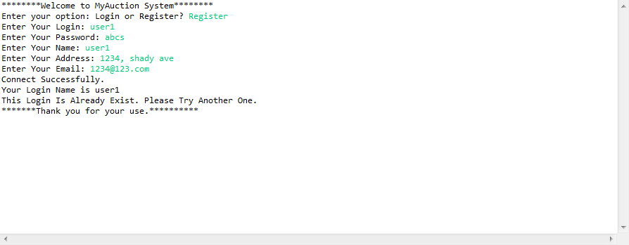

**Customer Interface:**

A registered customer could log in this system and then, a brief menu would appear. The customer chooses what he wants to run.

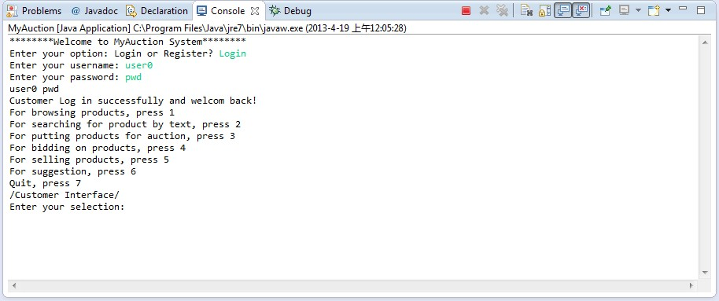

**1) Browse Products**

Press 1: the customer could browse products by their categories and then sort them in two orders, by highest bid amount or just by product name.

The following gives us an example of sorting the products by highest bid amount.

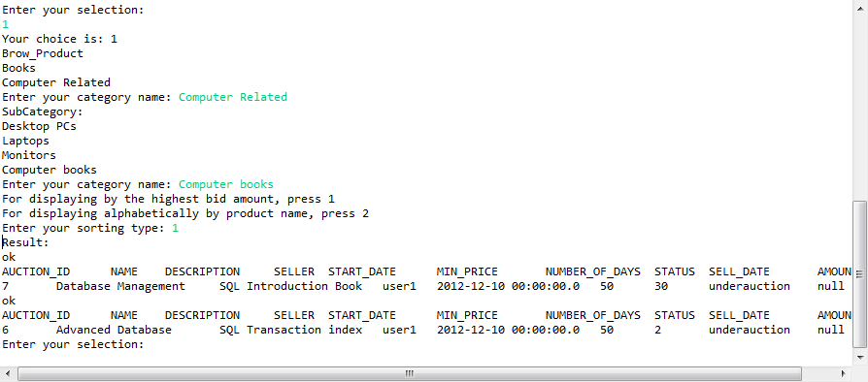

Otherwise, the customer could make the products in the order by their name, pressing 2 when choosing the sorting type.

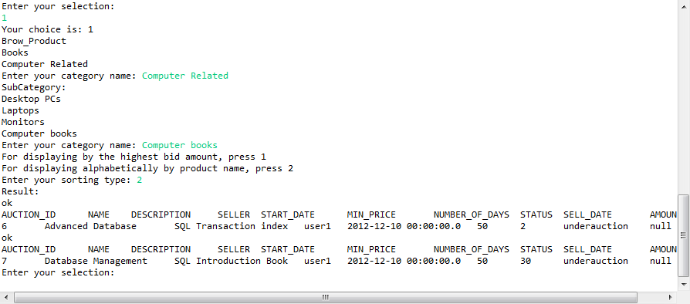

**2) Search products by text**

By pressing 2, the customer could search all the qualified products which contain up to two keywords he gives.

After that, the customer needs to provide the system with his keywords. For example, one wants to search all the products whose description contain the keyword “dell” and “notebook”. He might give us the following situation. And both uppercases and lowercases would be searched, since this function ignores whether it is upper or lower cases.

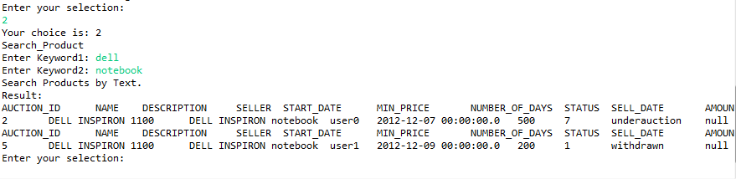

In another condition, one customer only wants to find out all the electronics products by the brand “dell”. Then he can leave the second keyword empty to inform the system that there is only one keyword he wants to search. As a result, the system would give us the following results.

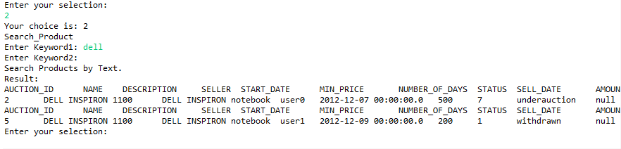

**3) Put products for auction**

Press 3: the customer can put any of his products for auction. The system will determine which customer he is from his login name and will automatically give the auction id to this product which is the total number of products plus one. It would be illustrated as below.

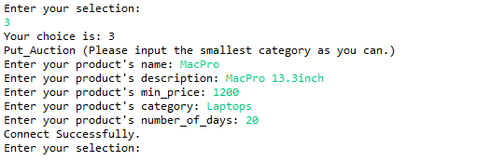

After that, we’ll have this product in our “PRODUCT” table with the status “underauction”.

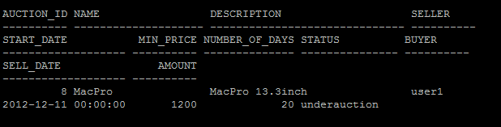

1. **Bid For Products**

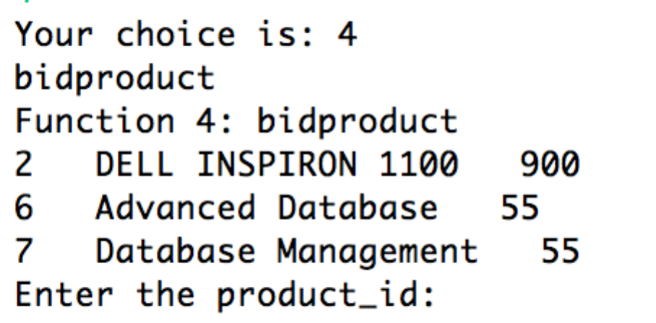Press 4: The customer who has logged in can bid for the products, which are under auction. The system firstly will display all the products that are under auction.

Then the user can enter the auction_id for above products.

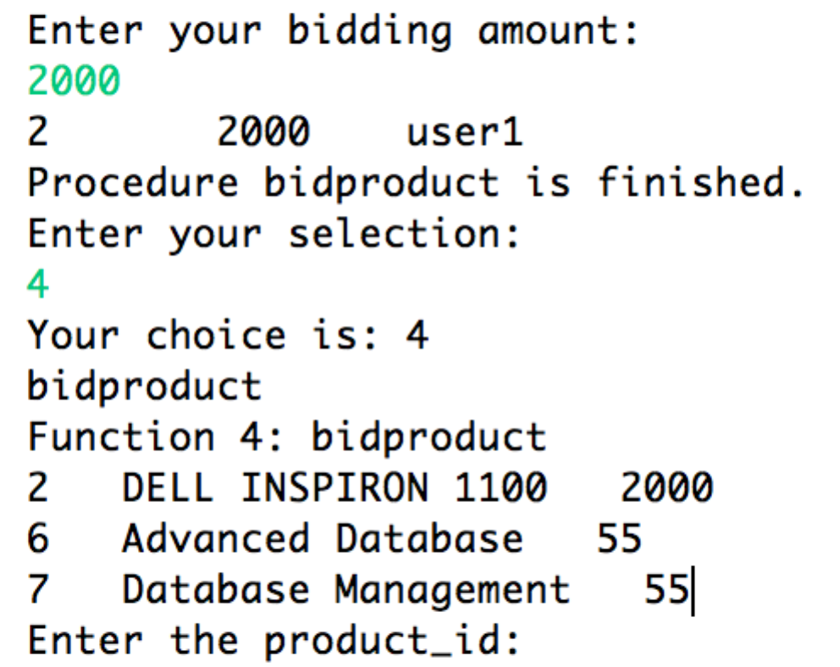

Apparently, the bidding amount for product2 is updated when the user finished his bid. Also by calling the stored procedure in Oracle, the system is able to handle two exceptions: the bidding amount is less than the current amount and the product is not under auction.

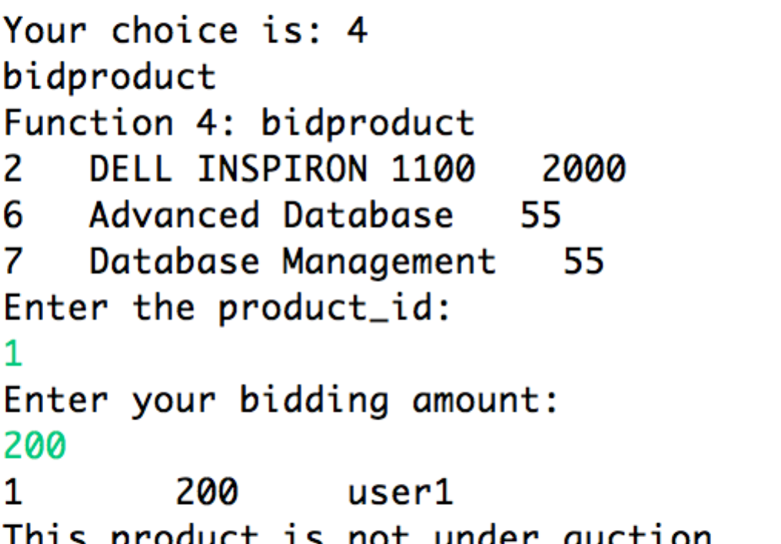

Besides, we also check the correctness of the trigger here.

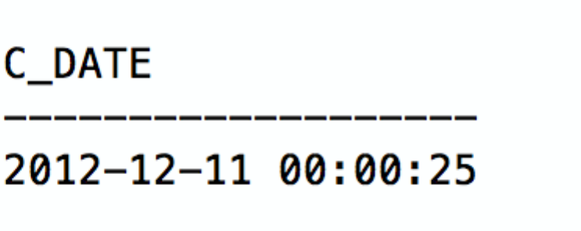

1. **Update the Status for product**

Press 5: This function allows the customer to decide to sell or withdraw his products that are under auction. Firstly, the system displays all the products under auction for this specified customer.

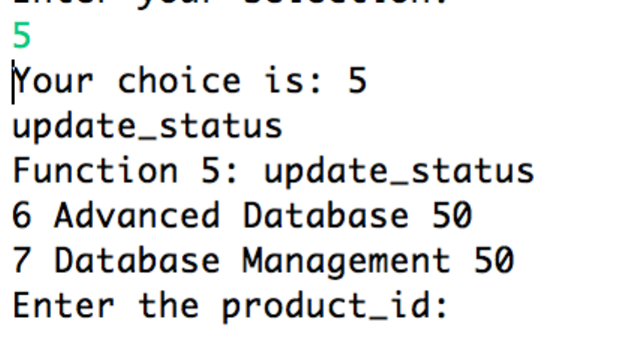 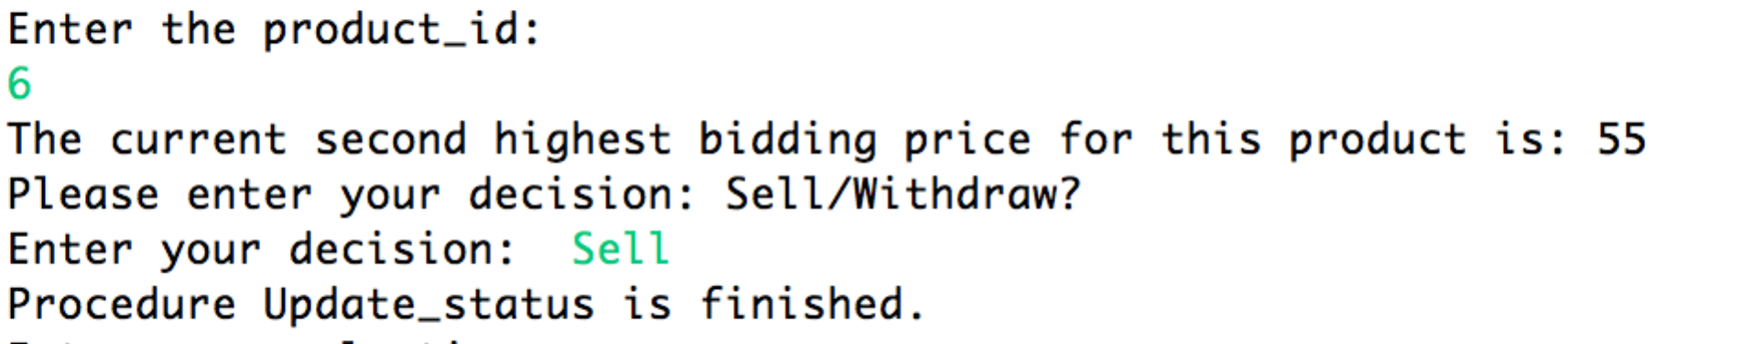

Then the user is asked to sell or withdraw his auction, after being show the second highest bidding price for this product. At last, all the functions are accomplished.

1. **Suggestion**

Press 6: The customer is able to get further helpful information for his exploring. The output lists all other popular products.

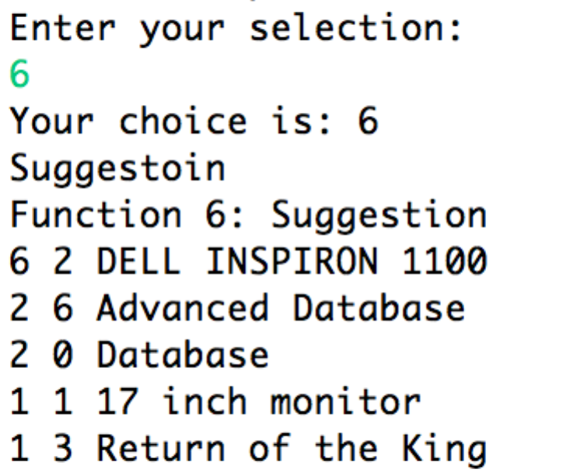

**Administrator Interface:**

The administrator of this system would use his own login name and password to enter the administrator interface. It is shown below. He will get several options to view the condition of this auction system. In addition, he has the ability to update the system date.

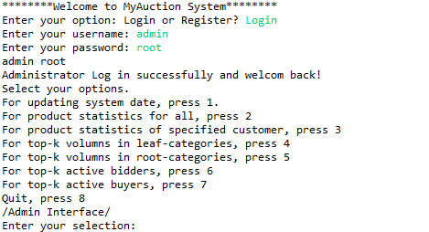

1. **Update System date**

Press 1: This function is designed for the administrator to update the time of the system manually. The date is updated successfully.

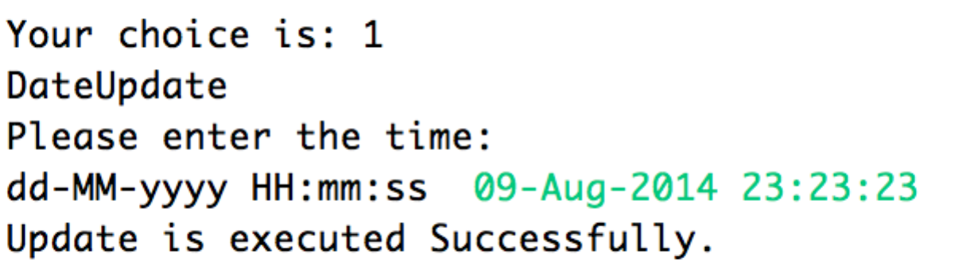. 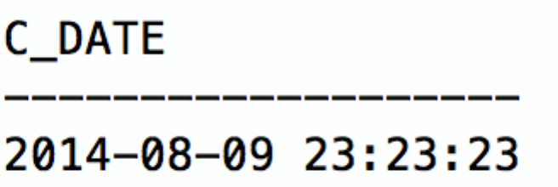

1. **Statistic information from all system users**

Press 2: The administer is able to get the statistic information from all users, including the status of all product, bidding price or the final price. ‘Null’ is to show that the product is not sold or no one has ever bided on this product.

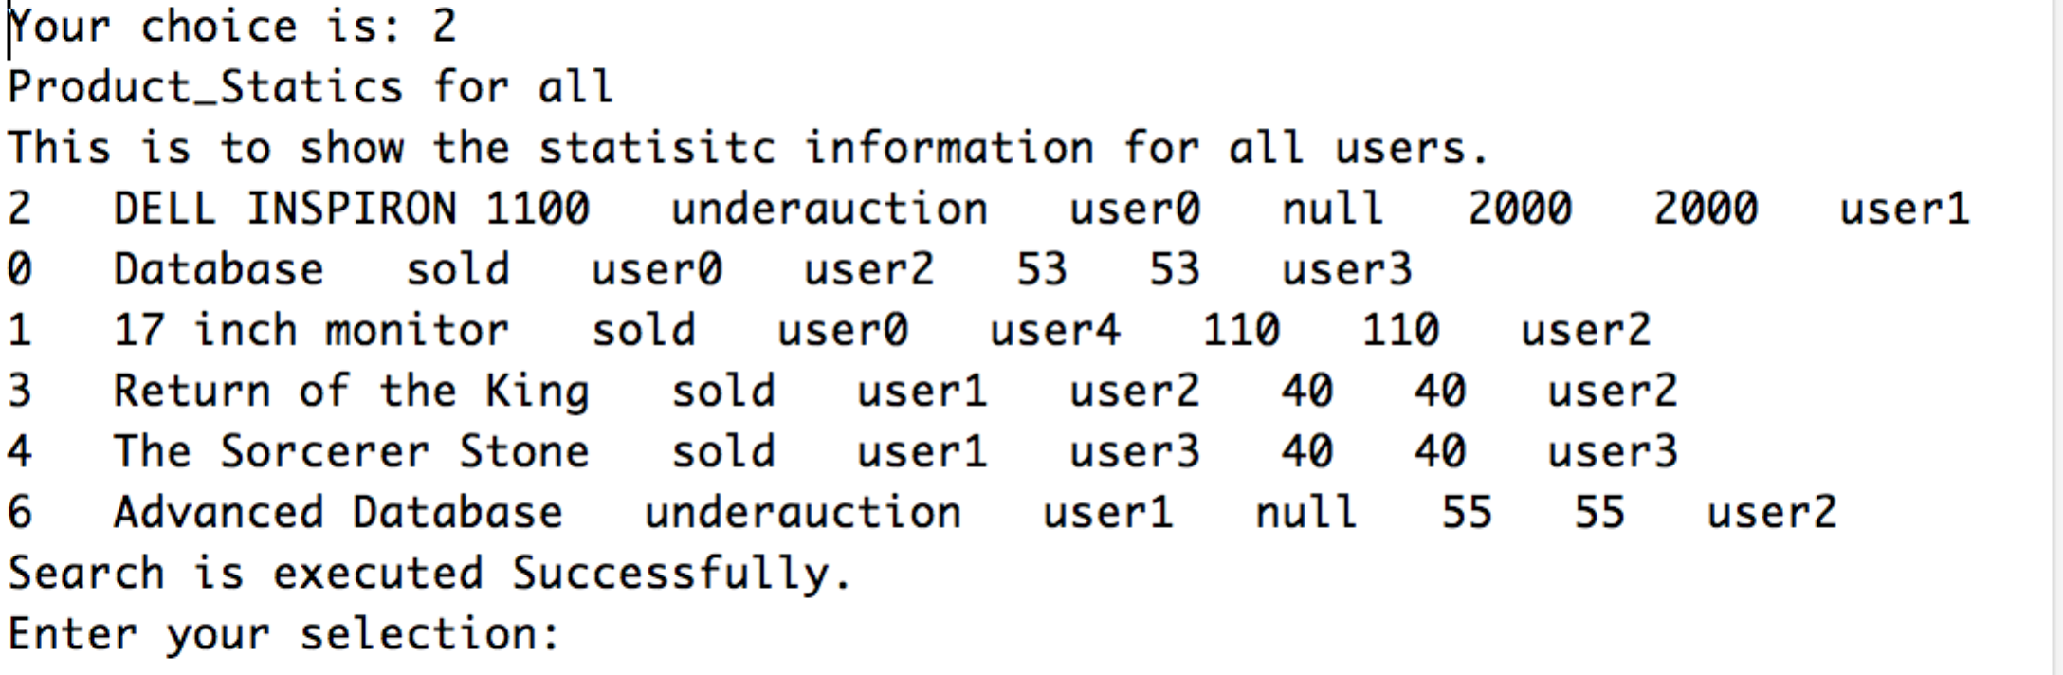

1. **Statistic information from a specific user**

Press 3: Similar to the previous function, this function is designed to explore statistic information for a specific user:

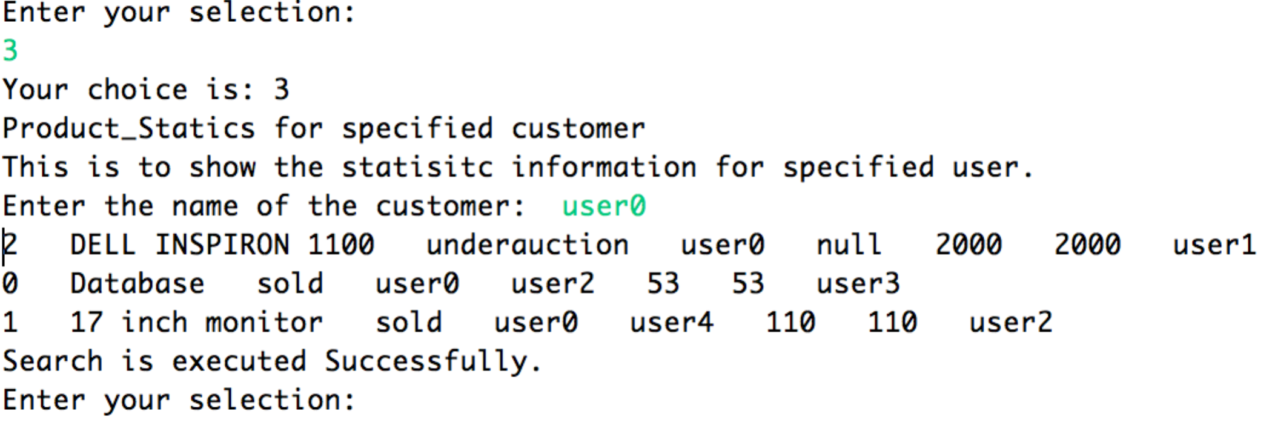

1. **Top-k highest volume in leaf-categories**

Press 4: The administrator can choose to browse the leaf-categories which have the highest volume of sold products to the lowest. He can specify the time period and number of categories for the highest volume of products.

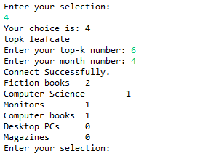

1. **Top-k highest volume in root-categories**

On the contrary to the former one, in this situation, the administrator could browse the root-categories with the highest volume of sold products. And similarly, he can choose how much to view and how long from today as the time period.

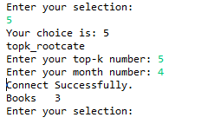

1. **Top-K active bidders**

Press 6: This function is designed to find the most top k bidder with X month. The administrator can enter the parameter k and x by himself. Here is sample-searching output:

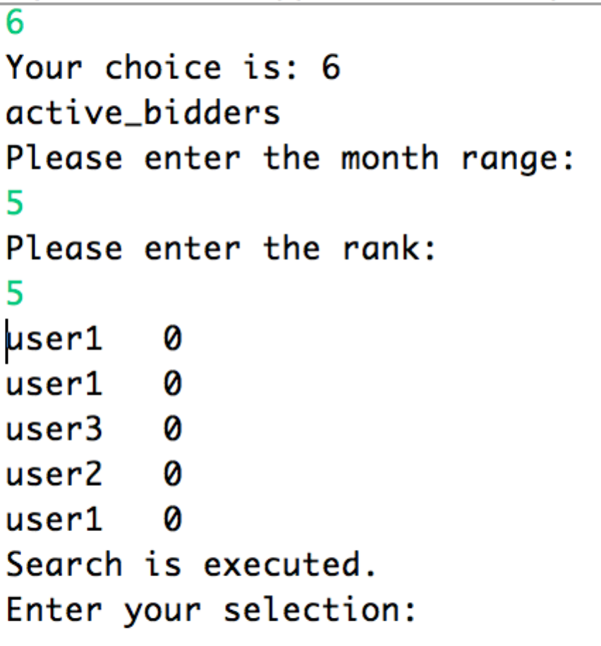

1. **Top-K active buyers**

Press 7: this function is designed to searching the most active top k buyer with in X months, which is similar to the previous function.

