Atoms, molecules, ions structure

1. Atoms structure (proton, neutron, and electron)
2. Elements(mass number, atomic number, chemical symbol, isotopes)
   1. Mass number (number of proton + neutron)
   2. Atomic number (number of proton)
   3. Chemical symbol alphabet representing the element
   4. Isotopes: atoms with same atomic number but different mass number (atoms with different number of neutrons)
3. Periodic table
   1. 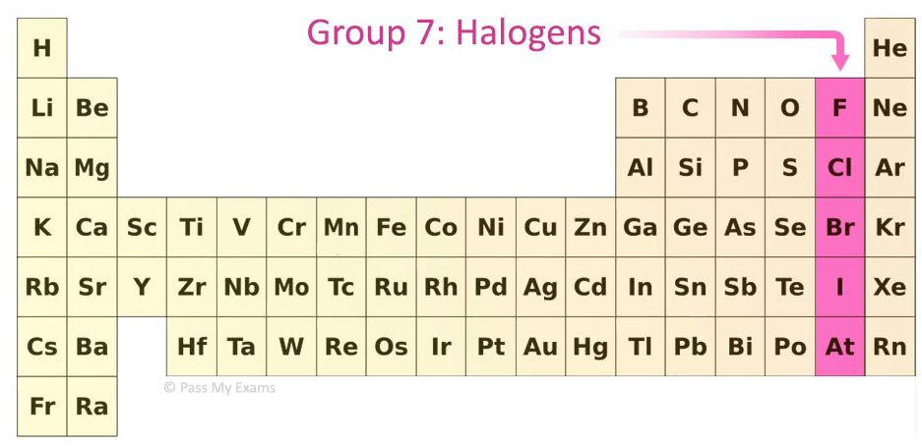
4. Na
5. Mole concept
6. Type Chemical Bonds
7. Atomic Mass Unit a.m.u = 1/12 mass of one carbon atom (1.66*10-24)
8. mole = amount of atoms ratio to 12g of carbon-12 atoms

1L = 1000cm3

1L = 0.001m3

PV=nRT (formula using what units?)

Formula using what units?

Nanometer(nm) is how much?

|  |  |
| --- | --- |
| **Deci** | **-1** |
| **Centi** | **-2** |
| **Mili** | **-3** |
| **Micro** | **-6** |
| **Nano** | **-9** |
| **Pico** | **-12** |
| **Femto** | **-15** |
|  |  |
| **Deca** | **1** |
| **Hector** | **2** |
| **Kilo** | **3** |
| **Mega** | **6** |
| **Giga** | **9** |
| **Tera** | **12** |

Questions :

<https://www.ptable.com/> USE THIS WEBSITE FOR PERIODIC TABLE

|  |
| --- |
| Which one of the following has been the most extensively tested? |
| |  |  | | --- | --- | |  | law | |  | hypothesis | |  | theory | |  |

A **scientific law** is a statement based on repeated experimental observations that describes some aspect of the universe.

A **hypothesis** is a proposed explanation for a phenomenon.

A **theory** is a contemplative and rational type of abstract or generalizing thinking, or the results of such thinking.

|  |
| --- |
| How many µg are in 0.0134 g? |
| |  |  | | --- | --- | |  | 1.34 x 10−4 | |  | 1.34 × 10−6 | |  | 1.34 | |  | 1.34 × 106 | |  | 1.34 × 104 | |  |

0.0134g -> 1.34*10-2g -> 1.34*10-2+6ug

-2+6

|  |
| --- |
| Typically, the mass of an atom of an element in grams is closest to |
| |  |  | | --- | --- | |  | 10−10. | |  | 1. | |  | 1023. | |  | 10−22. | |  | 10−32. | |  |

1 amu approx. 10^-24

|  |
| --- |
| Which of the following is a metal? |
| |  |  | | --- | --- | |  | Si | |  | Se | |  | P | |  | S | |  | Sr | |  |

Strontium, G2

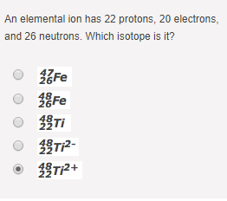

|  |
| --- |
| ________ rays are a stream of fast-moving electrons. |
| |  |  | | --- | --- | |  | Alpha | |  | Beta | |  | Gamma | |  | none of these | |  |
| Which one of the following should be the most similar in chemical properties to strontium? |
| |  |  | | --- | --- | |  | Li | |  | At | |  | Rb | |  | Ba | |  | Ga | |  |

|  |
| --- |
| Which of these acids has a name that begins with hydro-? |
| |  |  | | --- | --- | |  | HCl | |  | HClO | |  | HClO2 | |  | HClO3 | |  | HClO4 | |  |

|  |
| --- |
| Which of the following compounds is *not* a possible ionic compound? |
| |  |  | | --- | --- | |  | CsCl | |  | SrO | |  | GaF3 | |  | Cs2O | |  | NaF2 | |  |

|  |
| --- |
| A certain number of electrons has a total charge of approximately 1.1 × 10−18 C. How many electrons are there? |
| |  |  | | --- | --- | |  | 1 | |  | 2 | |  | 4 | |  | 7 | |  | 11 | |  |

One electron have 1e charge

Calculator (Constant 23) 1.1*10^-18 / e = 6.865≈7

|  |
| --- |
| How many neutrons are there in the nucleus of a 108Ag atom? |
| |  |  | | --- | --- | |  | 61 | |  | 47 | |  | 54 | |  | 108 | |  | none of these | |  |

108-47 = 61

|  |
| --- |
| Which one of the following is *incorrectly* labeled? |
| |  |  | | --- | --- | |  | Mg; alkali metal | |  | Ca; alkaline earth metal | |  | I; halogen | |  | Rn; noble gas | |  | Te; chalcogen | |  |

Te: chalcogen : G16 OR “Oxygen Family”

|  |
| --- |
| Which of the following statements is true for neutral atoms? |
| |  |  | | --- | --- | |  | It is possible for neutral atoms of different elements to have the same number of electrons. | |  | The number of neutrons in a neutral atom must always equal the number of protons. | |  | The number of neutrons in a neutral atom must always equal the number of electrons. | |  | It is possible for neutral atoms of different elements to have the same number of neutrons. | |  | It is possible for neutral atoms of different elements to have the same number of protons. | |  |

Can you try? this I am not sure.

|  |
| --- |
| An iron-56 nucleus contains |
| |  |  | | --- | --- | |  | 56 protons. | |  | 56 neutrons. | |  | 26 protons and 26 neutrons. | |  | 56 protons and 56 neutrons. | |  | 26 protons and 30 neutrons. | |  |

Fe 26 proton

|  |
| --- |
| Which one of the following is *incorrectly* labeled? |
| |  |  | | --- | --- | |  | Ne; noble gas | |  | Cu; transition metal | |  | Zn; transition metal | |  | Ga; transition metal | |  | Cl; halogen | |  |

|  |
| --- |
| Which of the following is a metal? Zn; F; S; I; Se |
| |  |  | | --- | --- | |  | Zn | |  | F | |  | S | |  | I | |  | Se | |  |

|  |
| --- |
| What is the energy in joules of an electron undergoing a transition from *n* = 3 to *n* = 5 in a Bohr hydrogen atom? |
| |  |  | | --- | --- | |  | -2.56 x 10-19 J | |  | 1.55 x 10-19 J | |  | 2.18 x 10-19 J | |  | -3.48 x 10-17 J | |  |

|  |
| --- |
| Of the following regions of the electromagnetic spectrum, which one has the shortest wavelength? |
| |  |  | | --- | --- | |  | X rays | |  | ultraviolet | |  | microwaves | |  | radio waves | |  | infrared | |  | gamma rays | |  |

|  |
| --- |
| How many photons of frequency 1.50 x 1014 s-1 are needed to give 30.1 J of energy? |
| |  |  | | --- | --- | |  | 9.94 x 1020 photons | |  | 1.01 x 1019photons | |  | 3.03 x 1020 photons | |  | 9.94 x 10-20 photons | |  | 0.450 photons | |  |

VERY DIFFICULT

One photons of frequency f ,E = hf = (6.626 * 10-34 *1.50*1014 ) = 9.939*10-20

30.1/E = ANSWER C

|  |
| --- |
| In the Bohr theory, which of the following emissions will have the largest energy? |
| |  |  | | --- | --- | |  | *n* = 5 going to *n* = 4 | |  | *n* = 3 going to *n* = 2 | |  | *n* = 4 going to *n* = 2 | |  | *n* = 2 going to *n* = 3 | |  | *n* = 4 going to *n* = 3 | |  |

|  |
| --- |
| The Heisenberg uncertainty principle states that it is impossible to precisely know both the position and the ___________ of an electron in an atom. |
| |  |  | | --- | --- | |  | shape | |  | mass | |  | momentum | |  | color | |  |

|  |
| --- |
| Write the electron configuration for the atom Zn, abbreviating with the appropriate noble-gas inner core. |
| |  |  | | --- | --- | |  | [Ar]4*s*24*d*10 | |  | [Ar]4*s*23*d*10 | |  | [Kr]4*s*23*d*10 | |  | [Ar]4*s*13*d*10 | |  | [Kr]4*s*24*d*10 | |  |

MUST DO IT YOURSELF IF FEELS DIFFERENT WHEN TRYING TO CHANGE TO nobel-gass inner core.

|  |
| --- |
| Which subshell is highlighted in the periodic table below? |
| |  |  | | --- | --- | |  | 5*d* | |  | 5*p* | |  | 4*p* | |  | 5*s* | |  |

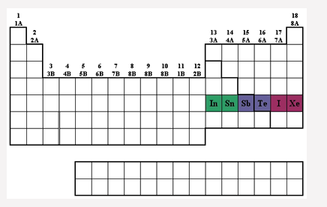

|  |
| --- |
| Which of the following particles traveling at 1.00 x 104 m/s has the largest de Broglie wavelength? |
| |  |  | | --- | --- | |  | neutron | |  | electron | |  | helium nucleus () | |  | proton | |  |

|  |
| --- |
| What is the wavelength of radiation that has a frequency of 5.11 x 1011 s-1? |
| |  |  | | --- | --- | |  | 5.87 x 10-4 cm | |  | 5.87 x 10-2 m | |  | 5.87 x 10-12 m | |  | 5.87 x 10-4 m | |  |

|  |
| --- |
| The de Broglie wavelength of an electron is 8.7 x 10-11 m. The mass of this electron is 9.1 x 10-31kg. What is the velocity in m/s of this electron (*h* = 6.63 x 10-34 J·s)? |
| |  |  | | --- | --- | |  | 7.3 x 10-4 m/s | |  | 8.4 x 106 m/s | |  | 1.2 x 10-7 m/s | |  | 6.9 x 10-54 m/s | |  |

|  |
| --- |
| Which one of the following elements has one or more unpaired electrons in the ground state? |
| |  |  | | --- | --- | |  | zirconium | |  | cadmium | |  | mercury | |  | neon | |  | calcium | |  |

Very good question. (tip usually elements at the spdf-block ends is fully filled)

|  |
| --- |
| What is the relationship between the number of nodes in an *s* orbital and the principal quantum number? |
| |  |  | | --- | --- | |  | The number of nodes equals the principal quantum number plus 1. | |  | The number of nodes equals the square of the principal quantum number. | |  | The number of nodes equals the principal quantum number. | |  | The number of nodes equals the principal quantum number minus 1. | |  |

A **node** is a point where the electron probability is zero.

|  |
| --- |
| In which choice below are the elements ranked in order of *increasing* first-ionization energy? |
| |  |  | | --- | --- | |  | Ar, Cl, S, Si, Al | |  | Al, Si, S, Cl, Ar | |  | Cl, S, Al, Ar, Si | |  | Al, S, Si, Cl, Ar | |  |

**Thermochemistry**

**Energy**

**Work and heat**

**Enthalpy**

**Standard enthalpies of reactions and formations**

**Energy**

1. Ability to do work or transfer heat.
2. **Work(W)**: Energy to cause and object to move.
3. $W=F∙d$ (J OR Nm(NewtonMeter) )
4. **Heat(q):** Energy used to cause the temperature to rise.
5. **Potential Energy (U):** position or chemical composition.
6. **Kinetic Energy(K)**: motion.
7. **SI unit = J, nonSI (cal,kWh)**

**First Law of Thermodynamics**

1. Energy can neither be created nor desteroyed
2. Total energy of universe is **CONSTANT**, energy is conserved.

Chemical kinetics

1. Rate of chemical reaction
2. Reaction mechanism

Factors Sufficient energy, Come in contact (collide)

1. Physical states (homogeneous?)
2. Contact Area ^ , collision ^
3. Concentration ^ , collision ^
4. Temperature ^ , speed(energy) ^ , collision ^
5. Catalyst ^, Energy v

Reaction Rates

1. d(concentration) / d(time)
2. always positive that’s why reactant’s rate’s is –d[reactants]/d[time]
3. rate will change as it progresses
4. slope to the tangent of [concentration] against time
5. using initial rate to compare

$rate=-\frac{1}{a}\frac{∆Reactant 1}{∆t} OR rate=\frac{1}{b}\frac{∆Product 1}{∆t} , FOR aREACTANT1→b PRODUCT 1$

Rate Law

$rate=k {[Reactant 1]}^{m}{[Reactant 2]}^{n}$

1. m and n is determined experimentally
2. k is rate constant, depend on temperature
   1. first-Order = s-1
   2. second-Order = M-1s-1
3. Concentration can always be replaced by pressure
4. First Order :
$rate=k {[Reactant]}^{1}$

$\ln{\frac{{\left[A\right]}_{t}}{{\left[A\right]}_{0}}}=-kt$

$\text{ln}{{\left[\text{A}\right]}_{\text{t}}}is proportional to \text{t}, they will draw a straight line$

5. Second Order :
$rate=k {[Reactant]}^{2} OR k {[Reactant1]}^{1}{[Reactant2]}^{1}$

$\frac{1}{{[Reactant]}_{instantaneous}}=\frac{1}{{[Reactant]}_{initial}}+tk$

$\frac{1}{{[Reactant]}_{instantaneous}} is proportional to t, they will draw a straight line$

6. Zero Order
   1. no dependence on concentration
$rate=k$

${[Reactant]}_{instantaneous}={[Reactant]}_{initial}+kt$

7. Half life
   1. Time required to get to half concentration, $t_{1/2}$
   2. First-order : $t_{1/2}= \frac{ln 2}{k}$, not dependent to concentration
   3. Second-order : $t_{1/2}=\frac{1}{k{[Reactant]}_{initial}}$ dependent to concentration
8. Using $t_{1/2}$ to determine k draw a line half the [concentration] then use the time lapsed is half-life
9. Carbon dating
   1. Estimate the age
   2. [ $14C]$ is the indicator for half-life Living organism have a fixed number of 14C but when dead 14C leaks out but not in therefore we can compare to the initial amount of 14C
10. Arrhenius Equation
 $k=Ae^{-\frac{E_{a}}{RT}}$

 $A frequency factor , E_{a} activation energy$

 $\ln{k} vs \frac{1}{T} straight line$

 1. A , frequency factor
       1. Frequency of collision, (physical states)
       2. Probability of effective collision, (nature of reaction)
       3. PROPER ORIENTATION & SUFFICIENT ENERGY 🡺 REACTION!!!!
 $E_{a} activation energy$

      4. Minimum energy required
       5. (catalyst)
       6. Overcome 🡺 REACTION!!!!
       7. Measure from reactant height to highest
11. Catalyst?
    1. ↓ $E_{a}$ ↑REACTION!!!!
    2. Changing pathway/mechanism (more step or few step)
    3. Enzyme is a catalyst
    4. Doesn’t perma change chemically/ physically
 $2H_{2}{\left(g\right)+O}_{2}(g)\underset{→}{Pd(s)}H_{2}O$

   5. Air-pollutants (CO,NO,CxHY) oxidation (speed up!)

CHEMICAL EQUILIBRIUM

Study of the end of reaction! Forward / backward reaction is the same(very little reaction)(not every reaction!!!)

Rate of DECOMPOSITION (forward) = Rate of Combination (backward)

N2O4↔2 NO2

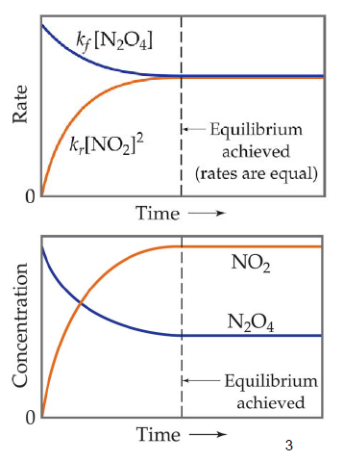 Reactant -> Product , but Product -> Reactant at the same time.

Therefore [Reactant], [Product] is the constant.

Since,

$$k_{f}\left[N_{2}O_{4}\right]=k_{r}{\left[NO_{2}\right]}^{2} \\ \frac{k_{f}}{k_{r}}=\frac{{[{NO}_{2}]}^{2}}{[N_{2}O_{4}]}$$

By rearranging you will get a ratio, we will call it as K which is a constant.

For reaction

$$aA+bB→cC+dD \\ K=\frac{[product]}{[reactant]}=\frac{{[C]}^{c}{[D]}^{d}}{{[A]}^{a}{[B]}^{b}}$$

P can also be used. If reactant is gas

$$K_{P}=\frac{[product]}{[reactant]}=\frac{{[P_{c}]}^{c}{[P_{D}]}^{d}}{{[P_{A}]}^{a}{[P_{B}]}^{b}}$$

Also Kp and Kc can be relate with (RT) Product coefficient – Reactant coefficient

$$K_{P}=K_{C}{(RT)}^{c+d-(a+b)}$$

K>1 favored [product] > [reactant]

K<1 not favored [product] < [reactant]

For multiple steps reactions…

$$K^{1+2}=K^{1}*K^{2}$$

Pure solids, liquids (H­­2O) should not be in equation. HOMOGENOUS: SAME PHASE, HETEROGENEOUS: DIFF PHASE

Le Chartelier

If Concentration product ^, concentration reactant ^ (more backward) vice versa

If pressure ^, try to reduce by going towards more compact amount of compound reduce number of molecule

If temperature ^, try to go to endothermic reaction (more colder) vice versa

If volume ^, pressure v try to go to more number of molecule.

Catalyst only speed up equilibrium doesn’t change equilibrium.