**Documentation**

Software

Python Version: Python 3.5 or higher version

Packages

import glob

import datetime

import math

import pandas as pd

import numpy as np

import lightgbm as lgb

from sklearn.metrics import accuracy_score, roc_curve, auc, confusion_matrix, accuracy_score

from sklearn.utils import class_weight

from keras import Sequential

from keras.layers import Dense, LSTM

from keras.preprocessing.sequence import pad_sequences

import matplotlib

import matplotlib.pyplot as plt

How to run

Provide paths on main.py file

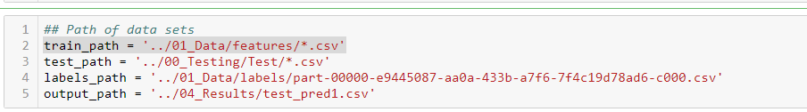

Project Organization

* 01_Data
  + Train Data
  + Validation Data
  + Test Data
* 02_Code
  + 01_EDA
  + 02_Feature_Engineering_CV_Folds_Hyper_Parameter_Tunning
  + 06_Visualization
  + Feature_engineering
  + main
* 04_Results
  + test_pred1