Lecture 8: Rmarkdown - a tool for reporting results from R

Yanfei Kang

16 Apr, 2017

# Packages required in this lecture

install.packages(c("rmarkdown", "forecast"))

# Why R markdown?

* Much **easier** *syntax* ~~syntax~~ than LaTex or Html
* Dynamic: easy to update and work with the R codes
* Multiple output formats
* Makes presentation easy
* Keep me organized of weekly research progress reports

# Header 1

## Header 2

# Creation of lists

## unordered

* Item 1
* Item 2

## ordered

1. Item 1
2. Item 2
   * item 2a
   * item 2b

# Inline codes

Write inline **R** code using backtick quotes: forecast()

# Blockqotes

It's always better to give than to receive.

# Equations

* $x+y=z$ for inline equations

$$x+y=z$$

# Hyperlink

[R markdown tutorial](http://rmarkdown.rstudio.com)

# R code chunks with plot

See Hyndman and Athanasopoulos (2014).

library(forecast)  
plot(stlf(AirPassengers, lambda=0))

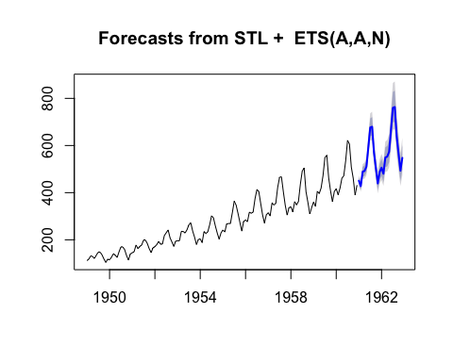

# R code chunks with table

knitr::kable(head(iris))

|  |  |  |  |  |
| --- | --- | --- | --- | --- |
| Sepal.Length | Sepal.Width | Petal.Length | Petal.Width | Species |
| 5.1 | 3.5 | 1.4 | 0.2 | setosa |
| 4.9 | 3.0 | 1.4 | 0.2 | setosa |
| 4.7 | 3.2 | 1.3 | 0.2 | setosa |
| 4.6 | 3.1 | 1.5 | 0.2 | setosa |
| 5.0 | 3.6 | 1.4 | 0.2 | setosa |
| 5.4 | 3.9 | 1.7 | 0.4 | setosa |

# Plain code block

library(forecast)  
plot(stlf(AirPassengers, lambda=0))

# 关于期末大报告

1. 准备两个文件，*.R和*.pdf。
2. 将*.pdf文件打印上交纸质版。请课代表于2017年6月5日中午12点前一起交到A935。
3. 同时，邮箱上交两个文件电子版，截止日期为2017年6月5日。

# References

Hyndman, Rob J, and George Athanasopoulos. 2014. *Forecasting: Principles and Practice*. OTexts.