**Phase 1:** [**Blue Iguanodon**](https://myelms.umd.edu/courses/1223780/assignments/4367814)

Collaborated with Agent Phoenix

The dataset shared for the assignment consists of multiple folders and html files which is related to some unexpected activities concerning wildlife law enforcement, endangered species issues, and ecoterrorism. The goal of the assignment is to identify the threat and also share evidence regarding the same by analyzing the documents manually and using visualization tools.

**Threat 1:**

The first threat identified is related to the endangered species issue where Cesar Gil, an animal lover and biologist is infecting chinchillas with monkeypox which in turn infects the individuals owning chinchillas as pets. The motive behind infecting humans with this infection was to stop people from owning chinchillas as pets. This threat is identified from the html files in the Blogs folder that consists of blogs dated from May 2003 to July 2004.

**Evidence:**

1. The word tree in Jigsaw for the word chinchillas reveals that the Chinchillas are rodents native to the Andes in Chile.
2. It also mentions how people are willing to spend a lot of money to look cool or following the latest fashion and is the wrong reason to get any kind of animal.
3. The blogs consists of evidence regarding poaching of chinchillas in Chile and Chapman trying to save chinchillas from extinction by moving them to North America.
4. In the blog “Chinsurrection” written by Cesar Gil, it is mentioned how owning a chinchilla became the new fad especially in Los Angeles.
5. Cesar Gil is a chinchilla farmer and is supposedly infecting the rodents to be adopted as pets with monkeypox.
6. One of the comics in the blogs shows the kid in the family owning the pet getting infected with monkeypox.
7. The comics also has a column where it is mentioned that people in LA have been infected with the rare monkeypox disease and are blaming chinchillas for the same. It also shows that the chinchillas are now free and not being owned by pet owners.

**Photos:**

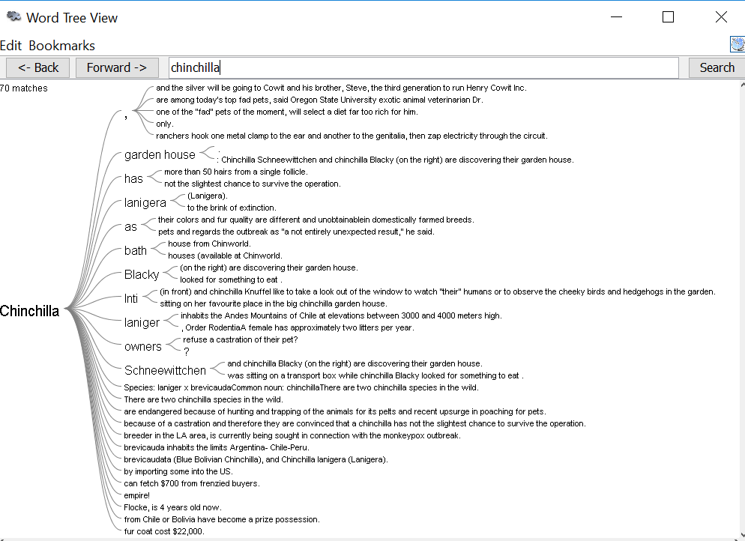

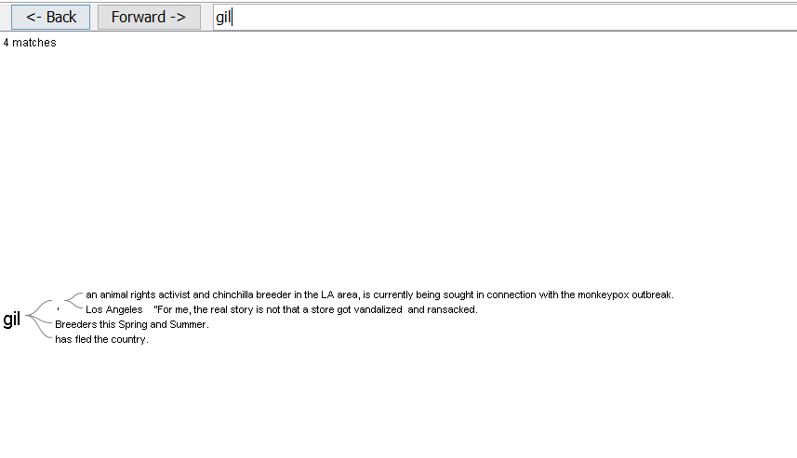

**Threat 2:**

The second threat identified is related to ecoterrorism where liquid cocaine is being smuggled from South America to North America via Florida. The cocaine is being smuggled in the packages used for shipping fish between the countries.

**Evidence:**

1. The word tree for the word catfish reveals that the fish is being shipped into the United states by the shipping company named “Fish and Wildlife Service”(FWS).
2. The Fish trade file confirms that fish packages are being imported into United States from South America.
3. It also mentions that the packaging bags may be contaminated with a substance that can cause serious illness.
4. The word tree for the word symptoms mentions symptoms and the reactions in the individuals handling the fish packages.
5. On reading the documents in the MSDS folder that describes various chemicals and their side effects, it is observed that it is the same as the reaction noticed in package handlers.
6. Hence, it can be concluded that the packages contain the same chemical substances which are byproducts of liquid cocaine being smuggled from South America.

**Photos:**

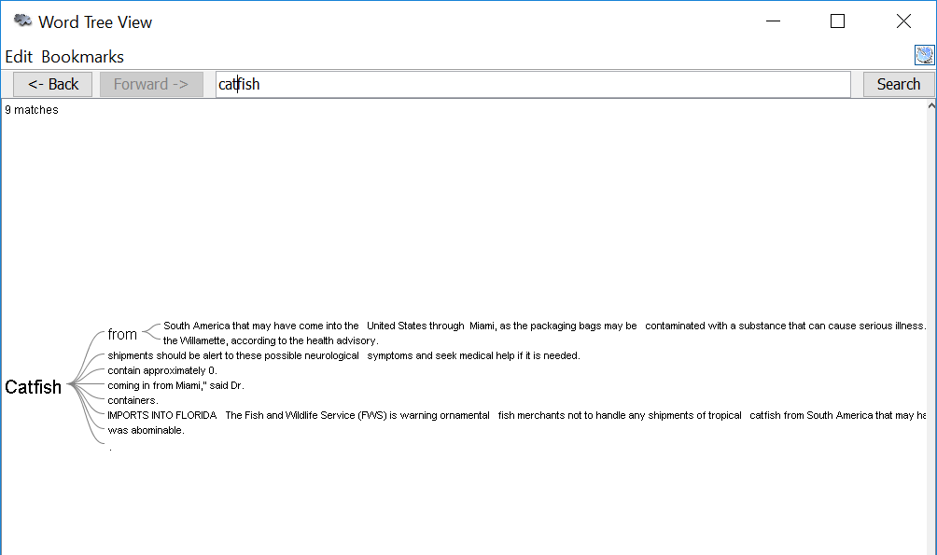

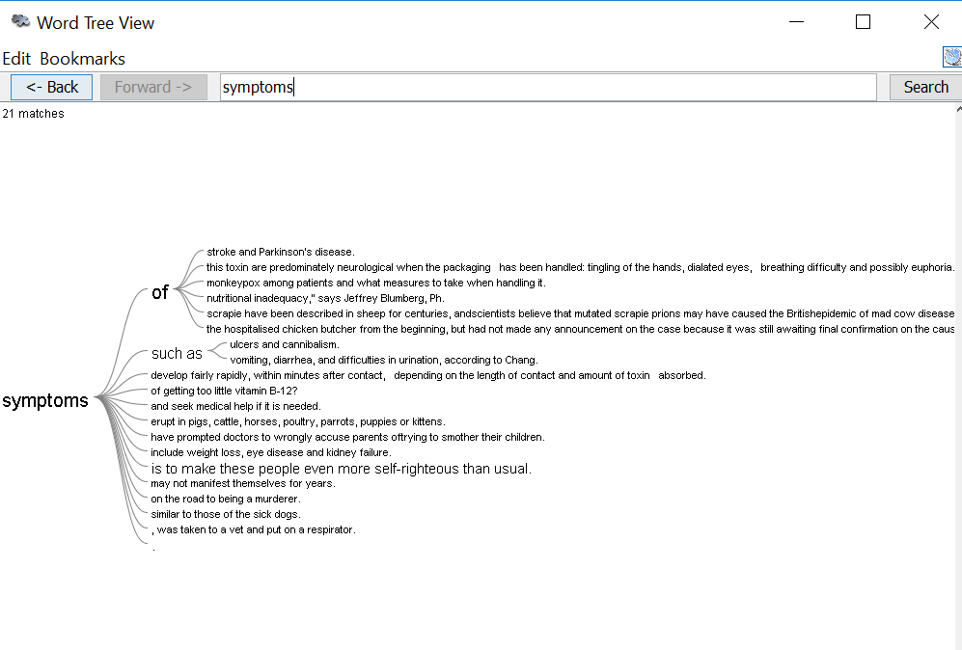

**Threat 3:**

There are multiple evidences in the data set which point towards the import and export of animals from countries like Zimbabwe and Namibia in Africa.

**Evidence:**

1. The Databases subfolder in the data set contains an excel spreadsheet listing export of animals from various countries within Africa to all countries in the world.
2. Also, one of the blog posts on the blog Chinchilla dreamin talks about a raid on a house in Northern England where hundreds of exotic animals were found.

**Method:**

1. We manually analyzed the blogs and noted things down in a chronological sequence.
2. We then generated word trees for the key words found while analyzing the case using Jigsaw.
3. This led us to the first threat which involved extinction of chinchillas and infecting chinchillas with monkeypox.
4. Manually analyzing the fish trade file gave us gist of the import of fish packages into the US from South America.
5. On specifically looking into catfish in jigsaw, we identified that there were issues with the packaging that was causing serious illness in individuals handling packages.
6. On comparing the reactions with the symptoms mentioned in the files for specific chemicals, we concluded that smuggling of cocaine was causing the issue and was the second threat in the assignment.
7. Similarly, by manually analyzing and then analyzing specific words in Jigsaw we concluded that trade of animals between countries was the third and threat with smaller significance.