MCP Verification Is the New Gold in the AI Coding Era
Code is cheap, verification is gold: proper MCP use in Python.
Most AI projects fail, and most teams build agents the same way: as black boxes that nobody can open. When an agent gives a wrong answer at 2 a.m., your engineers guess, and your customers find the bugs. Picture THREADS instead of ASYNCIO: your engineer pauses the agent, asks it a question and sees the answer in seconds. Each step is checked before it reaches a customer. If your team cannot do this today, you are already in the majority that fails. Act now: this article shows how, with tested Python code.

With threads, you can stop on a breakpoint, examine, test, verify and fix. With the usual asyncio code, the MCP session fails.
Welcome to the era of vibe coding: you describe what you want, and AI writes the code. AI tools write hundreds of lines of Python in seconds. Writing code is no longer the difficult part. The difficult part is to know that the code works correctly.
What you feel is not a good guide. In METR’s randomized trial, experienced developers used early-2025 AI tools. They needed 19% more time, but they thought that they were 20% faster. In a Stanford study, developers with an AI assistant “wrote significantly less secure code”. But they were “more likely to believe they wrote secure code”.
A demo that works is not proof of reliability. The most dangerous bugs are not the bugs that are difficult to fix. They are the bugs that you do not know about. Thus, this article uses one axiom: unverified code is presumed defective.
Verification is not optional any more. It is the price that you pay to stay in the game. Your client must not be your first real tester. Unverified MCP code is a failure that has not occurred yet.
Many teams now connect AI agents to MCP servers. Most teams use the same method. They copy the official quickstart and write each function with async def. They start the program with asyncio.run(main()). The demo works, and the sprint closes.
Then the agent goes to production. One day it gives an incorrect answer, and nobody can say why. The bug was in the code from the first day. Nobody saw it, because the code did not let anybody stop and test each step by hand.
This story is common. A RAND report cites estimates that “more than 80 percent of AI projects fail”. That is twice the failure rate of IT projects without AI. For AI agents, Gartner predicts that over 40% of projects will be canceled by the end of 2027. One of its reasons is “inadequate risk controls”. A team that cannot verify its agent cannot control its risk.
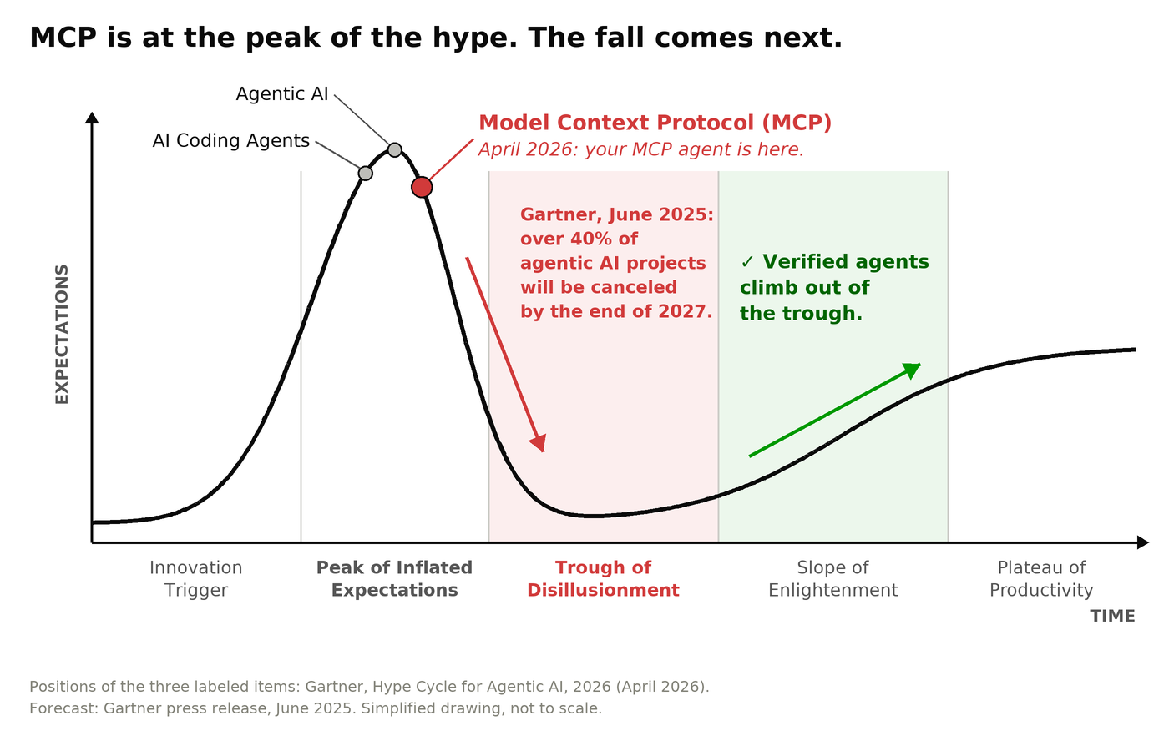
Gartner’s Hype Cycle for Agentic AI, 2026, puts MCP at the Peak of Inflated Expectations. The Trough of Disillusionment comes next. Step-by-step verification helps your agent through it.
The full report, Hype Cycle for Agentic AI, 2026, is free after you register, as a Gartner reprint. The report puts MCP in its “At the Peak” section. It rates the benefit of MCP as high, but only 1% to 5% of its target audience uses it. The newest Gartner Hype Cycle for Artificial Intelligence “puts control ahead of capability”. Gartner says that organizations adopt AI agents faster than they develop controls for them. Step-by-step verification is one of these controls.
In June 2025, Gartner gave its warning: over 40% of agentic AI projects will be canceled by 2027. Ten months later, its Hype Cycle puts agentic AI and MCP at the peak of the hype. The warning is still valid, and the deadline is now close. You and your manager are now warned: if you keep the same strategy, the failure is not bad luck. It is a willful failure. Start to verify each step of your agent today.
So ask yourself one question: can you step through this code?
To step through code, you stop the program on a line. Then you run it one line at a time. In VS Code, you set a breakpoint and press F10 to go to the next line. At each line, you can examine each value.
Here is the full test. Set a breakpoint on a line of your agent. Press F10 to step over a tool call. Examine the result. Then, while the program is still stopped, send one more question to the MCP server. With this question, you test your assumption.
With the usual async code, you cannot do the last step. This article shows why. It also shows how to fix the problem.
This article does not show how to call a tool. Any AI assistant can write that code. It is also not a fight of threads against asyncio. The real question is this: does your design make verification practical and repeatable? This article gives evidence, clear terms, the problem, the fix and measurements.
In short:
- Debugging starts after a failure. Professional engineers verify the code before a failure occurs. They step through the code and examine each value. This is possible only when the code is observable.
- The usual async MCP code makes this verification difficult. async spreads to every function. Code snippets do not work in all places. And a stopped Debug Console cannot send requests to the MCP server.
- The fix is small. One background thread owns asyncio and the MCP session. All your other code is plain Python with threads. For an agent, the speed stays almost the same, and you can examine every line.
You cannot fix a bug that you do not know about. Step-by-step verification finds these bugs before they cause a failure.

Terms in this article
If you are new to MCP or to async Python, read these short definitions first:
- MCP (Model Context Protocol): a standard protocol that lets an AI agent use tools.
- MCP server: a program that gives tools to an agent. For example, GitHub’s MCP server has tools that read repositories and releases.
- Tool call: one request from your agent to an MCP server. For example: “get the latest release of this repository”.
- Thread: one path of execution in a program. A program can run many threads at the same time.
- asyncio: the Python library for async code (async def and await). It runs many tasks on one thread.
- Event loop: the part of asyncio that runs the tasks. If the event loop stops, no async task can continue.
- Breakpoint: a mark on a line of code. The debugger stops the program when the program gets to this line.
- Debug Console: the VS Code panel where you type Python code while the program is stopped.
- debugpy: the Python debugger that VS Code uses.
- Step-by-step verification: you stop the program at a breakpoint. You examine each value, check the result by hand and test more cases. Then you go to the next line.

Code is easy to write and difficult to understand
“Everyone knows that debugging is twice as hard as writing a program in the first place. So if you’re as clever as you can be when you write it, how will you ever debug it?” (Brian Kernighan)
This rule is Kernighan’s law. It is older than all the frameworks that you use, and today it is more important than before. AI tools make code almost free to write. But it is still expensive to understand code.
The numbers show this cost. In Stripe’s Developer Coefficient report, the average developer spends “more than 17 hours a week dealing with maintenance issues, such as debugging and refactoring.” CISQ calculated that poor software quality cost the US at least $2.41 trillion in 2022.
Companies do not pay us to write code. They pay us for justified confidence that the code works correctly. All of this article comes from this idea.

Unverified code is presumed defective
The word “presumed” is important. It does not say that each unverified line has a bug. It says who must give the proof: the code, not the user who finds the failure. Code that runs is not proof of correctness. AI-generated code that looks correct is not proof either.
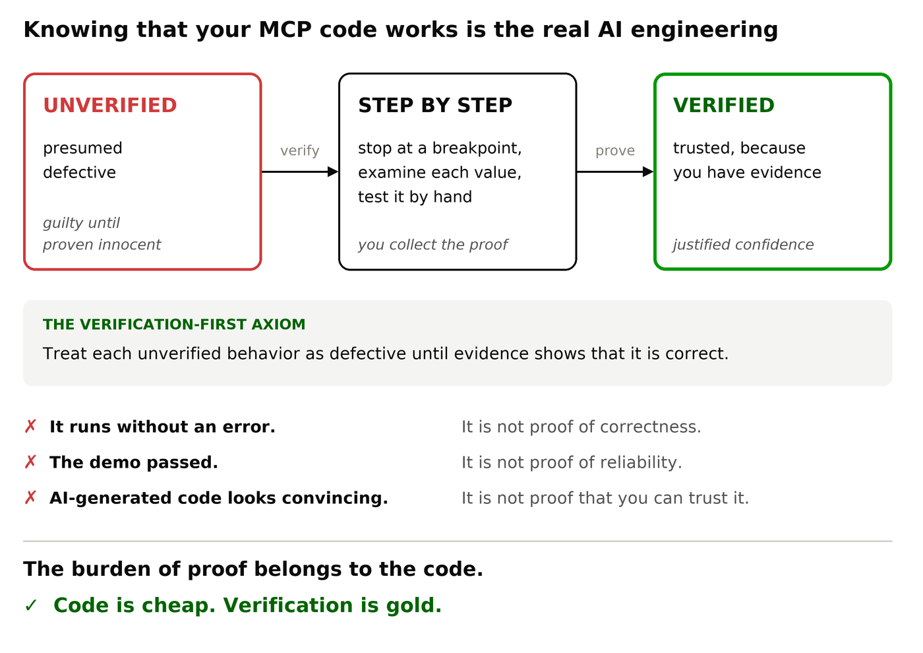
“New code is guilty until proven innocent.” Step-by-step verification gives the evidence that moves code from presumed defective to trusted.
This idea is not new. In their book Pragmatic Unit Testing, Andy Hunt and Dave Thomas give this principle: “New code is guilty until proven innocent.” They also ask a good question: “If the code ran correctly, how would I know?”
Michael Feathers goes further. For him, “legacy code is simply code without tests.” In his 1984 Turing Award lecture, Ken Thompson gave this moral: “You can’t trust code that you did not totally create yourself.” AI-generated code is code that you did not create.
Modern guides say the same. The OWASP cheat sheet for secure coding with AI has a clear rule. Do not let an AI agent write security-critical code and its tests “without independent verification”.
Security engineers apply the same rule to networks. Zero trust means “no implicit trust granted to assets or user accounts”. And the Google SRE book starts with a traditional rule: “Hope is not a strategy.”
In the AI era, code is cheap. To know that it works is the real engineering. If you cannot verify it, you cannot trust it.

Use the correct words: fault, error and failure
Many developers say “debugging” for all work on bugs. But the full job is larger. Exact words help us to do exact work. Dependability engineering gives us good words. They come from the classic taxonomy by Avižienis, Laprie, Randell and Landwehr (IEEE, 2004):
- A fault is the cause: the incorrect line of code.
- An error is the incorrect state that the fault causes when the program runs.
- A failure is the moment when the incorrect state becomes visible: an incorrect answer, a crash or a deleted database.
Two sentences from this paper are very important: “A fault is active when it causes an error, otherwise it is dormant.” And: “Errors that are present but not detected are latent errors.”
In simple words: a dormant fault is a bug that has not caused a problem yet. A latent error is an incorrect value that nobody has seen yet.
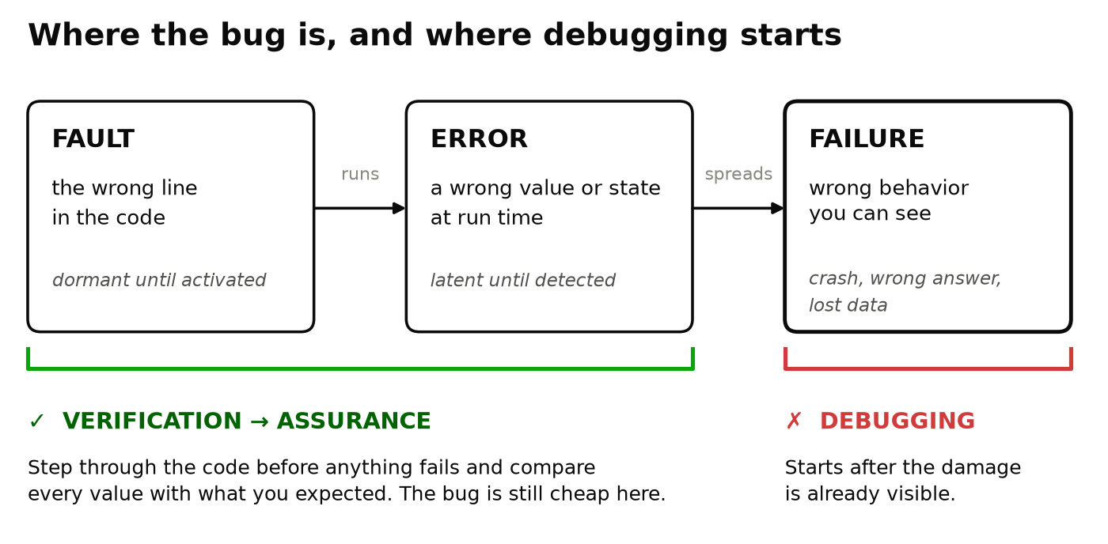
Debugging starts at the failure. Verification finds dormant faults and latent errors before a failure occurs.
Debugging starts after a failure. You know that something is wrong. You also know approximately what is wrong and where. Debugging is reactive: it repairs damage that already occurred.
The dangerous bugs have not caused a failure yet. They are dormant faults and latent errors in code that “works”. When you look for them, you do not debug. You do verification, and verification gives software assurance. NIST defines software assurance as “the level of confidence that software is free from vulnerabilities […] and that the software functions as intended by the purchaser or user.”
Tests alone cannot give this confidence. Dijkstra said this in his 1972 Turing Award lecture: “Program testing can be a very effective way to show the presence of bugs, but is hopelessly inadequate for showing their absence.” Tests examine only the cases that you thought of. Latent errors are in the cases that you did not think of.
How do professional engineers find these cases? They watch the code while it runs. Steve Maguire wrote this rule in Writing Solid Code (Microsoft Press, 1993):
“Don’t wait until you have a bug to step through your code.”
Step through each new code path. Watch each value when it changes. Compare each value with the value that you expected. I call this method step-by-step verification.
Step-by-step verification is the least expensive assurance tool that a developer has. In 2008, a Microsoft engineering blog said it clearly: “Stepping through code is not ‘old school’ and it is not optional.”
Here are the four terms in short form:
- Debugging: after a failure. You know the symptom. You find and repair the fault.
- Verification: before a failure. You make sure that the code does exactly what you intended.
- Assurance: the justified confidence that you get from verification.
- Observability: the property of the code that makes all three possible.
Step-by-step verification has one condition: the code must be observable. In control theory, observability is “a measure of how well internal states of a system can be inferred from knowledge of its external outputs.” The software quality standard ISO/IEC 25010 uses the term analysability. It is the ability “to diagnose a product for deficiencies or causes of failures.” For a Python developer, observability means one clear promise:
I can stop on any line, see each variable, and try the next step by hand.
Without observability, you cannot verify. And a demo that works is not proof of reliability.

Vibe coding makes the problem larger
In February 2025, Andrej Karpathy gave a name to a new trend: “vibe coding”. In vibe coding, you “fully give in to the vibes, embrace exponentials, and forget that the code even exists.”
“Forget that the code even exists.” Now look at what occurs when nobody remembers the code:
- Stability decreases. Google’s DORA 2024 research calculated that a 25% increase in AI adoption comes with a 7.2% decrease in delivery stability. The 2025 report confirms: “AI adoption does continue to have a negative relationship with software delivery stability.”
- Copy-paste replaces design. GitClear examined 211 million changed lines of code. It found that copy-pasted code was more than moved (refactored) code for the first time. Its 2026 update shows more problems: code-block duplication increased by 81%, and “error-masking constructs” increased by 47%.
- Each change has more defects. CodeRabbit found that pull requests with AI-generated code had about 1.7× more issues than human-only pull requests. Logic and correctness issues were 75% more frequent.
- Larger models are not more secure. Veracode found that 45% of AI-generated code samples added OWASP Top 10 vulnerabilities. Security performance “remained flat, regardless of model size or training sophistication.”
- Developers see the problem. In the 2025 Stack Overflow survey, 66% of developers said that their largest frustration is “AI solutions that are almost right, but not quite.” Also, 45% said that it takes more time to debug AI-generated code.
- Developers do not see their real speed. You saw METR’s result at the start: 19% more time, but the developers felt 20% faster. METR’s later data about newer tools shows some speedup. But METR says that this evidence is very weak. The important lesson is the difference between what developers think and what is true.
- Sometimes the result is a disaster. In July 2025, a Replit agent deleted a production database during a code freeze. Its user said that the agent continued “covering up bugs and issues by creating fake data, fake reports.”
“Almost right, but not quite” is a good definition of a latent error. Latent errors stay in code that nobody examines.

Sprint reports count the wrong thing
It is easy to count pull requests. It is difficult to count verified behavior. Thus, many organizations count only what is easy.
Faros AI collected telemetry from more than 10,000 developers. The data shows this pattern. Developers on teams with high AI adoption merged 98% more pull requests. But review time increased by 91%, and bugs per developer increased by 9%. At the company level, the researchers found no significant improvement in throughput or quality.
This is Goodhart’s law. Marilyn Strathern wrote its well-known form: “When a measure becomes a target, it ceases to be a good measure.” A thousand generated lines look good in a sprint report. But if nobody stepped through them, they are not an asset. They are a risk with a green checkmark.
Even Google’s CEO used careful words. He said that more than a quarter of all new code at Google “is generated by AI, then reviewed and accepted by engineers.” The second part of this sentence is our job.
A responsible engineer can answer three questions about each line of the system:
- What does this line do?
- What value does it produce?
- How do I know?
You cannot answer these questions for code that you cannot observe. Responsibility needs observability.

The Zen of Python gives the same rules
Type import this in Python. Many lines of the Zen of Python are rules for observable code:
- “Flat is better than nested.” Real agents have many levels. A planner calls a router. The router calls a tool runner. The tool runner calls the MCP client. You must be able to step through each level.
- “Errors should never pass silently.” Sometimes a tool call waits with no message until a timeout. This is an error that passes silently.
- “In the face of ambiguity, refuse the temptation to guess.” Do not guess what the tool returned. Stop on the line and examine the value.
- “If the implementation is hard to explain, it’s a bad idea.” If you cannot go through the code in a debugger, you cannot explain it.
- “Now is better than never. Although never is often better than right now.” The Zen of Python gave this lesson about sprint reports more than 20 years ago.

The MCP problem: async in every function
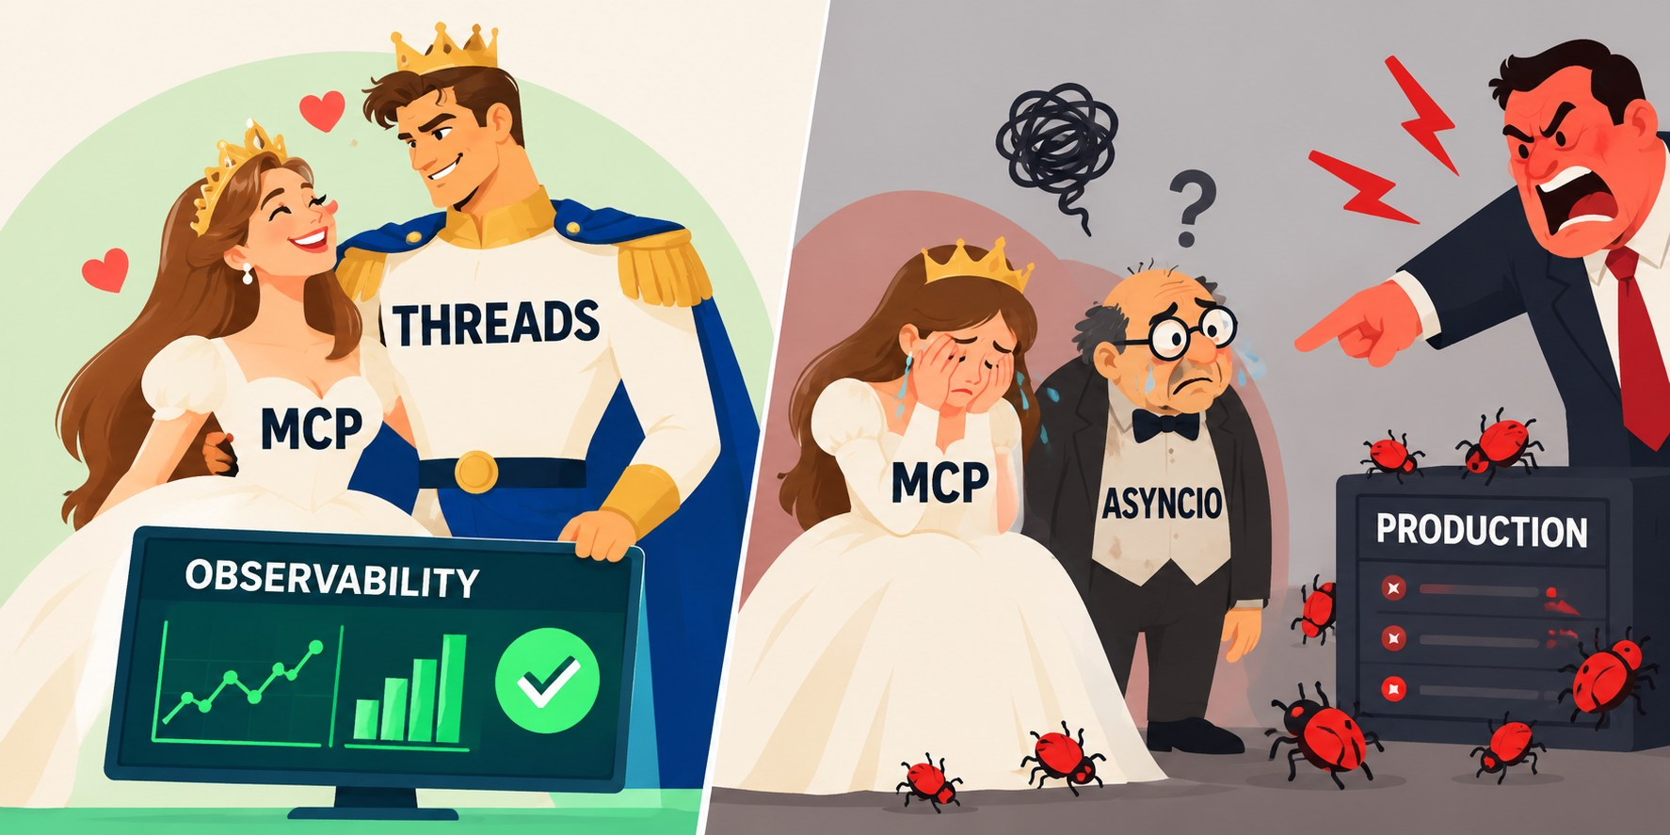
The Model Context Protocol (MCP) gives tools to an agent. An MCP server publishes a list of its tools (tools/list). Your client calls a tool (tools/call). The protocol is simple. But the Python code that most people write around it is not simple.
The official Python SDK is async-only. Each client method is a coroutine (an async def function). The official “Build an MCP client” tutorial uses the same style: async def process_query, async def chat_loop, async def main and asyncio.run(main()). Most developers copy this code. AI assistants now generate it in large quantities:
The usual way
async def call_json(client, tool, arguments): # async ...
result = await client.call_tool(tool, arguments)
return json.loads(result.content[0].text)

async def latest_release(client, repo): # ... so this must be async ...
owner, name = repo.split("/")
args = {"owner": owner, "repo": name}
return (await call_json(client, "get_latest_release", args))["tag_name"]

async def report(client, repos): # ... and this ...
jobs = [latest_release(client, repo) for repo in repos]
return await asyncio.gather(*jobs)

Bob Nystrom described the result in 2015 in “What Color is Your Function?”. His rule: “You can only call a red function from within another red function.” And: “Red functions are asynchronous ones.”
In simple words: when a function uses await, its caller must also be async. Then the caller of that caller must be async too. One await deep in your tool runner changes every function above it. Your full agent changes color.
Armin Ronacher, the creator of Flask, wrote about this problem in “Playground Wisdom: Threads Beat Async/Await” (2024): “Call stacks are really, really important. They help with debugging and are also crucial for profiling.”
This problem causes real failures every day. The SDK’s own issue tracker has a long issue with the title “cannot get response from await session.call_tool()”. In it, many users report tool calls that never return. Many of these reports have the same cause. The code used the session from the incorrect task, thread or event loop.

The VS Code test: pause and ask
I use this test on each MCP codebase:
- Set a breakpoint in the tool runner, on the line after a tool returns.
- Start the debugger. Wait until it stops on the breakpoint.
- Examine the result.
- Test an assumption: type one line in the VS Code Debug Console. For example, ask the server about a different repository.
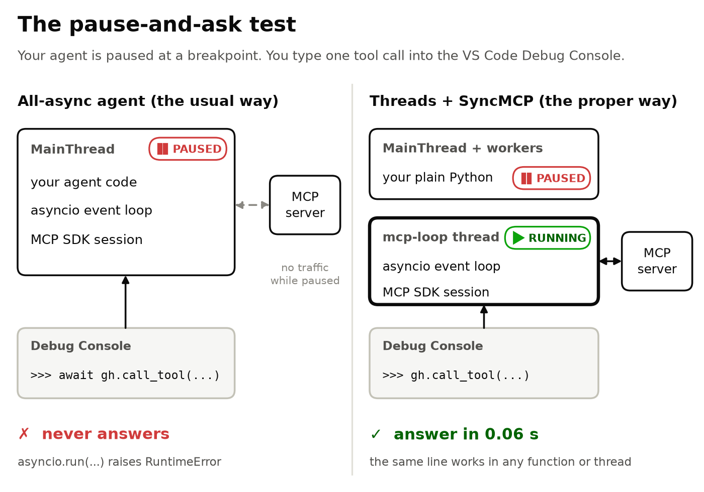
The pause-and-ask test: stop at a breakpoint. Then send one more question to the MCP server.
I did this test with the usual all-async program. In this program, the connected client is in a variable gh. I used debugpy 1.8 (the engine of the VS Code Python debugger) on Python 3.11 to 3.13. These are the results:
- await gh.call_tool("get_me", {}) never returns an answer. The event loop that must deliver the answer runs on the same thread that you stopped.
- asyncio.run(gh.call_tool("get_me", {})) fails with RuntimeError: asyncio.run() cannot be called from a running event loop.
- loop.run_until_complete(...) fails with RuntimeError: This event loop is already running.
This result is not specific to my computer. debugpy has accepted await in the Debug Console since 2022. The feature request “await keyword support in Debug Console” was closed as completed. But debugpy runs the coroutine in a new event loop on a different thread. The MCP session belongs to the original event loop. This loop is on the thread that you stopped. Thus, the answer never arrives.
A debugpy maintainer explained the cause: “the tracing mode in which the debugger pauses is a sync function and thus we need a way to call async code from sync code.” Python 3.14 added pdb.set_trace_async(). It supports await at the pdb prompt. But it works only in pdb. Also, it works only at the location where you put this call before the start of the program.
To be exact: with asyncio, you can still set breakpoints and press F10. The asyncio debug mode also helps: it reports slow callbacks and calls from the wrong thread. But you cannot explore. You cannot ask the live system a question at the moment when you examine its state. This exploration is the most important part of step-by-step verification.
With the design in this article, you type the same call without await: gh.call_tool("get_me", {}). While the program is stopped, the answer comes in 0.06 seconds.

The copy-paste test
Engineers use code snippets all the time. They copy snippets from the documentation into the code. They copy snippets from the code into the Debug Console, and from a message into a REPL. Async code often breaks these snippets:
- You paste result = await gh.call_tool(...) into a normal function. You get SyntaxError: 'await' outside async function.
- You paste asyncio.run(...) into async code. You get a RuntimeError.
- You type async code into the stopped Debug Console. You get the problems from the previous section.
A correct MCP snippet needs no change. It works in a function, a worker thread, a REPL and the Debug Console:
result = gh.call_tool("get_latest_release",
{"owner": "github", "repo": "github-mcp-server"})

The fix: threads outside, asyncio in a box
You cannot remove asyncio, because the SDK needs it. But you can isolate it. The full design has four rules:
- One owner. One background thread runs one event loop. Only this thread uses the MCP SDK. It opens the session, keeps it and closes it. I call this thread the messenger.
- Plain code in all other places. Your agent is normal Python: normal functions and normal threads. It has no async and no await.
- Send the request, then wait. Your code sends a coroutine to the messenger with asyncio.run_coroutine_threadsafe(). Then it waits for the answer, with a timeout.
- The messenger never stops. When VS Code stops your program, it does not stop the messenger. The bridge tells debugpy to ignore this thread with debugpy.trace_this_thread(False). Thus, the connection to the server continues to work.
This design is not unusual. The SDK issue above gives the same rule. One contributor wrote: “Any await on call_tool must happen in the same task context that owns the ClientSession.” One owner. All other code sends requests to the owner.
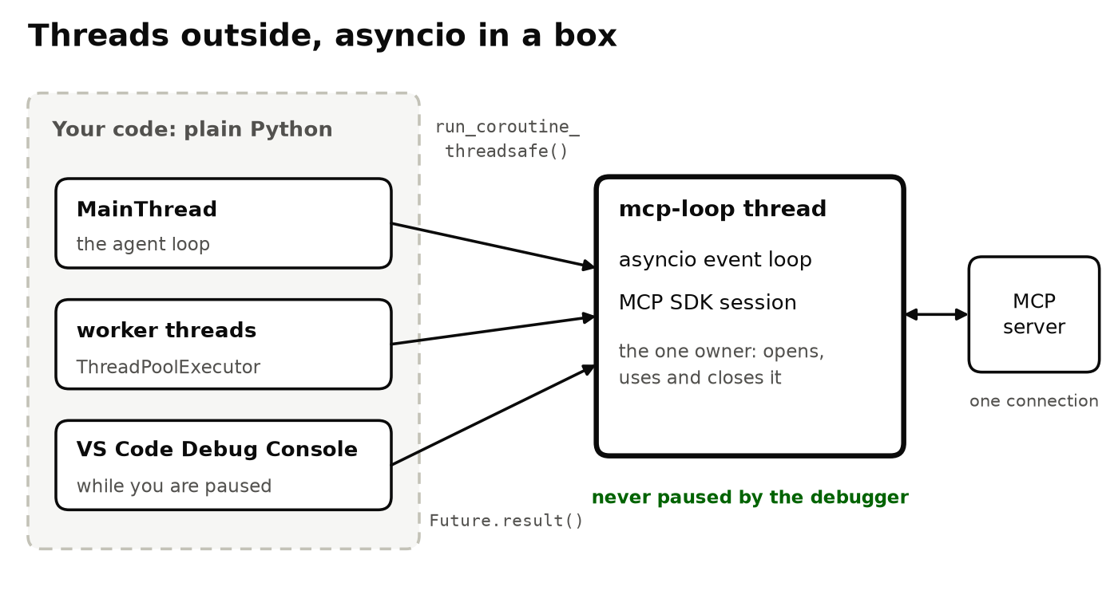
Threads outside, asyncio in a box: one messenger thread owns the event loop and the MCP session.
Here is the full bridge. It is a small module, mcp_bridge.py, with the class SyncMCP. It has approximately 100 lines:
mcp_bridge.py
"""mcp_bridge.py - the async MCP SDK behind a plain, blocking API."""
import asyncio
import concurrent.futures
import sys
import threading
from contextlib import asynccontextmanager

import httpx2 # installed together with mcp 2.x
from mcp import Client
from mcp.client.streamable_http import streamable_http_client

GITHUB_MCP_URL = "https://api.githubcopilot.com/mcp/"

class SyncMCP:
"""One background thread owns the event loop and the MCP session.
Your code calls normal blocking methods, from any thread."""

def __init__(self, open_client, timeout=60.0):
self.timeout = timeout
self._loop = asyncio.new_event_loop()
self._thread = threading.Thread(
target=self._run_loop, name="mcp-loop", daemon=True)
self._thread.start()
self._ready = concurrent.futures.Future()
self._owner = asyncio.run_coroutine_threadsafe(
self._own(open_client), self._loop)
try:
self._ready.result(timeout) # connection errors are raised here
except BaseException:
self._owner.cancel() # don't leave the thread behind
self.close()
raise

def _run_loop(self):
_keep_running_when_paused()
self._loop.run_forever()

async def _own(self, open_client):
self._stop = asyncio.Event()
try:
# one task opens AND closes the session (an anyio rule)
async with open_client() as client:
self._client, self.tools, cursor = client, [], None
while True: # read the whole menu before the first call
page = await client.list_tools(cursor=cursor)
self.tools += page.tools
if not (cursor := page.next_cursor):
break
self._ready.set_result(None)
await self._stop.wait()
except BaseException as exc:
if not self._ready.done():
self._ready.set_exception(exc)
raise

def start_tool(self, name, arguments=None):
"""Start a call and return a Future at once (it can be cancelled)."""
if threading.current_thread() is self._thread:
raise RuntimeError("never call SyncMCP from its own loop")
call = self._client.call_tool(
name, arguments or {}, read_timeout_seconds=self.timeout)
return asyncio.run_coroutine_threadsafe(call, self._loop)

def call_tool(self, name, arguments=None):
"""Call a tool and wait for the result, like a normal function."""
return self.start_tool(name, arguments).result(self.timeout + 5)

def close(self):
self._loop.call_soon_threadsafe(self._stop.set)
concurrent.futures.wait([self._owner], timeout=10)
self._loop.call_soon_threadsafe(self._loop.stop)
self._thread.join(timeout=5)
if not self._thread.is_alive():
self._loop.close()

def _keep_running_when_paused():
"""VS Code (debugpy): don't freeze this thread at your breakpoints."""
try:
debugpy = sys.modules.get("debugpy")
if debugpy and debugpy.is_client_connected():
debugpy.trace_this_thread(False)
except Exception:
pass # debugpy is loaded but not debugging this process

def github(token, url=None):
"""GitHub's official MCP server, read-only tools."""
headers = {"Authorization": f"Bearer {token}",
"X-MCP-Readonly": "true"}

@asynccontextmanager
async def open_client():
timeout = httpx2.Timeout(30, read=300)
async with httpx2.AsyncClient(headers=headers,
timeout=timeout) as http:
transport = streamable_http_client(url or GITHUB_MCP_URL,
http_client=http)
async with Client(transport) as client:
yield client

return SyncMCP(open_client)

def text_of(result):
"""The text blocks of a tool result, joined."""
return "\n".join(b.text for b in result.content if b.type == "text")

This code needs the 2.x Python SDK: mcp 2.2 or later. This version installs httpx2 automatically. The code does not work with the 1.x SDK that older tutorials use. I tested it with mcp 2.2 and 2.3.
Two details are important:
- The messenger reads the full tool list before the first call. From this list, the SDK learns which arguments GitHub’s server expects in HTTP headers. With mcp 2.2, calls to most of its tools failed without this list. Since mcp 2.3, the SDK reads the list again and sends the call one more time. Thus, when you read the list first, you prevent one rejected request.
- start_tool() returns a standard concurrent.futures.Future. Thus, you can cancel a call while it runs. You can also wait for the first of many calls, or give a call a deadline.
Now your agent is plain Python again. It can have many levels and many threads, and you can step through each line:
agent_example.py
"""agent_example.py - nested plain functions + threads, one MCP session."""
import json
import os
import sys
from concurrent.futures import ThreadPoolExecutor

from mcp_bridge import github, text_of

def call_json(gh, tool, arguments):
result = gh.call_tool(tool, arguments) # F10 steps over the call
if result.is_error: # errors should never pass silently
raise RuntimeError(f"{tool}: {text_of(result)}")
return json.loads(text_of(result))

def latest_release(gh, repo):
owner, name = repo.split("/")
args = {"owner": owner, "repo": name}
return call_json(gh, "get_latest_release", args)["tag_name"]

def report(gh, repos, serial=False):
if serial: # one job at a time: follow it end to end
return [latest_release(gh, repo) for repo in repos]
with ThreadPoolExecutor(max_workers=8) as pool: # one shared session
return list(pool.map(lambda repo: latest_release(gh, repo), repos))

if __name__ == "__main__":
gh = github(os.environ["GITHUB_TOKEN"])
try:
repos = ["github/github-mcp-server", "modelcontextprotocol/python-sdk"]
print(report(gh, repos, serial="--serial" in sys.argv))
finally:
gh.close()

Do this test:
- Set a breakpoint on the line if result.is_error:.
- Press F5. VS Code stops in a worker thread, and result contains the answer.
- In the Debug Console, call a tool. You get an answer.
- Look at the thread list. It shows MainThread, mcp-loop and the worker threads.
Then run the program with --serial. Now the same functions run one after the other. Thus, you can follow one job from the top of the agent to the network and back. Use F10 (step over), F11 (step into) and Shift+F11 (step out).
I did this test with debugpy on Python 3.11 and 3.13. Each tool call that I typed in the Debug Console returned in 0.06 seconds.


Measurements, not opinions
I measured the two designs on the same computer. I used a local copy of GitHub’s official MCP server: github-mcp-server 1.12.2, with test data in place of GitHub’s data. I used Python 3.11 and 3.13. Over the internet, each call takes more time. The comparison is the important part.
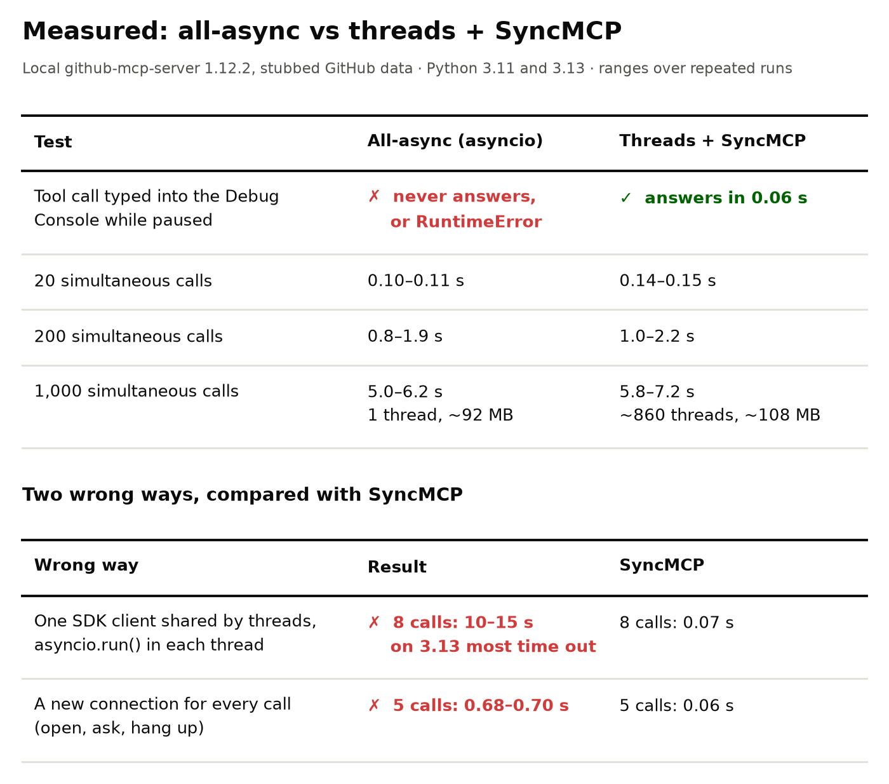
Measured with a local copy of GitHub’s MCP server. Each range covers repeated runs on Python 3.11 and 3.13.
- Speed is not the cost. With 20 calls at the same time, the bridge added approximately 40 milliseconds (0.14 s instead of 0.10 s). With 200 calls at the same time, the results of the two designs overlapped from run to run.
- Very large numbers of calls are faster with asyncio. With 1,000 calls at the same time, asyncio was usually 5–20% faster. It used one thread instead of approximately 860, and approximately 16 MB less memory.
- An agent does not see the difference. An agent makes a small number of tool calls in each step. But a crawler that sends thousands of calls at the same time must stay async.
- The Debug Console works. With asyncio, a tool call in the stopped Debug Console never returns. With the messenger, it returns in 0.06 seconds.
- Incorrect method 1: share the SDK client between threads, and run a separate asyncio.run() in each thread. This method does not crash, but it becomes very slow. Eight calls took 10 to 15 seconds instead of 0.07 seconds. On Python 3.13, most of the calls timed out.
- Incorrect method 2: open a new connection for each call. Five calls took 0.7 seconds instead of 0.06 seconds.
Threads are not expensive for this job. A thread that waits for the network does not hold the Python GIL (global interpreter lock). Also, Python moves in this direction: Python 3.14 made the free-threaded build officially supported.

What this design costs
A professional engineer tells the trade-offs:
- Shared data needs discipline. A thread can switch at any line. asyncio switches only at await. Give each job its own data and combine the results at the end. Or use a threading.Lock.
- Requests from the server need small async callbacks. Examples are sampling, elicitation and progress notifications. These callbacks run in the messenger.
- In an async web framework, use async code. An example is FastAPI. You can also call the bridge with asyncio.to_thread().
- For thousands of calls at the same time, use asyncio. The measurements show this.
None of these costs changes the most important property: you can examine each line of your agent.
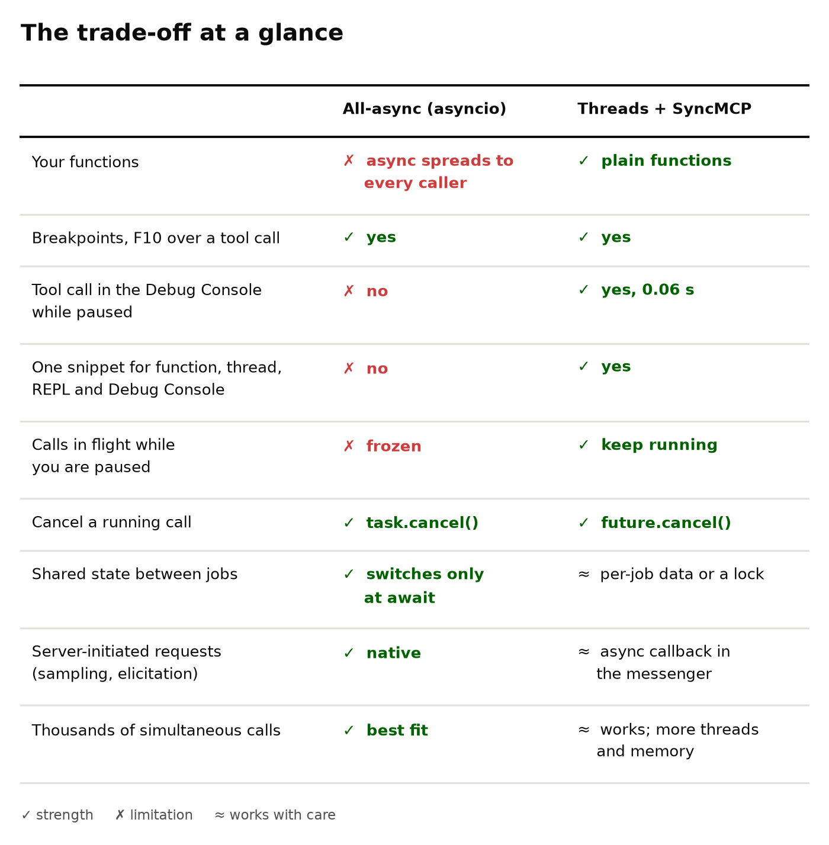
The trade-offs, side by side.

Checklist for correct MCP code
Before you say that an MCP integration is complete, make sure that it passes these seven checks:
- You can set a breakpoint on each line of agent code. F10 steps over a tool call, and the result is ready.
- When the program is stopped, the Debug Console can call a tool and get an answer.
- Each MCP snippet works with no change in a function, a thread, a REPL and the Debug Console.
- Only one owner uses the MCP session.
- Each call has a timeout. A failed tool result causes an exception. It does not pass silently.
- A serial mode lets you follow one job from start to end.
- Before you commit code, step through each new path. This is most important for AI-generated code. Do not wait until you have a bug.

Summary
Today, anyone can generate code. Thus, code generation is not a special skill. The skill is to know, line by line and value by value, that the code does what you say. You must also be able to show this when someone asks.
Many developers try to make code appear quickly. Professional engineers try to prove quickly that the code is correct.
Code is cheap. Verification is gold. Unverified code is presumed defective, so verify it before your users find its bugs. Correct MCP use in Python starts in the debugger.

Code for this tutorial
The full code is in the same repository as this document:
- mcp_bridge.py: the bridge, with the class SyncMCP and the helper github().
- agent_example.py: the plain, threaded agent. Run it with --serial to follow one job from start to end.
- async_style.py: the same agent in the usual all-async style, for comparison.
- tests/run_examples.py: runs the three examples against a local fake server. No GitHub token is necessary.
- tests/debug_console_check.py: does the pause-and-ask test for the two designs with debugpy.
To install and run the code, read README.md.

References
- METR, “Measuring the Impact of Early-2025 AI on Experienced Open-Source Developer Productivity”, July 2025: metr.org; follow-up, February 2026: metr.org
- N. Perry, M. Srivastava, D. Kumar, D. Boneh (Stanford University), “Do Users Write More Insecure Code with AI Assistants?”, ACM CCS 2023: arxiv.org
- J. Ryseff, B. F. De Bruhl, S. J. Newberry, The Root Causes of Failure for Artificial Intelligence Projects and How They Can Succeed, RAND Corporation, August 2024: rand.org
- Gartner, “Gartner Predicts Over 40% of Agentic AI Projects Will Be Canceled by End of 2027”, press release, June 2025: gartner.com
- Gartner, “What the 2026 Hype Cycle for Agentic AI Reveals”, April 2026: gartner.com
- R. Kandaswamy, L. Ramos, G. Olliffe, T. Coshow, P. den Hamer, E. Brethenoux, Hype Cycle for Agentic AI, 2026, Gartner, 2 April 2026 (updated 20 July 2026), ID G00842058. Free copy after registration: hyland.com; Gartner reprint
- Gartner, “The Latest Gartner Hype Cycle for Artificial Intelligence Puts Control Ahead of Capability”, October 2026: gartner.com
- Kernighan’s law, from B. Kernighan and P. J. Plauger, The Elements of Programming Style, 2nd ed., 1978: laws-of-software.com
- Stripe, The Developer Coefficient, September 2018: stripe.com
- CISQ, Cost of Poor Software Quality in the U.S.: A 2022 Report: it-cisq.org
- A. Hunt, D. Thomas, Pragmatic Unit Testing (C# with NUnit edition), The Pragmatic Bookshelf, summary card: media.pragprog.com
- M. Feathers, Working Effectively with Legacy Code, Prentice Hall, 2004; the definition is restated in Tech Lead Journal #195, October 2024: techleadjournal.dev
- K. Thompson, “Reflections on Trusting Trust”, ACM Turing Award lecture, Communications of the ACM 27(8), August 1984: doi.org
- OWASP Cheat Sheet Series, Secure Coding with AI Cheat Sheet: cheatsheetseries.owasp.org
- S. Rose, O. Borchert, S. Mitchell, S. Connelly, Zero Trust Architecture, NIST SP 800-207, August 2020: csrc.nist.gov
- B. Treynor Sloss, “Introduction”, in Site Reliability Engineering, Google, O’Reilly, 2016: sre.google
- A. Avižienis, J.-C. Laprie, B. Randell, C. Landwehr, “Basic Concepts and Taxonomy of Dependable and Secure Computing”, IEEE Transactions on Dependable and Secure Computing, 2004: PDF
- NIST CSRC Glossary, “software assurance” (NISTIR 8074 Vol. 2): csrc.nist.gov
- E. W. Dijkstra, “The Humble Programmer” (EWD 340), ACM Turing Award lecture, 1972: cs.utexas.edu
- S. Maguire, Writing Solid Code, Microsoft Press, 1993 (guidelines quoted at softwarequotes.com)
- “Why Stepping Through Code Trumps Unit Testing”, Microsoft Developer Blogs archive, 2008: learn.microsoft.com
- “Observability” (control theory): Wikipedia
- ISO/IEC 25010, maintainability and analysability: iso25000.com
- A. Karpathy on “vibe coding”, February 2025: x.com
- DORA 2024 findings on AI adoption, summarized by RedMonk: redmonk.com
- “Announcing the 2025 DORA Report”, Google Cloud: cloud.google.com
- GitClear, AI Copilot Code Quality: 2025 Data: gitclear.com
- GitClear, The Maintainability Gap: 2026 AI Code Quality Research: gitclear.com
- CodeRabbit, State of AI vs Human Code Generation, December 2025: coderabbit.ai
- Veracode, 2025 GenAI Code Security Report, July 2025: veracode.com
- Stack Overflow Developer Survey 2025, AI section: survey.stackoverflow.co
- The Register on the Replit and SaaStr incident, July 2025: theregister.com
- Faros AI, The AI Productivity Paradox, July 2025: faros.ai
- “Goodhart’s law”: Wikipedia
- S. Pichai on AI-generated code at Google, October 2024, via Windows Central: windowscentral.com
- PEP 20, The Zen of Python: peps.python.org
- MCP Python SDK, Client API: py.sdk.modelcontextprotocol.io
- Model Context Protocol, “Build an MCP client”: modelcontextprotocol.io
- B. Nystrom, “What Color is Your Function?”, 2015: journal.stuffwithstuff.com
- A. Ronacher, “Playground Wisdom: Threads Beat Async/Await”, 2024: lucumr.pocoo.org
- MCP Python SDK issue #262, “cannot get response from await session.call_tool()”: github.com
- debugpy issue #951, “await keyword support in Debug Console”, closed as completed in 2022: github.com
- Python documentation, pdb.set_trace_async() (new in 3.14): docs.python.org
- Python documentation, “Developing with asyncio”, debug mode: docs.python.org
- What’s New in Python 3.14 (PEP 779, free-threaded Python officially supported): docs.python.org


