Screen resolution: 50%
Search text: 'a'
Number of search results: 8
Output:-
batch size: 11

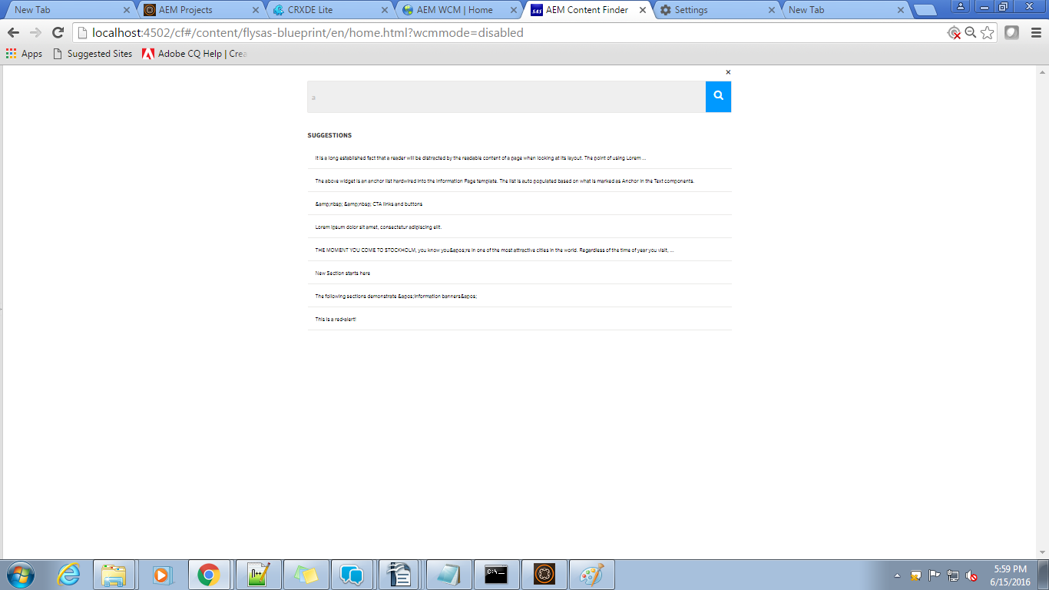
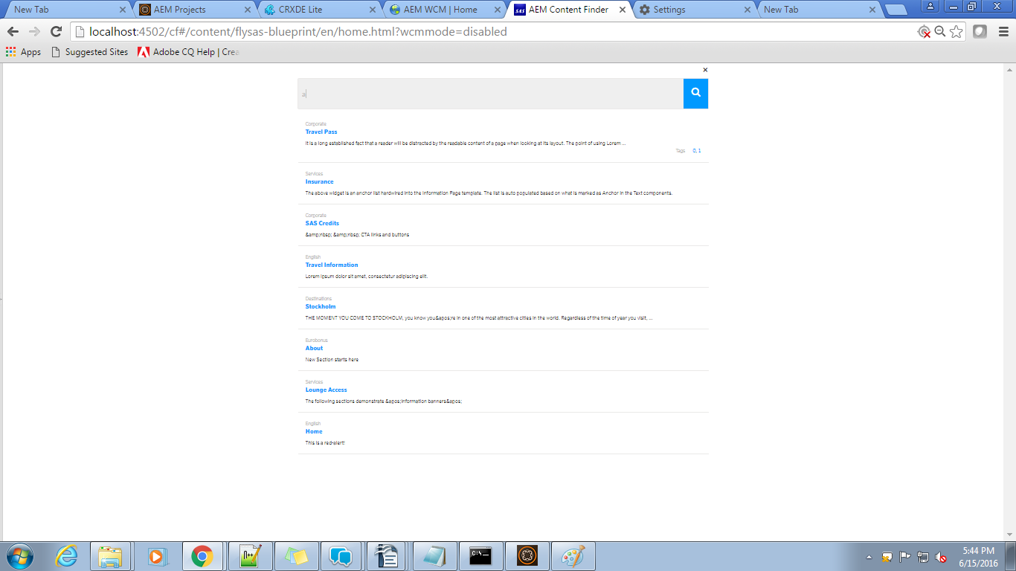

Screen resolution: 67%
Search text: 'a'
Number of search results: 8
Output:-
batch size: 8

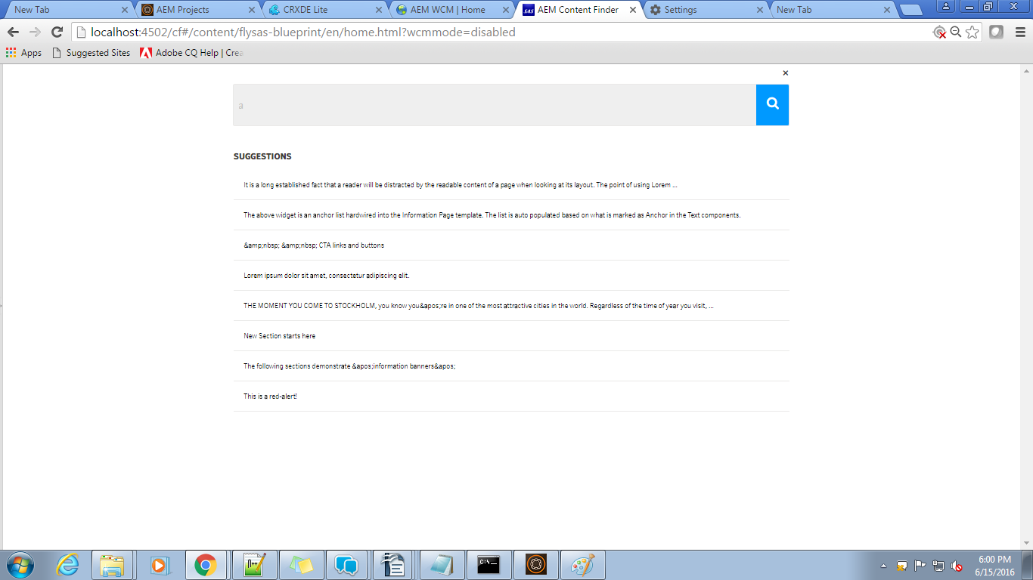
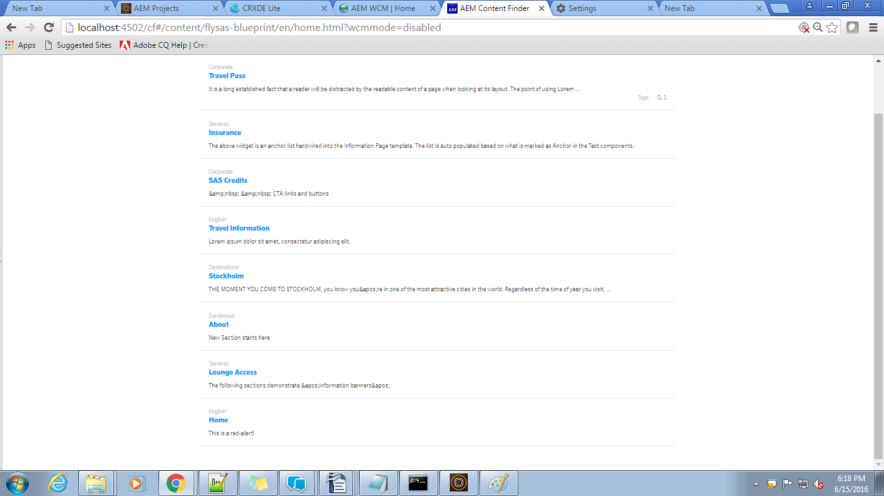

Screen resolution: 75%
Search text: 'a'
Number of search results: 8
Output:-
batch size: 7

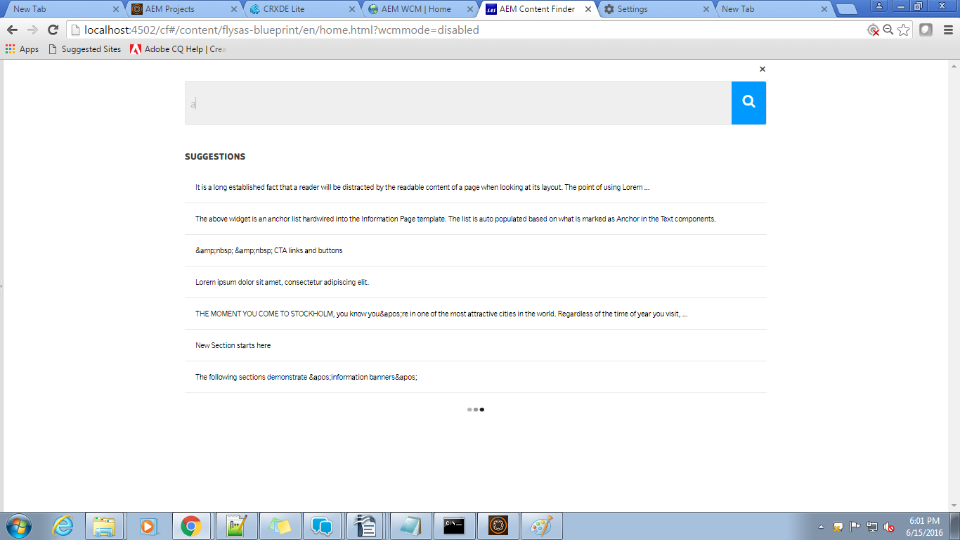
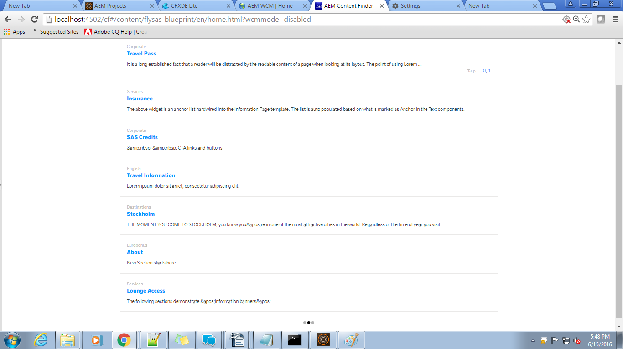

Screen resolution: 90%
Search text: 'a'
Number of search results: 8
Output:-
batch size: 6

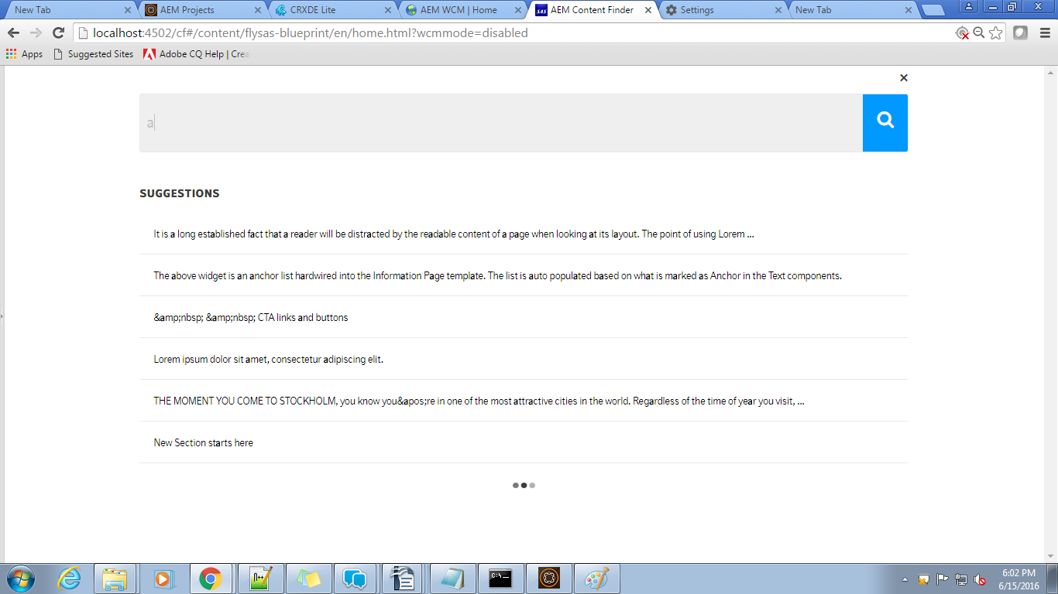
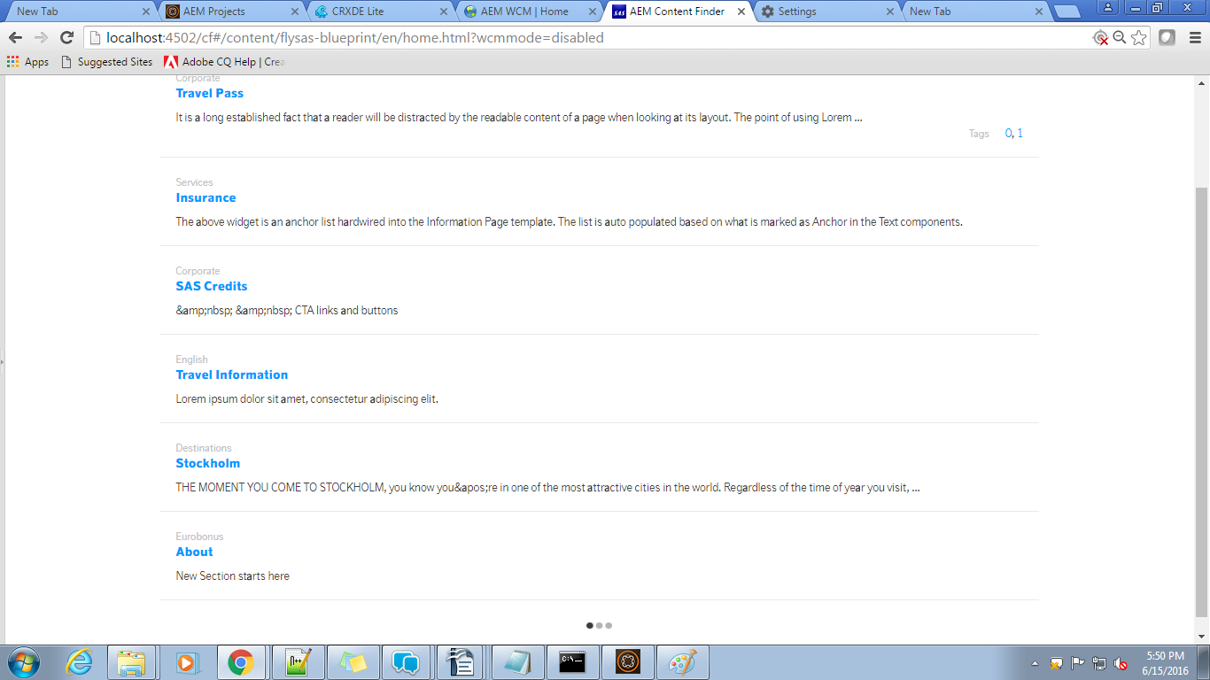

Screen resolution: 100%
Search text: 'a'
Number of search results: 8
Output:-
batch size: 5

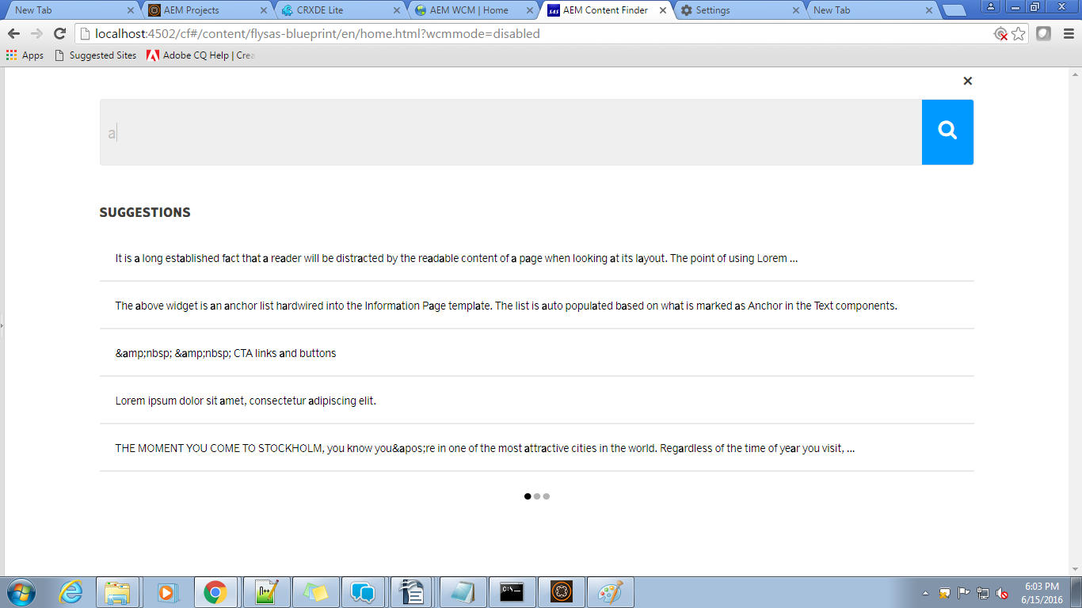
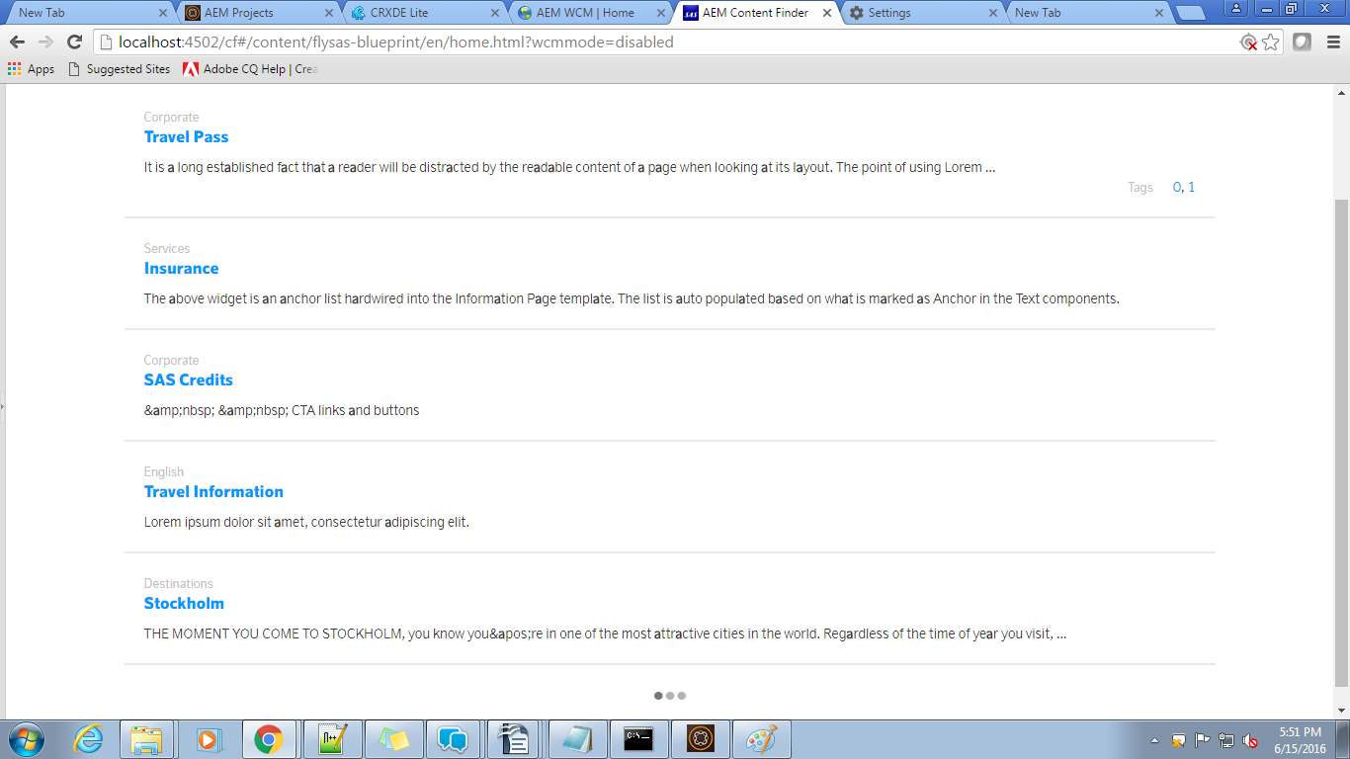

Screen resolution: 110%
Search text: 'a'
Number of search results: 8
Output:-
batch size: 5

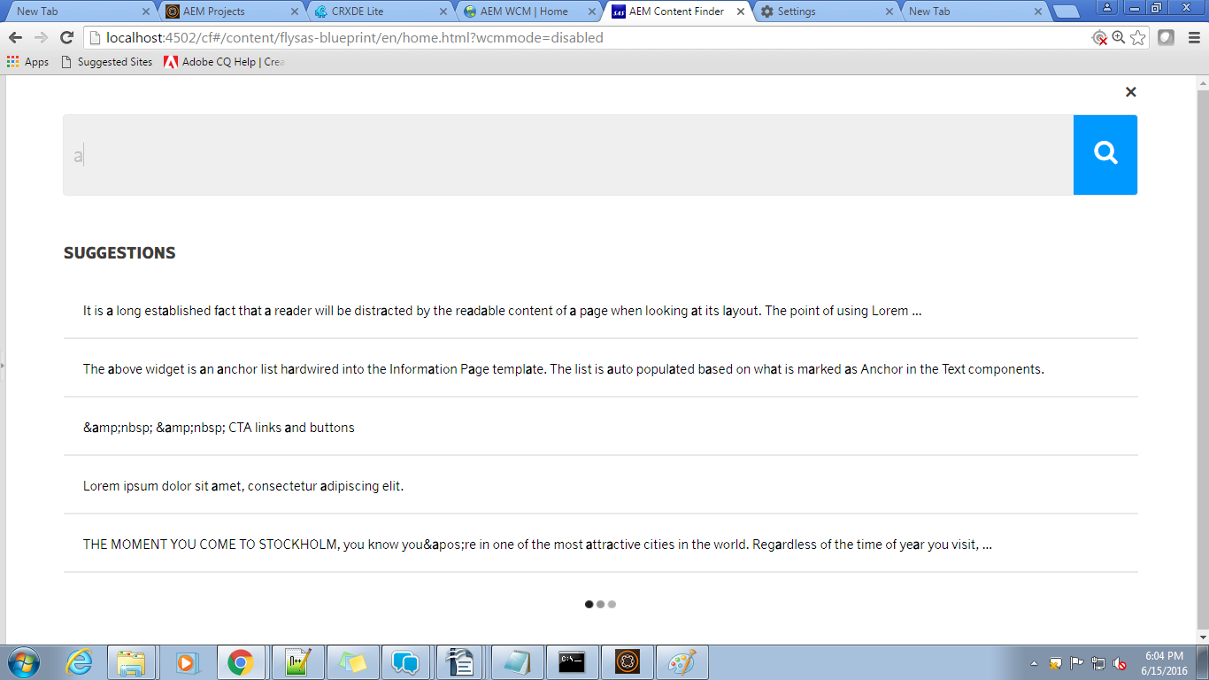
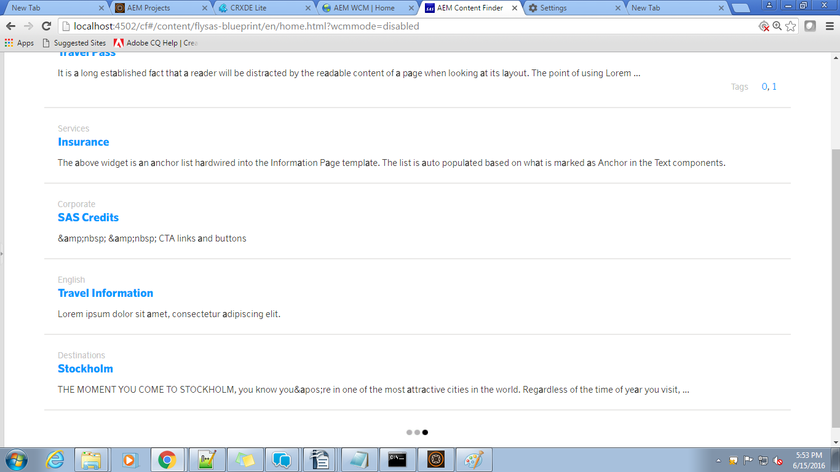
Screen resolution: 125%
Search text: 'a'
Number of search results: 8
Output:-
batch size: 4

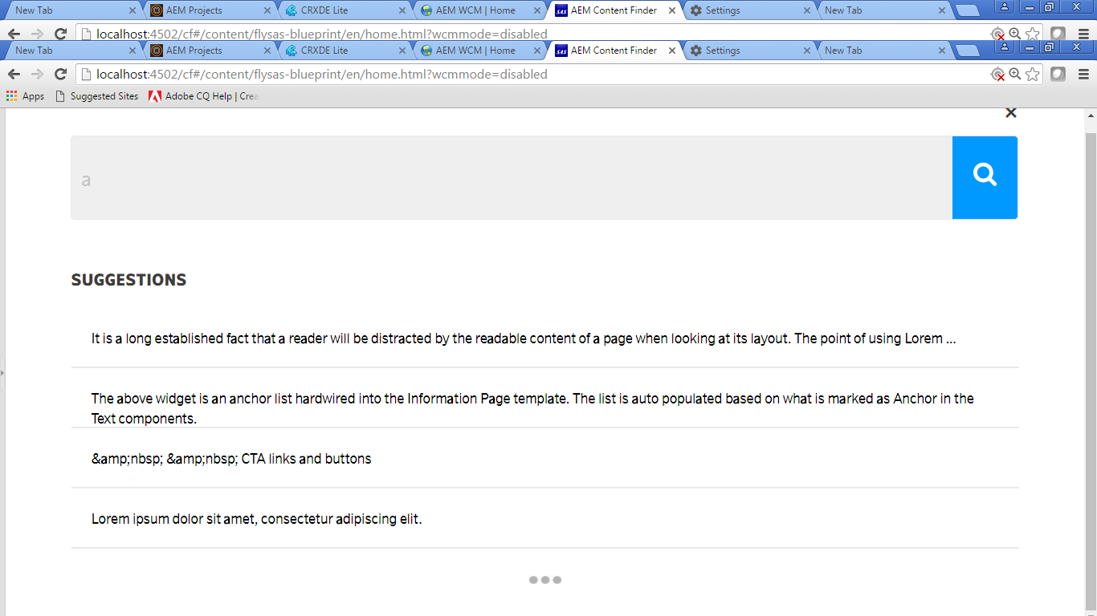
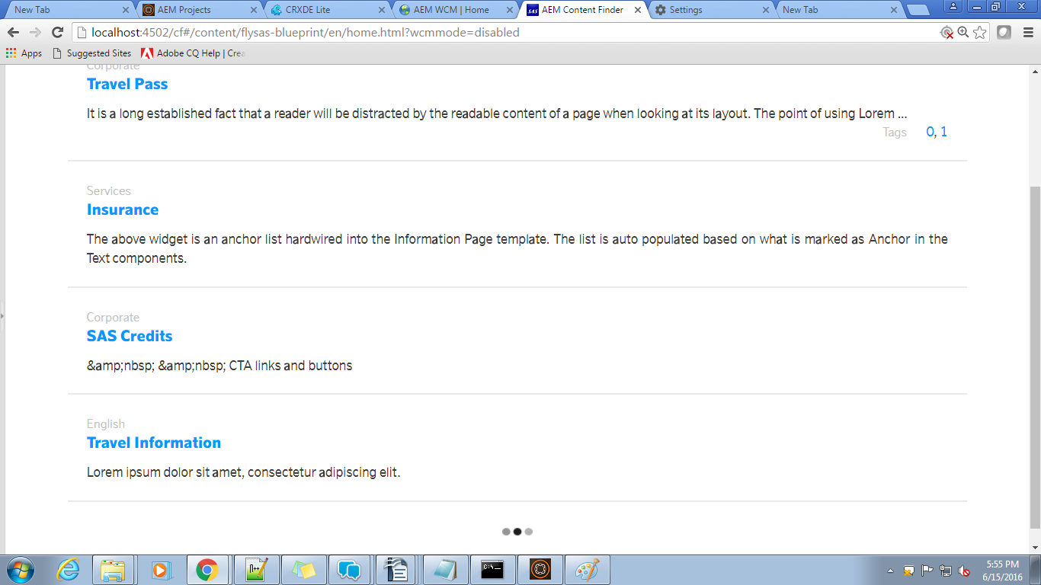
Screen resolution: 150%
Search text: 'a'
Number of search results: 8
Output:-
batch size: 3

