PROJECT REPORT

ON
Realtime Sign Language to English Language Conversion using CNN for Disabled People

submitted by

VAIBHAVI PADAMWAR

SANDEEP MALVIYA

HARSHDA PATIL

SANGHAVI APPAM

In partial fulfillment for the award of the degree

Of

Bachelor of Engineering
Of
Savitribai Phule Pune University

IN

Computer Engineering


2021-2022
PROJECT REPORT

ON

Realtime Sign Language to English Language Conversion using CNN for Disabled People

Submitted by

VAIBHAVI PADAMWAR

SANDEEP MALVIYA

HARSHDA PATIL
SANGHAVI APPAM

Guided by

Prof. Disha Deotale

Computer Engineering

G.H. Raisoni Institute of Engineering & Technology Pune

SAVITRIBAI PHULE PUNE UNIVERSITY

2021-2022
G.H. Raisoni Institute of Engineering & Technology Pune

Department of Computer Engineering


CERTIFICATE

This is to certify that the Project Entitled

Realtime Sign Language to English Language Conversion using CNN for Disabled People

Submitted by

Vaibhavi Padamwar 71832302F
Sanghavi Appam 72005223J
Harshda Patil 71916336G
Sandeep Malviya 71832276C

of the class have successfully completed their project Phase-I work on Realtime Sign Language to English Language Conversion using CNN for Disabled People at in the partial fulfilment of the Graduate Degree course in B.E at the Department of Information Technology, in the academic Year 2021-2022 as prescribed by the.

Prof. Disha Deotale Prof. SonaliSonawane
Project Guide Project Coordinator

Prof. Rachna Sable Dr. R.D.Kharadkar
HOD, Computer Department Principal

Abstract

Sign language is a natural language that uses different means of expression for communication in everyday life. As compared to other sign language ISL interpretation has got less attention by the researcher. This paper presents an Automatic translation system for gesture of manual alphabets in English sign language. It deals with images of bare hands, which allows the user to interact with the system in a natural way. System provides an opportunity for deaf persons to communicate with normal people without the need for an interpreter. We are going to build systems and methods for the automatic recognition of English sign language. The first step of this system is to create a database of English Sign Language. Hand segmentation is the most crucial step in every hand gesture recognition system since if we get better segmented output, better recognition rates can be achieved. The proposed system also includes efficient and robust hand segmentation and tracking algorithm to achieve better recognition rates. A large set of samples has been used to recognize 43 isolated words from the Standard English sign language. In the proposed system, we intend to recognize some very basic elements of sign language and to translate them to text and vice versa in the English language.

GHRIET, Department of Computer Engineering 2021-2022
Acknowledgments

We take this opportunity to thank our project guide Prof. Disha Deotale and Head of the Department, Mrs. Rachana Sable for their valuable guidance and for providing all the necessary facilities, which were indispensable in the completion of this project report. We are also thankful to all the staff members of the Department of Computer Engineering of G.H. Raisoni of Institute of Engineering & Technology, Pune for their valuable time, support, comments, suggestions and persuasion. We would also like to thank the institute for providing the required facilities, Internet access and important books.

Vaibhavi Padamwar
Sandeep Malviya
Sanghavi Appam
Harshda Patil

INDEX

Introduction 1
1.1 Overview 2
1.1.1 Motivation 2

1.1.2 | Objective | 2

Literature Survey 3
  - Study Of Research Paper 4
- Problem Statement 14
  - Problem Statement 15
- Project Requirement 16
  - EXTERNAL INTERFACE REQUIREMENT 17

 | 4.1.1 | User Interface . . . . . . . . . . . . . . . . . . . . . . . . | .17
 | 4.1.2 | Hardware Interfaces: . . . . . . . . . . . . . . . . . .. . | .17
 | 4.1.3 | Software Interfaces . . . . . . . . . . . . . . . . . . . . . | .18
 | 4.2 NON | FUNCTIONAL REQUIREMENT . . . . . . . . . . . .. . | .18
 | 4.2.1 | Performance Requirements . . . . . . . . . . . . . . .. . | .18
 | 4.2.2 | Safety Requirement . . . . . . . . . . . . . . . . . . . . . | .18
4.2.3 Software Quality Attributes 18

System Analysis 20
  - system Architecture 21
    - Module 21
5.1.2 Data Flow Diagram 22
5.2 UML DIAGRAMS 25

6 Software Information |  |  | 30
7 Project Plan  - Stakeholder List |  | 36 | 35
7.2 System Implementation Plan |  | 36
8 Conclusion |  |  | 37
8.1 Conclusion |  | 38
9 References |  |  | 39

List of Figures

  - System Architecture 21
  - Data Flow (0) Diagram 23
  - Data Flow (1) Diagram 24
  - Data Flow (2) Diagram 24
  - Class Diagram 26
  - Use Case Diagram 27
  - Activity Diagram 28
  - Sequence Diagram 29

CHAPTER 1

INTRODUCTION

1 OVERVIEW

In recent years hand gesture recognition system is one of the most trending topics for research. The disabled person who is unable to talk and unable to speak uses gestures for communication purposes. There are many people in the world who cannot understand the hand gestures or sign language. All the peoples who cannot understand the sign languages can use the automated system which can recognize the gestures and their meaning

Motivation

Consider having a conversation with a deaf person. This may already appear to be a daunting task, especially if you are unfamiliar with sign language. Such is the problem faced by millions of deaf people who are unable to communicate and interact with hearing people. To overcome this problem, we proposed system for the deaf person as well as vocal people who are communicating with each other with the help of sign language. So, we decided we needed to do something to help these physically challenged people, which is why we came up with this idea.

Objective

English Alphabets To communicate in sign language requires a specific sign language that can be used as way of communication. Our proposed system is implemented in English sign language. English sign language is Indian sign language used as medium of communication. 2 shows the sign language images for corresponding Marathi alphabets. Proposed system is designed to recognize the 43 English sign which consist of vowels and consonants. During the recognition English sign language is translated into corresponding English text and similarly for vice versa

CHAPTER 2

LITERATURE SURVEY

2.1 STUDY OF RESEARCH PAPER

Paper Name | Author | Abstract
Multimedia Technologies To Teach Sign Language In A Written Form. | Farkhadov M.P. | - In this paper we investigate the features of signs in the sign languages and related problem of how to describe the features linguistically.  - We present a brief overview of existing sign notations, which allows us to record all sign elements in the form of sequence of characters.
Toward A Mexican Sign Language System Using Human Computer Interface | C.R. Estrivero-Chavez  M.A. Contreras-Teran  J.A Miranda-Hernandez | - This article presents new algorithm that serves as support for people interested in learning sign language based on the Mexican sign language.  - The system uses the leap motion machine shadow interaction system a capture the position of each finger of both hands.
American Sign Language Alphabets Recognition Using Hand Crafted And Deep Learning Features | Rajesh George Rajan1  Dr.M.Judith Leo | - In this paper a combination of hand-crafted features and deep learning method is used to classify the signs in more accurate manner.  - The skin color based YCbCr segmentation method and local binary pattern is applied for ac-curate shape segmentation and for texture features or local shape info.
Neural Network Based Real Time Sign Language Interpreter For Vir- Tual Meet | Janeera.D.A  K.Mukilan Raja | - Due to the covid-19 pandemic, people were forced to stay home, and most professions switched to work from home mode. The world switched to video conferencing to stay connected from remote environment.  - Neural network algorithm is used in our model to predict the signs and translate them.
A Rule Based System For Bangla Voice And Text To Bangla Sign Language Interpretation | Md. Arifur Rahman  Md. Masud Rana | - It is very difficult in Bangladesh to make communication between sign and non-sign people even though entire world because most of the non-sign people do not understand the sign language.  - To create effective communication between sign and non-sign people we have proposed a rule-based system for Bangla voice and text to Bangla sign lang interpretation.

CHAPTER 3

PROBLEM STATEMENT

3.1 PROBLEM STATEMENT

- Around 46 million people in the world are handicapped who can’t speak or listen properly.
- Dumb people use hand signs to communicate, hence normal people face problems in recognizing their language by signs made.
- The hearing-impaired people always have problems in communicating with normal people.
- They have a problem in conveying their thoughts and ideas to normal people who have very limited or sometimes no knowledge of sign language.
- This makes the hearing-impaired community lose interest in common activities and they avoid communicating with normal people at times and live in isolation.

CHAPTER 4

PROJECT REQUIREMENT

EXTERNAL INTERFACE REQUIREMENT 4.1.1User Interface
Application Based M sign language.

Hardware Interfaces:

RAM: 8 GB
As we are using Machine Learning Algorithm and Various High-Level Libraries Laptop
RAM minimum required is 8 GB. Hard Disk: 40 GB
Data Set of CT Scan images is to be used hence minimum 40 of GB of Hard Disk memory is required.
Processor: Intel i5 Processor
PyCharm IDE that Integrated Development Environment is to be used and data loading should be fast hence Fast Processor is required
IDE: Spyder
Best Integrated Development Environment as it gives possible suggestions at the time of typing code snippets that make typing feasible and fast.
Coding Language: Python Version 3.5
Highly specified Programming Language for Machine Learning because of availability of High-Performance Libraries.
Operating System: Windows 10
Latest Operating System that supports all types of installation and development environments.

Software Interfaces

Operating System: Windows 10

IDE: Visual Studio Code, Spyder, PyCharm

Programming Language: Python

NON-FUNCTIONAL REQUIREMENT 4.2.1PerformanceRequirements
The performance of the functions and every module must be well. The overall performance of the software will enable the users to work efficiently. The performance of encryption of data should be fast. Performance of the providing virtual environment should be fast Safety Requirement. The application is designed in modules where errors can be detected and easily. This makes it easier to install and update new functionality if required.

Safety Requirement

The application is designed in modules where errors can be detected and fixed easily. This makes it easier to install and update new functionality if required.

Software Quality Attributes

Our software has many qualities attribute that are given below: -

Adaptability:
This software is adaptable by all users.

Availability:
This software is freely available to all users. The availability of the software is easy for everyone.

Maintainability:
After the deployment of the project if any error occurs then it can be easily maintained by the software developer.

Reliability:
The performance of the software is better which will increase the reliability of the Software.

User Friendliness:
Since the software is a GUI application; the output generated is much user friendly in its behavior

Integrity:
Integrity refers to the extent to which access to software or data by unauthorized persons can be controlled.

Security:
Users are authenticated using many security phases so reliable security is provided.

Testability:
The software will be tested considering all the aspects.

CHAPTER 5

SYSTEM ANALYSIS

SYSTEM ARCHITECTURE

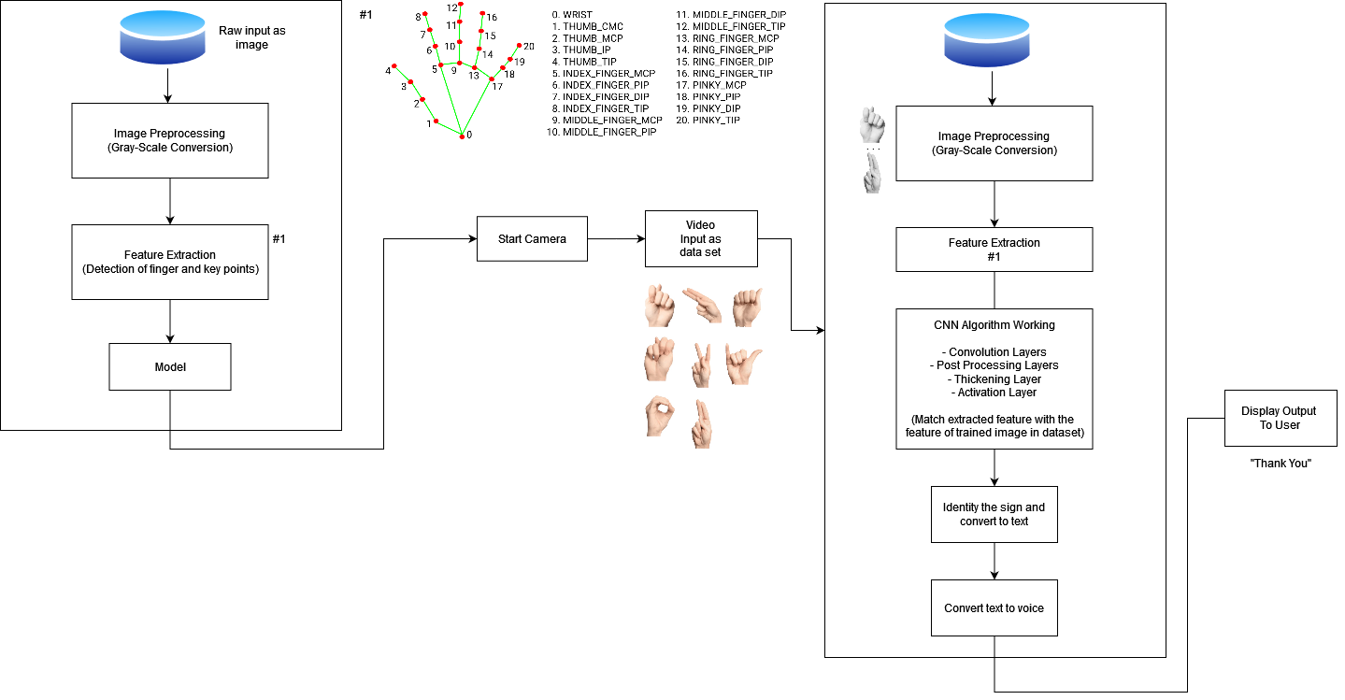
Figure 5.1: System Architecture

Module

      - Admin

      - In this module, the admin has to log in by using valid user name and password. After login successful he can do some operations, such as View All Users and Authorize, View All E-Commerce Website and Authorize, View All Products and Reviews, View All Products Early Reviews, View All Keyword Search Details, View All Products Search Ratio, View All Keyword Search Results, View All Product Review Rank Results.

      - View and Authorize Users

      - In this module, the admin can view the list of users who all registered. In this,
the admin can view the user’s details such as, user name, email, address and admin authorize the users.

      - View Charts Results

      - View All Products Search Ratio, View All Keyword Search Results, View All Product Review Rank Results.

      - Ecommerce User

      - In this module, there are n numbers of users are present. User should register before doing any operations. Once user registers, their details will be stored to the database. After registration successful, he has to login by using authorized user name and password Once Login is successful user will do some operations like Add Products, View All Products with reviews, View All Early Product’s reviews, View All Purchased Transactions.

      - End User

      - In this module, there are n numbers of users are present. User should register before doing any operations. Once user registers, their details will best or to the database. After registration successful, he has to login by using authorized user name and password. Once Login is successful user will do some operations like Manage Account, Search Products by keyword and Purchase, View Your Search Transactions, View.

Data Flow Diagram

In Data Flow Diagram, we Show that flow of data in our system in DFD0 we show that base DFD in which rectangle present input as well as output and circle show our system, In DFD1 we show actual input and actual output of system input of us system is text or image and output is rumor detected likewise in DFD 2 we present operation of user as well as admin.


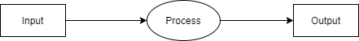

Figure 5.2: Data Flow (0) diagram

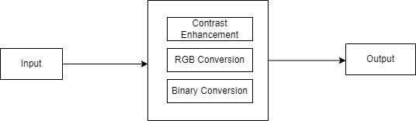

Figure 5.3: Data Flow (1) diagram


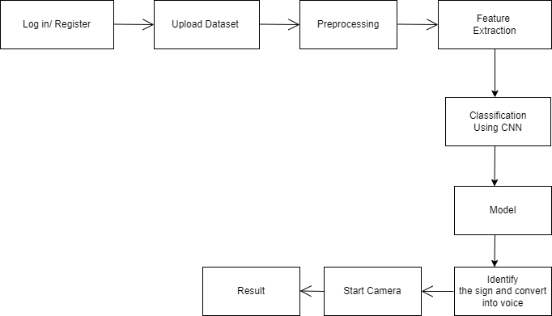

Figure 5.4: Data Flow (2) diagram

UML DIAGRAMS

Unified Modeling Language is a standard language for writing software blueprints. The UML may be used to visualize, specify, construct and document the artifacts of a software intensive system. UML is process independent, although optimally it should be used in process that is use case driven, architecture-centric, iterative and incremental. The Number of UML diagram is available.

Class Diagram.

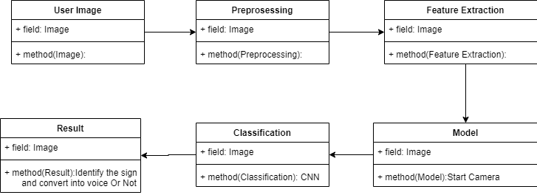

Figure 5.5: Class Diagram

Use case Diagram.

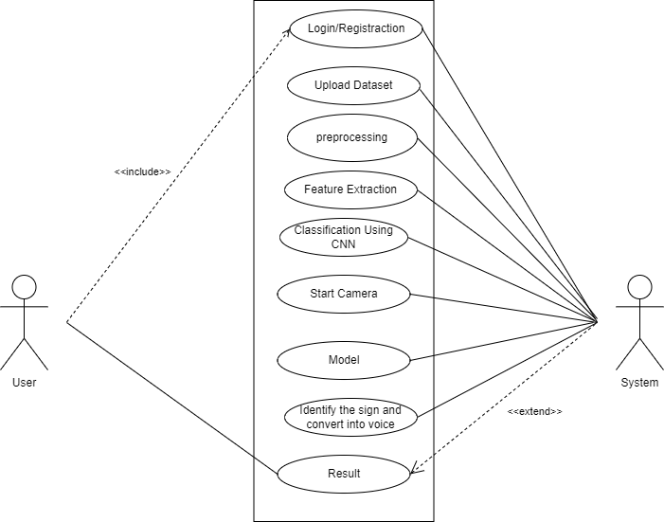

Figure 5.6: Use case Diagram

Activity Diagram.
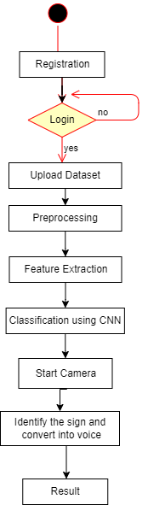

Figure 5.7: Activity Diagram

Sequence Diagram.

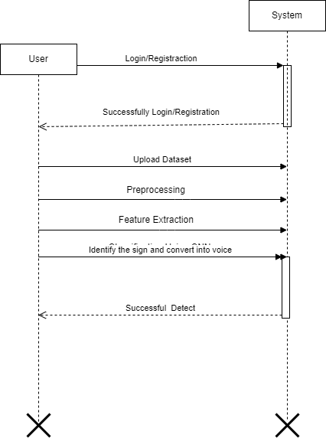

Figure 5.8: Sequence Diagram

CHAPTER 6

SOFTWARE INFORMATION
Python is an interpreted, high-level and general-purpose programming language. Created by Guido van Rossum and first released in 1991, Python’s design philosophy emphasizes code readability with its notable use of significant whitespace. Its language constructs and object-oriented approach aim to help programmers write clear, logical code for small and large-scale projects.

Python is dynamically typed and garbage-collected. It supports multiple programming paradigms, including structured (particularly, procedural), object-oriented, and functional programming. Python is often described as a” batteries included” language due to its comprehensive standard library. Python was created in the late 1980s as a successor to the ABC language. Python 2.0, released in 2000, introduced features like list comprehensions and a garbage collection system with reference counting.

Python 3.0, released in 2008, was a major revision of the language that is not completely backward-compatible, and much Python 2 code does not run unmodified on Python 3. The Python 2 language was officially discontinued in 2020 (first planned for 2015), and” Python 2.7.18 is the last Python 2.7 release and therefore the last Python 2 release.” [30] No more security patches or other improvements will be released for it. With Python 2’s end-of-life, only Python 3.6.x and later are supported. Python interpreters are available for many operating systems. A global com- munity of programmers develops and maintains CPython, a free and open-source reference implementation. A non-profit organization, the Python Software Foundation, manages and directs resources for Python and CPython development.

Python was conceived in the late 1980s by Guido van Rossum at Centrum Wiskunde Informatica (CWI) in the Netherlands as a successor to the ABC language (itself inspired by SETL), capable of exception handling and interfacing with the Amoeba operating system. Its implementation began in December 1989. Van Rossum shouldered sole responsibility for the project, as the lead developer, until 12 July 2018, when he announced his” permanent vacation” from his responsibilities as Python’s Benevolent Dictator for Life, a title the Python community bestowed upon him to reflect his long-term commitment as the project’s chief decision-maker. He now shares his leadership as a member of a five-person steering council. In January 2019, active Python core developers elected Brett Cannon, Nick Coghlan, Barry Warsaw, Carol Willing and Van Rossum to a five-member” Steering Council” to lead the project.

Anaconda: Anaconda is a free and open-source distribution of the Python and R programming languages for scientific computing (data science, machine learning applications, large-scale data processing, predictive analytics, etc.), that aims to simplify package management and deployment. The distribution includes data-science packages suitable for Windows, Linux, and macOS. It is developed and maintained by Anaconda, Inc., which was founded by Peter Wang and Travis Oliphant in 2012. As an Anaconda, Inc. product, it is also known as Anaconda Distribution or Ana- conda Individual Edition, while other products from the company are Anaconda Team Edition and Anaconda Enterprise Edition, both of which are not free.

Package versions in Anaconda are managed by the package management system conda. This package manager was spun out as a separate open-source package as it ended up being useful on its own and for other things than Python. There is also a small, bootstrap version of Anaconda called Mini Conda, which includes only conda, Python, the packages they depend on, and a small number of other packages. Anaconda distribution comes with over 250 packages automatically installed, and over 7,500 additional open-source packages can be installed from PyPI as well as the conda package and virtual environment manager. It also includes a GUI, Ana- conda Navigator, as a graphical alternative to the command line interface (CLI). The big difference between conda and the pip package manager is in how package dependencies are managed, which is a significant challenge for Python data science and the reason conda exists.

When pip installs a package, it automatically installs any dependent Python packages without checking if these conflict with previously installed packages [citation needed]. It will install a package and any of its dependencies regardless of the state of the existing installation [citation needed]. Because of this, a user with a working installation of, for example, Google TensorFlow, can find that it stops working having used pip to install a different package that requires a different version of the dependent NumPy library than the one used by TensorFlow. In some cases, the package may appear to work but produce different results in detail.

In contrast, conda analyses the current environment including everything currently installed, and, together with any version limitations specified (e.g. the user may wish to have TensorFlow version 2,0 or higher), works out how to install a compatible set of dependencies, and shows a warning if this cannot be done.

Open-source packages can be individually installed from the Anaconda repository, Anaconda Cloud (anaconda.org), or the user’s own private repository or mirror, using the conda install command. Anaconda, Inc. compiles and builds the packages available in the Anaconda repository itself, and provides binaries for Windows 32/64 bit, Linux 64 bit and MacOS 64-bit. Anything available on PyPI may be installed into a conda environment using pip, and conda will keep track of what it has installed itself and what pip has installed.

Custom packages can be made using the conda build command, and can be shared with others by uploading them to Anaconda Cloud, PyPI or other repositories. The default installation of Anaconda2 includes Python 2.7 and Anaconda3 includes Python 3.7. However, it is possible to create new environments that include any version of Python packaged with conda

CHAPTER 7

PROJECT PLAN
In this chapter we are going to have an overview about how much time does it took to complete each task like- Preliminary Survey Introduction and Problem Statement, Literature Survey, Project Statement, Software Requirement and Specification, System Design, Partial Report Submission, Architecture Design, Implementation, Deployment, Testing, Paper Publish, Report Submission and etcetera. This chapter also gives focus on stakeholder list which gives information about project type, customer of the proposed system, user and project member who developed the system.

STAKEHOLDER LIST

  - SYSTEM IMPLEMENTATION PLAN

The System Implementation plan table, shows the overall schedule of tasks compilation and time duration required for each task.

Sr. No. | Name/Title | Start Date | End Date
1 | Preliminary Survey
2 | Introduction and Problem  Statement
3 | Literature Survey
4 | Project Statement
5 | Software Requirement and  Specification
6 | System Design
7 | Partial Report Submission
8 | Architecture Design
9 | Implementation
10 | Deployment
11 | Testing
12 | Paper Publish
13 | Report Submission

CHAPTER 8

CONCLUSION

8.1 CONCLUSION

Considering our above methodology, we come to the conclusion that the newly designed system of image processing technologies is suitable for parasite detection. The morphological segmentation technique and improved watershed segmentation technique proves to be the best in detection of the cells and segmenting them from the non-region of interest portion. To characterize the sort of plasmodium parasite for which we utilized machine learning technologies and cubic SVM proves to be the best by having the highest accuracy score. The system has been tested with around 110 thin film blood smear images and the results are satisfactory. The inconsistencies among the images were a challenge but we have tried to make our system robust.

CHAPTER 9

REFERENCES
    - Goldin-Meadow S., Brentari D. Gesture, sign, and language: The coming of age of sign language and gesture studies. Behav Brain Sci. – 2017. – 60 p.
DOI: 10.1017/S0140525X15001247. URL: https://pubmed.ncbi.nlm.nih.gov/26434499/

    - Zaytseva G.L. Zhestovaya rech’. Daktilologiya: Uchebnik dlya studentov vysshikh uchebnykh zavedeniy [A Sign speech. Dactylology. Tutorial for students of higher educational institutions]. Moscow, Vlados Publ. – 2000. – 192 p. (in Russian)

    - Kimmelman V. Information structure in Russian Sign Language and Sign Lan- guage of the Netherlands: Dissertation Amsterdam Center for Language and Communication (ACLC). Faculty of Humanities (FGw) Amsterdam. – 2014. – 267 p. URL: http://dare.uva.nl/record/1/432175

4. Galib Ibne Haidar, Hasin Ishraq Reefat: Glove Based American Sign Language Interpretation
Using Convolutional Neural Network and Data Glass.
2020 IEEE Region 10 Symposium (TENSYMP), 5-7 June 2020, Dhaka, Bangladesh

5. Myasoedova M.A., Myasoedova Z.P., Farkhadov M.P.: Multimedia technologies to teach Sign
Language in a written form.
DOI: 10.1109/AICT50176.2020.9368720

6. Ebey Abraham, Akshatha Nayak, Ashna Iqbal: Real-Time Translation of Indian Sign
Languageusing LSTM. 2019 Global Conference for Advancement in Technology (GCAT)
Bangalore, India. Oct 18-20, 2019

7. Deepika Pahuja, Sarika Jain: Recognition of Sign Language Symbols using Templates
2020 8th International Conference on Reliability, Infocom Technologies and Optimization (Trends and Future Directions) (ICRITO) Amity University, Noida, India. June 4-5, 2020

8. Dr.L.Priya, A.Sathya, S. Kanaga Suba Raja: INDIAN AND ENGLISH LANGUAGE TO
SIGN LANGUAGE TRANSLATOR- AN AUTOMATED PORTABLE TWO WAY
COMMUNICATOR FOR BRIDGING NORMAL AND DEPRIVED ONES
2020 2nd International Conference on Power, Energy, Control and Transmission Systems

9. Necati Cihan Camgoz ̈ , Oscar Koller, Simon Hadfield and Richard Bowden: Sign Language Transformers: Joint End-to-end Sign Language Recognition and Translation
2020 IEEE/CVF Conference on Computer Vision and Pattern Recognition (CVPR)

10. Yufei Yan, Zhijun Li*, Qunzhu Tao, Chenyu Liu, Rui Zhang: Research on Dynamic Sign
Language Algorithm Based on Sign Language Trajectory and Key Frame Extraction
2019 2nd International Conference on Electronics Technology

