*I pull my jacket hood over my head and shiver as the sun starts to rise on this frigid Rocky Mountain winter morning. I reach the top the hill just as the sun starts to peak over the ridge in the distance. I set up my spotting scope and peer through, a pair of yellow eyes stare back at me. A black wolf stands over the two-day old remains of an elk carcass as I wonder silently if it notices its audience of one. As the air starts to warm, magpies, eagles, and an impossible number of ravens descend on the lone wolf. It eventually gives up on gnawing the frozen bones and pads swiftly across the meadow, but not without a leg for an afternoon snack.*

This year I braved my first real winter field season in order to collect data on the scavengers that utilize wolf kills and other carrion on the vast Yellowstone landscape. Despite my colleagues telling me that it was a mild year, as a “Cali Kid”, a fact that Doug Smith won’t let me forget, anything lower than 0°F was unthinkable to me. But the hundreds of hours spent on the side of the road with only the occasional uninterested visitor or familiar wolf watcher to break the stillness were well worth it.

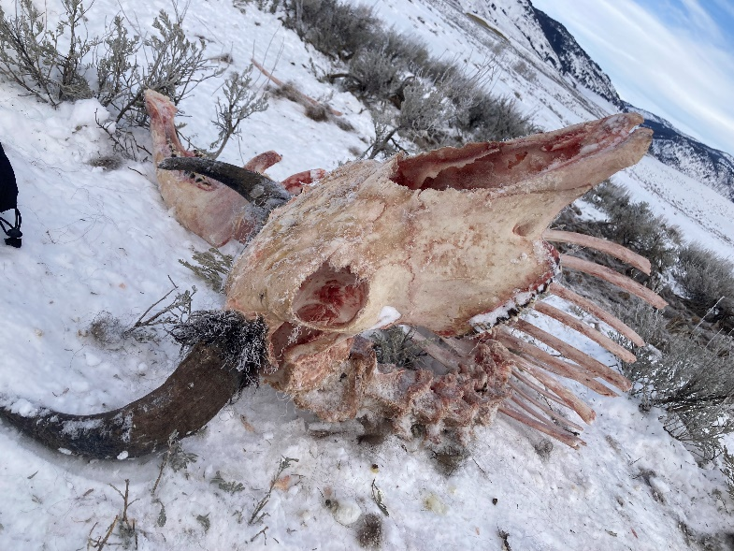Scavengers (especially avian and invertebrate) are an underappreciated part of our ecosystems that provide critical ecosystem services such as the quick removal of carrion, limiting the spread of diseases such as brucellosis. How they fit into the Yellowstone ecosystem, especially with the large shifts in the predator populations that provide them with food during the winter, has garnered little attention compared to the trophic cascades to elk and vegetation. The original study that I am replicating now was done between 1998 and 2001 by Chris Wilmers, a PhD student from UC Berkeley collaborating with the Yellowstone Wolf Project. Despite the federal government excelling at long term monitoring programs, the rigorous examination of scavengers’ winter activities ended with Wilmers. That is until now.

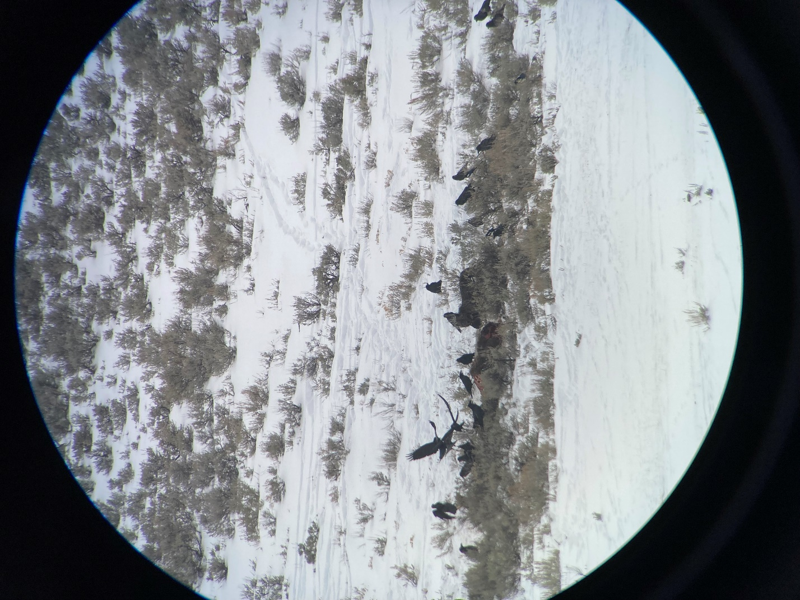Two decades after the original study and the reintroduction of wolves, a lot has changed. The wolf population during the original study period was still recovering but has been stable for the past decade. Scavenger counts have also changed drastically since the original study. The Christmas Bird Count, an annual winter count organized by the Audubon Society and held throughout the Americas, has shown large increases in the detection of ravens and magpies around human dominated areas of Montana. This growing group of highly mobile avian scavengers outside the park is likely to have impacts on the protected system. A larger scavenger guild can inhibit the foraging of wolf packs through kleptoparasitism. Understanding this dynamic now, as wolf populations are stable and scavenger continue to rise, will allow us to identify future changes to the system and if the balance shifts so that scavengers begin to have overbearing negative affect on predators.

Being the recipient of the David L. Mech Fellowship has brought me into the forefront of the current debates around wolf hunting in the Rocky Mountains. This title didn’t impact the research so much as it made me an ambassador for the species. As a visible member of the Yellowstone Wolf Project, visitors had many questions about the current state of Yellowstone wolves, how the hunt was impacting population and social dynamics, and if we thought they would prove resilient to the newly placed, yet oddly familiar, hardships of the winter. Navigating this to inform visitors and ease tensions has helped me understand the debates that often surround progress in environmental sustainability.