**Abstract**

**Introduction**

Yellowstone National Park existed in a predator deficient state for 70 years during the 20th century. The US Army had extirpated gray wolves (*Canis lupus*) and cougars (*Puma concolor*) from Yellowstone by 1926 (Weaver 1978, Noss et al. 2002). Grizzly bears (*Ursus arctos horribilis*) were in significant decline (Craighead et al. 1974) in part due to the closure of National Park landfills in 1970 that had previously provided supplemental feeding for bears, leaving many habituated and requiring lethal removal (Knight & Eberhardt 1985, Eberhardt et al. 1986). During this time, efforts to determine the scavenger population response to the lack of carrion providers were scarce. Coyote abundance was noted to be at its greatest in the Northern Range during the absence of wolves (Crabtree & Sheldon 1999). Winter avian scavenger monitoring in the National Park was completely absent with only Christmas Bird Counts providing tangential evidence for abundance trends in the surrounding regions during this period. Common ravens (*Corvus corax*) and black-billed magpies (*Pica hudsonia*) winter detections increased in developed areas (Appendix A, Supp. Fig. 1, 2). Natural protected areas in the winter are not surveyed.

The reclamation of the landscape by apex predators in the mid-90s (Bangs and Fritts 1996, Ruth 2004) had significant impacts on the entire landscape through multiple trophic cascades. Wolf presence impacts ungulate behavior and spatial use leading to reduced grazing on woody plants (Fortin et al. 2005, Beschta & Ripple 2016). Wolves heavily impacted coyote populations, reducing density and pack sizes from the previously inflated numbers as soon as they were placed on the landscape (Crabtree & Sheldon 1999). Wolves also provide scavenger communities with a more even distribution of carrion across the winter months and less variation in biomass between years (Wilmers & Getz 2004). A limited number of studies were performed on the newly present wolves and common ravens (*Corvus corax*), a ubiquitous foraging generalist. These studies found that the population growth of ravens in the western US was correlated with increased anthropogenic land use (Marzluff et al. 1994) and that the local Yellowstone population could not be attributed to the reintroduction of wolves (Walker et al. 2018). However, wolves on the landscape did impact the spatial use of ravens, allowing them to persist away from developed anthropogenic areas more consistently during the winter with the availability of carrion (Walker et al. 2018). In these natural areas, ravens associated with wolves and were often already present when kills occurred (Stahler et al. 2002).

This study aims to assess scavenger usage of predator-acquired carcasses during the winter. The status of carrion use by scavengers in Yellowstone National Park has not been monitored intensively since Wilmers et al. (2003) sampled wolf-acquired carcasses between 1998-2001 while wolf populations were still recovering. Wolf and cougar populations have since stabilized and the grizzly population continues to rise (White et al. 2017). Comparing the two study periods, we expect to detect an increase in ravens and magpies, following general population trends in areas surrounding the park. We expect to detect less coyotes at carcasses due to lower densities created by the reintroduction of wolves. We also aim to assess differences in the benefits of wolf and cougar-associated carcasses to scavengers. We expect to have lower counts at cougar acquired carcasses as cougars will hide and defend their kills from scavengers. Finally, we will compare the results of Wilmers et al (2003) sampling method with less intensive options used by the Yellowstone Wolf Project to monitor scavengers. The sampling method created by Wilmer’s et al. (2003) is incredibly time intensive. Understanding the other options for collecting similar data will inform future long-term monitoring protocols.

**Methods**

*Study Area*

We studied the use of carcasses by diurnal scavengers in the northern range of Yellowstone National Park (hereafter referred to as northern range). Ungulate species (Elk, *Cervus canadensis*; American bison, *Bison bison*) migrate through this region during the winter. During the study period, the northern range was used by 4 wolf packs and several smaller groups of dispersers. This area is the primary location for one of the longest running monitoring and research programs for gray wolves as well as a significant monitoring programs for cougars and carcass availability and acquisition on the landscape. The road through the northern range remains open to the public during the winter which allowed us to easily view carcasses from a safe location with the use of 10x42 binoculars and a 20-60 spotting scope. We used software R version 4.2.1 (R Development Core Team 2021) for data processing and analysis.

*Data Collection*

We replicated the monitoring procedure outlined by Wilmers et al. 2003 and will place any adjustments to the procedure here. We recorded the number of predator and scavenger species present at 10-minute intervals and separated detections into spatial areas around the carcass including *at carcass* (within feeding distance), *carcass* arena (within 15 meters), and *field of view* (within 500 meters). We made no precautionary measures to prevent observer bias due to only a single individual with experience in raptor identification (minimal chance at misidentification of eagles sp.) performing observations throughout the data collection period. We concluded monitoring when all scavenging species were absent from within the *carcass arena* for three consecutive sampling points. Five scavenging species were consistently detected at carcasses and will be the focus of analysis (common raven, black-billed magpie, coyote, bald eagle, golden eagle; Appendix B, Supp. Table 1).

*Changes to Maximum Concurrent Counts at wolf acquired carcasses since 1998-2001*

We examined the changes to the maximum concurrent count at wolf associated carcasses since Wilmers’ data collection between 1998-2001 using a Mann-Whitney U test. We restricted Wilmer’s data to only carcasses that were classified as a “wolf kill” or a “kill scavenged from an early stage” to match carcasses observed during the 2021-22 period.

*Primary Predator Effect on Maximum Concurrent Counts*

We examined the effect of the primary predator species present at the carcass on the maximum concurrent number of scavengers detected using a two-sample t-test for normally distributed data, and a Mann-Whitney U test for non-normally distributed data. Normality was assessed with a Shapiro-Wilkes test. We restricted data used to calculate maximum concurrent count of scavengers on cougar-acquired carcasses to only times that had cougars as the most recent predator detected to account for kills often being visited by wolves during the observation period, scaring away cats and altering the visibility and availability of the carcass to scavengers (Appendix C, Supp. Fig. 3, 4, 5).

*Sampling Method Effect on Maximum Concurrent Counts*

We examined the effect of three sampling methods with differing intensity levels on the maximum number of concurrent individuals of various scavenging species detected. Sampling methods compared include intensive ground monitoring, opportunistic ground monitoring coinciding with wolf presence, and opportunistic, and opportunistic aerial counts. When comparing intensive ground to opportunistic ground sampling, the maximum number of concurrent individuals for the intensive monitoring sampling method was calculated by including all individuals within a 500-meter radius of the carcass. We excluded carcasses that were monitored by both intensive and opportunistic ground monitoring methods from the opportunistic ground sample due to the influence from the individual performing the intensive ground monitoring. Maximum concurrent count for each major species from opportunistic ground and intensive ground sampling were compared using a two-sample t-test for normally distributed data, and a Mann-Whitney U test for non-normally distributed data. Normality was assessed with a Shapiro-Wilkes test.

Opportunistic aerial maximum concurrent count data was gathered by comparing photos taken from fixed-winged aircraft and notes taken by the aerial observers. We excluded individuals within the *field of view* when calculating the maximum concurrent count of the intensive ground survey method due to the aerial count having insufficient time to scan the surrounding area, the likely obstruction of the surrounding area by tree cover, and the limited scope of aerial photos of the area surrounding the carcass. We restricted the aerial count data to carcasses that were detected in the northern range of Yellowstone National Park. Maximum concurrent count for each major species from opportunistic aerial and intensive ground sampling were compared using Mann-Whitney U tests.

**Results**

We observed 14 wolf kills and 3 cougars kills on the northern range of Yellowstone National Park for a total of 19580 minutes from November 15, 2021 to March 31, 2022. Eight species (6 avian, 2 mammal; Appendix B, Supp. Table 1) were detected around carcasses during intensive monitoring protocols. A ninth species (red fox; *Vulpes vulpes*) was observed foraging at a wolf-acquired carcass not observed under the intensive ground observation protocols. Ravens, magpies, coyote, and bald eagles were present at all wolf-acquired kills (Appendix B; Supp. Table 1). Ravens, magpies, and golden eagles were present at all cougar-acquired carcasses (Appendix B; Supp. Table 2).

Ravens, magpies, and bald eagles have increased in concurrent numbers at wolf-acquired carcasses since 1998-2001 (p < 0.04, n1998-01 = 72, n2021-22 = 14; Fig. 1; Appendix D, Supp. Table 4). No difference detected in the maximum concurrent counts of coyotes and golden eagles (p > 0.31, Appendix D, Supp. Table 4).

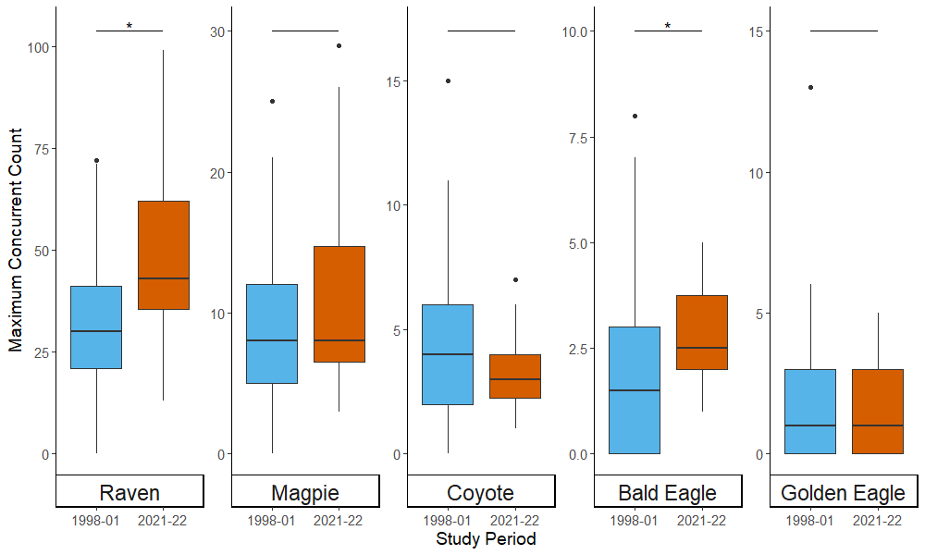Figure . The boxplots show significant differences between the maximum concurrent counts of scavenger species at carcasses observed within each study period.

Coyotes had a greater maximum concurrent count at wolf-primary carcass than those primarily associated with cougar (nwolf = 14, ncougar = 3; Fig. 2; Appendix D, Supp. Table 5). All other species showed no significant difference in maximum concurrent count at wolf or cougar-primary carcasses (Fig. 2; Appendix D, Supp. Table 5). 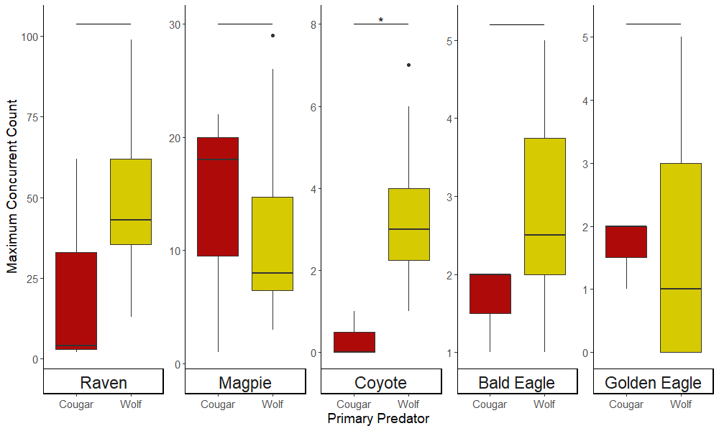

Figure 2. The boxplots show significant differences between the maximum concurrent count of scavenger species at carcasses with wolf and cougars as the primary predator present.

Opportunistic ground and intensive ground sampling showed no significant difference in the maximum concurrent count of golden eagles (Fig 3; Appendix F, Supp. Table 6). All other species showed significantly lower maximum concurrent counts from opportunistic ground and opportunistic aerial sampling when compared to intensive ground sampling (Fig 3, 4; Appendix F, Supp. Table 6, 7).

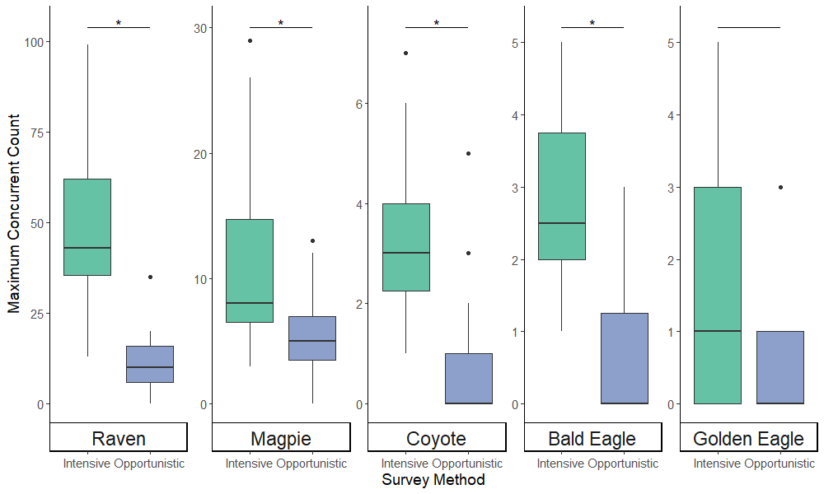

Figure . The boxplots show significant differences between the average maximum concurrent count of scavenger species recorded between intense ground and opportunistic ground sampling.

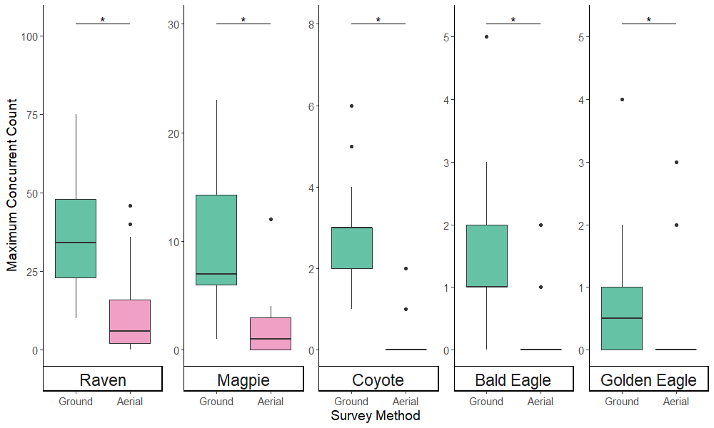

Figure . The boxplots show significant differences between the average maximum concurrent count of scavenger species recorded between intense ground and opportunistic aerial sampling.

**Discussion**

Our data shows an increase in the usage of winter wolf-acquired carcasses by wide ranging generalist foragers (raven and bald eagle) that have shown growing populations in the areas north of Yellowstone National Park (Appendix A, Supp. Fig. 2). The population growth of ravens and other corvids in the western US has been linked to increasing anthropogenic land use (Marzluff and Neatherlin 2006). The transformation of natural lands into agricultural and other developed areas creates new food subsidies that these mobile, generalists can take advantage of to increase survival rates and breeding success (Marzluff and Neatherlin 2006). Magpies did not show a change in the maximum concurrent count despite also being generalist foragers. Increasing populations in Montana (Appendix A, Supp. Fig. 1) are likely also influenced by more prevalent anthropogenic food subsidies (Marzluff and Neatherlin 2006). However, magpie dispersal and commuting potential is much lower than that of the larger raven and bald eagle, so an increasing population in surrounding areas will have less impact on the interior processes of large protected areas.

We were unable to detected changes to the maximum concurrent count of coyotes or golden eagles at wolf-acquired carcasses. This failed to meet our expectation of lower coyote counts following population decline from wolf-induced mortalities (Crabtree and Sheldon 1999). Neither study identified the number of unique individuals, leading to a potential misrepresentation of the actual number of individuals benefiting from carcasses. Although, coyote pack size, a measure more likely represented by maximum concurrent count, also decreased following wolf reintroduction (Crabtree and Sheldon 1999). Golden eagle winter abundance in Yellowstone is unknown since individuals may migrate to and from the region during this time and yearly winter populations likely fluctuating. The Yellowstone breeding population has shown little growth due to low nesting success (Haines 2021).

This increase in the abundance of scavengers at wolf-acquired carcass, most notably ravens, which increased their average by 18 (from 32 in 1998-01 to 50 in 2021-22), may eventually lead to kleptoparasitism issues for smaller packs. Scavengers can steal a large proportion of carrion from small packs of wolves who don’t have the numbers to outrace the mass arrival of scavengers (Hayes et al. 2000). The effects of this in the current Yellowstone system will likely depend on the future of Montana wolf hunting quotas. A large hunt (25 individuals that primarily lived within Yellowstone National Park borders), as seen in the winter of 2021-22 during the recent sampling period, can result in the emergence of new, smaller groups that would suffer more from increased scavenger competition (CITATION). If scavenger populations continue growing, negative impacts will eventually be felt by larger packs as well.

Differences in scavenger usage at cougar- and wolf-primary carcasses were unlikely to be detected due to the small sample size of cougar kills (n = 3) and the extreme variability in behavior of predators around cougar-primary carcasses. Cougar and wolf behavior at kill sites varies greatly. Cougars are subordinate apex predators, surrendering their prey to other predators such as wolves and bears (grizzly; black [*Ursus americanus*]). They actively deter smaller scavengers and mesocarnivores such as red fox, coyotes, and any number of avian scavengers by camouflaging and defending their kills (Allen et al. 2015). Wolves will show dominance over all mammalian scavengers, except bears, and will compete indirectly with avian scavengers by gorging before they can arrive (Wilmers et al. 2003, Kaczensky et al. 2005). They then retreat to rest, allowing scavengers free reign over the food source.

As other systems progress with reconstructing their native predator populations by reintroducing wolves, the benefits that current predators have to scavengers may change. Cougars in other ecosystems can provide large amounts of carrion to scavengers, even extending beyond the biomass that is provided by wolves in Yellowstone (Elbroch and Wittmer 2012). However, the high elevation, harsh winter climate, and abundance of competitively dominant predators creates a system where cougars may be less willing to abandon any food source they acquire. This shouldn’t prevent the continuation of these programs as the benefit a fully intact ecosystem provides many more benefits than the ability to subsidies any inflated scavenger populations.

Active cougar residency at a kill did not affect red fox foraging during the southern GYE winter (O’Malley et al. 2018). Their residency metric only ends after the last feeding bout though and they were not able to account for how far away the cat was from the carcass at any point in between the start and end of residency. So, it is possible that the cat made a kill, sat a mile away, allowing foxes to feed safely, and then returned later.

Cougars in Patagonia abandon more biomass to scavengers than wolves in Yellowstone (232.1 ± se 31.1 kg meat/month/100 km2; Elbroch and Wittmer 2012). However, they are simply abandoning kills instead of being pushed off kills. With the presence of wolves in the Yellowstone ecosystem, the dynamic is vastly different. I think that cougars in YNP are less likely to just abandon kills because there are instances where their kills can be taken away from them by wolves. Also unsure about weather conditions here vs in their study area (Chile's Aysén District in central Patagonia) and the time period that they collect data for. If they had better weather conditions due to either location/elevation or time period, then that may have facilitated the ability of cats to just leave kills for other opportunities.

The future of scavenger monitoring in the park is uncertain as we have shown that current opportunistic sampling methods from ground and air are not sufficiently able to assess maximum concurrent counts of scavengers. Perhaps alterations can be made to these opportunistic methods to increase their viability while still reducing the effort below intensive ground survey methods.

**Acknowledgements**

CH received funding from the David L. Mech fellowship at the International Wolf Center. CH, DS, and DWS received funding from many individual donors through Yellowstone Forever to the Yellowstone Wolf Project. A special thanks to Yellowstone Wolf Project biological technicians, Jeremy SunderRaj, Taylor Rabe, and Wesley Binder, for assistance in locating predator-acquired carcass sites. Christmas Bird Count data is provided by the National Audubon Society and through the generous efforts of Bird Studies Canada and countless volunteers across the Western Hemisphere.

**Lit Cited**

Allen, M.L., L.M. Elbroch, C.C. Wilmers, H.U. Wittmer. The Comparative Effects of Large Carnivores on the Acquisition of Carrion by Scavengers. *The American Naturalist, 185(6): 822-833*.

Bangs E.E. and S.H. Fritts. 1996. Reintroducing the gray wolf to central Idaho and Yellowstone National Park. Wildlife Society Bulletin 24: 402-413.

Bartumeus, F., L. Giuggioli, M. Louzao, V. Bretagnolle, D. Oro, S.A. Levin. 2010. Fishery Discards Impact Seabird Movement Patterns at Regional Scale. *Elsevier, 20(3): 215-222*.

Beschta, R.L. and W.J. Ripple. 2016. Riparian vegetation recovery in Yellowstone: The first two decades after wolf reintroduction. *Biological Conservation, 198: 93-103*.

Crabtree R.L. and J.W. Sheldon. 1999. Coyotes and canid coexistence. In *Carnivores in Ecosystems: The Yellowstone Experience*, edited by Clark T.W., A.P. Curlee, S.C. Minta, P.M. Kareiva, 127 – 163.New Haven, CT: Yale University Press.

# Craighead, J.J., J.R. Varney, F.C. Craighead Jr. 1974. A Population Analysis of the Yellowstone Grizzly Bear. *Bulletin: Forestry, 1949-1982. 25*

Eberhatdt, L.L., R.R. Knight, B.M. Blanchard. 1986. Monitoring grizzly bear population trends. *Journal of Wildlife Management, 50: 613-618*.

# Eberhardt, L.L. and R.R. Knight. 1996. How Many Grizzlies in Yellowstone? *The Journal of Wildlife Management, 60(2): 416-421*.

Fortin, D., H.L. Beyet, M.S. Boyce, D.W. Smith, T. Duchesne, J.S. Mao. 2005. Wolves Influence Elk Movements: Behavior Shapes a Trophic Cascade in Yellowstone National Park. *Ecology, 86(5): 1320-1330*.

Haines, D.B. 2021. Golden Eagle Resource Selection and Environmental Drivers of Reproduction in the Northern Range of Yellowstone National Park. *MS Thesis: University of Montana*.

Hayes R.D., A.M. Baer, U. Wotschikowsky, A.S. Harestad. 2000. Kill rate by wolves on moose in the Yukon. *Canadian Journal of Zoology 78: 49-59*.

Kaczensky, P., R.D. Hayes, C. Promberger. Effect of raven *Corvus corax* scavenging on the kill rates of wolf *Canis lupus* packs. *Wildlife Biology, 11(2): 101-108*.

Knight, R.R. and L.L. Eberhardt. 1985. Population dynamics of Yellowstone grizzly bears. *Ecology, 66: 323-334*.

Marzluff, J.M., R.B. Boone, G.W. Cox. 1994. Historical changes in populations and perceptions of native pest bird species in the West. *Studies in Avian Biology, 111(4): 15202-15220*.

Marzluff, J.M. and E. Neatherlin. 2006. Corvid response to human settlement and campgrounds: Causes, consequences, and challenges of conservation. *Biological Conservation, 130(2): 301-314*.

Marzluff, J.M., M-C. Loretto, C.K. Ho, G.W. Coleman, M. Restani. 2022. Thinking like a raven: restoring integrity, stability, and beauty to western ecosystems. *Human-Wildlife Interactions, 15(3): 22*.

National Audubon Society. 2022. The Christmas Bird Count Historical Results [Online]. Available http://www.christmasbirdcount.org [Accessed April 13, 2022]

O’Malley, C., L.M. Elbroch, P.E. Lendrum, H. Quigley. Motion-triggered video cameras reveal spatial and temporal patterns o red fox foraging on carrion provided by mountain lions. *PeerJ, 6: e5324* doi.org/10.7717/peerj.5324

R Development Core Team. 2021. R: A language and environment for statistical computing. Vienna, Austria: R Foundation for Statistical Computing. <https://www.R-project.org/>

Ruth, T. K. 2004. Ghost of the Rockies: The Yellowstone cougar project. *Yellowstone Science, 12: 13–24*.

Stahler, D., B. Heinrich, D. Smith. 2002. Common ravens, *Corvus corax*, preferentially associate with grey wolves, *Canis lupus*, as a foraging strategy in winter. *Animal Behaviour, 64(2): 283-290*.

USGS (United States Geological Survey). 2021. Breeding Bird Survey [Online]. Available https://www.pwrc.usgs.gov/bbs/rawdata/ [Accessed April 11, 2022]

Walker, L.E., J.M. Marzluff, M.C. Metz, A.J. Wirsing, L.M. Moskal, D.R. Stahler, D.W. Smith. 2018. Population responses of common ravens to reintroduced gray wolves. *Ecology and Evolution, 8(22): 11158-11168.*

# Weaver, H. 1978. The Wolves of Yellowstone. *USDI, National Park Service, Natural Resources Report 14*.

# White, P.J., K.A. Gunther, F.T. Van Manen, eds. 2017. *Yellowstone grizzly bears: ecology and conservation of an icon of wildness*. Bozeman, MT: Yellowstone Forever.

# Wilmers, C. C., Crabtree, R. L., Smith, D. W., Murphy, K. M., and W. M. Getz. 2003. Trophic facilitation by introduced top predators: grey wolf subsidies to scavengers in Yellowstone National Park. *Journal of Animal Ecology 72: 909-916*.

# Wilmers, C.C. and W.M. Getz. 2004. Simulating the effects of wolf-elk population dynamics on resource flow to scavengers. *Ecological Modelling, (1-2): 193-208*.

Yonk, R.M., J.C. Mosley, P.O. Husby. 2018. Human Influences on the Northern Yellowstone Range. *Rangelands, 40(6): 177-188*.