Appendix A: Detection trends of common ravens and black-billed magpies in Montana from Christmas Bird Count surveys.

Supplemental Figure 1. Average number of black-billed magpies counted on Montana Christmas bird counts. Routes included in calculations were limited to those that had been conducted greater than 8 times (25th quantile) since CBC inauguration in Montana in 1900. Black dashed lines show one standard deviation from the average count with a lower limit of 0. Red dashed line shows the year feeding of grizzly bears was prohibited. Blue dashed line shows the year the grey wolf reintroduction was initiated.

Supplemental Figure 2. Average number of common ravens counted on Montana Christmas bird counts. Routes included in calculations were limited to those that had been conducted greater than 8 times (25th quantile) since CBC inauguration in Montana in 1900. Black dashed lines show one standard deviation from the average count with a lower limit of 0. Red dashed line shows the year feeding of grizzly bears was prohibited. Blue dashed line shows the year the grey wolf reintroduction was initiated.

Appendix B: Percentage of carcass sites scavenged by each species detected

Supplemental Table 1. Percentage of wolf-acquired carcasses where each scavenging species was detected during intensive ground sampling. Additionally, a red fox was detected foraging at one carcass not observed under the intensive ground observation method (n = 14).

|  |  |
| --- | --- |
| **Species** | Percentage of Sites Present |
| Common raven | 100% (14) |
| Black-billed magpie | 100% (14) |
| Coyote | 100% (14) |
| Bald eagle | 100% (14) |
| Golden eagle | 64.3% (9) |
| Rough-legged hawk | 7.1% (1) |
| Bobcat | 7.1% (1) |
| American crow | 7.1% (1) |

Supplemental Table 2. Percentage of cougar-acquired carcasses where each scavenging species was detected during intensive ground sampling (n = 3).

|  |  |
| --- | --- |
| **Species** | Percentage of Sites Present |
| Common raven | 100% (3) |
| Black-billed magpie | 100% (3) |
| Coyote | 33.3% (1) |
| Bald eagle | 66.7% (2) |
| Golden eagle | 100% (3) |

Appendix C: Time series plots of cougar-acquired carcasses

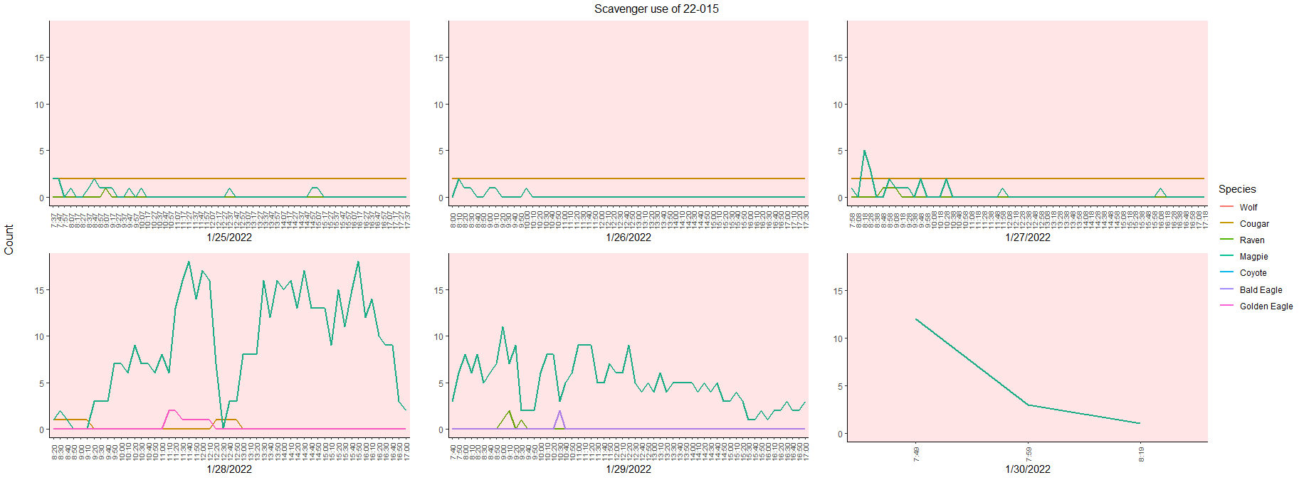

Supplemental Figure 3. Time series plot of scavenger counts across duration of observation on carcass 22-015. Red background indicates time used to calculate maximum concurrent counts for cougars where they were the most recent predator present.

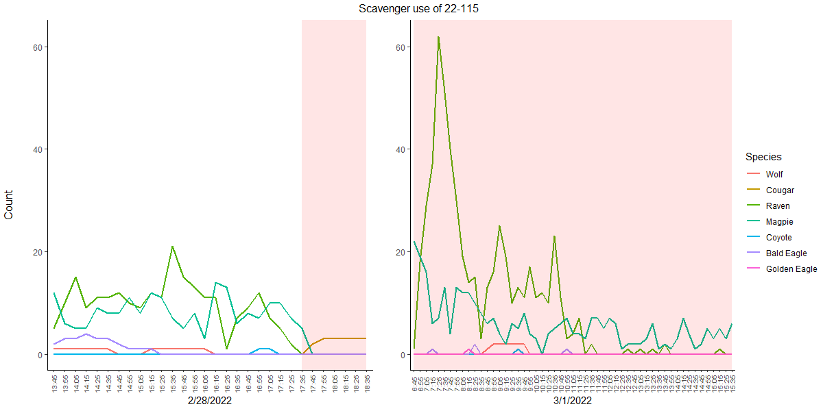

Supplemental Figure 4. Time series plot of scavenger counts across duration of observation on carcass 22-115. Red background indicates time used to calculate maximum concurrent counts for cougars where they were the most recent predator present.

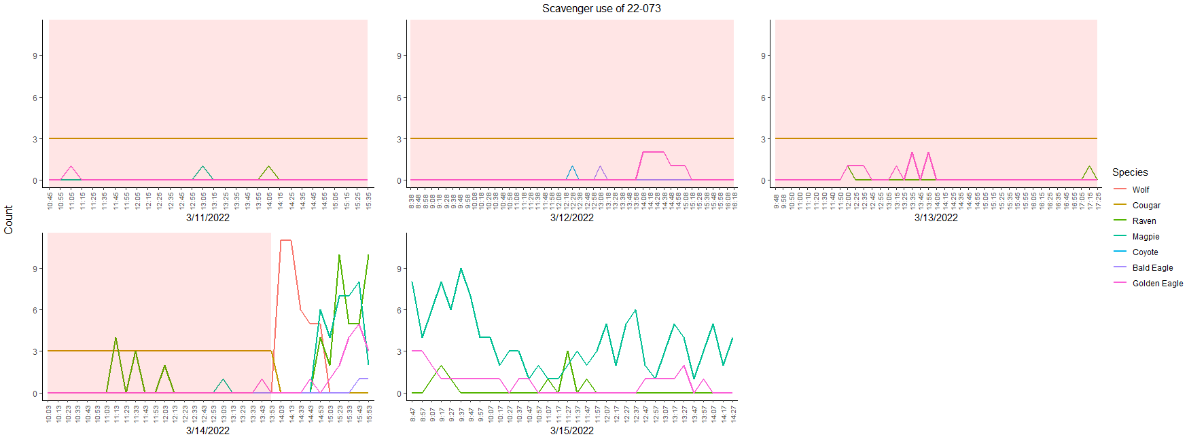

Supplemental Figure 5. Time series plot of scavenger counts across duration of observation on carcass 22-073. Red background indicates time used to calculate maximum concurrent counts for cougars where they were the most recent predator present.

The three cougar-primary carcasses observed showed completely different scenarios, allowing for variable numbers of scavengers. Kill 22-015 (Appendix C, Supp. Fig. 3) was made by a female cougar and a single kitten who defended the carcass for its duration. Scavengers refrained from feeding or approaching the carcass until the cougars had abandoned the kill and were only able to forage for a short while on the little that remained after the cougars left. Kill 22-115 (Appendix C, Supp. Fig. 4) was made by a female cougar with two kittens. During the day they retreated upslope (WHAT DISTANCE? CHECK GPS), allowing scavengers and a few solitary wolves access to feed until the cougars would return in the evenings. Kill 22-073 (Appendix C, Supp. Fig. 5) was made by a female cougar and her two kittens, and similar two 22-015, the adult stayed present directly at the kill site to defend the carcass. This behavior was disrupted when she was chased off by a pack of wolves who claimed the carcass as their own and were quickly followed by the entire host of scavengers that wolf kills are typically associated with.

Appendix _: Average maximum concurrent counts at wolf- and cougar-acquired carcasses

Supplemental Table 3. Average high count and standard error of main scavenger species detected at wolf- and cougar-acquired carcasses during the 2021-22 study period (n = 14).

|  |  |  |  |  |  |
| --- | --- | --- | --- | --- | --- |
|  | Raven | Magpie | Coyote | Bald Eagle | Golden Eagle |
| Wolf  acquired | 50 $±$ 6.56 | 11.86 $±$ 2.15 | 3.4 $±$ 0.46 | 2.79 $±$ 0.35 | 1.57 $±$ 0.43 |
| Cougar acquired | 22.67 $±$ 19.68 | 13.67 $±$ 6.44 | 0.33 $±$ 0.33 | 1.67 $±$ 0.33 | 1.67 $±$ 0.33 |

Appendix D: Statistical results of comparison of maximum concurrent counts between 1998-2001 and 2021-22 study periods

Supplemental Table 4. The maximum concurrent count of scavenging species detected within 500 meters of wolf acquired carcasses observed during 1998-2001 and 2021-22 sampling periods were compared using multiple t-tests (*) or Mann-Whitney U tests (**). Shown are t or W-values, degrees of freedom (for t-test only), p-value, and 95% confidence intervals.

|  |  |  |  |  |
| --- | --- | --- | --- | --- |
| **Species** | **t or W** | **df** | **p-value** | **Confidence Interval** |
| **Raven\*** | -3.48 | 84 | <0.001* | -28.3 – -7.7 |
| **Magpie\*\*** | 409.5 | -- | 0.27 | -6.0 – 1.0 |
| **Coyote\*\*** | 577.5 | -- | 0.39 | -1.0 – 2.0 |
| **Bald Eagle\*\*** | 289.5 | -- | 0.01 | -2.0 – -2.0e-5 |
| **Golden Eagle\*\*** | 509 | -- | 0.96 | -1.0 – 1.0 |

Appendix E: Statistical results of comparison of wolf- and cougar-acquired carcass maximum concurrent counts

Supplemental Table 5. The maximum concurrent count of scavenging species detected within 500 meters of a carcass observed with wolves or cougars as the primary predator were compared using multiple t-tests (*) or Mann-Whitney U tests (**). Shown are t or W values (depending on test used), degrees of freedom (for t-test only), p-value, and 95% confidence intervals.

|  |  |  |  |  |
| --- | --- | --- | --- | --- |
| **Species** | **t or W** | **df** | **p-value** | **Confidence Interval** |
| **Raven\*** | 1.65 | 15 | 0.12 | -7.9 – 62.6 |
| **Magpie\*\*** | 19 | -- | 0.85 | -14.0 – 11.0 |
| **Coyote\*\*** | 41 | -- | 0.01* | 1.0 – 5.0 |
| **Bald Eagle\*\*** | 32 | -- | 0.17 | -4.2e-5 – 3.0 |
| **Golden Eagle\*\*** | 18.5 | -- | 0.8 | -2.0 – 2.0 |

Appendix F: Statistical results of comparison of sampling method maximum concurrent count

Supplemental Table 6. The maximum concurrent count of scavenging species detected within 500 meters of a carcass observed by intensive ground and opportunistic ground sampling were compared using multiple t-tests (*) or Mann-Whitney U tests (**). Intense ground sampling data compared with opportunistic ground data collected by Yellowstone Wolf Project during winter (Nov 15, 2021 – Mar 31, 2022). Shown are t or W values (depending on test used), degrees of freedom (for t-test only), p-value, and 95% confidence intervals.

|  |  |  |  |  |
| --- | --- | --- | --- | --- |
| **Species** | **t or W** | **df** | **p-value** | **Confidence Interval** |
| **Raven\*** | 5.55 | 15.846 | <0.001* | 23.7 – 53.0 |
| **Magpie\*\*** | 176.5 | -- | 0.008* | 1.0 – 10.0 |
| **Coyote\*** | 201 | -- | <0.001* | 2.0 – 3.0 |
| **Bald Eagle\*\*** | 199 | -- | <0.001* | 1.0 – 3.0 |
| **Golden Eagle\*\*** | 155.5 | -- | 0.053 | -3e-5 – 2.0 |

Supplemental 7. The maximum concurrent count of scavenging species detected within 15 meters of a carcass observed by intensive ground and opportunistic time aerial sampling were compared using multiple Mann-Whitney U tests. Intense ground sampling data compared with aerial data collected by Yellowstone Wolf Project during winter (Nov 15, 2021 – Mar 31, 2022). Shown are W-values, p-value, and 95% confidence intervals.

|  |  |  |  |
| --- | --- | --- | --- |
| **Species** | **W** | **p-value** | **Confidence Interval** |
| **Raven** | 421 | <0.001* | 17.0 – 37.0 |
| **Magpie** | 424.5 | <0.001* | 4.0 – 10.0 |
| **Coyote** | 455.5 | <0.001* | 2.0 – 3.0 |
| **Bald Eagle** | 404.5 | <0.001* | 1.0 – 2.0 |
| **Golden Eagle** | 338.5 | <0.001* | 3.6e-5 – 1.0 |