Chapter 2: Breeding raven foraging decisions in the face of multiple sources of carrion.
Introduction
Individual organisms must allocate time across daily activities, such as foraging, resting, and maintenance, to maximize their fitness (Dunbar et al. 2009). Some animals may adjust their time budget based on their understanding of available resources. Such decisions may be influenced by changing environmental conditions, including predation risk and food and water availability. Bighorn sheep (Ovis canadensis) select habitat for predator avoidance unless constrained by drought conditions (Gedir et al. 2020). Female common eiders (Somateria mollissima) abandon their chicks when in poor body condition, trading reproductive success for foraging opportunities (Bustnes and Erikstad 1991). These decisions become more difficult when resources are not scarce but are instead unpredictable.
Scavengers utilize an inherently unpredictable, ephemeral resource. The availability of carrion can vary from year to year due to weather conditions, leading to animal deaths from starvation or exposure. Carrion availability can also vary with population size, distribution, and the hunting success rates of local predators. Scavengers have developed efficient methods of locating carrion, such as soaring in vultures and sensitive olfaction in mesocarnivores (NEED REFS). However, when multiple sources of carrion are available, optimally foraging scavengers should weigh the costs of travel against the probability of finding food when deciding which resource to exploit on any given day (Bernays and Funk 1999, Tan and Tan 2017).
Natural and anthropogenic resources present scavengers with differing spatial and temporal predictability. Foods provided by people can be more predictable in space and time than those provided by other carnivores (Bartumeus et al. 2010, Cortés-Avizanda et al. 2012). Human hunters often “field dress” large harvested animals, leaving behind edible biomass in gut piles containing organs, muscle, bones, and hide that are then available to scavengers. The spatial and temporal distribution of carrion created from recreational hunting and natural predation creates different foraging opportunities for scavengers. In gray wolf (Canis lupus)- dominated systems, natural carrion is temporally unpredictable due to wolves' low hunting success (MacNulty 2002) and occurs across a wide spatial scale (Wilmers et al. 2003b). Anthropogenic carrion is more temporally and spatially aggregated, with heavy harvest occurring around roadways and backcountry access points, thereby providing more individuals from species with high mobility access to the area with a reliable resource (Wilmers et al. 2003b). Human persecution of larger carnivores and mesocarnivores may also prevent certain species, such as coyotes (Canis latrans) and wolves, from safely accessing anthropogenic carrion, thereby removing dominant competitors (Wilmers et al. 2003b).
Common ravens (Corvus corax) are foraging generalists and facultative scavengers with a high movement potential due to efficient soaring. They evolved alongside wolves and humans and use carrion and offal provided by both species. Ravens are attracted to wolf presence and howls (Harrington 1978, Stahler et al. 2002) and the sights and sounds of human hunters (White 2005, Marzluff et al. 2021). Ravens adjust their foraging behavior depending on human and wolf provisioning. Winters with higher wolf prey-acquisition rates are associated with greater raven use of wolf-habitat relative to anthropogenic landscapes (Walker et al. 2018). Territory holding ravens defend area around their nesting and roosting sites year-round (B. Heinrich 1988); however, outside of the breeding season, when free from parental duties, they are not as restricted in their use of space (Ho et al. 2023).
To better understand how variations in the availability of carrion from natural and anthropogenic sources influence the foraging and movement decisions of territory-holding ravens, we monitored their movements in Yellowstone National Park. Gray wolves were reintroduced to the landscape in 1995 and have since returned to a healthy, stable population level (Cassidy et al. 2025). Their return to the landscape contributed to a more consistent regime of natural carrion throughout the year ;(Wilmers et al. 2003a, Wilmers and Getz 2004). Yellowstone is surrounded by private and public lands that permit recreational ungulate hunting during the winter. These two carrion sources are both readily used by common ravens ,(Ho et al. 2023). In fact, ravens that hold breeding territories within Yellowstone National Park have been documented commuting during the winter between their territories and hunting areas outside the park boundaries (Marzluff et al. 2021).
We investigate two decisions made by territorial ravens during the non-breeding season: 1) when to leave the territory in search of distant foods, and 2) where to search for food after leaving the territory. We predict that ravens are less likely to leave their territories when (1) there is a wolf kill within their territory that provides a close food resource and attracts other conspecifics into the territory and (2) there is less recreational hunting biomass available that would provide a large and reliable distant resource. After a raven leaves its territory, we predict it will visit recreational hunting areas more often when (1) hunting biomass is more readily available and (2) no wolf kill is located while traveling.

Methods
Study area
Yellowstone National Park is a large (8903 km²), mostly intact temperate ecosystem that includes sagebrush steppe, montane grassland, mixed conifer and pine forests, and thermally active regions. Yellowstone is bordered to the north by the Custer Gallatin National Forest, public land managed by the USFS that is open to recreational hunting during various seasons. Hunters target elk (Cervus canadensis) and bison (Bison bison) that migrate from Yellowstone during the winter and resident populations of mule (Odocoileus hemionus) and white-tailed deer (Odocoileus virginianus) when winter conditions drive ungulates to lower elevations (Geremia et al. 2011, Rickbeil et al. 2019). In contrast, inside the park a relatively dense wolf population creates carrion during the winter and recreational hunting is prohibited.
Tracking raven movement
We tracked common raven movements in and around Yellowstone National Park between October 2019 and March 2024. Ravens were captured between October 2019 and January 2024 using remote-controlled net launchers (Coda Enterprises, Ltd). Various anthropogenic foods and carrion sources were used as bait. Territorial ravens were caught opportunistically in large feeding groups with vagrant ravens and as targeted efforts at territories along the road within the national park. Solar-powered GPS data loggers (e-obs GmbH; Bird Solar UMTS, 25 g) were then fit to the bird using Teflon harness straps (total assembly weight <4% body mass). The GPS data loggers recorded locations every 30 minutes during daylight hours when battery voltage exceeded 3,900 mV, and hourly when between 3,900 and 3,700 mV. No locations were recorded when the battery voltage was below 3,700 mV. Movement data were downloaded from the GPS data loggers via radio connection to a hand-held receiver or uploaded directly to a Movebank database through a 3G cell network connection.
Territorial status was determined by examining raven movements during the breeding season (Webb et al. 2011). We confirmed this in most cases by observing nesting attempts. Four ravens that were non-breeding at the time of capture transitioned into territorial individuals during the study period. We removed male ravens when both birds in a territorial pair were tagged to avoid pseudoreplication because raven pairs travel together during the winter while foraging. Males had fewer days with successful fixes and a lower daily fix rate than females because their longer feathers more frequently covered the solar panel, preventing charging and resulting in lower battery levels.
We only used GPS points from an individual raven that were separated by at least 29 minutes. This removed instances of fixes obtained in quick succession due to an unintended interaction with the satellite during uploads, while maintaining the maximum number of GPS points.
Availability of wolf-killed carrion
We determined the location and timing of wolf kills using the output of a random forest algorithm developed by Binder et al. (2026) that predicts carrion locations from wolf movements (2 locations within 100 meters), timing (locations within 72 hours), and landscape features. The model makes no determinations about the prey species or cause of death. Each wolf kill was available to be used by ravens from the beginning of wolf use until 1 day after the last wolf GPS point. This additional day accounts for the continued availability and use of the carcass by scavengers after wolves have abandoned it. For resources within a raven’s territory (Fig. 1), we considered all wolf-killed carcasses within 1 kilometer of a territory to be immediately known by the local raven. For resources located after leaving the territory, we considered a raven to have visited a wolf kill if there was at least 1 GPS point within 500 meters of an active kill site. Cougar kills were not considered as the usage of this resource by ravens was minimal compared to wolf created carrion (Loretto et al. in press).
Recreational hunting regions
We defined two separate hunting areas corresponding to the MT Fish, Wildlife, and Parks rifle hunting season and the tribal hunting season (Figs. 1, 2). During MTFWP rifle hunting season, which occurs on slightly varying dates from the last week of October to the end of November or first week of December, elk and deer are the main targets and are small enough to be packed out by hunters. We delineated this region (hereafter, MTFWP hunting region) using a 5 km buffer around all roads located 10 km from the park entrance station in Gardiner, MT. We recognize that additional take will occur outside of this region, but the vast majority of hunting occurs within this space.
Bison hunting is more concentrated around the roadway as bison migration is largely funneled in the open area along the south side of the Yellowstone River at the park boundary. Adult male bison can weigh over 750 kg during the hunting season (Yellowstone Bison Office, National Park Service, unpublished data), so the effort required to hike a bison harvest back to the road is great and is avoided when possible. We created the bison hunting polygon (hereafter bison hunting region with a 1 km buffer around the Old Yellowstone trail and Highway 89 extending to the cattle grate at the south end of Yankee Jim Canyon, which prevents the northward movement of bison.
Recreational hunting season
We retrieved the MTFWP rifle hunting dates from the hunting regulations published annually by MTFWP (Table 1). We defined the bison hunting season as the period from the first day on which bison were taken during that winter (i.e., November 2019 – March 2020), which included a second day with a successful take within 7 days, and extended until the end of the winter study period (March 30; Table 1). Bison-hunting dates are flexible because harvest is influenced more by bison movement than by hunting-date regulations for tribal hunters (December 1st to March 31st). A single exception was made for 2024, when only a single day during the study period had a successful take. An unknowable t
ake occurs outside of these periods from other sources such as tribes harvesting other species (e.g. elk, deer, etc.). These harvests are on a much smaller scale than either the MTFWP hunting season or the tribal bison hunt (Kqyn Kuka, ADD AFFILIATION, personal communication).

Availability of hunter-killed carrion

To calculate availability of hunter created biomass we obtained hunter take information for elk and deer during the rifle hunting period from the Montana Fish, Wildlife, and Parks for the 313 hunting district (https://myfwp.mt.gov/fwpPub/harvestReports) and bison take from the NPS Bison Office (unpublished data). Bison taken in the Gardiner Basin were recorded daily through surveys and communications with NPS law enforcement, private hunters, and game wardens. MTFWP estimates were not daily and needed to be adjusted to account for daily variation because ungulate migration timing is weather-dependent (Rickbeil et al. 2019). We accounted for daily variation in hunter success by using GPS data gathered from elk radio-tagged by the Yellowstone Wolf, Cougar, and Elk project to determine the proportion of elk that have moved outside the national park boundary and are available for hunters to take. This proportion of available elk was scaled within the year and applied to the take values for all ungulate species for that hunting year.
$$daily take=yearly take× \frac{daily proportion elk}{\text{sum}(proportion elk)}$$
The exception is male mule deer which are protected during the last two weeks of the hunting season. The final take numbers of each species were adjusted to account for differences in the weights of various species with all deer species having a 0.3x multiplier and bison having a 2.15x multiplier (elk are the standard at 1x). These multipliers were calculated by comparing early winter weights of deer and elk and late winter weights of bison ((Murphy et al. 1998) NPS Bison Office unpublished data). To account for biomass lingering between days, 25% of the biomass from the previous day was carried over.
Raven movement decisions
To determine if a raven left its territory, we first defined the spatial boundaries of each territory. We determined a raven’s territory location and size by creating a 90% minimum convex polygon (MCP) using the package adehabitatHR (version 0.4.22) in R (version 4.5.1; Development Core Team 2021) from GPS points collected during the breeding season (May - July). We used a less inclusive 90% MCP to remove excursive movements made after nest failure when adults are free to move widely (Fig 1). We determined that a raven stayed on its territory if all locations on that day were within 1 kilometer of the 90% MCP boundary.
We determined a raven foraged for hunter-killed carrion if it had at least 1 GPS point within the appropriate hunting region polygon. The MTFWP hunting region was active for the duration of the MTFWP hunting season and the bison hunting region was active from that date until March 30th. We removed days with fewer than 5 GPS points where ravens did not leave the territory or did not use a hunting area because it was possible that the data were insufficient to detect a movement.
Covariates
Since traveling requires both time and energy, we considered the distances of each raven’s territory to the hunting regions. The commute distance for each raven was calculated by taking the Euclidean distance from the center of the MCP to Yellowstone’s northern entrance station in Gardiner, MT as that was a central location to both hunting regions.
Ravens perform pre-breeding behaviors such as territory defense and nest building to retain possession of their territory. The need to perform these behaviors may impact a raven’s decision to leave its territory. Ravens in Yellowstone typically lay eggs at the end of March until the middle of April (unpublished data). These pre-breeding behaviors should be more prevalent closer to the breeding season. For this reason, months were classified into two categories: early winter comprising November and December, and late winter representing March.
Ravens recognize spaces with higher frequencies of wolf kills (Loretto et al in press). Ravens that hold territories in such areas may be more willing to risk staying on their territories even when a kill is not immediately available. We calculated this by taking an average of the 30-day carcass acquisition rates of wolves using the random forest predictive algorithm across all years that the raven was monitored on territory.
Ravens are social animals that can utilize information sharing to locate foraging opportunities (Marzluff et al. 1996). A territorial raven, even if it doesn’t utilize a communal roost with other ravens to gather information, might still consider the movement decisions of other ravens when deciding their own course of action. We considered the proportion of other ravens leaving their territories or visiting the hunting regions on a particular day, not including the individual in consideration.
Walker et al. (2018) found snowpack to be an important predictor in raven use of wolf habitat in Yellowstone. We included snow depth and maximum daily temperature from Mammoth, WY, as a predictor that might similarly impact territorial raven decision-making.
Raven conditional movement model
We investigated how the availability from two sources of carrion, hunters and wolves, drives movement decisions of breeding ravens during the winter by creating a conditional binomial generalized linear mixed model (GLMM) using the R package lme4 (version 1.1-37) with a random effect for individual. We used a conditional model to decompose the commuting process into two distinct decisions. The first is whether a raven decides to leave its territory (hereafter, the territory model), and the second is whether, after leaving the territory, the raven decides to visit the hunting regions (hereafter, the hunting model). We used the second part of the conditional model to account for the presence of other resources (e.g. wolf kills outside the territory or food in other gateway communities) that may influence a raven’s decision.
We restricted both models to data from the 30-day early (Nov 15 - Dec 15) and late (March 1 - 30) winter study periods done by the Yellowstone Wolf, Cougar, and Elk project, because that is the period the wolf carcass predictive algorithm works for due to a higher wolf collar fix rate. We included an interaction term between the wolf-kill covariate (active kill and visited kill) and the amount of hunting biomass to determine whether one resource was prioritized over the other in the decision-making process. We included two covariates to represent the hunting season and assess the extent to which ravens tracked potential biomass versus a broader, seasonally determined availability. Other covariates in the territory model include distance to the hunting regions, average wolf kill density within the territory, pre-breeding season period, the proportion of other ravens leaving their territories, daily maximum temperature, and daily snow depth. Other covariates in the hunting model are the distance to the hunting region, the proportion of other ravens visiting the hunting regions, average daily temperature, and daily snow depth.

Results
Between October 2019 and March 2024, we gathered 2090 decision days (mean = 104.5, sd = 62.6, range = 4 - 216) from 20 territorial ravens (12 female, 8 male). Ravens decided to leave their territories an average of 86.8% of days (range = 13.9 – 100%, sd = 20%, Fig.3). After leaving their territory, ravens traveled an average 34.6 km (range = 7.4 – 64, sd = 15.7) to forage in the hunting area an average of 68.2% of days (range = 0 – 100%, sd = 32%, Fig. 3). On extraterritorial trips not to the hunting area, ravens would often forage at wolf kills or other gateway communities such as West Yellowstone, MT (Fig 4). Two ravens residing at Old Faithful (7485, 7494; 63 km from hunting regions), the farthest territories from the hunting regions, never traveled to the hunting area (Fig. 3). Conversely, two individuals that lived in the interior (8900, 33 km from hunting regions) and in the northern range (8902, 9.5 km from hunting regions) always chose to leave their territories (Fig. 3).
Wolf kills were rarely available to territorial ravens, either within their territory or beyond it (Fig. 3). Raven territories were on average 5.9 km² (range = 0.8 – 21.2 km², sd = 6.3 km²) and each territory only had a wolf kill available for a mean of 3.1% of days (range = 0 – 25%, sd = 6.2%). Wolf kills were only found outside of the territory on a mean of 9.5% of days (range = 1.8 – 33.3%, sd = 7.7%). Most extraterritorial trips (68.5%) with a wolf kill involved the raven investigating the hunting areas as well (range = 16.7 – 100%, sd = 33.2%). In addition to the two main carrion resources available in the landscape, ravens also visited various anthropogenic subsidies. Ravens spent some time at the landfill and sewage treatment ponds in Gardiner an average of 15.2% of trips to the hunting regions throughout the winter (range = 0 – 60%, sd = 17.3%).

Foraging movement decisions
Food availability and weather conditions both impacted a raven’s decision to leave its territory. A wolf kill within 1 km of a raven’s territory decreased the chance of it leaving its territory (-0.950696, SE = 0.336099, p < 0.01, Table 2, Fig. 5). The availability of hunter created carrion did not impact a raven’s decision to leave its territory, regardless of the metric of consideration (hunting season: -0.117355, SE = 0.203209, p = 0.56; hunting biomass: -0.000691, SE = 0.079927, p = 0.99; Table 2, Fig. 5). There was some evidence that ravens left their territories more often as snow depth increased (0.169126, SE = 0.100207, p < 0.1, Table 2). There was also a trend that ravens were less likely to leave their territory during March compared to November and December (-0.375404, SE = 0.203475, p < 0.1, Table 2). The effect of time period was not complicated by the temperature during late and early winter (0.02524, SE = 0.17565, p = 0.89, Table 2).
When a raven left its territory, its destination was influenced by many factors. Ravens were more likely to visit the hunting regions during the hunting season (0.71482, SE = 0.1776, p < 0.001, Table 3, Fig. 7), but they were not influenced by the actual amount of biomass available in hunting areas (-0.09048, SE = 0.07678, p = 0.24, Table 3). When a wolf kill was located outside of a raven’s territory, it greatly reduced the likelihood of visiting the hunting area (-1.29118, SE = 0.27139, p < 0.001, Fig. 7). Ravens with territories closer to the hunting regions visited the hunting area more often (-1.83694, SE = 0.40598, p < 0.001, Table 3). Ravens made the same travel decisions as other territorial ravens after leaving their territory (0.40688, SE = 0.07663, p < 0.001 Table 3). Ravens’ visits to the hunting area increased as temperatures dropped (-0.16889, SE = 0.07226, p < 0.05) and snow depth increased (0.29086, SE = 0.0892, p < 0.01, Table 3, Fig. 8).

Discussion
Foraging is the fundamental behavior that allows an animal to increase its fitness. When an individual is malnourished, they are physically less capable of avoiding predators or competing to reproduce. Generalist foragers have expanded their palates to include anthropogenic resources, supplementing their foraging and increasing the survival and capacity to reproduce (Marzluff and Neatherlin 2006, Beckmann and Lackey 2008, Bino et al. 2010). Wide-ranging species or individuals that are not tied to territories can selectively alter their space-use to associate with certain resources based on availability (Loretto et al. 2016, Walker et al. 2018, Langley et al. 2021). Species that live within territories year round will move beyond their territories to utilize anthropogenic resources (Ho et al. 2023, López-Peinado et al. 2023). Examining the decisions of territory defending breeders faced with unpredictable availability can provide insight into movement decisions when presented with natural and anthropogenic resources.
Ravens during the winter, like many generalists, are more limited in their foraging options. For Yellowstone’s population of ravens, anthropogenic subsidies and natural predation create the majority of these resources (Ho et al. 2023). In the case of carrion created through recreational hunting and natural predation events, the locations have minimal overlap in space with recreational hunting only legally occurring outside of the national park boundaries (Wilmers et al. 2003b). Territorial ravens must commute to these areas to access anthropogenic resources. We show that territorial ravens use the availability of carrion generated through recreational hunting and predation to determine daily movement patterns. This is in line with a previous study done on the population of ravens in Yellowstone, which was likely skewed towards behavior of nonbreeders due to count surveys being nondiscriminatory and the population being mostly nonbreeders (Walker et al. 2018). While Walker et al. (2018) showed greater numbers of ravens in wild areas during winters with higher rates of wolf predation, they also found an increased abundance of ravens in anthropogenic areas during years with greater snow depth that is likely attributed to increased hunter success due to a heavier ungulate migration (Geremia et al. 2011, Walker et al. 2018).
Ravens often chose to stay within their territories when a wolf kill was present, meeting our expectations. This provides an immediate food resource that a raven can exploit as the local territorial ravens are often the first to locate the carcass (Heinrich and Marzluff 1995). However, this foraging opportunity also leads to a large influx of other scavengers in the area, including ravens, through spatial association with wolves and local enhancement (Heinrich and Marzluff 1995, Stahler et al. 2002, Wilmers et al. 2003a). Territorial ravens may be staying on territory to maintain possession of their territory. Ravens are social creatures and dominant individuals will spend time at food resources displaying to other conspecifics (Heinrich and Marzluff 1995). It is currently unknown through what mechanisms ravens claim or lose ownership of territories, although usurpation and conflict is a common method in other avian species (Arcese 1989, Piper et al. 2000). As a non-migratory species that remains on their territory all year (B. Heinrich 1988), physical presence, visual displays, and vocalizations can all assist the territory owner in retaining possession of the space (Peek 1972, Piper et al. 2000). During the study period we documented one occasion of a territorial pair losing their territory unprecipitated by a mortality event of at least one of the individuals (unpublished data) which contradicts previous assertions that raven pair bonds are only broken by mortality (Bernd Heinrich 1988, Webb et al. 2012).
Our results support the idea that movement decisions are at least partially driven by breeding behaviors by showing reduced extraterritorial movements in March compared to November and December. During this late winter period just prior to the start of the breeding season in April, we observed ravens performing active pre-breeding season behaviors such as nest building. This decision requires a raven to have foraged efficiently during a resource deficient period (winter) and be in good condition to forgo foraging as it is unlikely that there will be a carrion source in its territory. Ravens that bred earlier in the Greater Yellowstone Ecosystem were shown to have greater nesting success (Dunk et al. 1997). Being able to complete pre-breeding season tasks early is important as mistiming the initiation of breeding can result in lower success due to a lack of critical food sources (Visser et al. 2006). Ravens in Yellowstone heavily utilize insects outbreaks such as grasshoppers and salmonflies during the summer breeding season, which allows them to provide a protein dense food to growing chicks (Ho et al. 2023).
Ravens did not consider potential resources in the hunting area when deciding whether to stay within their territory that day. Once they did leave their territory, ravens traveled to the hunting area during the hunting season but were not basing this decision on the amount of available biomass. Hunter kills often have greater raven numbers than wolf kills (Wilmers et al. 2003b), so the expectation would be for a territorial raven to face heavy competition regardless of the amount of hunter carrion available that day. Given that territory holders tend to be dominant individuals, they would be able to gain access to contested resources. The distance between a raven’s territory and the hunting area would also preclude them from having accurate daily information about carrion availability on any day. Only a single tagged raven in our sample group is within the potential range to stay on territory and hear gunshots from the hunting area, which ravens can learned to associate with a potential successful harvest (White 2005). Most ravens were thus making decisions based on information from recent visits, memory of previous years, and other daily proxies. We showed these proxies included weather conditions such as daily temperature and snow depth, which increased chances of leaving the territory and visiting the hunting area when deeper. Snow may indicate to ravens when ungulate populations are migrating out of the park (Geremia et al. 2011, Rickbeil et al. 2019), placing them on lands where they are available to be hunted. Hunters are also more efficient with snow on the ground as it allows them to more easily track ungulate movement. This tracking of weather patterns to optimize foraging movement efficiency is similar to gray-cheeked mangabeys in Uganda considering recent weather patterns effects on the maturation of fruit (Janmaat et al. 2006).
The amount of hunter biomass available did not alter a raven’s perception of wolf kills, making their movement a linear decision-making process with the immediate resource taking precedence. This includes wolf kills that were found outside of the territory. When a raven decided to leave its territory, it was unlikely that they were leaving with the purpose of locating a previously unknown, naturally occurring carcass. All wolf kills that were visited outside of territories, except for one, are within the travel corridor ravens take to reach the Gardiner hunting regions (Fig 1). Territorial ravens in the northern range frequently travel the ~35 km commuting distance to the hunting areas while uploading 0 or 1 intermediate travel points which indicates direct, non-stop flight. The presence of the newly located resource during transit likely altered their plan but was likely not the intended destination. This sort of route planning between distant, known resources has been documented in primates (Noser and Byrne 2007), elephants (Polansky et al. 2015), and is likely performed by ravens (Loretto et al. in press). The presence of dependable, alternative anthropogenic resources within close proximity of the hunting regions such as the Gardiner landfill and sewage treatment ponds, buffers the risk for ravens in deciding to commute by providing an alternative foraging location that is still calorie efficient.
Ravens did not consider the productivity of their territories when making movement decisions, despite their ability to remember this attribute at a broader spatial scale (Loretto et al. in press). Localized kills are apparent to the local breeders and wolf hunting activity most often occurs at dawn and dusk due to wolves’ crepuscular nature. Since territorial ravens often spend the first few hours after sunrise within their territory preening and performing pair-bonding activities, this would allow ample time for most wolf kills to have occurred before they have decided whether to travel.
Despite being social creatures that have the ability to share and receive information about potential food resource (Marzluff et al. 1996), ravens deciding whether to consider were not influenced by the movement of other territorial ravens. This decision was based on factors that each raven could interpret independently such as active kills within their territory or weather conditions. Once a raven has left its territory, it was influenced by the movement of other ravens, often traveling in concert with conspecifics.
Our results suggest that the breeding population of common ravens within Yellowstone National Park utilize recreational hunting as a supplementary food source with their primary target being naturally occurring carrion created through predation. As a foraging generalist, their ability to forage efficiently based on daily changes in food availability allows them to be successful. Since movement decisions are not influenced by the amount of biomass made available by hunters, it is unlikely that efforts to reduce its availability would be effective at preventing the exploitation of the resource. Other studies have shown moderate success in using supplemental feeding within protected areas to reduce movements outside the protected area for large avian scavengers (López-Peinado et al. 2023). However, until the resource is either eliminated or an alternative resource is available on a daily scale, ravens will likely continue to return to recreational hunting areas on days where no other foraging opportunity is available. At small scales, the removal of a landfill site can completely eliminate the presence of ravens (Marzluff et al. 2021). This continued usage of anthropogenic resources buffers raven populations against any decreases in natural carrion availability. Increasing the availability of natural carrion through the recovery of carnivore populations will only reduce the time spent outside of the protected area and in anthropogenic areas.

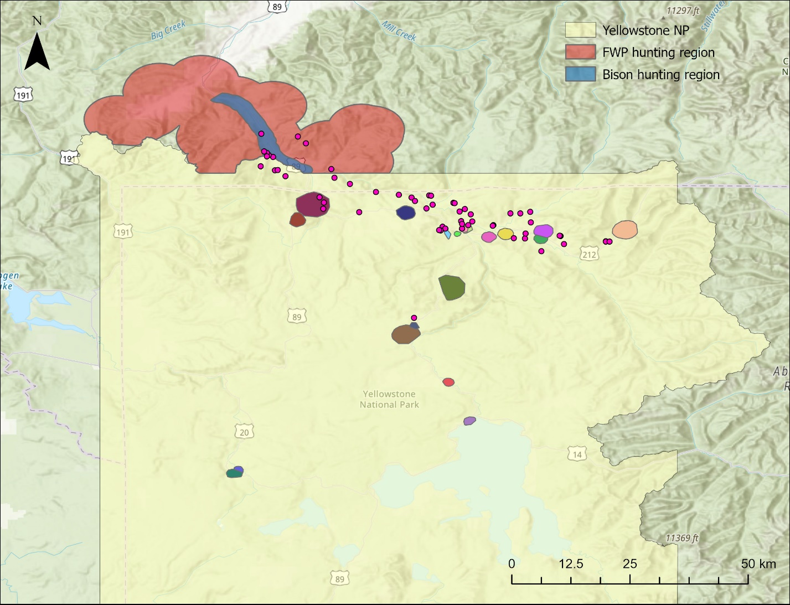
Figure 1. Map of Yellowstone National Park showing the locations of tagged raven territories as colored polygons inside the boundaries. The MTFWP (red) and bison (blue) hunting regions are highlighted outside the north-western boundary of the national park. The MTFWP region was used during the duration of the rifle hunting season. The bison region was used after the end of the MTFWP rifle hunting season and ran until the end of the winter study period (March 30).
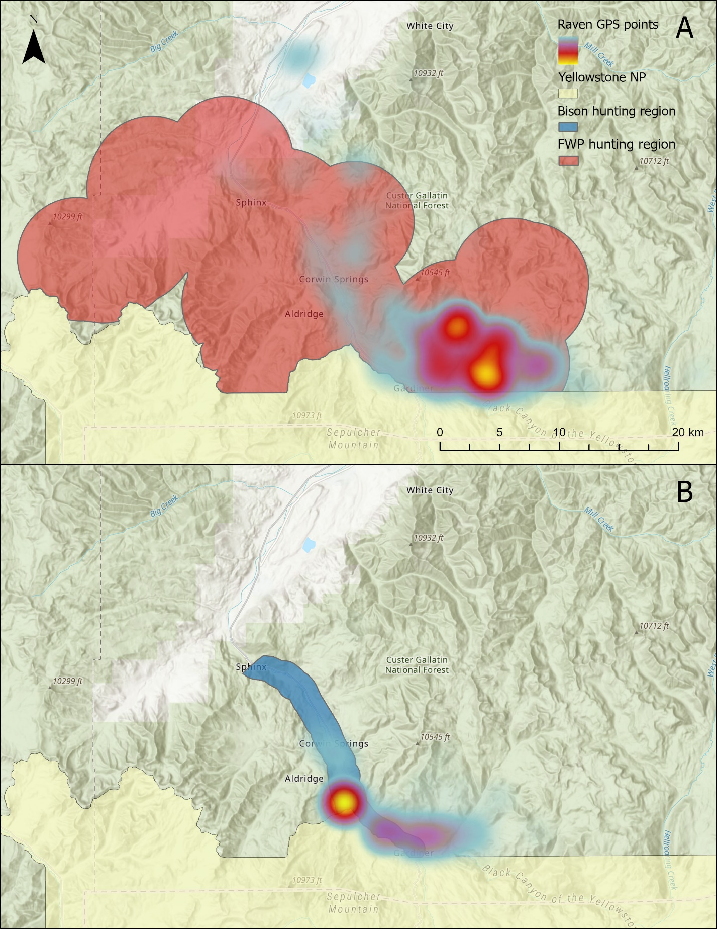
Figure 2. Maps showing the MTFWP hunting region (A) and the bison hunting region (B) compared to a heatmap of the raven GPS points outside of the Yellowstone National Park during (A) November and (B) March respectively. Warmer colors indicate higher point densities.

Table 1. Shows the start and end dates for the MTFWP and bison hunting seasons for a given winter (e.g. winter of 2019 is from November 2019 – March 2020).
 | MTFWP |  | Bison
Winter of | Start date | End date | Start date
2019 | 10/26/2019 | 12/1/2019 | 2/23/2020
2020 | 10/24/2020 | 11/29/2020 | 1/25/2021
2021 | 10/23/2021 | 11/28/2021 | 3/22/2022
2022 | 10/22/2022 | 11/27/2022 | 12/8/2022
2023 | 10/21/2023 | 11/26/2023 | 3/24/2024

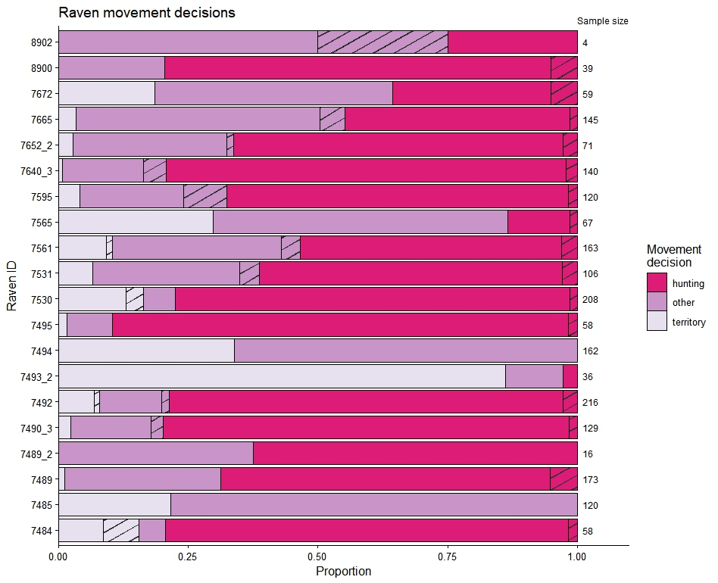
Figure 3. The proportion of decision days that each raven made a particular movement decision. The “other” category is used to encapsulate all extra-territorial movements that did not result in a visit to the hunting regions. Instances where a wolf kill was available (territory) or visited (other/hunting) are denoted by the striped area. The total number of decision days for each raven is displayed on the right-hand side of the plot.

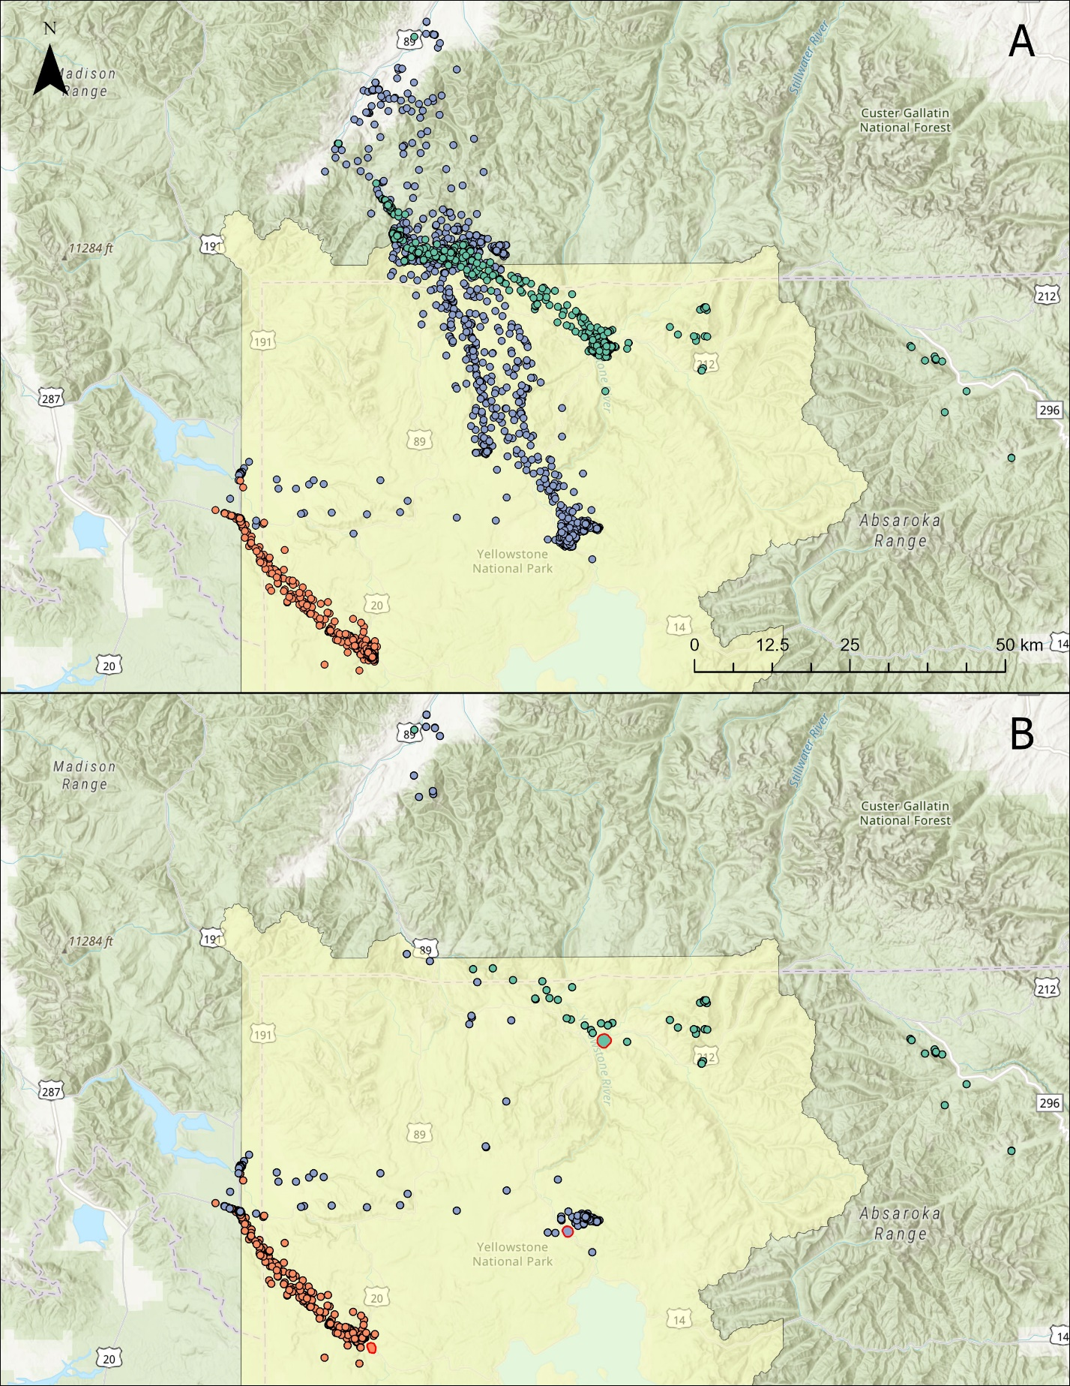
Figure 3. Map A shows the GPS movements of 3 common ravens at varying distances from the hunting regions. Map B shows the GPS movements of these 3 ravens when they decide to leave their territory, but do not end up visiting the hunting regions. Each raven’s territory is shown as a polygon with a red border in their color.

Table 2. Model results from the binomial generalized linear mixed model looking at the impact of covariates on the probability of ravens leaving their territory daily. N = 2115.
 | Estimate | Standard Error | p-value
Intercept | 2.952317 | 0.430538 | 7.02e-12
Wolf kill | -0.950696 | 0.336099 | 0.00467
Hunting biomass | -0.000691 | 0.079927 | 0.9931
Hunting season | -0.117355 | 0.203209 | 0.5636
Kill density | 0.154272 | 0.432232 | 0.72115
Distance | -0.272044 | 0.393263 | 0.48909
Study period | -0.375404 | 0.203475 | 0.06504
Max temp | -0.134228 | 0.150456 | 0.37232
Snow depth | 0.169126 | 0.100207 | 0.09146
Proportion traveling | 0.093792 | 0.079772 | 0.23969
Wolf kill * hunting Biomass | -0.156723 | 0.373471 | 0.67475
Study period * Max temp | 0.02524 | 0.17565 | 0.88574

Table 3. Model results from the binomial generalized linear mixed model looking at the impact of covariates on the probability of ravens visiting the hunting areas surrounding Gardiner, MT when they choose to leave their territory daily. n = 1716.
 | Estimate | Standard Error | p-value
Intercept | 0.23775 | 0.39677 | 0.54902
Visit kill | -1.29118 | 0.27139 | 1.96e-6
Hunting biomass | -0.09048 | 0.07678 | 0.23864
Hunting season | 0.71482 | 0.1776 | 5.7e-5
Distance | -1.83694 | 0.40598 | 6.05e-6
Proportion traveling | 0.40688 | 0.07663 | 1.1e-7
Max temp | -0.16889 | 0.07226 | 0.01942
Snow depth | 0.29086 | 0.0892 | 0.00111
Visit kill * Hunting biomass | -0.61927 | 0.35461 | 0.08075

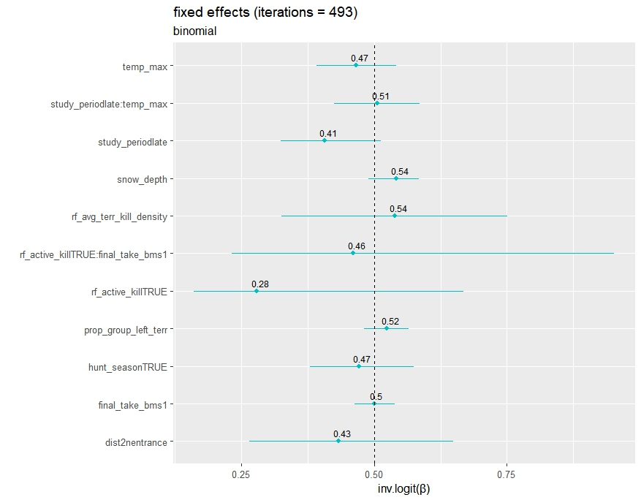
Figure 4. Bootstrapped 95% confidence intervals for model parameters from the territory model showing probability of ravens leaving their territory. Values are back transformed to the probability scale.
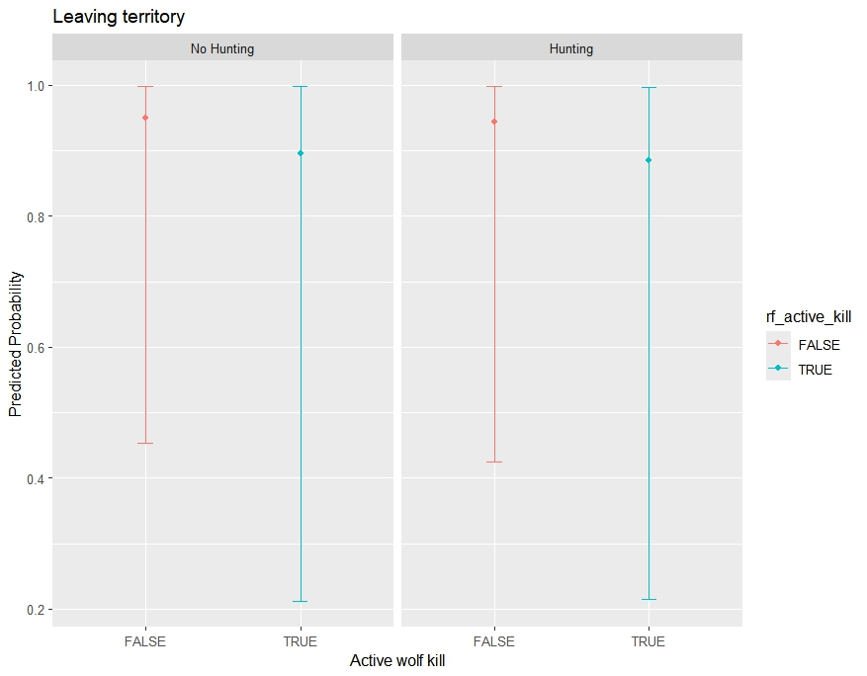
Figure 5. Bootstrapped predicted probability and 95% prediction intervals of ravens leaving their territory based on active wolf kills within their territories and whether the timing of the hunting season. All other continuous scaled covariates are held at 0 and the study period was set to early.
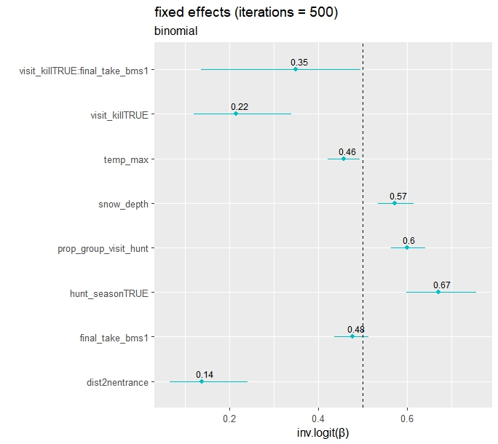
Figure 6. Bootstrapped 95% confidence intervals for model parameters from the hunting model showing probability of ravens visiting the hunting regions when they choose to leave their territory. Values are back transformed to the probability scale.
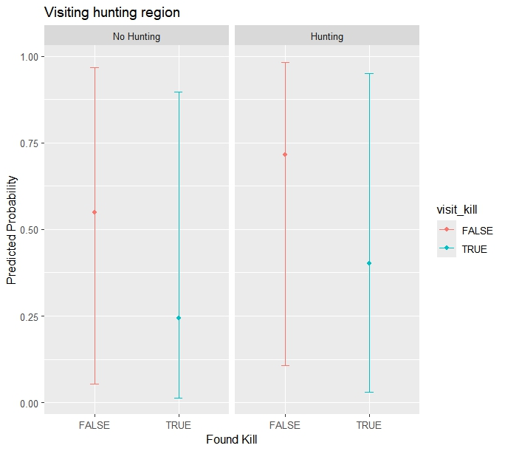
Figure 7. Bootstrapped predicted probability and 95% prediction intervals of ravens visiting the hunting regions based on the timing of the hunting season and whether they located a wolf kill after leaving their territory. All other continuous scaled covariates are held at 0.

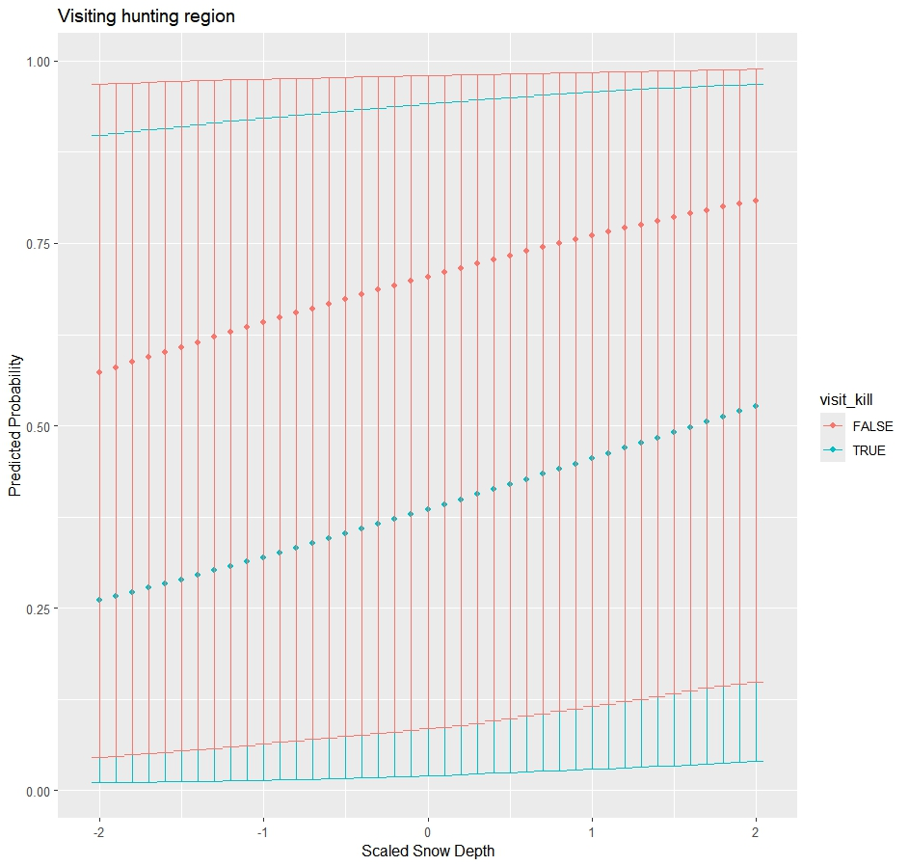
Figure 8. Bootstrapped predicted probability and 95% prediction intervals of ravens visiting the hunting regions based on snow depth and whether they located a wolf kill after leaving their territory. All other continuous scaled covariates are held at 0 and hunting season was set to true.

