Appendix A
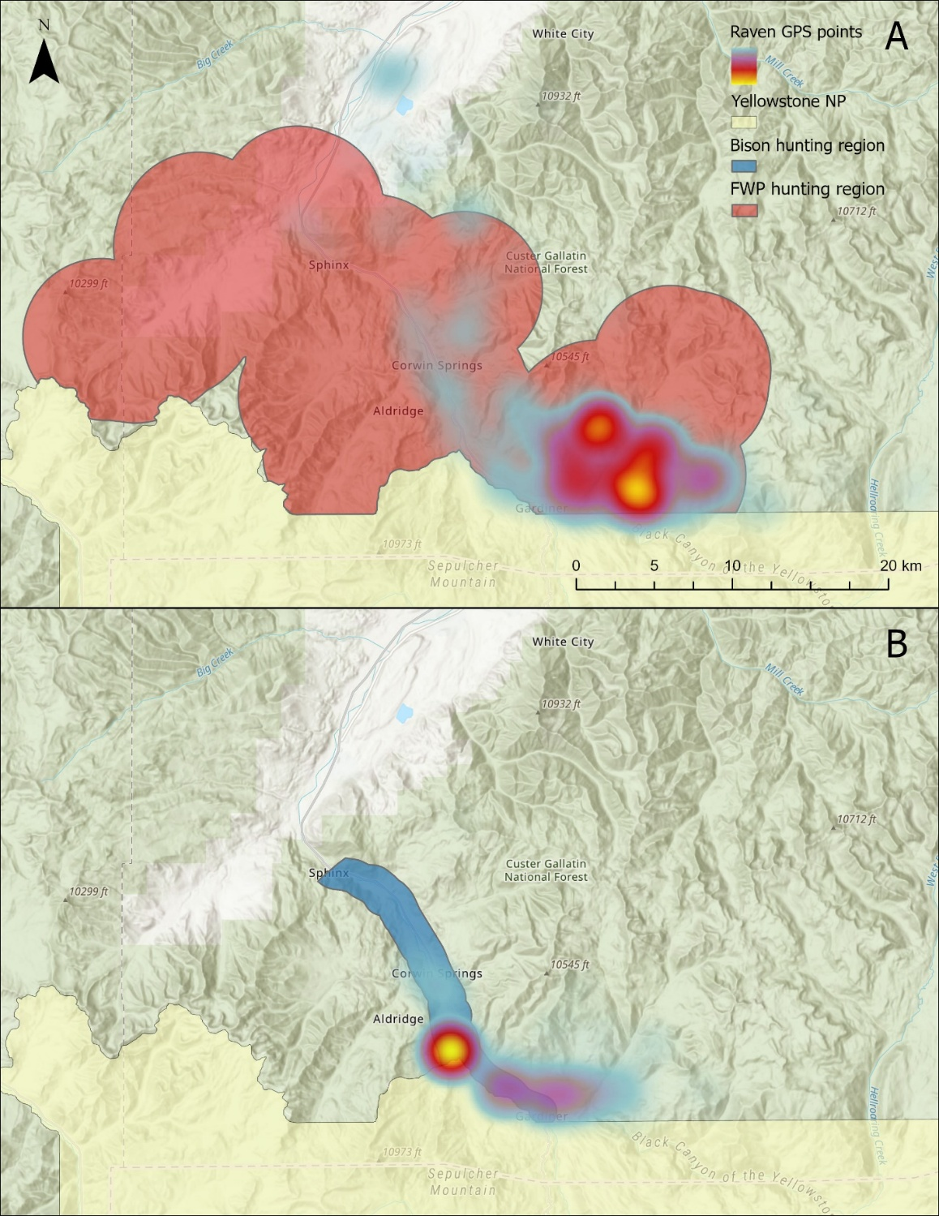
Supplemental Figure 1. Maps showing the MTFWP hunting region (A) and the bison hunting region (B) compared to a heatmap of the raven GPS points outside of the Yellowstone National Park during (A) November and (B) March, respectively. Warmer colors indicate higher point densities.
Appendix B
Supplemental Table 1. Shows the start and end dates for the MTFWP and bison hunting seasons for a given winter (e.g. winter of 2019 is from November 2019 – March 2020).
 | MTFWP |  | Bison
Winter of | Start date | End date | Start date
2019 | 10/26/2019 | 12/1/2019 | 2/23/2020
2020 | 10/24/2020 | 11/29/2020 | 1/25/2021
2021 | 10/23/2021 | 11/28/2021 | 3/22/2022
2022 | 10/22/2022 | 11/27/2022 | 12/8/2022
2023 | 10/21/2023 | 11/26/2023 | 3/24/2024

Appendix C
Table 1. Model results from the binomial generalized linear mixed model looking at the impact of covariates on the probability of ravens leaving their territory daily (n_{days} = 2095).
 | Estimate | Standard Error | p-value
Intercept | 3.463227 | 0.48412 | 8.45e-13
Wolf kill (TRUE) | -0.779855 | 0.354021 | 0.0276
Hunting biomass | -0.004894 | 0.081979 | 0.9524
Hunting season (TRUE) | -0.128697 | 0.218953 | 0.5567
Kill density | 0.146333 | 0.450206 | 0.7452
Distance | -0.277551 | 0.40771 | 0.496
Study period (Late) | -0.782575 | 0.290179 | 0.007
Snow depth | 0.687682 | 0.302247 | 0.0229
Max temperature | -0.065505 | 0.089254 | 0.463
Proportion traveling | 0.128014 | 0.081463 | 0.1161
Wolf kill * hunting Biomass | -0.162953 | 0.377667 | 0.6661
Study period * Snow depth | -0.55434 | 0.320752 | 0.0839

Supplemental Table 2. Model results from a binomial generalized linear mixed model looking at the impact of all covariates except for max temperature and snow depth on the probability of ravens leaving their territory daily (n_{days} = 2095).
 | Estimate | Standard Error | p-value
Intercept | 3.11445 | 0.4442 | 2.36e-12
Wolf kill (TRUE) | -0.81462 | 0.35293 | 0.021
Hunting biomass | 0.01868 | 0.08244 | 0.8208
Hunting season (TRUE) | -0.20295 | 0.2064 | 0.3255
Kill density | 0.13564 | 0.45558 | 0.7659
Distance | -0.28869 | 0.41214 | 0.4836
Study period (Late) | -0.32356 | 0.18066 | 0.0733
Proportion traveling | 0.17505 | 0.07947 | 0.0276
Wolf kill * hunting Biomass | -0.15014 | 0.36722 | 0.6827

Appendix D
Table 2. Model results from the binomial generalized linear mixed model looking at the impact of covariates on the probability of ravens visiting the hunting areas surrounding Gardiner, MT when they choose to leave their territory daily (n_{days} = 1633).
 | Estimate | Standard Error | p-value
Intercept | 0.57638 | 0.41484 | 0.16438
Visit kill (TRUE) | -2.30747 | 0.35798 | 1.15e-10
Hunting biomass | -0.0844 | 0.08005 | 0.29173
Hunting season (TRUE) | 0.55949 | 0.19234 | 0.00363
Distance | -1.73387 | 0.42206 | 3.99-5
Max temperature | -0.22203 | 0.07784 | 0.00434
Snow depth | 0.21941 | 0.09446 | 0.02019
Proportion traveling | 0.37545 | 0.08118 | 3.75e-6
Visit kill * Hunting biomass | -0.74834 | 0.49372 | 0.12959

