Chapter 2: Breeding raven foraging decisions in the face of multiple sources of carrion.
Introduction
Optimal foraging theory attempts to capture the decision-making process individuals undergo when trying to maximizing energy intake, including which patches to forage in and when to leave those patches (Pyke 1984). To maximize fitness, individuals should forage in patches where calorie intake is greatest and move to a different patch when the foraging efficiency of a new patch becomes greater. However, since omniscience about distant patches is unachievable, this decision is not clear cut since comparisons between foraging patches cannot be made accurately. Individuals must leverage knowledge of local patterns to make calculated risks about foraging. Ultimately, this decision becomes more challenging as patches become less predictable.
Scavengers utilize an inherently unpredictable, ephemeral resource. The availability of carrion can vary from year to year due to weather conditions, leading to animal deaths from starvation or exposure (Houston 1982, Gese et al. 1996). Carrion availability can also vary with prey distribution, population size, and the hunting success of local predators (Bump et al. 2009). Scavengers have evolved efficient movement patterns and sensitive olfactory senses to locate carrion (Ruxton and Houston 2004, Naves-Alegre et al. 2022). However, when multiple sources of carrion are available, optimally foraging scavengers should weigh the costs of travel against the probability of finding food when deciding which resource to exploit.
Natural and anthropogenic resources present scavengers with differing spatial and temporal predictability (Wilmers et al. 2003b). Foods provided by people can be more predictable in space and time than those created by predation (Bartumeus et al. 2010, Cortés-Avizanda et al. 2012). The spatial and temporal distribution of carrion created from recreational hunting and natural predation creates different foraging opportunities for scavengers. In gray wolf (Canis lupus) dominated systems, natural carrion is temporally unpredictable due to wolves’ low hunting success rate (MacNulty 2002) and occurs across a wide spatial scale (Wilmers et al. 2003b). Anthropogenic carrion is more temporally and spatially aggregated, with heavy harvest occurring around roadways and backcountry access points (Wilmers et al. 2003b). Human persecution of larger carnivores and mesocarnivores also prevent certain scavengers, such as coyotes (Canis latrans) and wolves, from safely accessing spaces with anthropogenic carrion, consequently excluding dominant competitors (Wilmers et al. 2003b). This reduces the costs of exploiting anthropogenic resources for smaller scavengers.
Common ravens (Corvus corax) are foraging generalists and facultative scavengers with a high movement potential due to efficient gliding flight (von Axel in prep). They evolved alongside wolves and humans and use carrion from both species. Ravens have learned to associate wolf presence and howling (Harrington 1978, Stahler et al. 2002) and the sight and sounds of human hunters (White 2005, Marzluff et al. 2021) with potential foraging opportunities. Ravens adjust their space use depending on human and wolf provisioning utilizing wolf-habitat more than anthropogenic landscapes in winters with higher wolf prey-acquisition rates (Walker et al. 2018). Territory-holding ravens defend areas around their nesting and roosting sites year-round (Heinrich 1988); however, outside of the breeding season, when free from parental duties, they are not as restricted in their use of space (Ho et al. 2023). This gives them the opportunity to make decisions about how to optimize their time to utilize these various resources.
To better understand how variation in the availability of carrion from natural and anthropogenic sources influences the movement decisions of territory-holding ravens, we monitored their movements in Yellowstone National Park. Wolves were reintroduced to the landscape in 1995 and have since returned to a healthy, stable population level (Cassidy et al. 2025). Their return to the landscape contributed to more consistent provisioning of natural carrion throughout the year (Wilmers et al. 2003a, Wilmers and Getz 2004). Yellowstone is surrounded by private and public lands that permit recreational ungulate hunting during the winter. Human hunters often “field dress” large, harvested animals, leaving behind edible biomass in gut piles containing organs, bones, and hide that are then available to scavengers. These two carrion sources are both readily used by common ravens (Wilmers et al. 2003b, Ho et al. 2023). In fact, ravens that hold breeding territories within Yellowstone National Park have been documented commuting during the winter between their territories and hunting areas outside the park boundaries (Marzluff et al. 2021, Ho et al. 2023).
We investigate two movement decisions made by territorial ravens during the non-breeding season: 1) when to leave the territory in search of distant foods, and 2) where to search for foods after leaving the territory. We hypothesize that movement decisions will be primarily governed by carrion availability. Ravens should therefore make decisions that are compatible with optimal foraging theory. We predict that ravens are less likely to leave their territories when there is a wolf kill within their territory, providing a proximate food resource, and there is less recreational hunting biomass available, making a commute an inefficient use of time. After a raven leaves its territory, we predict it will visit recreational hunting regions more often when hunting biomass availability is greater, and no wolf kill is encountered while traveling to provide a more immediate foraging opportunity.

Methods
Study area
Yellowstone National Park is a large (8903 km²), mostly intact temperate ecosystem that includes a mix of habitat types, including sagebrush steppe, montane grasslands, mixed conifer and pine forests, and thermally active regions. Yellowstone is bordered to the north by the Custer Gallatin National Forest, public land managed by the USFS that is open to recreational hunting during various seasons. Hunters target elk (Cervus canadensis) and bison (Bison bison) that migrate from Yellowstone during the winter and resident populations of mule (Odocoileus hemionus) and white-tailed deer (Odocoileus virginianus) when winter conditions drive ungulates to lower elevations (Geremia et al. 2011, Rickbeil et al. 2019). In contrast, inside the park, a relatively dense wolf population creates carrion.
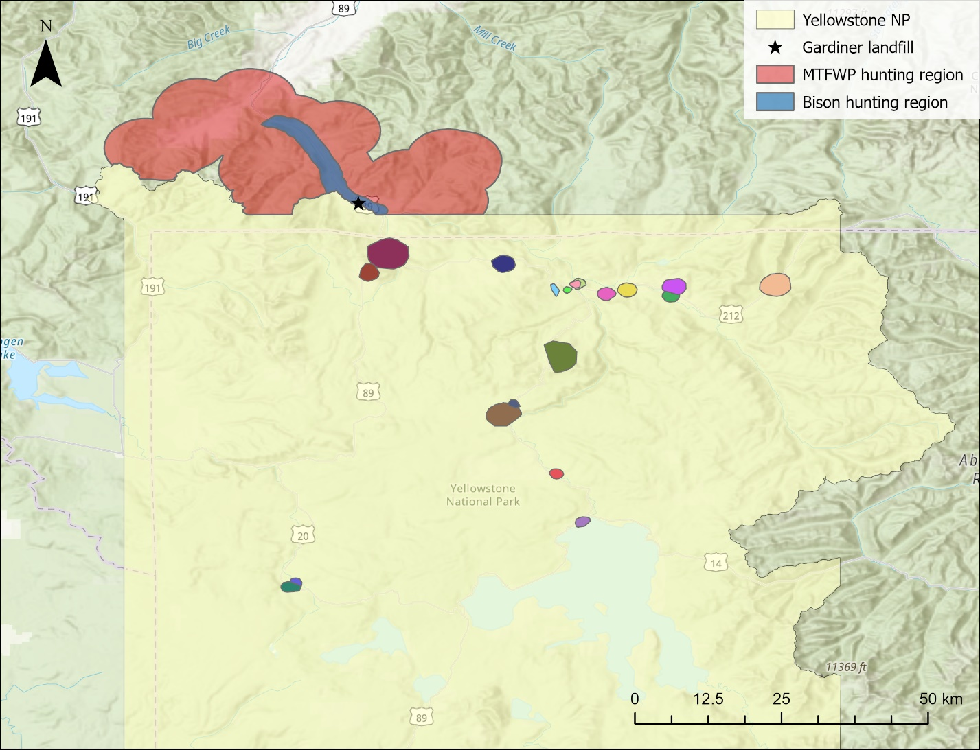
Figure 1. Map of Yellowstone National Park showing the locations of tagged raven territories as colored polygons inside the boundaries. The MTFWP (red) and bison (blue) hunting regions are highlighted outside the north-western boundary of the national park. The MTFWP region was used during the duration of the rifle hunting season. The bison region was used after the end of the MTFWP rifle hunting season and ran until the end of the winter study period (March 30). The landfill and water treatment pond within the hunting regions utilized by ravens is located at the star.

Tracking raven movement
We tracked common raven movements in and around Yellowstone National Park between October 2019 and March 2024. We captured ravens between October 2019 and January 2024 with remote-controlled net launchers (Coda Enterprises, Ltd) using various anthropogenic foods and carrion sources as bait. We caught territorial ravens opportunistically in large feeding groups with vagrant ravens and as targeted efforts at territories along the road within the national park. We fitted solar-powered GPS data loggers (e-obs GmbH; Bird Solar UMTS, 25 g) to the bird using Teflon harness straps (total assembly weight <4% body mass The GPS data loggers recorded locations every 30 minutes during daylight hours when battery voltage exceeded 3,900 mV, and hourly when between 3,900 and 3,700 mV. No locations were recorded when the battery voltage was below 3,700 mV. Movement data were downloaded from the GPS data loggers via Bluetooth connection to a hand-held receiver or uploaded directly to a Movebank database through a 3G cell network connection.
We determined a raven’s territorial status by examining its movements during the breeding season when they show restricted movements compared to non-breeders (Webb et al. 2011). We confirmed this in most cases by observing nesting attempts. Four ravens that were non-breeders at the time of capture transitioned into territorial individuals during the study period. We removed male ravens when both birds in a territorial pair were tagged to avoid pseudoreplication because raven pairs travel together during the winter while foraging. Males had fewer days with successful fixes and a lower daily fix rate than females because their longer feathers more frequently covered the solar panel, preventing charging and resulting in lower battery levels.
We only used GPS points from an individual raven that were separated by at least 29 minutes. This removed instances of fixes obtained in quick succession due to an unintended interaction with the satellite during uploads, while maintaining the maximum number of GPS points.
Recreational hunting regions
We defined two hunting areas corresponding to the Montana Fish, Wildlife, and Parks (MTFWP) rifle hunting season and the tribal bison hunting season. During the MTFWP rifle hunting season, elk and deer are the target species and are small enough to be packed out by hunters. We delineated this region (hereafter MTFWP hunting region, Fig. 1, Sup. Fig. 1) using a 5 km buffer around all roads 10 km away from the park entrance station in Gardiner, MT.
Bison hunting is more concentrated around the roadway as bison migration is largely funneled into the open area along the south side of the Yellowstone River at the park boundary. Adult male bison can weigh over 750 kg during the hunting season (Yellowstone Bison Office, National Park Service, unpublished data), so the effort required to pack a harvested bison back to the road is great and is avoided by hunters when possible. We created the bison hunting polygon (hereafter bison hunting region, Fig. 1, Sup. Fig. 1) with a 1 km buffer around the Old Yellowstone trail and Highway 89 from Gardiner, MT, to the cattle grate at the south end of Yankee Jim Canyon, which limits the northward movement of bison. We recognize that additional take will occur outside of these regions, but most bison harvest occurs within this space.
We removed a 500-meter area around the Gardiner landfill and sewage treatment ponds in both hunting regions to minimize the confounding effect of the consistent resource that is located just within the border of both hunting regions.
Recreational hunting season
We retrieved the MTFWP rifle hunting season dates from the hunting regulations published annually by MTFWP (Sup. Table 1). After the end of the MTFWP hunting season we defined the duration of the bison-hunting season as the period from the first day on which bison were taken during that winter (i.e., November 2019 – March 2020), which included a second day with a successful take within 7 days, and extended until the end of the winter study period (March 30; Sup. Table 1). Bison-hunting dates are flexible because harvest is influenced by bison movement more than hunting-date regulations for tribal hunters. A single exception was made for the winter of 2023 (March 2024), when only a single day at the end of the winter had a successful take.
Availability of hunter-killed carrion
We calculated the availability of hunter-created biomass using hunter take information for elk and deer during the rifle hunting period from Montana Fish, Wildlife, and Parks for the 313 hunting district (https://myfwp.mt.gov/fwpPub/harvestReports) and bison take from the NPS Bison Office (unpublished data). We adjusted MTFWP annual take estimates to account for daily variation because ungulate migration timing is weather-dependent (Rickbeil et al. 2019). We accounted for daily variation in hunter success by using GPS data gathered from elk radio-tagged by the Yellowstone Wolf, Cougar, and Elk project to determine the proportion of elk that had moved outside the national park boundary and are available for hunters to take. We scaled this proportion of available elk within the year and applied to the take values for all ungulate species for that hunting year.
$$daily take=yearly take× \frac{daily proportion elk}{\text{sum}(proportion elk)}$$
The exception is male mule deer, which are protected during the last two weeks of the hunting season. Bison taken in the Gardiner Basin were recorded by the NPS Bison Office daily during the winter through surveys and communications with NPS law enforcement, private hunters, and game wardens.
We adjusted the final take numbers to account for differences in the weights of each target species with all deer species having a 0.3x multiplier and bison having a 2.15x multiplier (elk are 1x). These multipliers were calculated by comparing early winter weights of deer and elk and late winter weights of bison ((Murphy et al. 1998) NPS Bison Office unpublished data). We accounted for biomass lingering between days by allowing 25% of the biomass to carry over between days.
Availability of wolf-killed carrion
We determined the location and timing of wolf kills using the output of a random forest algorithm developed by Binder et al. (2026) that predicts carrion locations from wolf movements, timing, and landscape features. The model makes no determinations about the prey species or cause of death and only functions optimally during the winter study periods performed by the Wolf, Cougar, and Elk Project (November 15 – December 15, March 1- 30). Each wolf kill remained available to ravens from the beginning of wolf use until 1 day after the last wolf GPS point. This additional day accounts for the continued availability and use of the carcass after wolves have abandoned it. We considered a raven to have visited a wolf kill if there was at least 1 GPS point within 500-meters of an active kill site. We removed wolf-kill sites identified by the predictive model that were within the appropriate hunting region for the date because the raven had already arrived to forage for hunter-killed carrion.
Raven movement decisions
To determine if a raven left its territory, we first defined the spatial boundaries of each territory. We determined a raven’s territory location and size by creating a 90% minimum convex polygon (MCP) using the package adehabitatHR (version 0.4.22) in R (version 4.5.1; Development Core Team 2021) from GPS points collected during the breeding season (May - July). We used a less inclusive 90% MCP to remove excursive movements made after nest failure when adults were free to move widely (Fig 1). To counter the slight underestimation caused by using a 90% MCP, we determine that a raven stayed on its territory if all locations on that day were within 1 kilometer of the 90% MCP boundary.
We determined a raven foraged for hunter-killed carrion if it had at least 1 GPS point within the appropriate hunting region polygon. The MTFWP hunting region was active for the duration of the MTFWP hunting season, and the bison hunting region was active from that date until March 30th. We removed days with fewer than 10 GPS points where the raven did not leave its territory or did not visit the hunting area because the data may have been insufficient to detect the movement. At a 30-minute fix-rate, 10 GPS points represent 5 hours, which is half of winter daylight hours.
Covariates
Since traveling requires both time and energy, we considered the distances of each raven’s territory to the hunting regions. We calculated the commute distance for each raven by taking the Euclidean distance from the center of the 90% MCP to Yellowstone’s northern entrance station in Gardiner, MT, as that was a central location to both hunting regions.
Ravens perform pre-breeding behaviors such as territory defense and nest building to retain possession of their territory and increase the chances of nest success. The need to perform these behaviors may impact a raven’s decision to leave its territory. Ravens in Yellowstone typically lay eggs at the end of March until the middle of April (unpublished data). These pre-breeding behaviors should be more prevalent closer to the onset of the breeding season. For this reason, months were classified into two categories: early winter, comprising November and December, and late winter, representing March.
Ravens utilize spatial memory for foraging, recognizing spaces with higher frequencies of wolf kills (Loretto et al. 2026). Ravens in such areas may remember and be more willing to risk staying on their territories even when a kill is not immediately available. We calculated this by taking an average of the 30-day carcass acquisition rates of wolves using the random forest predictive algorithm across all years that the raven was monitored on territory.
Ravens are social animals that can utilize information sharing to locate foraging opportunities (Marzluff et al. 1996). A territorial raven, even if it doesn’t utilize a communal roost with other ravens to gather information, might still consider the movement decisions of other ravens when deciding their own course of action. We considered the proportion of other ravens leaving their territories or visiting the hunting regions on a particular day.
Walker et al. (2018) found snowpack to be an important predictor in raven use of wolf habitat in Yellowstone. We similarly included snow depth and maximum daily temperature from Mammoth, WY, as predictors that might similarly impact territorial raven decision-making.
Raven conditional movement model
We investigated how the availability from two sources of carrion, hunters and wolves, drives movement decisions of breeding ravens during the winter by creating a conditional binomial generalized linear mixed model (GLMM) using the R package glmmTMB (version 1.1.13) with a random effect for individual. We used a conditional model to decompose the commuting process into two distinct decisions. The first is whether a raven decides to leave its territory (hereafter territory model). The second is if, after leaving the territory, the raven decides to visit the hunting regions (hereafter hunting model). We used the second part of the conditional model to account for the presence of other resources (e.g. wolf kills outside the territory or food in other gateway communities) that may influence a raven’s decision.
We restricted both models to the 30-day early (Nov 15 - Dec 15) and late (March 1 - 30) winter study periods performed by the Yellowstone Wolf, Cougar, and Elk Project because that is the period the wolf carcass predictive algorithm works for. We included two covariates to represent the hunting season and assess to what extent ravens tracked the potential biomass versus a broader seasonally determined availability. We included an interaction term between the wolf-kill covariate (active kill and visited kill) and the amount of hunting biomass available to determine if anthropogenic resources were prioritized in the decision-making process. Other covariates in the territory model include the distance to the hunting regions, average wolf kill density within the territory, pre-breeding season period, the proportion of other ravens leaving their territories, daily maximum temperature, and daily snow depth. Other covariates in the hunting model are the distance to the hunting region, the proportion of other ravens visiting the hunting regions, average daily temperature, and daily snow depth.

Results
During the winters months (Sep – Mar) during our sampling period, we gathered 4157 decision days (mean = 218.8, range = 3 – 604, sd = 162) from 19 territorial ravens (12 female, 7 male). Ravens decided to leave their territories an average of 66.5% of days (range = 0 – 100%, sd = 24.6%). After leaving their territory, ravens traveled between 7.4 and 57.5 km (median = 32.6, sd = 12.2) to forage in the Gardiner hunting areas 48.2% of days (range = 0 – 89.7%, sd = 29.6%). Two ravens residing at Old Faithful (7485, 7494; 63 km from hunting regions), the territories farthest from the hunting regions, never traveled to the hunting area and preferred to forage in West Yellowstone, MT (Fig. 3). Conversely, there were also individuals (8900, 7495) that preferred to visit the Gardiner hunting regions (Fig. ).
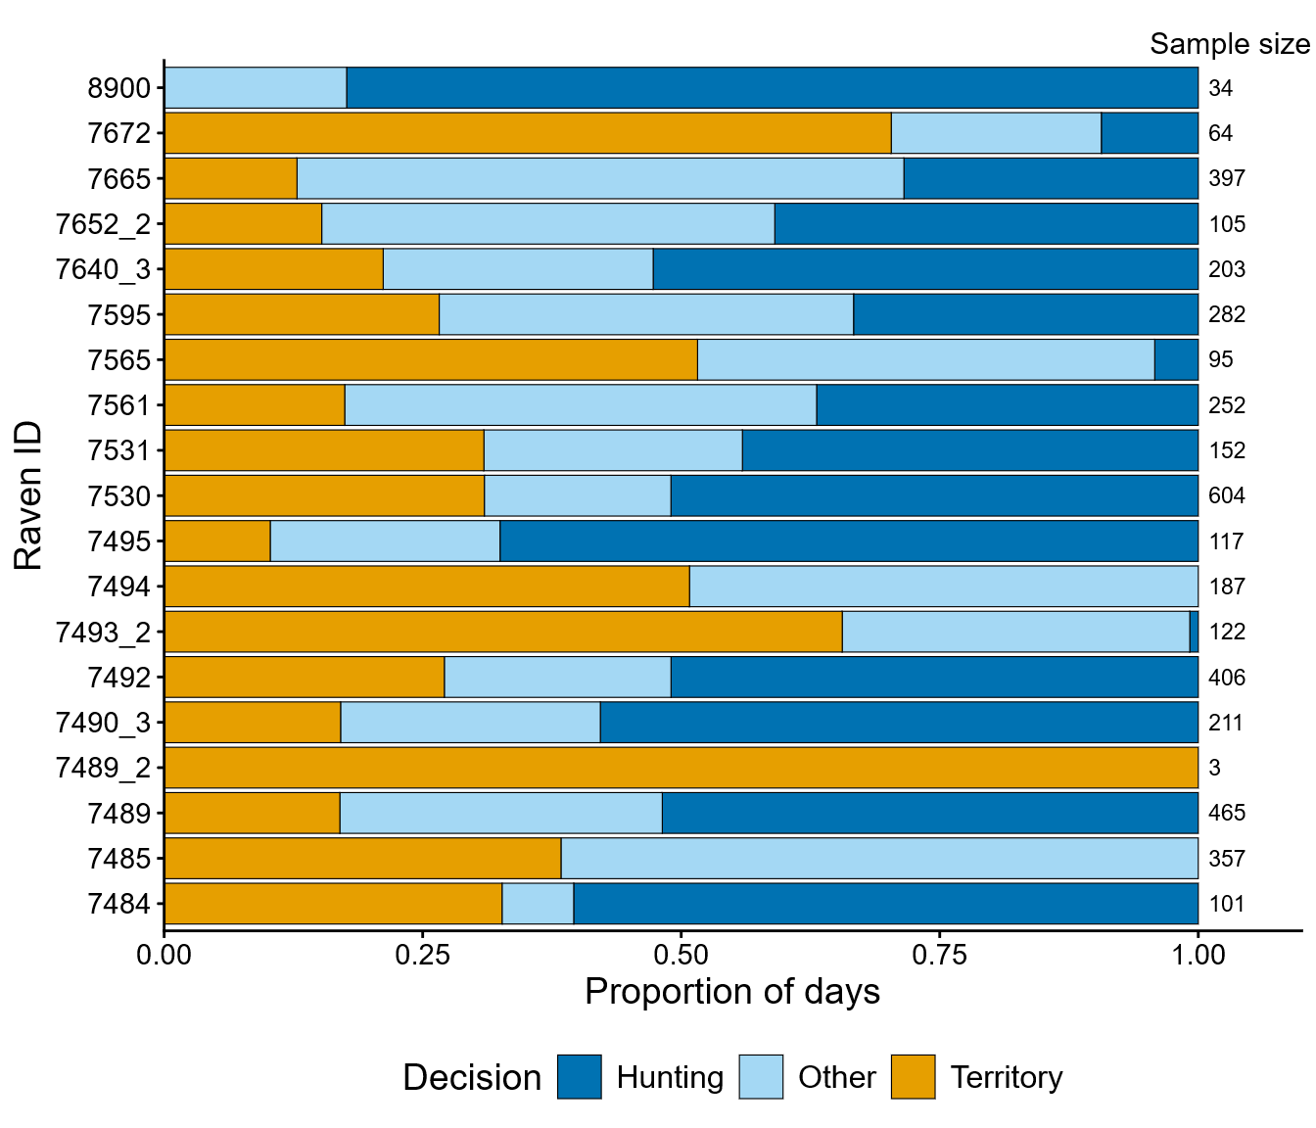
Figure . The proportion of decision days during the winter (October – March) on which each raven made a particular movement decision. If a raven decided to leave its territory, its decision was one of two results. The “Other” category is used to encapsulate all extraterritorial movements that did not result in a visit to the hunting regions. The “Hunting” category is used to show a raven visited the Gardiner hunting regions to forage for hunter-created carrion. The total number of decision days for each raven is displayed on the right-hand side of the plot.

Ravens largely remained on territory until October when ungulate hunting began and the number of visits to the hunting regions increased (Fig. ). The number of trips to the hunting regions then remained relatively consistent with slight peaks during the primary hunting months of November and March while the centers of activity shifted in accordance with the location of primary source of anthropogenic subsidies (Fig. ). The proportion of days that ravens left their territories to visit sites other than the Gardiner hunting region remained constant throughout the winter. Before hunting began in late October and between hunting seasons in the middle of winter, ravens visiting the hunting regions spent more time at the Gardiner landfill and sewage treatment ponds. During the hunting periods, ravens spent the most time in the areas with highest hunting effort for the target species. During mid-winter, while GPS points reconcentrated around the Gardiner landfill, there was still considerable amounts of activity occurring within the same space used during the MTFWP hunting season.

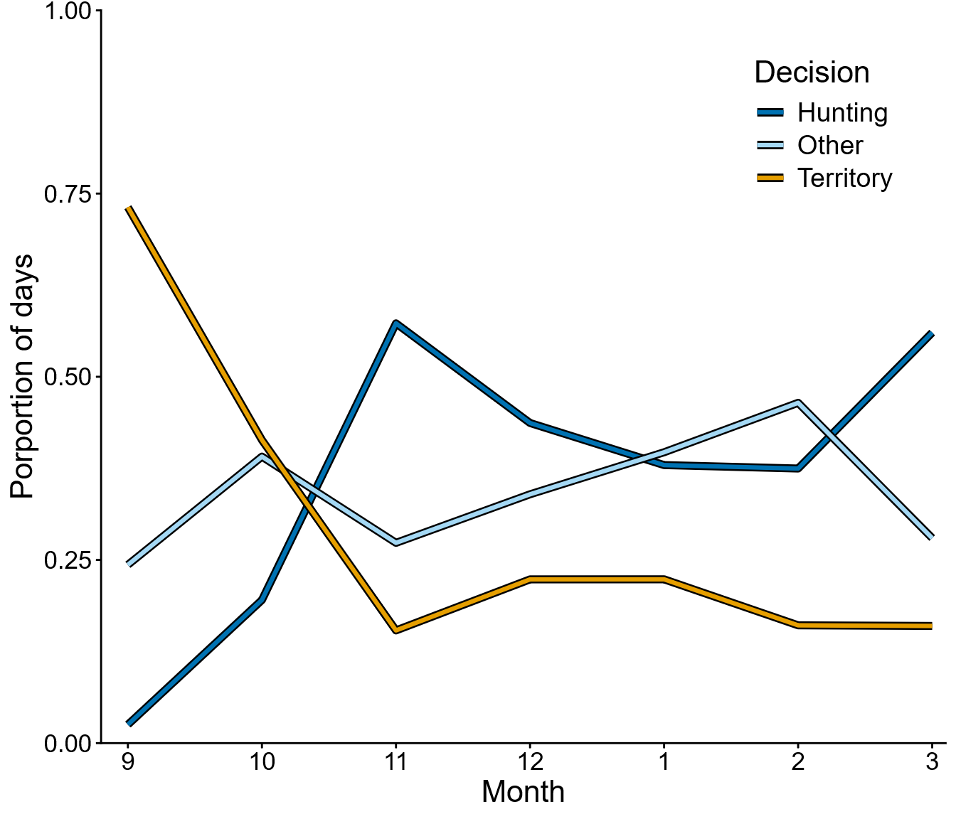Figure 8. Plot shows the average number of days (between ravens) a raven made various movement decisions during each winter month.
Figure 9. Maps show hotspots of raven activity outside of Yellowstone throughout the various winter periods when structured ungulate hunting does and does not occur. The entire mapping period is between September 1 and March 31 with each individual map based around the timing of the various hunting seasons as defined in the methods. The models use a subset of this data from Nov 15 - Dec 15 and Mar 1 - Mar 30.

During the modeling periods when information about wolf kills was available, we had 1536 decision days (mean = 85.3, range = 20 – 180, sd = 50.6). Wolf kills were rarely utilized by individual territorial ravens, either within their territory or beyond it. Raven territories were 0.8 – 21.2 km² (median = 3.3 km², sd = 6.3 km²) and each territory only had a wolf kill available for a mean of 4% of days (range = 0 – 28.9%, sd = 7.6%). We recorded ravens going within 500-meters of wolf kills on their territories 29.5% of days we defined as having an available wolf kill and ravens visited a particular wolf kill on at least one day during its available duration 37.5% of the time. Wolf kills were only visited outside of the territory on a mean of 3.9% of days that a raven left its territory (range = 0 – 13.7%, sd = 4.5%, Fig. 2). 49.4% of extraterritorial trips with a wolf kill involved the raven investigating the hunting areas as well (range = 14.3 – 100%, sd = 34.7%, Fig. 2).
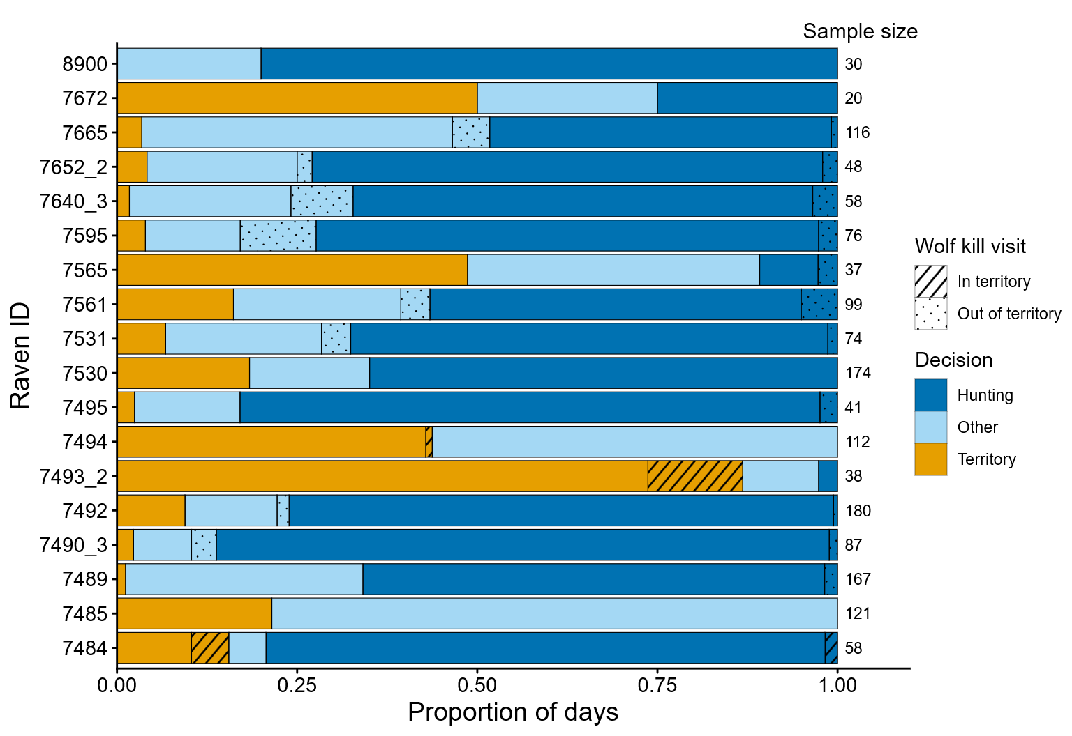
Figure 2. The proportion of decision days during modeling period on which each raven made a particular movement decision. If a raven decided to leave its territory, its decision was one of two results. The “Other” category is used to encapsulate all extraterritorial movements that did not result in a visit to the hunting regions. The “Hunting” category is used to show a raven visited the Gardiner hunting regions to forage for hunter-created carrion. Instances where a wolf kill was active in their territory (stripes) or visited outside their territory (dots) are denoted by the pattern in the appropriate category for the final decision made that day. The total number of decision days for each raven is displayed on the right-hand side of the plot.

Foraging movement decisions
Only food availability impacted a raven’s decision to leave its territory. When a wolf kill was present within a raven's territory, the raven was 64.1 - 66.7% less likely to leave, departing on only 22.2 - 27.1% of such days (OR = 0.04, 95% CI: 0.002, 0.43). All other covariates that we considered did not show significant effects on a raven’s decision to leave their territories (p > 0.14).
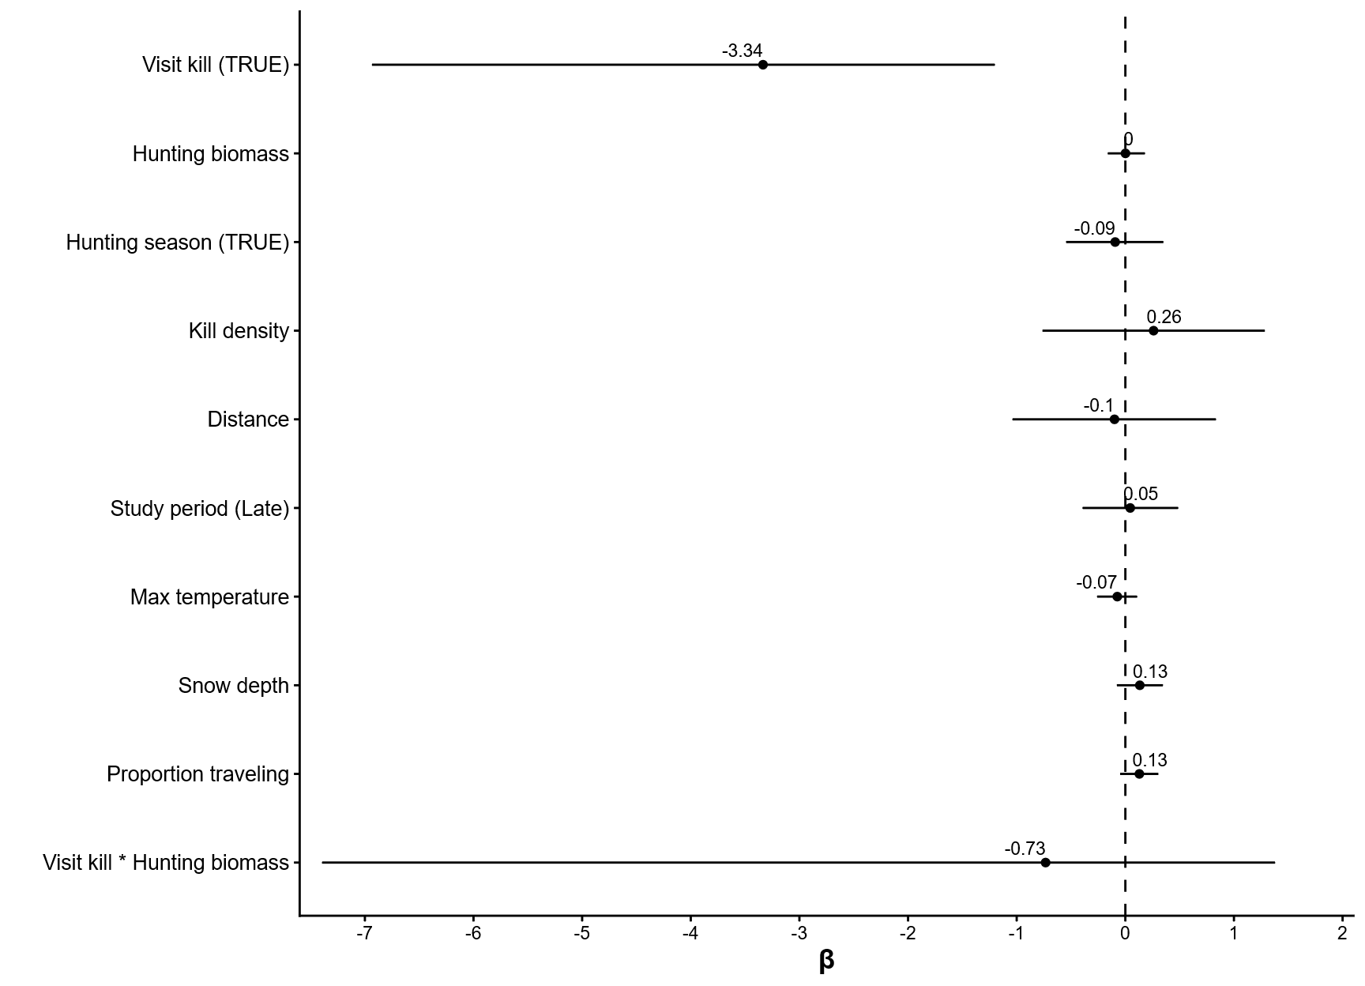
Figure 4. 95% confidence intervals for model parameters from the territory generalized linear mixed model investigating the probability of a raven leaving its territory each day (n = 2103).
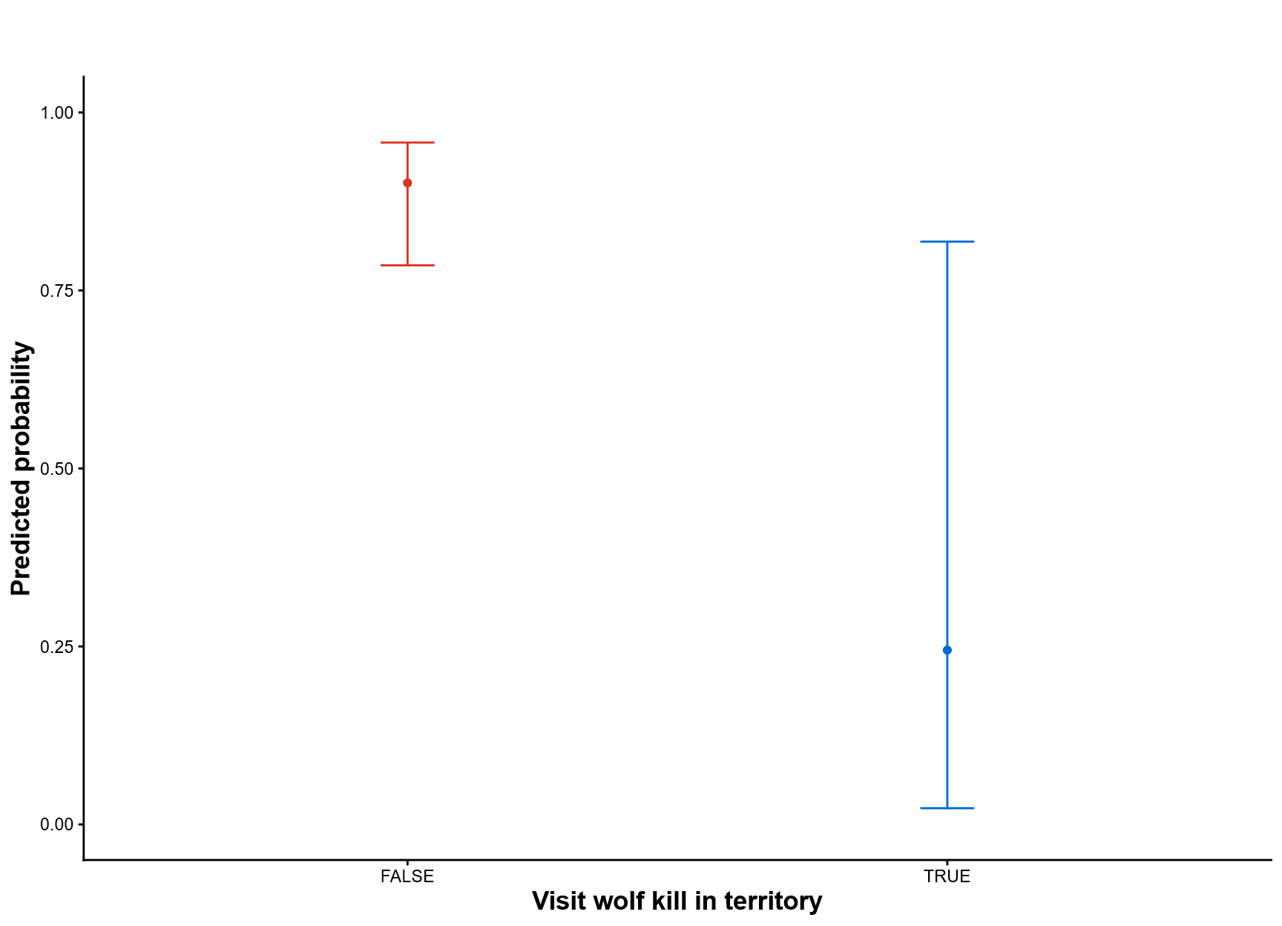
Figure 5. Predicted probability and 95% confidence intervals of ravens leaving their territory based on active wolf kills within their territories (p = 0.01). Hunting season was set to False, study period set to early, and all other standardized covariates held at 0.

In contrast, a raven’s final destination after leaving its territory was influenced by many factors. Ravens were more likely to visit the hunting regions during the hunting season (OR = 2.8, 95% CI: 1.9, 4.2), but they were not influenced by the actual amount of biomass available in hunting areas (p = 0.31). When a wolf kill was located outside of a raven’s territory, it reduced the probability of visiting the hunting area by 29.6 – 43.2% resulting in a predicted 8.1 – 19.8% of trips ending in a visit to the hunting region (OR = 0.11, 95% CI: 0.05, 0.22). Ravens with territories farther to the hunting regions visited the hunting area less often (OR = 0.21, 95% CI: 0.09, 0.49). Raven visits to the hunting area increased as snow depth decreased (OR = 1.3, 95% CI: 1.1, 1.5), and there was evidence that increasing temperatures decreased probabilities (OR = 0.87, 95% CI: 0.75, 1.02). Ravens were more likely to travel to the hunting area when a greater proportion of GPS tracked territorial ravens made the same decision (OR = 1.3, 95% CI: 1.1, 1.5).

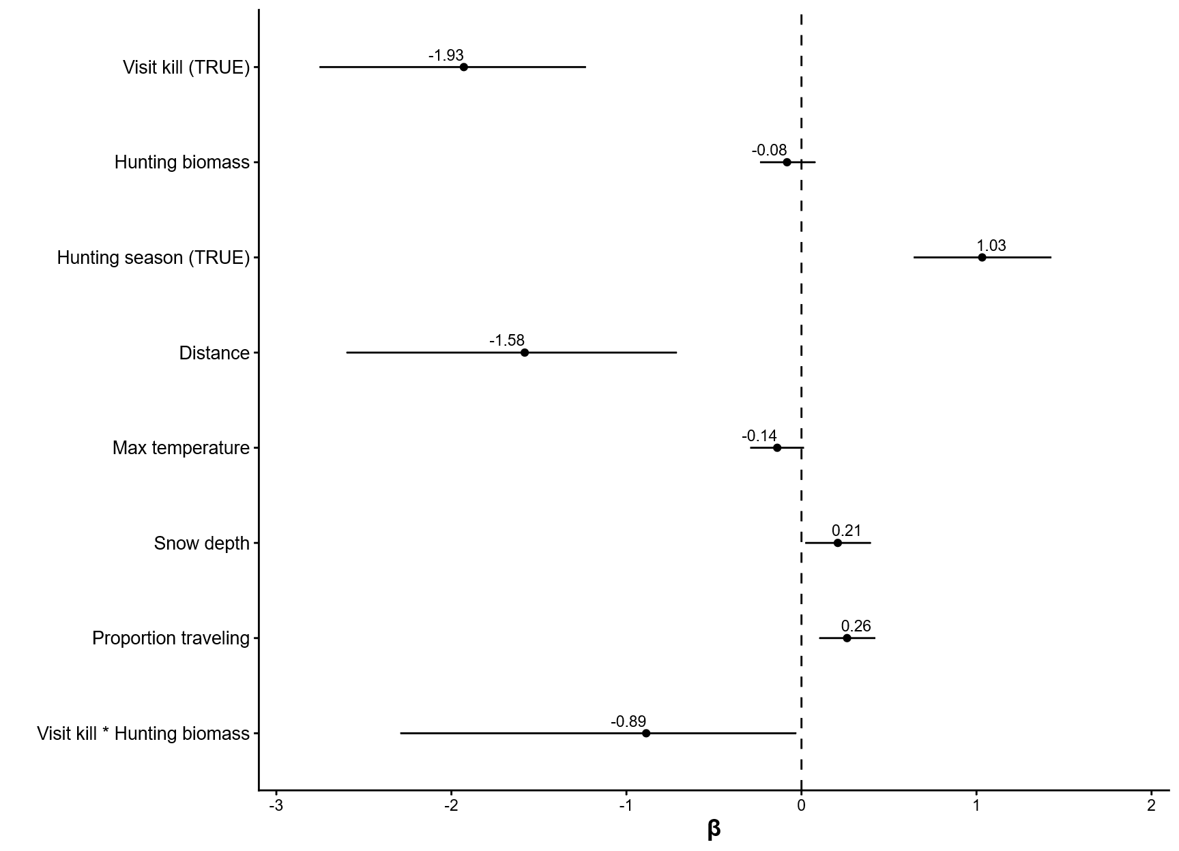
Figure 6. 95% confidence intervals for model parameters from the hunting generalized linear mixed model investigating the probability of ravens visiting the hunting regions on days it has left its territory (n = 1586).
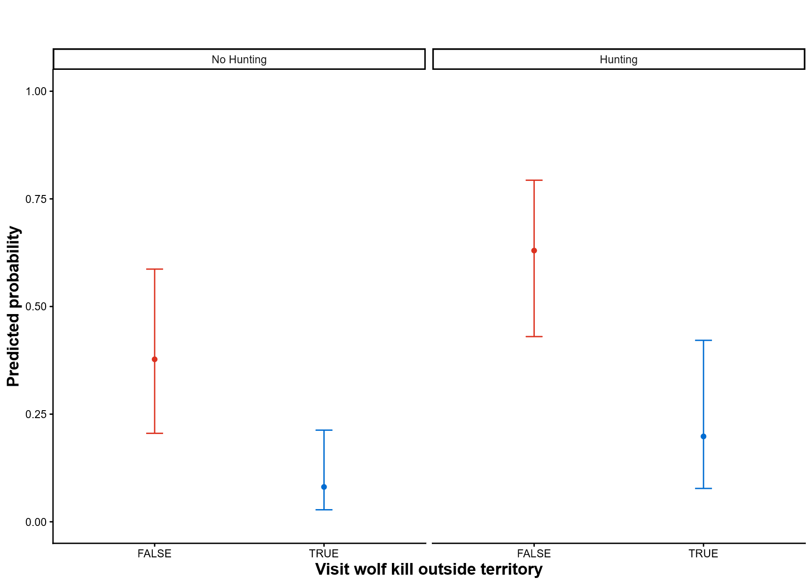
Figure 7. Predicted probability and 95% confidence intervals of ravens visiting the hunting regions based on the timing of the hunting season (p < 0.001) and whether they located a wolf kill after leaving their territory (p < 0.001). All other continuous scaled covariates are held at 0.

Discussion
During the non-breeding season, territorial ravens do not abandon territories to track distant resources, as some non-territorial ungulates do to track palatable foods (Middleton et al. 2018). Instead, they remain bound to their nesting space with the freedom to travel and exploit distance resources during the day (Ho et al. 2023). When we considered the competing effects of wolf kills and recreational hunting on raven movement decisions, ravens used daily knowledge of local resource consistent with our hypotheses. Although, individuals varied considerably in their decisions (Fig. 2). Regardless of the location, visiting a wolf kill heavily decreased the probability of continuing to the next resource. We found no evidence that ravens tracked the productivity of wolves within their territory, so territories were abandoned at a high rate since kill availability was low. When leaving territories, ravens were unlikely to be searching for wolf kills. Previous studies mapping movements from territorial individuals in our study population showed direct commute paths with few deviation to pass through other areas in the northern range where wolf kills might be located (Marzluff et al. 2021). This sort of route planning between distant, known resources is used by baboons and elephants (Noser and Byrne 2007, Polansky et al. 2015) and is likely performed by ravens (Loretto et al. 2026). Route planning to known resources allows overall energetic costs to be predictable. The presence of a newly located resource during travel, such as a wolf kill, likely alters their plan but was not the intended destination.
After leaving their territories, ravens were more likely to visit the hunting regions during the hunting season, regardless of the amount of biomass created by hunters. However, we were unable to find the same effect of hunting season on a raven’s probability of leaving their territories. This effect was likely masked by the limited time frame of the data, which failed to capture the initial increase in visits to the hunting area associated with the start of MTFWP rifle hunting, and alternative resources being present within our defined hunting regions. Throughout the entire winter, ravens shifted their space use in the hunting regions consistent with the location of the primary available resource. During the hunting season, ravens were less concentrated around the landfill that are consistently available throughout the year, indicating that refuse is lower priority than carrion. Outside of the primary hunting seasons, ravens seeking alternative foraging opportunities often visited the Gardiner landfill and sewage treatment ponds. Additionally, ravens also took advantage of low levels of tribal hunting during mid-winter that occurs in a similar region to the MTFWP hunt. Tribal hunters, while having a more limited take compared to the MTFWP season (1-2 ungulates a week), still create carrion throughout the central winter months that can draw large groups of ravens.
Ravens with territories far from the Gardiner hunting regions often chose to visit closer anthropogenic areas such as West Yellowstone, MT (orange points in Fig. ). Carrion may be preferred by ravens when both are equally available, but the commute time for ravens farthest from recreational hunting may be more than a third of daylight hours, during which they cannot perform any other critical behaviors. This leads to an optimization decision where individuals choose the less-preferred resource with the lower travel cost. In the case where the territory is equidistant between anthropogenic resources, ravens often choose the Gardiner hunting regions (purple dots in Fig.). However, they still occasionally made trips to the alternative, less optimal anthropogenic site. These occasional trips allow them to update their knowledge about the foraging conditions of distant patch (Smith and Sweatman 1974). West Yellowstone primarily offers refuse as the primary foraging opportunity for ravens but also has variable bison hunting effort between years.
Figure 3. Map showing examples of GPS movements by 3 common ravens at varying distances from the Gardiner hunting regions.

Yellowstone provides ravens with a wealth of foraging options that breeding ravens can exploit. This allows them to optimize their movements by choosing where to travel each day. In a system where raven territories are farther from predictable foraging locations, the decision to travel away from the territory becomes more nuanced. Ravens may choose to remain on territory as the opportunity cost of travel may present too much risk. Alternatively, if territories provide poor resource availability and starvation is a constant risk, ravens in areas with low resource density may be unable to defend their territories during the winter, instead showing more free movement like nonbreeders.
Ravens did not consider the movement of other breeding ravens when deciding to leave their territories despite being social creatures that have the ability to share and receive information about potential food resources (Marzluff et al. 1996). Ravens left their territories at high enough rates that it was unnecessary to consider other variables besides food availability. Once a raven left its territory, it often made the same movement decisions as conspecifics that had left their own territories. Ravens without knowledge of an available food source may be following other traveling ravens to take advantage of their knowledge (Marzluff et al. 1996). However, knowledge of the hunting regions is pervasive throughout the local population as they are heavily utilized by juvenile individuals during their first winter as it does not require extensive experience with the landscape. Group movements may then be coincidental and reflective of shared knowledge instead of information sharing or stealing.
Ravens evolved alongside both wolves and humans, learning to exploit the foraging opportunities created by each. The rapid expansion of human civilization in the western US led to distinct changes in its ecosystems characterized by the loss of large wildlife populations such as bison and wolves, shifting foraging opportunities for ravens during the winter. In the absence of wolves for nearly 70 years, ravens increasingly oriented their foraging behavior around anthropogenic resources, deepening an association between human development and winter food availability. Two decades after the reintroduction of wolves, when recreational hunting efforts have declined significantly and wolf and prey population have stabilized after reintroduction (Cassidy et al. 2025), ravens are faced with a very familiar landscape of opportunity, albeit one where availabilities have changed. Ravens remain the largest scavenger population exploiting carrion created by recreational hunting (Wilmers et al. 2003b) and utilize anthropogenic resources in greater abundance than natural resources during the winter (Ho et al. 2023). Yet ravens have also readapted to the restored predator guild by shifting their space use to overlap with wolves more during winters with greater wolf predation rates (Walker et al. 2018). Anthropogenic subsidies continue to be the prevailing resource used by breeding ravens during the winter with natural carrion playing a supplementary role.

