Chapter 2: Breeding raven foraging decisions in the face of multiple sources of carrion.
Introduction
Individual organisms must allocate time across daily activities, such as foraging, resting, and maintenance, to maximize their fitness (Dunbar et al. 2009). Some animals may adjust their time budget to maximize their chances of survival based on their understanding of available resources. Such changes may be influenced by changing environmental conditions, including predation risk and food and water availability. Barbary macaques(Macaca sylvanus) in forests heavily modified for pastoralism minimized their diurnal resting time to attain enough food (Ménard et al. 2013). Female common eiders (Somateria mollissima) abandon their chicks when in poor body condition, trading reproductive success for foraging opportunities (Bustnes and Erikstad 1991). These decisions become more challenging when resources are not scarce but are instead unpredictable.
Scavengers utilize an inherently unpredictable, ephemeral resource. The availability of carrion can vary from year to year due to weather conditions, leading to animal deaths from starvation or exposure. Carrion availability can also vary with the population size, distribution, and the hunting success rates of local predators. Scavengers have developed efficient movement patterns to facilitate the location of carrion and sensitive olfactory senses (Ruxton and Houston 2004, Naves-Alegre et al. 2022). However, when multiple spatially explicit sources of carrion are available, optimally foraging scavengers should weigh the costs of travel against the probability of finding food when deciding which resource to exploit.
Natural and anthropogenic resources present scavengers with differing spatial and temporal predictability. Foods provided by people can be more predictable in space and time than those created by predation (Bartumeus et al. 2010, Cortés-Avizanda et al. 2012). The spatial and temporal distribution of carrion created from recreational hunting and natural predation creates different foraging opportunities for scavengers. In gray wolf (Canis lupus) dominated systems, natural carrion is temporally unpredictable due to wolves’ low hunting success rate (MacNulty 2002) and occurs across a wide spatial scale (Wilmers et al. 2003b). Anthropogenic carrion is more temporally and spatially aggregated, with heavy harvest occurring around roadways and backcountry access points, thereby providing more access to individuals from species with high mobility (Wilmers et al. 2003b). Human persecution of larger carnivores and mesocarnivores may also prevent certain species, such as coyotes (Canis latrans) and wolves, from safely accessing spaces with anthropogenic carrion, consequently excluding dominant competitors (Wilmers et al. 2003b). This allows smaller scavengers to benefit from anthropogenic resources more heavily.
Common ravens (Corvus corax) are foraging generalists and facultative scavengers with a high movement potential due to efficient soaring. They evolved alongside wolves and humans and use carrion from both species. Ravens have learned to associate wolf presence and howling (Harrington 1978, Stahler et al. 2002) and the sight and sounds of human hunters (White 2005, Marzluff et al. 2021) as indicators of potential foraging opportunities. Ravens adjust their space use depending on human and wolf provisioning utilizing wolf-habitat more than anthropogenic landscapes in winters with higher wolf prey-acquisition rates (Walker et al. 2018). Territory-holding ravens defend areas around their nesting and roosting sites year-round (Heinrich 1988); however, outside of the breeding season, when free from parental duties, they are not as restricted in their use of space (Ho et al. 2023). This gives them the opportunity to make decisions about how to optimize their time to utilizes these various resources.
To better understand how variation in the availability of carrion from natural and anthropogenic sources influences the foraging and movement decisions of territory-holding ravens, we monitored their movements in Yellowstone National Park. Wolves were reintroduced to the landscape in 1995 and have since returned to a healthy, stable population level (Cassidy et al. 2025). Their return to the landscape contributed to a more consistent regime of natural carrion throughout the year (Wilmers et al. 2003a, Wilmers and Getz 2004). Yellowstone is surrounded by private and public lands that permit recreational ungulate hunting during the winter. Human hunters often “field dress” large, harvested animals, leaving behind edible biomass in gut piles containing organs, bones, and hide that are then available to scavengers. These two carrion sources are both readily used by common ravens (Wilmers et al. 2003b, Ho et al. 2023). In fact, ravens that hold breeding territories within Yellowstone National Park have been documented commuting during the winter between their territories and hunting areas outside the park boundaries (Marzluff et al. 2021, Ho et al. 2023).
We investigate two movement decisions made by territorial ravens during the non-breeding season: 1) when to leave the territory in search of distant foods, and 2) where to search for foods after leaving the territory. We predict that ravens are less likely to leave their territories when there is a wolf kill within their territory, providing a proximate food resource, and there is less recreational hunting biomass available, making a commute an inefficient use of time. After a raven leaves its territory, we predict it will visit recreational hunting regions more often when hunting biomass availability is greater, and no wolf kill is encountered while traveling to provide a more immediate foraging opportunity.

Methods
Study area
Yellowstone National Park is a large (8903 km²), mostly intact temperate ecosystem that includes a mix of habitat types, including sagebrush steppe, montane grasslands, mixed conifer and pine forests, and thermally active regions. Yellowstone is bordered to the north by the Custer Gallatin National Forest, public land managed by the USFS that is open to recreational hunting during various seasons. Hunters target elk (Cervus canadensis) and bison (Bison bison) that migrate from Yellowstone during the winter and resident populations of mule (Odocoileus hemionus) and white-tailed deer (Odocoileus virginianus) when winter conditions drive ungulates to lower elevations (Geremia et al. 2011, Rickbeil et al. 2019). In contrast, inside the park, a relatively dense wolf population creates carrion during the winter.
Tracking raven movement
We tracked common raven movements in and around Yellowstone National Park between October 2019 and March 2024. We captured ravens between October 2019 and January 2024 with remote-controlled net launchers (Coda Enterprises, Ltd) using various anthropogenic foods and carrion sources as bait. We caught territorial ravens opportunistically in large feeding groups with vagrant ravens and as targeted efforts at territories along the road within the national park. We fitted solar-powered GPS data loggers (e-obs GmbH; Bird Solar UMTS, 25 g) to the bird using Teflon harness straps (total assembly weight <4% body mass The GPS data loggers recorded locations every 30 minutes during daylight hours when battery voltage exceeded 3,900 mV, and hourly when between 3,900 and 3,700 mV. No locations were recorded when the battery voltage was below 3,700 mV. Movement data were downloaded from the GPS data loggers via Bluetooth connection to a hand-held receiver or uploaded directly to a Movebank database through a 3G cell network connection.
We determined a raven’s territorial status by examining its movements during the breeding season when they show restricted movements compared to non-breeders (Webb et al. 2011). We confirmed this in most cases by observing nesting attempts. Four ravens that were non-breeders at the time of capture transitioned into territorial individuals during the study period. We removed male ravens when both birds in a territorial pair were tagged to avoid pseudoreplication because raven pairs travel together during the winter while foraging. Males had fewer days with successful fixes and a lower daily fix rate than females because their longer feathers more frequently covered the solar panel, preventing charging and resulting in lower battery levels.
We only used GPS points from an individual raven that were separated by at least 29 minutes. This removed instances of fixes obtained in quick succession due to an unintended interaction with the satellite during uploads, while maintaining the maximum number of GPS points.
Recreational hunting regions
We defined two hunting areas corresponding to the MT Fish, Wildlife, and Parks (MTFWP) rifle hunting season and the tribal bison hunting season. During the MTFWP rifle hunting season, elk and deer are the main targets and are small enough to be packed out by hunters. We delineated this region (hereafter MTFWP hunting region, Fig. 1, Sup. Fig. 1) using a 5 km buffer around all roads 10 km away from the park entrance station in Gardiner, MT.
Bison hunting is more concentrated around the roadway as bison migration is largely funneled into the open area along the south side of the Yellowstone River at the park boundary. Adult male bison can weigh over 750 kg during the hunting season (Yellowstone Bison Office, National Park Service, unpublished data), so the effort required to hike a bison harvest back to the road is great and is avoided by hunters when possible. We created the bison hunting polygon (hereafter bison hunting region, Fig. 1, Sup. Fig. 1) with a 1 km buffer around the Old Yellowstone trail and Highway 89 from Gardiner, MT, to the cattle grate at the south end of Yankee Jim Canyon, which limits the northward movement of bison. We recognize that additional take will occur outside of these regions, but the vast majority of hunting occurs within this space.
Recreational hunting season
We retrieved the MTFWP rifle hunting season dates from the hunting regulations published annually by MTFWP (Sup. Table 1). After the end of the MTFWP hunting season we defined the duration of the bison-hunting season as the period from the first day on which bison were taken during that winter (i.e., November 2019 – March 2020), which included a second day with a successful take within 7 days, and extended until the end of the winter study period (March 30; Sup. Table 1). Bison-hunting dates are flexible because harvest is influenced by bison movement more than hunting-date regulations for tribal hunters. A single exception was made for the winter of 2023 (March 2024), when only a single day at the end of the winter had a successful take. An undocumented take occurs outside of these active hunting periods from other sources, such as tribes harvesting other species (e.g. elk, deer, etc.). These harvests are on a much smaller scale than either the MTFWP hunting season or the tribal bison hunt (Kqyn Kuka, MTFWP Tribal Liaison and Tribal Coordinator, personal communication).
Availability of hunter-killed carrion
We calculated the availability of hunter-created biomass using hunter take information for elk and deer during the rifle hunting period from Montana Fish, Wildlife, and Parks for the 313 hunting district (https://myfwp.mt.gov/fwpPub/harvestReports) and bison take from the NPS Bison Office (unpublished data). We adjusted MTFWP annual take estimates to account for daily variation because ungulate migration timing is weather-dependent (Rickbeil et al. 2019). We accounted for daily variation in hunter success by using GPS data gathered from elk radio-tagged by the Yellowstone Wolf, Cougar, and Elk project to determine the proportion of elk that had moved outside the national park boundary and are available for hunters to take. We scaled this proportion of available elk within the year and applied to the take values for all ungulate species for that hunting year.
$$daily take=yearly take× \frac{daily proportion elk}{\text{sum}(proportion elk)}$$
The exception is male mule deer, which are protected during the last two weeks of the hunting season. Bison taken in the Gardiner Basin were recorded by the NPS Bison Office daily during the winter through surveys and communications with NPS law enforcement, private hunters, and game wardens.
We adjusted the final take numbers to account for differences in the weights of each target species with all deer species having a 0.3x multiplier and bison having a 2.15x multiplier (elk are 1x). These multipliers were calculated by comparing early winter weights of deer and elk and late winter weights of bison ((Murphy et al. 1998) NPS Bison Office unpublished data). We accounted for biomass lingering between days by allowing 25% of the biomass to carry over between days.
Availability of wolf-killed carrion
We determined the location and timing of wolf kills using the output of a random forest algorithm developed by Binder et al. (2026) that predicts carrion locations from wolf movements, timing, and landscape features. The model makes no determinations about the prey species or cause of death and only functions optimally during The winter study periods performed by the Wolf, Cougar, and Elk Project (November 15 – December 15, March 1- 30). Each wolf kill was available to be used by ravens from the beginning of wolf use until 1 day after the last wolf GPS point. This additional day accounts for the continued availability and use of the carcass after wolves have abandoned it. For resources within a raven’s territory (Fig. 1), we considered all wolf-killed carcasses within 1 kilometer of a territory to be immediately known by the local raven. For resources located after leaving the territory, we considered a raven to have visited a wolf kill if there was at least 1 GPS point within 500 meters of an active kill site. We removed wolf-kills sites identified by the predictive model that were within the appropriate hunting region for the date because the raven had already arrived to forage for hunter-killed carrion.
Raven movement decisions
To determine if a raven left its territory, we first defined the spatial boundaries of each territory. We determined a raven’s territory location and size by creating a 90% minimum convex polygon (MCP) using the package adehabitatHR (version 0.4.22) in R (version 4.5.1; Development Core Team 2021) from GPS points collected during the breeding season (May - July). We used a less inclusive 90% MCP to remove excursive movements made after nest failure when adults were free to move widely (Fig 1). To counter the slight underestimation caused by using a 90% MCP, we determine that a raven stayed on its territory if all locations on that day were within 1 kilometer of the 90% MCP boundary.
We determined a raven foraged for hunter-killed carrion if it had at least 1 GPS point within the appropriate hunting region polygon. The MTFWP hunting region was active for the duration of the MTFWP hunting season, and the bison hunting region was active from that date until March 30th. We removed days with fewer than 10 GPS points where the raven did not leave its territory or did not visit the hunting area because the data may have been insufficient to detect the movement. At a 30-minute fix-rate (which can be conservative for winter due to low battery levels) 10 GPS points represent 5 hours, which is half of daylight hours.
Covariates
Since traveling requires both time and energy, we considered the distances of each raven’s territory to the hunting regions. We calculated the commute distance for each raven by taking the Euclidean distance from the center of the 90% MCP to Yellowstone’s northern entrance station in Gardiner, MT, as that was a central location to both hunting regions.
Ravens perform pre-breeding behaviors such as territory defense and nest building to retain possession of their territory and increase the chances of nest success. The need to perform these behaviors may impact a raven’s decision to leave its territory. Ravens in Yellowstone typically lay eggs at the end of March until the middle of April (unpublished data). These pre-breeding behaviors should be more prevalent closer to the onset of the breeding season. For this reason, months were classified into two categories: early winter, comprising November and December, and late winter, representing March.
Ravens utilize spatial memory for foraging, recognizing spaces with higher frequencies of wolf kills (Loretto et al. in press). Ravens in such areas may remember and be more willing to risk staying on their territories even when a kill is not immediately available. We calculated this by taking an average of the 30-day carcass acquisition rates of wolves using the random forest predictive algorithm across all years that the raven was monitored on territory.
Ravens are social animals that can utilize information sharing to locate foraging opportunities (Marzluff et al. 1996). A territorial raven, even if it doesn’t utilize a communal roost with other ravens to gather information, might still consider the movement decisions of other ravens when deciding their own course of action. We considered the proportion of other ravens leaving their territories or visiting the hunting regions on a particular day.
Walker et al. (2018) found snowpack to be an important predictor in raven use of wolf habitat in Yellowstone. We similarly included snow depth and maximum daily temperature from Mammoth, WY, as predictors that might similarly impact territorial raven decision-making.
Raven conditional movement model
We investigated how the availability from two sources of carrion, hunters and wolves, drives movement decisions of breeding ravens during the winter by creating a conditional binomial generalized linear mixed model (GLMM) using the R package lme4 (version 1.1-37) with a random effect for individual. We used a conditional model to decompose the commuting process into two distinct decisions. The first is whether a raven decides to leave its territory (hereafter territory model). The second is if, after leaving the territory, the raven decides to visit the hunting regions (hereafter hunting model). We used the second part of the conditional model to account for the presence of other resources (e.g. wolf kills outside the territory or food in other gateway communities) that may influence a raven’s decision.
We restricted both models to data from the 30-day early (Nov 15 - Dec 15) and late (March 1 - 30) winter study periods performed by the Yellowstone Wolf, Cougar, and Elk Project because that is the period the wolf carcass predictive algorithm works for due to a higher wolf collar fix rate. We included two covariates to represent the hunting season and assess to what extent ravens tracked the potential biomass versus a broader seasonally determined availability. We included an interaction term between the wolf-kill covariate (active kill and visited kill) and the amount of hunting biomass available to determine if anthropogenic resources were prioritized in the decision-making process. Other covariates in the territory model include the distance to the hunting regions, average wolf kill density within the territory, pre-breeding season period, the proportion of other ravens leaving their territories, daily maximum temperature, and daily snow depth. Other covariates in the hunting model are the distance to the hunting region, the proportion of other ravens visiting the hunting regions, average daily temperature, and daily snow depth.

Results
Between October 2019 and March 2024, we gathered 2095 decision days (mean = 104.8, sd = 63, range = 4 - 219) from 20 territorial ravens (12 female, 8 male). Ravens decided to leave their territories an average of 87.5% of days (range = 13.9 – 100%, sd = 19.8%, Fig. 2). After leaving their territory, ravens traveled an between 7.4 and 64 km (median = 32.6 km, sd = 15.7) to forage in the hunting area 70.6% of days (range = 0 – 100%, sd = 31.4%, Fig. 2). Two ravens residing at Old Faithful (7485, 7494; 63 km from hunting regions), the territories farthest from the hunting regions, never traveled to the hunting area and preferred to forage in West Yellowstone, MT (Fig. 2, 3). Conversely, two individuals that lived in the interior (8900, 33 km from hunting regions) and in the northern range (8902, 9.5 km from hunting regions) always chose to leave their territories (Fig. 2).
Wolf kills were rarely available to territorial ravens, either within their territory or beyond it. Raven territories were 0.8 – 21.2 km² (median = 3.3 km², sd = 6.3 km²) and each territory only had a wolf kill available for a mean of 3.1% of days (n_{kills} = 25, range = 0 – 25%, sd = 6.1%). We recorded ravens going within 500 m of wolf kills on their territories 26.5% of days we defined as having an available wolf kill (53.1% for within 1000 m) and ravens visited a particular wolf kill on at least one day during its available duration 32% of the time. Wolf kills were only found outside of the territory on a mean of 9.5% of days when ravens left their territory (n_{kills} = 49, range = 1.8 – 33.3%, sd = 7.7%, Fig. 2). Most extraterritorial trips (68.5%) with a wolf kill involved the raven investigating the hunting areas as well (range = 16.7 – 100%, sd = 33.2%, Fig. 2). In addition to the two main carrion resources available on the landscape, ravens also visited various anthropogenic subsidies. We recorded at least one GPS point at the landfill and sewage treatment ponds in Gardiner, MT, an average of 15.2% of trips to the hunting regions throughout the winter (range = 0 – 60%, sd = 17.3%, Fig. 1).
Foraging movement decisions
Food availability and weather conditions both impacted a raven’s decision to leave its territory. A wolf kill within 1 km of a raven’s territory decreased its chances of leaving its territory by 4.4 – 7.7%, choosing to leave their territory a predicted 84.7 – 91.6% of the time a wolf kill was present (-0.8, SE = 0.36, p < 0.05, Table 1, Fig. 4, 5). The availability of hunter-created carrion did not impact a raven’s decision to leave its territory, regardless of the metric of consideration (hunting biomass: -0.013, SE = 0.081, p = 0.88; hunting season: -0.22, SE = 0.21, p = 0.31, Fig. 4, 5; Table 1, Fig. 4). Ravens left their territories more often when snow depth was greater (0.20, SE = 0.10, p < 0.05, Table 1). Ravens were less likely to leave their territory during March compared to November and December (-0.46, SE = 0.21, p < 0.05, Table 1). The effect of the study period was not complicated by the temperature during late and early winter (0.049, SE = 0.18, p = 0.79, Table 1). The removal of the weather covariates from the model did lead to a positive impact of other ravens traveling from their territory (0.18, SE = 0.079, p < 0.05, Sup. Table 2).
When a raven left its territory, its destination was influenced by many factors. Ravens were more likely to visit the hunting regions during the hunting season (0.56, SE = 0.19, p < 0.01, Table 2, Fig. 6), but they were not influenced by the actual amount of biomass available in hunting areas (-0.083, SE = 0.080, p = 0.3, Table 2, Fig. 6). When a wolf kill was located outside of a raven’s territory, it greatly reduced the likelihood of visiting the hunting area by 48.2 – 50.8% with a predicted 15.9 – 25.9% of days ending in a visit to the hunting region (-2.2, SE = 0.35, p < 0.001, Table 2, Fig. 6). Ravens with territories closer to the hunting regions visited the hunting area more often (-1.7, SE = 0.42, p < 0.001, Table 2, Fig. 6). Ravens were more likely to travel to the hunting area when a greater proportion of GPS tracked territorial ravens made the same decision (0.38, SE = 0.081, p < 0.001 Table 2, Fig. 6). Ravens’ visits to the hunting area increased as temperatures dropped (-0.22, SE = 0.078, p < 0.01, Table 2, Fig. 6) and snow depth increased (0.22, SE = 0.094, p < 0.05, Table 2, Fig. 6).

Discussion
Organisms face thousands of critical decisions throughout their lives and make decisions on every scale. Macro-scale decisions such as whether to disperse to a new area are made infrequently. These choices confer high-risk and high-reward on an individual’s fitness, potentially reducing competition and providing new breeding opportunities (Johnson and Gaines 1987, Bonte et al. 2014). Micro-scale decisions enable individuals to optimize efficiency, for example, by reducing predation risk based on location within a herd (Morrell et al. 2011). At the daily level, decisions about when, where, and what behavior to exhibit allow an individual to meet their immediate survival needs (Fortin et al. 2002). These decisions can be influenced by immediate environmental conditions, such as weather and resource availability (Grubb 1978, Peat and Goulson 2005), or by more cognitive processes such as memory (Noser and Byrne 2007, Polansky et al. 2015).
Place-bound ravens do not seasonally abandon territories to track distant resources, as some non-territorial ungulates do to track palatable foods (Middleton et al. 2018). Instead, as hypothesized, ravens used daily knowledge of local resources to decide when to commute from their territories; although, decisions varied widely among individuals (Fig. 2). Ravens remained on their territories more often when a wolf kill was present, regardless of whether humans were hunting in distant areas or if such hunting produced large amounts of offal (Fig. 5). Our ability to detect an effect may have been diminished by limited sampling from days farther from the hunting season. Ravens also left their territory more often when snow depth was deeper, matching previous studies (Walker et al. 2018). When a wolf kill within their territory was not available, ravens traveled to search for alternative foraging opportunities. As predicted, ravens visited the recreational hunting areas more often during the hunting season (Fig. 7) and during harsher weather unless a wolf kill was found outside of their territory.
We were surprised to observe large variation in raven response to wolf kills by the location of the kill. Ravens responded more strongly to wolf kills outside of their territories than those inside with ravens seemingly forgoing locally available carrion in favor of alternative resources. While we were able to find a statistically significant negative effect of wolf kills within the territory that matched our hypothesis, our sample size for kills availabile within raven territories was limited, potentially leading to a misrepresentation of the true effect size. Our assumption about raven’s having almost perfect knowledge of wolf kills in their territory may have been incorrect, leading ravens to leave the territory when a wolf kill was present because they did not know it was present. This becomes a more likely explanation for ravens with larger territories. Alternatively, this large disparity in the response to wolf kills in their territory can be explained by foraging efficiency. Territorial ravens, while dominant, can be outcompeted by large groups (Heinrich and Marzluff 1995) and foraging on their territories places them in a situation where they are competing against all conspecifics intruders to the detriment of their own foraging (Heinrich 1994). Foraging outside of their territory may be less demanding as they are only competing within their immediate space for access to food (Heinrich and Marzluff 1991).
The hunting areas are predictable foraging opportunities during the hunting season, providing nutrients for ravens on days when no natural foraging opportunities are apparent. However, most of our sample group operated with limited knowledge in the hunting area as the distance between a raven’s territory and the hunting area precludes them from having current information about carrion availability. Only one tagged raven in our sample group is within the potential range to stay on territory and hear gunshots from the hunting area, which ravens can learned to associate with a potential successful harvest (White 2005). Most ravens were thus making decisions based on information from memory of previous years (Figs. 8, 9) and other daily conditions such as temperature and snow depth. When foraging opportunities created by recreational hunting were sparse, the risk taken by ravens deciding to commute was buffered by the presence of alternative anthropogenic resources within close proximity of the hunting regions, such as the landfill and sewage treatment ponds (Fig. 1).
Ravens leaving their territory were unlikely to be searching for wolf kills. The presence of a newly located resource, such as a wolf kill, during travel likely alters their plan but was not the intended destination. Ravens traveled to the hunting area efficiently, with individuals farther from the hunting area having a longer time between the last point in their territory and the first point in the hunting area (Sup. Fig. 2), which we interpret as little time spent searching for alternative resources. Previous studies mapping movements from individuals in our study population showed direct commute paths with few deviation to pass through other areas in the northern range where wolf kills might be located (Marzluff et al. 2021), Loretto et al. in press). This sort of route planning between distant, known resources is likely performed by ravens (Loretto et al. in press) and allows their costs, including the time and energy investment of traveling, to be more predictable and consistent. While the energy gained from foraging at the hunting area may be predictable, the commute time for the GPS tracked ravens farthest from the hunting may be more than a third of winter daylight hours, during which they could not perform any other critical behaviors.
As a non-migratory species that defends its territory all year (Heinrich 1988), physical presence, visual displays, and vocalizations can assist the territory owner in retaining possession of the space (Peek 1972, Piper et al. 2000). Our results support the idea that movement decisions are at least partially driven by breeding behaviors by showing reduced extraterritorial movements in March compared to early winter. During this late winter period just prior to the start of the breeding season, we observed ravens performing active pre-breeding season behaviors (e.g. nest building). Ravens can persist for many days without food and can take advantage of cached resources (Heinrich 1994). Ravens that bred earlier in the Greater Yellowstone Ecosystem have greater nesting success (Dunk et al. 1997) and mistiming the initiation of breeding can result in lower success due to a lack of critical food sources (Visser et al. 2006). Ravens in Yellowstone utilize seasonal insect outbreaks (e.g. grasshoppers and salmonflies) during the summer breeding season (Ho et al. 2023), which allows them to provide a protein-dense food to growing chicks.
Despite being social creatures that have the ability to share and receive information about potential food resources (Marzluff et al. 1996), a raven deciding whether to leave its territory was not influenced by the movement of other territorial ravens. Ravens are instead responding to the same climactic covariates when making this decision. This decision was instead based on factors that each raven could interpret independently, such as active kills within their territory or weather conditions. Once a raven left its territory, it made the same decision as conspecifics. Ravens without knowledge of an available food source may be following other traveling ravens to take advantage of their knowledge (Marzluff et al. 1996). Knowledge of the hunting regions is pervasive throughout the local population as they are heavily utilized by juvenile individuals during their first winter as it does not require extensive knowledge of the landscape. Group movements may then be coincidental and reflective of shared knowledge instead of information stealing or sharing.
Our results suggest that the daily decisions of breeding common ravens within Yellowstone National Park are influenced by the presence of daily resources. More immediately available resources are prioritized while recreational hunting is supplementary on days when they do not encounter any naturally occurring carrion. As a foraging generalist, their ability to forage efficiently based on daily changes in food availability allows them to be successful. Since movement decisions are not influenced by the amount of biomass made available by hunters, it is unlikely that efforts to reduce its availability would be effective at preventing the exploitation of the resource. Other studies have shown moderate success in using supplemental feeding within protected areas to reduce movements outside the protected area for large avian scavengers (López-Peinado et al. 2023). At small scales, the removal of a landfill site can eliminate the presence of ravens (Marzluff et al. 2021). However, until the resource is either eliminated or an alternative resource is available on a daily scale, ravens will likely continue to return to recreational hunting areas on days when no other foraging opportunity is available. This continued usage of anthropogenic resources buffers raven populations against any decreases in natural carrion availability. Increasing the availability of natural carrion through the recovery of carnivore populations will likely reduce the time spent foraging for anthropogenic subsidies.

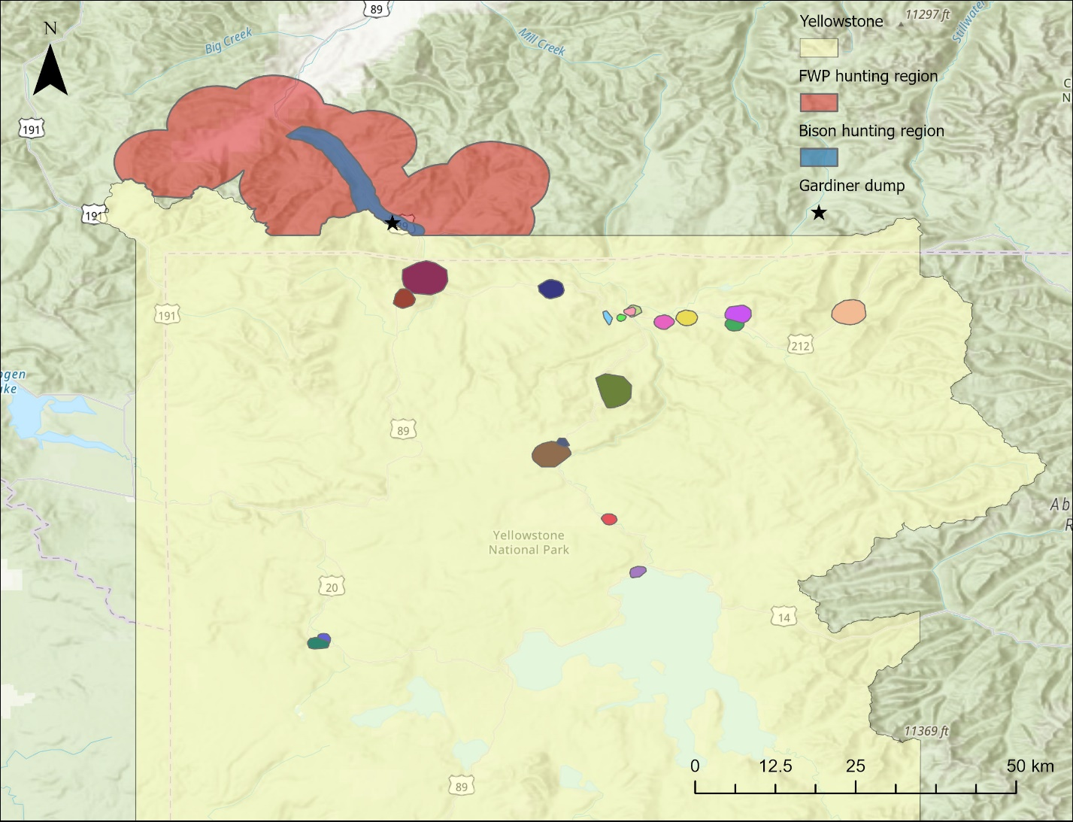
Figure 1. Map of Yellowstone National Park showing the locations of tagged raven territories as colored polygons inside the boundaries. The MTFWP (red) and bison (blue) hunting regions are highlighted outside the north-western boundary of the national park. The MTFWP region was used during the duration of the rifle hunting season. The bison region was used after the end of the MTFWP rifle hunting season and ran until the end of the winter study period (March 30). The landfill and water treatment pond within the hunting regions utilized by ravens is located at the star.
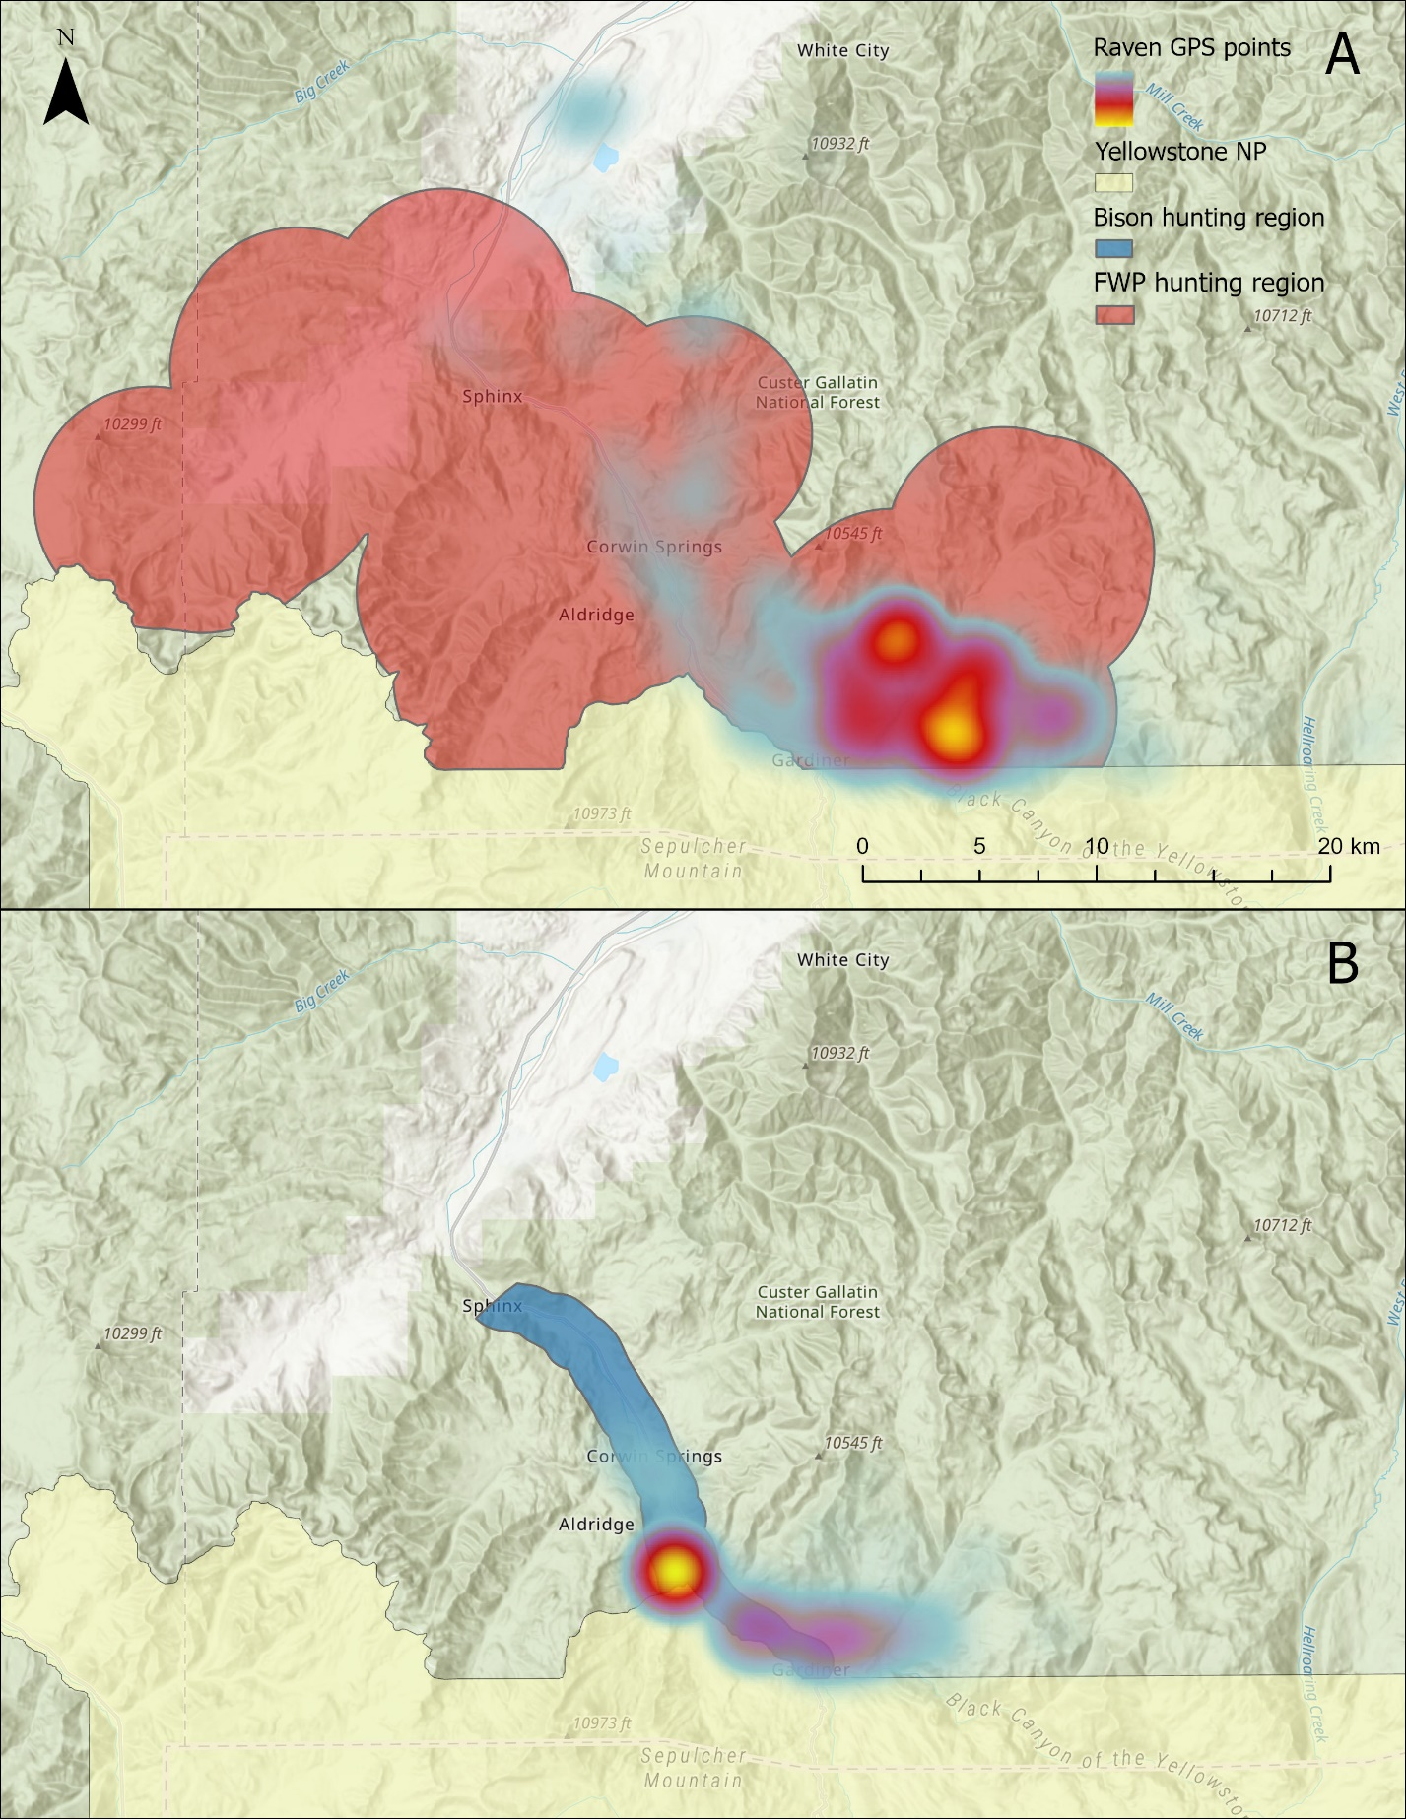
Supplementary Figure 1. Maps showing the MTFWP hunting region (A) and the bison hunting region (B) compared to a heatmap of the raven GPS points outside of the Yellowstone National Park during (A) November and (B) March, respectively. Warmer colors indicate higher point densities.

Supplementary Table 1. Shows the start and end dates for the MTFWP and bison hunting seasons for a given winter (e.g. winter of 2019 is from November 2019 – March 2020).
 | MTFWP |  | Bison
Winter of | Start date | End date | Start date
2019 | 10/26/2019 | 12/1/2019 | 2/23/2020
2020 | 10/24/2020 | 11/29/2020 | 1/25/2021
2021 | 10/23/2021 | 11/28/2021 | 3/22/2022
2022 | 10/22/2022 | 11/27/2022 | 12/8/2022
2023 | 10/21/2023 | 11/26/2023 | 3/24/2024

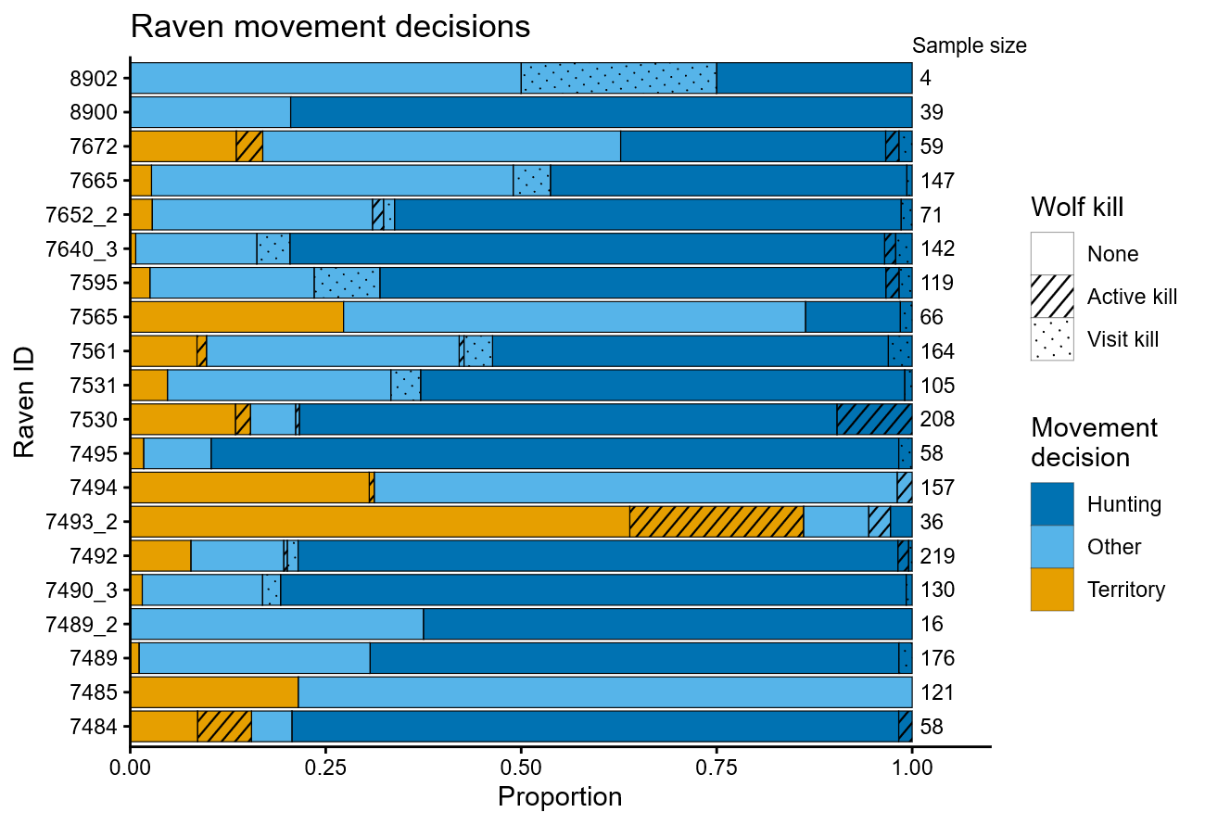
Figure 2. The proportion of decision days on which each raven made a particular movement decision. If a raven decided to leave its territory, its decision was one of two results. The “Other” category is used to encapsulate all extraterritorial movements that did not result in a visit to the hunting regions. The “Hunting” category is used to show a raven visited the Gardiner hunting regions to forage for hunter-created carrion. Instances where a wolf kill was active in their territory (stripes) or visited outside their territory (dots) are denoted by the pattern in the appropriate category for the final decision made that day. The total number of decision days for each raven is displayed on the right-hand side of the plot.

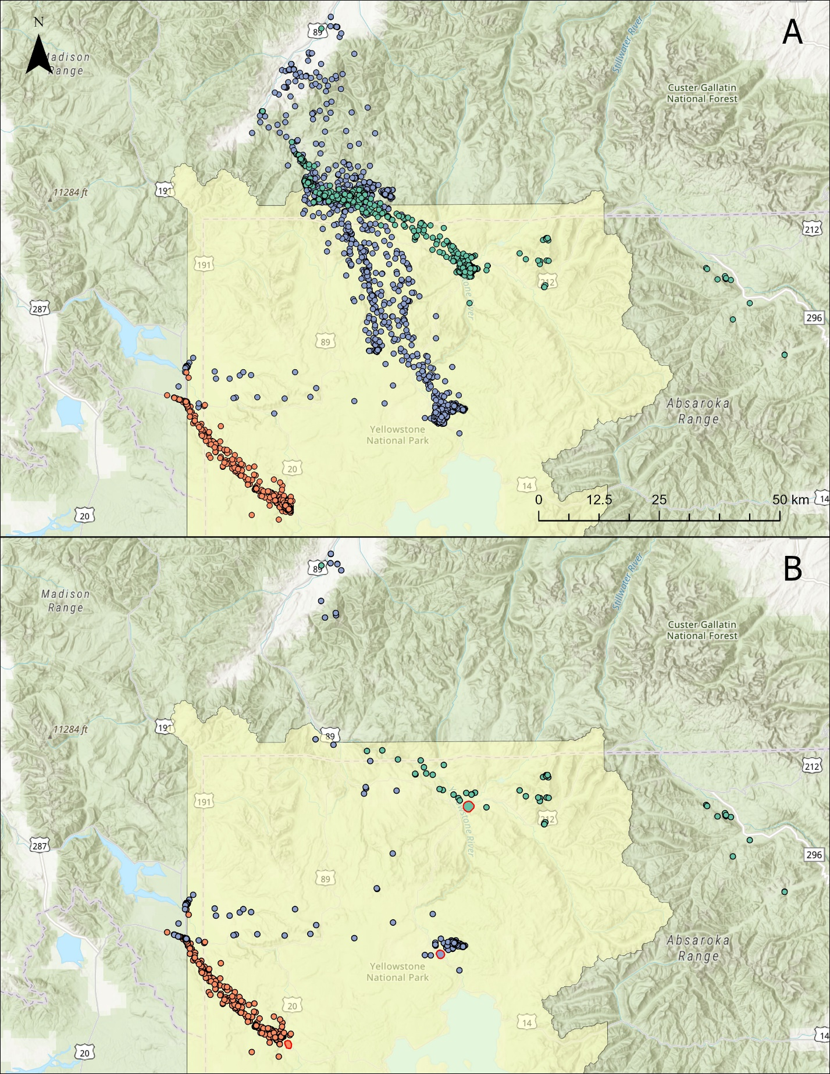
Figure 3. Map A shows the GPS movements of 3 common ravens at varying distances from the hunting regions. Map B shows the GPS movements of these 3 ravens when they decide to leave their territory, but do not end up visiting the hunting regions. Each raven’s territory is shown as a polygon with a red border in their color.

Table 1. Model results from the binomial generalized linear mixed model looking at the impact of covariates on the probability of ravens leaving their territory daily (n_{days} = 2095).
 | Estimate | Standard Error | p-value
Intercept | 3.18873 | 0.45039 | 1.44e-12
Wolf kill (TRUE) | -0.79651 | 0.35631 | 0.0254
Hunting biomass | -0.01258 | 0.08095 | 0.8765
Hunting season (TRUE) | -0.21529 | 0.21283 | 0.3117
Kill density | 0.14646 | 0.4478 | 0.7436
Distance | -0.26946 | 0.40568 | 0.5065
Study period (Late) | -0.4603 | 0.21161 | 0.0296
Max temperature | -0.11708 | 0.15752 | 0.4573
Snow depth | 0.20464 | 0.10428 | 0.0497
Proportion traveling | 0.12784 | 0.08201 | 0.119
Wolf kill * hunting Biomass | -0.17153 | 0.38091 | 0.6525
Study period * Max temp | 0.04887 | 0.18312 | 0.7896

Supplementary Table 2. Model results from a binomial generalized linear mixed model looking at the impact of all covariates except for max temperature and snow depth on the probability of ravens leaving their territory daily (n_{days} = 2095).
 | Estimate | Standard Error | p-value
Intercept | 3.11445 | 0.4442 | 2.36e-12
Wolf kill (TRUE) | -0.81462 | 0.35293 | 0.021
Hunting biomass | 0.01868 | 0.08244 | 0.8208
Hunting season (TRUE) | -0.20295 | 0.2064 | 0.3255
Kill density | 0.13564 | 0.45558 | 0.7659
Distance | -0.28869 | 0.41214 | 0.4836
Study period (Late) | -0.32356 | 0.18066 | 0.0733
Proportion traveling | 0.17505 | 0.07947 | 0.0276
Wolf kill * hunting Biomass | -0.15014 | 0.36722 | 0.6827

Table 2. Model results from the binomial generalized linear mixed model looking at the impact of covariates on the probability of ravens visiting the hunting areas surrounding Gardiner, MT when they choose to leave their territory daily (n_{days} = 1633).
 | Estimate | Standard Error | p-value
Intercept | 0.58091 | 0.4146 | 0.16118
Visit kill (TRUE) | -2.24366 | 0.35199 | 1.84e-10
Hunting biomass | -0.08311 | 0.08007 | 0.29924
Hunting season (TRUE) | 0.55666 | 0.19216 | 0.00377
Distance | -1.7391 | 0.42184 | 3.75e-5
Max temperature | -0.22064 | 0.07779 | 0.00456
Snow depth | 0.21748 | 0.09435 | 0.02117
Proportion traveling | 0.37658 | 0.08115 | 3.47e-6
Visit kill * Hunting biomass | -0.77337 | 0.49238 | 0.11626

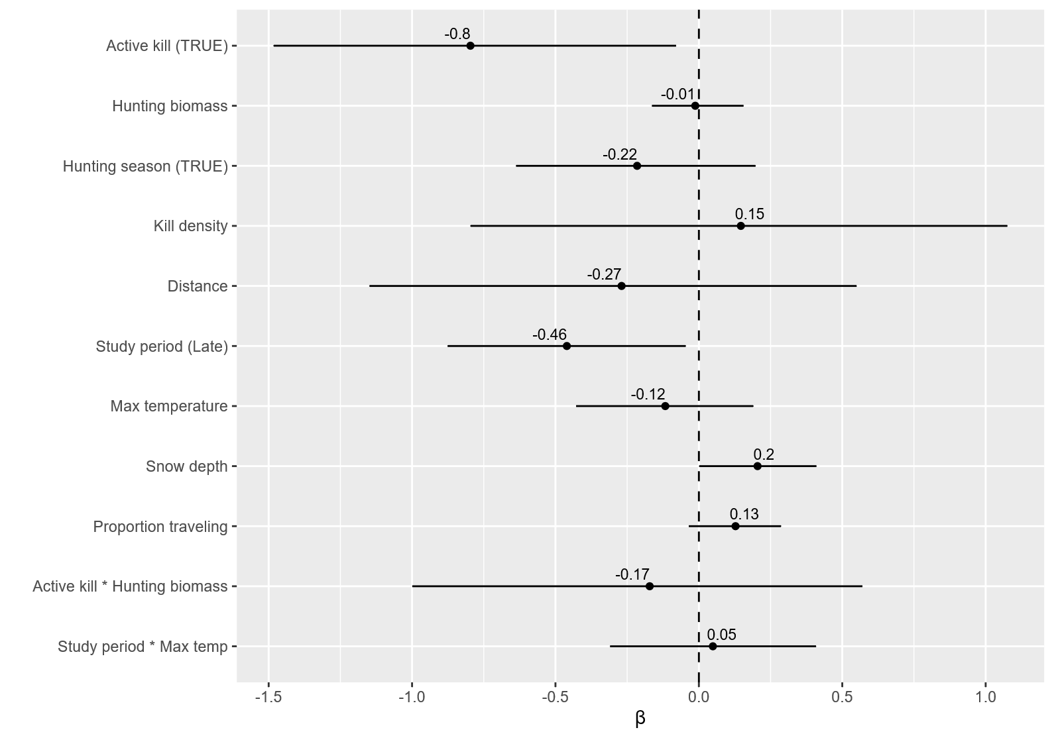
Figure 4. 95% confidence intervals for model parameters from the territory generalized linear mixed model investigating the probability of a raven leaving its territory each day.
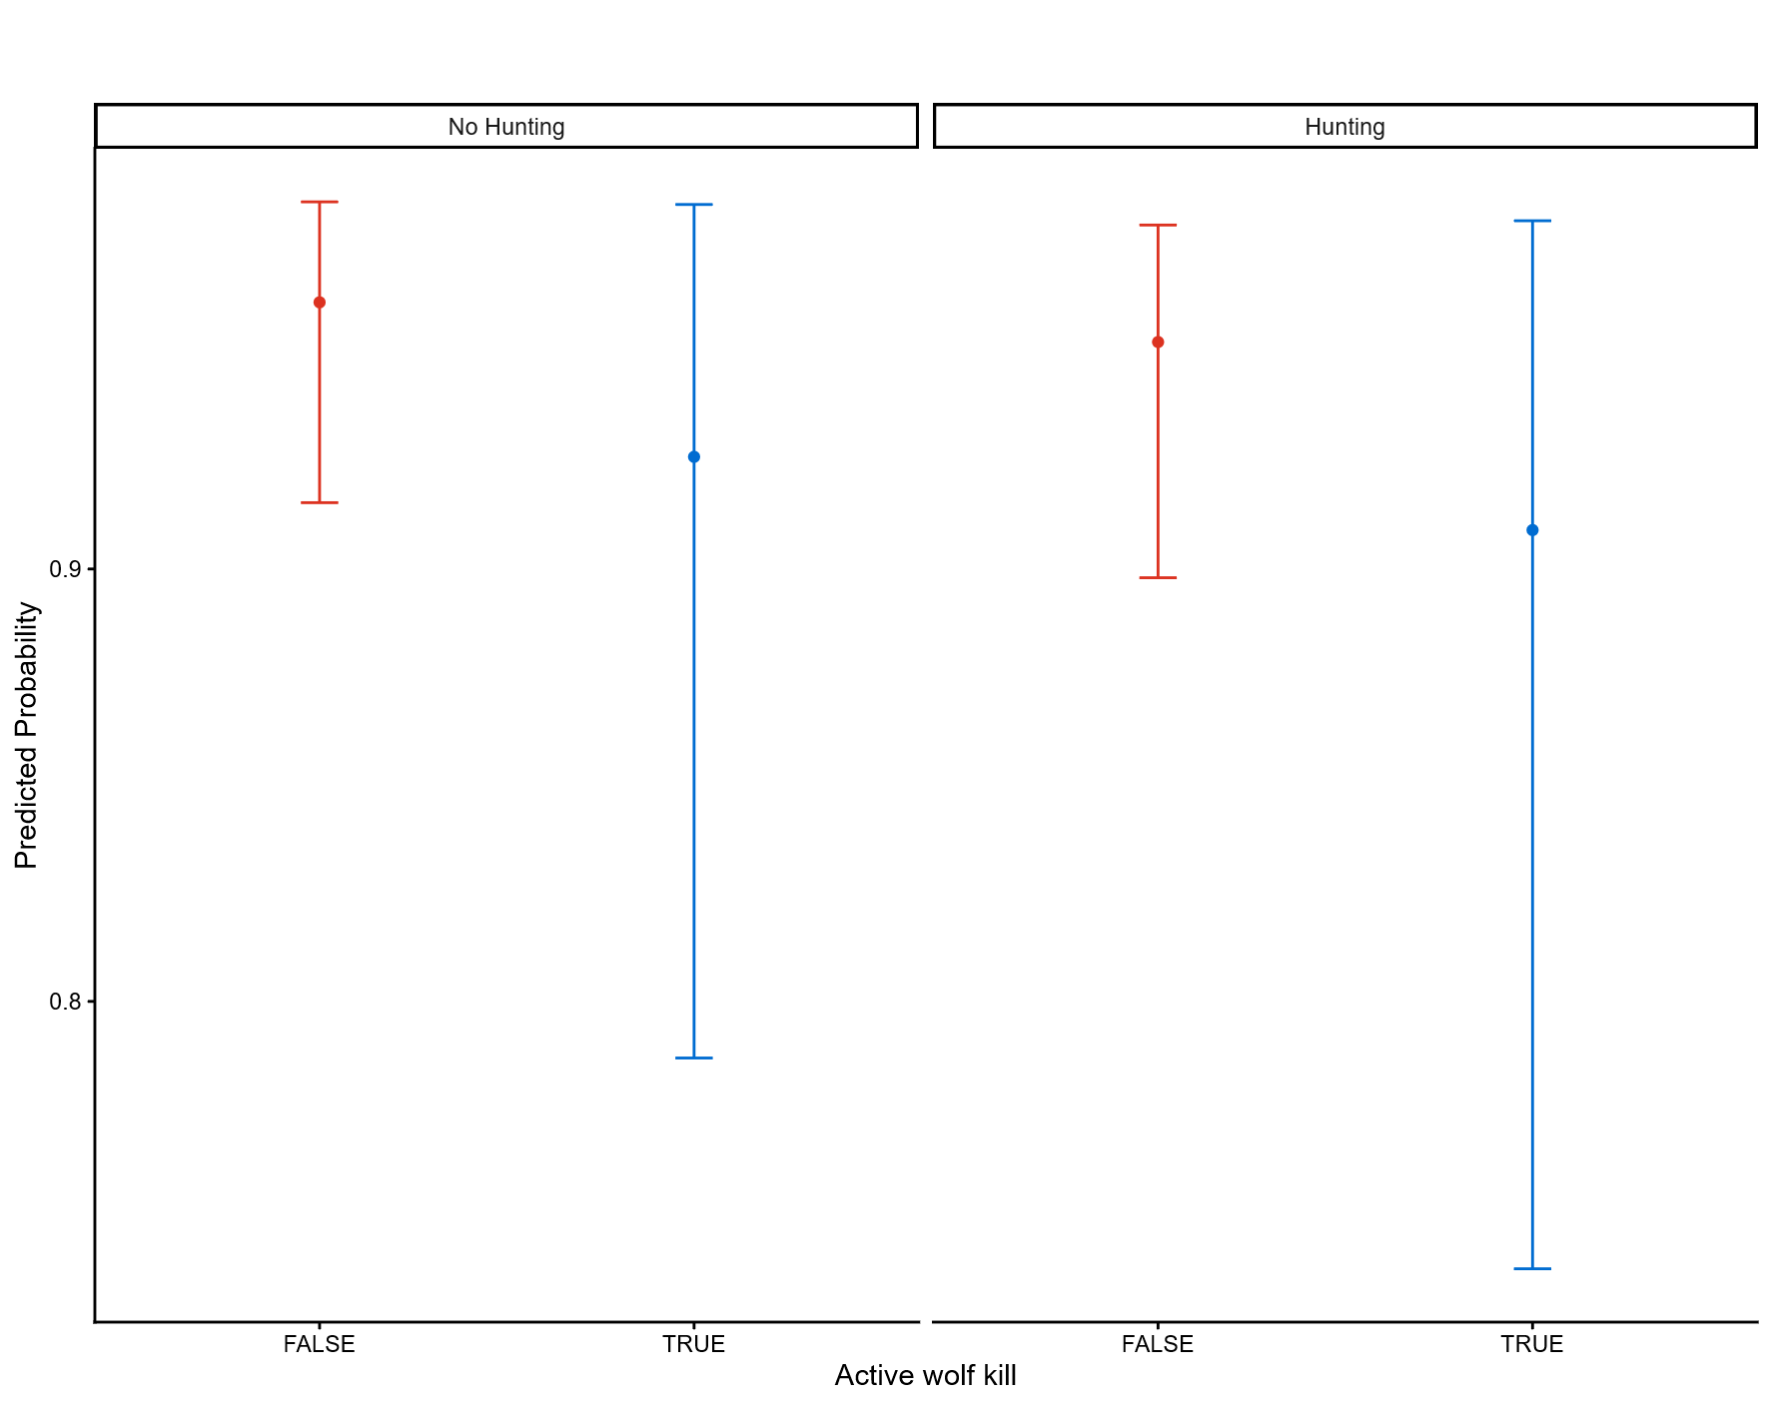
Figure 5. Predicted probability and bootstrapped 95% confidence intervals (n = 1000) of ravens leaving their territory based on active wolf kills within their territories (p < 0.05) and the status of the hunting season (p = 0.31). All other continuous scaled covariates are held at 0 and study period was set to early.
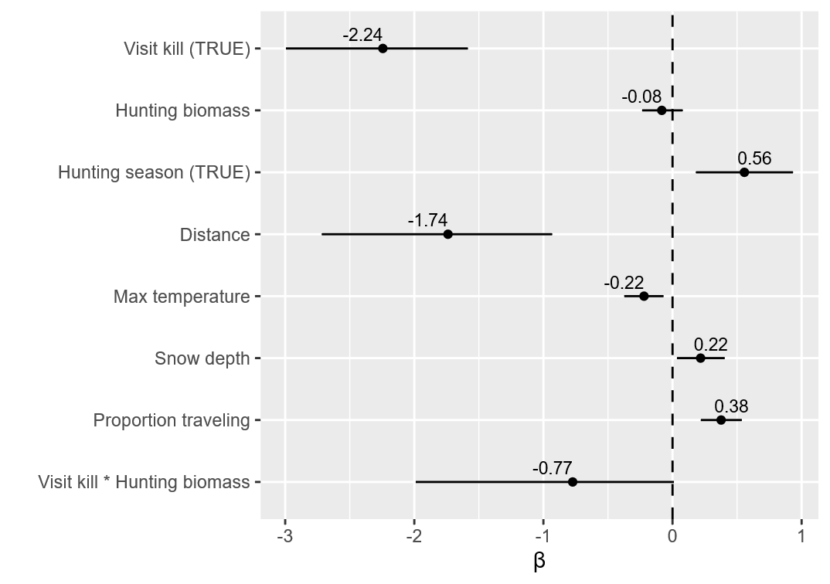
Figure 6. 95% confidence intervals for model parameters from the hunting generalized linear mixed model investigating the probability of ravens visiting the hunting regions on days it has left its territory.
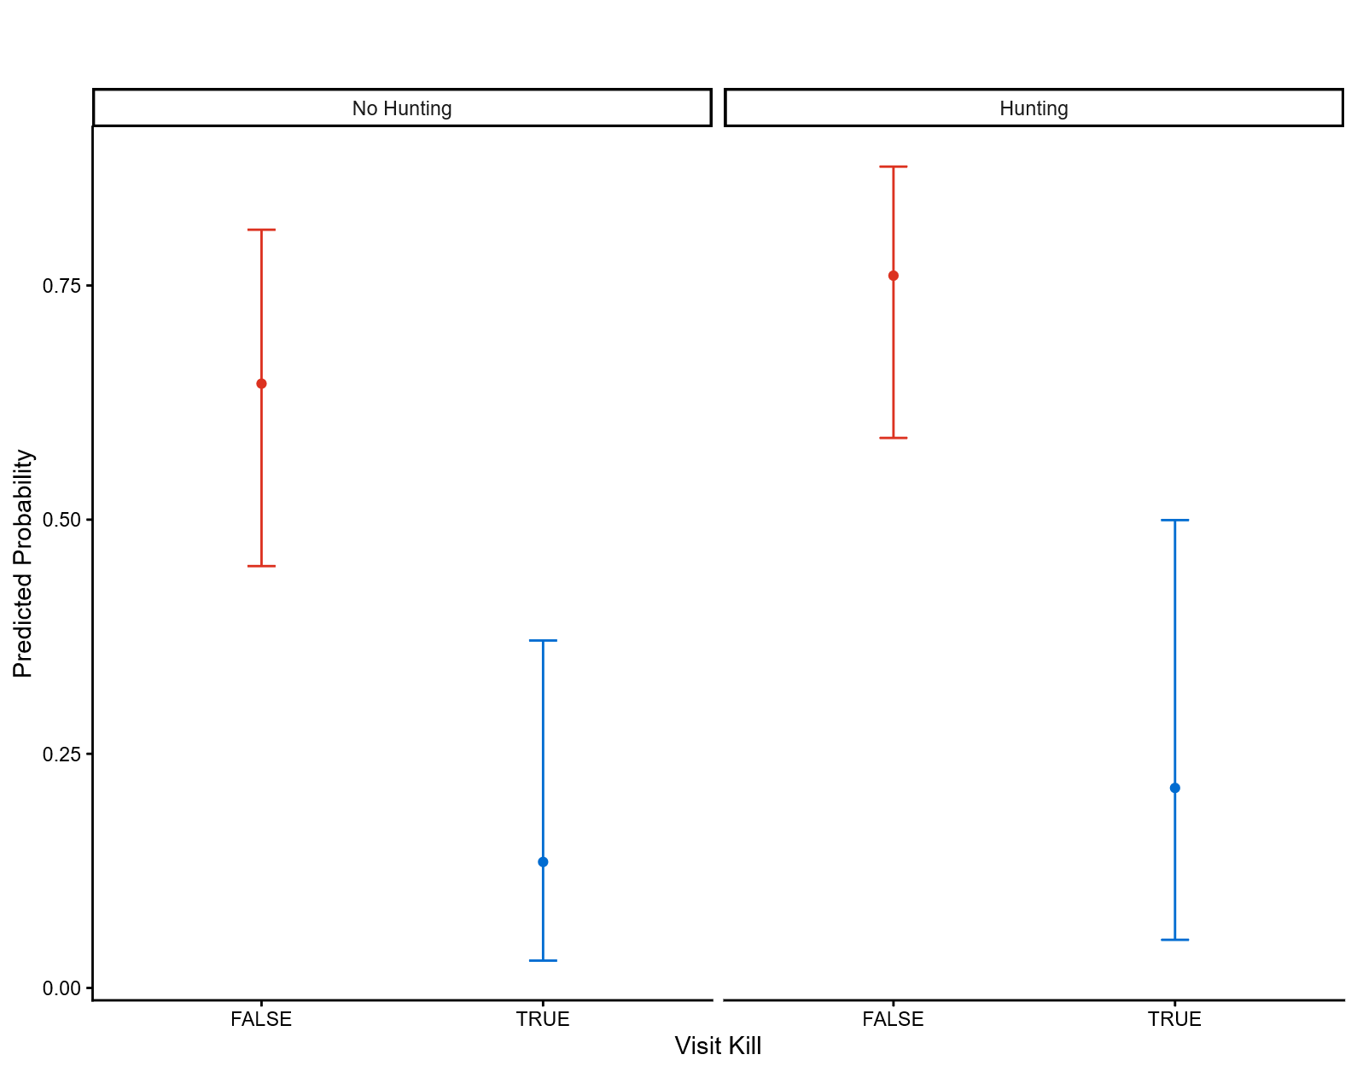
Figure 7. Predicted probability and bootstrapped 95% confidence intervals (n = 1000) of ravens visiting the hunting regions based on the timing of the hunting season (p < 0.01) and whether they located a wolf kill after leaving their territory (p < 0.001). All other continuous scaled covariates are held at 0.

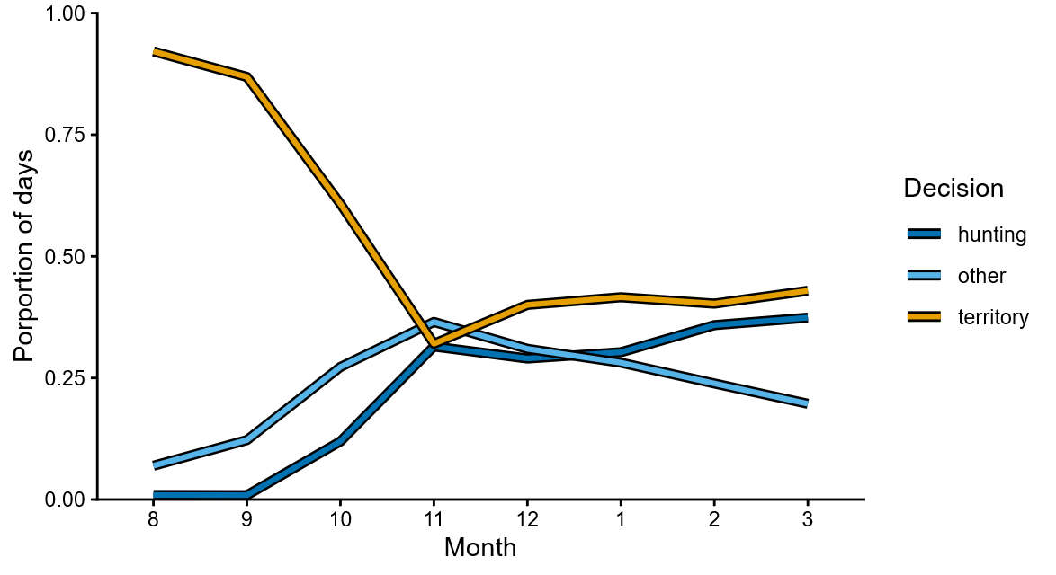
Figure 8. Plot shows the average (between ravens) proportion of days ravens made each movement decision during the fall/winter.

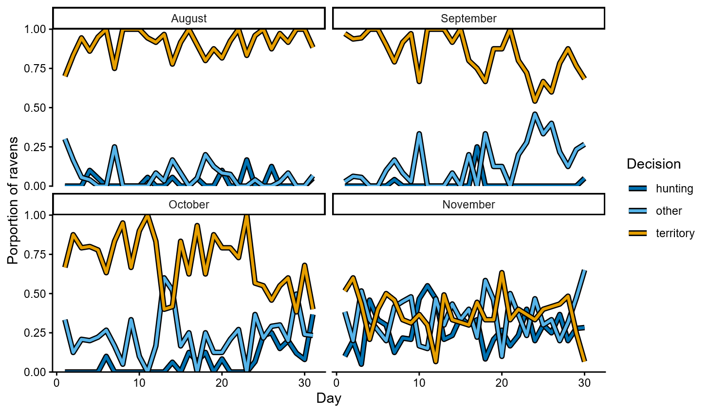
Figure 9. Plot shows the average (between years) proportion of ravens that made a movement decision on each day during the early winter months. In the months prior to the hunting season, trips to the hunting regions were farther apart. However, in the week preceding the MTFWP rifle hunting season (~ Oct 23), we see more consistent visits to the hunting regions.

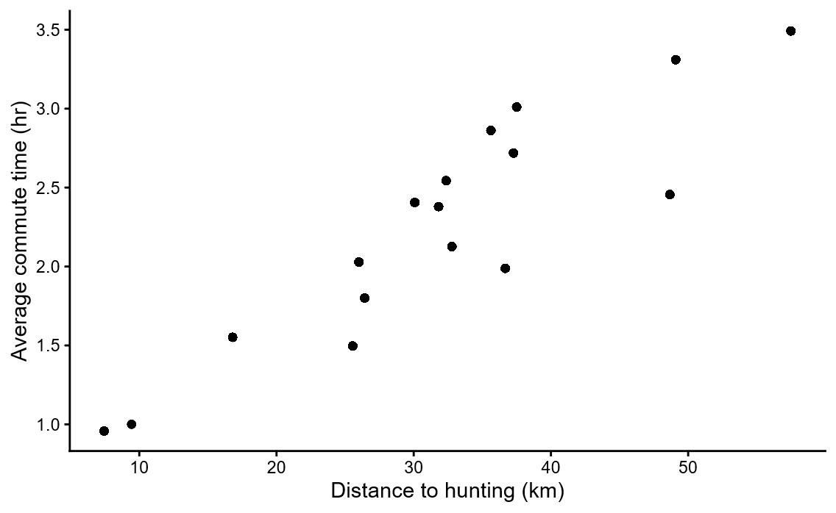
Supplementary Figure 2. Plot showing the average commute times for ravens between their territories and the Gardiner hunting regions. Commute times were calculated as the time difference between the last point within a raven’s territory and the first point in the date-appropriate hunting region. GPS fixes were taken at 30-minute or 1-hour intervals depending on battery level with the potential for missed fixes, so these values are likely inflated.

