Chapter 2: Breeding raven foraging decisions in the face of multiple sources of carrion.
Introduction
Protected areas are important tools for conserving biodiversity, protecting threatened species, and maintaining the resilience of common species (Devictor et al. 2007, Geldmann et al. 2013, Watson et al. 2014, Gray et al. 2016). However, for species with high movement potential the efficacy of a static regulated space can vary. Animals may leave the protected area to forage (Ho et al. 2023, López-Peinado et al. 2023), to accommodate varying requirements of life stages (Moffitt et al. 2009, Di Franco et al. 2018), or because of a home range larger than the protected area (Phipps et al. 2013). Understanding what factors are driving movements outside of a protected area is critical as these movements may expose a target population to new risks and higher mortality rates, reducing the efficacy of the protected area (Devictor et al. 2007, Moffitt et al. 2009, Di Franco et al. 2018). Alternatively, it may provide benefits like food subsidies or breeding space (Walker et al. 2018, Ho et al. 2023).
Protected areas are often located near relatively undeveloped areas which can provide similar habitat for wildlife but may have differing regulations. For example, protected areas commonly restrict recreational hunting, creating a refuge inside the protected area. However, for scavengers, hunting can create an additional source of carrion on the landscape. Carrion is a vital source of nutrients for facultative scavengers that can be created through natural processes such as predation, senescence, or disease as well as human activities such as recreational hunting. It is an essential energy source during the winter for scavengers when other natural food resources may be less available, allowing populations to persist (Selva et al. 2005, Needham et al. 2014, Walker et al. 2018). Carrion provided outside protected areas from human hunting can alter the behavior of scavengers seeking to find alternative food sources (Walker et al. 2018, Ho et al. 2023).
The spatial and temporal distribution of each carrion resource creates different foraging opportunities for scavengers. Sources of natural carrion are temporally unpredictable due to the low hunting success rate of gray wolves (MacNulty 2002) and occur across a wide spatial scale (Wilmers et al. 2003b). Anthropogenic carrion is more temporally and spatially aggregated, which provides more individuals from species with high mobility access to the area with a reliable resource (Wilmers et al. 2003b). Persecution by humans may also prevent certain species such as coyotes and wolves, from safely access spaces with anthropogenic carrion, removing dominant competitors (Wilmers et al. 2003b).
Common ravens (Corvus corax) are foraging generalists and facultative scavengers with a high movement potential due to efficient soaring that have seen dramatic growth in their populations in North America (Harju et al. 2021). They have historically utilized gray wolves (Canus lupus) as a source of carrion and investigate howling and hunting behavior for potential food (Harrington 1978, Stahler et al. 2002). Winters with higher wolf prey-acquisition rates also promotes vagrant raven use of wolf-habitat instead of anthropogenic landscapes (Walker et al. 2018). However, with the explosive growth of anthropogenic influence around the world, ravens have adapted to exploit anthropogenic resources such as human hunting, even learning to recognize gunshots as an indicator of potential food (White 2005). Territory holding ravens defend their breeding territories year-round (Heinrich 1988); however, outside of the breeding season they are not as restricted in their use of space (Ho et al. 2023) because they are not bound by central place foraging where they are required to provision an incubating female or young.
To better understand how variations in the availability of carrion from natural and anthropogenic sources influences the foraging and movement decisions of territory holding ravens in protected areas, we conducted a study in Yellowstone National Park. Gray wolves were reintroduced to the landscape in 1995 and have since returned to a healthy, stable population level (Cassidy et al. 2025). Their return to the landscape played a role in creating a more consistent regime for natural carrion throughout the year (Wilmers et al. 2003a, Wilmers and Getz 2004). Yellowstone is surrounded by public lands held by the US Forest Service (USFS) that allows recreational ungulate hunting during the winter. Hunters field dress their kills and leave behind edible biomass from gut piles, skeletal remains with meat, bones, and hide that are then available to scavengers. These two sources of carrion are both readily utilized by common ravens (Ho et al. 2023). In fact, ravens that hold breeding territories within Yellowstone National Park have been documented commuting during the winter between their territories and hunting areas outside the park boundaries (Marzluff et al. 2021).
In this study, we use data from global positioning system (GPS) tracked ravens to test the hypothesis that movement decisions are influenced by the availability of carrion from natural sources and carrion provided from recreational hunting outside Yellowstone influences raven movement decisions. We predict that ravens are less likely to commute away from their territories when (1) there is an active resources within their territory that provides a close food resource and attracts other conspecifics into the territory and (2) there is less recreational hunting biomass available that would provide a more reliable resource and a potentially greater biomass acquired than a predator kill. After a raven has left its territory, we predict that a raven will visit recreational hunting areas more often when (1) hunting biomass is more readily available and (2) no wolf kill is located while traveling.

Methods
Study area
Yellowstone National Park is one of the largest, mostly intact temperate ecosystems at 8903 km². It is covered in a mix of habitat types including sagebrush steppe, grasslands, mixed conifer and pine forests, and thermally active regions. The northern range of Yellowstone National Park is bordered by the Custer Gallatin National Forest, public land managed by the USFS that is open to the public for recreational hunting during various seasons. This area, which is located outside the northern boundary of Yellowstone, is an area with high ungulate hunting effort during the winter each year. Hunters are targeting elk (Cervus canadensis) and bison (Bison bison) that migrate through during the winter and resident populations of mule (Odocoileus hemionus) and white-tailed deer (Odocoileus virginianus) when winter conditions drive ungulates to lower elevations (Geremia et al. 2011, Rickbeil et al. 2019). In contrast, across the park boundary recreational hunting is prohibited. Instead, a relatively dense wolf population creates carrion during the winter.
Raven movement tracking
We tracked common raven movement in Yellowstone National Park using GPS tracking technology to examine the impacts of carrion availability on foraging decisions of territorial ravens. Ravens were captured between October 2019 and January 2024 using remote controlled net launchers (Coda Enterprises, Ltd). Various anthropogenic foods and carrion sources were used as bait. Territorial ravens were caught opportunistically in large feeding groups with vagrant ravens and as targeted efforts at territories along the road within the national park. Multiple ravens that were vagrant at the time of capture transitioned into territorial individuals during the study period. Solar powered GPS data loggers (e-obs GmbH; Bird Solar UMTS, 25 g) were then fit to the bird using teflon harness straps (total assembly weight <4% body mass). The GPS data loggers recorded locations at 30-minute intervals when above 3,900 mV, no GPS locations when below 3,700 mV, and 1-hour intervals when in between. Movement data was downloaded from the GPS data loggers via Bluetooth connection to a hand-held receiver or uploaded directly to a Movebank database through a 3G cell network connection. Territorial ravens were determined by examining their movements during the breeding season when they show restricted movements compared to vagrant individuals (Webb et al. 2011). We removed male ravens when both birds in a territorial pair were tagged to avoid pseudoreplication because raven pairs are known to travel together during the winter while foraging. The male ravens had less days with successful fixes and a lower daily fix rate than females due to their feather more often covering the solar panel and causing lower battery levels.
For this analysis, the raven GPS points collected were cleaned so that all consecutive GPS points from an individual had at least 29 minutes between them. This removed instances of fixes taken in quick success due to an unintended interaction with the satellite during uploads, while maintaining the greatest number of GPS points.
Raven movement decisions
To determine if a raven left its territory, we first define the spatial boundaries of each territory. We determined a raven’s territory location and size by creating a 90% minimum convex polygon (MCP) using the package adehabitatHR (version 0.4.22) in R (version 4.5.1; Development Core Team 2021) from GPS points collected during the breeding season (May - July) across all breeding seasons an individual was monitored. A 90% MCP was used to account for movements made after any nest failure which alleviates the movement restrictions placed on the adult by central place foraging (Fig 1). A raven was determined to have stayed on its territory if all GPS on that day were within 1 kilometer of the territory boundary.
We defined two separate polygons for the hunting area potentially utilized by ravens to locate foraging opportunities from gutpiles created from the MT Fish, Wildlife, and Parks rifle hunting season or the tribal hunting season (Fig 1, 2). During MTFWP rifle hunting season, which occurs on slightly varying dates from the last week of October to the end of November or first week of December, elk and deer are the main targets and are consistently farther from roadways and small enough to be packed out by smaller groups of hunters. To capture this region (hereafter MTFWP hunting region), a 5 km buffer was created around all roads 10 km away from the park boundary around Gardiner, MT. We recognize that additional take will occur outside of this region, but the vast majority of hunting will occur within this space.
Bison hunting is more concentrated around the roadway as bison migration is largely funneled in the open area along the south side of the Yellowstone River at the park boundary. Adult male bison can weigh over 750 kg during the hunting season (Yellowstone Bison Office, National Park Service, unpublished data), so the effort required to hike a bison harvest back to the road is much greater and avoided when possible. The bison hunting polygon (hereafter bison hunting region) was created with a 1 km buffer around the Old Yellowstone trail and Highway 89 extending to the cattle grate at the south end of Yankee Jim Canyon. The cattle grate prevents the northward movement of bison to reduce the potential spread of brucellosis to ranched cattle populations. We defined the bison hunting season being from the first day that bison were taken during that winter (i.e. November 2019 – March 2020) that had a second day with a successful taken within 7 days, extending until the end of the winter study period (March 30). Bison hunting dates are flexible due to harvest being influenced more by bison movement than hunting date regulations for tribal hunters (December 1st to March 31st). A single exception was included for 2024 when only a single day during the study period had a day with a successful take.
A raven was determined to have attempted to obtain hunter created carrion if it had at least 1 GPS point within the appropriate hunting region polygon. The MTFWP hunting region was active for the duration of the MTFWP hunting season and the bison hunting region was active from that date until March 30th. Days were removed for ravens when they had less than 5 GPS points and the decision for that day was negative for that model (e.g. raven didn’t leave territory) as there is uncertainty about whether the decision of the raven is not captured due to missed fixes.
Usage of wolf killed carrion
We determined the location and timing of wolf kills utilizing the output from a random forest algorithm created by Binder et al. (2026) that predicts if a wolf GPS cluster, defined as 2 GPS points from an individual within 100 meters and 72 hours of each other, is a carcass. The model uses a mix of movement, timing, landscape, and climate covariates and makes no determinations about the prey species or cause of death. Each wolf kill was available to be used by ravens from the beginning of the wolf GPS cluster until 1 day after the last wolf GPS point. This additional day accounts for biomass still being available and used by scavengers after wolves have abandoned the carcass. For resources within a raven’s territory (Fig. 1), we considered all wolf killed carcasses within 1 kilometer of a territory available to the local raven. For resources located after leaving the territory, we considered a raven to have visited a wolf kill if there was at least 1 GPS point within 500 meters of an active kill site. Cougar kills were not considered as the usage of this resource by ravens was minimal compared to wolf created carrion (Loretto et al. in review).
Availability of hunter carrion
Ungulate hunting north of Yellowstone occurs in the 313 and 314 hunting districts around the town of Gardiner, although the 314 region also extends much farther north into the Paradise Valley. This space is used for both the state controlled ungulate hunt as well as hunting by indigenous tribes with treaty rights. Ravens regularly utilize the very southern portions of these hunting regions to locate gutpiles left by hunters.
To calculate availability of hunter created biomass we obtained hunter take information for elk and deer during the rifle hunting period from the Montana Fish, Wildlife, and Parks for the 313 hunting district (https://myfwp.mt.gov/fwpPub/harvestReports) and bison take from the NPS Bison Office (unpublished data). Bison take in the Gardiner Basin was recorded daily through surveys and communications with NPS law enforcement, private hunters, and game wardens. MTFWP estimates were not daily, and needed to be adjusted to account for daily variation since ungulate migration timing is weather dependent (Rickbeil et al. 2019). We accounted for daily variation in hunter success by using GPS data gathered from elk collared by the Yellowstone Wolf, Cougar, and Elk project to determine the proportion of elk that have moved outside the national park boundary and are available for hunters to take. This proportion of available elk was scaled within year and applied to the take values for all ungulate species for that hunting year.
$$daily take=yearly take× \frac{daily proportion elk}{\text{sum}(proportion elk)}$$
The exception is mule deer bucks that are protected during the last 2 weeks of the hunting season and have no legal take during this period. The final take numbers of each species were adjusted to account for differences in the weights of various species with all deer species having a 0.3x multiplier and bison having a 2.15x multiplier (elk are the standard at 1x). These multipliers were calculated by comparing early winter weights of deer and elk and late winter weights of bison ((Murphy et al. 1998) NPS Bison Office unpublished data). To account for biomass lingering between days,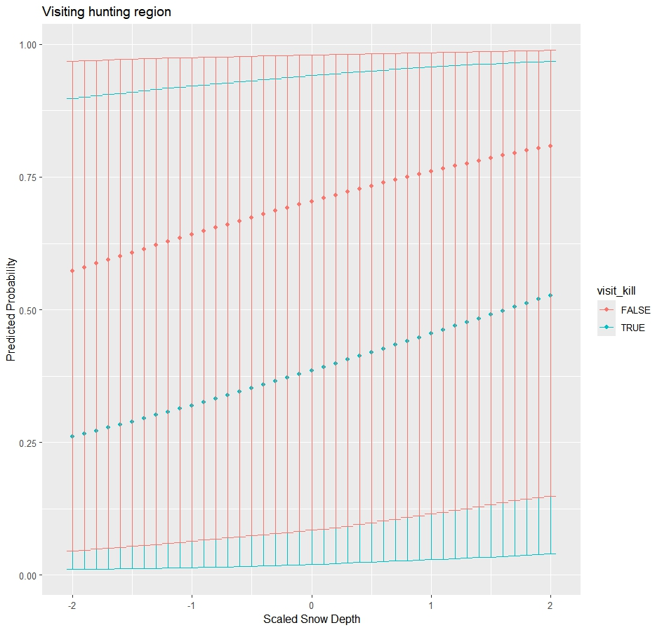 25% of the biomass from the previous day was carried over.
Covariates
Since traveling requires both time and energy, we considered the distances of each raven’s territory to the hunting regions. The commute distance for each raven was calculated by taking the Euclidean distance from the center of the MCP to Yellowstone’s northern entrance station in Gardiner, MT as that was a central location to both hunting regions.
Ravens perform pre-breeding behaviors such as territory defense and nest building to retain possession of their territory. The need to perform these behaviors may impact a raven’s decision to leave its territory. Ravens in Yellowstone typically lay eggs at the end of March until the middle of April (unpublished data). These pre-breeding behaviors should be more prevalent closer to the breeding season. For this reason, months were classified into two categories: early winter comprising November and December, and late winter representing March.
Another variable that could affect a raven movement is varying usage by wolves for each territory, as ravens will recognize spaces with higher frequencies of wolf kills (Loretto et al in review). Ravens that hold territories that are more productive, in that wolves create kills in the area more often, may remember and be more willing to risk staying on their territories even when a kill is not immediately available. We calculated this by taking an average of the 30-day carcass acquisition rates of wolves using the random forest predictive algorithm across all years that the raven was monitored on territory.
Ravens are social animals that can utilize information sharing to locate foraging opportunities (Marzluff et al. 1996). A territorial raven, even if it doesn’t utilize a communal roost with other ravens to gather information, might still consider the movement decisions of other ravens when deciding their own course of action. We considered the proportion of other ravens leaving their territories or visiting the hunting regions on a particular day, not including the individual in consideration.
Walker et al. (2018) found snowpack to be an important predictor in raven use of wolf habitat in Yellowstone. Similarly, we included snow depth and maximum daily temperature from Mammoth, WY as a predictor that might similarly impact territorial raven decision making.
Raven movement model
We investigated how the availability from two sources of carrion, hunters and wolves, drives movement decisions of breeding ravens during the winter by creating a conditional binomial generalized linear mixed models (GLMM) using the R package lme4 (version 1.1-37) with a random effect for individuals. The conditional model breaks the commuting process into two separate decisions. The first part is whether a raven decides to leave its territory (hereafter territory model) and the second part is if the raven left its territory, if it then decides to visit the hunting regions (hereafter hunting model). This second part of the conditional model allowed for other destination that a raven might visit such as a wolf kill outside of its territory or a different anthropogenic resource.
We restricted both models to data from the 30-day early (Nov 15 - Dec 15) and late (March 1 - 30) winter study periods done by the Yellowstone Wolf, Cougar, and Elk project because that is the period the wolf carcass predictive algorithm works for due to a higher wolf collar fix rate. Both models included an interaction effect between the wolf kill covariate (active kill and visited kill) and the amount of hunting biomass available to determine if one resource was given priority over the other in the decision-making process. Two covariates were used to represent the hunting season to determine to what degree ravens were tracking the potential biomass versus a broader general availability determined by the hunting season. Other covariates in the territory model are the distance to the hunting regions, average wolf kill density within the territory, pre-breeding season period, the proportion of other ravens leaving their territory, daily maximum temperature, and daily snow depth. Other covariates in the hunting model are the distance to the hunting region, the proportion of other ravens visiting the hunting regions, average daily temperature, and daily snow depth.

Results
Between October 2019 and March 2024, we gathered 2090 decision days (mean = 104.5, sd = 62.6, range = 4 - 216) from 20 territorial ravens (12 female, 8 male) in Yellowstone National Park. 16 individuals were captured as territory holders and 4 individuals were captured as vagrant non-breeders and transitioned into territorial holders during the study period. 2 territorial males were excluded due to being in a territorial pair with a tagged female. There was wide variation in the individual movement decisions of ravens with many ravens often deciding to travel outside of the park to the hunting regions (Fig 3). Outside of the two main carrion resources available on the landscape, ravens also visited various anthropogenic subsidies. Ravens spent some time at the landfill and sewage treatment ponds in Gardiner an average of 15.2% of trips to the hunting regions throughout the winter (range = 0 – 60%, sd = 17.3%). Ravens that lived in the interior portion of Yellowstone also utilized West Yellowstone, MT for regular foraging on anthropogenic subsidies (Fig 4).
Wolf kills availability was not plentiful for territorial ravens, either within their territory or without. Raven territories were on average 5.9 km² (range = 0.8 – 21.2 km², sd = 6.3 km²), but each territory only had a wolf kill available on an average of 3.1% of days (range = 0 – 25%, sd = 6.2%). On extraterritorial trips, wolf kills were only found on an average of 9.5% of days (range = 1.8 – 33.3%, sd = 7.7%). However, an average of 68.5% of extraterritorial trips with a wolf kill also involved the raven investigating the hunting areas as well (range = 16.7 – 100%, sd = 33.2%).

Foraging movement decisions
We broke the foraging movements of territorial ravens into two parts to determine how food availability, weather, and social cues impact extraterritorial movement decisions.
Food availability and weather conditions both impacted a raven’s decision to leave their territory. A wolf kill within 1 km of a raven’s territory decreased the chance of it leaving its territory (-0.9506975, SE = 0.336099, p < 0.01, Table 1, Fig. 5). The availability of hunter created carrion did not impact a raven’s decision to leave its territory, regardless of the metric of consideration (hunting season: -0.1173545, SE = 0.2032094, p = 0.56; hunting biomass: -0.0006911, SE = 0.079927, p = 0.99; Table 1, Fig. 5). There is some evidence showing that ravens leave their territories more often when snow depth was greater (0.1691263, SE = 0.1002069, p < 0.1, Table 1). There was also a trend that ravens were less likely to leave their territory during March compared to November and December (-0.3754036, SE = 0.2034757, p < 0.1, Table 1). The effect of time period was not impacted by the temperature during late and early winter (0.0252384, SE = 0.1756506, p = 0.89, Table 1).
When a raven decided to leave its territory, their destination was impacted by a multitude of factors. Ravens were more likely to visit the hunting regions during the hunting season (0.71482, SE = 0.1776, p < 0.001, Table 2, Fig. 7), but again they were not influenced by the actual amount of biomass available in hunting areas (-0.09048, SE = 0.07678, p = 0.24, Table 2). When a wolf kill was located outside of their territory, it heavily decreased the chances of visiting the hunting area (-1.29118, SE = 0.27139, p < 0.001, Fig. 7). Ravens with territories closer to the hunting regions visited the hunting area much more often (-1.83694, SE = 0.40598, p < 0.001, Table 2). Ravens made the same travel decisions as their peers after leaving their territory (0.40688, SE = 0.07663, p < 0.001 Table 2). Ravens also visited the hunting area more often on days with colder temperatures (-0.16889, SE = 0.07226, p < 0.05) and deeper snow (0.29086, SE = 0.0892, p < 0.01, Table 2, Fig. 8).

Discussion
Ravens during the winter, like many generalists, are more limited in their foraging options. For Yellowstone’s population of ravens, anthropogenic subsidies and natural predation create the majority of these resources (Ho et al. 2023). In the case of carrion created through recreational hunting and natural predation events, the locations have minimal overlap in space with recreational hunting only legally occurring outside of the national park boundaries (Wilmers et al. 2003b). This creates a situation where territorial ravens must travel a median distance of 32.6 km (range = 7.4 – 64 km, sd = 15.7) to reach the primary area used by hunters in the northern range. We show that territorial ravens use the availability of carrion generated through recreational hunting and predation to determine their daily movement patterns. This is in line with a previous study done on the population of ravens in Yellowstone, which was likely skewed towards behavior of nonbreeders due to count surveys being nondiscriminatory and the population being mostly nonbreeders (Walker et al. 2018). While Walker et al. (2018) showed greater numbers of ravens in wild areas during winters with higher rates of wolf predation, they also found an increased abundance of ravens in anthropogenic areas during years with greater snow depth that is likely attributed to increased hunter success due to a heavier ungulate migration (Geremia et al. 2011, Walker et al. 2018).
Ravens often chose to stay within their territories when a wolf kill was present within their territory, meeting our expectations. This provides an immediate food resource that a raven can exploit as the local territorial ravens are often the first to locate the carcass (Heinrich and Marzluff 1995). However, this foraging opportunity also leads to a large influx of other scavengers in the area, including ravens, through spatial association with wolves and local enhancement (Heinrich and Marzluff 1995, Stahler et al. 2002, Wilmers et al. 2003a). Ravens are social creatures and dominant individuals will spend time at food resources displaying to other conspecifics (Heinrich and Marzluff 1995). Alternatively, territorial ravens may also be choosing to stay on territory to maintain possession of their territory. It is currently unknown through what mechanisms ravens claim or lose ownership of territories, although usurpation and conflict is a common method in other avian species (Arcese 1989, Piper et al. 2000). As a non-migratory species that remains on their territory all year (Heinrich 1988), physical presence, visual displays, and vocalizations can all assist the territory owner in retaining possession of the space (Peek 1972, Piper et al. 2000). Our results further support the idea that movement decisions are at least partially driven by breeding behaviors by showing reduced extraterritorial movements in March compared to November and December, when ravens have been observed performing more active pre-breeding season behaviors such as nest building. During the study period we documented one occasion of a territorial pair losing their territory unprecipitated by a mortality event of at least one of the individuals (unpublished data).
A raven’s response to hunter created carrion is a bit more nuanced. Ravens did not consider potential resources in the hunting area when deciding whether to stay within their territory that day. Once they did leave their territory, ravens traveled to the hunting area during the hunting season but were not basing this decision on the amount of available biomass. Hunter kills often have greater raven numbers than wolf kills (Wilmers et al. 2003b), so the expectation would be for a territorial raven to face heavy competition regardless of the amount of hunter carrion available that day. Given that territory holders tend to be dominant individuals, they would be able to gain access to contested resources. The distance between a raven’s territory and the hunting area would also preclude them from having accurate daily information about carrion availability on any day. Only a single tagged raven in our sample group is within the potential range to stay on territory and hear gunshots from the hunting area, which ravens can learned to associate with a potential successful harvest (White 2005). Most ravens were thus making decisions based on information from recent visits, memory of previous years, and other daily proxies. We showed these proxies included weather conditions such as daily temperature and snow depth, which increased chances of leaving the territory and visiting the hunting area when deeper. Snow may indicate to ravens when ungulate populations are migrating out of the park (Geremia et al. 2011, Rickbeil et al. 2019), placing them on lands where they are available to be hunted. Hunters are also more efficient with snow on the ground as it allows them to more easily track ungulate movement. This tracking of weather patterns to optimize foraging movement efficiency is similar to gray-cheeked mangabeys in Uganda considering recent weather patterns effects on the maturation of fruit (Janmaat et al. 2006).
The amount of hunter biomass available did not alter a raven’s perception of wolf kills, making their movement a linear decision-making process with the immediate resource taking precedence. This includes wolf kills that were found outside of the territory. When a raven decided to leave its territory, it was unlikely that they were leaving with the purpose of locating a previously unknown, naturally occurring carcass. All wolf kills that were visited outside of territories, except for one, are within the travel corridor ravens take to reach the Gardiner hunting regions (Fig 1). Territorial ravens in the northern range frequently travel the ~30 km commuting distance to the hunting areas while uploading 0 or 1 intermediate travel points which indicates direct, non-stop flight. The presence of the newly located resource during transit likely altered their plan but was likely not the intended destination. This sort of route planning between distant, known resources has been documented in primates (Noser and Byrne 2007), elephants (Polansky et al. 2015), and is likely performed by ravens (Loretto et al. in review). The presence of dependable, alternative anthropogenic resources within close proximity of the hunting regions such as the Gardiner landfill and sewage treatment ponds, buffers the risk for ravens in deciding to commute by providing an alternative foraging location that is still calorie efficient.
Ravens did not consider the productivity of their territories when making movement decisions, despite their ability to remember this attribute at a broader spatial scale (Loretto et al. in review). Localized kills are apparent to the local breeders and wolf hunting activity most often occurs at dawn and dusk due to wolves’ crepuscular nature. Since territorial ravens often spend the first few hours after sunrise within their territory preening and performing pair-bonding activities, this would allow ample time for most wolf kills to have occurred before they have decided whether to travel.
Despite being social creatures that have the ability to share and receive information about potential food resource (Marzluff et al. 1996), ravens deciding whether to consider were not influenced by the movement of other territorial ravens. This decision was based on factors that each raven could interpret independently such as active kills within their territory or weather conditions. Once a raven has left its territory, it was influenced by the movement of other ravens, often traveling in concert with conspecifics.
Our results suggest that the breeding population of common ravens within Yellowstone National Park utilize recreational hunting as a supplementary food source with their primary target being naturally occurring carrion created through predation. As a foraging generalist, their ability to forage efficiently based on daily changes in food availability allows them to be successful. Since movement decisions are not influenced by the amount of biomass made available by hunters, it is unlikely that efforts to reduce its availability would be effective at preventing the exploitation of the resource. Other studies have shown moderate success in using supplemental feeding within protected areas to reduce movements outside the protected area for large avian scavengers (López-Peinado et al. 2023). However, until the resource is either eliminated or an alternative resource is available on a daily scale, ravens will likely continue to return to recreational hunting areas on days where no other foraging opportunity is available. At small scales, the removal of a landfill site can completely eliminate the presence of ravens (Marzluff et al. 2021). This continued usage of anthropogenic resources buffers raven populations against any decreases in natural carrion availability. Increasing the availability of natural carrion through the recovery of carnivore populations will only reduce the time spent outside of the protected area and in anthropogenic areas.

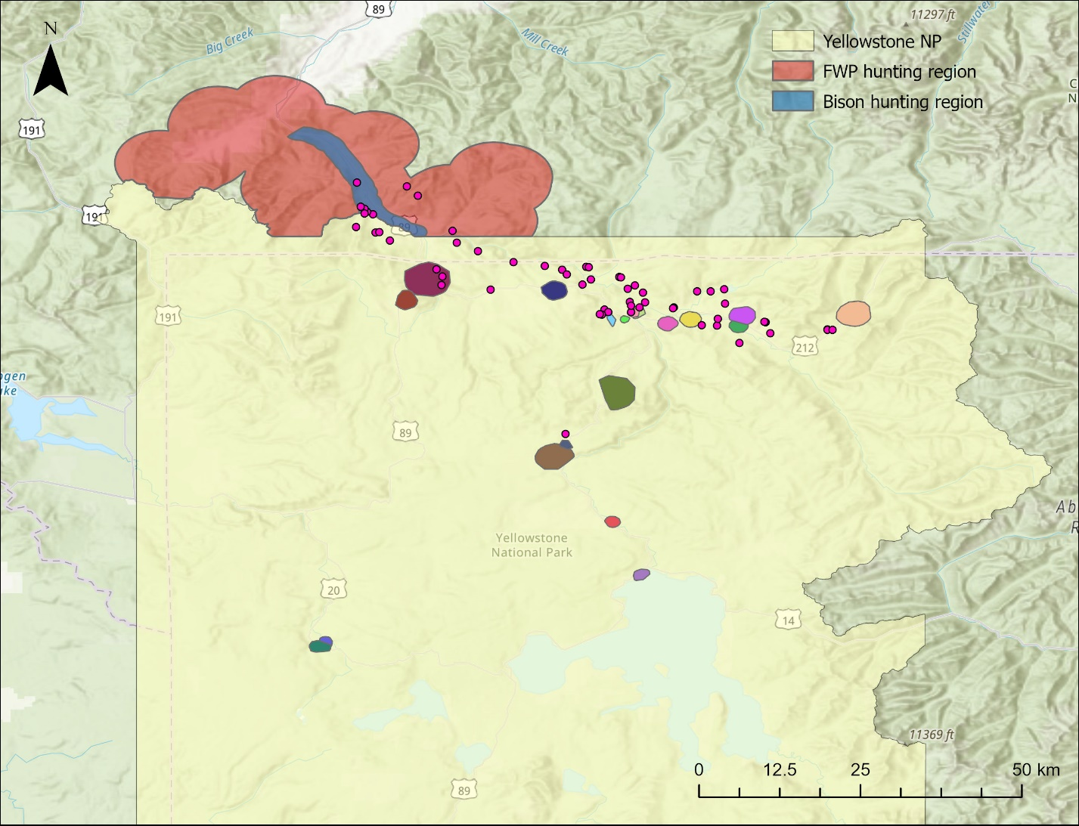
Figure 1. Map of Yellowstone National Park showing the locations of tagged raven territories as colored polygons inside the boundaries. The MTFWP (red) and bison (blue) hunting regions are highlighted outside the north-western boundary of the national park as the locations used to determine if ravens attempted to locate hunter created carrion. The MTFWP region was used during the duration of the rifle hunting season. The bison region was used after the end of the MTFWP rifle hunting season and ran until the end of the winter study period (March 30).
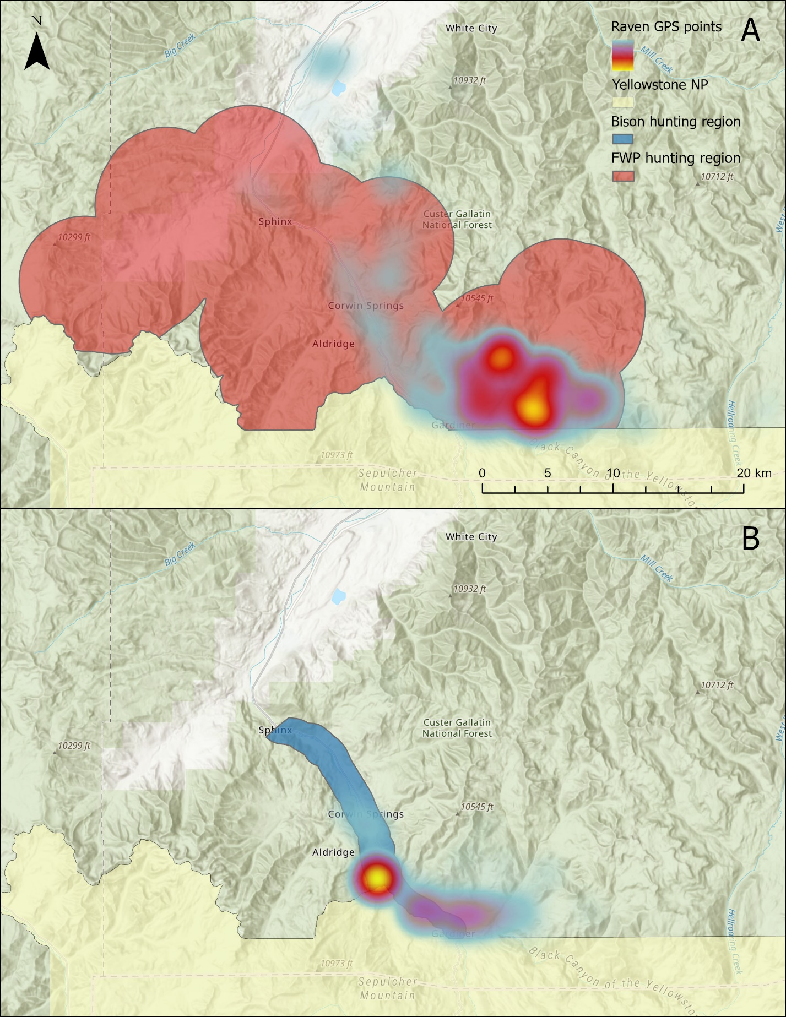
Figure 2. Maps showing the MTFWP hunting region (A) and the bison hunting region (B) compared to a heatmap of the raven GPS points outside of the Yellowstone National Park during November and March respectively. Warmer colors indicate higher point densities.

Figure 3. The proportion of decision days that each raven made a particular movement decision. The total number of decision days for each raven is displayed on the right-hand side of the plot. The “other” category is used to encapsulate all extra-territorial movements that did not result in a visit to the hunting regions.

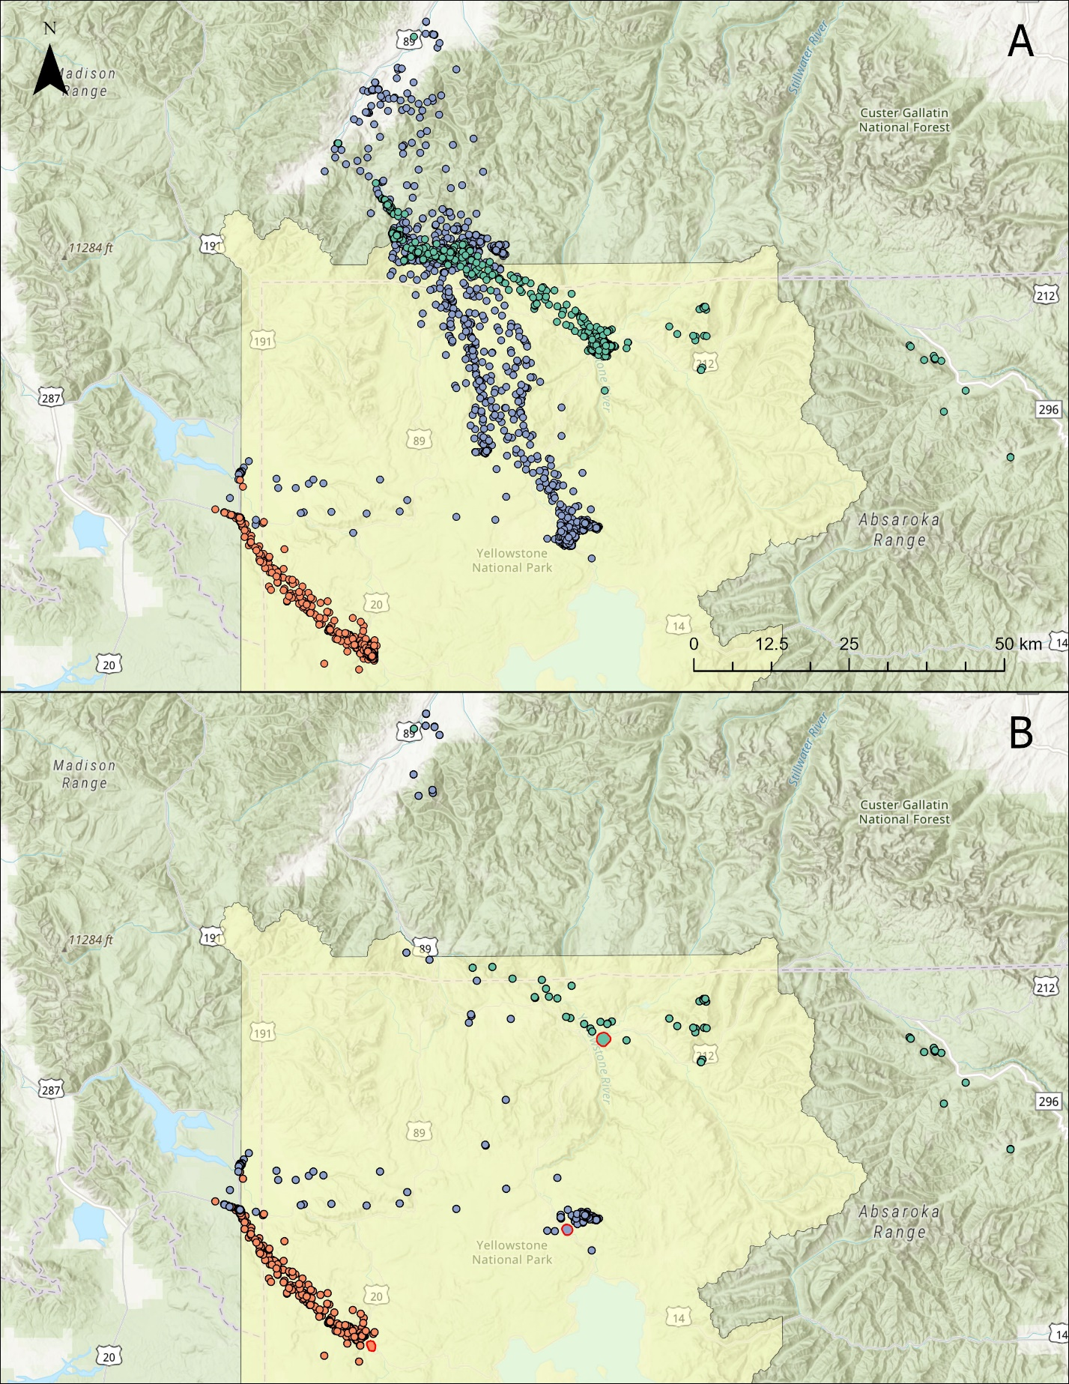
Figure 3. Map A shows the GPS movements of 3 common ravens at varying distances from the hunting regions. Map B shows the GPS movements of these 3 ravens when they decide to leave their territory, but do not end up visiting the hunting regions. Each raven’s territory is shown as a polygon with a red border in their color.

Table 1. Model results from the binomial generalized linear mixed model looking at the impact of covariates on the probability of ravens leaving their territory daily. N = 2115.
 | Estimate | Standard Error | p-value
Intercept | 2.9523176 | 0.4305425 | 7.02e-12
Wolf kill | -0.950699 | 0.3361002 | 0.00467
Hunting biomass | -0.0006909 | 0.0799271 | 0.9931
Hunting season | -0.1173553 | 0.2032099 | 0.5636
Kill density | 0.1542735 | 0.4322348 | 0.72115
Distance | -0.272044 | 0.3932647 | 0.48909
Study period | -0.3754031 | 0.2034761 | 0.06504
Max temp | -0.1342267 | 0.1504567 | 0.37232
Snow depth | 0.1691263 | 0.1002070 | 0.09146
Proportion traveling | 0.0937923 | 0.0797717 | 0.23969
Wolf kill * hunting Biomass | -0.1567256 | 0.3734736 | 0.67475
Study period * Max temp | 0.0252383 | 0.1756509 | 0.88575

Table 2. Model results from the binomial generalized linear mixed model looking at the impact of covariates on the probability of ravens visiting the hunting areas surrounding Gardiner, MT when they choose to leave their territory daily. n = 1716.
 | Estimate | Standard Error | p-value
Intercept | 0.23776 | 0.39677 | 0.54902
Visit kill | -1.29118 | 0.27139 | 1.96e-6
Hunting biomass | -0.09048 | 0.07678 | 0.23864
Hunting season | 0.71482 | 0.1776 | 5.7e-5
Distance | -1.83694 | 0.40598 | 6.05e-6
Proportion traveling | 0.40688 | 0.07663 | 1.1e-7
Max temp | -0.16889 | 0.07226 | 0.01942
Snow depth | 0.29086 | 0.0892 | 0.00111
Visit kill * Hunting biomass | -0.61927 | 0.35461 | 0.08075

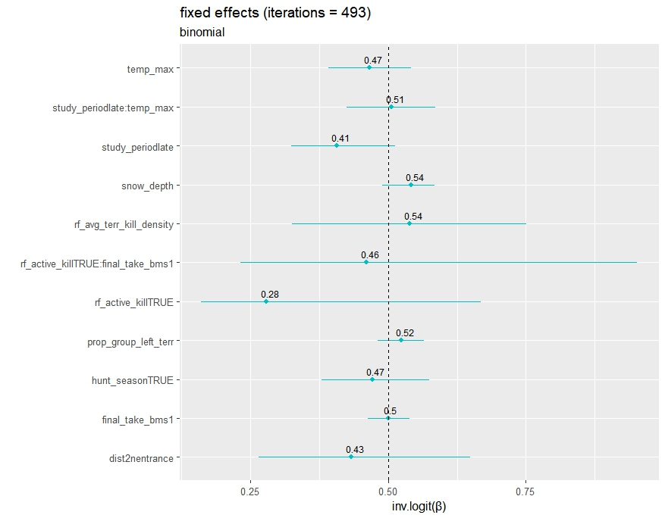
Figure 4. Bootstrapped 95% confidence intervals for model parameters from the territory model showing probability of ravens leaving their territory. Values are back transformed to the probability scale.
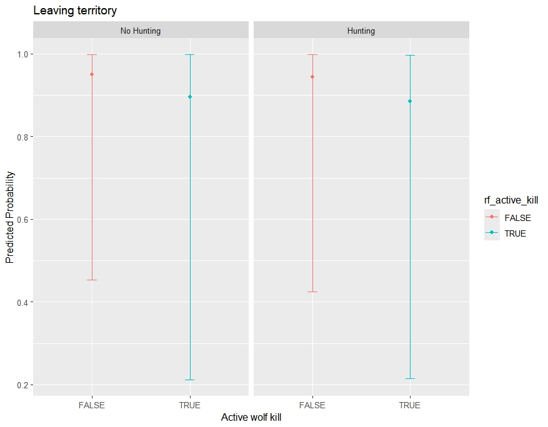
Figure 5. Bootstrapped predicted probability and 95% prediction intervals of ravens leaving their territory based on active wolf kills within their territories and whether the timing of the hunting season. All other continuous scaled covariates are held at 0 and the study period was set to early.
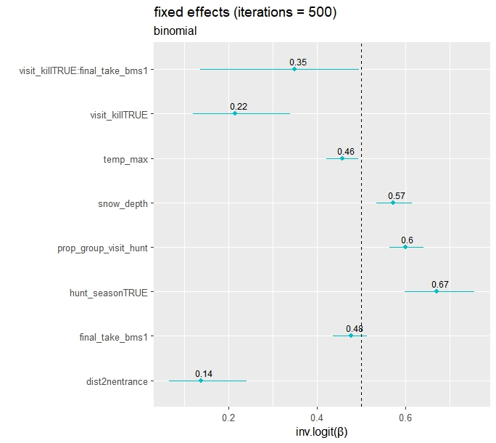
Figure 6. Bootstrapped 95% confidence intervals for model parameters from the hunting model showing probability of ravens visiting the hunting regions when they choose to leave their territory. Values are back transformed to the probability scale.
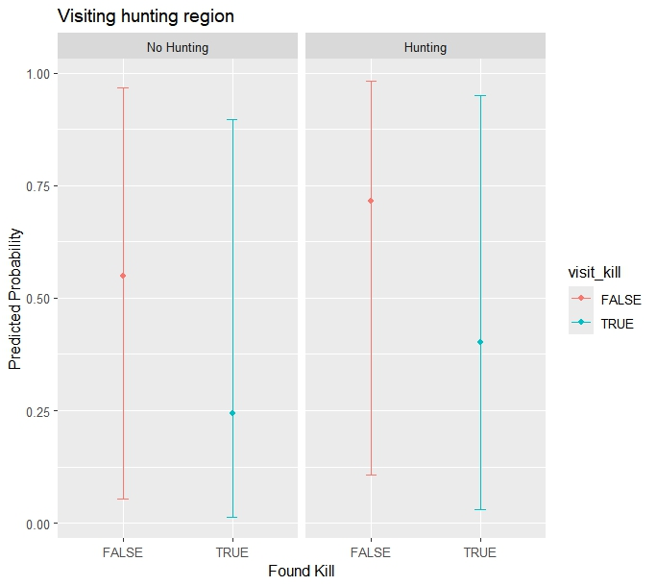
Figure 7. Bootstrapped predicted probability and 95% prediction intervals of ravens visiting the hunting regions based on the timing of the hunting season and whether they located a wolf kill after leaving their territory. All other continuous scaled covariates are held at 0.

Figure 8. Bootstrapped predicted probability and 95% prediction intervals of ravens visiting the hunting regions based on snow depth and whether they located a wolf kill after leaving their territory. All other continuous scaled covariates are held at 0 and hunting season was set to true.

