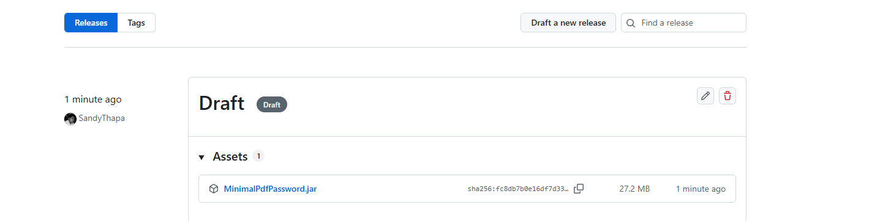
## Downloading the JAR Prebuilt JAR files are available under GitHub Releases. Developers do not need to build the project to use it. Simply download the JAR and reference it from PeopleSoft.

