**Assignment-6**

18481A0503

Python code:

import cv2

print(cv2.__version__)

cascade_src = 'cars.xml'

video_src = 'dataset/video1.avi'

#video_src = 'dataset/video2.avi'

cap = cv2.VideoCapture(video_src)

car_cascade = cv2.CascadeClassifier(cascade_src)

while True:

ret, img = cap.read()

if (type(img) == type(None)):

break

gray = cv2.cvtColor(img, cv2.COLOR_BGR2GRAY)

cars = car_cascade.detectMultiScale(gray, 1.1, 1)

for (x,y,w,h) in cars:

cv2.rectangle(img,(x,y),(x+w,y+h),(0,0,255),2)

cv2.imshow('video', img)

if cv2.waitKey(33) == 27:

break

cv2.destroyAllWindows()

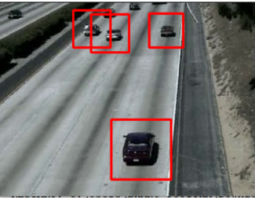

Detected pic