Bug Report

Bug #1: Start Date Calendar Does Not Display

Logged in as: civihr_admin

Staff Member: Sandra DeCarlo

Steps to Reproduce:

1. Click on Job Roles tab
2. Click Edit for the QA Analyst Role
3. Click on the calendar icon for the start date

Expected Results: The calendar would display to select a date

Actual Results: The calendar does not display, only a white box.

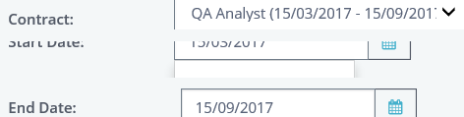

Bug #2: Cannot edit contract dates using clock icon

Logged in as: civihr_admin

Staff member: Jackie Smith

Steps to Reproduce:

1. Click on the Job Contract link
2. Click on the clock icon next to Contract Dates to change the date

Expected Result: The field would become editable

Actual Result: The triangle pops up to display loading and does not load the editable field

Note: In order to correct this issue, I need to search for the staff member again and go back in. Switching to a different link such as Job Role does not fix this issue.

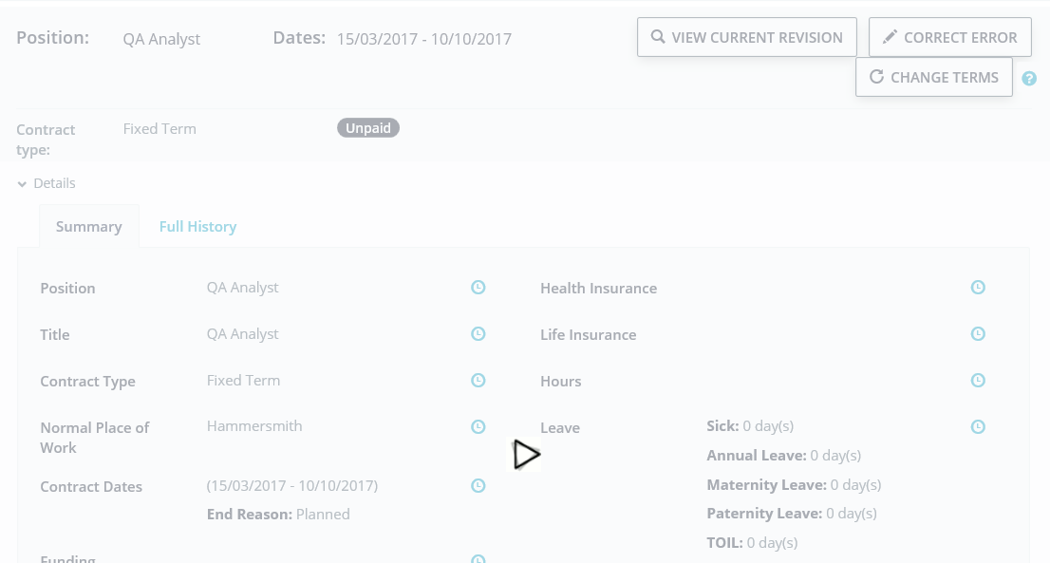

Bug #3: Cannot save changes when changing contract date to prior to role end date

Logged in as: civihr_admin

Staff member: Jackie Smith

Steps to Reproduce:

1. Create a contract with start date 15/03/2017 and end date 10/10/2017
2. Create a role using the above contract dates
3. On the Job Contract link, click on Change Terms
4. Edit the end date to be 10/06/2017 and click Save

Expected Results: Should see an error display or be able to save this item and see an error display regarding the job role dates being outside of contract dates.

Actual Results: Unable to save and no error displays