685.621

***SANDESH IYER***

Algorithms for Data Science

Homework 5

Assigned at the start of Module 10

Due at the end of Module 11

Total Points 100/100

1. .
   1. See image below

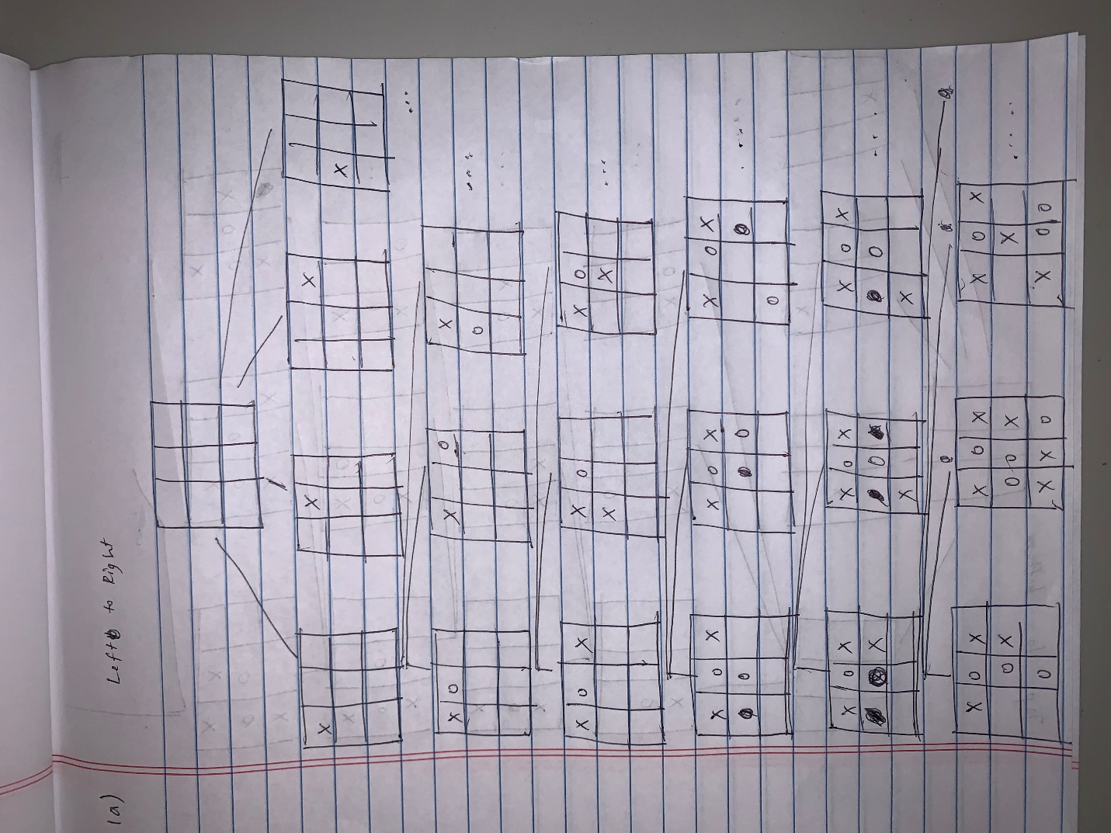

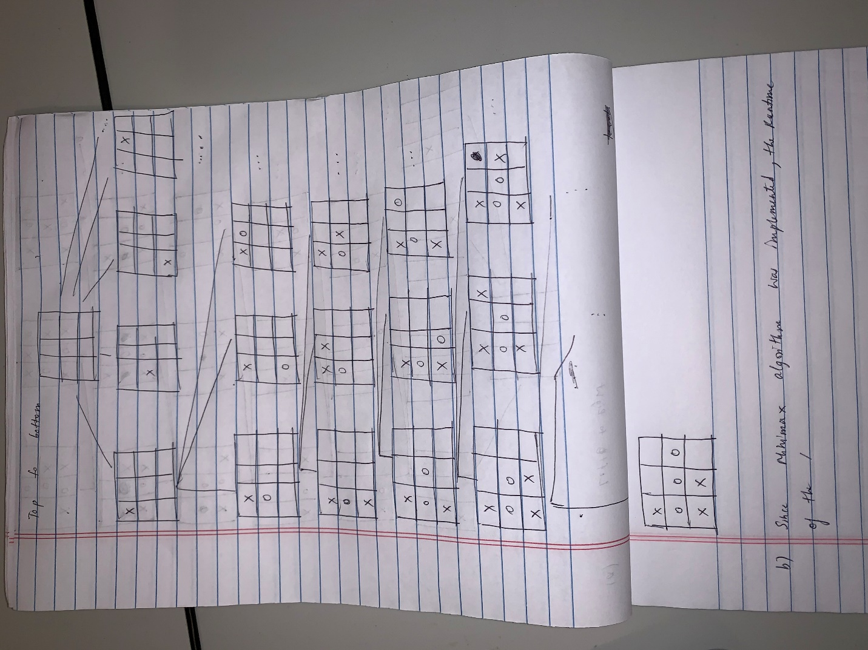

* 1. I ended up implemented the full code for an unbeatable Tic Tac Toe game in python since the assignment seemed very interesting. See attached code. Since minimax algorithm was used, the time complexity of the minimax is O(b^m) and the space complexity is O(bm), where b is the number of legal moves at each point and m is the maximum depth of the tree. Simply run python tictacto.py to run program and play the game.