Impetus — AI Photoshoot
AI-Powered Catalogue Photoshoot Generation at Scale

1) What it does
Impetus AI Photoshoot is an AI-powered product photoshoot platform that generates professional e-commerce catalogue images from flat-lay or mannequin product shots. It takes product reference images, avatar selection, pose pool, and background settings as inputs — and outputs high-quality, on-model photoshoot images ready for catalogue listing.
Three generation modes: Instant (real-time, results in ~2-4 minutes per set), Batch (asynchronous, cost-optimized for bulk runs), and Single Image (on-demand regeneration for QC fixes and custom edits).
The system is fully agentic — from smart accessory placement (analyzes actual pose images to determine which accessories are visible per camera angle) to background-aware lighting extraction, to autonomous issue detection and self-correction via the Auto-Edit pipeline.

2) The AI photoshoot flow
Step | Name | Description
01 | Upload | Product reference images (front/back/side) uploaded to the platform. Supports clothing, footwear, and lingerie.
02 | Analyse | Product image views classified (front, back, side, three-quarter) and garment details extracted — fabric, color, pattern, silhouette.
03 | Avatar & Pose | The user selects avatars (gender, age, ethnicity) and poses from the pose pool. 12 camera view types available: front, back, side, full-angle, closeup, and angled views.
04 | Background & Lighting | Background image selected. Lighting characteristics (direction, warmth, type) extracted for seamless model blending.
05 | Prompt | Natural language prompt assembled per pose: product + avatar + theme + view-aware lighting + filtered accessories. Polished for flow and grammar.
06 | Generate | On-model images generated in parallel batches (up to 20 concurrent). Background reference image passed alongside the prompt. Supports 4K output.
07 | Detection | Unified Detection Agent scans each generated image against product references. Detects color, logo, print, fabric, and pose mismatches with code execution for zoom/crop inspection.
08 | Auto Edit | Edit Agent fixes detected issues with bounding-box-guided surgical editing. Validate-retry loop with max 2 attempts per image. Identity and background preservation enforced.
09 | Quality | Images scored (10.0 base, deductions per issue). Score ≥ 7.0 → Approved. Below routes to Manual QC.
10 | Deliver | Final images uploaded to GCS, resolution optimized, available via CDN.

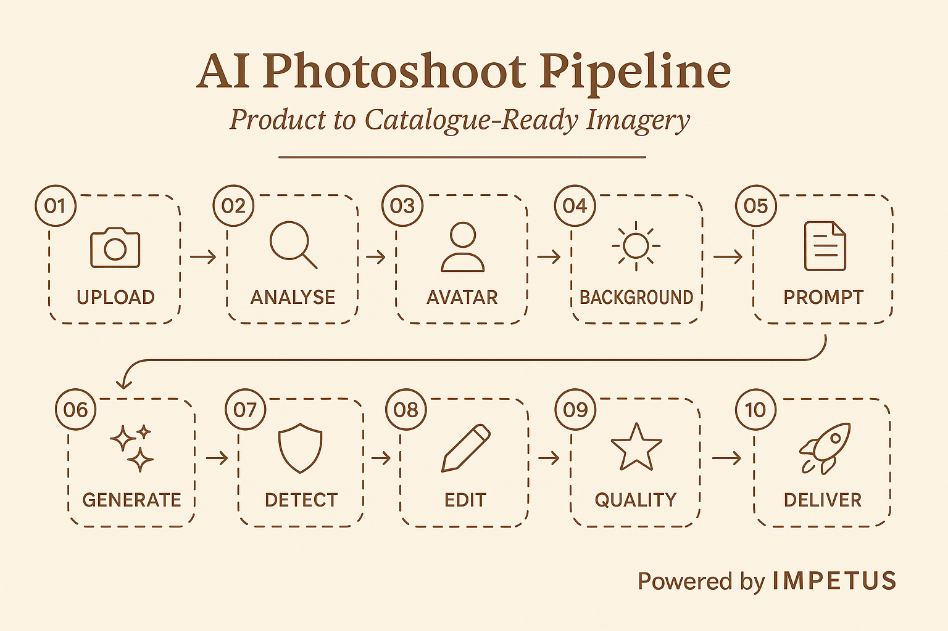

3) Category coverage
Current category support and enhancement roadmap. The platform is built category-agnostic with category-specific prompt tuning and pose pools.
# | Category | Covered | Enhancement Plan
1 | Men’s Western: Shirts, T-shirts | Yes | —
2 | Men’s Western: Denim (Non-Washed) | Yes | Current focus. Clean denims and solid washes work well.
3 | Men’s Western: Denim (Washed/Distressed) | Partial | Washed denim patterns difficult to replicate. Active R&D.
4 | Men’s Western: Non-Denim Bottoms | Yes | —
5 | Women’s Western: Tops, Dresses, Jackets | Yes | —
6 | Women’s Western: Bottoms | Yes | —
7 | Women’s Ethnic Wear: Kurtas, Sets | In Progress | Under development (target: May 28)
8 | Kids Apparel: Boys & Girls | Yes | —
9 | Footwear: Men & Women | Yes | Shoe-specific prompt builder with ground contact.
10 | Lingerie / Innerwear | Yes (New) | Conversation-thread approach. Text-based model identity.
11 | Bags & Accessories | Partial | Pose pool available, expanding coverage.

4) Execution track record
Trends Reboot — 4K Catalogue Digitization
Executed a full catalogue digitization for the Trends Reboot business. Starting from 9,936 raw Intellipack images, the data curation pipeline segregated, deduplicated, and quality-filtered down to 2,975 usable styles across 3,957 products. The AI photoshoot pipeline then generated 47,473 images — 12 shots per product — and pushed them to GCS ready for Ajio catalogue listing.
The pipeline evolved across three versions:
- V1 and V2 — Understood and Incorporated Ajio cataloging team feedback — improved poses, consistent characters across SKUs, lifestyle shots.
- V3 — Added verification agent loops (product accuracy, styling consistency, aesthetics checks) + parallel processing at scale.
Final mile automation: Ajio-standard naming conventions (style_id/color_id/product_id/MODEL.jpg), resolution optimization (3712×4608 → 1117×1400), and JPEG compression (<250KB) — eliminating manual cropping effort for QC and saving significant time at scale.
Metric | Count
Styles | 2,975
Products | 3,957
Images Generated | 47,473
Shots per Product | 12

Lingerie Pipeline Unlocked
Lingerie is now unlocked as a category on Impetus AI Photoshoot. Traditional lingerie shoots come with higher production challenges: specialized styling and lighting, limited model availability, premium talent pricing, and longer turnaround timelines — making it one of the most expensive categories to scale via traditional photoshoots.
With Impetus AI Photoshoot, brands can generate high-quality lingerie imagery from mannequin inputs, reduce dependency on model availability, achieve faster turnaround with scalable catalogue production, and significantly reduce production costs.
Key technical innovation: passing a model reference image for face consistency would trigger NSFW safety filters in lingerie cases. Generating without a reference caused face drift across SKUs. The solution: create the “model identity” via structured text attributes (age, ethnicity, face cut, complexion, jawline, etc.) and generate a base model on the fly. All views are then generated sequentially within the same conversation thread (front VTON → side view → back view → closeup), which keeps the face consistent without passing a raw reference image.
- 8-stage pipeline (C1–C8) with parent-child context branching across conversation threads.
- For bulk: user uploads a ZIP (SKUs + assets), processed async server-side with progress updates.
- Sample outputs created for Red Tag, aligned to their brand requirements.
- Opens up a premium pricing opportunity for Snap-enabled lingerie production.
Innerwear & Ethnic Wear
Innerwear generation has been started alongside the lingerie pipeline, leveraging the same conversation-thread approach for face consistency. Ethnic wear (kurtas, kurta sets, ethnic dresses) is currently under active development — the pipeline focuses on proper draping, embroidery rendering, and cultural authenticity. Target date for initial ethnic wear capability: May 28.

5) Auto-editing & eval approach
Every generated image goes through an autonomous detection-and-fix pipeline. The system uses a multi-agent architecture: a Detection Agent finds issues, an Edit Agent fixes them, and a Check Agent validates the corrections.
Auto Detection:
- Unified Detection Agent with code execution capability scans each generated image against product references.
- Uses zoom/crop code execution for detailed inspection of fine details (logos, text, embroidery).
- Detects: color mismatches, logo/branding errors, typography issues, print problems, embroidery inconsistencies, fabric discrepancies, pose deviations.
- Each issue returned with a confidence score (0–100%) and structured description.
Auto-Edit:
- BBox Generation: draws bounding boxes on detected issues with validation loop (max 2 attempts).
- Edit-Validate Loop: Edit Agent performs surgical fixes. Check Agent validates. Max 2 retry attempts per image.
- Smart retry: if partial progress, use edited image as base; otherwise retry from original with feedback.
- Identity preservation enforced — penalties for face change (−4.0), background change (−3.0), new regressions (−2.0 each).
Scoring:
- Base score: 10.0. Deduction = total_issues × (avg_confidence / 100) × 1.5.
- Score ≥ 7.0 → APPROVED. Below 7.0 → REJECTED (routes to Manual QC).
- Auto QC score achieved: 8.06/10 on crop extraction pipeline.
- Realism scoring weighted: Human Realism (55%), Product Details (30%), Scene Composition (15%).
- 9.0–10.0: Exceptional. 8.0–8.9: Very good. 7.0–7.9: Good. Below 7.0: Needs correction.

6) What’s next
- Ethnic Wear Pipeline — Under active development. Kurtas, kurta sets, ethnic dresses. Targeting May 28 for initial capability.
- Washed Denim Improvement — Washed and distressed denim patterns difficult to replicate. Active R&D — non-washed denims are the current focus.
- Pipeline Stitching — End-to-end automation ready for upcoming batches. Data curation → generation → optimization → GCS upload fully automated.
- Segmentation Pipeline — Building fabric swatch shot generation for PDP enhancement.
- Auto-Edit at Scale — Expanding auto-detection and auto-edit coverage across all categories.
- Accuracy Improvements — Ongoing quality improvements as feedbacks arrive from Ajio cataloging teams and brand partners.

Impetus — May 2026

