Mobile Tailor
Custom clothes, made to fit you. Designed in 2 minutes, stitched in 7 days, delivered home.
Trends x Fynd Companion App | 2 May 2026
Executive Summary
Indian customers want clothes that actually fit them. Today, getting a custom fit means a tailor's shop: it is slow, inconsistent, and the customer does not know how the garment will look until it is finished. Trends sells ready-made shirts to a body that is never average.
Mobile Tailor brings the tailor inside the Trends app. The customer scans her body in 30 seconds using her phone camera, picks a garment that she sees on a 3D model of herself, adjusts the fit on six sliders, chooses collar, pocket, buttons and a monogram, pays, and the garment is stitched in our Bangalore micro-factory and delivered home in 7 days.
The economics work because we make to order. There is zero unsold inventory, zero markdown, and zero store space cost. At a selling price of Rs. 499 the per-piece cost of a shirt is at parity with a regular Trends shirt today; T-shirts are within Rs. 5. The customer pays the same price for a far better garment, and every additional customisation she asks for is priced live and adds margin.
We are asking for approval of one micro-factory in Bangalore at a capex of Rs. 8.27 Cr, capacity 200 pieces a day, and an alpha trial in one Bangalore Trends store from <<DATE NEEDED>>. First paying customer in 90 days.
Headline numbers
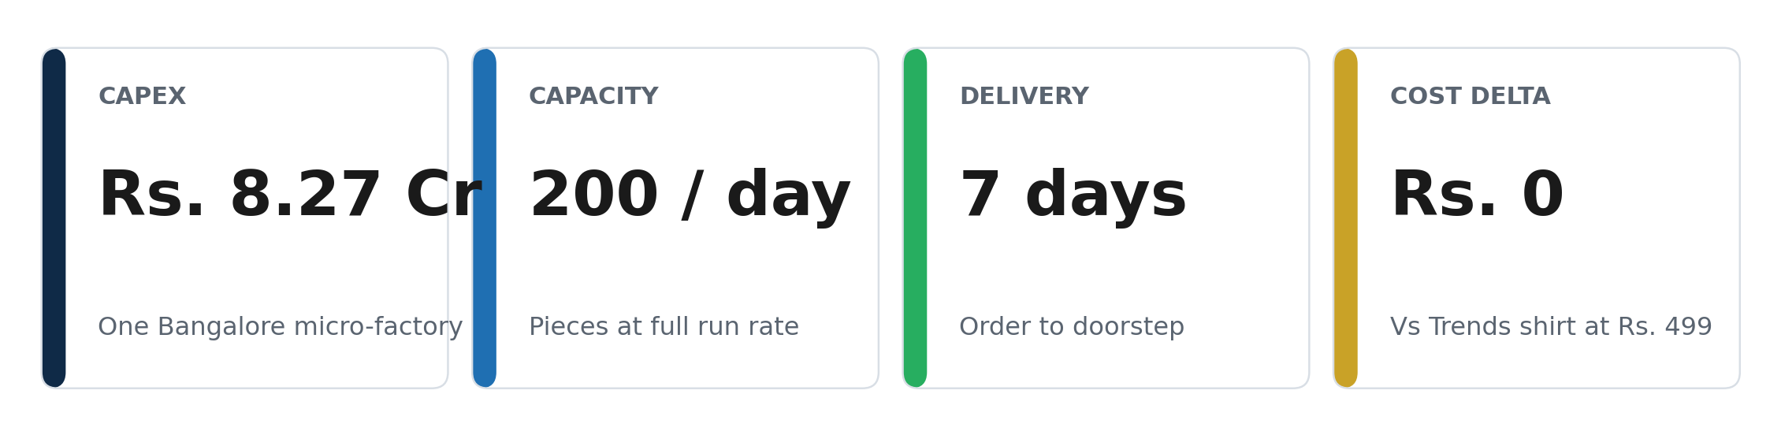
Operating intent: One scan, one fit, one promise. Made to order, never made to stock.
The Customer Promise
If you can take a 30 second scan and pick a garment, we will stitch a garment that fits your body, the way you want it, and deliver it to your home in 7 days. No shop visit. No measurement tape. No re-alterations.
• A guaranteed delivery date shown before payment, met every time.
• A fit you can see on a 3D model of yourself before you pay.
• Same price as a regular Trends garment if you only change the fit. Customisations are priced live and shown before you pay.
• A live order timeline showing the garment being sourced, cut, stitched, finished, and shipped.
Customer Journey
Two entry points reach the same screen. From the Ajio app, three home surfaces (banner on app open, hero card on the home feed, and a contextual ribbon on every Trends product page) deep-link the customer into the M-Tailor tab. In a Trends store, three placements (entry standee QR, fabric-bay shelf-talkers, and a back-wall scan zone) do the same. From there both paths walk through the same eight steps to a 7-day home delivery.
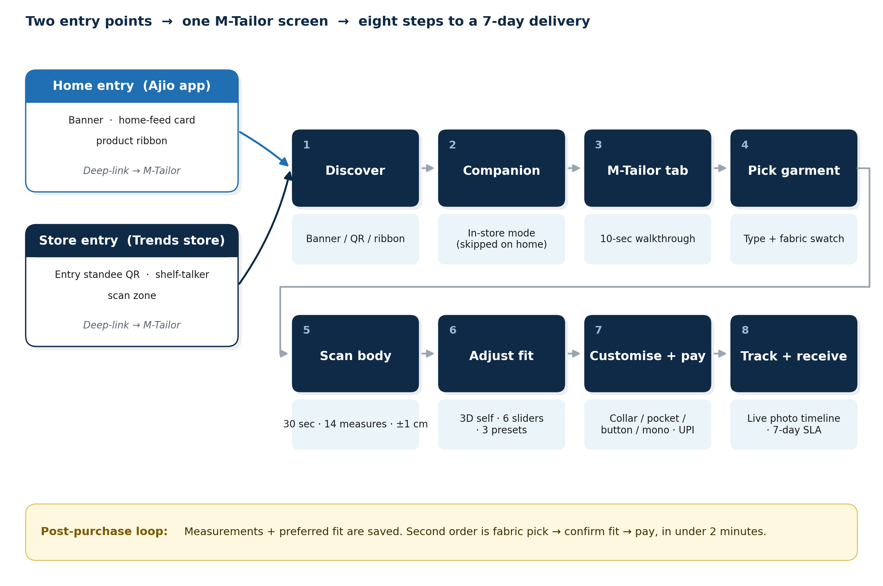
Two entry points → one M-Tailor screen → eight steps to a 7-day delivery.
# | Step | What happens
1 | Discover | Home banner / hero card / product-page ribbon, or in-store standee + shelf-talker QR.
2 | Companion | In-store mode auto-loads from QR (skipped on the home path).
3 | M-Tailor tab | Opens with a 10-second walkthrough; three sub-tabs: Pick, Measurements, Orders.
4 | Pick garment | Shirt, polo, T-shirt, chinos, pants. Fabric swatch grid with photo and price band.
5 | Scan body | Phone holder in store, or self-scan at home. 30 seconds, four poses, 14 measurements (mean error < 1 cm).
6 | Adjust fit | 3D model of self with garment draped on. Six sliders (±2 cm) and three presets: Slim / Regular / Relaxed.
7 | Customise + pay | Collar, pocket, buttons, monogram. Live price meter; guaranteed delivery date shown before pay; UPI / card.
8 | Track + receive | Vertical timeline with real photos at each factory stage; SLA badge; doorstep delivery in 7 days; one-tap reorder.
Post-purchase loop: Measurements and the customer's preferred fit are saved. Her second order is fabric pick → confirm fit → pay, in under 2 minutes.
Live Kitchen: The Customer Watches Her Garment Get Made
Like a transparent restaurant kitchen, the customer sees a real photo at every stage. Trust is built into the order screen, not into a marketing claim.
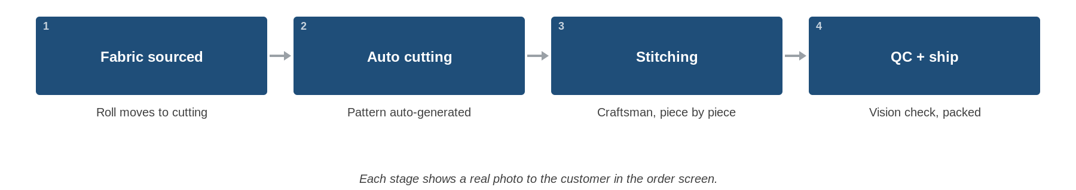
Each stage shows a real photo to the customer in the order screen.
Outcomes and How We Will Measure Them
What the customer gets and what the business gets, with the metric we will track for each.
Customer outcomes
Outcome | What the customer gets | Metric we track
Fit | A garment scanned to a real body in 30 seconds. | NPS > 70 post-delivery; fit-confidence at checkout > 80% (alpha) → > 90% (gamma).
Choice | 3D preview, 6 fit sliders, collar / pocket / buttons / monogram. | Customisation attach rate > 25% (alpha) → > 45% (gamma).
Trust | Live order timeline with real photos at each factory stage. | Return or re-stitch rate < 5% (alpha) → < 3% (gamma).
Speed | 7 days from order to home. | On-time delivery > 95% (alpha) → > 98% (gamma).
Business outcomes
Outcome | What the business gets | Metric we track
Zero unsold inventory | Fabric is pulled only when an order is paid for. | Markdown rate → 0%.
Zero store space cost | No shelf rent for this category; frees Trends shelves for higher-velocity SKUs. | Sq ft of Trends floor freed per store.
Margin uplift | Customisation add-ons priced live, opt-in. | Gross margin at plan (alpha) → plan + 2% (gamma).
Repeat behaviour | Saved fit accelerates the second order to under 2 minutes. | Repeat purchase rate > 25% within 90 days (alpha) → > 30% (gamma).
Capital discipline | One micro-factory at Rs. 8.27 Cr. | Payback under 18 months; scan-to-paid conversion > 12% (alpha) → > 22% (gamma).
Capacity | Single Bangalore line. | 60 pieces / day (alpha) → 150 (beta) → 200 / day at full run rate.
Operating Model
Two loops, one customer. The demand loop runs in the app. The supply loop runs in the micro-factory. The customer is the only person who sees both.
1. Demand loop (inside the app)
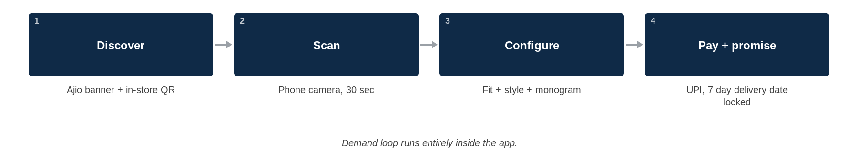
Demand loop runs entirely inside the app.
2. Supply loop (inside the micro-factory)
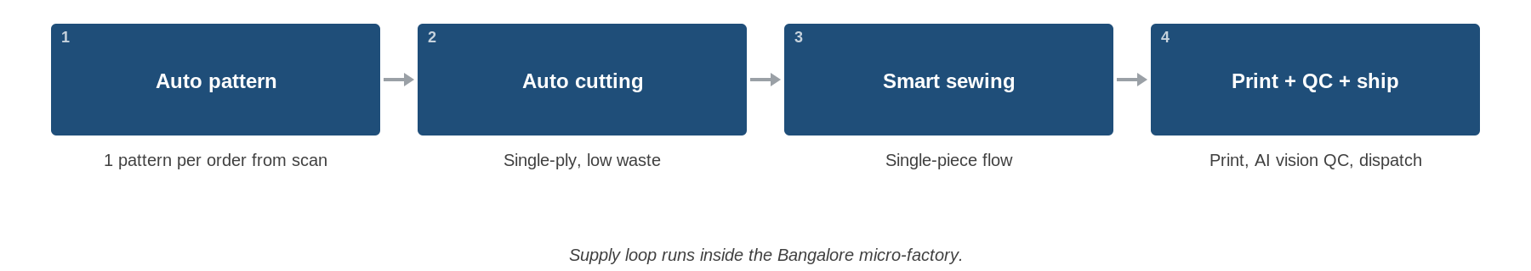
Supply loop runs inside the Bangalore micro-factory.
Unit Economics
Made to order is what makes the math work. We do not buy fabric we will not sell, we do not rent shelf space, and we do not mark down what does not move.
Product | Selling price | Net cost differential  vs regular Trends garment | Why
Shirt | Rs. 499 | Rs. 0 | Higher cut + make is offset by zero markdown and zero store-ops cost.
T-shirt | Rs. 243 | Rs. +5 | Same logic; the Rs. 5 is absorbed into channel margin.
Customisation add-on | Priced live in the app | Adds margin | Priced before pay; opt-in upside on every order.
Capex Detail (One Bangalore Micro-Factory, 200 pieces / day)
Equipment list as ordered. All numbers in INR, converted at cited Euro and USD rates. Total of Rs. 8,27,05,510 buys the full line, end to end.
S.No | Department | Equipment | Brand | Qty | Price / unit | Price (INR)
1 | Measurement | In-house |  | 1
2 | Fit | In-house |  | 1
3 | Pattern | Gerber MTM Accumark | Gerber | 1 | $ 23,000 | 22,31,000
4 | Pattern | Gerber MTM Accunest | Gerber | 1 | $ 8,000 | 7,76,000
5 | Cutting | Single-ply cutter | Morgan Italia | 2 | Euro 1,40,000 | 3,02,40,000
6 | Cutting | Labelling unit | Morgan Italia | 2 | Euro 18,000 | 38,88,000
7 | Cutting | Pattern matching system | Morgan Italia | 2 | Euro 14,000 | 30,24,000
8 | Cutting | Fusing machine | Hashima-900 LFS | 1 | $ 9,500 | 9,00,000
9 | Cutting | Direct-to-garment printer | Epson F3030 | 1 | $ 51,092 | 49,56,000
10 | Material movement | Conveyor system | Eton | 1 | $ 1,60,000
11 | Sewing | T-shirt line | Juki + others |  | INR | 14,68,000
12 | Sewing | Shirt line | Juki + others |  | INR | 60,54,000
13 | Sewing | Chinos / pants line | Juki + others |  | INR | 65,84,000
14 | Finishing | Pressing chamber 534 | Macpi | 1 | Euro 35,000 | 33,95,000
15 | Finishing | Pressing chamber 565.17-8526 | Macpi | 1 | Euro 25,000 | 24,25,000
16 | Finishing | Folding line ACE901 | EPA | 1 | Euro 1,26,880 | 1,23,07,360
17 | Finishing | Macpi 321.715 | Macpi | 1 | $ 20,950 | 20,32,150
18 | Folding + packing | EPA-5001 | EPA | 1 | Euro 25,000 | 24,25,000
 | Total |  |  |  |  | 8,27,05,510
Machinery and Process
Department-by-department list of the technology stack the factory runs on. Each block is single-purpose, replaceable, and sized for 200 pieces per day. (Visualisation of this section is planned in the next revision.)
Department | Technology
Measurement + Fit | AI body-scan via phone camera, 30 second capture, 14 measurements with mean error < 1 cm. 3D fit visualiser draws the garment on the customer's own body model in the app.
Pattern + CAD | Gerber Accumark for per-order pattern generation from the customer's scan. Gerber Accunest for nesting and yield optimisation, single-ply.
Cutting room | Morgan Italia single-ply cutter (single-piece precision required for made-to-order). Morgan labelling: every part is QR-tagged so the order never gets lost. Morgan matching system: stripes and plaids align across seams via projected grid. Hashima fusing machine; Epson F3030 direct-to-garment printer for monograms and prints.
Sewing | Juki and equivalent automats for shirts, polo, chinos and pants. Semi-automats for T-shirts and other knits, single-piece flow workstations.
Finishing | Macpi modular pressing line, steaming + ventilation chambers, 20-program touch screen. EPA ACE901 folding line, Macpi 321.715 finishing press.
Folding and packing | EPA-5001 automatic folding and packaging machine, then dispatch to last mile.
Material movement | Eton overhead conveyor, links cutting, sewing, finishing, folding without WIP piles.
Factory Indicative Layout
Single floor, 15,326 sq ft. Cutters and conveyor sit through the centre line. Sewing block on the right. Finishing, pressing and packing on the south wall. Fabric and trims store flush against the entrance for first-in-first-out flow.
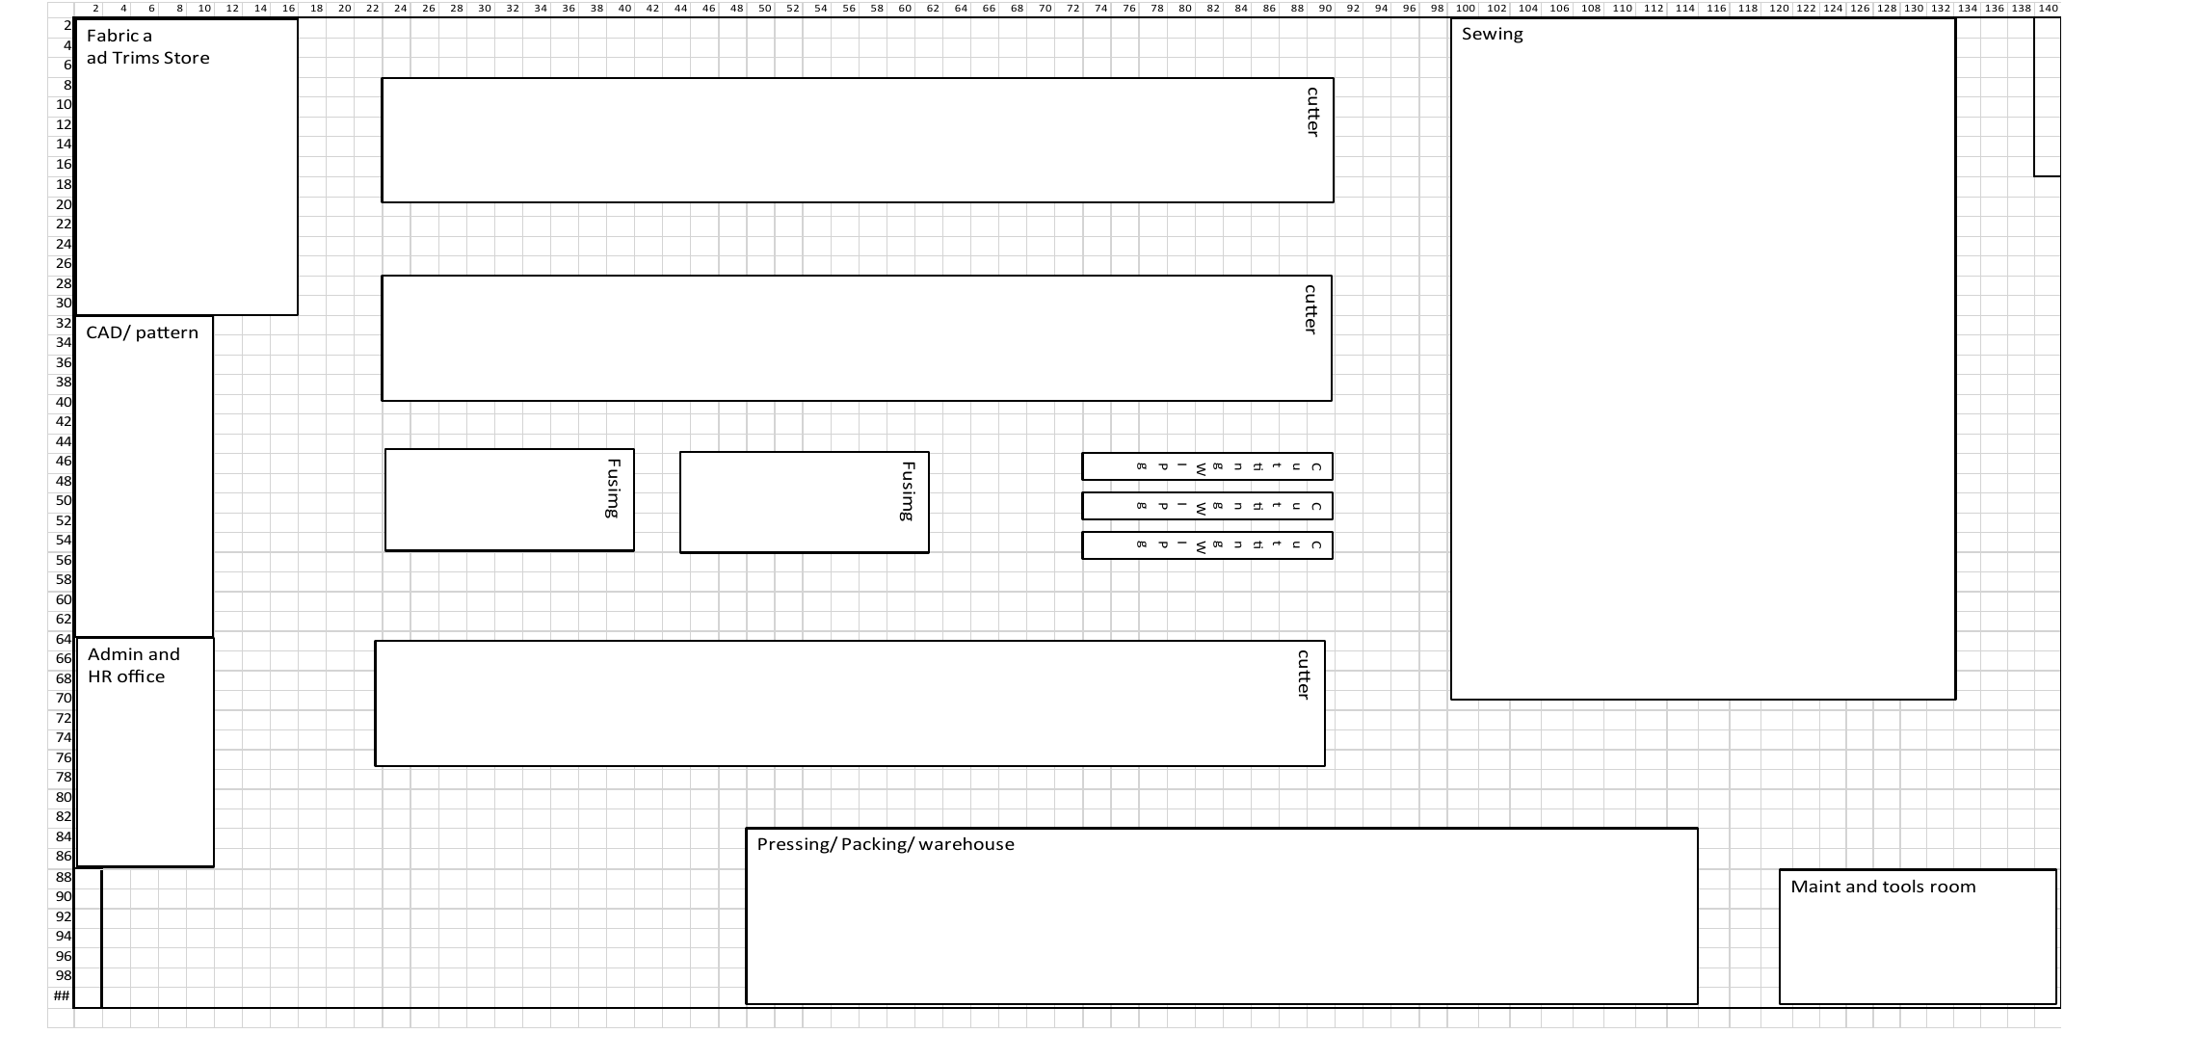
Indicative layout. Final dimensions to be locked with civil partner.
Phase Gate Plan
Phase | When | Scope | Exit criteria
ALPHA | Bangalore, <<DATE NEEDED>> | 1 store. Internal staff and invited customers only. Shirt + T-shirt. | First 100 paying customers; NPS > 70; delivery SLA met for 95% of orders.
BETA | Bangalore, <<DATE NEEDED>> | 5 stores in Bangalore. Public launch. Shirt, T-shirt, polo, pants. Manufacturing automation goes live. | 1,000 paying customers a month; repeat purchase > 25%; gross margin at plan.
GAMMA | All India, <<DATE NEEDED>> | All categories (men + women + kids), all geographies. Add 2 micro-factories near demand. | 10,000+ paying customers a month. Mobile Tailor permanent in the Ajio app.
Delivery Plan
Workstream | Outcome | Owner | Target
App: M-Tailor tab | M-Tailor tab live in Ajio companion. Scan, configure, pay, track end to end. | <<OWNER NEEDED>> | <<DATE NEEDED>>
Scan + 3D fit | 30-sec scan returns 14 measurements (mean error < 1 cm). Customer sees own body model with garment draped on it before paying. | <<OWNER NEEDED>> | <<DATE NEEDED>>
Live pricing + refund policy | Every customisation shows incremental price before payment. Refund policy <<PLACEHOLDER>> shown in app at checkout. | <<OWNER NEEDED>> | <<DATE NEEDED>>
Bangalore micro-factory | 1 facility live: scan, auto-pattern, cutting, stitching, print, QC, dispatch. 200 pieces a day. | <<OWNER NEEDED>> | <<DATE NEEDED>>
Alpha trial + 7-day delivery | First 100 paying customers in 1 Bangalore store. NPS > 70. 95% of orders delivered within 7 days. | <<OWNER NEEDED>> | <<DATE NEEDED>>
Decision Ask
1. Approve Rs. 8.27 Cr capex for one Bangalore micro-factory at 200 pieces a day.
2. Approve alpha trial in 1 Bangalore Trends store from <<DATE NEEDED>>, single named owner accountable for 7-day delivery and NPS > 70.
3. Approve 7-day delivery and the made-to-order, zero-stock model as the Trends standard for this category.
References (printable QR codes)
Resource | Notes
[ QR ] Prototype walkthrough (1m48s) | Scan body to home delivery.
[ QR ] Figma prototype | Tap-through on phone.
[ QR ] Factory walkthrough video | <<LINK NEEDED>>

