Script for Presentation

Using Machine Learning to Predict Chaos System: Case Study on Lorenz System

Reservoir Computing

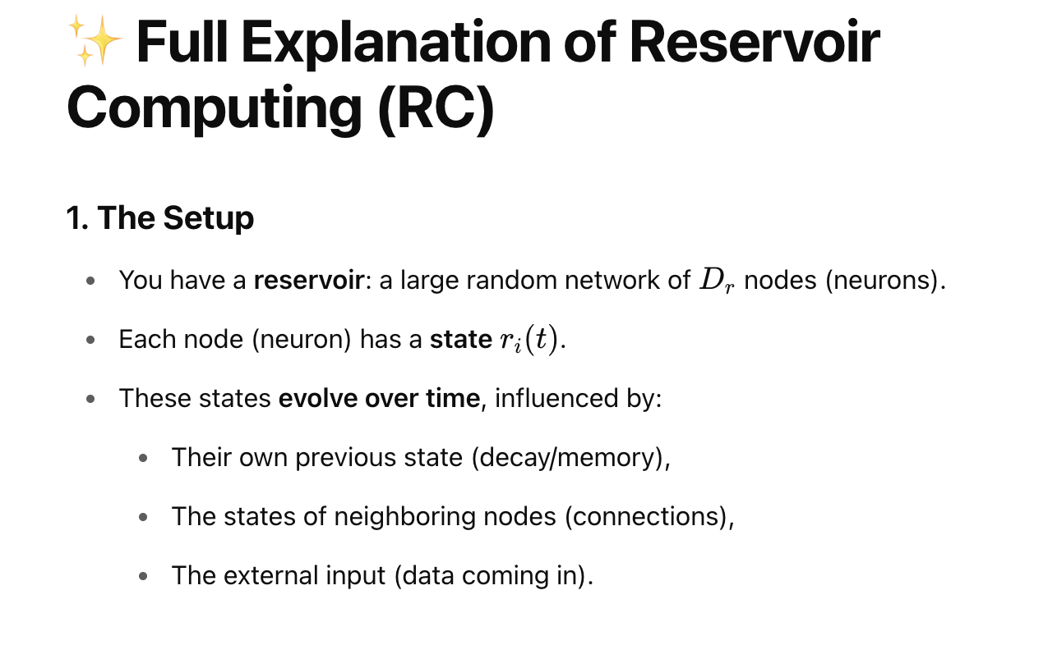

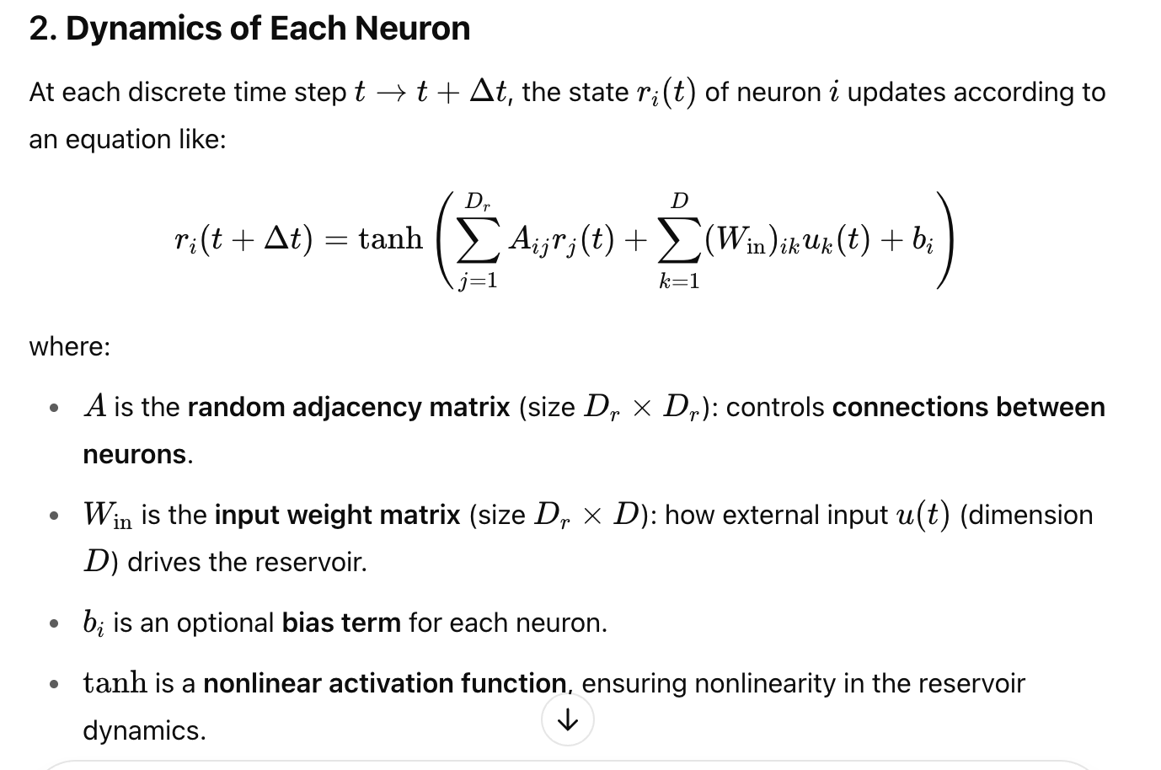 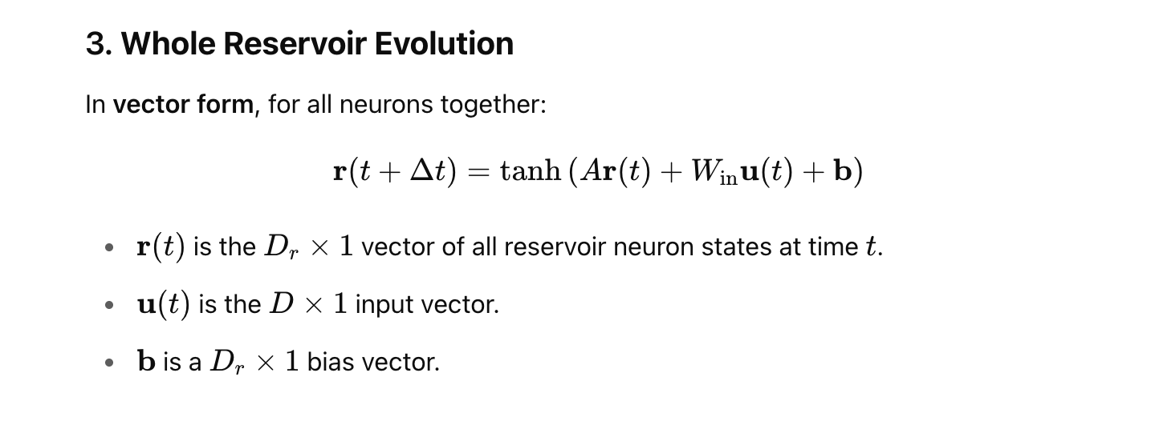 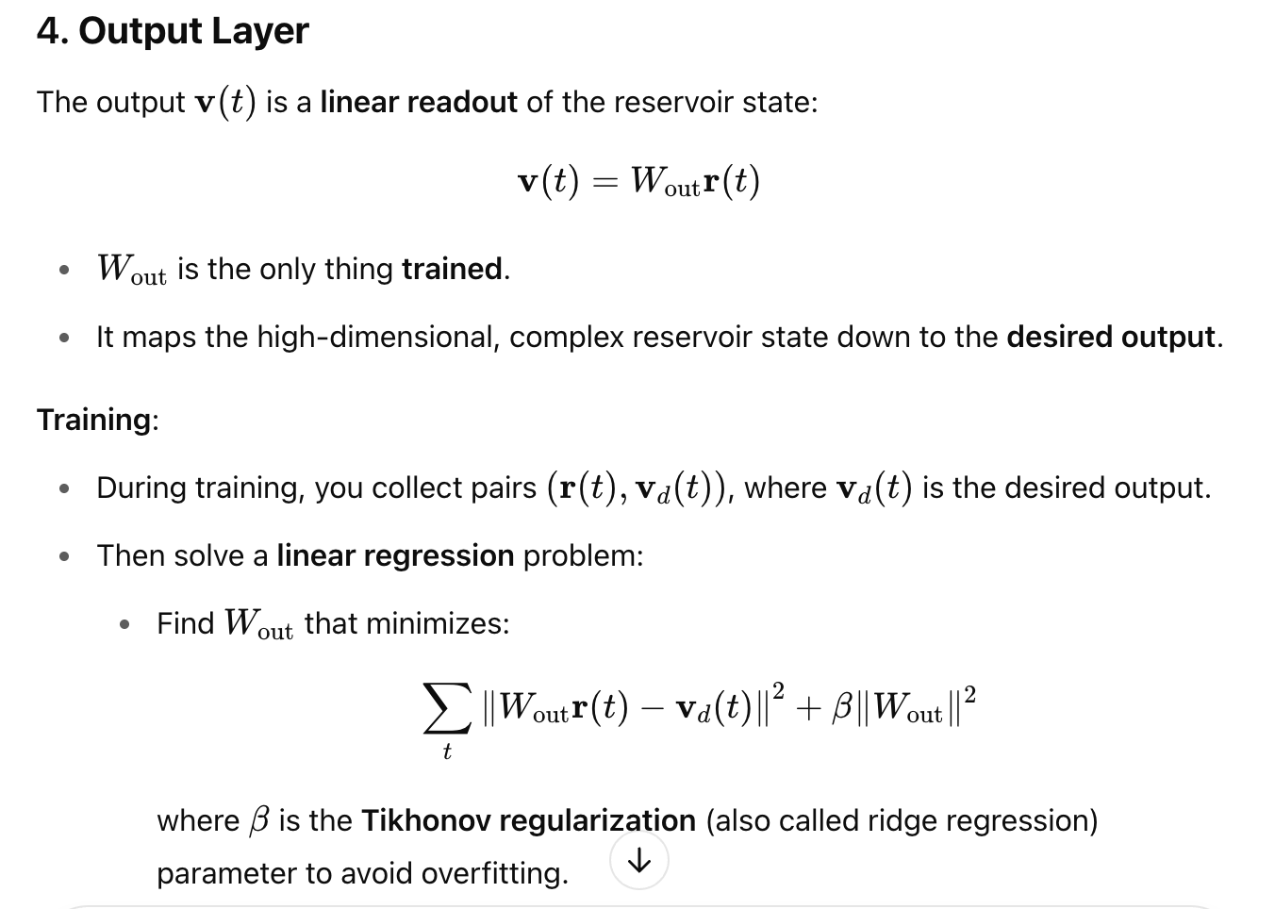 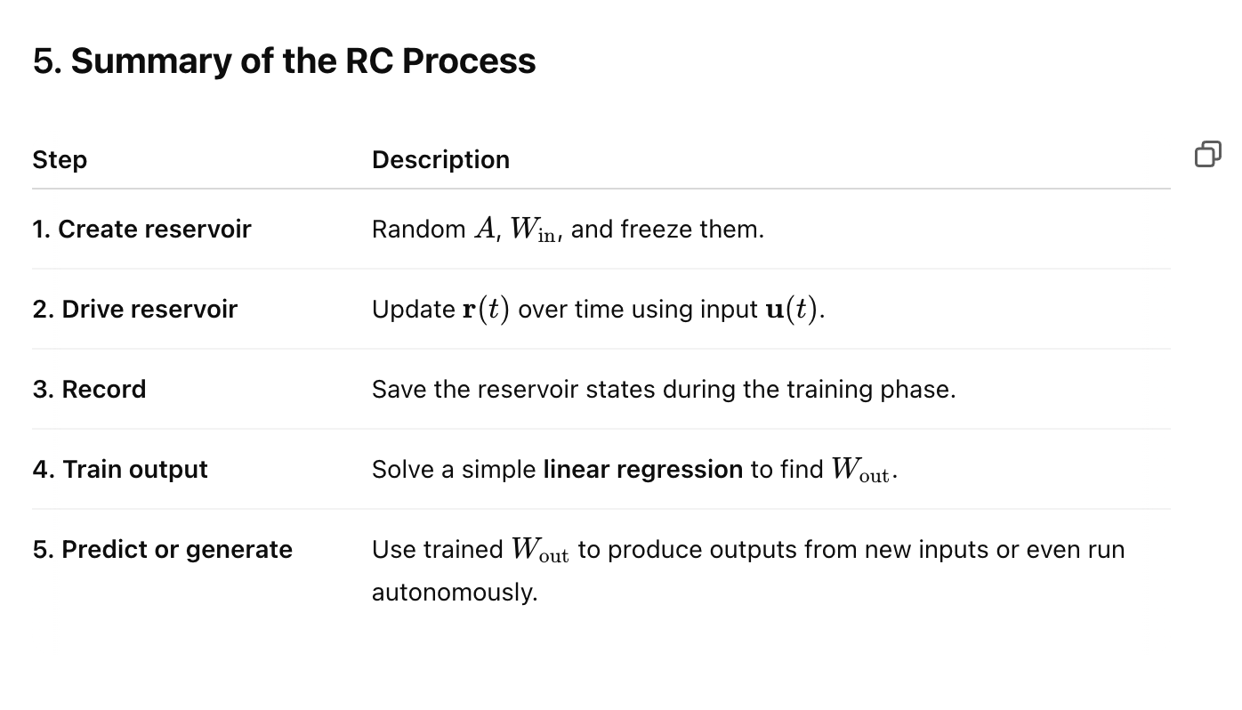 Example: Lorenz System:

**ackground and Introduction: The Lorenz System**

In the early 1960s, Edward Lorenz, a meteorologist and mathematician at the Massachusetts Institute of Technology (MIT), was exploring simplified mathematical models to understand atmospheric convection — the rising and falling motion of air due to temperature differences. Weather prediction was (and still is) an immensely complex problem, involving countless interacting variables. Lorenz sought to strip the complexity down to its essentials, hoping to capture the core dynamics with just a few simple equations.

In 1963, he introduced what became famously known as the **Lorenz system**: a set of three coupled, nonlinear ordinary differential equations. These equations describe how three quantities — conventionally labeled xxx, yyy, and zzz — evolve over time:

dxdt=σ(y−x)dydt=x(ρ−z)−ydzdt=xy−βz\begin{aligned} \frac{dx}{dt} &= \sigma (y - x) \\ \frac{dy}{dt} &= x (\rho - z) - y \\ \frac{dz}{dt} &= xy - \beta z \end{aligned}dtdx​dtdy​dtdz​​=σ(y−x)=x(ρ−z)−y=xy−βz​

Here:

* xxx represents the rate of convection,
* yyy represents the horizontal temperature variation,
* zzz represents the vertical temperature variation,
* σ\sigmaσ, ρ\rhoρ, and β\betaβ are positive parameters related to the physical properties of the fluid (such as the Prandtl number and Rayleigh number).

Originally, Lorenz was modeling the flow of fluid between two horizontal plates with a temperature difference between them. As the temperature difference increases, the steady, organized flow patterns ("rolls") can suddenly become unstable, leading to irregular, seemingly random motion — a hallmark of chaotic behavior.

My method: data generation and reservoir Prediction:

Results: Trajectories Return Map (optionally) Lyapunov Exponents

Negative Lyapunov exponents are associated with dissipative systems; Lyapunov exponents equal to zero are associated with conservative systems; and positive Lyapunov exponents are associated with chaotic systems (provided the system has an attractor).

• Evolves the system and **tracks how small deviations grow** (using Jacobian).

• Uses **QR decomposition** to prevent numerical errors (vectors collapse or explode).

• **Accumulates and averages** growth rates to estimate the **Lyapunov exponents**.

Q & A

Answer why only training output weights for RC