1. **MVC**

**Model - MyCalendar Class**

* It has all the backend functioning of the calendar instance
* Methods, to create events, view events by date, previous/next Month view

**View - CalendarView Class**

* Creates the main view of the calendar frame
* All frames, panels, components, buttons, are part of this class
* It handles the entire GUI of the program

**Controller - SimpleCalendar**

* Creates an Instance of MyCalendar and CalendarView Objects
* Has the main method

There also is an Event class which creates the Event Object.

**2. Screen Shots**

**Screen1:** Initial Screen

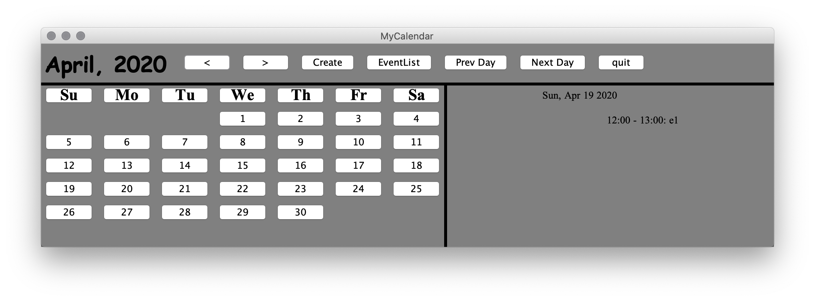

**Screen 2:** Previous Button

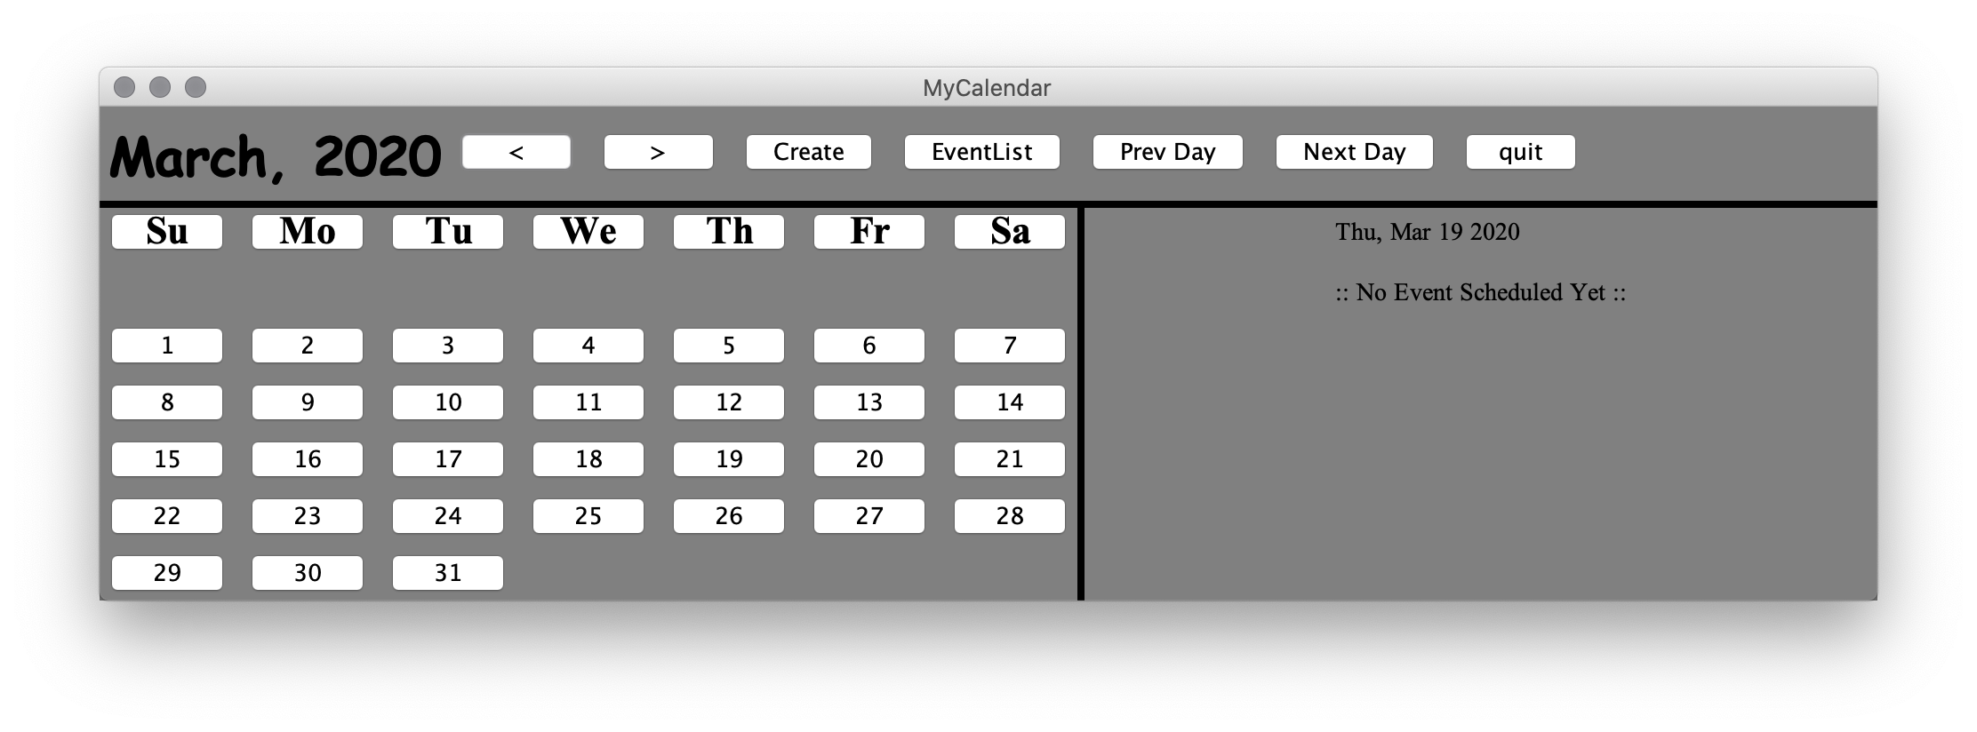

Previous Month (< Button) clicked 1 time

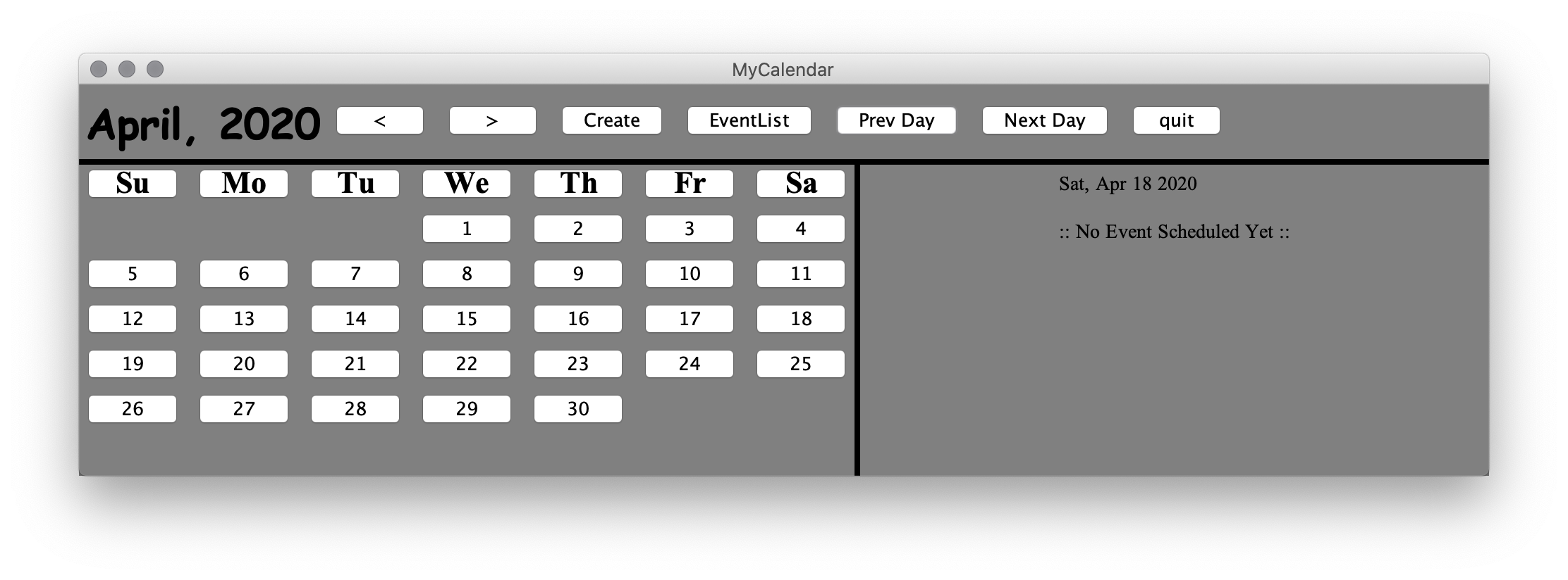

Previous Day (Prev Day button) clicked 1 time

**Screen 3:** Next Day (Next Day button) clicked 20 times

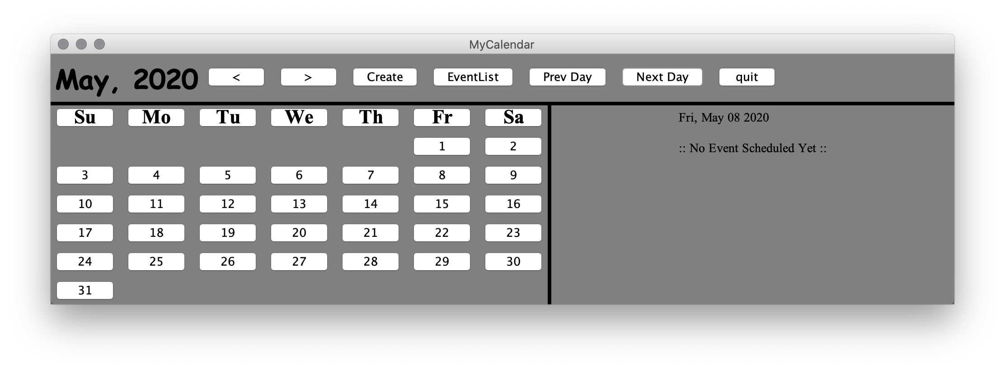

**Screen 4:** Creating an Event on a selected date (05/12/2020)

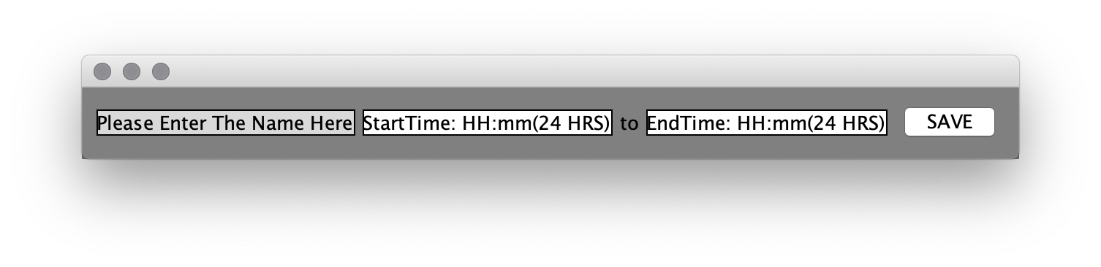

Create Frame Pop Up

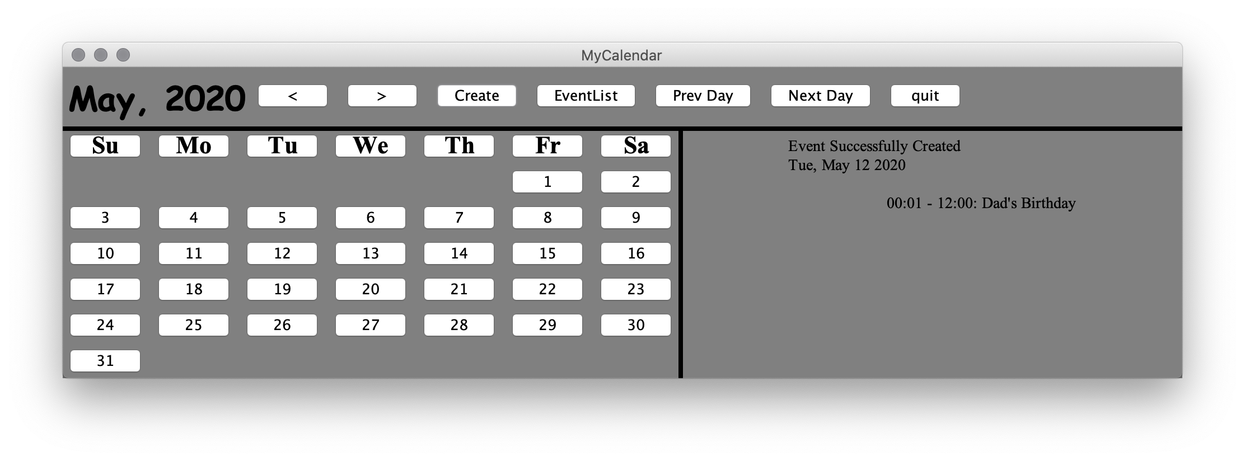

**Screen 5:** Creating an event on the previously selected date, and creating a time conflicting event

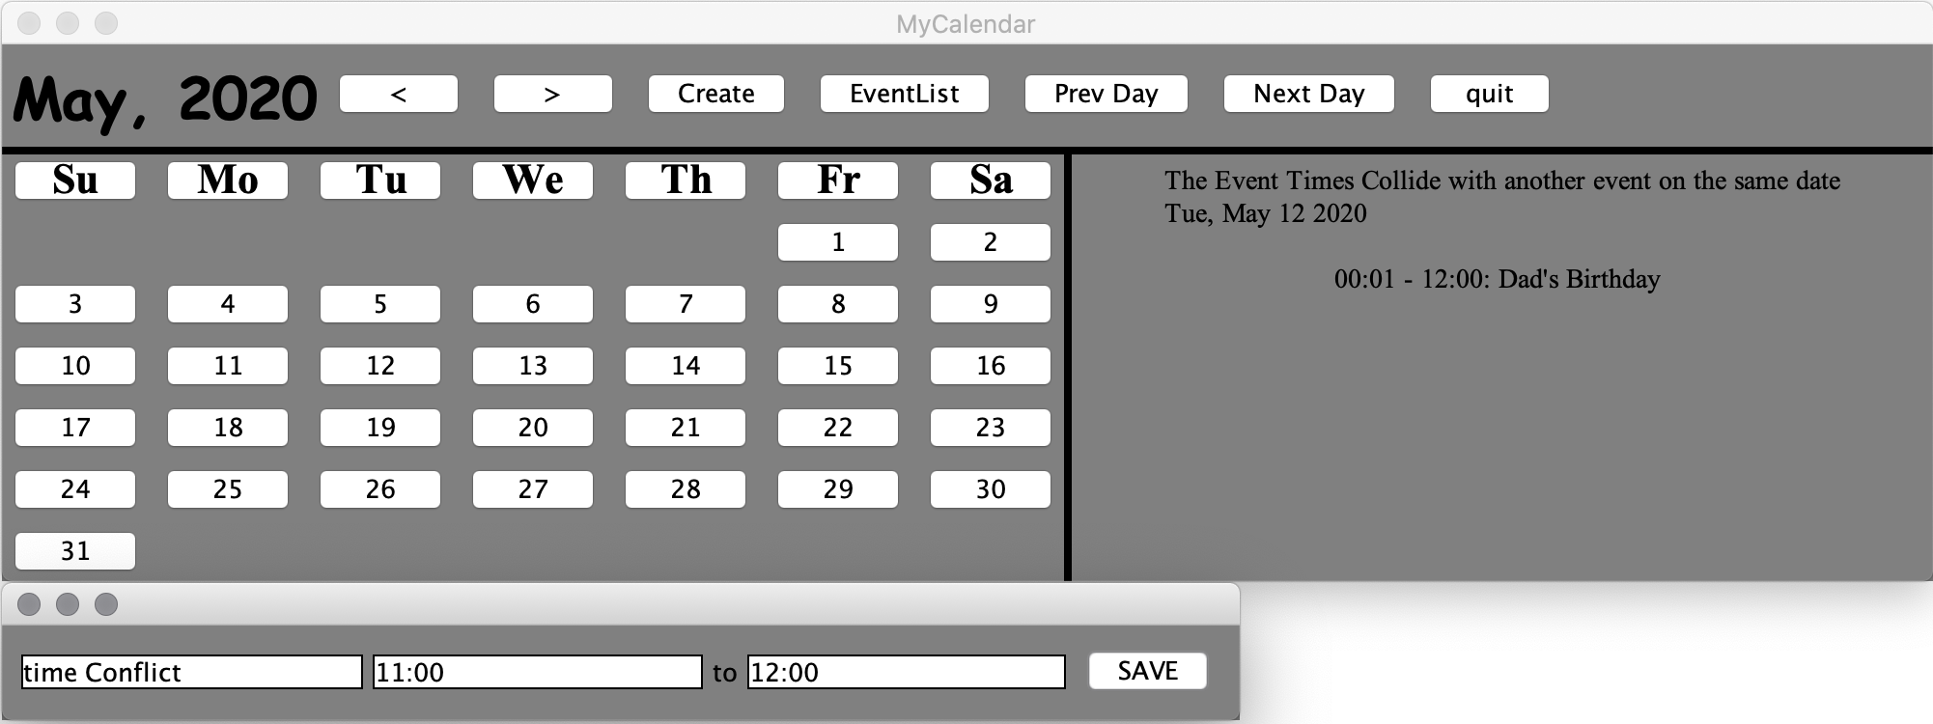

**Screen 6:** After entering an event on the same day you choose in the previous step and creating an event without a time conflict.

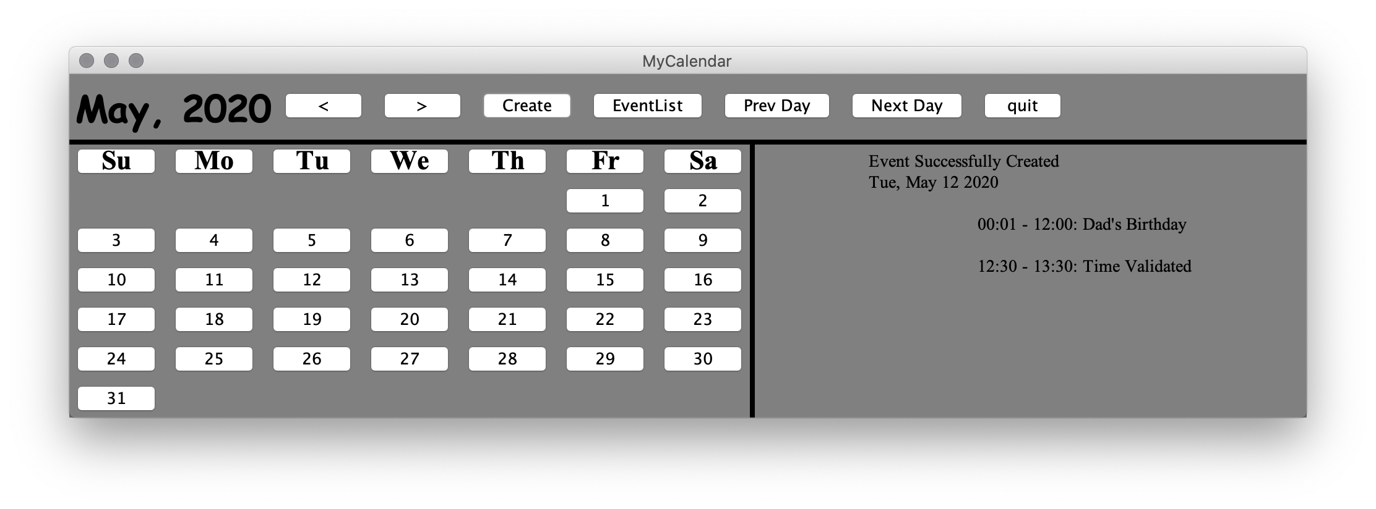

**All Event List:**

