Daniel Saneel

CS151

Dr. Suneuy Kim

Assignment 2 - MyFirstCalendar

**Use Cases**

**Use Case I: Create One Time event**

|  |  |  |
| --- | --- | --- |
| **Step** | **User’s Action** | **System’s Response** |
| **1** | The user Enters [C] to create an event |  |
| **2** |  | System prompts user to enter the name of the event |
| **3** | The user enters the event name |  |
| **4** |  | Prompts to enter the date of the event in YYYY-MM-dd: |
| **5** | The user enters the event date |  |
| **6** |  | Prompts to enter the starting time in: |
| **7** | The user enters the event start time |  |
| **8** |  | Prompts to enter the ending time: |
| **9** | The user enters the end time |  |
| **10** |  | System validates the times don’t clash with any existing event. |
| **11** |  | Prompts Your event has been successfully created! |
| **12** |  | System goes back to main menu |

**Use Case II: View Event by Month or Day**

|  |  |  |
| --- | --- | --- |
| **Step** | **User’s Action** | **System’s Response** |
| **1** | The user Enters [V] to view an event |  |
| **2** |  | System prompts use to  Select a view by option:  [D]ay View [M]onth view |
| **3** | The user enters [D] or [M] for specific view |  |
| **4** |  | System Displays the event month/day view with specific delimiters |
| **5** |  | System then prompts  [P]revious or [N]ext or [G]o back to the main menu? options |
| **6** | The user enters [P]  OR  The user enters [N]  OR  The user enters [G] |  |
| **7** |  | [System displays the previous month/day view]  OR  [System displays event on next day if it exists]  OR  [System displays the main menu of the system] |

**Use Case III: Delete a Selected event**

|  |  |  |
| --- | --- | --- |
| **Step** | **User’s Action** | **System’s Response** |
| **1** | The user enters [D] to delete an event |  |
| **2** |  | System prompts user to select  [S]elected [A]ll [DR] |
| **3** | The user enters [S] |  |
| **4** |  | System Prompts enter the date of the event to DELETE in yyyy-MM-dd format: |
| **5** | The user enters the date of the event to delete in format |  |
| **6** |  | System displays all the events scheduled on that day |
| **7** |  | System asks user to Enter the name of the event to delete: |
| **8** | The user enters the name of the event from the displayed list |  |
|  |  | System removes the event from the Calendar’s list of scheduled events |
| **9** |  | System prompts: event has been successfully deleted |

**Use Case IV: Go to an event by date**

|  |  |  |
| --- | --- | --- |
| **Step** | **User’s Action** | **System’s Response** |
| **1** | The user enters [G] to go to an event at a particular date |  |
| **2** |  | System prompts user to  enter the date of the event in YYYY-MM-dd: |
| **3** | The user enters the desired date |  |
| **4** |  | System displays all the events scheduled on that day, sorted by time |
| **5** |  | System displays main menu |

**Use Case V: Event List**

|  |  |  |
| --- | --- | --- |
| **Step** | **User’s Action** | **System’s Response** |
| **1** | The user presses [E] to get a list of all scheduled events |  |
| **2** |  | System displays all scheduled events in order:  One Time Events:  Recurring Events: |
| **3** |  | System displays the main menu |

**A set of CRC cards**

|  |  |
| --- | --- |
| **MyCalendar Class** | |
| Is a Calendar,  Handles all the back-end functioning of methods/operations.  Manages the list of events schedules,  Some Methods:  Creates Events, View Event, Deletes Event, Go to Event, Display Event. | **Event**  **MyCalendarTester**  **UI** |

|  |  |
| --- | --- |
| **Event Class** | |
| Creates Event Object  Event stores event information:  Name, start date, end date, start time, end time, recurring T/F, Recurring days. | **MyCalendar**  **UI** |

|  |  |
| --- | --- |
| **MyCalendarTester Class** | |
| Program Launcher Class  Has the main method  Creates a UI instance and calls the main menu. | **UI** |

|  |  |
| --- | --- |
| **UI** | |
| Manages User interaction and validates user input  Calls appropriate methods in the MyCalendar class for specific functions | **MyCalendar**  **Event** |

**UML CLASS DIAGRAM:**

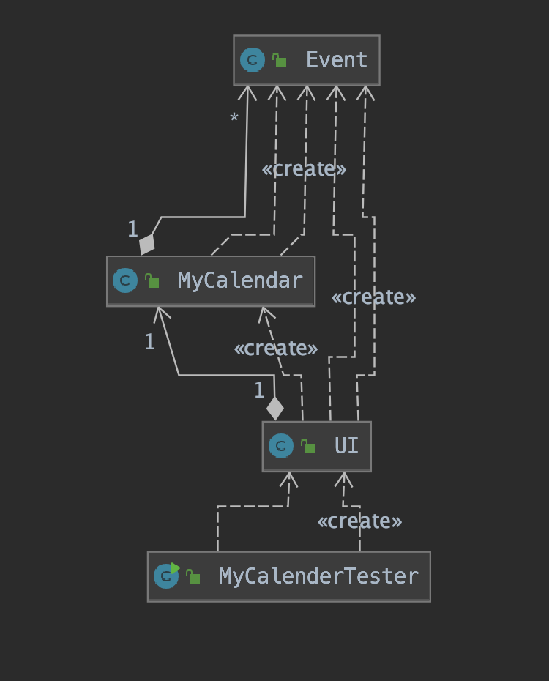

**Sequence Diagram: Create New Event Use Case**

Calls MyCalendar.viewByDate(Evennt.startDate), to check if event added and displays success message

Goes Back to Main Menu Options

True if no other event scheduled for the dat&time

UI creates a new Event object with given info,

Event Class returns the reference

User Enters C to create an Event, then enters name, date, start time, and end time.





UI then calls MyCalendar.timeValidated<Event> to check if the time clashes with any other existing event

If validated==true, calls createEvent(Event e) to add the event to the Calendar’s list of events