**System Concept**

Documented here is a Java system for a burial society, Ithemba (Ray of Hope). The application allows prospective customers of the society and staff members of the society to sign up for an account, the account is used to log into the system. When logged in, a general user can apply for an insurance policy, while employees / administrators can create insurance policies for customers.

**System Use Case Diagram**

The following use diagram is as seen from both general user and administrator perspectives.

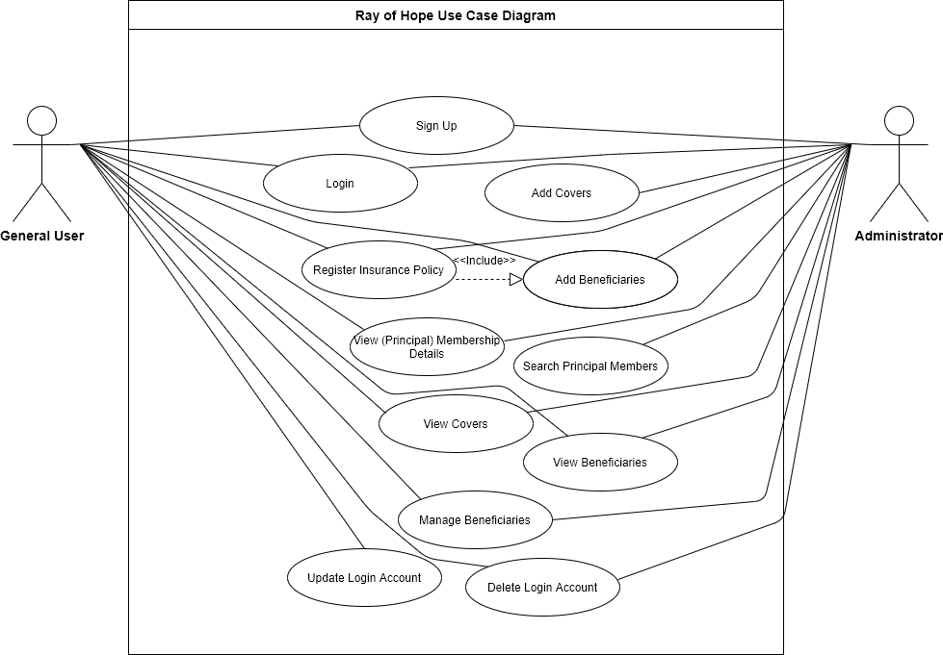

**The System Database**

This system is backed by a MySQL database system. The database schema is structured as follows:

* The database schema



* Users_Login table – this table stores login account details of every user of the system

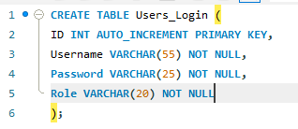

* Covers table – this table stores records of covers offered by the burial society.

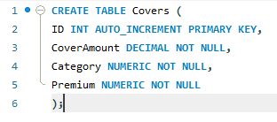



* Principal Members table – this table stores the details that are provided when a principal member applies for an insurance policy.

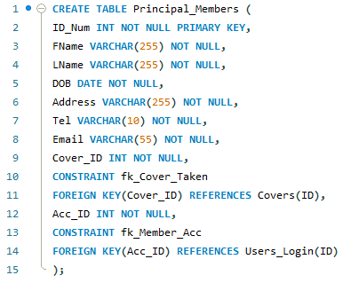



* Beneficiaries – this table stores all the beneficiaries dependent on each principal member.

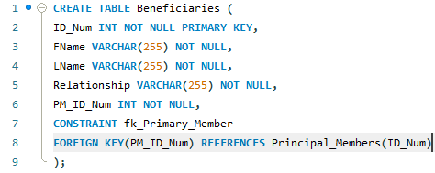





**Application User Manual**

* **The Login screen -** this is the first screen of the application. It has three button as **Add Acc** for signing up a new user, **Clear** for clearing text in the username and password text fields, and **Login** for logging in a user and give access to core functionalities of the system.

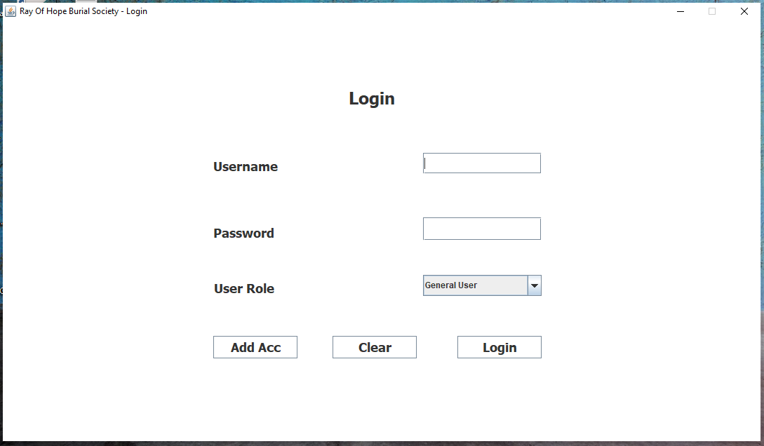

* **The Sign Up dialog –** this dialog screen is brought up when a user clicks the **Add Acc** button, a user registers a new login account by selecting the **sign up** button provided a username and password has been entered. The **clear** button clears text in the dialog text fields.

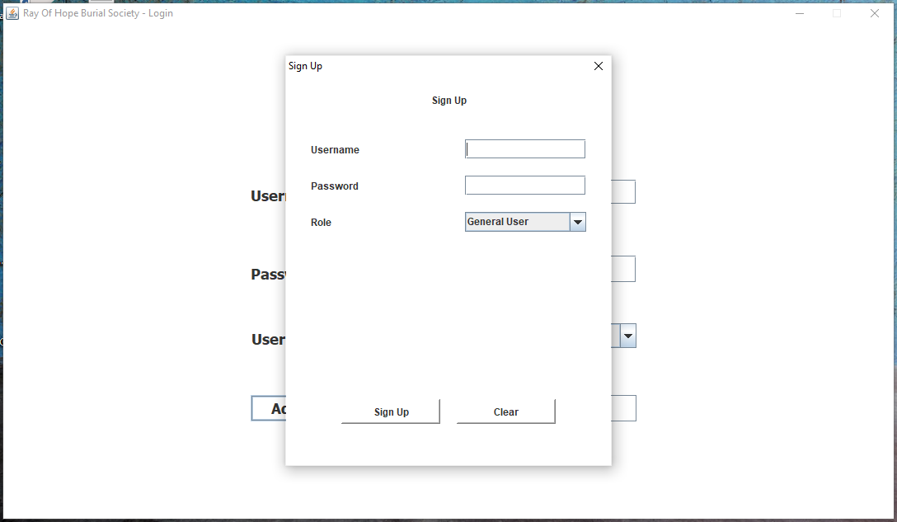

* **The Main screen/window –** this window is displayed differently for each user, depending on access rights granted to each user.
  + **Logged in as a Signed-Up-Administrator**

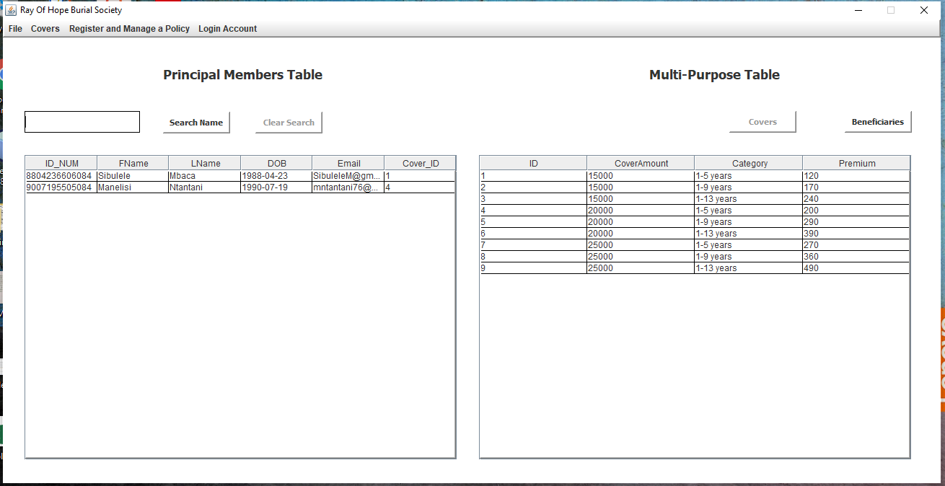

The Main window has four buttons: **search name** for searching principal members in the database and displaying the results on the principal members table, **clear search** for clearing a search and display all principal members in the database, **covers** for displaying burial covers offered by the burial society on the multi-purpose table, **beneficiaries** for displaying beneficiaries registered under each principal member policy.

* **File Menu**

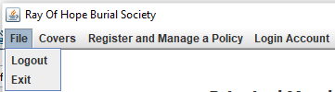

The File menu has two menu items, **Logout** for logging out of the application, and **Exit** for terminating the application run.

* **Covers Menu**



This menu item brings up a dialog for entering insurance covers offered by the burial society.

* **Manage Covers –** this dialog for entering insurance covers has 3 buttons, **Create** for creating a new record of an insurance cover, **Update** for updating existing burial covers, and **Clear** for removing text in the dialog text fields.

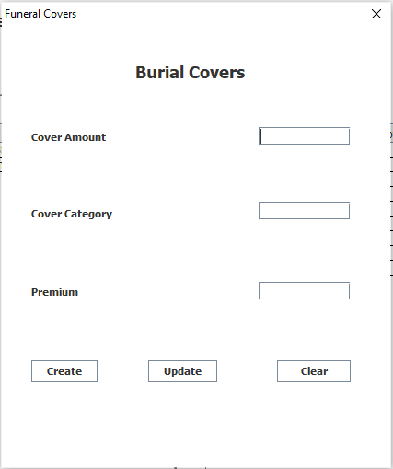

* **Register and Manage Policy Menu –** this menu provide two menu items: **Register and Manage Policy** for registering, updating, and deleting registered policies; and **Beneficiaries** for registering, updating, and deleting beneficiaries.
  + - **Register and Manage Policy –** this dialog is equipped with four buttons: **Register** for registering a new policy for a principal member, **Update** used by administrators to update registered principal member policies, **Delete** for deleting registered principal members (when used by administrators), and **Clear** for clearing graphical user interface text input fields.

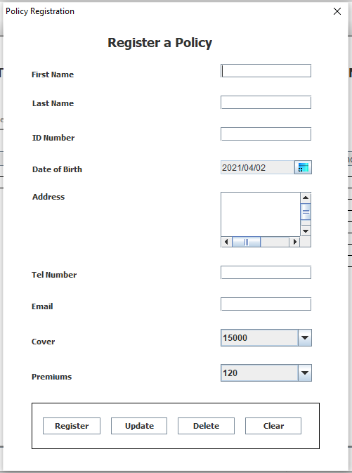

* **Beneficiaries –** this dialog is for adding beneficiaries (with button **register**), updating the beneficiaries (with button **update**), and deleting beneficiaries (with button **delete**). The dialog also has a button to **clear** graphical user interface text input fields.

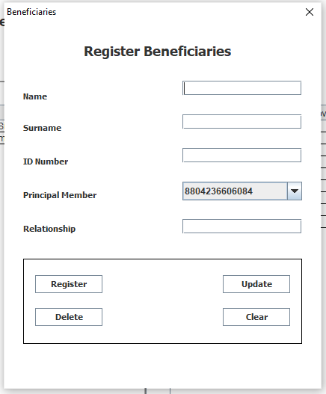

* **The Login Account menu –** this menu is equipped with two menu items:
  + **Update Login Details menu item –** this menu item brings up a dialog for updating login details of an administrator. When it is brought up, text input fields of this dialog are populated. The dialog is equipped with two buttons: **Update** for uploading to the database updated details, and **clear** for clearing text in the text input fields.

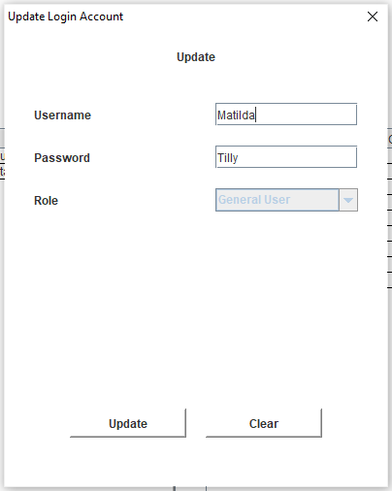

* + **Delete Account Details menu item –** this menu item deletes login details of the logged in administrative user.
* **Logged in as a default Administrator –** when a default administrator is logged in the Main window is displayed as follows. The four buttons **search name, clear search, covers, and beneficiaries** work as documented when a signed-up administrator is logged in.

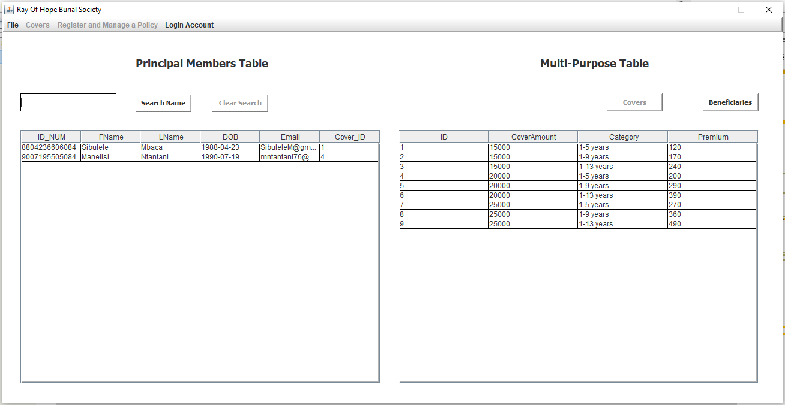

In the case of a default administrator being logged in only two menus are available, the **File menu** which is already documented above, and the **Login Account menu.**

* **The Login Account menu –** this menu has 3 menu item, two of which have been documented and are not activated.

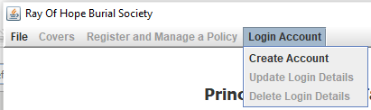

* **The Create Account menu item** – this menu item signs up a user as documented in the **Add Acc** button of the login screen.
* **Logged in as a General User –** when logged in as a general user the Main window is displayed as follows:

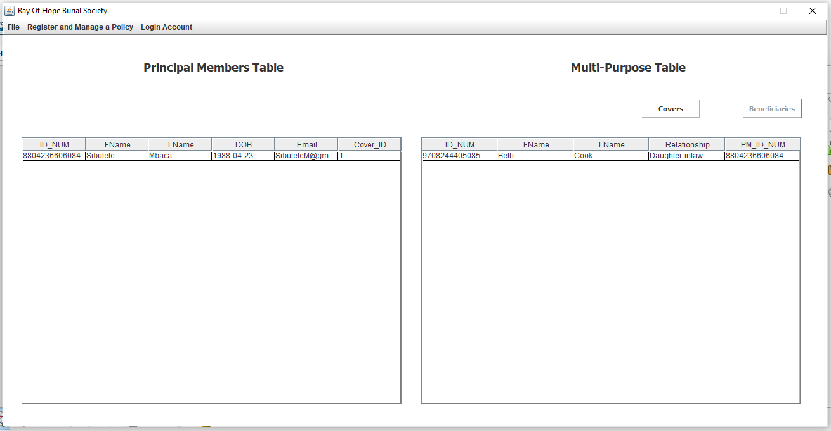

The principal members table displays the details of the logged in principal member. The **covers** button displays covers offered by the burial society, the **beneficiaries** button displays in the multi-purpose table all beneficiaries registered under the logged in principal member.

* **The File menu –** this menu and its menu item behave as documented above.
* **The Register and Manage a Policy menu** – for general users, this menu also possesses two menu items:
  + **Register and Manage Policy menu item** –which brings up a dialog for general users to register their burial policies (with the **register** button), update their policy details (with the **update** button), delete policy registration (with the **delete** button), and clear input in the GUI text input fields (with the **clear** button).
  + **Beneficiaries menu item** – this brings up the same beneficiaries dialog documented above. A general user is able to update details of only the beneficiaries which are registered under his/her burial policy.
* **The Login Account menu –** behaves exactly the same as it does for a signed-up-administrator. It provide two menu items, one for updating the login account details of the logged in general user, and another for deleting login details, policy, and/or beneficiary details associated with the currently logged in general user.