**Application Concept**

Implement a graphical user interface (GUI) using Java for Ithemba (Ray of Hope) burial society. The society is currently using paper-based forms to capture the client’s details, they will use the application to allow their clients to register electronically.

**Application Functional Requirements**

* The application must have a front screen to allow the client to create an account (login) using username and password.
* A client with an account must be able to login and register for the burial society policy.
* The front screen must also enable an administrator to log in and be able to view, insert, update, and delete the clients.
* Provide a search feature for an administrator that will allow the administrator to make search queries to and from the database tables.

**Application User Manual**

This application has three actors:

* Default administrator
* Administrator
* User/Client

The Use Case diagram below graphically depicts how each actor interacts with the system.

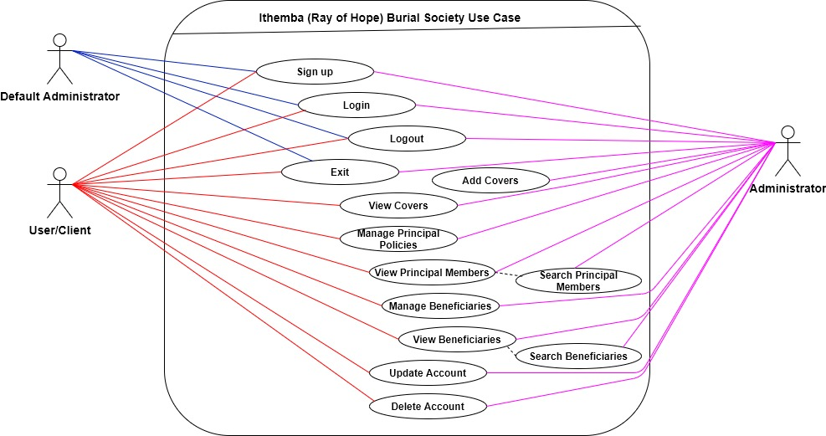

frmLogin

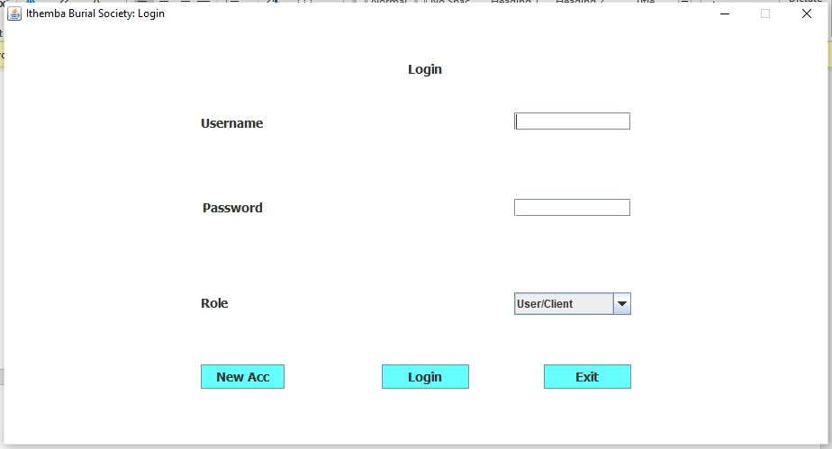

This is the application front screen; it allows a user to create a new login account and log into the application. The screen has three buttons:

* New Acc – this button is for creating a new user login account and it brings up the frmUserAccount screen.

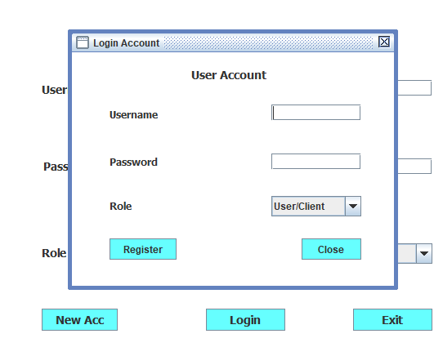

The frmUserAccount internal screen has a button for registering a new user login account and a button to close the internal form.

* Login – this button logs in the user to the application, if the user’s credentials are correct, and brings up the application main screen.
* Exit – this button terminates the current application run/instance.

Logged in actor: Default Administrator.

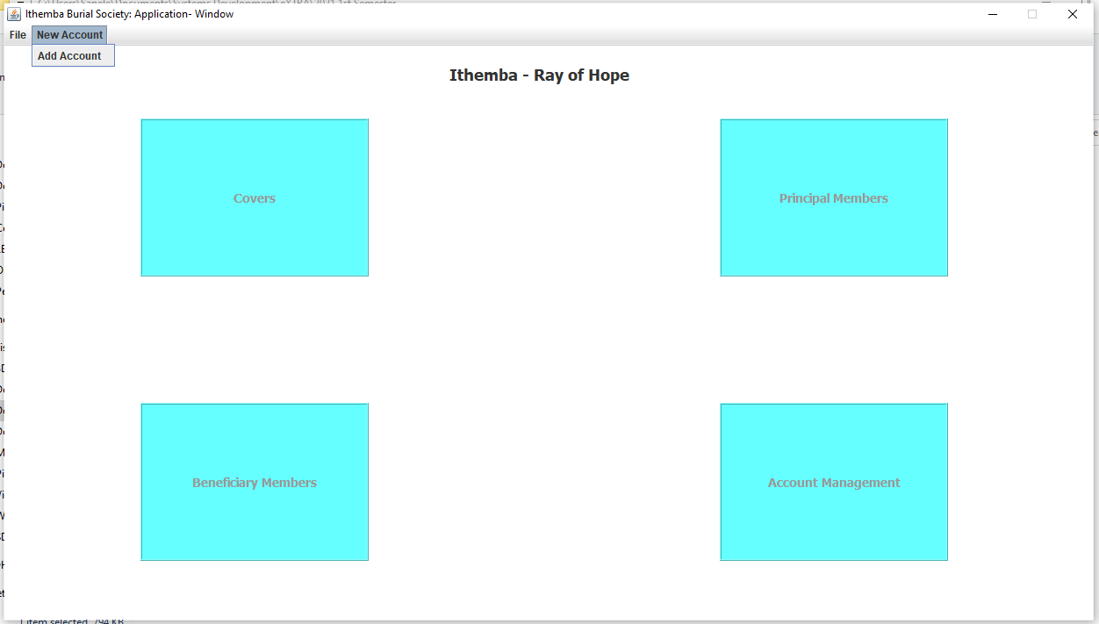

When a default administrator is logged in, the main functionality of the application is disabled. This administrator is provided options to logout, exit the application (under the file menu), and create a new login account so that they can have a login ID. The frmUserAccount screen, as shown above in the documentation, is used to register a new login account.

Logged in actor: Administrator.

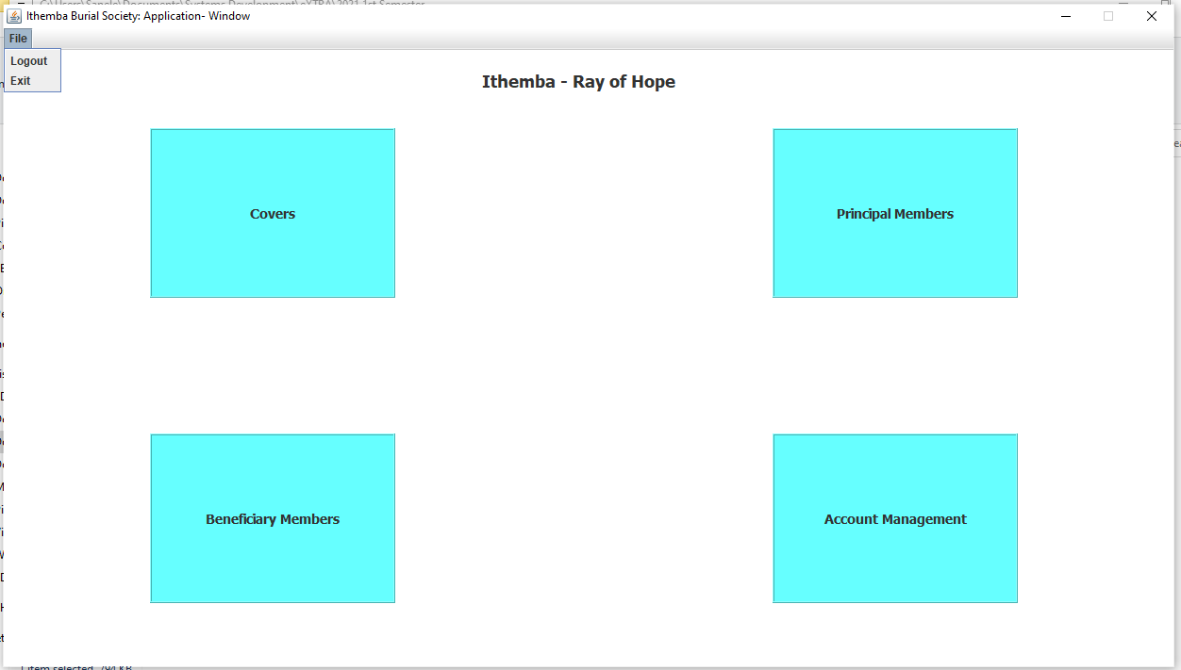

A logged in administrator has access to the functions shown above.

* File menu – this menu allows an administrator to logout and return to the login screen, and/or exit the application.
* Covers button – this button brings up a frmOptions dialog used, in this instance, to provide options to work with insurance covers.

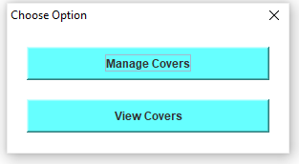

* + Manage Covers – this button brings up an internal form for adding covers to the database.

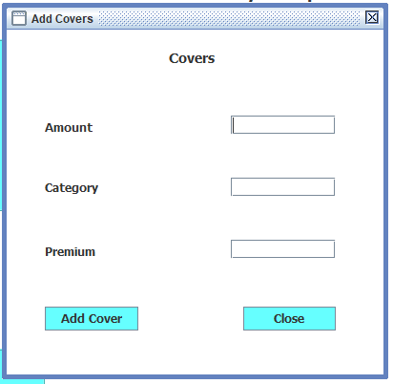

This internal form has two buttons: button Add Cover – for creating a record of a cover in the database, and button Close – for closing the Add Covers internal form.

* + View Covers – this button brings up a screen to view covers available at the burial society.

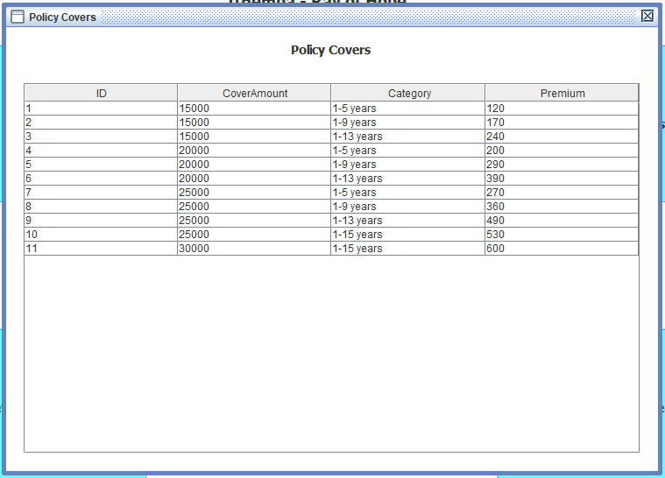

* Principal Members button - this button brings up a frmOptions dialog used, in this instance, to provide options to work with principal members’ policies.

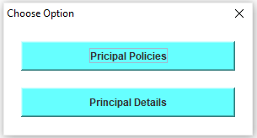

* + Principal Policies – this button brings up an internal form for registering, editing, and deleting principal members’ policies.

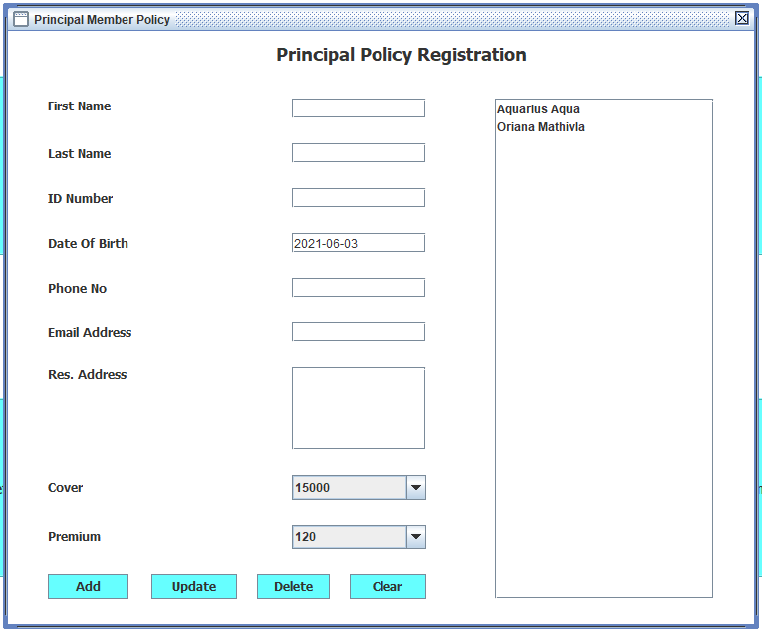

* + - Add – this button gives an administrator an option to create a login account for the principal member they are registering a policy for, after that a new policy is recorded to the database, finally, the administrator is prompted to register beneficiaries.
    - Update – this button allows for a principal member selected in the list to be updated.
    - Delete – this button allows for a principal member selected in the list to be deleted.
    - Clear – this button clears text in the text fields of the GUI.
  + Principal Details – this button brings up a screen to view principal members registered with the burial society.

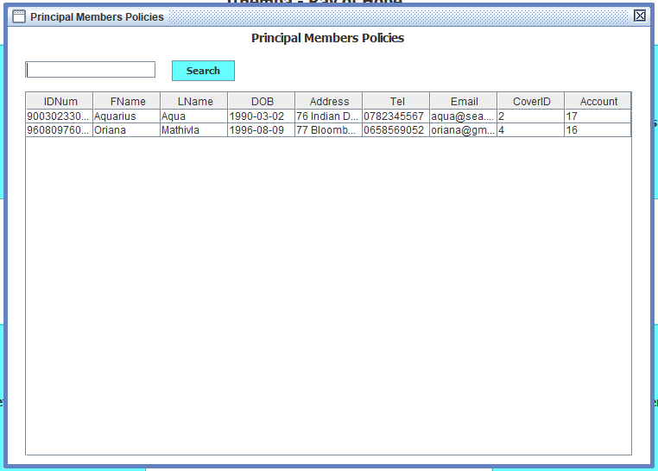

* + - Search – this button allows an administrator to search a principal member using the member’s first name and last name or only the first name or last name.
* Beneficiary Members - this button brings up a frmOptions dialog used, in this instance, to provide options to work with beneficiaries registered under principal members’ policies.

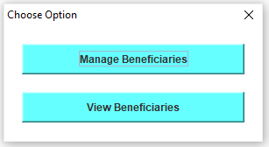

* + Manage Beneficiaries – this button brings up an internal form for registering, updating, and deleting records of beneficiaries in the database.

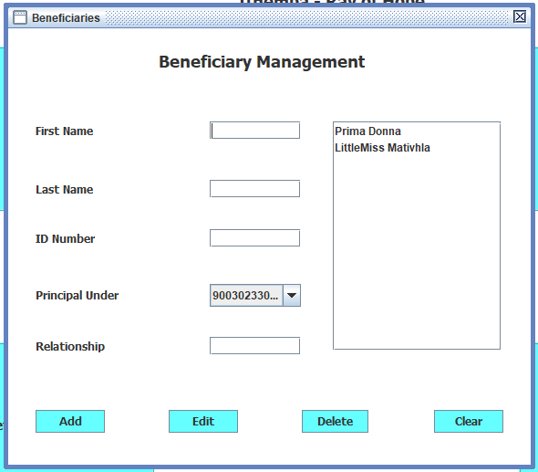

* + - Add – this button registers a beneficiary under a principal member policy.
    - Edit – this button allows editing a beneficiary that is selected in the list.
    - Delete – this button allows deleting a beneficiary that is selected in the list.
    - Clear – this button clears text in the GUI text fields.
  + View Beneficiary - this button brings up a screen to view principal members registered with the burial society.

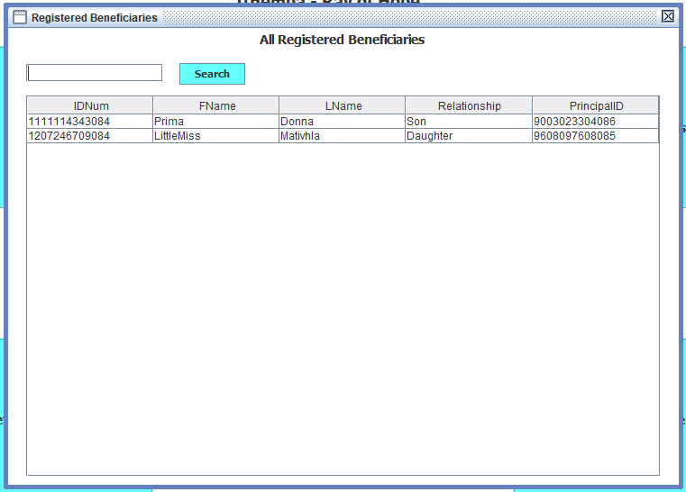

* + - Search – this button allows an administrator to search a beneficiary using the beneficiary’s first name and last name or only the first name or last name.
* Account Management – this button brings up a frmOptions dialog used, in this instance, to provide options to work with the logged in administrator’s login account.

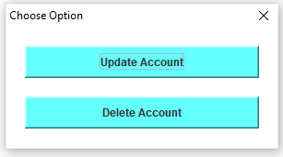

* Update Account – this button brings up an internal form that allows the logged in administrator to update their login details.

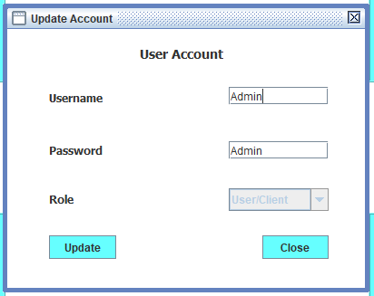

* + - Update – this button uploads to the database updated login details of the logged in administrator.
    - Close – this button closes the Update Account internal form.
* Delete Account – this button brings up an internal form that allows the logged administrator to delete their login account.

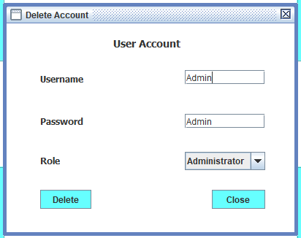

* Delete – this button deletes the login account of the logged in administrator.
* Close – this button closes the Delete Account internal form.

Logged in actor: User/Client.

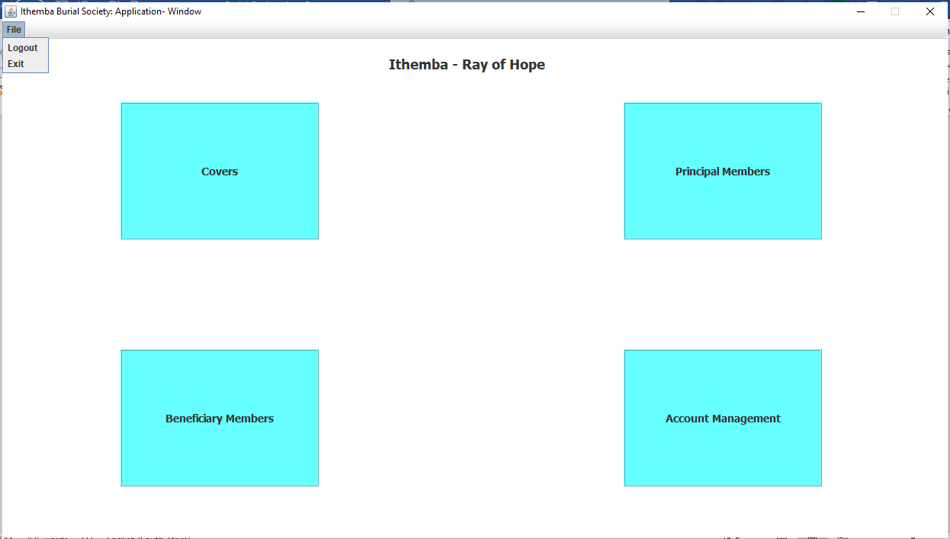

A logged in user/client has access to the functions shown above.

* File menu – this menu allows a user/client to logout and return to the login screen, and/or exit the application.
* Covers – this button displays the Policy Covers internal form that displays policy covers provided by the burial society.

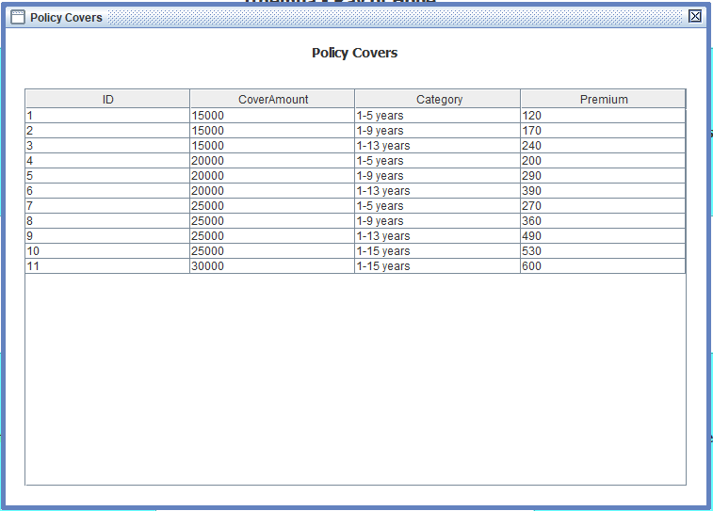

* Principal Members - this button brings up a frmOptions dialog to be used by clients and principal members to work with their policies.

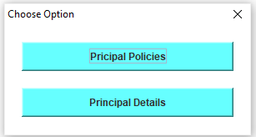

* + Principal Policies – this button allows clients/principal members to register a policy, update details of their policy, and delete their policy.

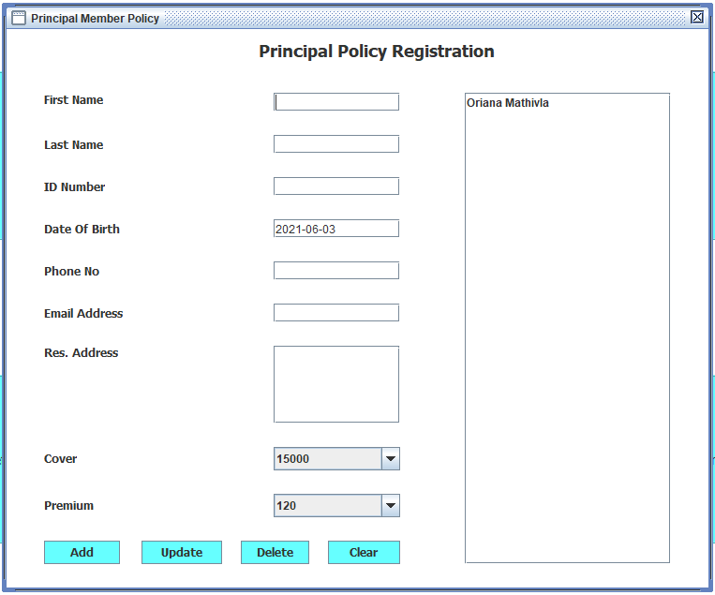

* Add – this button allows a principal member to register for a burial policy and provides an option to open the form for registering beneficiaries.
* Update – this button allows a principal member to update details of their policy.
* Delete – this button allows a principal member to delete all information related to their burial policy.
* Clear – this button clears text in the text fields of the GUI.
  + Principal Details – this button brings up an internal form for a logged in principal member to view their policy details.

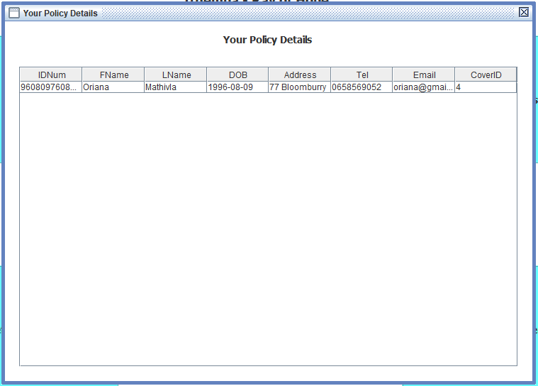

* Beneficiary Members – this button brings up a frmOptions dialog to be used by principal members to work with benefiters of their policies.

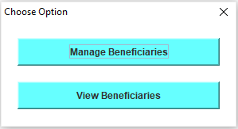

* + Manage Beneficiaries – this button brings up an internal form for principal members to register benefiters of their policies.

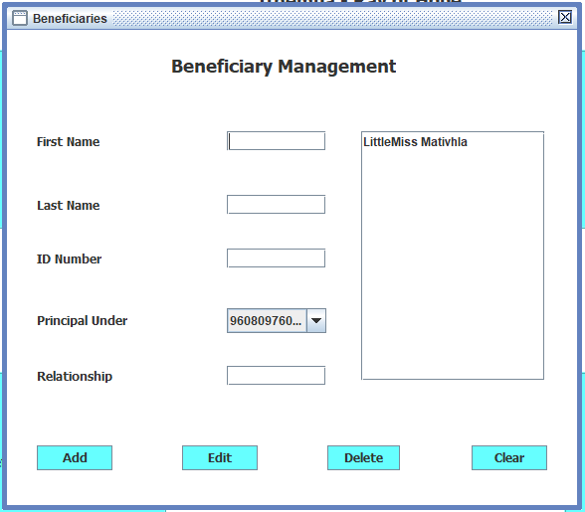

* Add – this button registers a beneficiary under the policy of the logged in principal member.
* Edit – this button updates details of the beneficiary that is selected in the list.
* Delete – this button deletes details of the beneficiary selected in the list and removes that beneficiary from the policy of the logged in principal member.
* Clear – this button clears text in the text field of the GUI.
  + View Beneficiaries – this button allows principal members to view beneficiaries registered under their policy.

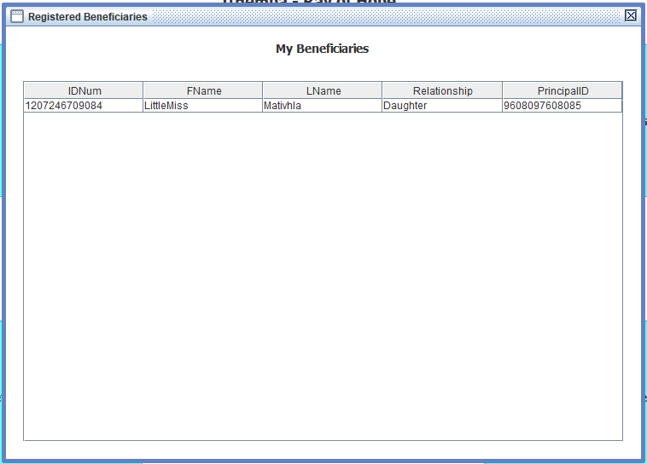

* Account Management - this button brings up a frmOptions dialog used, in this instance, to provide options to work with the logged in principal member’s login account.



* Update Account – this button brings up an internal form that allows the logged in principal member to update their login details.

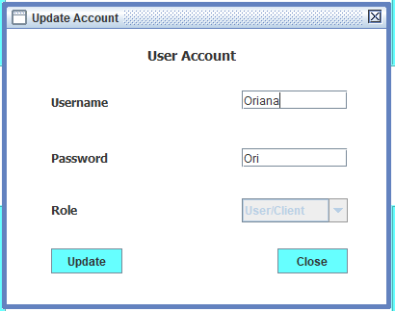

* + - Update – this button uploads to the database updated login details of the logged in principal member.
    - Close – this button closes the Update Account internal form.
* Delete Account – this button brings up an internal form that allows the logged user to delete their login account.

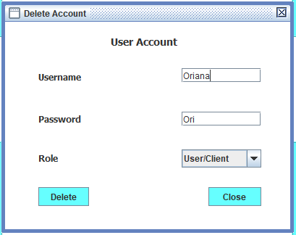

* Delete – this button deletes the login account of the logged in principal member.
* Close – this button closes the Delete Account internal form.