Sanele Nxasana 211275220  
Group 3B  
Technical Programming II: Version Control Assignment  
28 February 2016  
­­­­­­­­­­­­­­­­­­­_________________________________________________________________________________

1.I. GitHub initialisation.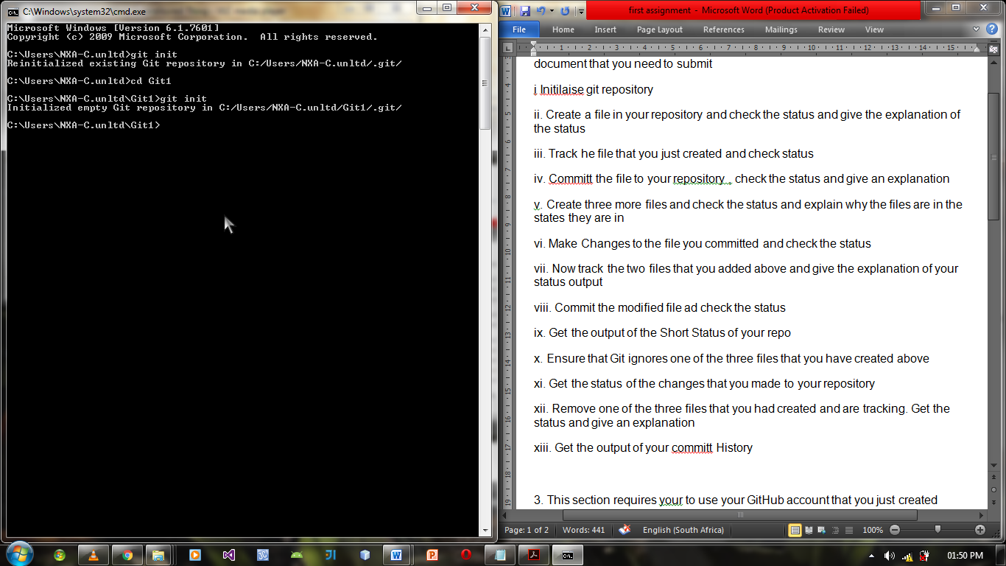

II/III. File ‘README.md’ has been created, status checked and proved the file is still in the working directory. File has also been tracked.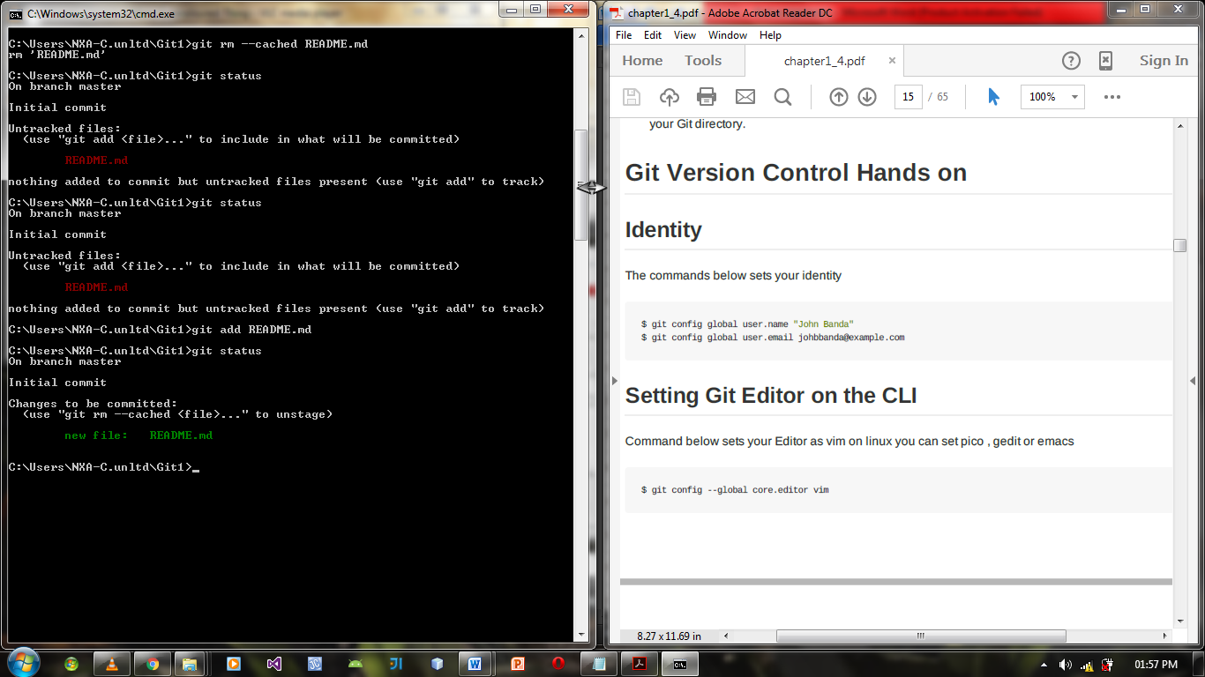

IV. The file has been committed and commit details are displayed.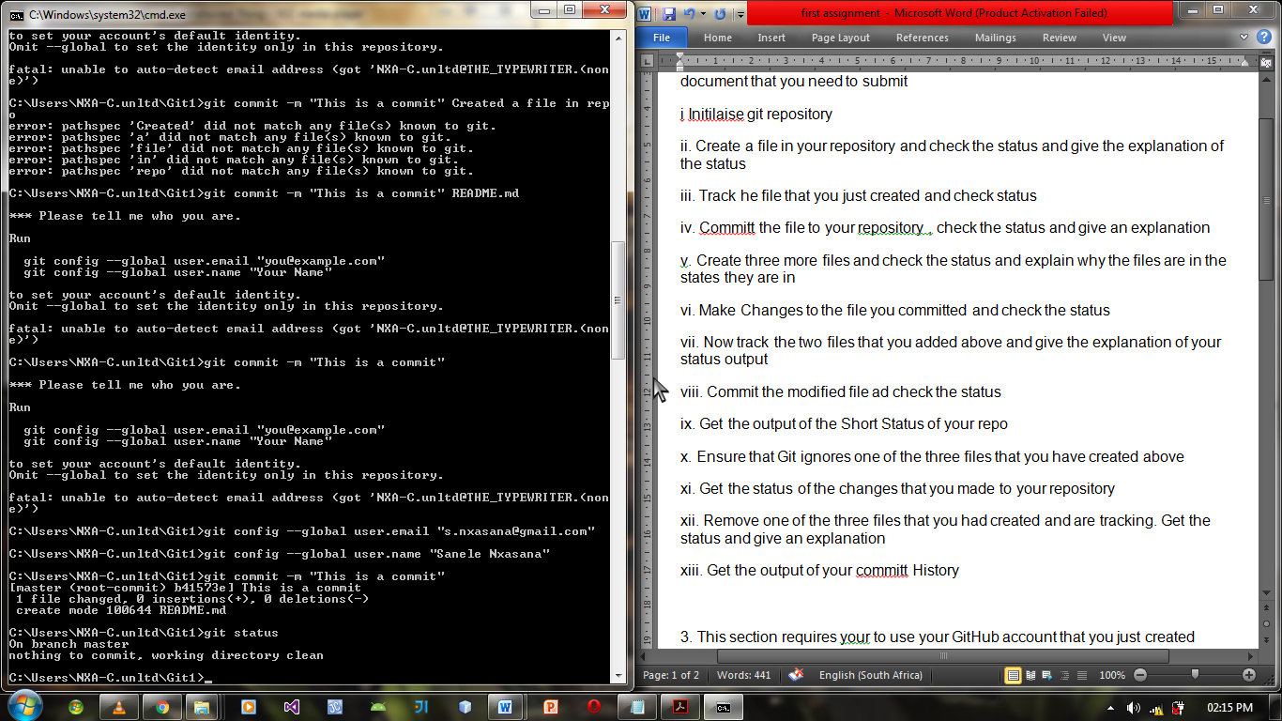

V. The created files are highlighted in red because they are untracked.  
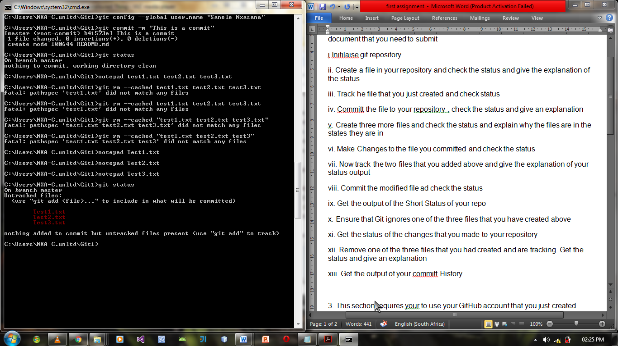  
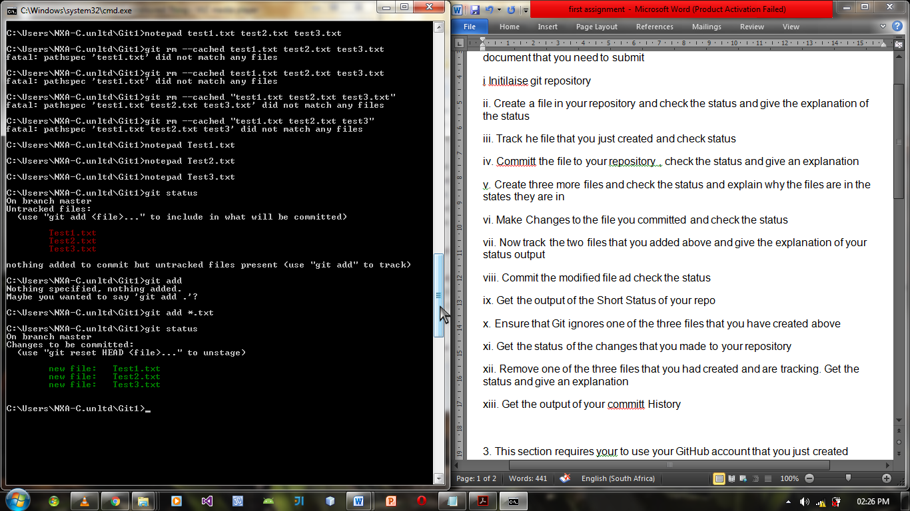

VI/VII. The modified file is highlighted in red and has the word ‘modified’ before it. The recently added files are highlighted in green because they have been tracked and need to be committed.  
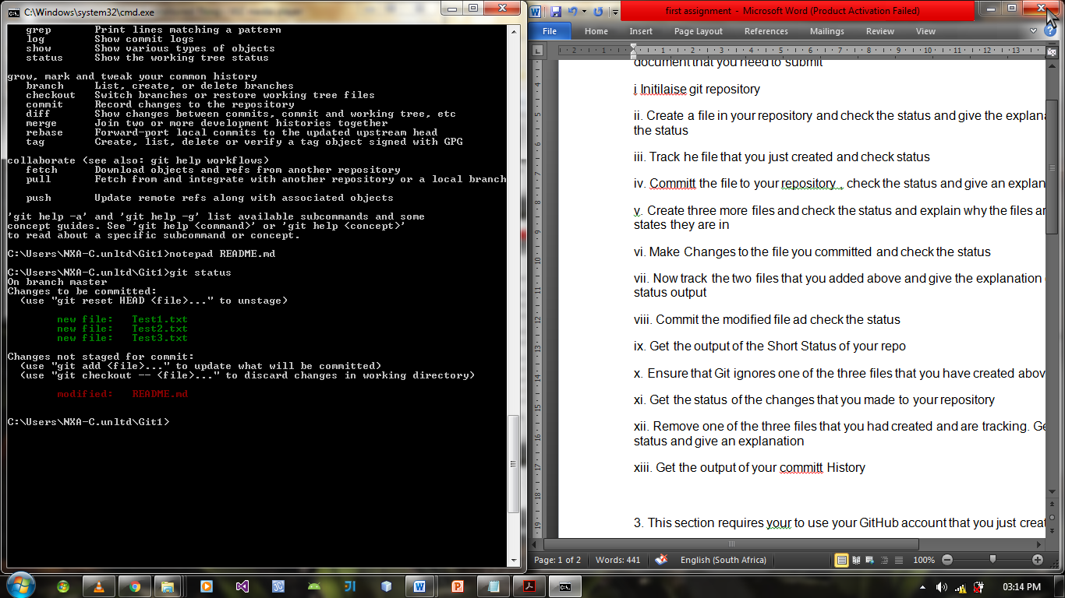

VIII. After committing, the new files and the modified files are saved/created.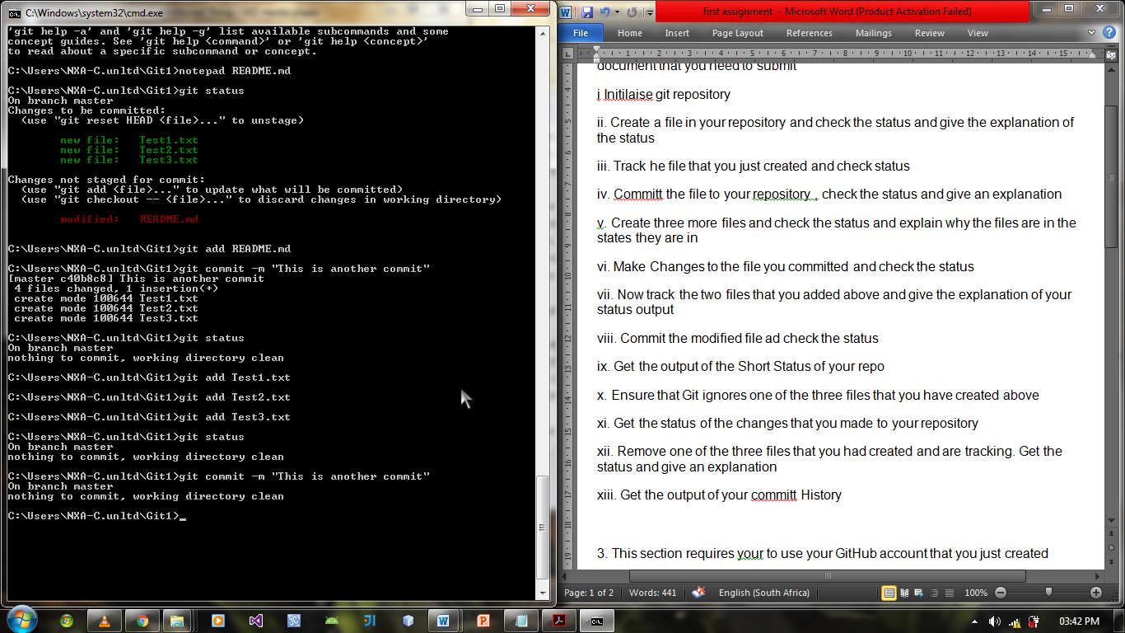

IX. The short status yields no output.  
 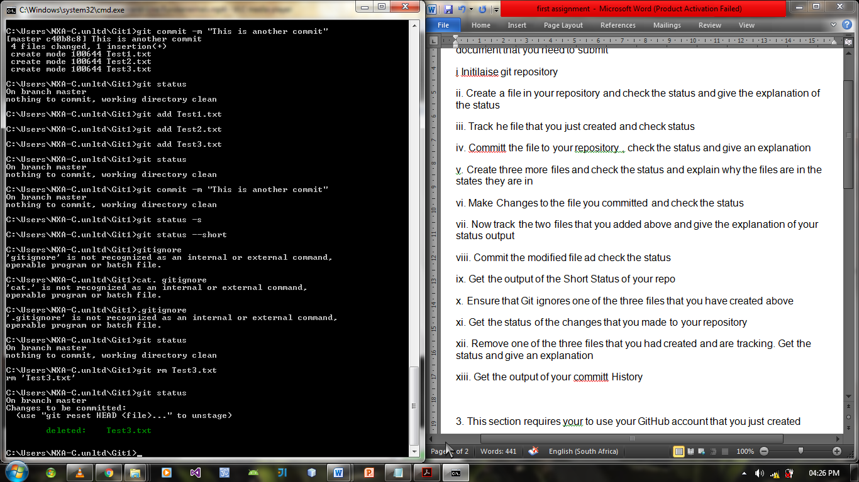

XII. Based on the status, the targeted file was removed successfully.  


XIII. The ‘git log’ command displays all the commits that have been executed.

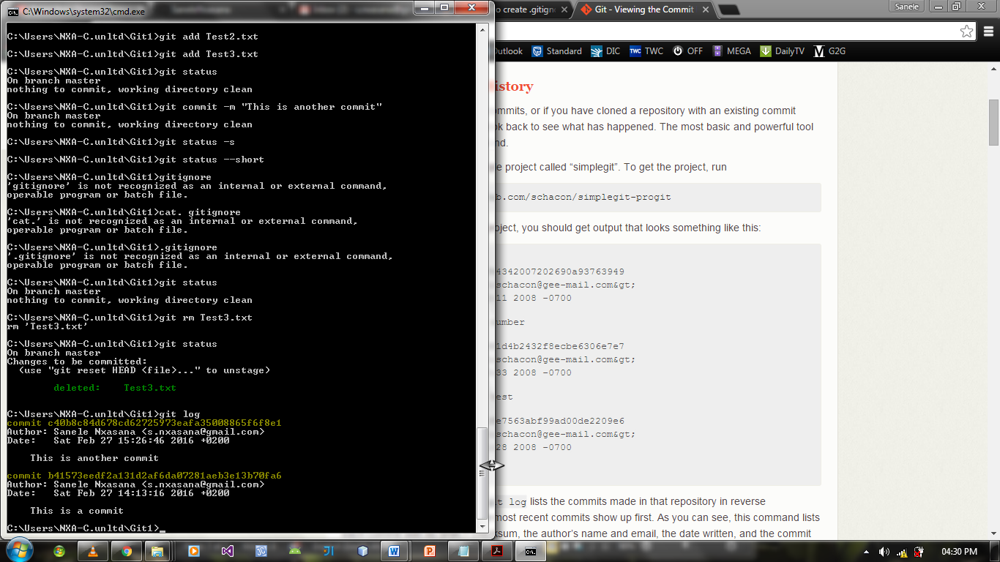

3.I. The ‘AssignmentRepo’ has been cloned, and based on the results, the clone was successful.  
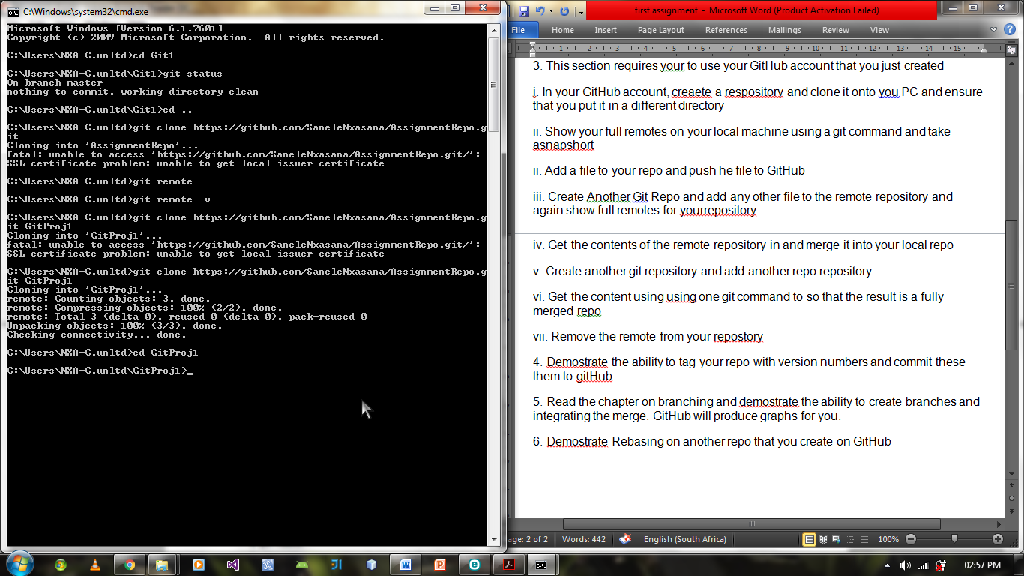

II. Full remotes.  
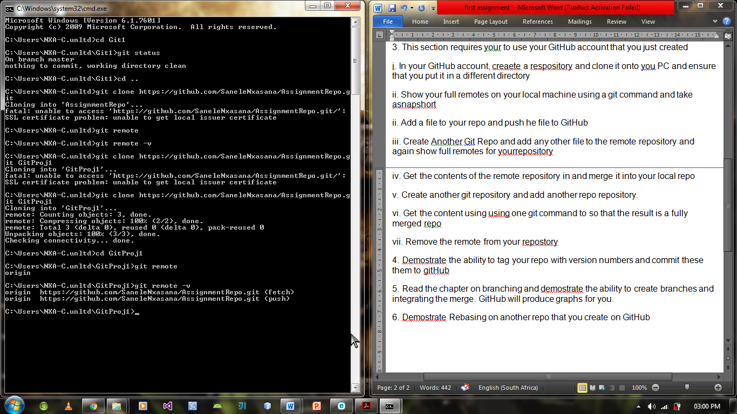

II.(2). File added to repository and pushed to GitHub successfully.  
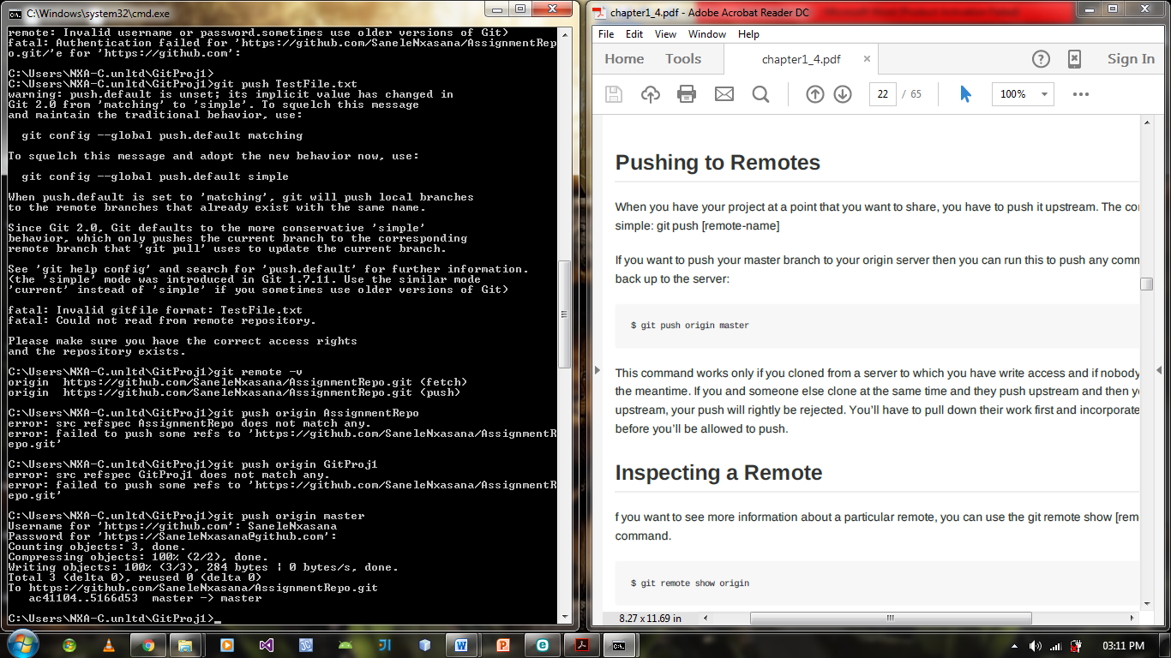

III/IV. Git repo is created, files are merged using the ‘clone’ command. All remotes are displayed.  
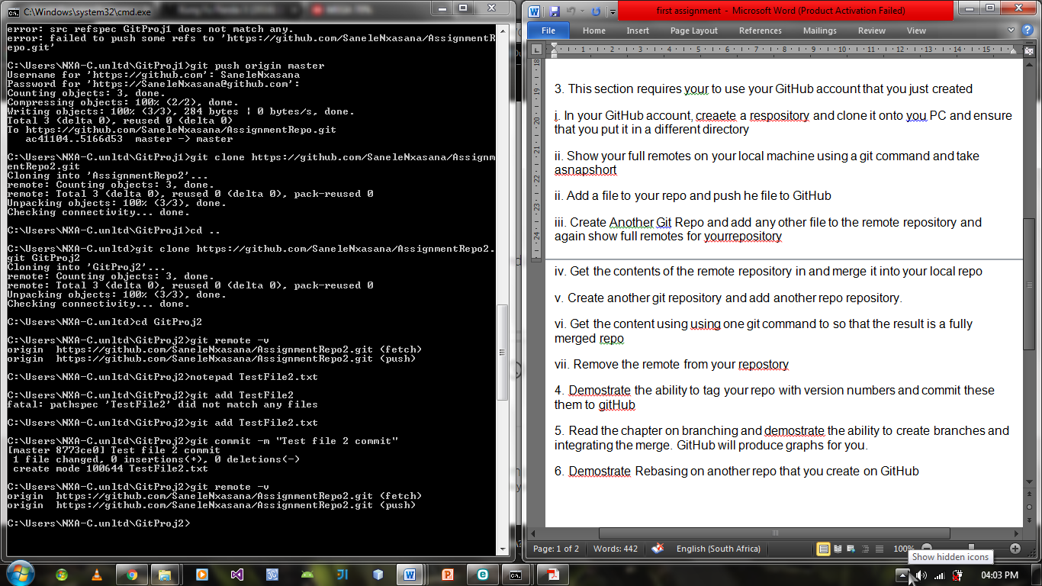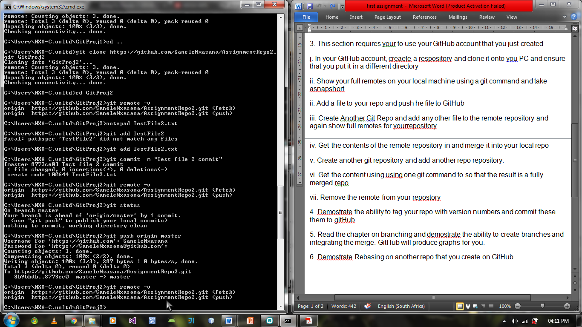

V. Created a repository then added another repository.  
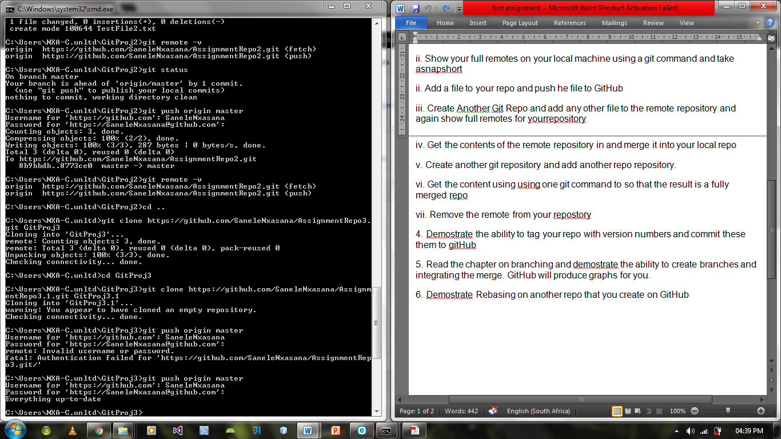

VII. Remote removed using ‘git remove remote origin’ command.  
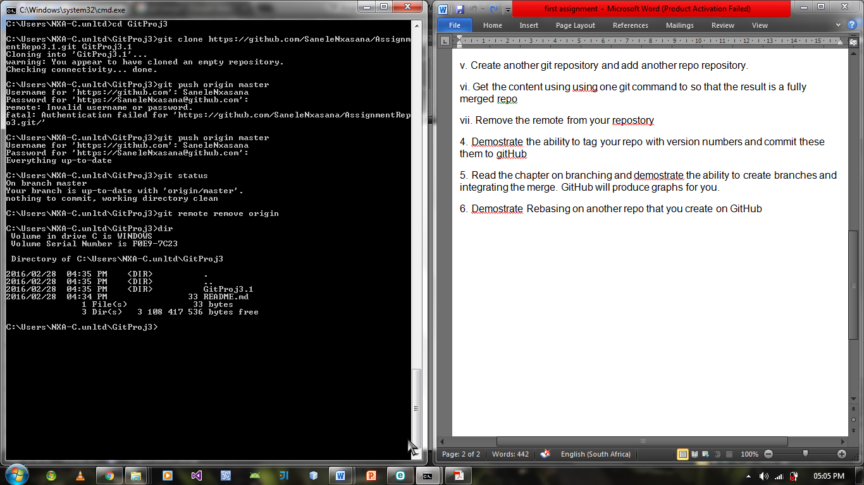

4. This repository has been successfully tagged with a version number.

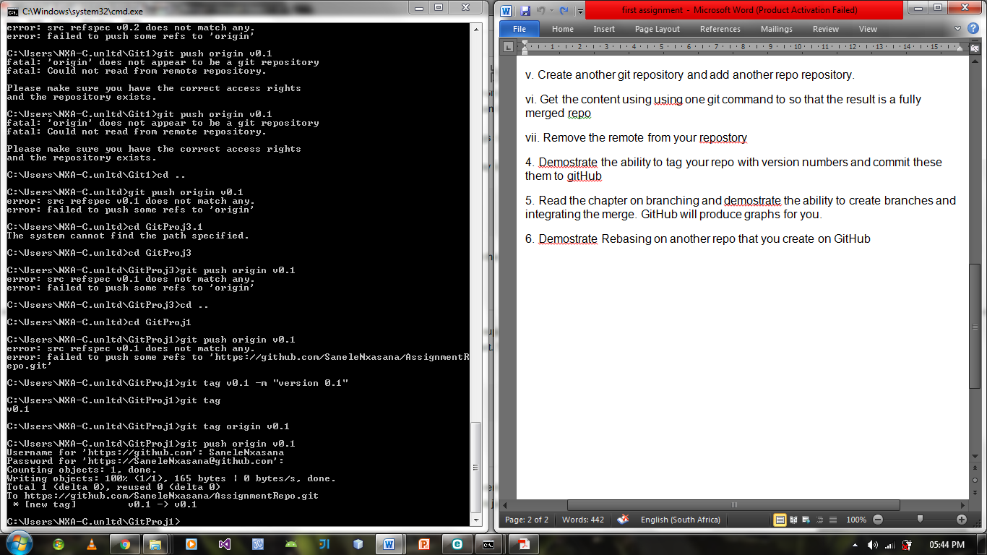

5. Branches have been created, merged, and sent to GitHub.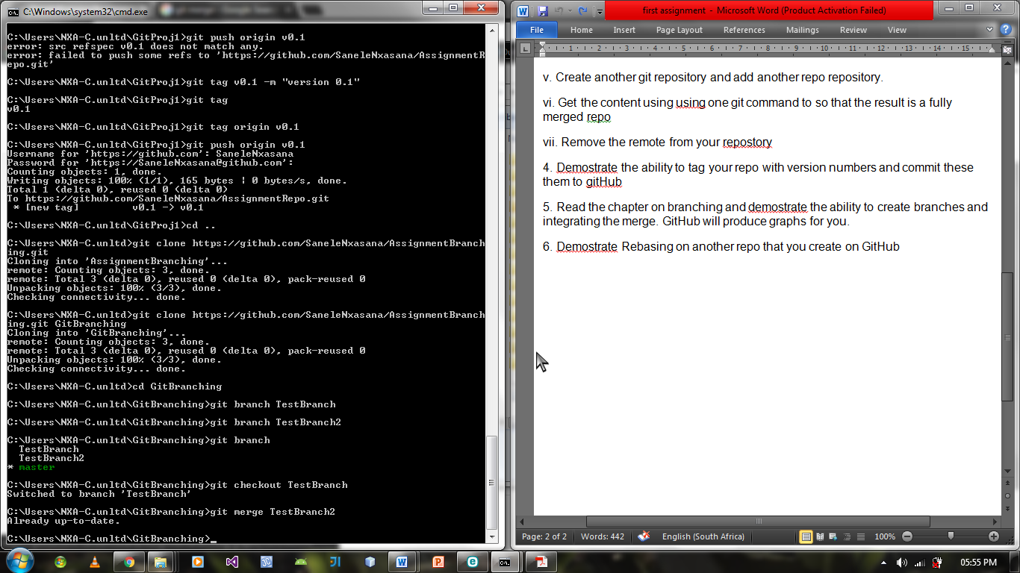

6. ‘Master’ has been rebased to ‘TestBranch’.

