

**AcenAAr Technologies Pvt. Ltd.**

76/2-sku-4f-1, Skandhanshi Vyapaar, Tailors Colony, Revenue ward no. 76, Kurnool-518001, Andrapradesh , India.

GSTIN NO: 37AAVCA3004E1ZU

CIN : U31901AP2021PTC118455

Mobile: 7032131793, 7989942182 web: [www.acenaartechnologies.com](http://www.acenaartechnologies.com/) e_mail: info@[acenaartechnologies.com](mailto:acenaartechnologies@gmail.com)

# Certificate

This is to confirm and certify that **Shaik Mohammad Fahed, S.Aswini,**

**B.Sai Vineela, U.Nagarjuna** B. Tech, students of Sai Rajeswari Institute of Technology, Proddatur.With **208R1A0547,208R1A0543,208R1A0508,208R1A0553** has successfully completed his/her project work titled Combining “**PQC and Image Steganography for Secure Communication**” on (Cryptography) Technology as part of his course curriculum.

He has done this project using (MATLAB) during the period of January 2024 to April 2024 under the guidance and supervision of **Ahmad Valli** from (ACENAAR TECHNOLOGIES PVT. LTD).

He has completed the assigned project well within the time frame. He is sincere, hardworking and his conduct during the project is commendable.

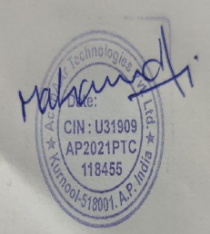

*Authorized Signatory with Date and Seal*