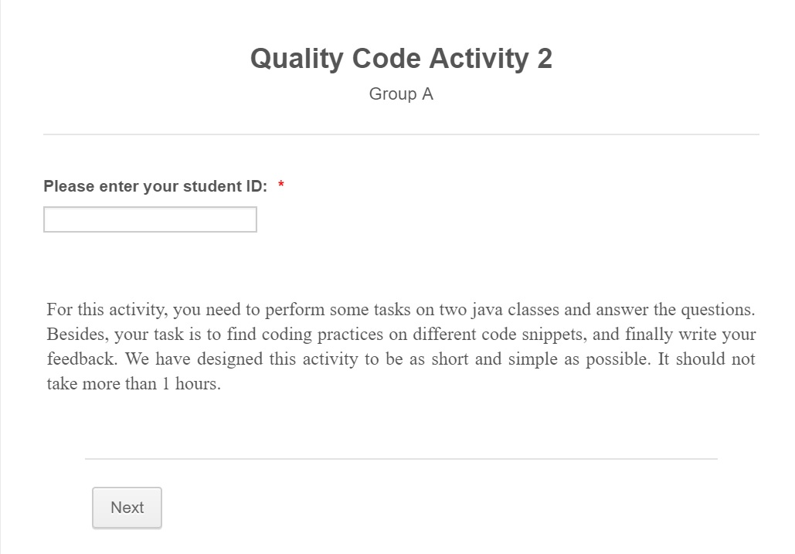

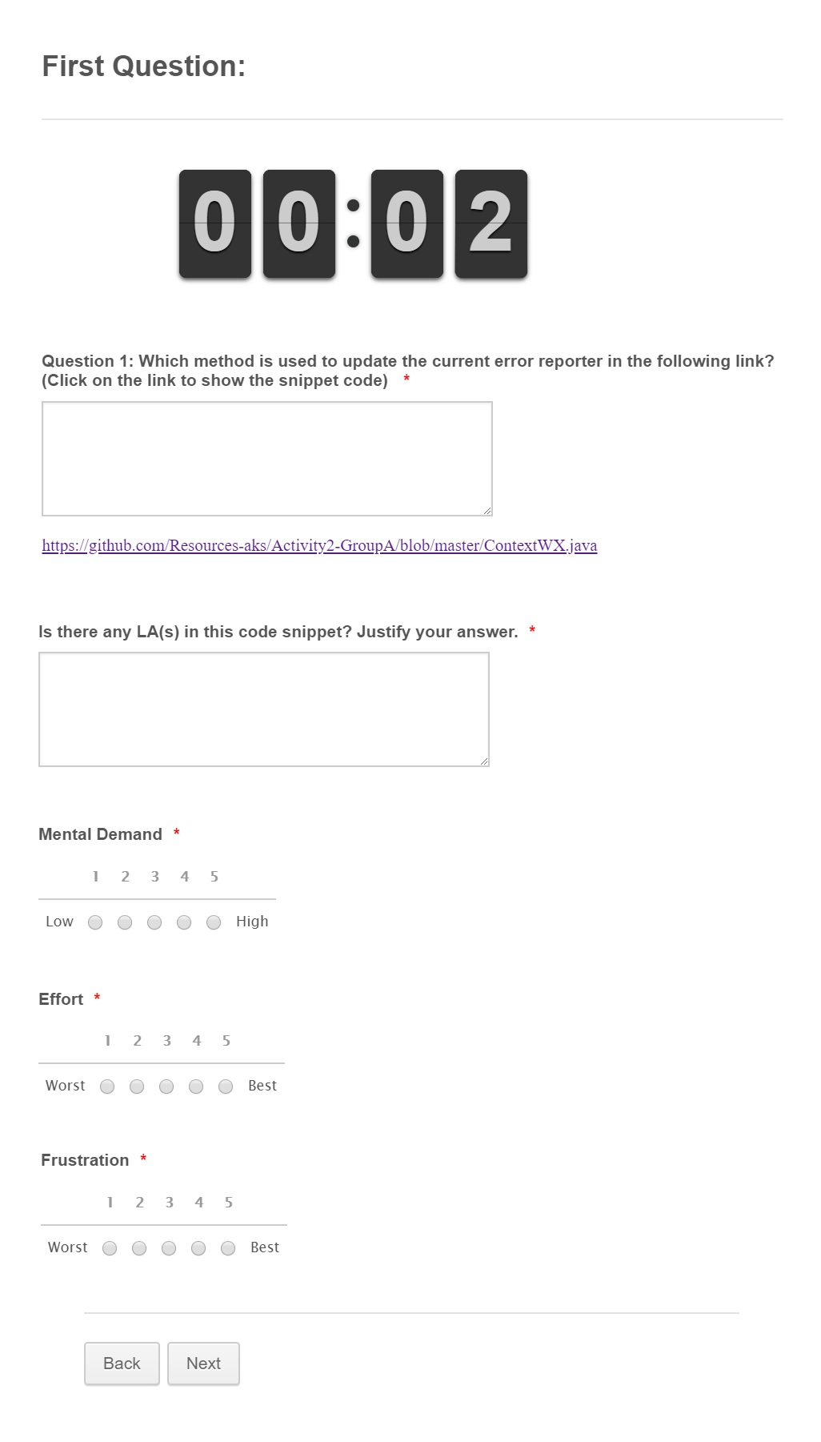[https://github.com/Resources-aks/Activity2-GroupA/blob/master/ContextWX.java](https://github.com/Resources-aks/Activity2-GroupA/blob/master/ContextWX.java" \t "_blank)

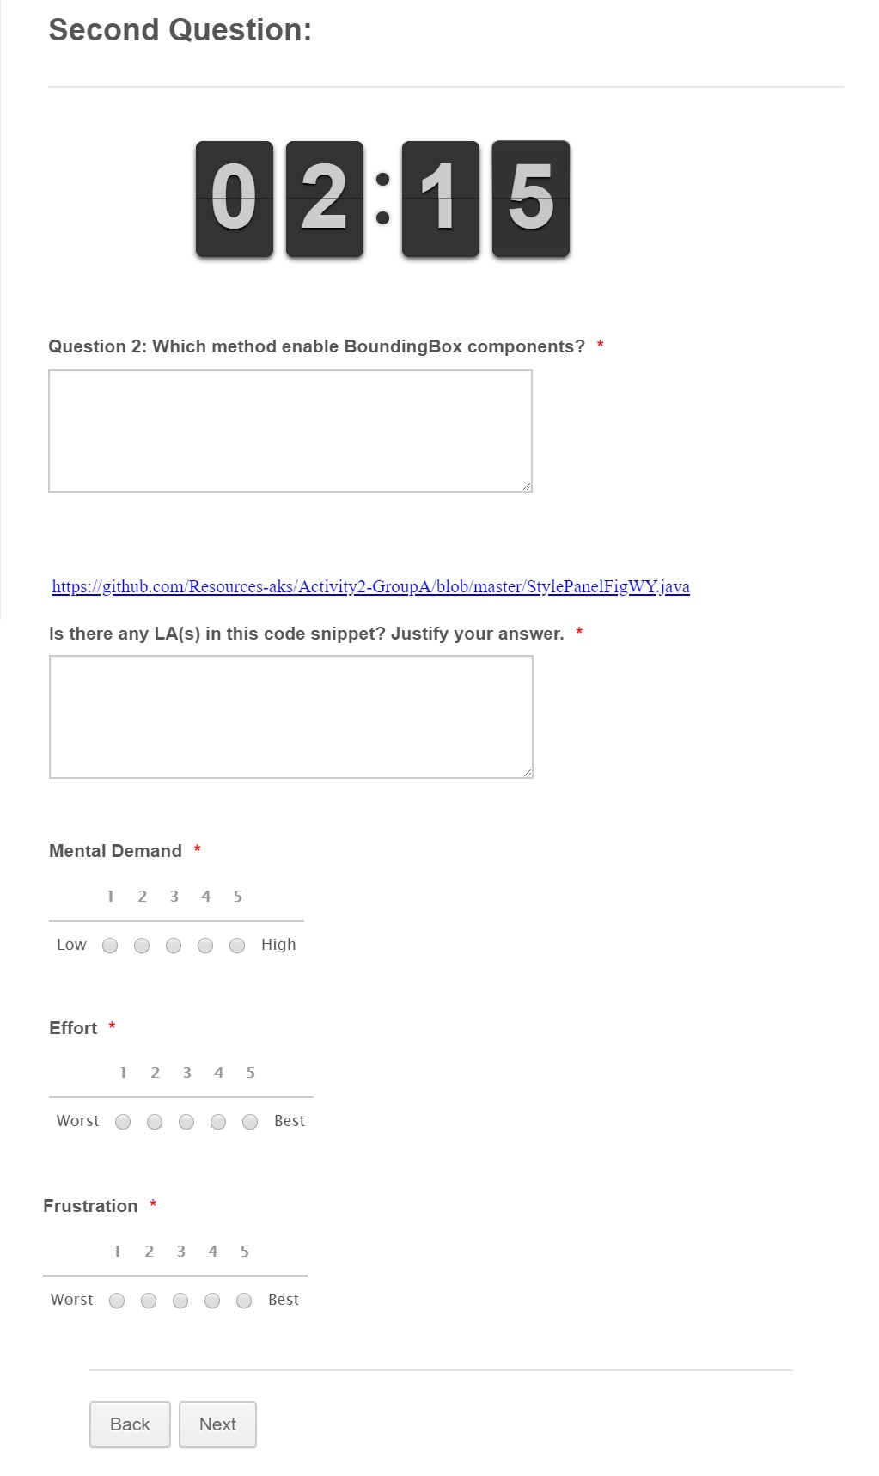[https://github.com/Resources-aks/Activity2-GroupA/blob/master/StylePanelFigWY.java](https://github.com/Resources-aks/Activity2-GroupA/blob/master/StylePanelFigWY.java" \t "_blank)

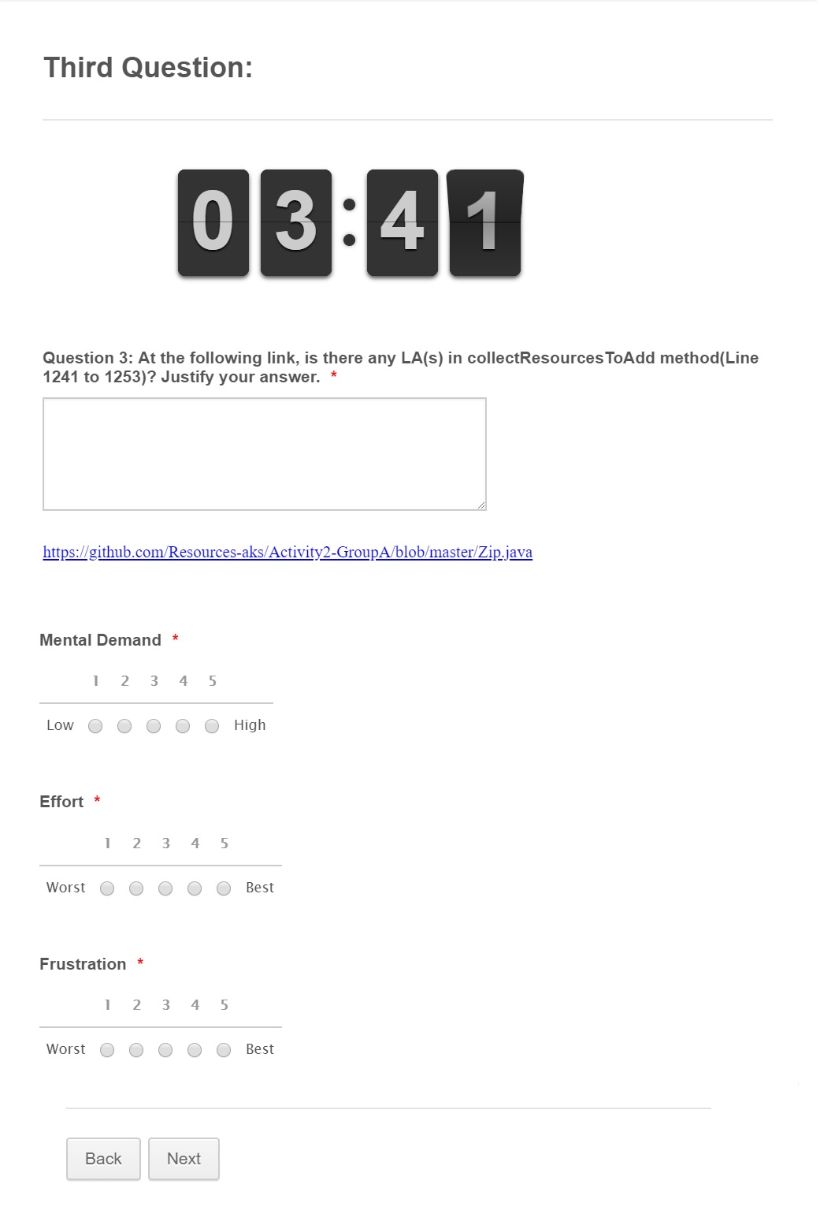

[https://github.com/Resources-aks/Activity2-GroupA/blob/master/Zip.java](https://github.com/Resources-aks/Activity2-GroupA/blob/master/Zip.java" \t "_blank)

