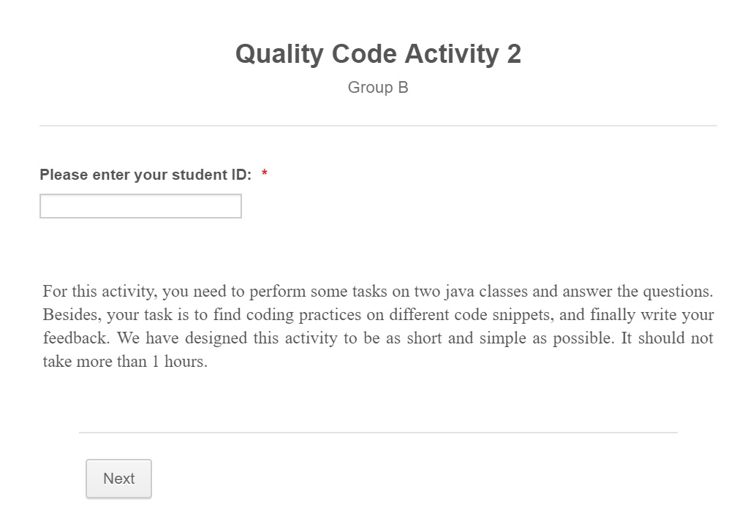

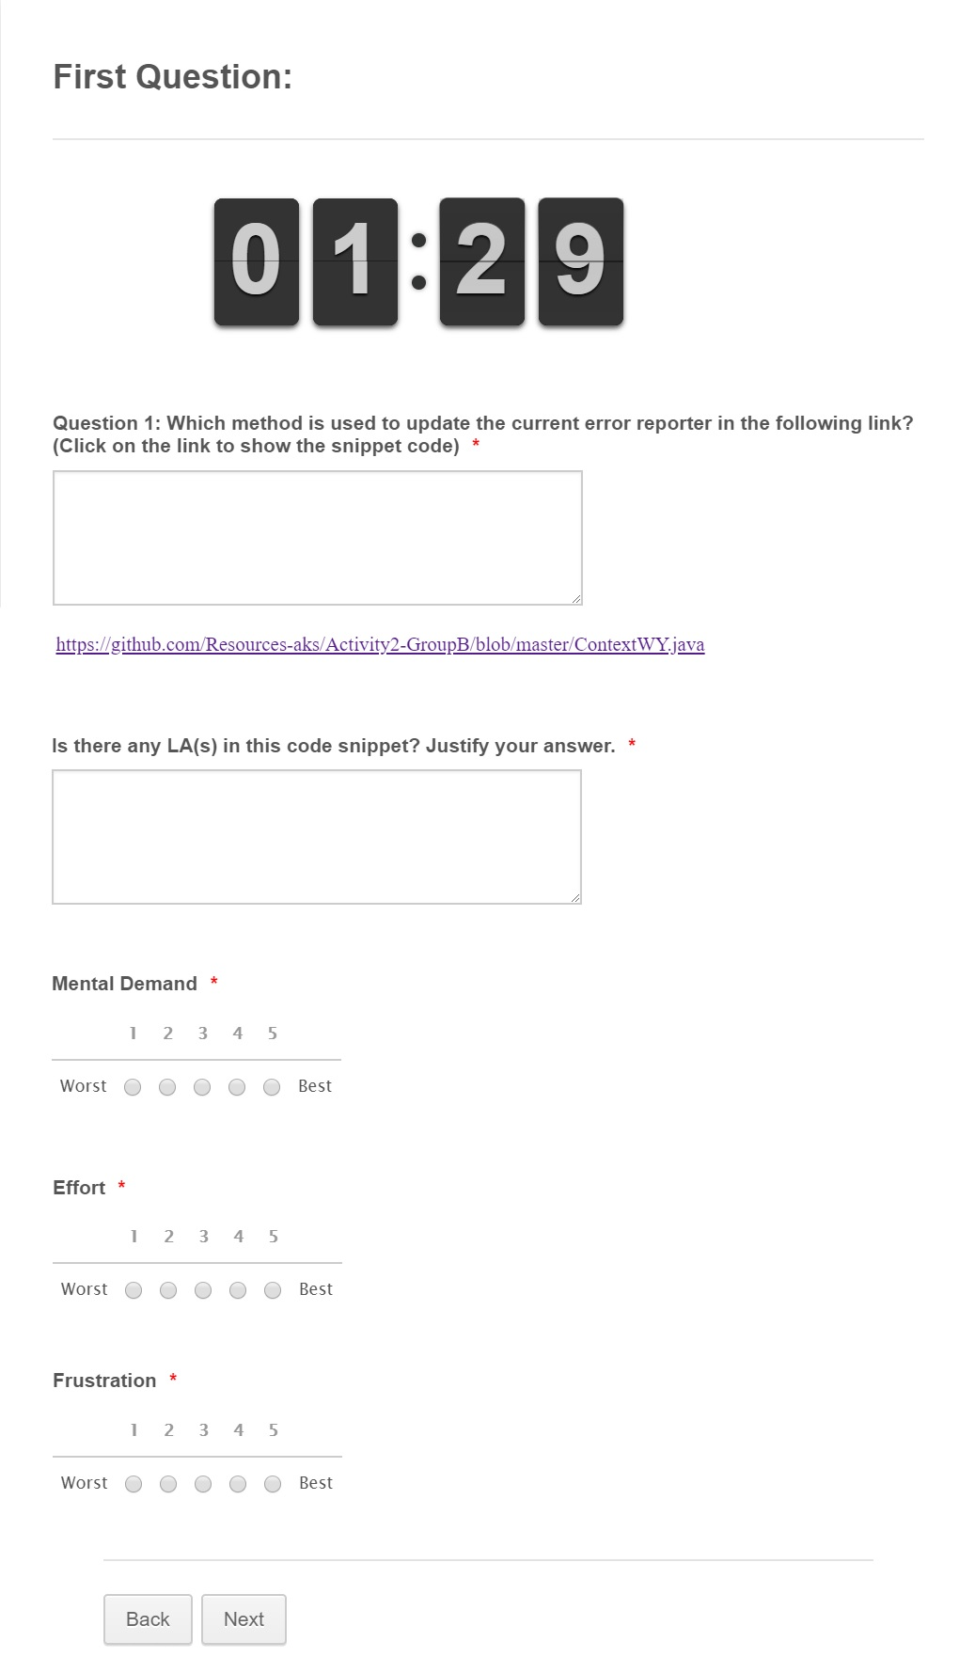<https://github.com/Resources-aks/Activity2-GroupB/blob/master/ContextWY.java>

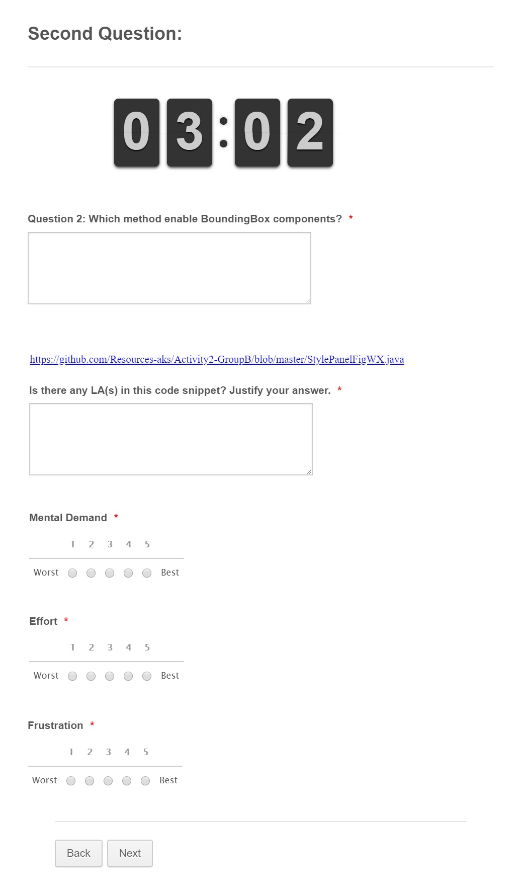

<https://github.com/Resources-aks/Activity2-GroupB/blob/master/StylePanelFigWX.java>

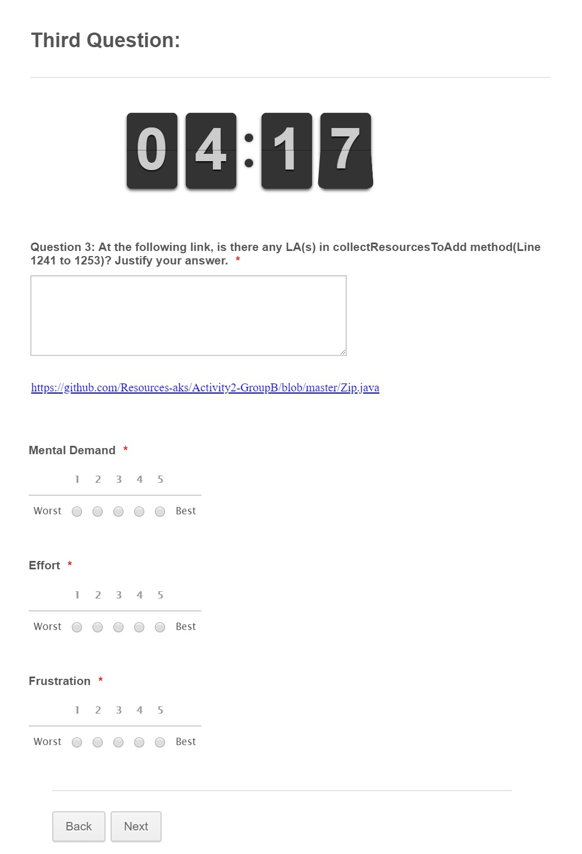

<https://github.com/Resources-aks/Activity2-GroupB/blob/master/Zip.java>

