MET CS544

Weilin Lu

Assignment 2

PART 1

|  |  |  |  |  |
| --- | --- | --- | --- | --- |
| Age | Number of people | % of total | BMI of above 30 | Probability |
| 18-34 | 4250 | 42.5% | 1062 | 24.99% |
| 35-49 | 2850 | 28.5% | 1710 | 60% |
| 50-64 | 1640 | 16.4% | 656 | 40% |
| Over 65 | 1260 | 12.6% | 189 | 15% |

a:)

P(have BMI of above 30)=(0.425*0.2499+0.6*0.285+0.4*0.164+0.15*0.126)*100

=36.17075%

b:)

P(18-34 have BMI of above 30)=[(0.2499*0.425)/0.3617075]*100

=29.63%(rounded)

c:)

P(35-49 have BMI of above 30)=[(0.6*0.285)/0.3617075]*100

=47.28%(rounded)

d:)

P(50-64 have BMI of above 30)=[(0.4*0.164)/0.3617075]*100

=18.14%(rounded)

e:)

P(Over 65 have BMI of above 30)=[(0.15*0.126)/0.3617075]*100

=5.23%(rounded)

PART 2

CODE AND OUPTPUT

a:)

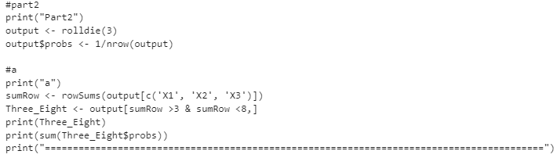

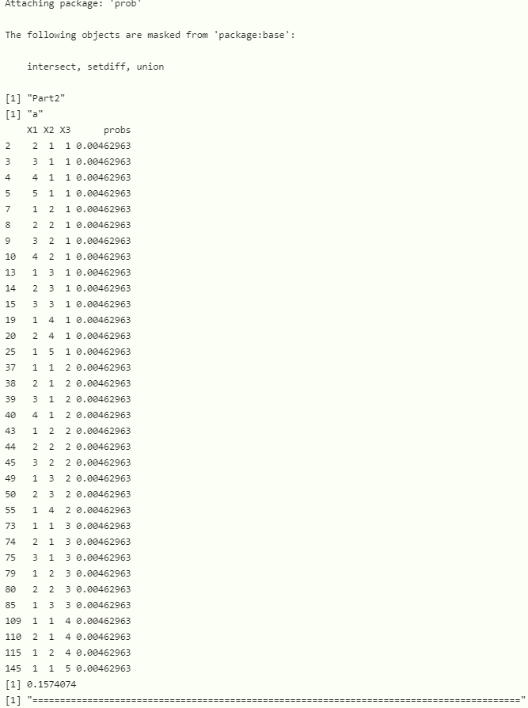

b:)

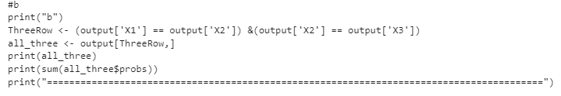

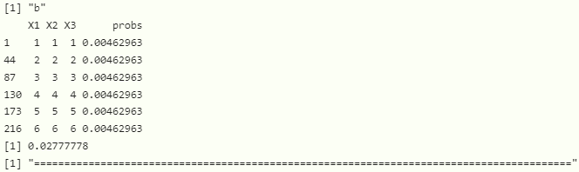

c:)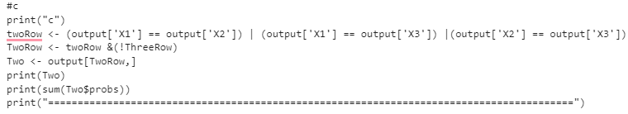

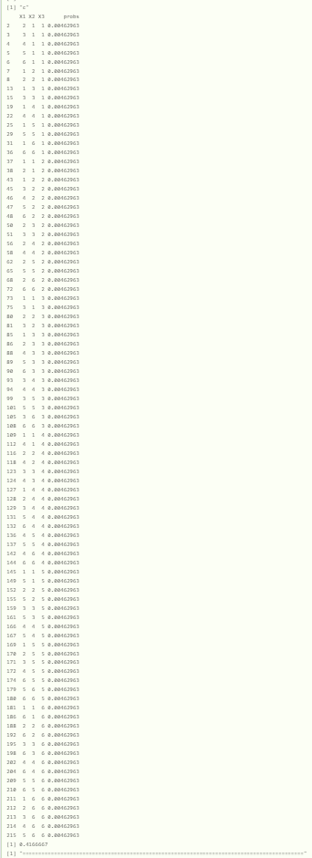

d:)

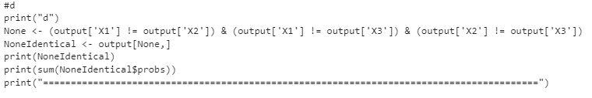

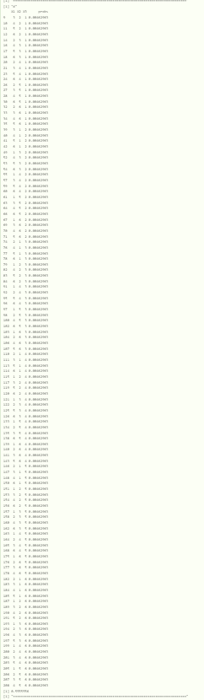

e:)

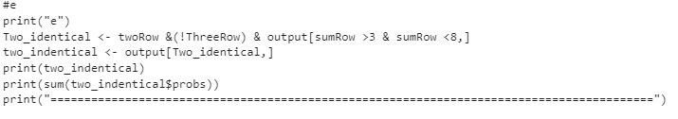

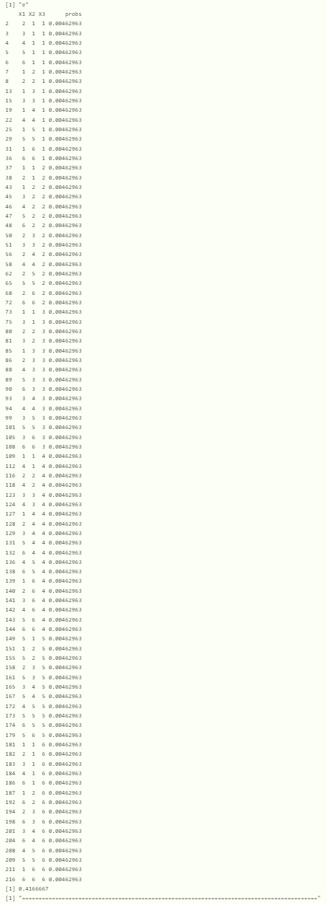

PART 3

CODE AND OUPUT

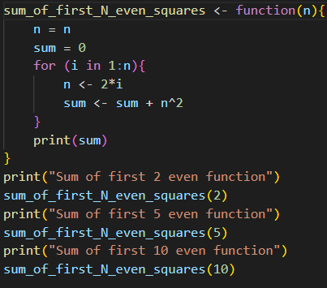

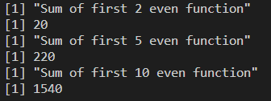

PART 4

a:)

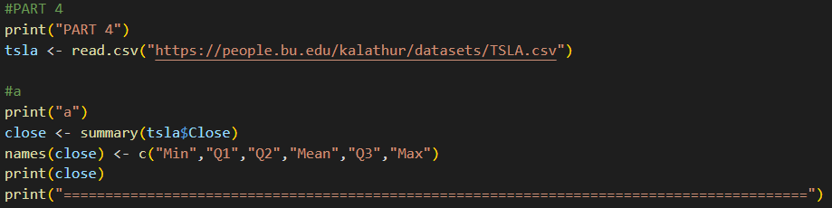



b:)

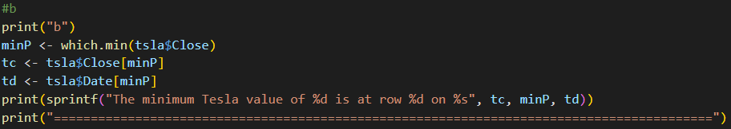



c:)

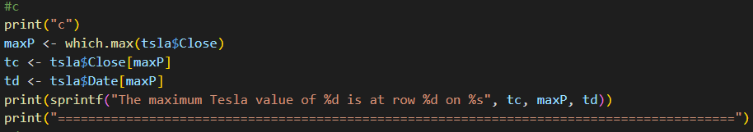



d:)

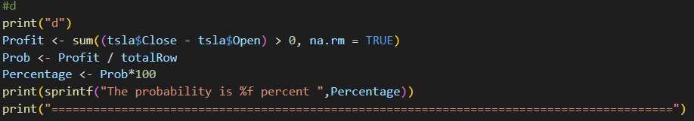



e:)

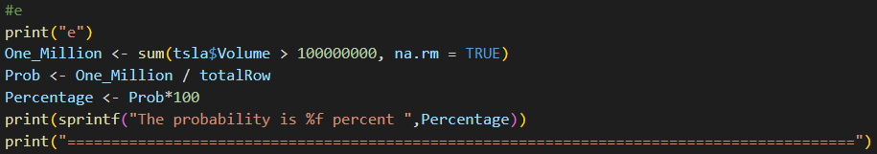



f:)

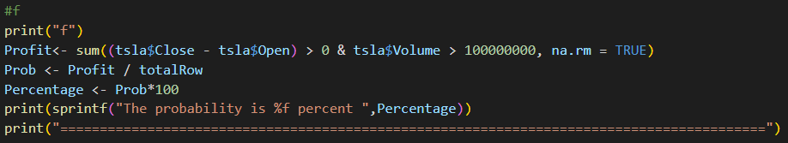



g:)

