Weilin Lu

CS544

Assignment 3

Part 1

1. :



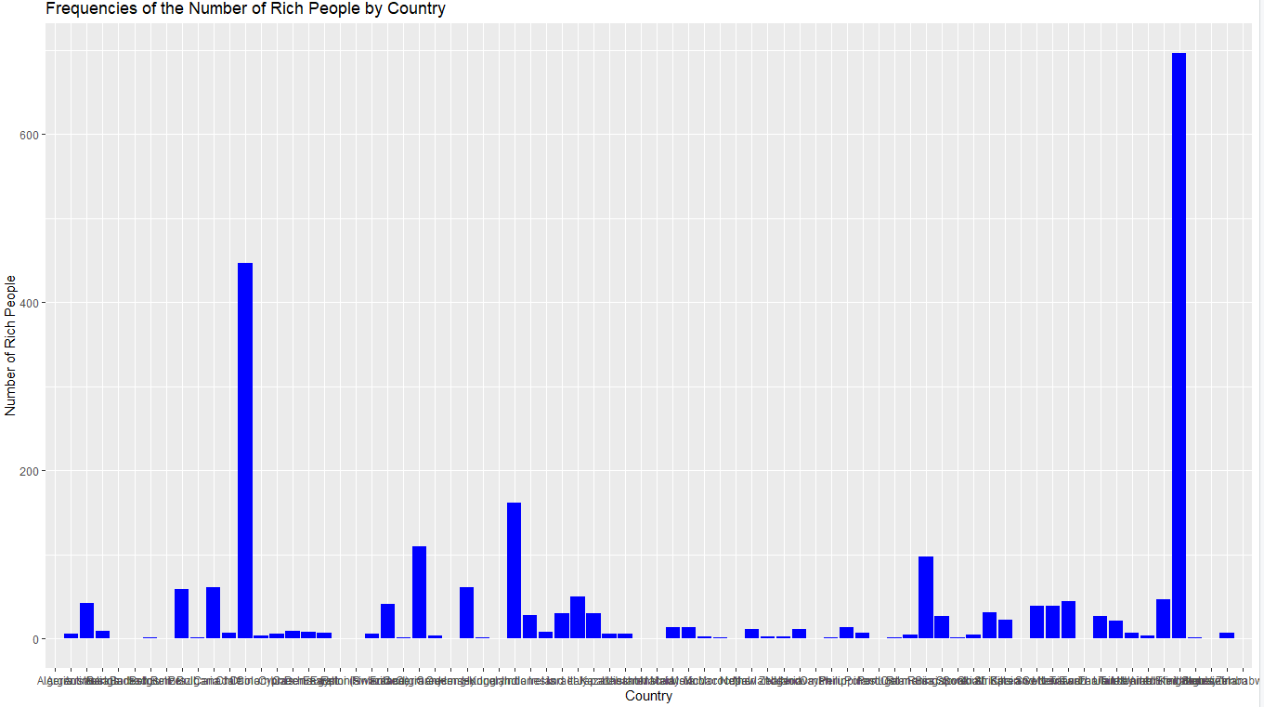

1. :



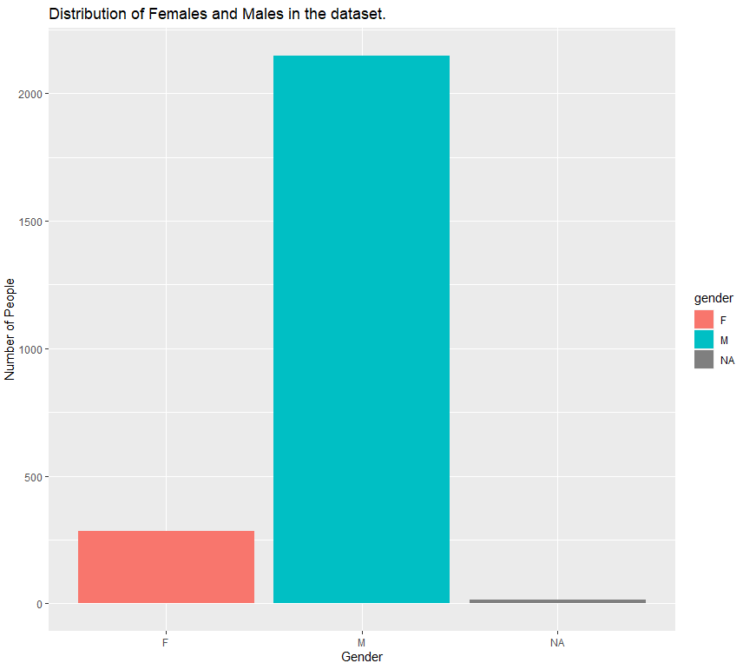

1. :

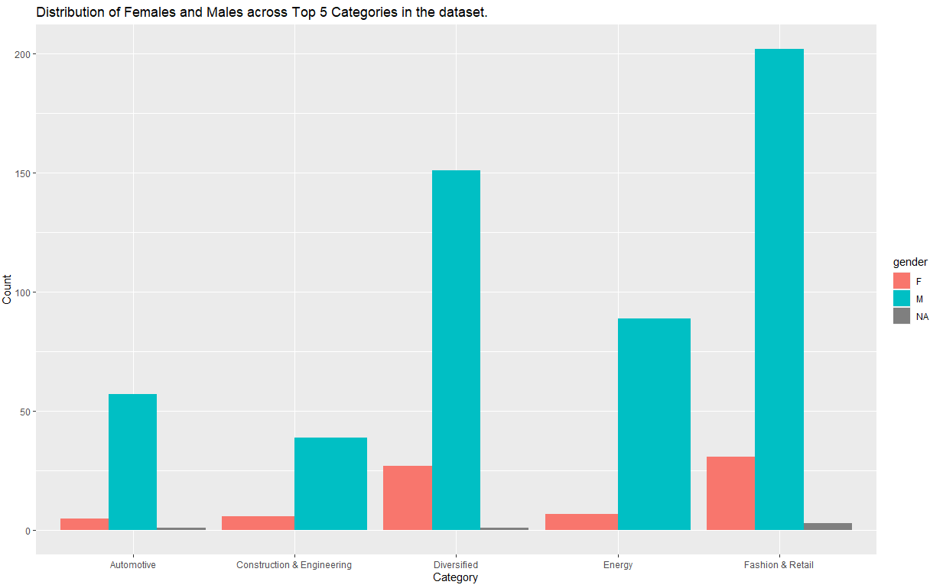

Part2

Code



1. :

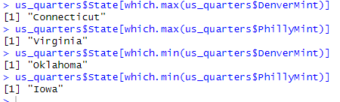

1. :

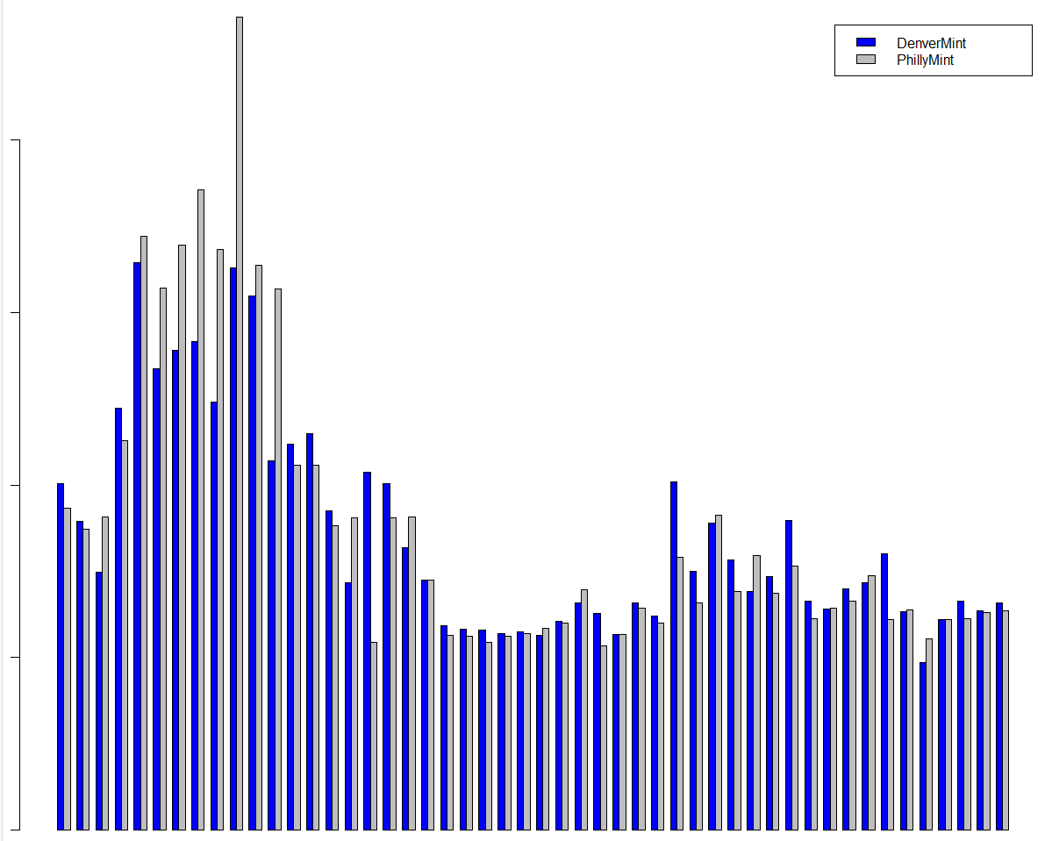

Two kind of mints have a strong correlation:these two mints cant have same amounts in each state.

From the barplot, i find there are some states have very high number of mints. These states could be outlier.

1. :

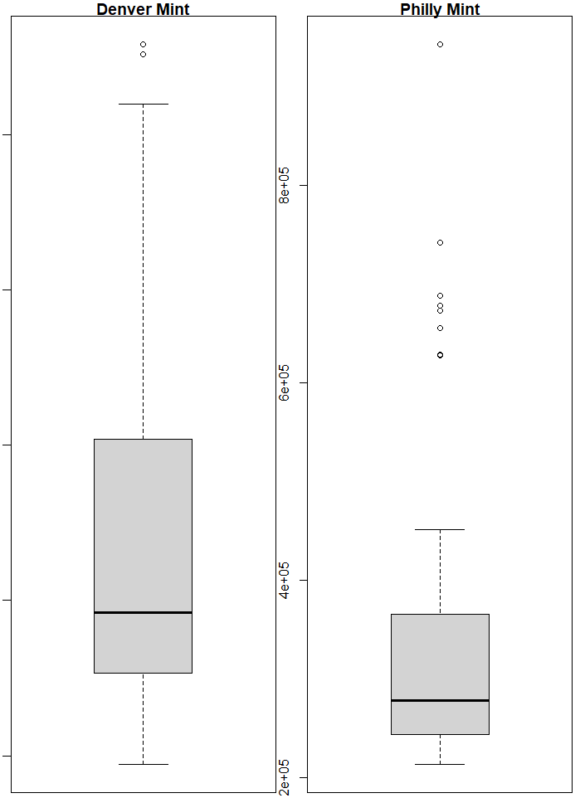

Philly mint has many outliers

Denver mint has a bigger range amount than Philly mint

1. :



Part 3

a):

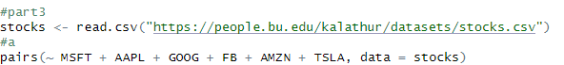

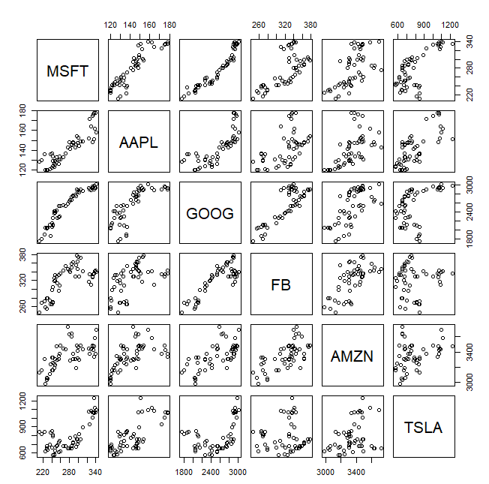

b):

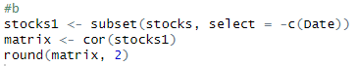

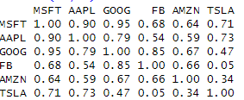

c):

1:Two stocks move in the same direction, which means they have a positive correlation. Otherwise, it is a negative correlation.

2:If two stocks have a value of 1, it represents a strong correlation, and if it is -1, it is a negative correlation. If it is 0, there is no correlation

3:The matrix only systemizes the linear correlation between stocks and does not contain other relationships

4:If the diagonal elements of the correlation matrix are all 1, it means that the stock is strongly correlated with itself

d):



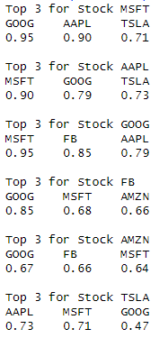

Part4

1. :

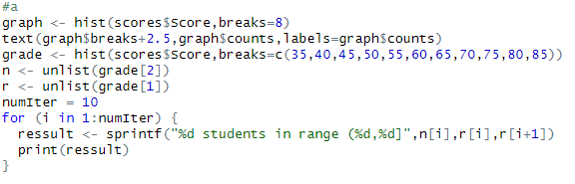

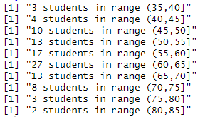

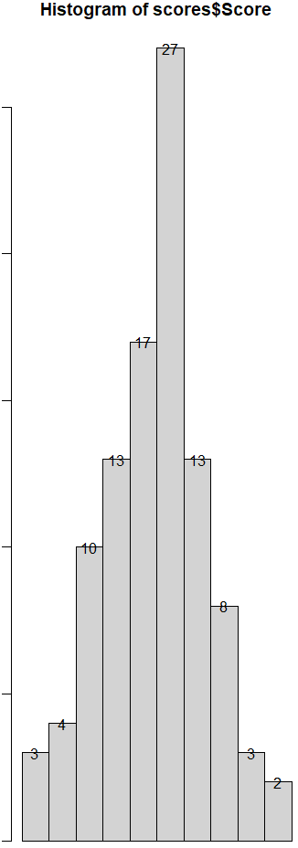

1. :

