Weilin Lu

CS-544

Assignment 5

Part1

1. :

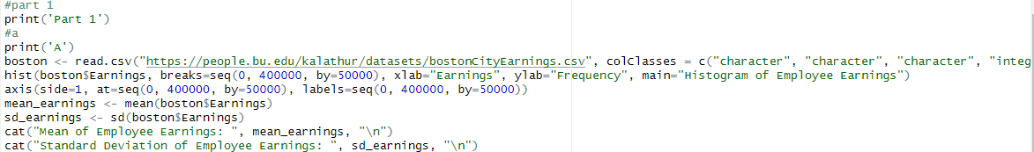

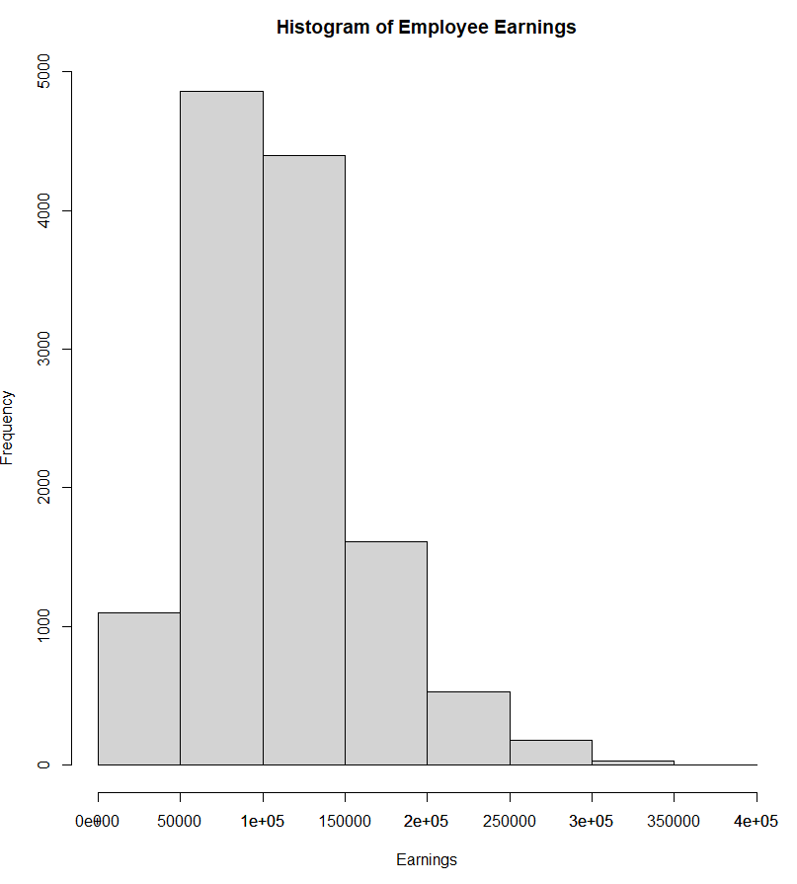

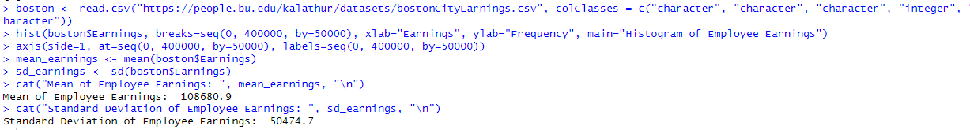

From the shape of the histogram, we can infer that the employee earnings are positively skewed, meaning that most of the employees earn lower salaries and only a few earn higher salaries.

1. :

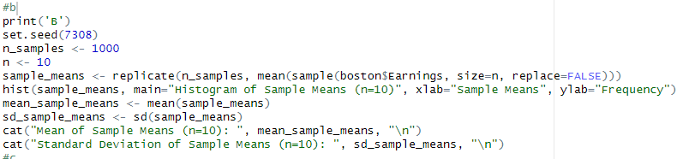

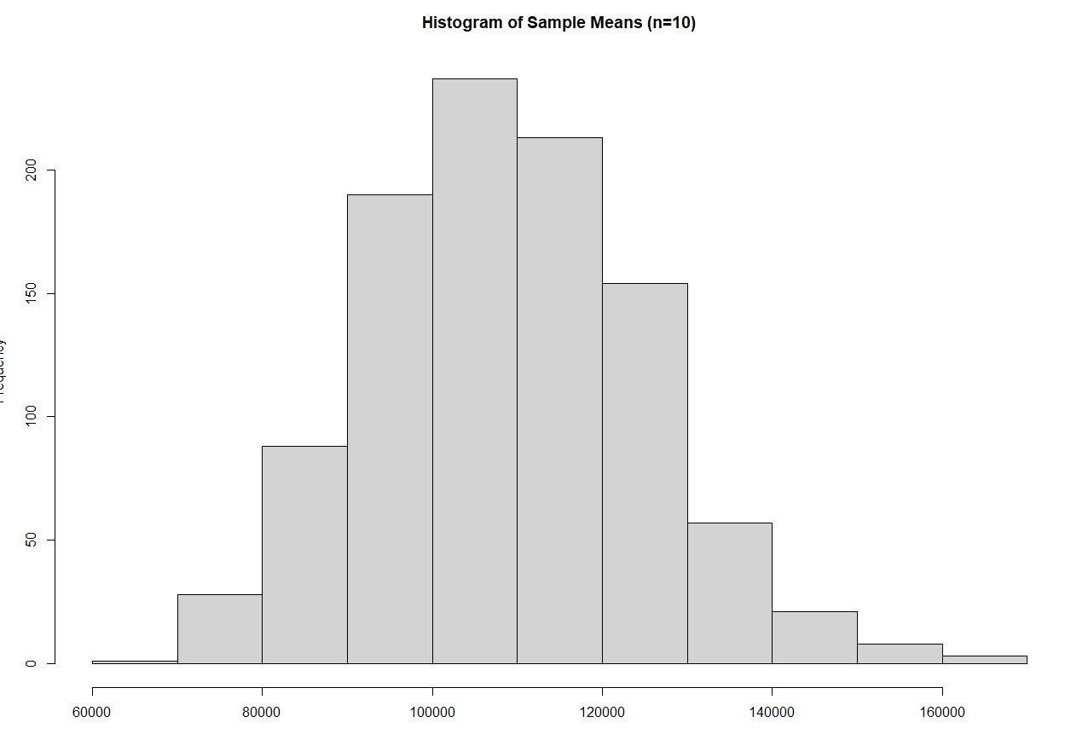

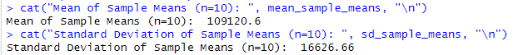

1. :

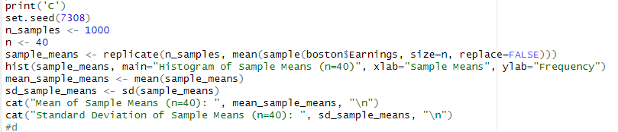

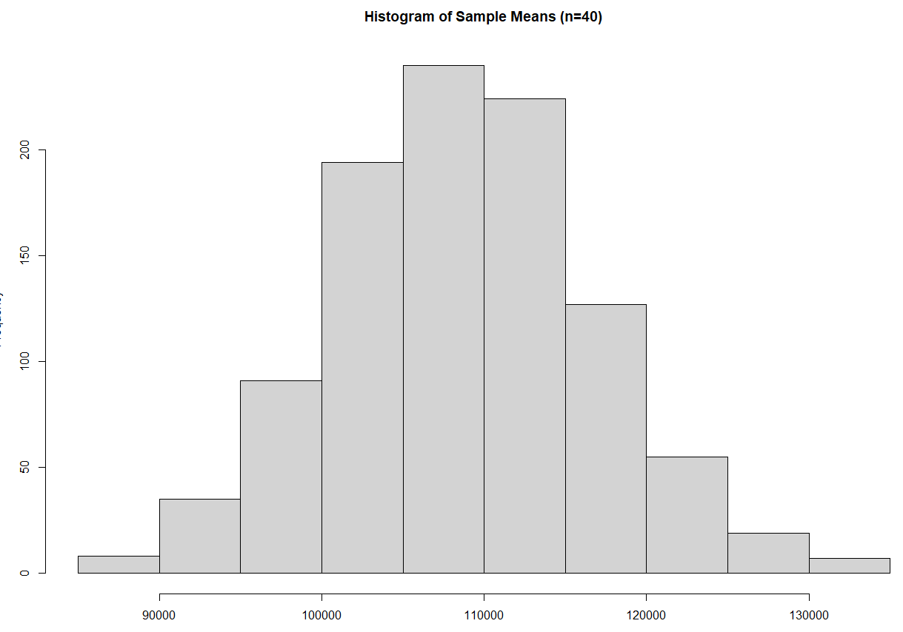

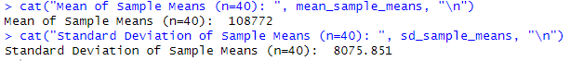

1. :

Comparing the means and standard deviations of the above three distributions, we can observe that the mean of the population (employee income) is higher than the mean of the sample mean and the standard deviation of the population is higher than the standard deviation of the sample means. As the sample size increases, the distribution of the sample mean becomes more normal and its standard deviation becomes smaller. This is consistent with the central limit theorem.

Part2

1. :

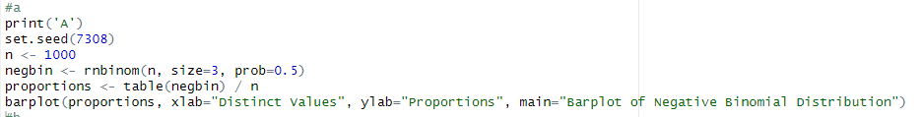

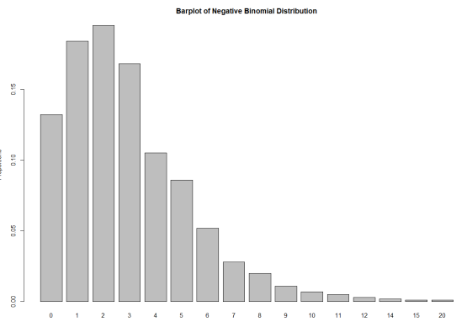

1. :

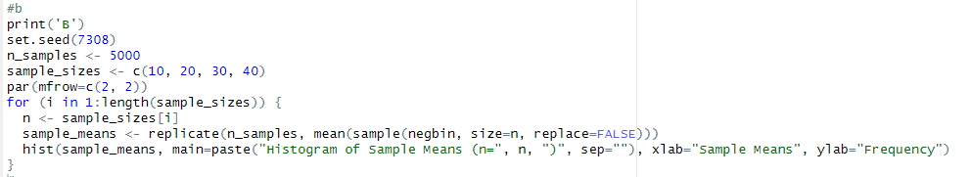

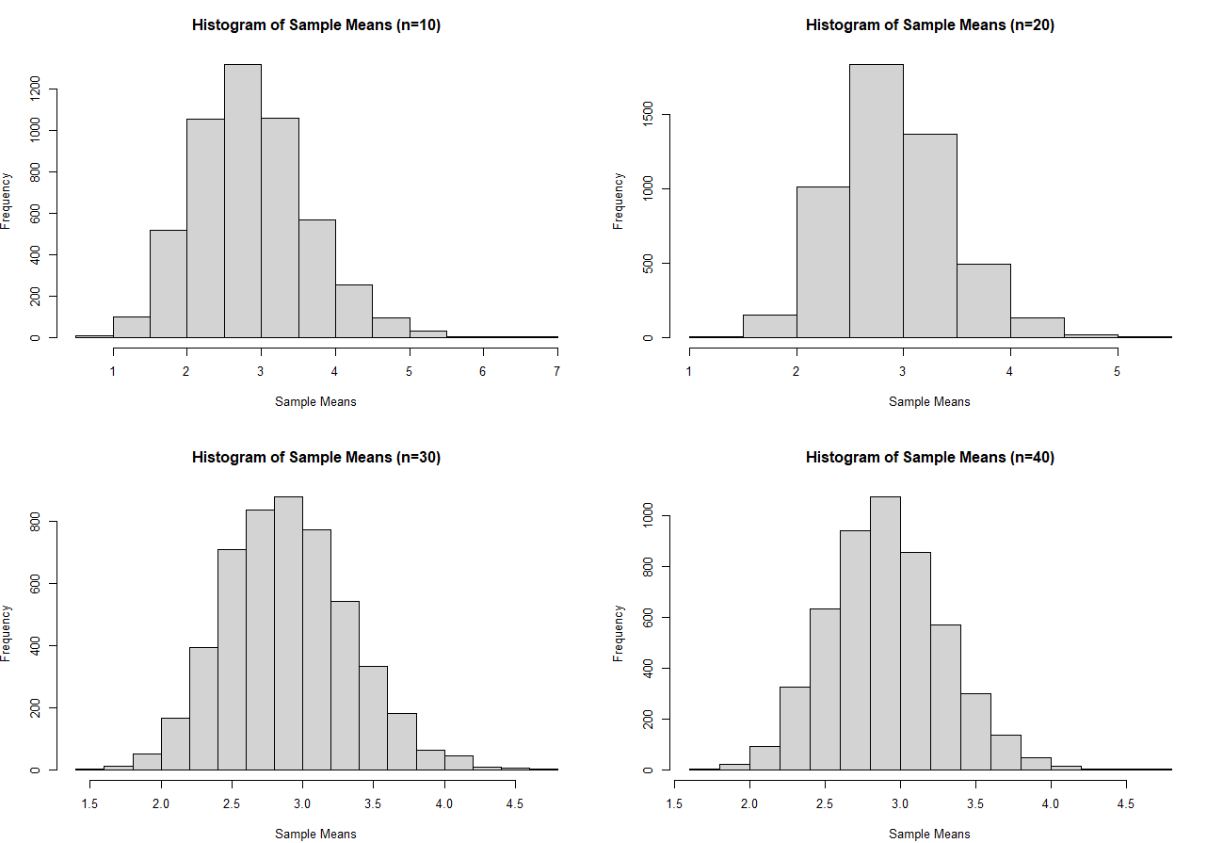

1. :

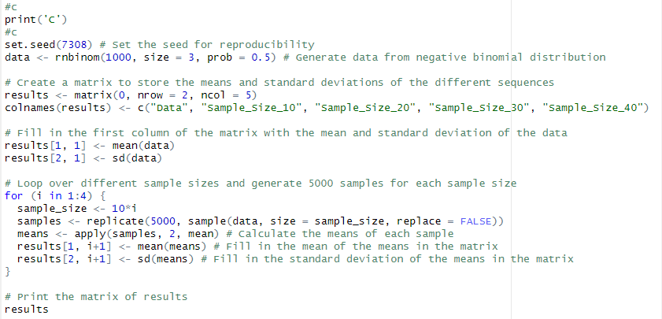

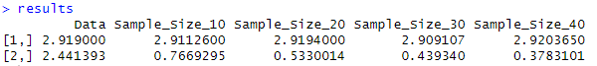

We can see that the means of the sample sequences are very close to the mean of the original data, and the standard deviations of the sample sequences are smaller than the standard deviation of the original data. This is in line with the central limit theorem, which states that the sample means tend to be normally distributed around the population mean, with a smaller variance as the sample size increases.

Part3

1. :

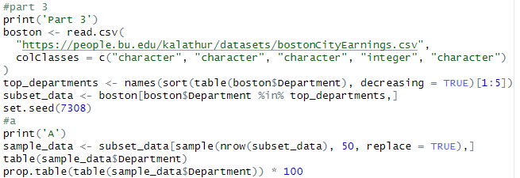

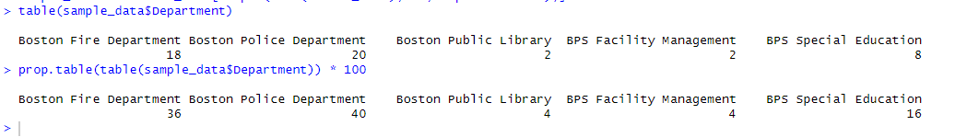

1. :

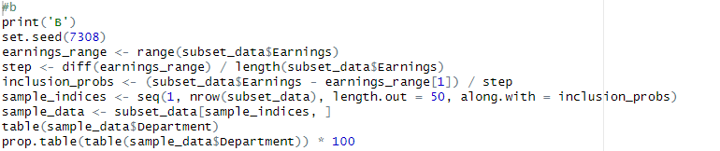

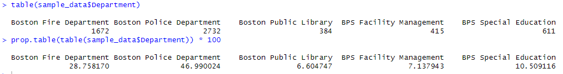

1. :

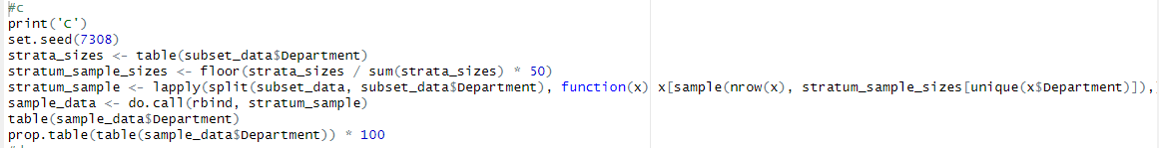

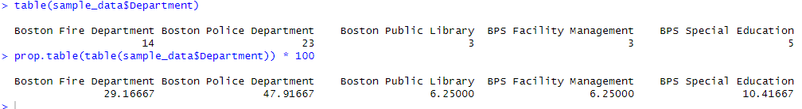

1. :

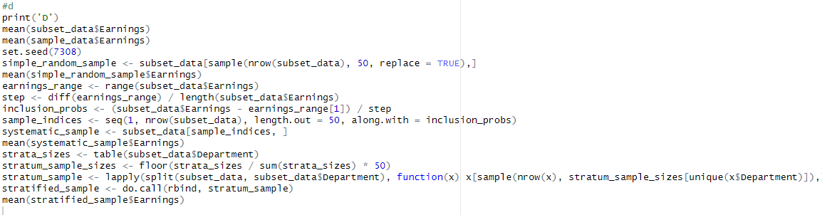







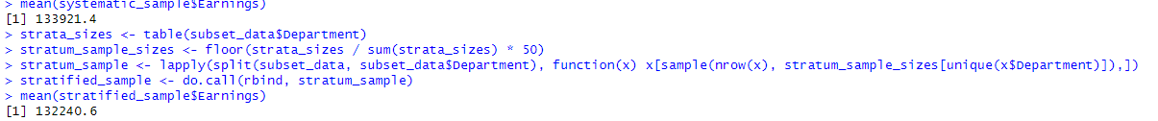

As we can see, the mean earnings for the simple random sample,the stratified sample and systematic sample are relatively close to the mean of the full data-set. This suggests that the systematic sampling method may have captured the full range of earnings levels in the data-set.