Weilin Lu

MetCS555

Assignment1

Question 1

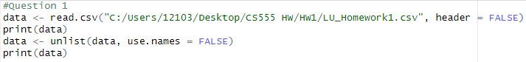

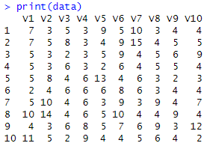

Question 2



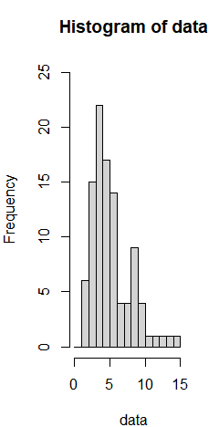

Question 3

3.1





|  |  |
| --- | --- |
| min | 2 |
| max | 15 |
| Q1 | 4 |
| Q2/Median | 5 |
| Q3 | 7 |
| Mean | 5.6 |
| Standard deviation | 2.733998 |

3.2

The best single number summary of the center of the distribution is 5 because this is the median number

3.3

The

The best single number summary of the spread of the distribution is 2.733998 because this is the Standard deviation

Question 4

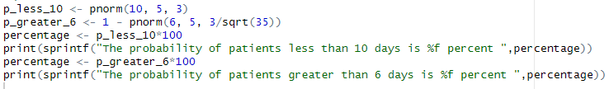

(a)



(b)

