Weilin Lu

Met-CS555

Assignment 3

Question 1

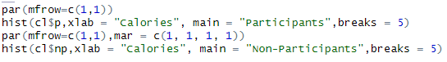

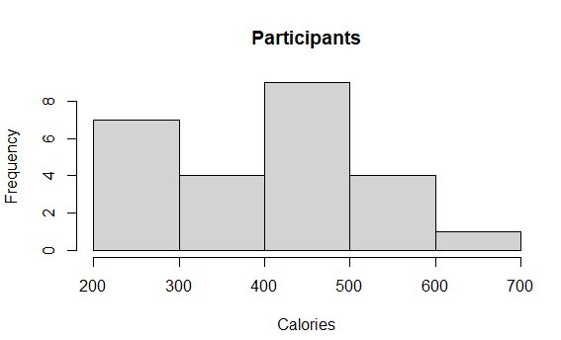

This graph looks like a right distribution graph

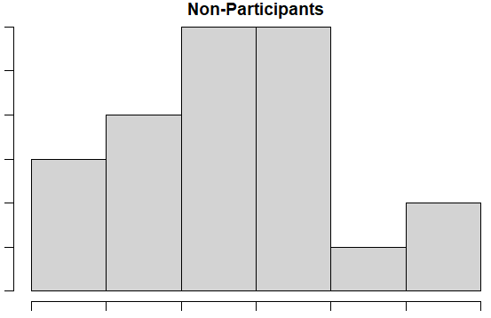

This graph looks like a left distribution graph

The same thing of these two graphs is their middle bar is highest,which mean they have the most number in the middle

Question 2

1:

H0:mu=0(The number of people who participated are same)

H1:mu!=0(The number of people who participated are different)

α=0.05

2:

The n is small, so the std is not sure.

t=(mean-mu)/(s/ $\sqrt{n}$)

3:

Calculate the critical value.If |t|>=1.711,reject H0.

4:

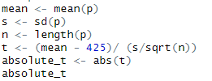



It is less than 1.711, continue

5:



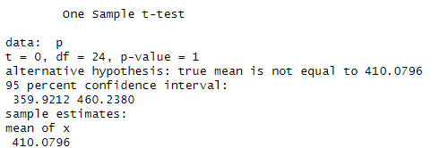

Rejection is not allowed rejection not allowed because participant is indistinguishable from 425

Question 3

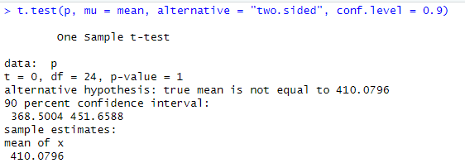

The 90% confidence interval for the mean calorie intake of the mean prep participants is [368.5004, 451.6588].So we can say the distribution interval is in this interval

Question 4

1:

h0:mu1=mu2

h1:mu1>mu2

α=0.05

2:

The sample test and n are small, so the std is not sure.

t=((mean1-mean2)-(mu1-mu2))/ $\sqrt{(s_1^2/n_1)+(s_2^2/n_2)}$

3:

Calculate the critical value. If |t|>=1.721, reject it. If not, continue.

4:

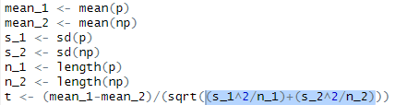



0.963609<1.721. Not reject.

5:

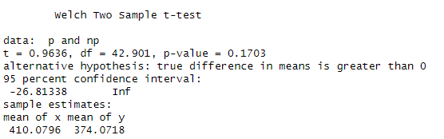

So we can say that the participants burned more calories than the non-participants.

Question 5

When α=0.05, the actual t i greater than we assumed, so we cannot reject two similar datasets. So the assumption test in question 4 is true.

Extra question

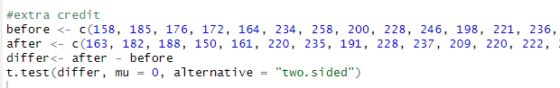

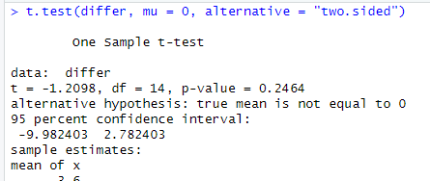

In the t-test, the p value is 0.2464,and the 95% confidence interval is [-9.982403,2.78403]. The t value is -1.2098. So we can not say it has a long term effect on their weight. So I wanna say no.