CS555

Weilin Lu

Assignment 3

1:

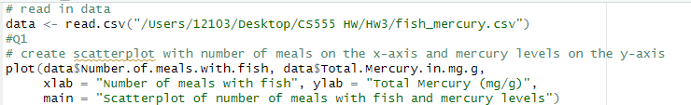

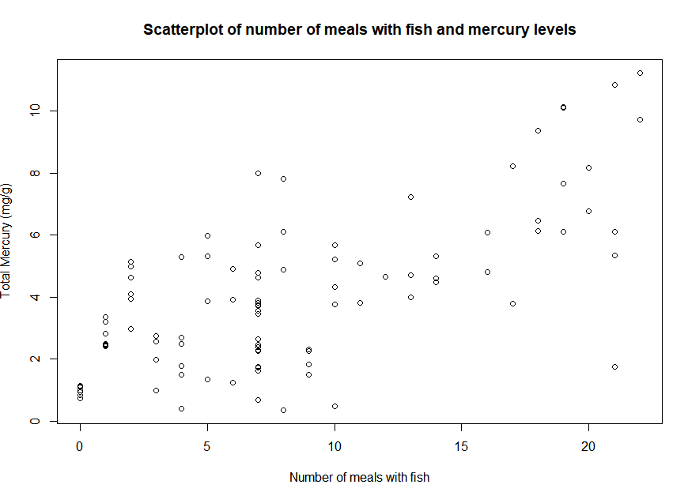

2:





3：

: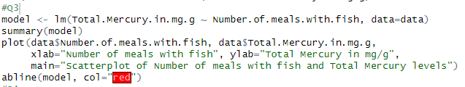

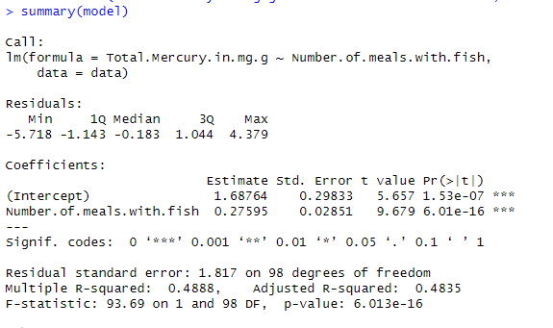

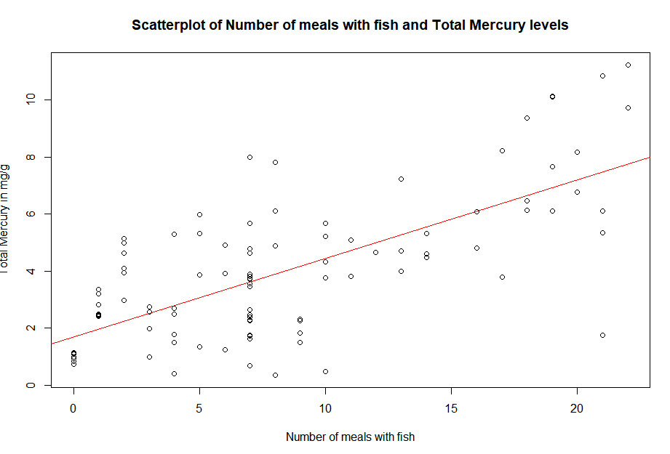

4；

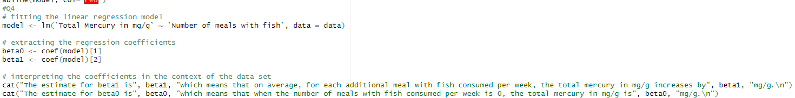



5：

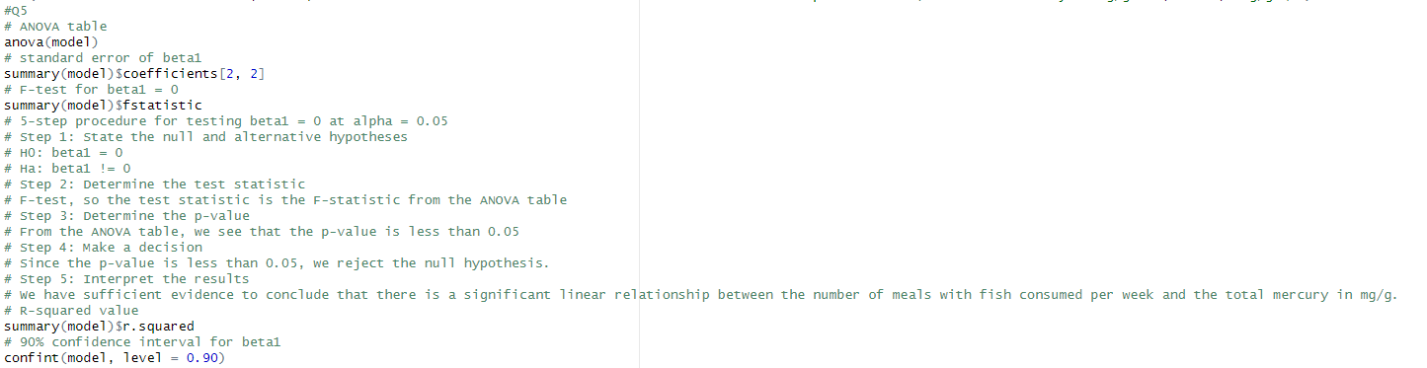

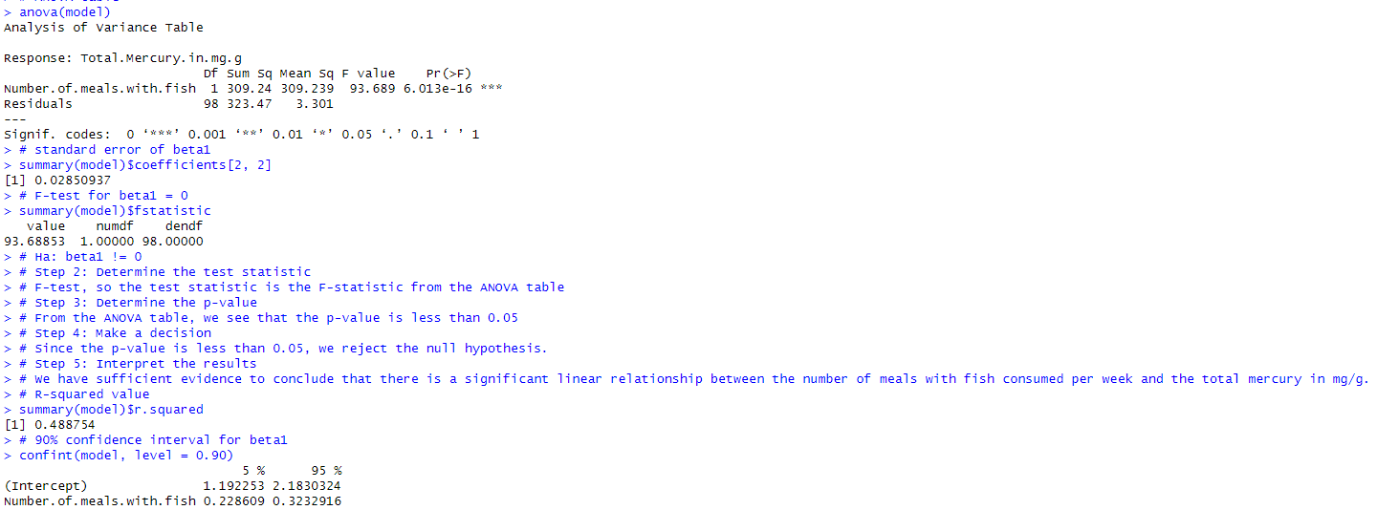

EXTRA CREDIT

1. :

NO. From the graph, if the seed weight is 1.6, the seed number is 12158. When the seed weight is 253, the seed number is 2475.So they are inversely proportional. An inverse relationship is not a linear model.

1. :

Model a is a better choice. Model a is a very typical inverse graph. And the inverse graph is very predictable

1. :

Weight should be:373

1. :

r^2=0.7016

r^2 is a statistical measure of the goodness of fit of the data. If r2 is closer to 1, the fit is better, otherwise it is worse. r2= 0.7016 shows that the logarithmic function can fit the relationship between the number of seeds and the weight of seeds relatively correctly.