# Package priority system

# Weilin Lu

# Assignment 6 2/15/2023

For this assignment, you will describe and implement the fifth and final release of your term project. You will incorporate *a greedy algorithm* as specified below. Submit this completed Word document as before, observing the 4-page limit excluding code etc..

## 1 SUMMARY DESCRIPTION—UPDATED (OR REPEATED IF UNCHANGED)

In this assignment, I use a greedy algorithm to show the delivery path of the package to the user by calculating the shortest path. (It will loading online csv file from git hub to calculate the shortest path).For example, their is several package information in the csv and the algorithm should calculate the shortest path from default city to next package’s city and show the the package order list by distance from low to high.

## 2 I/O EXAMPLE FROM PROJECTED COMPLETED PROJECT—UPDATED (OR REPEATED IF UNCHANGED)

## For example of input:

1,MA,Worcester

2,AZ,Tucson

3,MA,Boston

4,AZ,Phoenix

5,CA,San Francisco

6,CA,San Diego

7,NV,Las Vegas

Exmaple output:

Shortest path for package 1:

Start: Boston, MA

End: Worcester, MA

Path: (42.3601, -71.0589) -> ('MA', 'Worcester', 42.2621, -71.8034)

Total Distance: 0.7509222662832714

Priority: 1.3316957625315224

Notation:User should prepare their own csv file, copy their file link and paste it in the code:with open('/Users/felix/Desktop/package.csv', newline='') as csvfile. For example:with open('/Users/name/Desktop/file name.csv', newline='') as csvfile. User can find their file link by right click the file and choose:copy file link.

## 3 REQUIREMENTS IMPLEMENTED IN THIS RELEASE

### 3.1 Package.csv(input)

Package number is use for order the list State and city is use for let code know your destination.

### Input should contain package number,state,.city.The original input csv file does not need any changes(If you have your own csv file,replace the input file link with own your link).The code will input the csv file automatically.

The form of input csv file is as same as I provided in previous example input.

For the package number, don’t input a number which already exist. City and state,what ever put which city or state, just remember, spell it right.

### 3.2 Output requirement

## The output needs to tell the user the longitude and latitude of the passing city, and then tell the user the detailed distance and priority. After informing the user of all the detailed data, informing the user of the delivery order of the package according to the priority

## 4 ILLUSTRATIVE OUTPUT

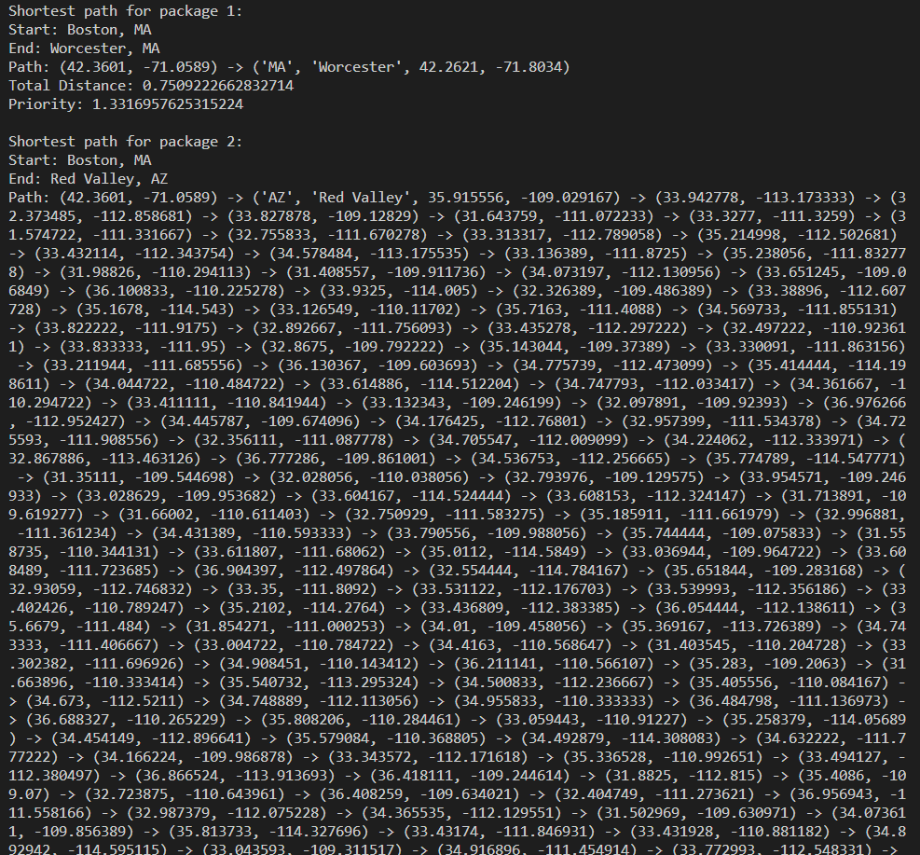

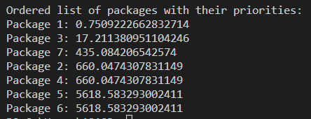

## 5 YOUR DIRECTORY

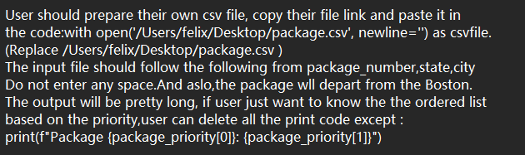

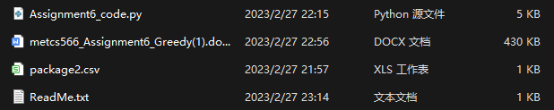

## 6 GREEDY DESIGN IMPLEMENTED

the greedy approach is used to find the shortest delivery path for each package. Specifically, the implementation first checks if the delivery city is in Massachusetts (MA) and if so, delivers the package directly. If not, it checks for cities in the same state as the delivery city and delivers the package to the closest city. If there are no cities in the same state, the implementation chooses the closest city as the delivery city.

### 6.1 Class model and Sequence Diagram

Class Diagram

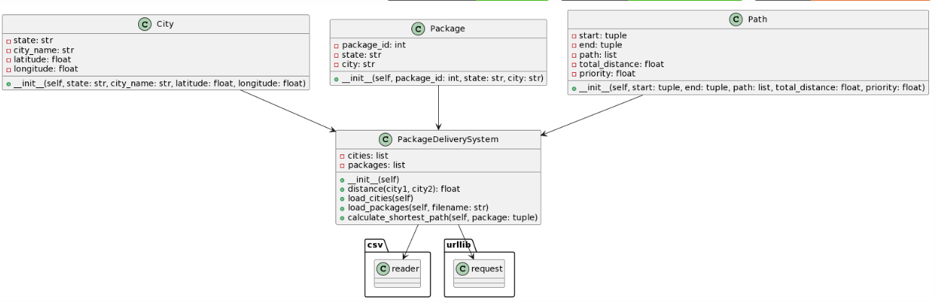

Sequence Diagram

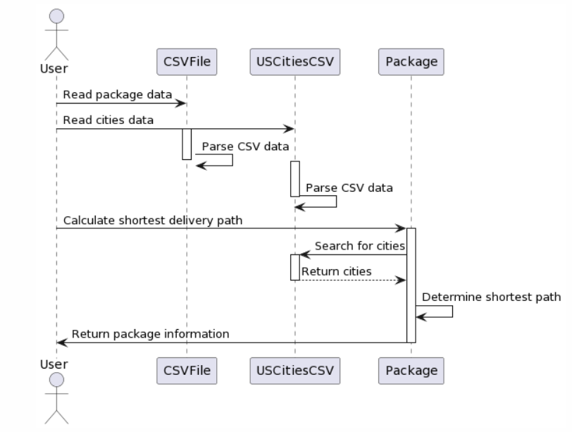

### 6.2 Code showing greedy programming

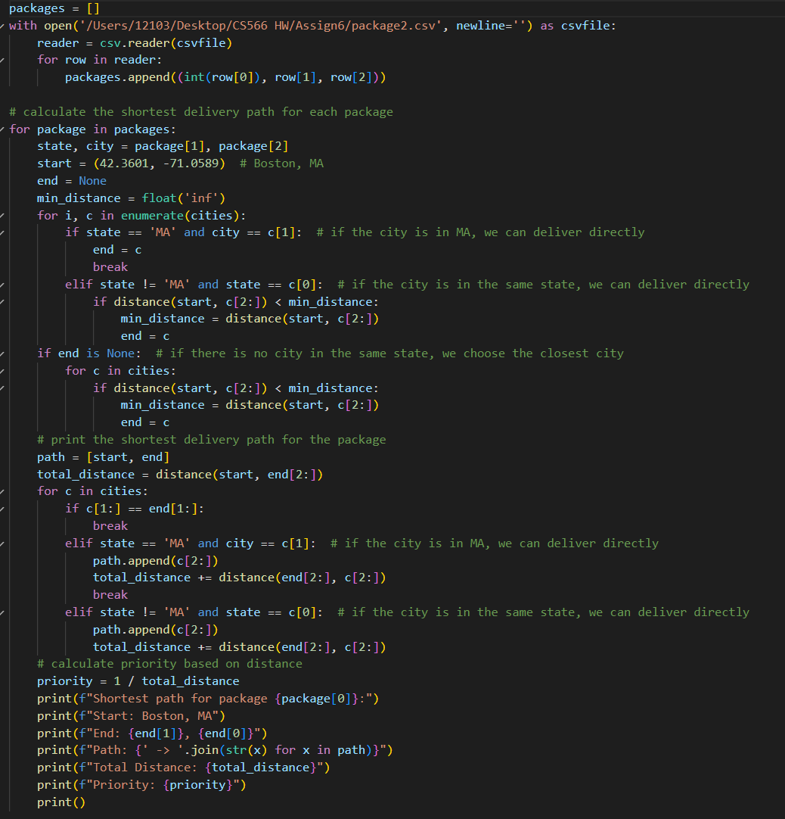

Greedy programming is appropriate here because we are looking for the shortest path between two cities, and a greedy algorithm can be used to make a locally optimal choice leading to a globally optimal solution. We first select the city that is in the same state as the destination city (if any), or the closest city if there is no city in the same state. Then, we use a greedy algorithm to find the shortest path from the starting city (Boston, MA) to the destination city by iteratively selecting the city closest to the current city until reaching the destination city. This method is simple, fast, and provides a good approximate solution to the problem.

### 6.3 Time complexity (efficiency)

The implementation iterates over all cities using a nested for loop to find the nearest city and finds the latitude and longitude of all passing cities. The time complexity of this operation is O(n^2), where n is the number of cities. In the worst case, when the destination city of the package is not in the same state or Massachusetts, the algorithm needs to compare the distance to all cities, which will take more time. The cities dataset is very large and the time complexity of the algorithm can be quite high. However, the actual impact of the algorithm depends on the size of the input data. If the number of input data increases, the time complexity of the algorithm will grow.

## 7 YOUR CODE

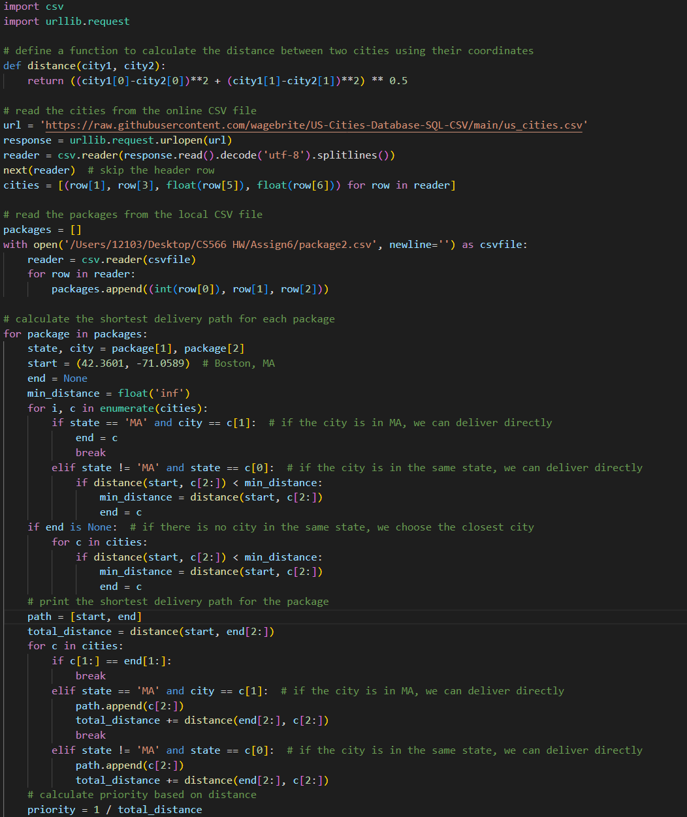

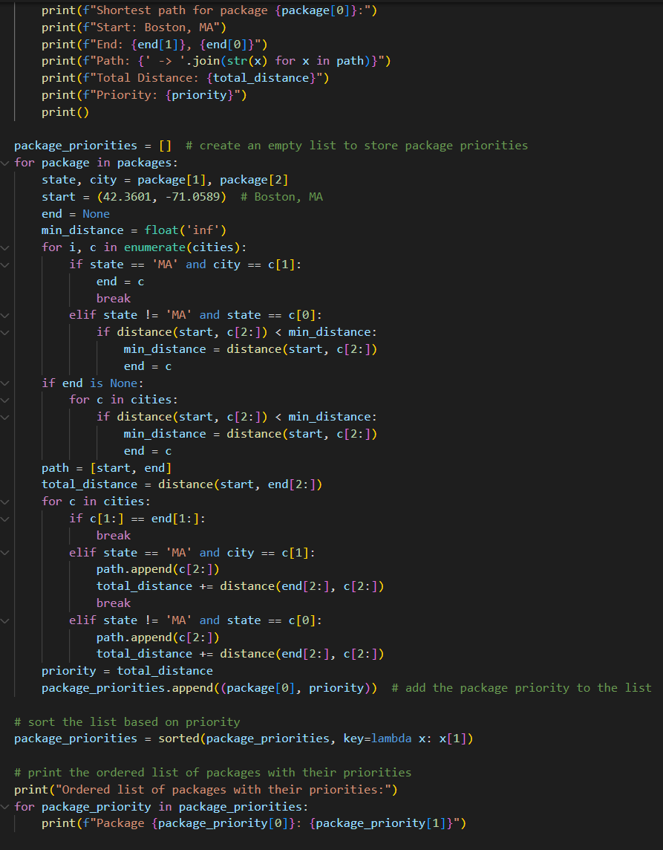

## 8 Evaluation



## References (if used. Each of [1], [2], etc. should occur within the paper above.)

[1]

[2]

## Appendix 1 (if needed; should be referenced above, and will be read as-needed only)

## Appendix 2 (if needed; should be referenced above, and will be read as-needed only)