Weilin Lu

Assign-10

Linear Discriminant Analysis

Q1

LDA equation:



QDA equation



Q2

LDA accuracy:100%



QDA accuracy:100%



Q3

LDA Confusion matrix

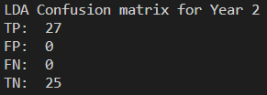

QDA Confusion matrix

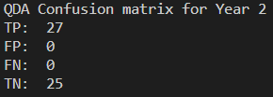

Q4

LDA:



QDA:



Q5

The long term strategy will has bigger amount at the end of the year.